Kentucky School for the Blind
Short Course Program

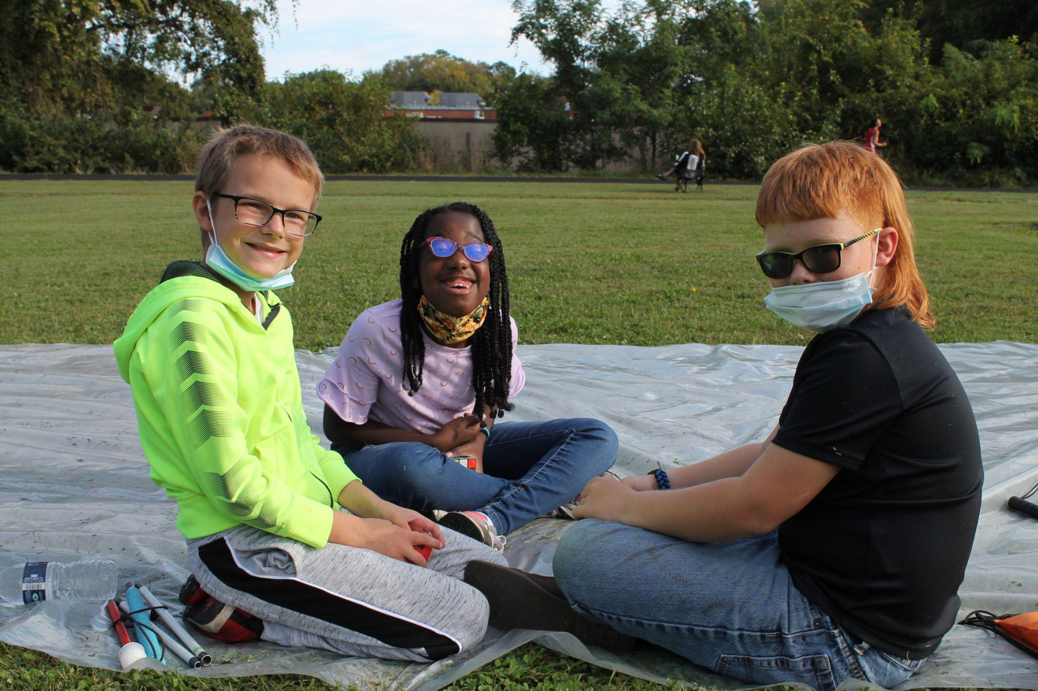

Introduction
The Kentucky School for the Blind Short Course Program is a nationally recognized model program that provides instruction in the Expanded Core Curriculum to K-12 students who are blind and visually impaired across the Commonwealth of Kentucky. Students may attend up to 12 weeks per school year while remaining enrolled in their home district. The program offers students the opportunity to receive direct and intensive instruction for their vision needs.

What can Short Course offer?
- Small class size
- Direct instruction with content certified Teacher of the Visually Impaired
- Interaction with peers who are blind or visually impaired
- Compensatory education - braille, study and organization skills, print reading/writing, tactile graphics
- Assistive technology - introduction to and practice with a variety of AT devices
- Independent living skills instruction - cooking, cleaning, money management, grocery shopping, personal hygiene, clothing care, time management, eating and table skills
- Social Interaction - body language, social conversations, etiquette, making friends
- Recreation and Leisure - introduction to and practice with a variety of recreational activities
- Career Education - transition plan development, career planning and awareness, soft skills development
- Self-Determination - self-knowledge, self-advocacy
- Orientation & Mobility - cane usage, finding different locations in the school, safe and appropriate travel in the community (direct instruction with orientation and mobility intern and concept reinforcement from a TVI)
- Adaptive Physical Education - daily PE class with certified adaptive PE teacher
- Music - weekly music class with emphasis on learning to play different instruments
- Yoga - weekly yoga class focused on breathing, mindfulness, and physical well-being and endurance
- Residential Program - supervised dorm facility where students can live from Sunday evening to Friday morning and can build more daily living skills, recreational activities, and social skills
To enroll your child, email or call Kyrstin Price.
kyrstin.price@ksb.kyschools.us 502-897-1583 x. 6104

