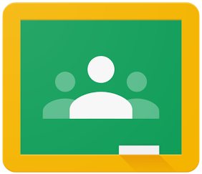
Google Classroom:
An Introduction for Parents/Students

If you would like to login to your child’s Google Classrooms to see and access digital learning activities, follow these directions:
- Turn on your child’s Chromebook and login with their school district username and password or the student's Clever badge.
- Access Google Classroom through the Google Classroom icon located on the bottom bar of the Chromebook.
  - Access to Google Classroom can also be achieved by going directly to the website classroom.google.com

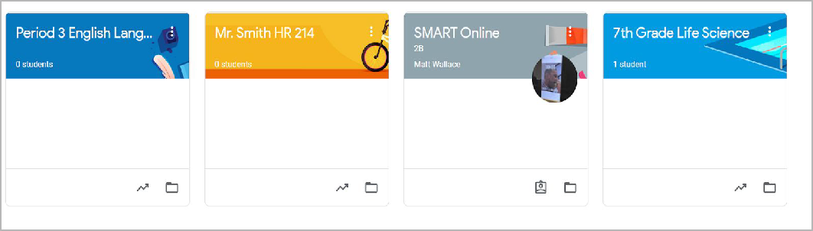

- Once you have opened up your class, you will be brought to the Classroom homepage, otherwise known as the “Stream”. See the image below to understand how to navigate and monitor this page:
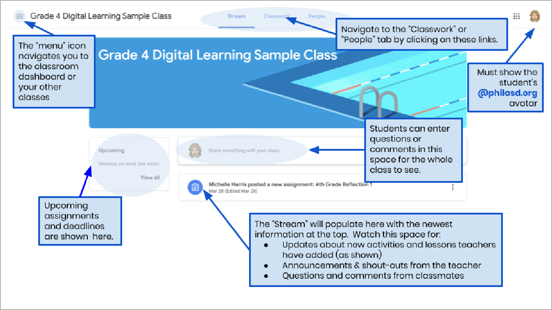

- Each Google Classroom has three main pages: the “Stream”, “Classwork”, and “People”:
- The Stream is your classroom home page. Watch this space for:
  - Updates about new materials and assignments
  - Announcements from your teachers
  - Questions and comments from students
- The Classwork tab is where teachers will post assignments and share class materials for students to access.
- The People tab lists the members of your class, including teachers and classmates, and gives you the option to email them directly.

- As you access the Classwork tab, you will see a list of assignments and materials, organized by topic.
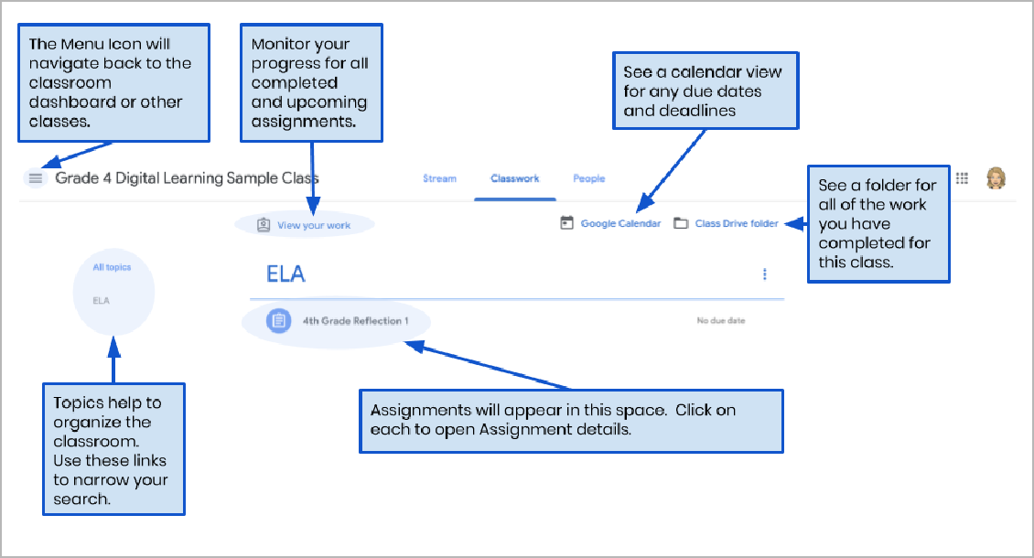
- Click to expand an assignment to access instructions, assignment details, and hyperlinks to the activities and resources. See the image below to better understand how to navigate the assignment windows, communicate with your classmates and teacher, and submit your work.
