
Google Meet is fully integrated into Google Classroom. Your child’s teacher will be posting links to join Google Hangouts Meet video conferences within Google Classroom. As a parent, it is important for you to understand:
- Google Hangouts Meet is part of Google Classroom which means it is safe, secure, and district-monitored.
- Your child should not be joining video conferences outside of Google Classroom and adult supervision.
- Your child cannot start or send a Google Hangout Meet link.
- Your child’s teacher may use Google Hangouts Meet for office hours, check-ins, or full virtual lessons. Check with your child’s teacher if

you do not fully understand how videoconferencing will be incorporated into daily instruction.

What students see when teachers invite them to a Google Hangouts Meet:

- Students should access videoconferences by logging into Google Classroom, just as they normally would. For Google Classroom login help, please see the directions above.

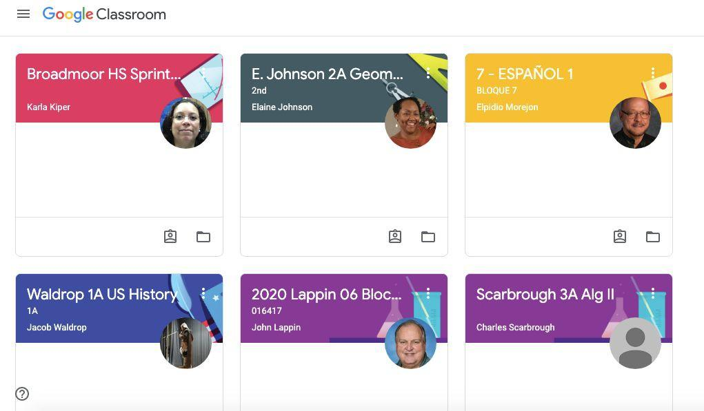
- Select the Google Classroom where your teacher has set up Google Hangouts Meet video conferencing sessions:

- Next, select the “Meet link” at the top of the classroom Stream.
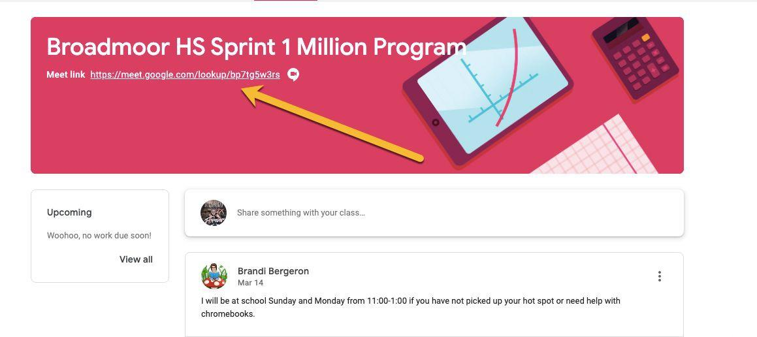
Please note: this link only works when the teacher has opened and started a Google Hangouts Meet videoconference. If a student selects this link without the teacher starting a meeting, here is what they will see:

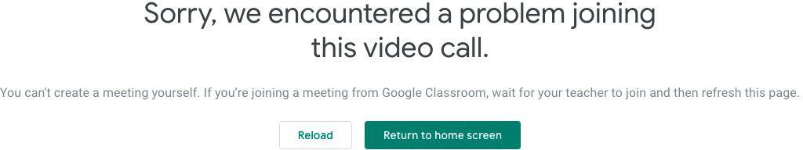

- Be sure that your camera and audio are on: Select “allow” to allow your camera and audio to be used during the videoconference.
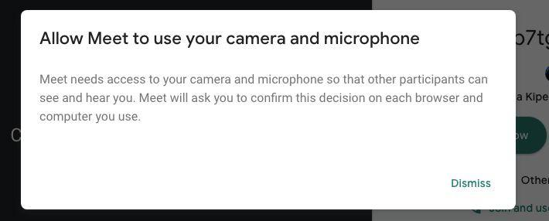
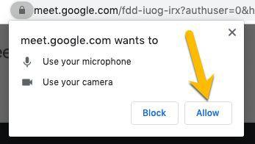

- Basic Controls:

Mute: always mute yourself when entering the class. If you don’t, your teacher will mute you. You should only unmute yourself when your teacher requests that you do so. This will keep the lesson running smoothly.

Leave: Clicking this button will cause you to leave the videoconference. Do not click this button unless your teacher requests that you do so, or the class meeting has ended.

Camera: turns your camera on or off.

Chat: The chat feature allows the teacher to send messages or links to lesson materials to the class and the student to send messages during the video conference.
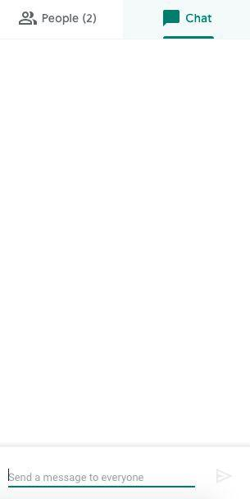

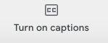
Turn on Captions: makes it easier to follow what is being said in meetings. For more on captions in Google Hangouts Meet select this link.

More Options: Click the three dots at the bottom right for even more options or help.
