La Grange Elementary School Council
Oldham County Schools

A G E N D A

April 24, 2023

- Call to Order
- Agenda Approval
- Review Norms

- Council discussions stay within the group until the action item has been approved by the Council
- Start on time and end on time
- Maintain a focus on ensuring the learning of all students
- Be willing to share ideas and open to new learning

- Council Action Items
- Master Schedule (Enclosure A)
- Professional Growth Plan (Enclosure B)
- Title I Funding Reallocation (Enclosure C)

- Principal’s Report
- 23-24 Related Arts program
- Initial MAP Growth Data in Science and Language
- Enter Closed Session to Discuss Certified Personnel Selection per KRS 61.801 (1) (f) for discussions that might lead to the appointment of an individual employee.
- Adjourn

La Grange Elementary
School-Based Decision-Making Council
Minutes
March 27, 2023
The La Grange Elementary School Site Based Decision Making Council met in the library for their regular meeting with the following members in attendance: Brittney Stephens – Teacher Rep, Jessie Gray- Teacher Rep., Tracy Simpson – Teacher Rep, Kiley Walker – Parent Rep, Sara Melhorn – Parent Rep and Heather Thomas - Chair.
Mrs. Thomas called the meeting to order at 2:41 pm.
1) A motion was made to accept the agenda by Kiley Walker. The motion was seconded by Sara Melhorn and the motion carried with no opposition.
2) Mrs. Thomas discussed the 504 Waiver Approval. She explained that District wide, the number of 504’s in place for students has grown significantly in recent years. Board Policy 4040 states that the 504 Committee in a school convenes annually to review accommodation plans. The requirement of the Office of Civil Rights states that a 504 plan be re-evaluated periodically, which may be conducted in accordance with the IDEA re-evaluation at three-year intervals (unless parents and/or a public agency agree that re-evaluation is necessary). A motion was made by Jessie Gray and seconded by Sara Melhorn to approve a waiver for the following portion of AR 4040 The 504-accommodation plan must be reviewed by the 504 team annually that states that the 504 team may re-evaluate at the three-year mark unless requested earlier by the parent/guardian. The motion carried with no opposition.
3) Mrs. Thomas presented the School Spacing Plan for the 2023-2024 school year. She also presented a map of the school which shows where teachers will be next year. Related Arts and the inclusion of our new STEM block were highlighted in the conversation. Mrs. Thomas also shared that Mrs. Sinkovic and Mrs. German would be joining our meeting to talk about VPA (Visual and Performing Arts) and how we are ensuring all music and art standards are addressed through this new related arts block. After minimal discussion, a motion was made by Brittney Stephens to accept the revisions to the Determination of Use of School Space Policy and approve the school spacing plan. The motion was seconded by Tracy Simpson. The motion was carried with no opposition.
4) Mrs. Thomas discussed the proposed budget for next year. After discussion within the Council, a motion was made by Sara Melhorn to accept the budget as proposed. The motion was seconded by Jessie Gray and carried with no opposition.
5) The Council entered Closed Session at 3:05 pm to discuss Personnel Selection per KRS 61.801(1)(f) for discussion that might lead to the appointment of an individual employee. The Council exited the Closed Session at 3:09 pm. With no additional business, a motion was made to adjourn by Sara Melhorn. The motion was seconded by Tracy Simpson and the Council adjourned at 3:13 pm.

April 24, 2023
Enclosure A
La Grange Elementary School Council
Oldham County Schools

CONCERN:

The Schedule of the Day and Week Policy for La Grange Elementary ensures that all students are provided equitable access to all components of the school’s curriculum within the master class schedule and aligns with La Grange Elementary School’s mission and vision statements.

Scheduling shall mean the development of a master plan for using time within the school day set by the state and the Board of Education and the use of time over a span of one week, one grading period, and/or one semester.

DISCUSSION:

In collaboration with the leadership committee, a draft version of our master schedule is very similar to our current schedule. The one significant change is the departmentalization of 4th grade and the creation of a separate writing block. At this point, both the EL and ECE individual schedules are not complete. These schedules will be finalized based on MAP and ACCESS scores.

RECOMMENDATION:

The 23-24 Master Schedule is being presented to Council for analysis, discussion, and approval. Pending further questions, approve the schedule as presented.

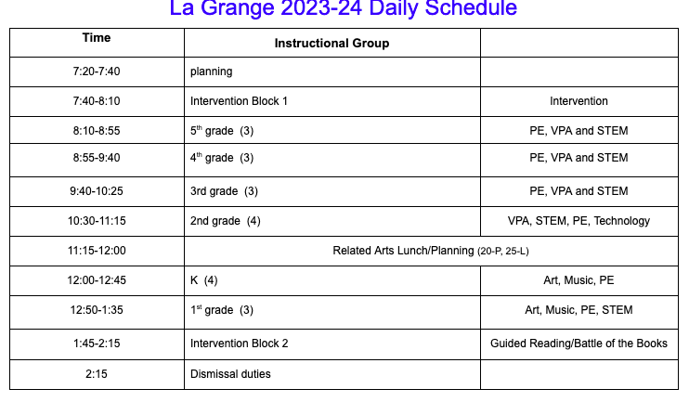
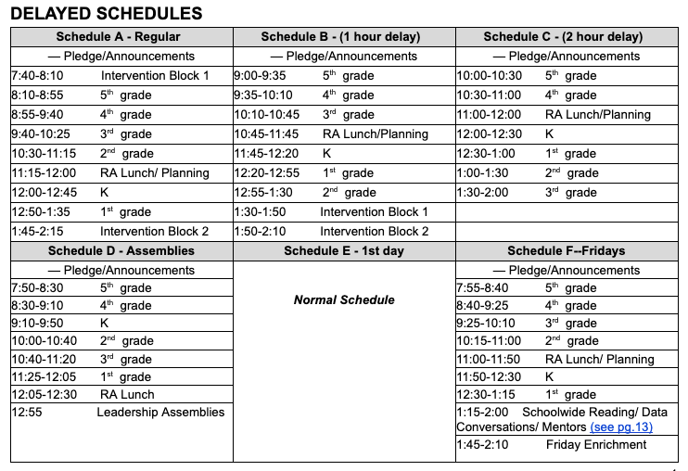

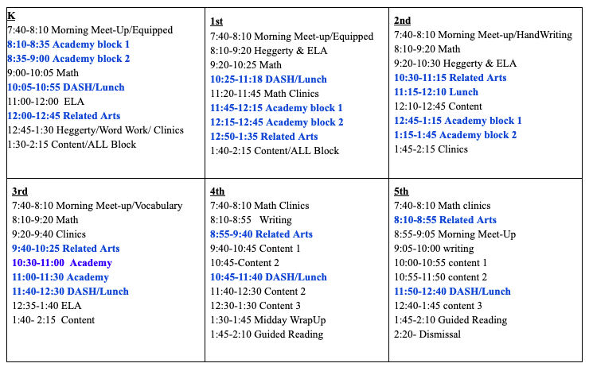

April 24, 2023
Enclosure B

La Grange Elementary School Council
Oldham County Schools
CONCERN:
Review Professional Development Plan for 2023-24

DISCUSSION:
All certified staff must complete 24 hours of professional development. The district has provided the option of completing the PD hours during the summer and/or using the 2 designated days during the school year.

School based decision-making councils have authority over determining professional development. With that said, there are specialized areas (special education teachers and related arts teachers) that need specialized training. Also, there have been common needs identified by the district that would benefit all teachers. Our PD plan represents both district and school options to individualize professional development based on the needs of the teacher.

RECOMMENDATION:
Review the 23-24 Professional Development Plan. Remand the plan back if changes, additions, or deletions are necessary. Approve the plan for implementation in the coming school year.

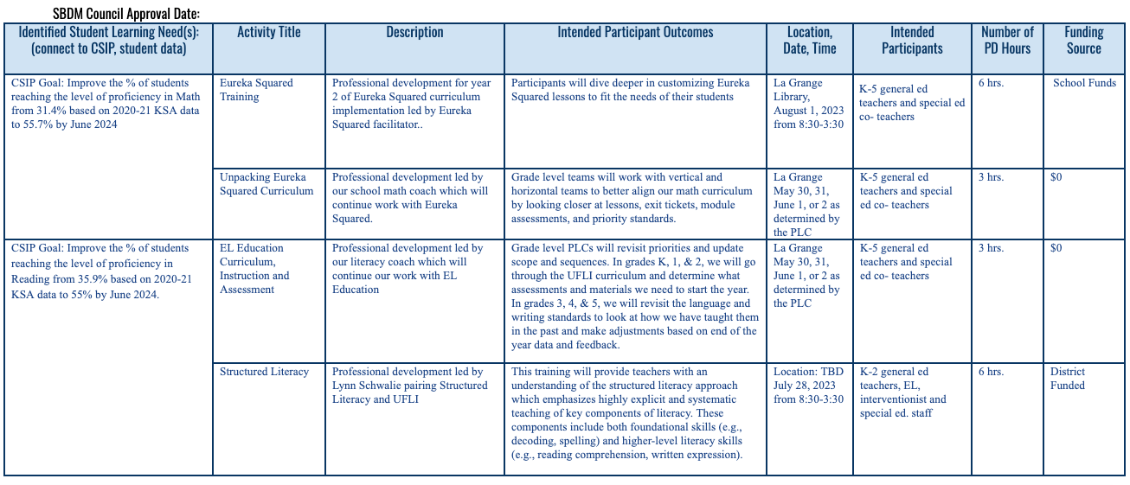
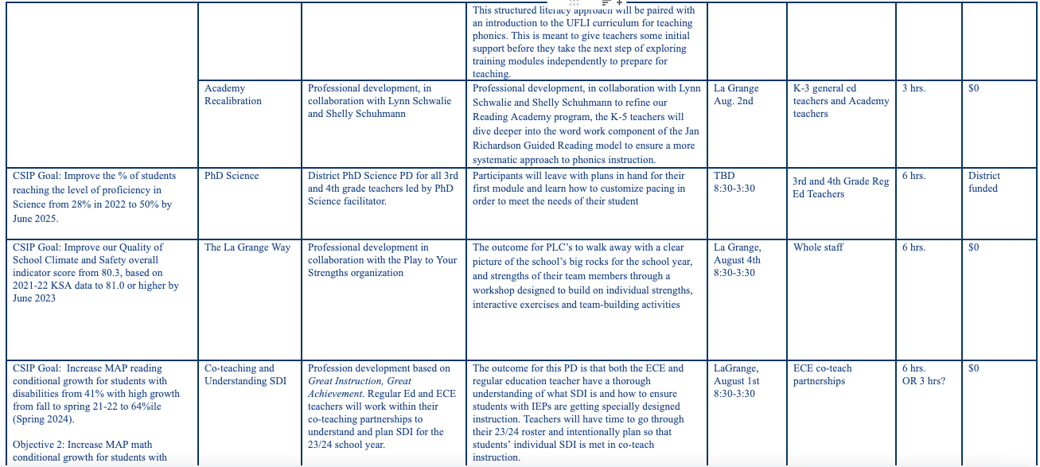

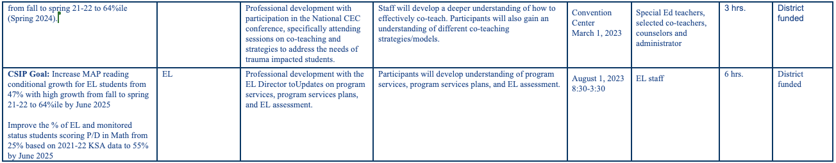

April 24, 2023
Enclosure C

La Grange Elementary School Council
Oldham County Schools

CONCERN:
Approve the Title I Budget Reallocation

DISCUSSION:
Based on our current budget, we have monies remaining in our textbook funds. With the approval of our new STEM lab, we need materials to launch this program. In order to reallocate the funds from textbook purchases to materials there needs to be approval from our Council.

RECOMMENDATION:
Review and discuss our funding reallocation for the 22-23 school year and approve.

