Submitted to Western Association of School and Colleges And the California Department of Education David Grissom, Principal Lynne Ewald, Vice-Principal Jennifer Baldwin, Vice-Principal Gregory Shelby, Vice-Principal March 2012
Santa Clara High School WASC Self-Study
3000 Benton St. Santa Clara, CA 95051

WASC Chapter I
School Profile

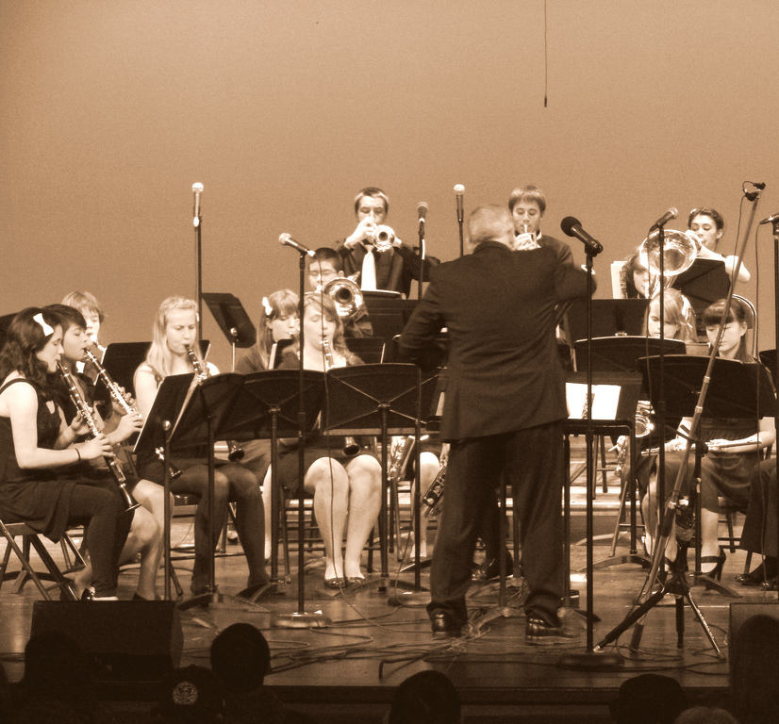

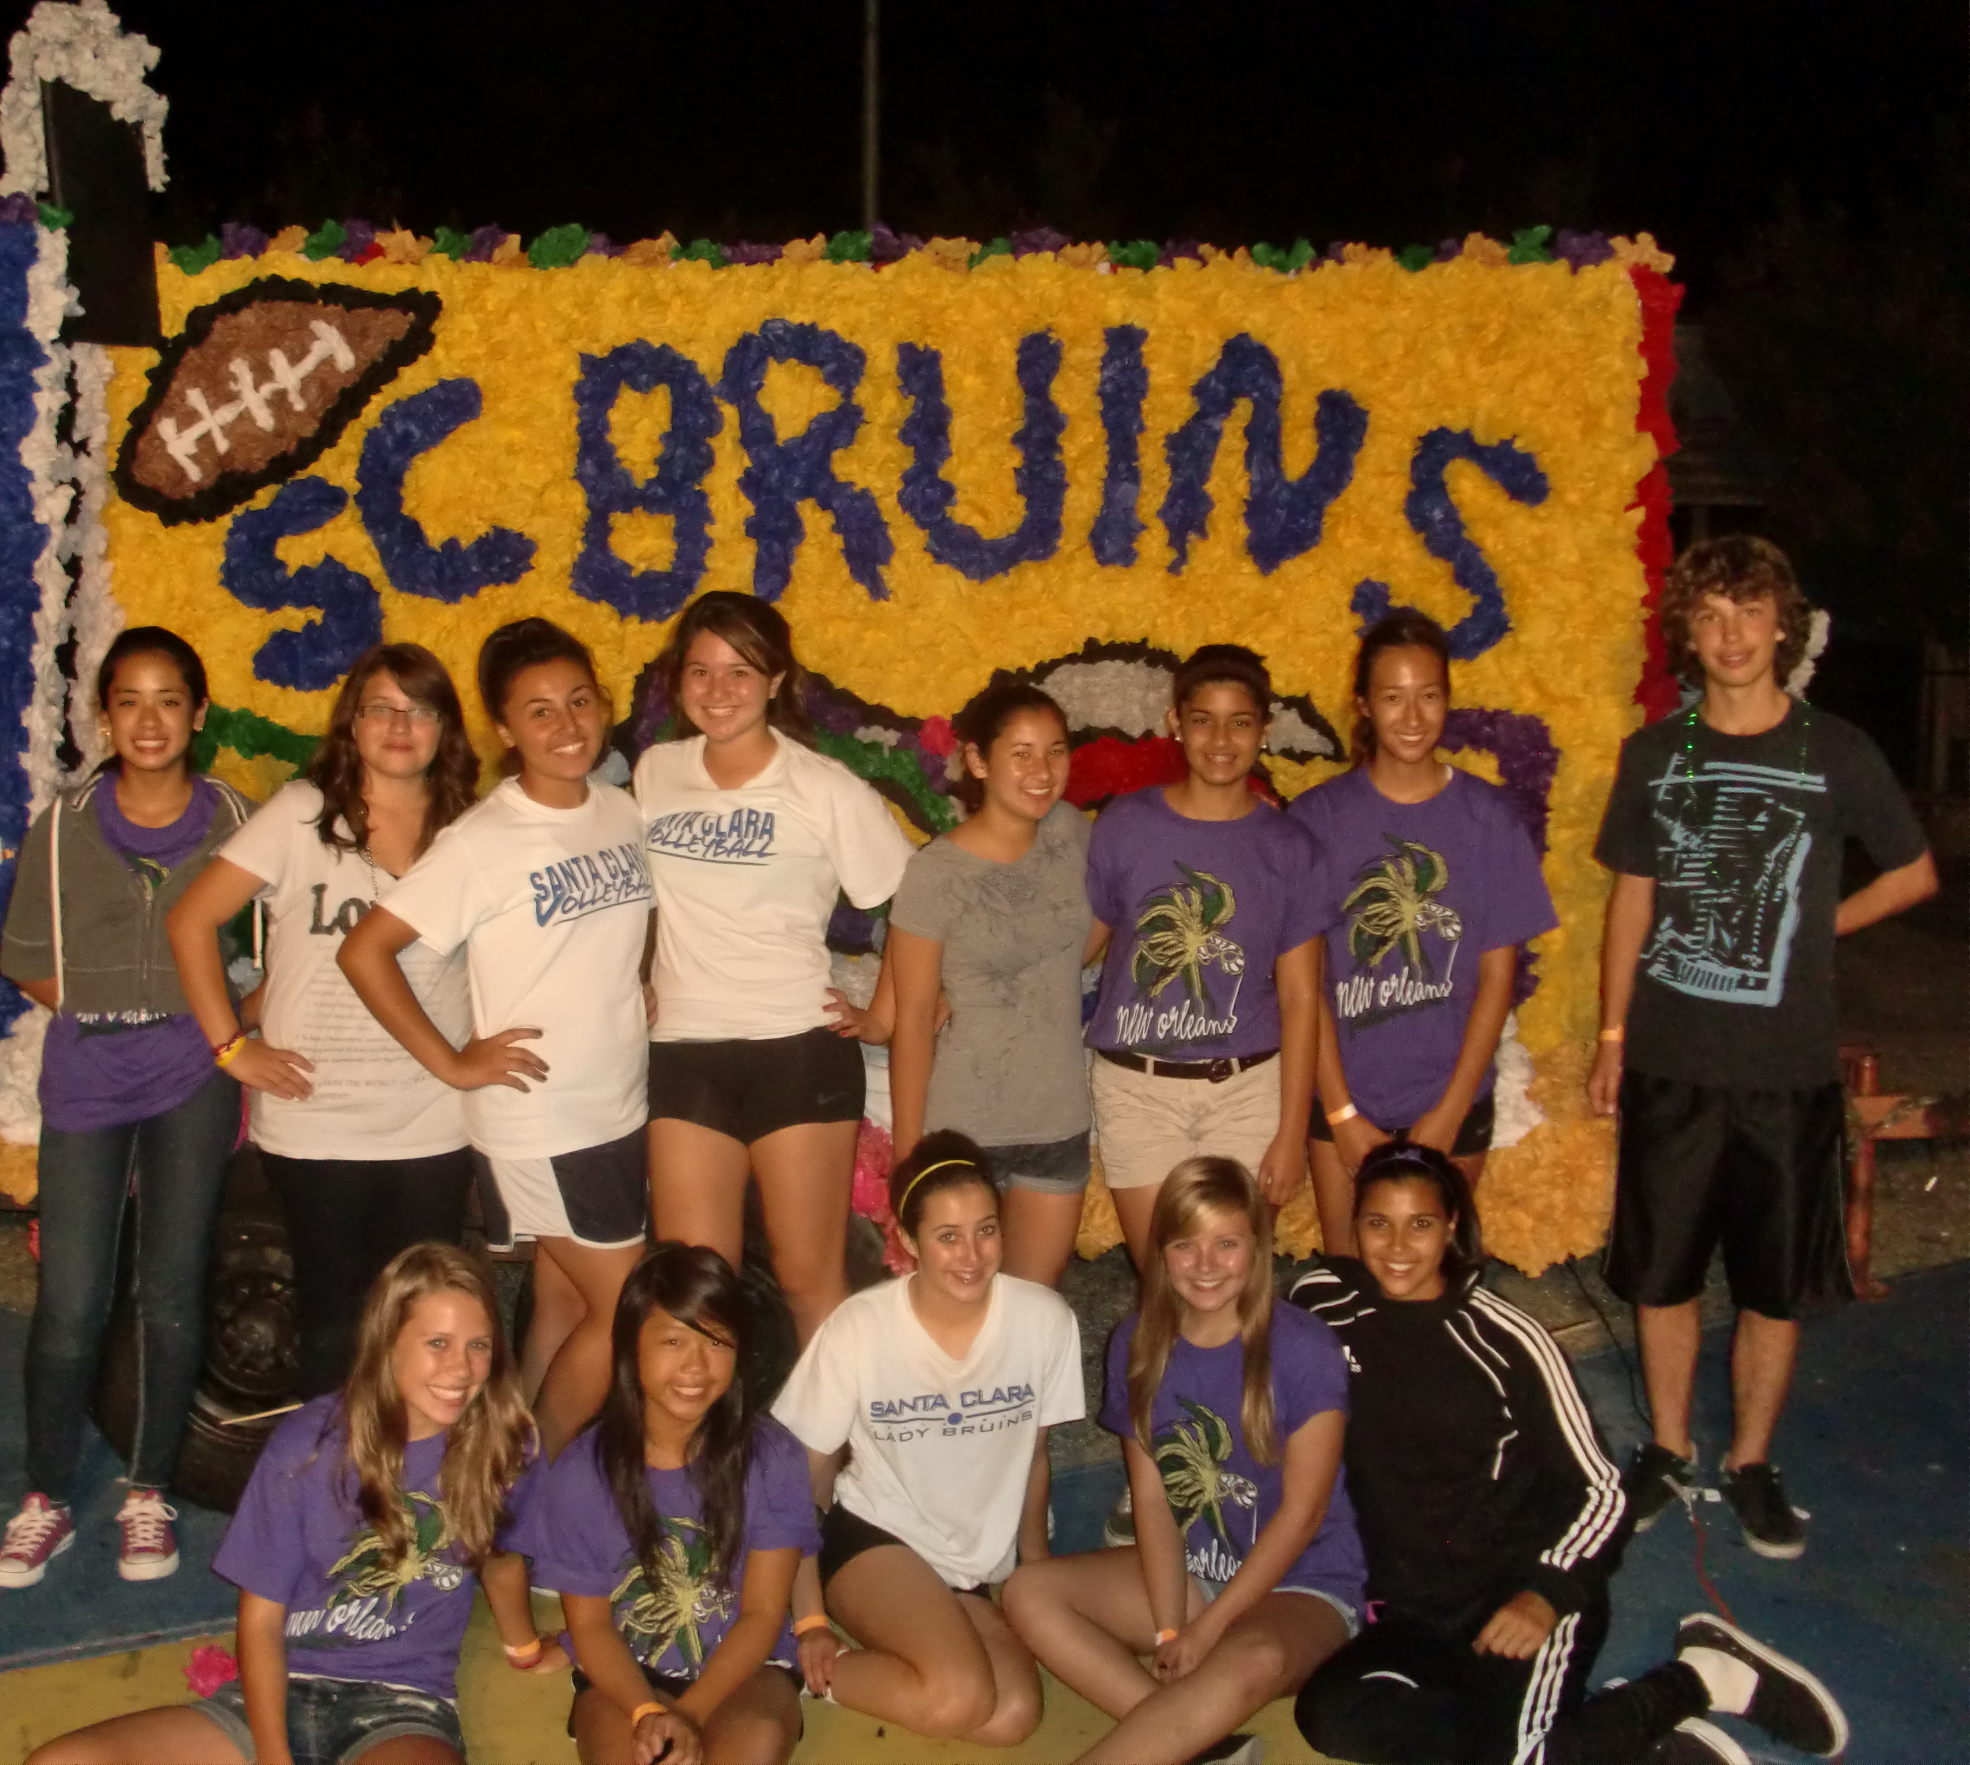
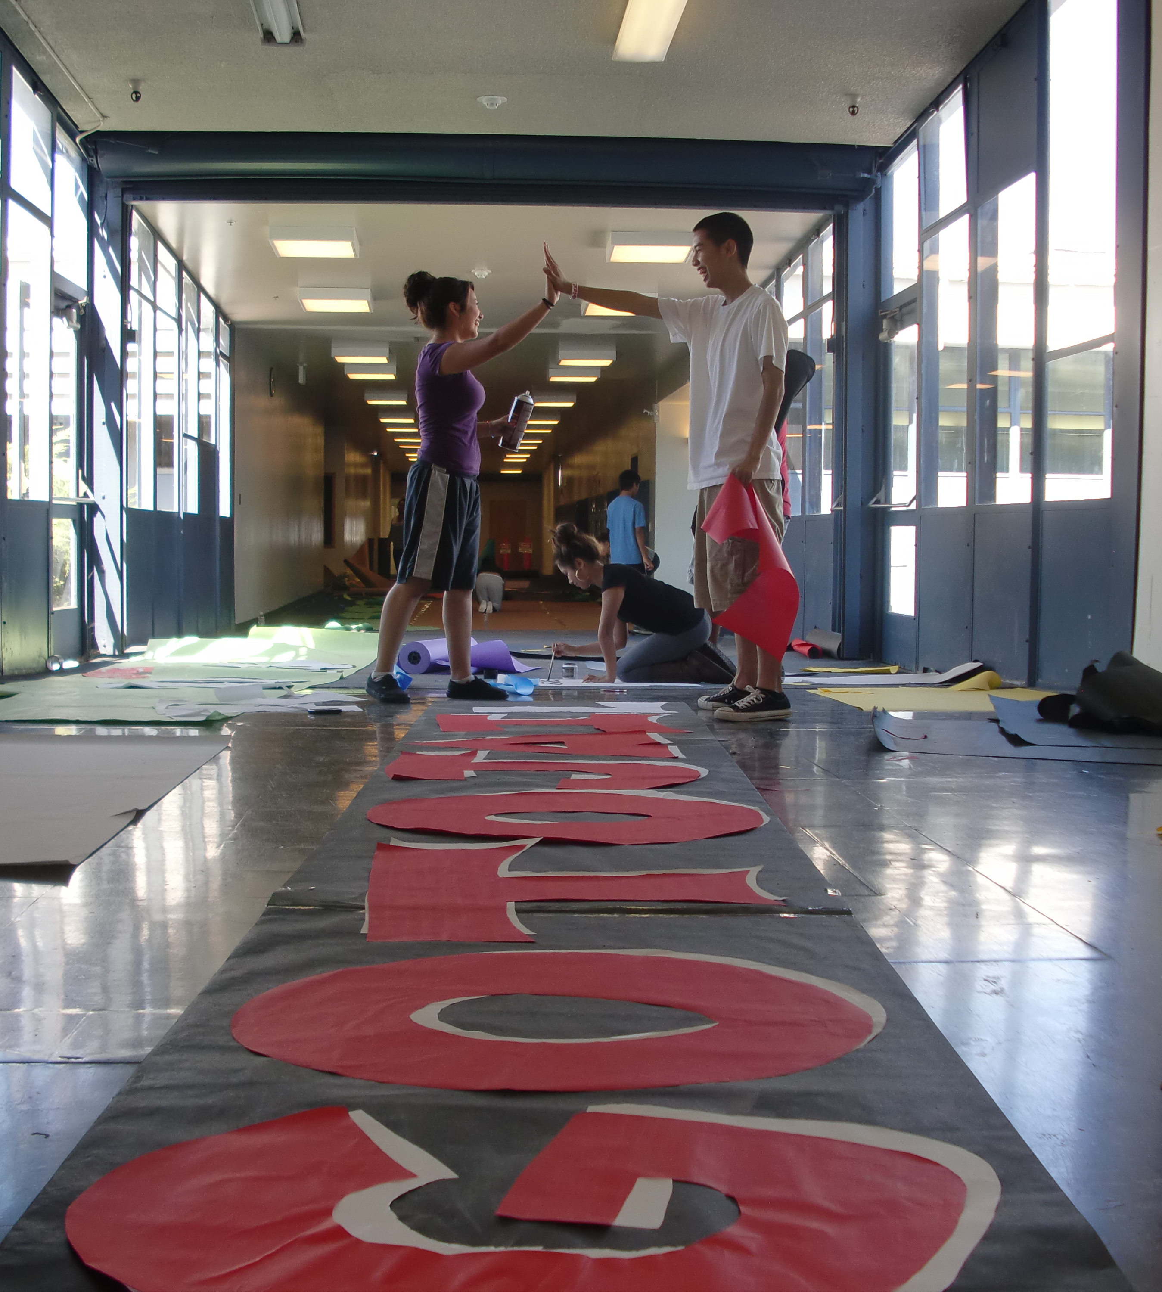
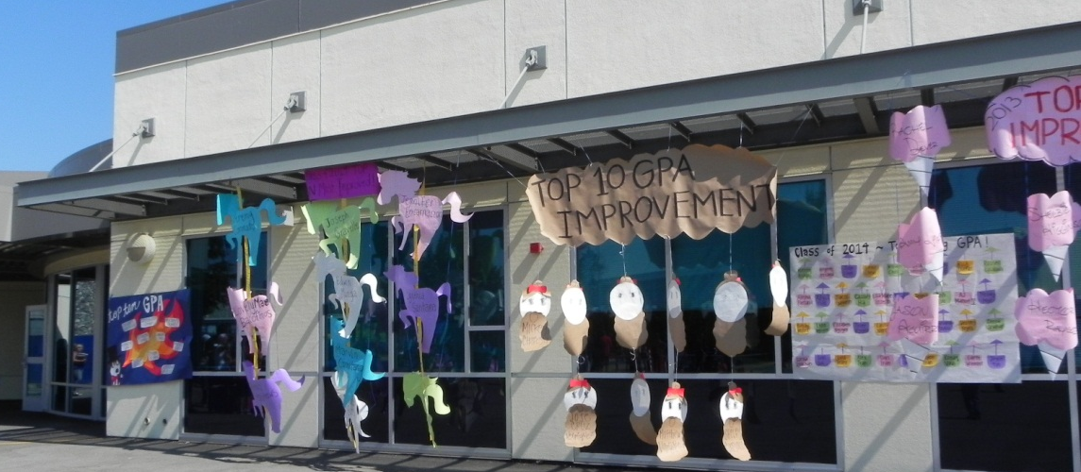

School Description (School Year 2011-12) 

Established in 1872, Santa Clara High School was originally located in the downtown area near the Santa Clara University campus. In 1981, it moved to its present location, a 32-acre campus on Benton Street with grades 10-12. The ninth grade was added in the fall of 1987. Presently a traditional 9-12 institution, it serves students from Santa Clara, Sunnyvale, and San Jose. The service area includes the Santa Clara downtown area, retail commercial establishments, industry in the North, and residential property ranging from the area’s most expensive property to the least expensive property.

Measure B bond monies were used to renovate the athletic fields and to construct the new performing arts center and science wing. The modernization of the library, D wing, and administration/student services building were the last part of this project. The community passed Measure J in November 2004, providing an additional $315 million for major renovations to the secondary schools. Currently under construction are the gymnasiums and the first of the classrooms. Displaced teachers from the A and B wings are conducting class in portables on the tennis courts. They are scheduled to return to their newly renovated classrooms in January, making room for the next set of displaced teachers, as all the classrooms on campus will be remodeled.

Because Santa Clara High has one of the longest histories in the State of California, there is a widespread and significant sense of school pride in athletics, music, co-curricular activities and academics. As seen through our One World Week and monthly celebrations such as Black History month and Latino Heritage, our student body embraces a wide variety of cultural and ethnic backgrounds. Our ASB students are enrolled in a leadership class, taught by the Student Activities Vice-Principal. They formulate activities to empower students and provide the opportunity to take ownership in our school. Our strong curricular program contains Advanced Placement offerings and supportive interventions in both Mathematics and English. Our athletic program is very competitive and has achieved many CCS titles over the years. Our band competes and wins in multiple competitions throughout the year.

The parents, community, and alumni provide outstanding support to the school and its students. Parental involvement is one of the strong points of the Santa Clara High School community with many active parent and community organizations: Santa Clara High School Athletic Boosters, PTSA, School Site Council, Site English Learner Advisory Committee, Grad Night Planning Committee, and the Music Boosters. The Santa Clara Schools Foundation is an organization that supports programs and projects not otherwise funded. We also benefit from a relationship with the local Chamber of Commerce, as well as district partnerships with corporations. These business relationships allow us to provide students with a variety of opportunities including: Junior Achievement speakers and workshops, Job Shadow programs, a Career Fair, and college and career presentations organized through the College and Career Center. Corporations offer mentors and tutors through employee volunteer programs. The community makes extensive use of the school’s facilities including the multi-purpose room, the computer labs, the gymnasiums, the recently renovated athletic fields, and the new performing arts theater. Adult education high tech courses are held in the computer labs and students are welcomed to join the evening classes.

The Administrative Team at Santa Clara High School meets weekly to assess our progress on WASC goals, adhere to our administrative goals, and deal with general operational issues at hand. Likewise, the district has a General Administrative Meeting (GAM) that is held monthly to discuss the district general operations, while the monthly Administrative Staff Development meeting focuses on building aptitude to reach our district vision. Our School Site Council, composed of the principal, parents, students, and faculty, makes decisions about our curriculum, school policies, and budget. The PTSA, Athletic Boosters, Music Boosters, and Grad Night committee meet monthly to support school activities. Our ELAC provides oversight on curriculum and the budget generated from the state for English Language Learners. Department chairs meet in a joint session prior to their department meetings. During our two hour collaboration time, our Departments meet on the first Thursday, followed by the School Planning Team groups the second Thursday, and then a faculty meeting on the third Thursday. Finally independent group collaboration occurs on the last Thursday of the month wherein different professional learning communities across the campus meet.

SCHS students are required to complete 230 credits and 20 hours of community service to graduate. We require 9th graders take Core P.E. and Freshmen Foundations. This allows freshmen to stay with their same classes making for small learning communities in their first year of high school.

Since 2006 we have slowly added AVID programs on campus. We now have two freshmen, two sophomore, one junior and one senior program. These small learning communities help prepare students for success in college and for their future endeavors.

- Community
Community 2010-2011

Santa Clara High is committed to educate a diverse population which consists of 1,878 students.

Grade Level | Number of Students  2010-2011 | Number of Students  2011-2012
Grade 9 | 456 | 507
Grade 10 | 489 | 450
Grade 11 | 454 | 471
Grade 12 | 431 | 448
Total Enrollment | 1,830 | 1878
Five Year Student Enrollment by Subgroup
Year | Hispanic | American Indian | Asian | Pacific Islander | Filipino | African American | White | Two or More | Total
2011-12 | 525 | 10 | 338 | 20 | 251 | 124 | 536 | 74 | 1878
2010-11 | 516 | 7 | 331 | 14 | 234 | 114 | 539 | 67 | 1822
2009-10 | 612 | 7 | 296 | 21 | 206 | 104 | 556 | 42 | 1,844
2008-09 | 548 | 11 | 315 | 19 | 199 | 92 | 577 | 88 | 1,849
2007-08 | 512 | 10 | 294 | 24 | 190 | 102 | 606 | 89 | 1,827

 | Female | Male | Total
2012
2011 | 949 | 935 | 1884
2010 | 927 | 903 | 1,830
Enrollment by Gender

Languages
Santa Clara High Schools predominant languages are English, Spanish, Vietnamese, Mandarin, Punjabi and Tagalog.

Programs 2009-10 | # of Students | % of Students
Special Education | 219 | 12%
AVID 9-12 | 144 | 8%
AP | 341 | 18%
Honors
English Language | 499 | 27%
C.C.O.C | 36 | 2%
Socio-Econ | 878 | 48%
Special Needs and Other Programs
Programs 2010-2011 | # of Students | % of Students
Special Education | 182 | 10%
AVID 9-12 | 202 | 11%
AP | 409 | 22%
Honors
English Language | 266 | 14%
C.C.O.C | 29 | 2%
Socio-Econ

Number of Entering Freshmen Compared to Exiting Seniors
Entering Freshmen Verses Exiting Seniors
August/Sept | # of Freshmen | June | # of Seniors | Difference
2005 | 562 | 2006 | 421 | 141
2006 | 498 | 2007 | 333 | 165
2007 | 475 | 2008 | 365 | 110
2008 | 469 | 2009 | 420 | 49
2009 | 499 | 2010 | 395 | 104
2010 | 456 | 2011 | 431 | 25

Percentage of Students Taking STAR in 2010-2011
Almost all SCHS students took the STAR test. 98.8% tested in 2010.
Languages Proficiency Number
SCHS has 348 English Learner (EL) students with 152 in designated IFEP; with the remaining in Specially Designed Academic Instruction in English (SDAIE) mainstreamed classes with EL authorized teachers, who possess the CLAD credential. The number of the EL students represents 19% of the total student population.

- Attendance
Attendance
Attendance Year | CBEDS Enrollment | # of Unexcused Absences | Truancy Rate
2010-2011 | 1878
2009-2010 | 1844 | 1240 | 67.25%
2008-2009 | 1851 | 531 | 28.69%
2007-2008 | 1829 | 273 | 14.93%

- Suspension
Suspension Data
This table displays the rate of suspensions and expulsions (the total number of incidents divided by the total enrollment) at the school and district levels for the most recent three-year period.

Rate | School |  |  | District
 | 2008-09 | 2009-10 | 2010-11 | 2008-09 | 2009-10 | 2010-11
Suspensions | 8.1 | 27.4 | 20.8 | 5.2 | 0.1 | 8.88
Expulsions | 0.8 | 0.7 | 0.16 | 0.4 | 0 | 0.14

The Table below shows the suspension and expulsion by category for Santa Clara High School.
Attendance Safety and Crime Data  Ed Code Text | Expulsions | Suspensions | Expulsions | Suspensions | Expulsions | Suspensions | Expulsions | Suspensions
 | 2007-2008 |  | 2008-2009 |  | 2009-2010 |  | 2010-11
Related to physical injury to another person |  | 52 | 2 | 1 |  | 7 |  | 25
Related to use of force or violence |  | 7 |  | 46 | 1 | 81 |  | 61
Related to firearms, knives, explosive devices, etc. | 2 | 3 | 6 | 2 | 10 | 11 | 1 | 2
Related to possession or sale of controlled substances, alcohol, or intoxicants. |  | 18 | 4 | 11 |  | 124 | 1 | 55
Committed or attempted to commit robbery or extortion |  | 1 |  |  |  |  |  | 1
Caused or attempted to cause damage to school property or private property |  | 5 | 1 | 4 |  | 11 | 1 | 14
Stole or attempted to steal school property or private property | 2 | 10 | 1 | 8 |  | 7 |  | 12
Related to possession or use of tobacco products |  | 54 |  | 4 |  | 32 |  | 30
Committed an obscene act or engaged in habitual profanity or vulgarity |  | 9 |  | 9 |  | 24 |  | 14
Related to possession or sale of drug paraphernalia |  | 5 |  |  |  | 5 |  | 11
Related to disruption of school activities or willful defiance | 1 | 314 |  | 33 |  | 74 |  | 143
Knowingly received stolen school property or private property |  | 7 |  |  |  |  |  | 1
Related to intimidation of a witness |  | 2 |  | 1
Related to bullying and bullying through electronic means |  |  |  |  |  | 7 |  | 4
Related to sexual harassment |  | 5 |  | 3 |  | 90 |  | 3
PDS-Related to hate violence |  | 4 |  |  |  | 3 |  | 3
Related to harassment, threats, or intimidation |  | 7 | 1 | 6 |  | 11 |  | 8
Possession of any knife or other dangerous object of no reasonable use to the pupil |  |  |  | 6 |  |  |  | 1
Related to terroristic threats |  | 2 |  |  | 2 | 3
Related to unlawful possession of controlled substances |  |  |  | 11 |  | 7
PDS-Assault or battery, as defined in Sections 240 and 242 of the Penal Code, upon any school employee |  |  |  |  |  | 3 |  | 1
PDS-Unlawfully selling a controlled substance listed in Chapter 2 (commencing with Section 11053) of Division 10 of the Health and Safety Co | 1 |  |  | 5 |  |  |  | 1
Over all Total: | 6 | 505 | 15 | 150 | 13 | 505 | 3 | 391
Violence and Drug Total: | 3 | 160 | 13 | 96 | 13 | 382 | 2 | 203
Violence/Drug Rate (Violence/Drug Total / Enrollment): | .16% | 8.75% | 0.7  % | 5.19  % | .7  % | 20.72  % | 1  % | 10.61%

- Socio-Economic Status
Free and Reduced Lunch
We currently have 772 students receiving free and reduced lunch, representing 41% of our student population. The number of students receiving free and reduced lunch has been steadily increasing each year.
 | SCHS Receiving Free and Reduced Lunch |  |  |  | District
Year | # of  Free | # of Reduced | Total # Receiving F & R | % | # of F & R | %
2011-2012 | 561 | 211 | 772 | 41 | 6,588 | 42
2010-2011 | 586 | 190 | 776 | 42 | 6,234 | 39
2009-2010 | 544 | 209 | 753 | 41 | 6,713 | 42
2008-2009 | 460 | 193 | 653 | 36 | 6,254 | 41

- Staff
Number of Certificated and Classified Staff 2010-2011
SCHS currently employs a highly trained, committed and professional staff. Currently SCHS has 89 certificated teachers teaching in their major area and 40 classified staff members. We have 1 full-time Librarian and 1 part-time library aide.
Our office staff consists of 8 employees. We also have 3 day and 3 night janitorial staff members with several district support staff available on a need basis.
Major/Minor Area of Expertise Of our teacher, 98.7% majored or minored in their subject area.
Teachers | School |  |  |  |  | District
 | 2007-08 | 2008-09 | 2009-10 | 2010-11 | 2011-12 | 2011-12
Teachers with Full CCredentialCredential | 73 | 76 | 83 | 86 | 89
Teachers without Full Credential | 8 | 7 | 5 | 3
Teachers Teaching Outside Subject Area of Competence | 2 | 1 | 1 | 1 | 1

Staff Assignments
All staff assignments are made according to staff credentialing. One staff member as of now is teaching outside their subject area but should be credentialed by the start of the 2011-2012 school year.
Gender
Staff Totals 2010-2011 | Gender
 | Female | Male
Classified | 23 | 5
Certificated | 50 | 45
Total | 73 | 50
Paraprofessionals
We have 14 paraprofessionals assisting in the Special Education classes. Several are one-on-one aides.
Staff Development
Staff development is thriving at SCHS. Currently we have late start Thursday’s wherein teachers collaborate from 8:00 PM to 10:00 PM, three out of four Thursdays a month.
Late Start Thursday’s
1st Thursday | Department Meetings
2nd Thursday | School Planning Teams
3rd Thursday | Faculty Meetings
4th Thursday | Staff Collaboration
5th Thursday | Staff Collaboration
Student and Staff Participation
We have a wide variety of active student clubs on campus (62, with staff being the advisors of those 62 groups. We also have several recurring activities named below.
On-going School Actives
Renaissance Academic Rallies Powder-puff Girls’ Football
Homecoming Club Fairs in the Quad
Winter Ball, Sadie Hawkins, & Prom Sports Rallies in the Quad
Lip Sync Competition Sports Awards Nights
Crab Feed Night of Acoustics
Battle of the Classes Staff/Student Competitions
One World Week
Our sports programs are extensive with over 360 student athletes on campus.
Community Involvement/ Trends/ Parent Organizations
We have a very popular Website (santaclara.schoolloop.com) that is monitored by the V.P. of Activities. Here we can clearly communicate with parents via loop mail and the community can view news and activities as well as our school calendar. Parents can also check their son/daughter’s grades and see modified schedules for special weeks.
The Parent Teacher Student Association, (PTSA) greatly contributes to the school’s programs and to our teachers by providing staff luncheons four times a year. This year (2010-2011) the organization consists of 307 members, which coincidently is the same as the 2009-2010 school year. Around 50 parent volunteers help SCHS on a continual basis. They volunteer their time to assist during schedule pick-up in the summer. They help with textbook distribution at the beginning of the academic year as well as setting counseling appointments and organizing students for picture day. They even lend a hand with the new student barbeque.
We have several community organizations such as Site Council, ELAC, Music Boosters and Athletic boosters.
We also have the Middle College Program located at Mission College in Sana Clara. The students there learn in a community college environment and are allowed to take supplemental classes such as P.E. and Electives at the college level.
Our Seniors are also given the opportunity to attend different community colleges in our area to take classes that are not offered at SCHS. Currently we have 41 enrolled in BYU online for independent studies, 104 enrolled in community college, and 18 students enrolled in The Bill Wilson Center Learning Lab. This data is from June 2010 to present.
We also provide Junior and Senior students with the opportunity to take classes at C.C.O.C. Currently we have 29 students attending classes in the morning at C.C.O.C, which has decreased 9% over the last year. This data was collected April 2011.

- Survey Data
Survey Data
The student body was given a survey in December 2011. They were asked multiple questions ranging from school climate and the campus itself, to curriculum and educational rigor. A few of the questions are highlighted below. The survey in its entirety is in the index at the back of the report.
Absolutely | | Usually | | Sometimes | | Rarely | | Never
6. Does your academic counselor know you, respond to appointment requests and give you timely information about high school graduation and college planning?
19% | 20% | 25% | 21% | 15%
7. Do your teachers plan relevant and interesting lessons, communicate assignments and grades regularly and offer extra help in difficult subjects?
14% | 36% | 33% | 13% | 2%
8. Do your teachers involve you in challenging learning experiences and make you aware of the content standards to be mastered in each class?
17% | 38% | 33% | 13% | 3%
11. Are the halls, quad and restrooms clean and free of litter?
5% | 19% | 35% | 27% | 17%
12. Are the rules and consequences involving attendance and tardies equitably enforced?
41% | 28% | 19% | 11% | 4%
14. Do the other members of the Santa Clara High School community show respect for your individuality and family culture?
28% | 35% | 23% | 12% | 4%
15. Do the Student Body activities like BOTC, lunch quad celebrations, rallies, Lip Sync and dances add connection and enjoyment to your time at Santa Clara High School?
40% | 25% | 18% | 12% | 6%
17. When you gather information to complete assignments, do you try to use several different methods and present your solutions creatively?
35% | 32% | 20% | 12% | 3%
20. When you do class work and projects with a group, do you take care of your responsibilities in the team and feel proud of what your group accomplished?
39% | 34% | 17% | 11% | 2%
21. As a member of the Santa Clara High School community, do you participate, show respect for other community members and help out when you can?
37% | 28% | 21% | 13% | 3%

Academic Performance Index
The Academic Performance Index (API) is California’s way of quantifying school performance based on student test scores. The index was created in 1999 to help parents and educators recognize schools that show progress and identify schools that need help. A school’s API determines whether it receives recognition or sanctions. It is also used to compare schools in a statewide ranking system. The California Department of Education (CDE) calculates a school’s API using student test results from the STAR Tests and, for high schools, the California High School Exit Exam (CAHSEE). APIs range from 200 to 1000. The CDE expects all schools to strive for APIs of at least 800.

Schools are expected to increase their API each year by at least 5% of the difference between their API and the statewide target of 800. A school’s base API score plus its growth target becomes that school’s goal for its next school year.

SCHS met all its API target growth in 2009-2010. Our API increased 26 points that year whereas in 2010-2011’s our API growth was 8 points. Although we didn’t meet our target in all subgroups that year, we did surpass the growth target of 5 points. 96 percent of our students took the test.

Number of Students included in the 2011 Growth API | 2011 Growth | 2010 Base | 2010-11 Growth Target | 2010-11 Growth | School wide | All Subgroups | Both School wide and Subgroups
1309 | 772 | 764 | 5 | 8 | Yes | No | No
Number of Students included in the 2010 Growth API | 2010 Growth | 2009 Base | 2009-10 Growth Target | 2009-10 Growth | School wide | All Subgroups | Both School wide and Subgroups
1313 | 760 | 734 | 5 | 26 | Yes | Yes | Yes

The table below shows the API scores for Santa Clara High School from 2005 to 2011. We have seen improvements in our scores for the last three years.

The 2011 API Subgroup table below indicates positive growth in all but two groups that were numerically significant. Our Filipino and EL Learners did not meet growth Target. We are looking into why this might be.
2011API By Subgroups
 | # of Students 2011 API | Numerically Significant | 2011 Growth | 2010 Base | 2010-11 Growth Target | 2010-11 Growth | Met Subgroup Growth Target
African American | 65 | No | 739
Amer. Indian/Alaskan | 5 | No |  | 742
Asian | 224 | Yes | 849 | 817 | A | 32 | Yes
Filipino | 167 | Yes | 798 | 806 | 4 | -8 | No
Hispanic | 433 | Yes | 695 | 684 | 7 | 11 | Yes
Native Hawaiian/P.I. | 9 | No |  | 671
White | 366 | Yes | 810 | 803 | A | 7 | Yes
Two or more races | 39 | No | 743 | 798
Socioeconomically Disadvantaged | 588 | Yes | 711 | 703 | 5 | 8 | Yes
English Learner | 356 | Yes | 669 | 670 | 7 | -1 | No
Students with disabilities | 176 | Yes | 586 | 559 | 12 | 27 | Yes

"A" | means the school or subgroups scored at or above the statewide performance target of 800 in 2010.

The 2010 API Subgroup table below indicates positive growth in all groups that were numerically significant.
2010 API By Subgroups
 | # of Students  2010 API | Numerically Significant | 2010 Growth | 2009 Base | 2009-10 Growth Target | 2009-10 Growth | Met Subgroup Growth Target
African American | 65 | No
Amer. Indian/Alaskan | 3 | No
Asian | 217 | Yes | 817 | 800 | A | 17 | Yes
Filipino | 170 | Yes | 805 | 796 | 4 | 9 | Yes
Hispanic | 428 | Yes | 682 | 655 | 7 | 27 | Yes
Native Hawaiian/P.I. | 13 | No
White | 382 | Yes | 798 | 769 | 5 | 29 | Yes
Two or more races | 35 | No
Socioeconomically Disadvantaged | 612 | Yes | 699 | 656 | 7 | 43 | Yes
English Learner | 356 | Yes | 667 | 648 | 8 | 19 | Yes
Students with disabilities | 160 | Yes | 538 | 521 | 14 | 17 | Yes

The 2010-2011 API Subgroups of Santa Clara High School compared to the California state Subgroups Growth chart below indicates that Santa Clara High School’s growth is mixed with our Filipino, Hispanic, Socio-economically disadvantaged, and ELL students dropping below the state’s growth rates while our Asian and students with disabilities performing at a higher growth rate.
2010-2011 API By Subgroups
 | SCHS 2010-11 Growth | State 2010-11 Growth | Difference
African American
Amer. Indian/Alaskan
Asian | 32 | 8 | 24
Filipino | -8 | 8 | -16
Hispanic | 11 | 15 | -4
Native Hawaiian/Pacific Islander
White | 7 | 7 | 0
Socio. Disadvantaged | 8 | 14 | -6
English Learner | -1 | 15 | -16
Students with disabilities | 27 | 15 | 12

API 6 Year Summary of Subgroup Growth
The chart below indicates that we have achieved the largest percentile growth with our Hispanic students and Socioeconomically Disadvantaged students.
6 Year API By Subgroups
 | 2006 | 2007 | 2008 | 2009 | 2010 | 2011
Asian | 777 | 816 | 795 | 803 | 817 | 849
Filipino | 745 | 771 | 745 | 786 | 805 | 798
Hispanic | 602 | 648 | 652 | 652 | 682 | 695
White | 765 | 753 | 767 | 764 | 789 | 810
Socio. Disadvantaged | 619 | 627 | 643 | 652 | 699 | 711
English Learner | 638 | 664 | 631 | 646 | 667 | 669
Students with disabilities |  | 474 | 488 | 512 | 538 | 586

The table below includes critical data related to our 6 year API school wide performance:
6 Year Critical Data-School Wide
 | 2005-05 | 2006-07 | 2007-08 | 2008-09 | 2009-10 | 2010-11
Percentage Tested | 98 | 98 | 98 | 98 | 98
API Growth | 715 | 730 | 726 | 731 | 760 | 772
API Target | 4 | 5 | 5 | 5 | 5 | 5
API Base | 716 | 714 | 730 | 726 | 734 | 764
Growth/Decline | -1 | +16 | -4 | +5 | +26 | +8
Met Target | No | Yes | No | Yes | Yes | Yes
Met All Subgroup Targets | No | No | No | No | Yes | No
Statewide Rank | 7 | 6 | 7 | 6 | 6 | 6
Similar Schools Rank | 6 | 5 | 8 | 2 | 5 | 5

California Standard Tests (CST)
This tables display the percent of students achieving at the Proficient or Advanced level (meeting or exceeding the state standards).

Subject | School |  |  | District |  |  | State
 | 2008-09 | 2009-10 | 2010-11 | 2008-09 | 2009-10 | 2010-11 | 2008-09 | 2009-10 | 2010-11
ELA | 45 | 49 | 54 | 55 | 57 | 60 | 50 | 52 | 54
Mathematics | 22 | 26 | 26 | 47 | 52 | 54 | 46 | 48 | 50
Science | 44 | 55 | 57 | 54 | 59 | 63 | 50 | 54 | 56
History | 48 | 54 | 53 | 44 | 46 | 49 | 41 | 44 | 48

The California Standards Test (CST) for English, Mathematics, Science, and History are intended to measure an individual student’s knowledge of the California content standards. Each student is tested only in the subjects that match their academic classes. After all 9th to 11th grade students are tested the results for a particular school are summarized by the percent of tested students who score at or above the Proficient level in each subject area.

The table below compares SCHS with the State of California. The numbers are the percent of tested students who have results at the Advanced and Proficient levels. The green numbers indicate subject areas where SCHS exceeded the state percentage. The red numbers indicate subject areas where SCHS had a lower percentage of Proficient or above scores than the state overall.

2010-11 | % Proficient and Advanced (CST) | 2006-07 |  | 2007-08 |  | 2008-09 |  | 2009-10 |  | 2010-11
# Students | Subject Level  Test | SCHS | State | SCHS | State | SCHS | State | SCHS | State | SCHS | State
494 | English 9 | 50 | 47 | 53 | 49 | 53 | 50 | 56 | 54 | 62 | 55
461 | English 10 | 41 | 37 | 42 | 37 | 41 | 44 | 49 | 45 | 54 | 48
431 | English 11 | 42 | 37 | 42 | 37 | 41 | 40 | 44 | 43 | 53 | 45
22 | Gen math | 7 | 21 | 12 | 27 | 4 | 26 | 14 | 27 | 0 | 28
429 | Algebra 1 | 18 | 24 | 11 | 14 | 11 | 28 | 13 | 31 | 14 | 32
410 | Geometry | 30 | 27 | 29 | 21 | 26 | 26 | 22 | 27 | 24 | 31
277 | Algebra 2 | 39 | 27 | 31 | 27 | 26 | 28 | 37 | 31 | 30 | 33
146 | Summ Math | 45 | 47 | 53 | 47 | 56 | 50 | 55 | 54 | 53 | 55
448 | World History | 34 | 29 | 37 | 33 | 47 | 38 | 54 | 42 | 49 | 44
413 | US History | 36 | 35 | 49 | 38 | 48 | 44 | 54 | 45 | 58 | 48
434 | Life Science | 41 | 37 | 41 | 36 | 44 | 38 | 55 | 39 | 55 | 50
581 | Biology | 48 | 37 | 44 | 42 | 43 | 42 | 53 | 46 | 58 | 49
434 | Chemistry | 31 | 34 | 16 | 22 | 20 | 36 | 25 | 37 | 26 | 38
84 | Physics | 25 | 35 | 65 | 43 | 63 | 46 | 66 | 49 | 76 | 52
133 | Earth Science | 18 | 26 | 28 | 28 | 24 | 28 | 25 | 33 | 34 | 35

2010-11 | % Below and Far Below (CST) | 2006-07 |  | 2007-08 |  | 2008-09 |  | 2009-10 |  | 2010-11
# Students | Subject Level  Test | SCHS | State | SCHS | State | SCHS | State | SCHS | State | SCHS | State
415 | English 9 | 25 | 26 | 22 | 25 | 19 | 23 | 18 | 21 | 10 | 18
448 | English 10 | 35 | 34 | 30 | 31 | 30 | 27 | 23 | 26 | 18 | 23
418 | English 11 | 34 | 39 | 32 | 37 | 35 | 35 | 28 | 30 | 24 | 26
20 | Gen math | 56 | 44 | 57 | 45 | 72 | 43 | 45 | 43 | 45 | 42
369 | Algebra 1 | 47 | 50 | 53 | 60 | 65 | 50 | 62 | 45 | 57 | 44
402 | Geometry | 36 | 50 | 45 | 54 | 57 | 51 | 53 | 46 | 48 | 43
285 | Algebra 2 | 24 | 45 | 27 | 44 | 39 | 44 | 37 | 41 | 47 | 38
158 | Summ Math | 21 | 29 | 19 | 26 | 14 | 26 | 15 | 23 | 22 | 22
457 | World History | 35 | 43 | 36 | 39 | 30 | 39 | 23 | 33 | 24 | 31
417 | US History | 29 | 37 | 29 | 36 | 26 | 33 | 22 | 31 | 21 | 29
433 | Life Science | 29 | 32 | 33 | 33 | 32 | 26 | 19 | 25 | 16 | 23
506 | Biology | 18 | 28 | 22 | 26 | 24 | 22 | 17 | 23 | 17 | 23
349 | Chemistry | 27 | 28 | 52 | 36 | 47 | 38 | 37 | 27 | 31 | 23
82 | Physics | 20 | 26 | 11 | 23 | 8 | 22 | 5 | 19 | 7 | 16
156 | Earth Science | 40 | 51 | 38 | 52 | 38 | 43 | 23 | 41 | 31 | 28
The table below compares SCHS with the State of California. The numbers are the percent of tested students who have shown results at the Below Basic and Far Below Basic levels. The green numbers indicate subject areas where SCHS percentages were less than the state percentages. The red numbers indicate subject areas where SCHS had a higher percentage of Below Basic and Far Below Basic scores than the state overall.

In summary, the 2010-11 CST results show that SCHS students recorded higher Proficient or Advanced percentages than the state for 8 out of 15 subject areas. SCHS students recorded lower Below Basic or Far Below Basic percentages than the state for 8 out of 15 subject areas. The General Math test is only given to a few students who, because of their language skill, were not enrolled in Algebra 1. Students who are taking Algebra 1 in high school did not pass Algebra 1 in 8th grade. Most students are required to take Geometry as 9th or 10th graders. All Algebra 2 and Summative Math classes consist of students who have passed Algebra 1 and Geometry and who choose to continue in their study of Mathematics.

English
The chart below illustrates that all three grade levels have demonstrated a gradual improvement over the last four years. The English 11 students showed notable improvement in our last year's results.

Math
The chart below illustrates the consistently high performance of our Summative Math group. These are students who are taking Trigonometry, Statistics or Calculus as 10th or 11th graders. The Algebra 2 students demonstrated a notable decline over last year’s results. Geometry scores have declined each year as larger numbers of 10th graders have enrolled in that course. The Algebra 1 scores have risen only slightly and are well below state levels. We do not offer a Pre-Algebra or General Math option for 9th graders.

History
The chart illustrates continuous growth in our World History advanced/proficient groups since 2006, until last year when there was a decline. The chart also illustrates growth in United States History advanced/proficient group from 2006 -2008. During 2007-2008 there was a minimal decline then again notable growth during 2009-2010 and again in 2010-2011. Over the last four years, we have had a dramatic increase in the enrollment in AP sections. We have grown from one to four sections offered in each course. Additionally, we have worked with the district to create common curriculum maps and pacing guides that align to the California State History Content Standards. We have created common district mid-terms and finals then analyzed the data to assess both student learning and teaching strategies.

Science
The chart test data below illustrates that our proficiency scores for most science subjects increased during the last school year (2010-2011). This is due to better aligning of the curriculum to standards and teacher collaboration during the past year.
In 2007-2008 we introduced Conceptual Chemistry as an introduction to chemistry for students with math or reading challenges – those who were not ready for general chemistry; as a result the chemistry enrollment increased as did the number of students taking the chemistry STAR test – which explains the drop in test scores during this year. Prior to that year these students would have taken Integrated Science II and would have taken that STAR test, a test which is no longer offered.
Biology scores increased significantly from the 2008-2009 school year due to better placement of freshmen in Earth science as opposed to Biology, per prerequisites. This is also due to better teacher collaboration over the 2009-2010 school year.
Earth Science scores have stayed generally stable over the past few years but took a dip in 2007-2008 and 2009-2010. This is due to more students being enrolled in the course. All freshmen either take Biology or Earth Science. The freshmen that take Earth Science are generally those in remedial math.

California Standard Tests (CST): Results by Subgroups
No Child Left Behind requires that California student subgroups (White, African- American, Latino, Asian/Pacific Islander, American Indian, Socioeconomic Disadvantaged, Special education, and English Learners) show Adequate Yearly Progress (AYP). The goal is that each group will improve by 5% each year.
The CST subject matter charts below show results over a three year period of time by subgroups and ethnicity.

The CST grade 9 ELA results reported by ethnicity indicate favorable movement for all groups except Filipino, who are still high achieving compared to other groups, and the English Learner category. Once the English Language Learners reach a proficient or advanced level on the CST, they would be moved out of the EL category and into mainstream classes. At this point they would join one of the other ethnic subgroups. Even so, the English Department has three Academic Support classes dedicated to helping these EL students.

9th Grade ELA Percentage Proficient/Advanced
 | 2007-  08 | 2008-09 | 2009-  10
African American | 38 | 35 | 50
Asian | 61 | 58 | 70
Filipino | 66 | 70 | 63
Hispanic | 40 | 33 | 38
White | 62 | 65 | 68
Socio. Disadvantaged | 38 | 35 | 41
EL | 11 | 11 | 9
with Disability | 14 | 20 | 27

The CST grade 10 ELA results reported by ethnicity indicate favorable movement for all groups except for English Learners and Students with Disabilities. Once the English Language Learners reach a proficient or advanced level on the CST, they would be moved out of the EL category and into mainstream classes. At this point they would join one of the other ethnic subgroups. Even so, the English Department has three Academic Support classes dedicated to helping these EL students. We also have a number of new Special Education teachers working with our Students with Disabilities this year, which will hopefully lend itself to favorable movement in this category in the future.

10th Grade ELA Percentage Proficient/Advanced
 | 2007-08 | 2008-09 | 2009-10
African American | 19 | 22 | 65
Asian | 52 | 51 | 57
Filipino | 46 | 47 | 59
Hispanic | 24 | 28 | 30
White | 59 | 52 | 56
Socio. Disadvantaged | 25 | 22 | 33
EL | 7 | 5 | 4
with Disability | 10 | 15 | 6

The CST grade 9-11 Algebra 1 results reported by ethnicity indicate favorable movement for all groups except Filipino, who are still very high achieving, and the English Learner category.
9-11 Algebra Percentage Proficient/Advanced
 | 2007-08 | 2008-09 | 2009-  10
African American | 3 | 8 | 9
Asian | 24 | 18 | 26
Filipino | 22 | 20 | 16
Hispanic | 9 | 6 | 7
White | 9 | 10 | 21
Socio. Disadvantaged | 7 | 9 | 11
EL | 6 | 6 | 2
with Disability | 5 | 6 | 7

The CST grade 9-11 Geometry results reported by ethnicity indicate favorable movement only for African American, Socioeconomically Disadvantaged, and Students with Disabilities groups. During 2010-2011the Math department has devoted considerable in-service and collaboration resources to the improvement of the Geometry scores.
9-11 Geometry Percentage Proficient/Advanced
 | 2007-08 | 2008-  09 | 2009-  10
African American | 15 | 15 | 17
Asian | 4 | 44 | 42
Filipino | 32 | 40 | 33
Hispanic | 14 | 9 | 5
White | 31 | 27 | 25
Socio. Disadvantaged | 20 | 12 | 15
EL | 21 | 11 | 2
with Disability | 13 | 10 | 11

California High School Exit Exam (CAHSEE) Combined Results – 10th Grade
All California public school students must pass the CAHSEE test in English and Mathematics to earn a high school diploma.
Subject | 2008-09 |  |  | 2009-10 |  |  | 2010-11
 | School | District | State | School | District | State | School | District |  | State
ELA | 57 | 56.5 | 52.9 | 59.4 | 57.9 | 54 | 68 | 65 | 59
Mathematics | 57.1 | 54.9 | 51.3 | 54.9 | 51.9 | 53.4 | 54 | 56 | 56
This table displays the percent of students achieving at the Proficient or Advanced level in ELA and Mathematics.

Santa Clara High School 10th graders performed better than the District and the State on both subject tests for the last three years. Students are well aware of the personal consequences of the CAHSEE results.
This table displays the 10th grade ELA percentage passed by subgroup for the CAHSEE. The groups with the lowest percentage passing –Latino, African American, English Learners and Special Education students have shown improvement each year.
Subgroup | 2009 |  | 2010 |  | 2011
 | # Passed | % Passed | # Passed | % Passed | # Passed | % Passed
10th grade All | 390 | 83 | 389 | 84 | 422 | 87
Latino | 113 | 77 | 112 | 80 | 142 | 89
White | 126 | 89 | 122 | 88 | 120 | 92
Asian | 71 | 85 | 67 | 80 | 69 | 86
Filipino | 50 | 89 | 58 | 94 | 53 | 85
African Amer. | 18 | 75 | 17 | 81 | 27 | 87
EO | 226 | 89 | 216 | 89 | 215 | 88
IFEP | 34 | 97 | 36 | 92 | 35 | 93
RFEP | 83 | 97 | 101 | 98 | 100 | 98
EL | 47 | 51 | 36 | 48 | 30 | 44
Non- ED | 212 | 87 | 191 | 90 | 193 | 90
ED | 152 | 78 | 180 | 79 | 162 | 79
Sp Ed | 18 | 42 | 25 | 51 | 33 | 56

This table displays the 10th grade Mathematics percentage passed by subgroup for the CAHSEE. The groups with the lowest percentage passing were Latino, African American, English Learners and Special Education students. Movement within groups was not significant but it was mostly positive.
Subgroup | 2009 |  | 2010 |  | 2011
 | # Passed | % Passed | # Passed | % Passed | # Passed | % Passed
10th grade All | 386 | 82 | 385 | 84 | 418 | 86
Latino | 111 | 77 | 101 | 74 | 134 | 79
White | 121 | 85 | 114 | 80 | 118 | 91
Asian | 75 | 89 | 78 | 93 | 78 | 98
Filipino | 52 | 93 | 59 | 95 | 51 | 82
African Amer. | 16 | 64 | 17 | 81 | 27 | 87
EO | 217 | 85 | 202 | 82 | 84 | 83
IFEP | 32 | 91 | 35 | 90 | 33 | 90
RFEP | 80 | 94 | 99 | 96 | 98 | 95
EL | 57 | 61 | 49 | 67 | 30 | 44
Non- ED | 214 | 88 | 186 | 87 | 192 | 88
ED | 147 | 76 | 181 | 80 | 162 | 79
Sp Ed | 19 | 43 | 19 | 40 | 33 | 56

No Child Left Behind- Adequate Yearly Progress (APY)
No Child Left Behind requires that all schools and districts make adequate yearly progress (APY) as indicated by the Annual Measureable Objectives (AMO) for each indentified subgroup. The California Department of Education (CDE) reports both state and federal accountability results under the general heading of the APR (Accountability Progress Report) system. These reports include AYP and API results which are located on the California Department of Education web page.
For High schools the AYP is based on the 10th grade CAHSEE ELA and Mathematic percentage proficient, graduation rates and API.

Santa Clara High School 2003-2011 Adequate Yearly Progress (AYP)-ELA
For 2010-2011 Santa Clara High School met the ELA AMO target for all groups except for Filipino, Hispanic, Economically-Disadvantaged, Students with Disabilities, and English Language Learners.
Percentage ELA Proficient (AYP)
Measurable Objective | 2003 % | 2004 % | 2005 % | 2006 % | 2007 % | 2008 % | 2009 % | 2010 % | 2011  % | 2011 ELA AMO Met
AMO Target | 11.2 | 11.2 | 22.3 | 22.3 | 22.3 | 33.4 | 44.5 | 55.6 | 66.7
All Students | 61.1 | 62.3 | 61 | 54.6 | 52.3 | 57 | 58.7 | 59.4 | 71.5 | Yes
African. Amer. | 45.4 | 56 | 64.7 | 52.2 | 35.7 | 38.5 | 45.8 | 57.9 | 72 | Yes
Asian | 74.5 | 70.4 | 73.2 | 62.5 | 61.8 | 68.8 | 64.5 | 60.8 | 79.2 | Yes
Filipino | 51.6 | 53.4 | 53.7 | 54.3 | 47.9 | 54.1 | 60.4 | 73.2 | 67.2 | No
Hispanic | 47 | 45.6 | 40.4 | 31.6 | 38.9 | 38.4 | 44.5 | 41.5 | 61.4 | No
White | 65.9 | 73.1 | 71.5 | 65.2 | 61.1 | 72.4 | 72.4 | 72.2 | 80.2 | Yes
Econ. Disadvantage | 37.5 | 41.4 | 44.4 | 32.8 | 34.6 | 33.3 | 40.2 | 45.5 | 59.8 | No
Student With Disab. | 6 | 5.8 | 16 | 15.8 | 15.6 | 12.8 | 18.2 | 12 | 37.5 | No
Eng. Learners | 27.8 | 35.8 | 30.3 | 26.3 | 26.2 | 28.3 | 34.1 | 32.8 | 43.2 | No

Santa Clara High School 2003-2010 Adequate Yearly Progress (AYP)-Math
 | Percentage Math Proficient (AYP)
Measurable Objective |  | 2003 % | 2004 % | 2005 % | 2006 % | 2007 % | 2008 % | 2009 % | 2010  % | 2011  % | 2011 Math AMO Met
AMO Target |  | 9.6 | 9.6 | 20.9 | 20.9 | 20.9 | 32.2 | 43.5 | 54.8 | 66.1
All Students |  | 50.6 | 53.8 | 49.4 | 52.6 | 59.5 | 57.1 | 56.7 | 54.9 | 56.4 | No
African. Amer. |  | 27.2 | 40 | 55.6 | 50 | 34.4 | 50 | 40 | 42.1 | 48 | No
Asian |  | 81.3 | 77.1 | 75 | 67.9 | 82.9 | 79.7 | 82.9 | 68.9 | 80.6 | Yes
Filipino |  | 32.2 | 55.8 | 36.6 | 63 | 70.8 | 66.7 | 62.3 | 64.3 | 55.7 | No
Hispanic |  | 32.8 | 34.2 | 31.2 | 29.9 | 42.9 | 38.7 | 40.1 | 37.3 | 36.4 | No
White |  | 52.7 | 59.3 | 54.5 | 58.2 | 61.7 | 64.2 | 61.8 | 62.2 | 68.6 | Yes
Econ. Disadvantage |  | 42.6 | 43 | 38.3 | 35 | 42.3 | 34.7 | 42 | 39.9 | 45.3 | No
Student with Disab. |  | 6 | 8.8 | 11.5 | 7.3 | 18.2 | 10.6 | 21.7 | 14 | 21.4 | No
Eng. Learners |  | 37 | 36.5 | 37.3 | 38.3 | 45.7 | 37.1 | 45.6 | 31.9 | 38 | No
For 2010-2011 Santa Clara High School did not meet the Mathematics AMO targets for most subgroups, African American, Filipino, Hispanic students, Economically Disadvantaged students, Students with Disabilities and English Language Learners.

California English Language Development Test (CELDT)
This table shows that our Spanish-speaking ELL students are testing higher that the district, county and state scores while our Korean, Filipino and Vietnamese students are performing below the district, county and state scores.

This segmented bar chart illustrates the percent of students at the various Language Proficiency levels for 2011. Fifty percent of our students are Early Advanced or Advanced. More than 60% of our English Learners are Spanish speaking.
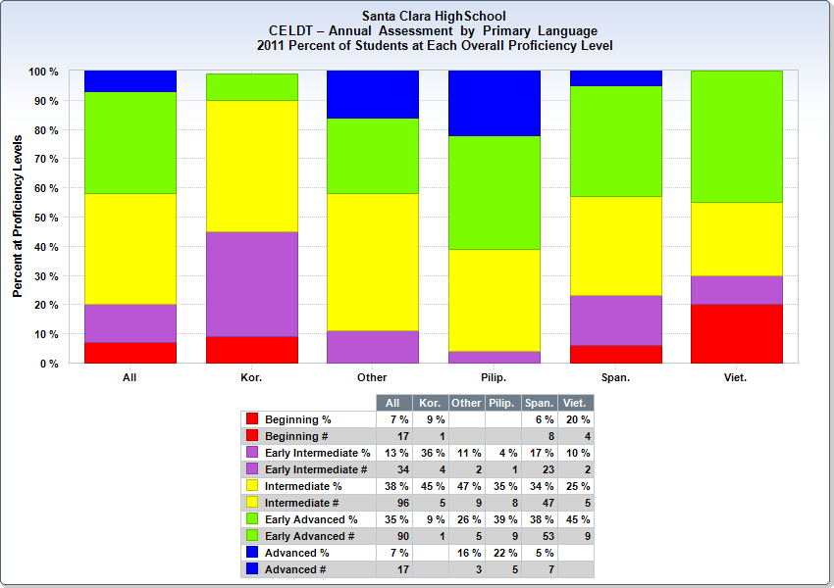

12th grade Scholastic Aptitude Test (SAT) Results
Santa Clara High School has had about 45% of the 12th grade students take the SAT tests over the last three years. This participation rate is higher than the State participation rate and very close to the County rate. Our average Verbal, Math and Written scores have improved each year. By 2008-2009 our averages had risen to levels very close to the State averages.
Santa Clara High School SAT Comparison
 |  | % Tested | Verbal Avg | Math Avg | Writing Avg
2006-07 | SCHS | 45.09 | 480 | 504 | 477
2006-07 | SCUSD | 37.57 | 487 | 515 | 481
2006-07 | Santa Clara Co. | 47.95 | 534 | 572 | 533
2006-07 | California | 36.9 | 493 | 513 | 491
2007-08 | SCHS | 44.79 | 482 | 513 | 477
2007-08 | SCUSD | 36.59 | 488 | 514 | 484
2007-08 | Santa Clara Co. | 46.42 | 537 | 573 | 539
2007-08 | California | 35.85 | 494 | 513 | 493
2008-09 | SCHS | 45.64 | 487 | 528 | 491
2008-09 | SCUSD | 35.8 | 497 | 530 | 496
2008-09 | Santa Clara Co. | 45.69 | 539 | 579 | 543
2008-09 | California | 34.68 | 495 | 513 | 494
2009-10 | SCHS | 37.38 | 485 | 524 | 495
2009-10 | SCUSD | 35.15 | 493 | 523 | 497
2009-10 | Santa Clara Co. | 44.36 | 550 | 588 | 556
2009-10 | California | 33.36 | 501 | 520 | 500
2010-11 | SCHS
2010-11 | SCUSD
2010-11 | Santa Clara Co.
2010-11 | California

CSU Early Assessment Program (EAP)
The CSU Early Assessment Program tests the 11th grade students for Math and English college readiness in conjunction with the CST tests. More than 95% of our qualified 11th grade students participate. The number of students who are evaluated for college readiness through this program has risen each year.
The Math assessment is given only to the 11th graders who are enrolled in Algebra 2, Trigonometry, Statistics or Calculus. As of 2011 31% of the Math students were deemed ready for college mathematics or they were classified as Conditionally Ready. If these students take a Math class as 12th graders they will not have to take the ELM test upon entering a CSU.
Early Assessment Program (EAP)- Math
 | 2008 | 2009 | 2010 | 2011
Math Ready | 31 | 21 | 30 | 49
Math Ready | 14% | 10% | 12% | 31%
Conditional | 107 | 77 | 113
Conditional | 49% | 37% | 47%
Not Ready | 79 | 110 | 99 | 109
Not Ready | 36% | 53% | 41% | 69%
Total Tested | 217 | 208 | 242 | 158

The English assessment is given to the 11th graders who are enrolled in English 11. As of 2011 30% of the students were deemed ready for college English classes. They will not have to take the ELA test upon entering a CSU.
Early Assessment Program (EAP)- English
 | 2008 | 2009 | 2010 | 2011
English Ready | 95 | 78 | 113 | 125
English Ready | 22% | 21% | 26% | 30%
Not Ready | 336 | 283 | 308 | 286
Not Ready | 77% | 75% | 72% | 70%
Total Tested | 439 | 378 | 430 | 411

We have a CSU English class for 12th graders but the testing is given to 11th graders so the benefits can’t be seen on the tests. We are aware that our college-ready percentage is low and are working to ensure our students are prepared to attend college.

Advanced Placement Test Results
SCHS Advanced Placement Test Results
Subject | 2007-08 |  | 2008-09 |  | 2009-10 |  | 2010-11
 | % Pass | # Test | % Pass | # Test | % Pass | # Test | % Pass | # Test
Biology | 69 | 13 | 65 | 23 | 67 | 12
Calculus | 23 | 31 | 56 | 25 | 37 | 27
English Lang | 64 | 42 | 77 | 30 | 63 | 49
English Lit | 87 | 15 | 75 | 12 | 82 | 11
European History | 63 | 40 | 69 | 45 | 54 | 59
French | 100 | 1 | 50 | 2 | 0 | 1
German | n/a | 0 | 50 | 2 | n/a | 0
Macroeconomics | 31 | 16 | 57 | 23 | 66 | 38
Physics B | 43 | 14 | 71 | 7 | 33 | 9
Spanish | 75 | 8 | 88 | 8 | 100 | 20
Statistics | 80 | 25 | 77 | 44 | 86 | 29
US Govt. | 69 | 13 | 76 | 17 | 57 | 28
US History | 66 | 38 | 49 | 41 | 54 | 90
Other | n/a | 0 | 100 | 1 | 100 | 1
Total Exams | 60 | 256 | 67 | 280 | 61 | 374
Total AP class enrollment | 335 |  | 450 |  | 522 |  | 698
Santa Clara High School’s AP Course participation has been increasing each year. The number of students has risen 48% over the last 3 years. Since AP is a program of nationally administered norm referenced exams, an average pass rate of over 60% reflects favorably on our school.
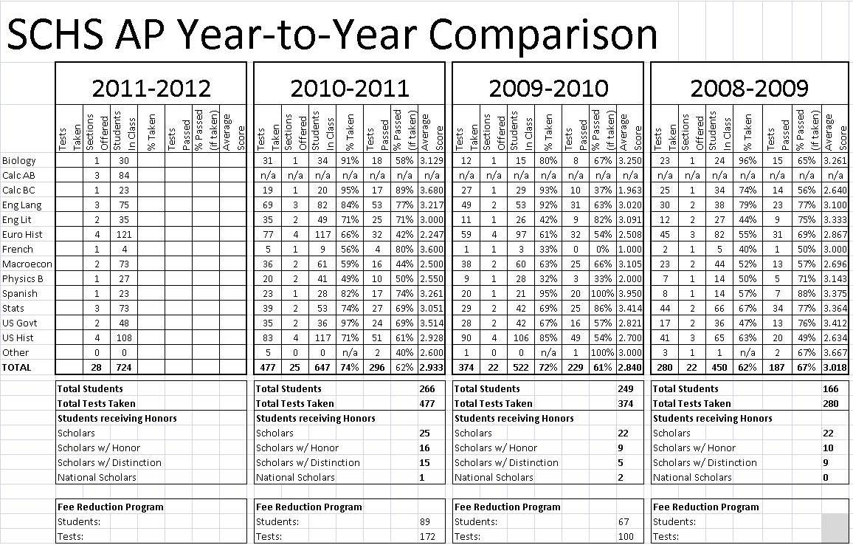

The percentage of SCHS graduates who met the UC/CSU class requirements is more than 40%. The percent of Filipino, Hispanic and African American students who successfully complete these classes is lower than the overall student population.
Percentage of SCHS Graduates Meeting UC/CSU Requirements
 | Asian |  | Filipino |  | Hispanic |  | African American |  | White |  | School Wide
Year | # | % | # | % | # | % | # | % | # | % | # | %
2006-07 | 59 | 57.6 | 35 | 37.1 | 84 | 28.6 | 12 | 33.3 | 117 | 47 | 321 | 42
2007-08 | 34 | 60 | 23 | 60 | 19 | 26 | 9 | 47 | 64 | 43 | 344 | 45
2008-09 | 50 | 63 | 23 | 52 | 29 | 27 | 5 | 26 | 59 | 45 | 392 | 44
2009-2010 | 38 | 63.3 | 9 | 32.1 | 33 | 28.9 | 4 | 21.1 | 66 | 51.2 | 157 | 43

Percentage of Students with Two or More D’s
Below is the D/F data from the Fall of 2008 to the Fall of 2010.
Fall 2008 D's and F's
 | Grade 9 |  | Grade 10 |  | Grade 11 |  | Grade 12
 | # D's or F's | % D's or F's | # D's or F's | % D's or F's | # D's or F's | % D's or F's | # D's or F's | % D's or F's
1D or 1F | 90 | 19% | 86 | 18% | 99 | 25% | 83 | 20%
2 or 3 D's or F's | 82 | 17% | 86 | 18% | 107 | 27% | 59 | 14%
4 or more D's or F's | 23 | 5% | 59 | 12% | 35 | 9% | 10 | 2%
Total | 195 | 42% | 231 | 49% | 241 | 60% | 152 | 36%

Spring 2009 D's and F's
 | Grade 9 |  | Grade 10 |  | Grade 11 |  | Grade 12
 | # D's or F's | % D's or F's | # D's or F's | % D's or F's | # D's or F's | % D's or F's | # D's or F's | % D's or F's
1D or 1F | 95 | 20% | 60 | 13% | 59 | 15% | 53 | 13%
2 or 3 D's or F's | 132 | 28% | 115 | 24% | 69 | 17% | 44 | 10%
4 or more D's or F's | 66 | 14% | 77 | 16% | 28 | 7% | 12 | 3%
Total | 293 | 62% | 252 | 53% | 156 | 39% | 109 | 26%

Fall 2009 D's and F's
 | Grade 9 |  | Grade 10 |  | Grade 11 |  | Grade 12
 | # D's or F's | % D's or F's | # D's or F's | % D's or F's | # D's or F's | % D's or F's | # D's or F's | % D's or F's
1D or 1F | 75 | 15% | 75 | 16% | 94 | 21% | 43 | 11%
2 or 3 D's or F's | 85 | 17% | 85 | 18% | 92 | 21% | 25 | 6%
4 or more D's or F's | 47 | 9% | 61 | 13% | 38 | 9% | 3 | 1%
Total | 207 | 41% | 221 | 47% | 224 | 51% | 71 | 18%

Spring 2010 D's and F's
 | Grade 9 |  | Grade 10 |  | Grade 11 |  | Grade 12
 | # D's or F's | % D's or F's | # D's or F's | % D's or F's | # D's or F's | % D's or F's | # D's or F's | % D's or F's
1D or 1F | 96 | 19% | 71 | 15% | 91 | 21% | 35 | 9%
2 or 3 D's or F's | 98 | 20% | 93 | 20% | 77 | 17% | 35 | 9%
4 or more D's or F's | 58 | 12% | 57 | 12% | 45 | 10% | 8 | 2%
Total | 252 | 51% | 221 | 47% | 213 | 48% | 78 | 20%

Fall 2010 D's and F's
 | Grade 9 |  | Grade 10 |  | Grade 11 |  | Grade 12
 | # D's or F's | % D's or F's | # D's or F's | % D's or F's | # D's or F's | % D's or F's | # D's or F's | % D's or F's
1D or 1F | 92 | 20% | 75 | 15% | 109 | 24% | 107 | 25%
2 or 3 D's or F's | 85 | 19% | 106 | 22% | 142 | 31% | 60 | 14%
4 or more D's or F's | 56 | 12% | 76 | 16% | 42 | 9% | 12 | 3%
Total | 233 | 51% | 257 | 53% | 293 | 65% | 179 | 42%

Graduation Rates Based on 12th Grade Enrollment and NCES Graduation Rate Defined by School
Santa Clara High School’s graduation rate based on the 12th grade enrollment is currently at 88%. This is higher than the District, County and State rates.
Graduation Rate Based on 12th Grade Enrollment
SCHS |  |  |  | District | County | State
Year | Enrollment | Graduates | % | % | % | %
2004-05 | 345 | 323 | 93.6% | 84.8% | 85.9% | 88.0%
2005-06 | 418 | 360 | 86.1% | 77.9% | 82.2% | 82.0%
2006-07 | 346 | 321 | 92.8% | 79.5% | 79.4% | 80.0%
2007-08 | 384 | 344 | 89.6% | 76.6% | 79.5% | 80.0%
2008-09 | 436 | 392 | 89.9% | 81.9% | 81.3% | 80.0%
2009-10 | 412 | 362 | 87.9% | 79.23% | 81.73% | 84.77%

Graduation Rates Based on NCES Defined by School
Santa Clara High School’s graduation rate based on the NCES definition is currently at 94%. This is noticeably better than the District, County and State rates.
Graduation Rate Based on NCES Definition
 | SCHS | District | County | State
Year | % | % | % | %
2004-05 | 83.5% | 88.0% | 88.4% | 85.1%
2005-06 | 83.3% | 90.0% | 86.5% | 83.4%
2006-07 | 96.1% | 86.9% | 82.6% | 80.6%
2007-08 | 91.5% | 87.1% | 81.9% | 80.2%
2008-09 | 95.1% | 88.0% | 81.5% | 78.6%
2009-10 | 94.0% | 88.6% | 84.8% | 80.5%

Santa Clara High School Drop Out Rates from 2005-2009
The table below demonstrates that the dropout rate of Santa Clara High School students is historically very low. The Hispanic, Filipino and African American students are more likely to be designated as drop outs than the overall population.
SCHS Drop Out Rate
Ethnicity | Year | Grade 9-12 Dropout Total | Grade 9-12 Enrollment | 4-yr Derived Dropout Rate | Average Dropout Rate
American Indian | 2005-06 | 0 | 19 | 0.0% | 0.0%
American Indian | 2006-07 | 0 | 15 | 0.0% | 0.0%
American Indian | 2007-08 | 0 | 10 | 0.0% | 0.0%
American Indian | 2008-09 | 0 | 11 | 0.0% | 0.0%
American Indian | 2009-10 | 0 | 7 | 0.0% | 0.0%
Asian | 2005-06 | 1 | 280 | 1.4% | 0.4%
Asian | 2006-07 | 1 | 274 | 1.6% | 0.4%
Asian | 2007-08 | 7 | 294 | 11.5% | 2.4%
Asian | 2008-09 | 5 | 315 | 6.0% | 1.6%
Asian | 2009-10 | 6 | 296 | 8.8% | 2.0%
Pacific islander | 2005-06 | 0 | 11 | 0.0% | 0.0%
Pacific islander | 2006-07 | 0 | 13 | 0.0% | 0.0%
Pacific islander | 2007-08 | 0 | 24 | 0.0% | 0.0%
Pacific islander | 2008-09 | 0 | 19 | 0.0% | 0.0%
Pacific islander | 2009-10 | 0 | 21 | 0.0% | 0.0%
Filipino | 2005-06 | 0 | 198 | 0.0% | 0.0%
Filipino | 2006-07 | 2 | 167 | 5.1% | 1.2%
Filipino | 2007-08 | 6 | 190 | 12.8% | 3.2%
Filipino | 2008-09 | 1 | 199 | 2.9% | 0.5%
Filipino | 2009-10 | 0 | 206 | 0.0% | 0.0%
Hispanic | 2005-06 | 2 | 501 | 1.8% | 0.4%
Hispanic | 2006-07 | 3 | 506 | 3.0% | 0.6%
Hispanic | 2007-08 | 6 | 512 | 6.9% | 1.2%
Hispanic | 2008-09 | 12 | 548 | 9.5% | 2.2%
Hispanic | 2009-10 | 7 | 612 | 5.2% | 1.1%
African America | 2005-06 | 0 | 109 | 0.0% | 0.0%
African America | 2006-07 | 1 | 96 | 8.3% | 1.0%
African America | 2007-08 | 4 | 102 | 17.1% | 3.9%
African America | 2008-09 | 1 | 92 | 5.0% | 1.1%
African America | 2009-10 | 0 | 104 | 0.0% | 0.0%
White | 2005-06 | 0 | 730 | 0.0% | 0.0%
White | 2006-07 | 3 | 650 | 2.4% | 0.5%
White | 2007-08 | 7 | 606 | 4.4% | 1.2%
White | 2008-09 | 3 | 577 | 2.1% | 0.5%
White | 2009-10 | 3 | 556 | 2.1% | 0.5%
2 or more races | 2005-06 | 0 | 43 | 0.0% | 0.0%
2 or more races | 2006-07 | 0 | 67 | 0.0% | 0.0%
2 or more races | 2007-08 | 1 | 89 | 4.5% | 1.1%
2 or more races | 2008-09 | 0 | 88 | 0.0% | 0.0%
2 or more races | 2009-10 | 0 | 42 | 0.0% | 0.0%
Total | 2005-06 | 3 | 1891 | 0.7% | 0.2%
Total | 2006-07 | 10 | 1788 | 2.8% | 0.6%
Total | 2007-08 | 31 | 1827 | 7.9% | 1.7%
Total | 2008-09 | 22 | 1849 | 4.9% | 1.2%
Total | 2009-10 | 16 | 1844 | 3.90% | 0.90%

Resources
SPARCS , SARC Report. School Plan. 2010 SchoolCity, Inc . Wednesday, March 30, 2011 <http://stars11.sccoe.org/SchoolPlan/NavigationPages/SARCInput.aspx>.

tsdweb@cde.ca.gov . California Department of Education. Monday, July 12, 2010 California Department of Education. Wednesday, March 30, 2011 <http://www.cde.ca.gov/index.asp>.

http://dq.cde.ca.gov/dataquest/


WASC Chapter II
Student / Community Profile

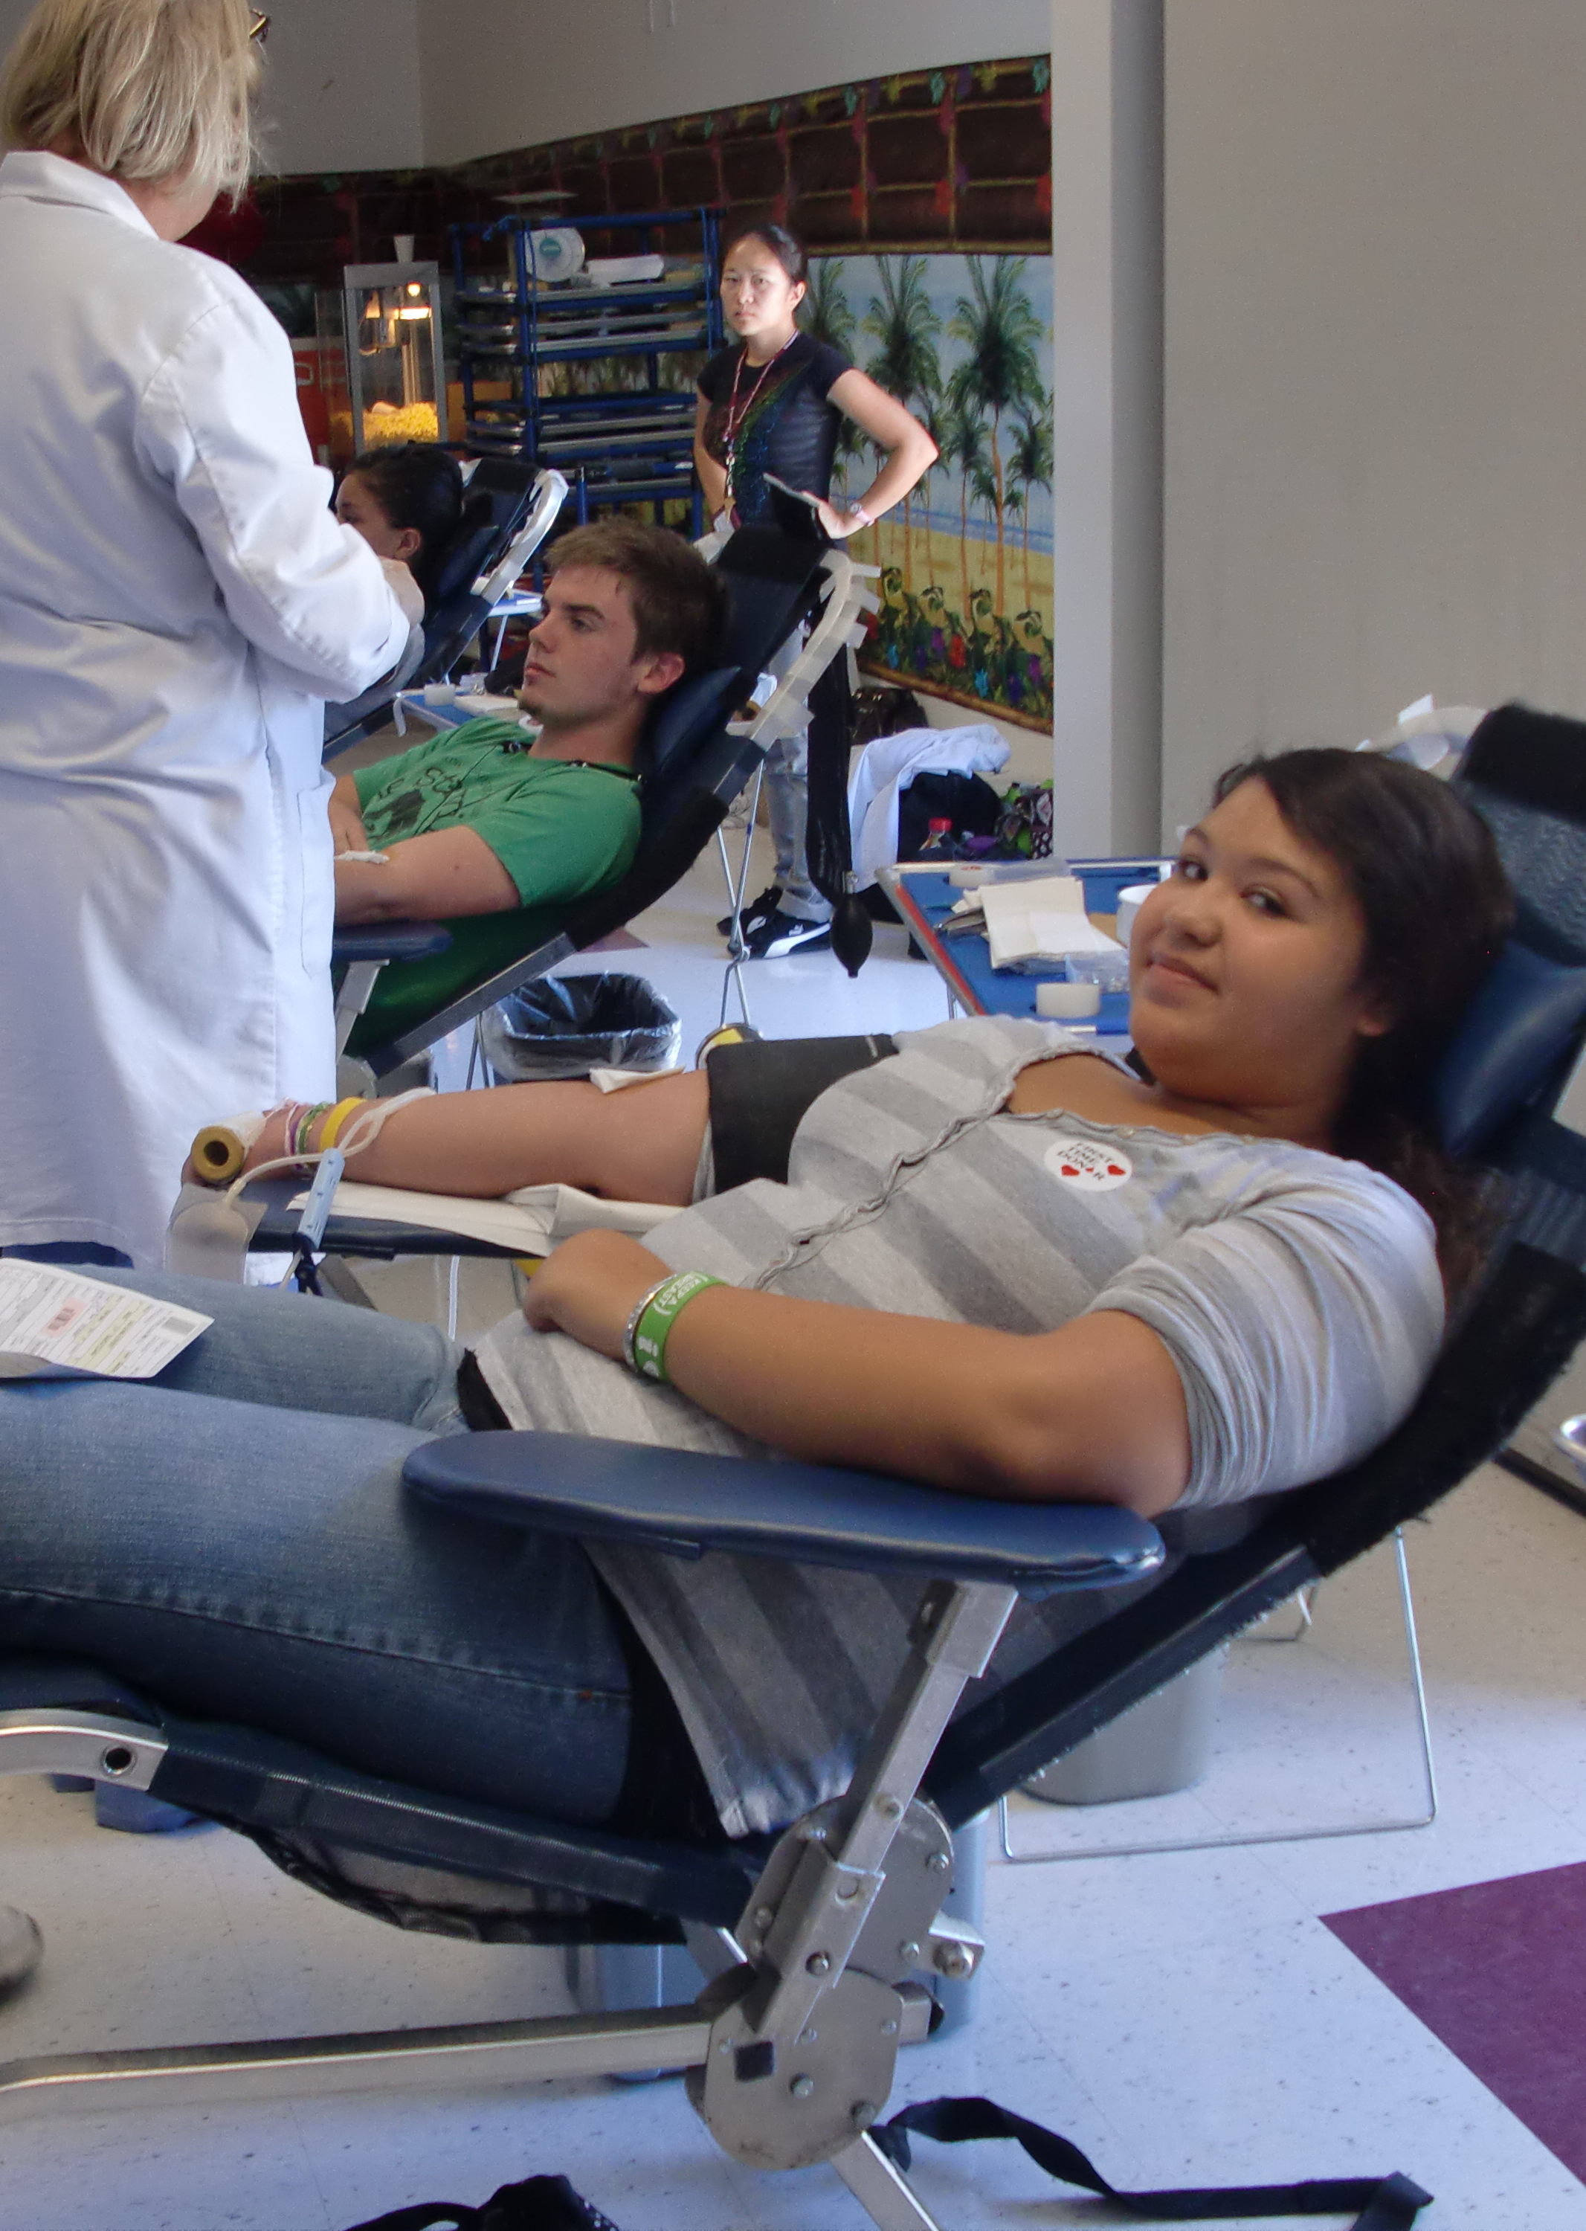


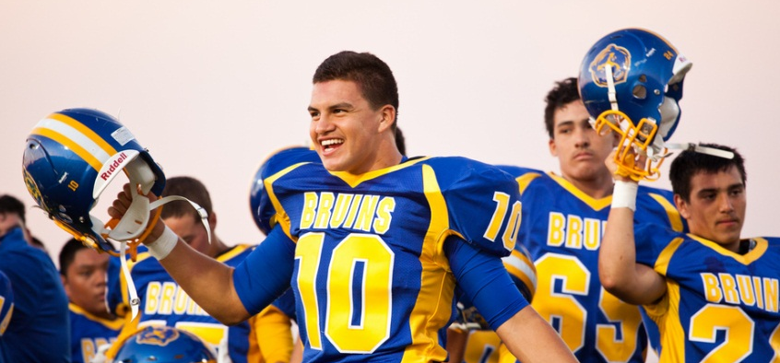

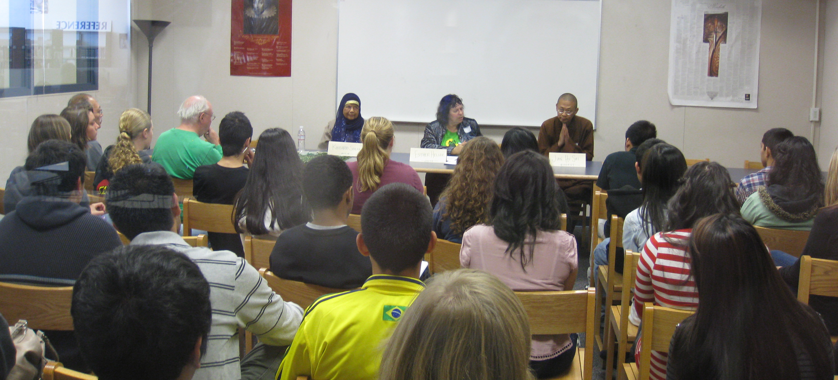

Overall Summary from Analysis of Profile Data
IMPLICATIONS of DATA to STUDENT PERFORMANCE:
Student achievement can be measured in a variety of ways including standardized testing, local assessments, and general school academic success. The CAHSEE, STAR, SAT, and AP exams are standardized. Our English performance based assessment and common finals in Math, Science, and Social Studies are local assessments. Course grades, GPAs, and college readiness exemplify general school academic success.
Since the last WASC visit, SCHS’s Academic Performance Index (API) has grown. There was a huge jump from 2009 to 2010 of 26 points. The general overall increase can be attributed to the consistent growth of our subgroups, wherein all groups collectively met their target in the 2009-10 school year. Nevertheless, when data is broken down by subgroups, White and Asian students perform near or over 800 whereas all others are below 700.
The percent of students performing advanced and proficient in STAR testing is varied depending on the subject matter. Generally, there has been an increase in Social Science and English by more than 10% with both subject matters now testing near or above 50% proficient and above. Mathematics has seen improvement in Summative Math and Algebra Two, but an actual net decrease in Geometry and Algebra. Science has posted enormously positive numbers in Biology and Physics, while Chemistry remains below 30% proficient or advanced. Earth Science continually improves and posted 34% proficient or advanced in 2011 compared to the initial 18% performance in 2007 when the class began. Respectively, SCHS falls behind the California State averages in the same subjects, Algebra, Geometry, Chemistry, and Earth Science.
When the STAR testing data is disaggregated into subgroups, the achievement gap clearly exists, but varies in degree depending on the subject matter. For instance the 10th grade ELA scores of African American students surpassed those of the traditionally high scoring White and Asian subgroups at 65% proficient. However, in Geometry Hispanics performed at 5% proficient or advanced. Despite the growth, there is a consistent achievement gap. The margin of difference, though shrinking, exists for our special education, low socio-economic, Latino, and African American students.
CRITICAL AREAS OF ACADEMIC NEED:
Through our self-study process, discussion in our focus groups and academic department chairs, our critical areas of academic need are clear. The data demonstrates repeatedly that the achievement gap continues to exist between our Hispanic and African American students and their Asian and White counterparts. Although it is apparent we at SCHS have made progress in closing that gap, it continues to exist. Another critical need highlighted by the data is our need to utilize common assessments to change practice for the betterment of student learning. Lastly, we have specific subject matter areas where our students lag behind the average for the state and the nation.
- There is a need to close the achievement gap in all areas. Despite seeing gains in all subgroups since the last WASC visitation, there remains a gap not only in the CST and CAHSEE results, but also in the grade performance of SCHS students. More Latino and African American students are taking college readiness coursework, but the ratio is still unbalanced. We need to continue the focus on equity, intervention, and support, while adjusting and using data to determine the appropriate course.
- The district office has taken the lead in supporting the development of common finals throughout the core curricular areas. While we are grateful for the time and support in accomplishing this feat, the next steps are to utilize the data to provide the most effective instruction. Additionally, there is a need for more formative assessments, which would allow immediate adjustments when students are not grasping subject matter.
- Throughout the past 6 years we have noticed two problematic areas where SCHS students perform below proficiency and lower than their peers statewide. These areas are in Mathematics (Geometry and Algebra) and Science (Chemistry). We have made significant efforts in Algebra and others to varying degrees in Chemistry. Nevertheless, the gap in SCHS achievement remains.
IMPORTANT QUESTIONS RAISED:
- How can SCHS more effectively address the underperformance of its subgroups in a manner that will better prepare them for proficiency?
- What strategies or programs can SCHS implement that will provide the support students need who are willing to take more rigorous coursework?
- What additional types of resources can be integrated into the educational process to ensure support for our English Language Learners and Special Education students?
- What can SCHS do to more effectively address the number of at risk students who are not receiving interventions and support?
- What are other programs statewide doing to be successful in Algebra, Geometry, and Chemistry that could be adapted to help SCHS become proficient in those areas?
- What can be done to empower teachers to engage students in a rigorous standards-based curriculum, while providing the support and identification of students at risk before they fail?
- Most items in our WASC improvement plan were met, but how can we ensure there is data to pinpoint and demonstrate which programs are eliciting success?
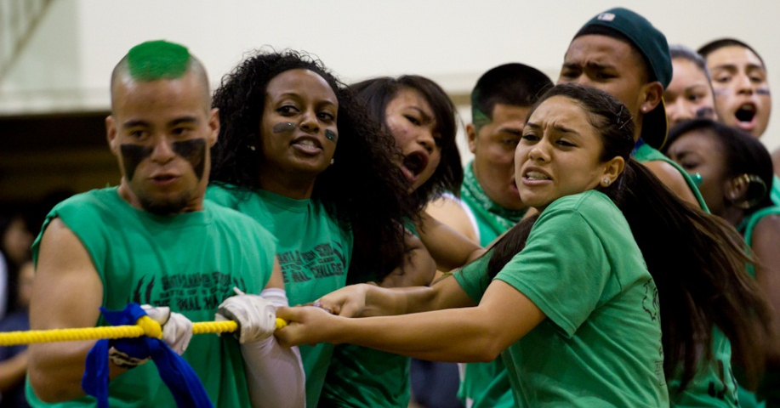
WASC Chapter III
Progress Report

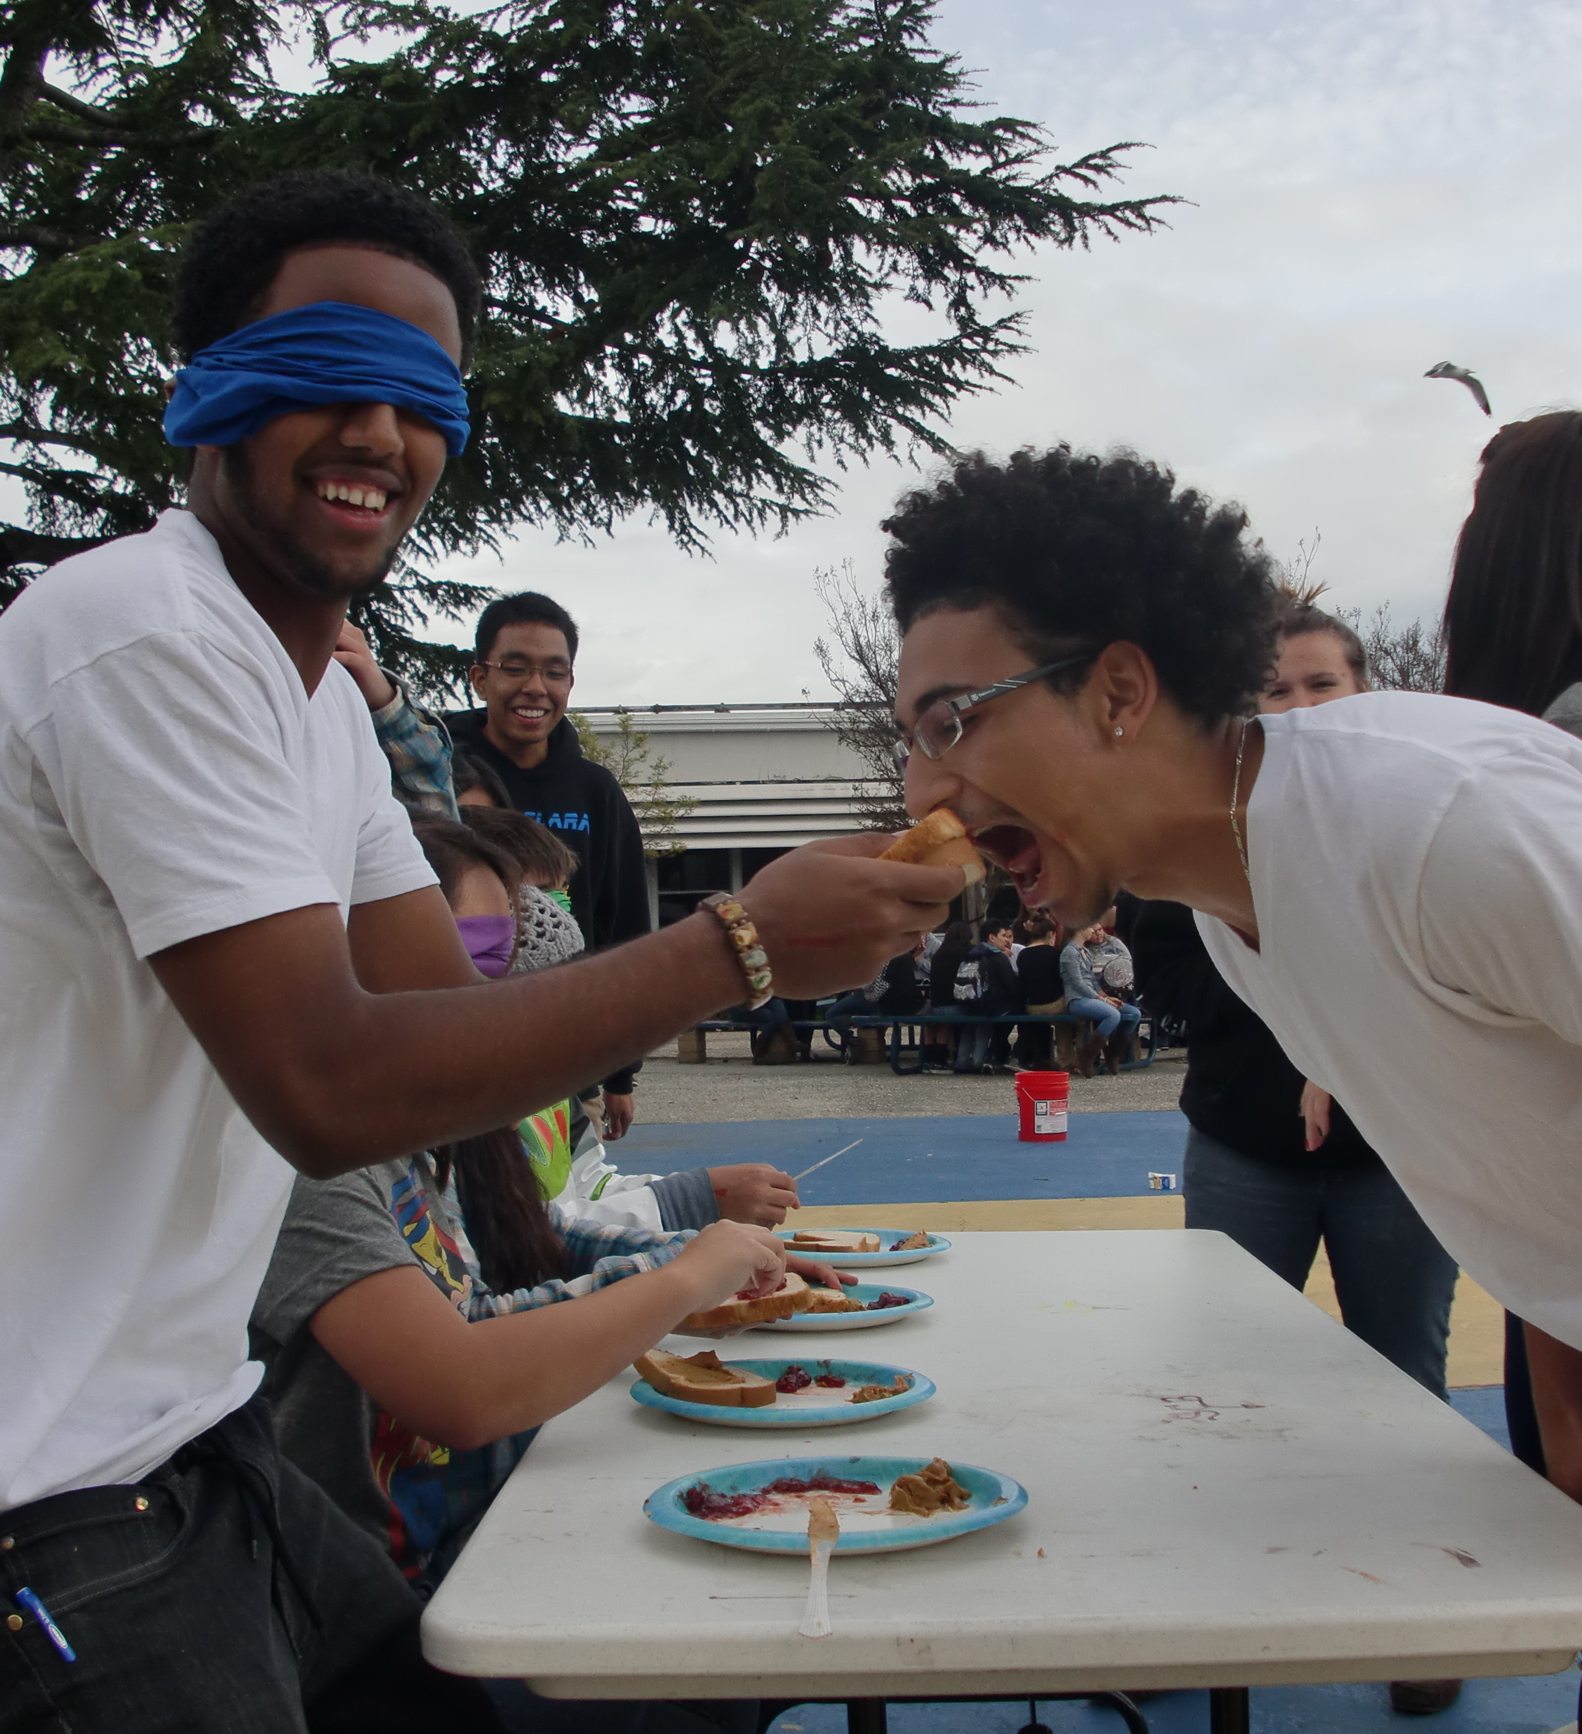
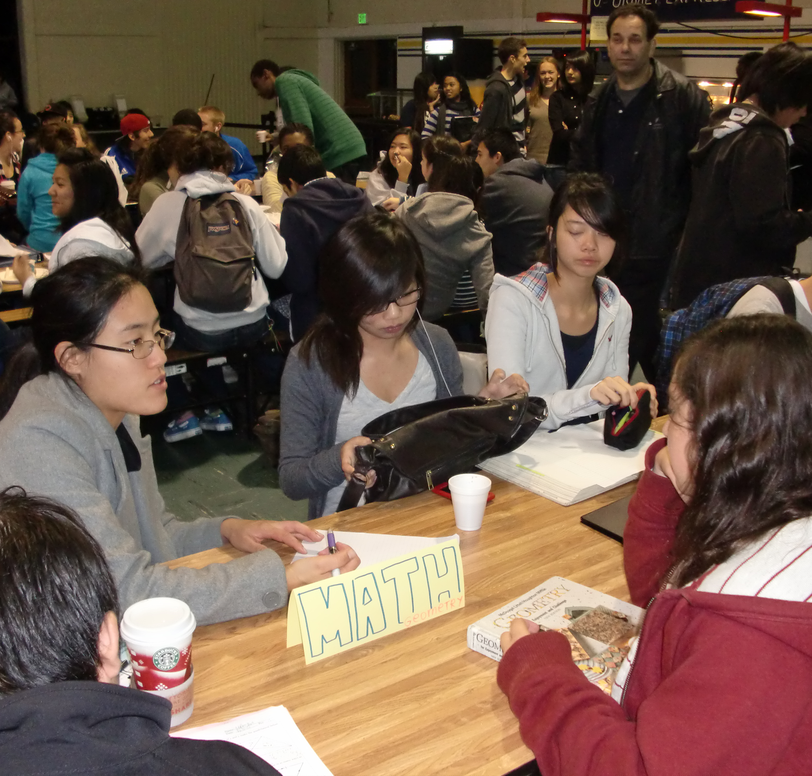

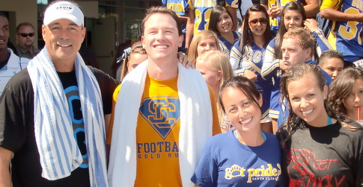

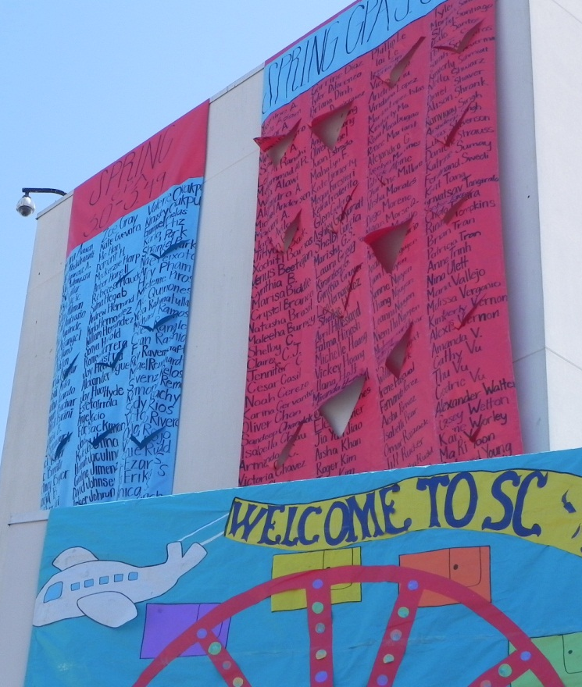
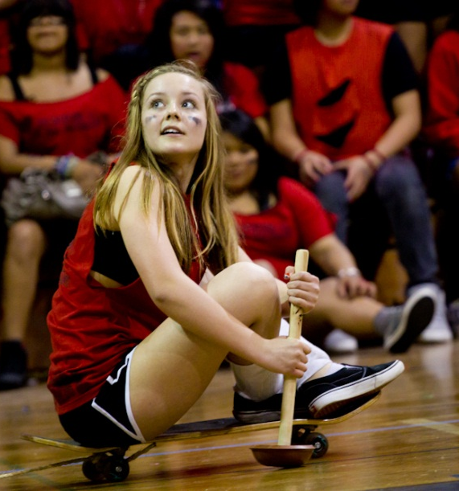

Significant Developments

Within the past three years since the WASC visit, our Santa Clara High School community has implemented new programs and changes campus wide. We have lost some key leaders who were instrumental in founding portions of the WASC plan and added new talent that have added innovative insights. The following includes some of the most crucial developments towards Santa Clara High School’s ongoing push for excellence.

Math Institute
In the spring of 2006, Santa Clara Unified School District embarked on a collaborative journey with San Jose State to change the way Mathematics was being taught primarily at the algebra level. The grant has allowed teachers access to high level professional development which is intended to help them reach all students using best practices.

Leadership Structure and Administration Changes
Since our last WASC visit, we have a new Principal and 2 new Vice Principals. Although new to their positions, they are not new to Santa Clara High School. Every administrator at SCHS was at one time a teacher here. Our new Principal, David Grissom has changed up the administrative responsibilities. The half time Vice Principal position changed to focus primarily on attendance, but was cut in 2010 because of budget shortfalls. Additionally, the other two positions have divided discipline by the alphabet and share many other duties. The activities Vice Principal’s responsibilities remain the same. This change in structure has added a huge learning curve, but a new dimension to the services offered campus wide.

LINK Crew
Our LINK crew program was in existence prior to our last WASC visit, but under new leadership, changes have been made to further accommodate success in our students. For example, the Cocoa and Cram session for freshmen studying for finals was a great support for our students. Budget cuts have scaled back the program considerably in the 2011-12 school year. There is no longer a class devoted to LINK crew so our Freshman orientation activities were scaled down accordingly.

Collaboration and Modified Block Schedule
In the spring of 2008, the certificated teaching staff voted to have a modified block schedule. This schedule has a blocked Wednesday and Thursday schedule with a 2 hour collaboration time built into Thursday morning. The classes are 84 minutes long and meet either on Wednesday or Thursday. To help teachers adjust to teaching these extended periods, staff development has been offered, but because of budget limitations, minimally. Most teachers value the slower pace of the schedule and have consistently voted to keep it.

Aeries School Information System
The district adopted Aeries information systems to replace “School Max.” Many stakeholders were involved in the selection and most seem quite satisfied with the results. Aeries provides teachers with immediate testing data on their students as well as overall attendance and academic history. Queries can be made by office staff to mine information and data more efficiently. In addition, our grading program School Loop has instant upload capabilities for teachers submitting grades.

School Planning Team and Professional Development
Prior to the WASC visit the School Planning Team (SPT) was in charge of staff development. The year after the WASC team visited, the team fell into disarray. The following year, the team was reshaped with new leaders, new teams, and newly created expectations. This has been an important part of meeting the WASC goals. In the late summer, the SPT has a retreat where they reflect on various data items, progress on the action plan, and using those reflections create goals for the year. Thereafter, the SPT leaders meet once a month and then one time with their teams during the second collaboration Thursday. They utilize the small learning community model of deciphering data to determine the problem, planning and goal setting to appropriately address the problem, and then taking action to meet the goal. Depending on the group and the problem will often times determine how much time each stage warrants. The SPT leaders then evaluate the progress and accomplishments of each group. One of our next steps is to increase the accountability level of all focus groups by having Site Council evaluate our progress.

English and Math Interventions
During the course of the last six years, intervention classes in English and Math were put in place to support CAHSEE achievement. The class has been very helpful to students struggling to pass the test. During the mid-term year, we added a Geometry support class and an English 10 support class. These two classes were new and needed more curriculum development to add further success. The ALEKS computer program has been utilized in Algebra classes to differentiate support for struggling students. In addition, the Read 180 program was adopted to support literacy for all students in need. For our students with an IEP (Individual Education Plan), we have created Basic Algebra, Geometry, and English classes that specifically target mainstreamed special education students who need specific subject matter support.

Academic Improvement Process
Early in our WASC term, Santa Clara experienced a small regression in its API scores. Administration, department leaders, the SPT, and district office personnel began to delve into the data to better understand the fluctuation. District wide, we have implemented curricular maps and have begun the process of standardizing common assessments. This will enable all stakeholders to have more data and feedback on which to reflect. Our API has since been on the rise.

UCSC grant and Professional Learning Communities
The administration and the UCSC New Teacher Project have teamed together on a grant to focus on building a professional learning community among our 10th grade English teachers. With focused work on peer observation and collaborative communication, this group has made significant strides in improving instruction. The next steps included implementing similar PLC peer groups throughout the department and throughout the school. The English department has been the most effective at implementing PLC groups. Each year, a small cohort (usually 3) of teachers, identify a problem, look at data, create goals, and take action. When they complete their action, they share with the department their progress and success.

Construction and Site Improvement
Over the last 11 years, several construction projects have occurred on the Santa Clara High School campus. Since the WASC team last visited, we have opened the new library and surrounding hallways. This improvement has made a significant impact on school climate. Last spring, the small gymnasium and female athletic facility was opened right as the large gym was closed. Sixteen portables were dropped on the tennis courts to facilitate the remodel of our main building. Teachers have been and will be packing and moving, teaching in temporary locations. Construction takes a great deal of input from administration and our teacher construction committees. The recently-remodeled, technology-ready classrooms in the A and B wings were opened at the beginning of 2012 to much appreciation from students and teachers alike. The expected finalization of the remodel is set for June 2015.

Equity
A racially fueled incident occurred the year following the WASC visit. This involved a bus driver who racially segregated our students. The incident brought forth strong emotions from African American students who had harbored many negative feelings towards our staff, administration, and district because of the treatment they had received over the years. Several interventions were initiated, one of which included an equity consultant named Edwin Javius. The following year, we also formed two focus groups which continue to focus on equity. Javius created a three year plan for equity was developed and was revised and implemented by both the Equity team and the Cultural Best Practices committee. Those two focus groups have evolved into the Achievement Gap focus group. They have moved fully to the project management model, where they study data, identify problems, collaborate to form specific and measureable goals, and then initiate action. This process is followed by reflection and a review to determine if more, different, or new projects are necessary. This approach allows for distinct issues of Santa Clara High School to be addressed and a more pro-active result to be accomplished.

EL
One of our midterm recommendations was to focus on EL learners. The district office created a master plan to address and outline our commitment to EL learners. In addition, the district provided an EL consultant, Ray Garcia to work with our teachers and leaders to improve our offered program. After the midterm visit, the SPT created an EL focus group comprised initially of EL or SDAIE teachers. They too have fully moved to a project management model. They initially looked through data to discern what the problem was. They then did research, brainstormed, and utilized Ray Garcia to create measureable goals. The action taken was an EL support class, wherein mainstreamed EL students are tutored, advised, and held accountable academically on a daily basis. In addition, Ray Garcia has worked with the Social Studies Department on best practices for EL students. They have focused on supporting all students by addressing academic language and vocabulary. This action, though ongoing, has demonstrated measureable improvement.

Furlough Days and Budget Cuts
Within the last 5 years, the Santa Clara Unified School District has seen an ever greater decrease in funding. Personnel at Santa Clara High School have been cut from the administrative level, certificated classroom instructors, as well as classified professionals. The impact and effects have been significant. Class sizes have increased due to both staffing cuts and the increase from 20 to 1 in English 9 and Algebra 9 classes to 36 to 1. As mentioned, a half time administrator focusing only on attendance was eliminated. Custodial, EL, clerical, and paraprofessional classified staff were cut. The district office administered a moratorium on all travel and conferences for the past 4 years. This has been challenging in that professional expertise has been difficult to access. Conversely, it also has been beneficial as we have looked to each other and our own professional learning community to grow. During the 2011-12 school year, each of the unions and district leadership accepted 5 furlough days. Though our site voted in favor of the furlough days, a general negative feeling has generated among the staff regarding them. In response to the lower morale, we instituted a new focus group, Staff Support. However, more trying times are ahead. The week prior to the March WASC visit, pink slips will be delivered. Next school year is expected to be even more trying, with a nearly 12 million dollar shortfall.

Implementation and Monitoring of the School-wide Action Plan
The SPT takes on the primary responsibility for ensuring that the WASC action plan is carried out. Each year, since the reformation of the SPT, they meet for a summer retreat and create goals that meet the expectations set forth in the plan. Utilizing data and our mission and vision statements, the SPT sets goals for the year. Together, these teams monitor and adjust the action plan as needs and situations change. The SPT revisits the WASC action plan, the SPSA, school data, and staff input to provide the most relevant and effective staff development and school improvement actions. The SPT has made adjustments to the plan and often times has created new focus groups to meet the expectations of the plan. For instance, it became apparent from data as well as feedback from the midterm visit, that EL students needed more support. We thus created a new focus group for EL and many progressive changes have resulted. Each focus group leader makes a practice of analyzing data, identifying problems, creating measureable goals, and then taking action. The leadership group then reflects on the progress that each group is making. Our goal as a leadership group for the next six years is to create a prototype of questions that better support our cycle of inquiry and to have more defined accountability measures.

The Principal and administrators have also taken a notable role in facilitating the implementation of the plan. At the beginning of each year, the administrators meet for a retreat to set goals that adhere to the WASC action plan. Within their weekly “admin meeting” the administrators reflect on the progress towards those goals.

The Single Plan for Student Achievement (SPSA) is compiled each year by an administrator with the input of the SPT, department chair persons, administration, and parents. The SPSA provides a constant connection to our WASC action plan by delineating funds for items prescribed within the plan and beyond. The SPSA is approved yearly by our Site Council and Board of Education. Our goal, which we have been already working towards, is to coordinate the WASC plan and the SPSA as closely as possible to make the SPSA more relevant and connected to the actions being taken on campus. In addition, the Site Council’s goal is to become more of a governing body where it takes on the reigns of accountability not only for funds that were granted, but for goals set forth in the SPSA.

Report on School-wide Action Plan Progress

WASC Item #1:
There are currently five subgroups who are not achieving at the same rate as the majority of our students: Latinos, African Americans, English Language Learners, Special Education and Socio-economically Disadvantaged. Our goal is to close this achievement gap.
# 1 Improve instructional strategies and materials
We have been in the process of adopting or using newly purchased textbook and supplemental materials throughout the school. Both Social Science textbooks, Science, Foreign Language, and English textbooks have been adopted since the last WASC visit. All textbooks purchased are aligned with state content standards and have extensive teacher supplemental materials that allow teachers to create multi-tiered lesson plans to address diverse learners in the classroom. Many teachers use supplemental student resources and on-line textbooks to allow students to access materials. AGS textbooks purchased by the Social Science and Science departments specifically address the needs of the English language learners and special education students. The books are specifically designed to address the language comprehension modifications these student populations require while still covering required core content standards. In addition to the textbooks, we have invested in the purchase of Vernier probeware and software for the science department. This software allows the students to collect data electronically and display it graphically. The variety and quality of laboratory investigations have been improved and expanded through the purchase of this equipment. In efforts to improve the overall writing scores, the English Department piloted and now has in place a CSU Expository Reading and Writing Course that will fulfill the senior writing course requirement. This course is designed to prepare students for college-level English and it is aligned with the California English-Language Arts Content Standards. The course assignments emphasize the in-depth study of expository, analytical, and argumentative reading and writing. All instructors teaching the course have been trained at workshops and receive support throughout the school year.

In addition to the purchase of new materials described above, teachers use collaboration time to focus on improving instructional strategies. Teachers meet in curricular groups and work to use common assessment and data to drive instructional strategies and curriculum improvement plans. These teachers will become instructional leaders who eventually take their process of data-driven reflection back to their individual departments to foster collaboration in an effort to focus on improving reading and writing strategies. The district has required all departments to create and/or implement interim assessments that focus on the content standards. Additionally, the 10th grade English teachers worked with UCSC New Teacher Project. They created a professional learning community that utilized peer observation and focused on strategies and practices that lead to greater student engagement. The PLC practice has spread throughout the English Department and other departments have versions of the PLC. Additionally, teachers in the Cultural Best Practices Focus Group worked on improving reading and writing skills through explicit language instructional strategies. The EL focus group also made efforts to improve direct academic vocabulary instruction across the curricular areas. The Literacy Focus Group created classroom posters of commonly confused and misspelled words and worked with teachers on strategies for better equipping our students to understand test-taking terms.
# 2 Create courses that meet the needs of underrepresented students
A major concern of the last WASC committee was the need for a system of school wide interventions for students performing well below grade level and those who need assistance maintaining within a standards-based course. Since the last WASC visit, there have been several new courses added to accommodate the diverse needs of our underrepresented populations. The math department offered an Algebra I Block course to help students meet their district graduation requirements. We are currently transforming that class into a split direct support class which promotes less tracking of students. A CAHSEE preparation class was added to help students who have not passed the Math or English portion of the California High School Exit Exam. Additionally, we have purchased ALEKS software and implemented ALEKS usage interventions throughout mathematics courses. This course helps teachers identify and work with struggling math students while allowing for more advanced students to increase their analytical skills. A summer bridge program was also initiated to support students transitioning from Geometry to Algebra 2. The course is meant to refresh Algebra skills and prepare students for the first semester of Algebra 2, where statistics showed poor performance. The class has also sought to support skills needed in Chemistry. This class was discontinued due to budget cuts. Three years ago, we added a Geometry support class to assist students struggling in regular geometry classes. The class was designed to increase the number of students completing higher level math levels and college math requirements. Additionally, the English department has created an English 10 support class to assist students struggling in their English 10 courses. After reviewing the data at the end of the year, the cost and benefit were weighed and the decision was made to look for other alternative support strategies.

The Science department developed a Medical Chemistry (now Conceptual Chemistry) course to assist students who do not have the math prerequisites for a regular Chemistry course. A Human Biology course has been designed for upperclassmen who have not met their science graduation requirements. Both classes provide an alternative format to encourage students to continue taking science classes while allowing them to improve their analytical skills.

The Foreign Language department has added Spanish for Native Speakers to meet the needs of our Latino students. The department will be looking into expanding this course into different levels, depending upon student enrollment numbers.

The Social Science department added an Ethnic Studies elective course. This course focuses on historically underrepresented ethnic groups and their experiences in American society.

The former WASC team made strong suggestions to “refine the instructional program and support services for EL students and ensure that they are offered academic support to better access the curriculum.” Currently, all departments offer classes that help English Language Learners. Each department has created EL courses to teach intensive content vocabulary and language development to students with LEP levels 1 & 2 and sheltered language instruction classes for students with LEP levels 3 SDAIE. The students with LEP levels 3 are in classes that offer sheltered language instruction. In accordance with the district EL Master Plan, we added an English Listening and Speaking course. This class was designed to focus on a key area of LEP assessment and move our students at a “stuck 3” LEP level into mainstream classes. All EL LEP levels 1and 2 were in this EL class, which focused on intensive course vocabulary and language developments. After the EL focus group was created, the data pointed them to supporting EL learners in a different way. They instated an EL support class to provide tutoring and guidance for “stuck 3s” as well as completely mainstreamed students.

With the help of the district leadership, we have established a READ 180 program. Testing was administered to all middle school students and those performing at basic and below basic on the ELA CST. We also focused on testing EL students and Special Education students. Once their lexile score was established, students were chosen to be in READ 180. This intensive 2 period course drastically improves literacy skills of students performing far below grade level. We have had 3 sections of the course, 2 mainstream and 1 special education. The prescribed curriculum offers students a structured mechanism to improve.

We are very excited about our AVID program, which offers traditionally underrepresented students who may not have thought about going to college the opportunity to engage in the college application process. Now in its sixth year, this program identifies freshmen students who have the desire to go to college, yet may not have the motivation at home or school to pursue such action on their own. The students are enrolled in classes which provide relevant information regarding the various classes, tests and requirements needed to enter a four-year college or university. The teachers provide opportunities for the students to meet with current college students, faculty members and motivational speakers who inspire them to continue to excel in their studies. In addition, field-trips to local colleges and universities enhance the experience for the students. Regular tutoring by current college students is an added benefit of the class. Once they enter as freshmen, they continue in the program until they graduate; however, any student who wishes to be in the program can be recommended to enter in their sophomore or junior year.
# 3 Increase culturally relevant and reading level specific library resources for curriculum enrichment
Since the last visit we have purchased new textbooks for our English language learners and special education students to meet their reading level needs in both the social science and science departments. We have purchased AGS books for the World History, United States History, American Government, Economics, and Biology courses.
The school librarian had made a concerted effort to purchase culturally relevant materials that reflect our diverse student populations. She has purchased a plethora of books by ethnically diverse authors and about ethnically diverse characters. In addition she made a small presentation brochure for members of the GSA (Gay-Straight Student Alliance), about relevant reading and media materials that are available at the school and public libraries. Additionally, she purchased books that specifically dealt with characters who were either gay, bi-sexual or questioning their gender identity. She has also made a concerted effort to buy high-interest, low-reading level books to encourage our struggling readers to begin the journey of becoming a life-long reader. During Teen Read Week, 1200-1400 students come to the library with their English teachers to hear book talks given by the librarian, teachers, community members, and fellow students about interesting and diverse books that they look forward to reading.
#4 Use research based strategies to create diverse curriculum
With the new block schedule, we fully understand the importance of diversifying curriculum. We have purchased guides and books to aid the teachers in block schedule lesson building. Over half of the math department attended the Math Institute, which teaches multiple ways to construct a math lesson. The English 10 teachers have been focusing on student engagement and finding ways to enhance curriculum to better reach all students. The mentor from UCSC has guided the group through the process and utilized current research to enhance the training process. Additionally, the administration has begun to use the work of Michael Smoker to drive collaboration and create a vision for small learning communities through our academic departments.

The Cultural Best Practices focus group used the help of an outside consultant, Dr. Edwin Javius, to begin creating a plan to improve instructional strategies while developing curriculum. The group decided to use explicit teaching strategies to improve reading and writing instruction. The group specifically used the research of Dr. Sharroky Hollie and Gloria Ladson-Billings to drive their instructional strategies improvement model for reading and writing language skills. In the next year they are going to seek consulting services of Dr. Hollie to create and add more culturally relevant and explicit teaching strategies to their repertoire. The focus group used a professional development morning to train the staff on these strategies.
Our district consultant, Ray Garcia has provided tremendous guidance for our EL focus group. He meets with them monthly and has challenged them to consistently reflect on data and together strategize ways based on research to create interventions that work. Out of this work, an EL support class with definitive structure has been established. Additionally, Mr. Garcia worked with the Social Studies department in improving academic vocabulary instruction.
Most recently, our new focus group entitled AVID Bridge, has looked into applying AVID strategies in all classrooms. Each member of the group is responsible for teaching their curricular department a strategy. These strategies are meant to bridge the achievement gap and enable all students to experience academic success.

#5 Recruit and retain staff who are ethnically diverse
While this continues to be an issue of focus, we have increased the ethnic diversity of the staff. We are fortunate to have added a native Spanish-speaker from Mexico to the foreign language department. We have increased our diversity among the staff 3 fold since the last visit. Many of our veteran teachers from surrounding colleges and universities including San Jose State, Stanford University, and Santa Clara University work as mentor teachers and/or allow undergraduate students to complete observational hours at the school site. A number of our new teachers who are ethnically diverse have come from the Stanford STEP program. We continue to seek qualified individuals from culturally diverse groups who will enrich our current ethnically and culturally diverse student population.

#6 Provide staff diversity training
Dr. Edwin Javius, an equity consultant, worked specifically with the Equity and Cultural Best Practices focus group leaders to develop an equity plan of action. In addition we sent a team of four staff members to an Equity Conference in Rancho Cucamonga where they developed an Equity Plan of Action and were able to meet with other consultants. Dr. Javius provided a school wide in-service for the district and the school on the need to focus on race as a key component of closing the achievement gap.
Three members of the School Planning Team, Krista Keneman, Viola Smith, and Kristin Castillo attended the Dream Deferred Conference in Los Angeles. The conference addressed the critical educational issues directly impacting African American students and classroom educators.
From these trainings, the Cultural Best Practices focus group has been developing a peer observation model wherein feedback concerning cultural best practices will be the focus. The Equity team has also begun to focus on how to bring equity training to all of our staff members.

The Achievement Gap focus group looks at data and then determines the best route to improve a given task by setting SMART goals. They have created and worked on a number of targets and goals, one revolving around diversity training and the Latino Advisory curriculum.

#7 Provide inspirational speakers for students

Throughout our campus, we have many areas where speakers with real life experience are brought in to share with our students. Our librarian has played a significant role in bringing speakers in as well as the Vice Principal for Activities. Other various teachers and departments have also contributed to providing guest speakers.
The Foreign Language department has had and will be having travel speakers in the classroom. These guest speakers have traveled extensively or are authors themselves.
Our GAINS program has had numerous off-campus field trips and has a monthly series of on-campus guest speakers. These speakers include female role models working in the fields of math and science.
The Visual Performing Arts department has increased their guest speakers who include vocationally relevant presenters such as choral directors and videographers.
The English Department sponsored a book talk in 2010 with Luis Valdez, the acclaimed author of Zoot Suit.
AVID has had a number of parents talk about their college experience and how their education relates to their current careers. Ron Martin, one of the parents and CAPE members, was the first to speak to the 11th grade AVID class.
From a school wide stand point, we have added speakers that embrace our increased vision of equity. The California Youth Outreach program regularly brings in former gang members to talk to students about the risks of gang life.

In February 2009, the SCHS Student Body Organization hosted an acclaimed one-man performer, Carl Ray, with his play A Killing in Choctaw. Mr. Ray told the true story of the murder of his father in a 1962 racial hate crime and his struggle for peace and forgiveness in the years since. The event was well received and thought provoking for the many students, staff and community members in attendance.
Our librarian secured the writer Art Rodriguez, author of East Side Dreams, who gave a book talk to approximately 250 students during lunchtime in May 2008. She also was able to coordinate and host book talks by authors Carrie Ryan (2009), Sarwat Chadda (2011), and Rachel Hawkins (2011) for large groups of interested and appreciative students.

#8 Review and revise course prerequisites

Every year the curricular departments review the course catalog to update any course descriptions, prerequisites, etc. In Mathematics, they have created documents (which are updated every year) with the math course sequence, which includes any prerequisites.
We revamped the science sequence in our course catalogue to make it easier for students and counselors to choose the right science courses. The Foreign Language department has worked with the administration to adhere to the prerequisites of Foreign Language. In doing so, they realized they needed to enforce their expectations rigorously to ensure student success at the next level. For instance, in the past, a student receiving a D in Spanish 2 may be passed on to Spanish 3 without the skills necessary to be successful. We now would make that student retake Spanish 2 to re-learn vital components. The Visual Performing Arts department changed the Intro courses to meet the needs of advanced students as well as match those of our sister school.

One major success that transpired since the last visit is open enrollment in our AP and honor classes. There are no barriers that exist for students who want to challenge themselves. The numbers of students taking AP courses had tripled since the last WASC visit.

#9 Provide a resource/ tutoring room with materials
During the 2007 –2008 school year, we had a centralized tutoring center in the school library after school hours that was staffed by teachers from various departments on a rotating basis; however, due to low attendance rates, we have revised the procedures. Each department makes arrangements to offer individual tutoring. The math department, where we have the greatest tutoring need, publishes a permanent tutoring schedule on the school website. Each department has tutoring services available by appointment or drop-in basis. In addition, the majority of staff open their doors during lunch and after school hours to offer individual tutoring for their students on an on-going basis.
There is a permanent study room in the school library that is available before, during and after school hours. All course books are available for students use and students are able to use library computers that are equipped with internet services and research based data banks on the library home page. The library has also created a supply area where students have access to and the use of construction paper, markers, colored pencils, glue sticks, scissors, rulers, and poster boards, all in an effort to make sure that all students have the materials needed in order to succeed in school.

The Visual Performing Arts department, including music, graphics, art, photo, and video has opened up their doors 4 times a week after school to offer assistance to students. They would like to provide a resource/tutoring room with materials and equipment for students to complete assignments and projects
The Mathematics department runs a department wide tutoring schedule that is published and distributed by teachers and counselors alike.
In an effort to encourage study skills for midterms, the Link Crew organized a Cocoa and Cram study session in the cafeteria on the second day of the midterm finals. Departmental tables are set up where teachers from each department tutor students. Approximately 200 students attend the session and nearly 40 staff members tutor at the event. We have started a culture where students are encouraged and supported in obtaining individual tutoring services or participating in group study sessions.
Transportation was one issue that we discovered was interfering with a number of students ability to stay after school hours to utilize tutoring services. For the last two years, we have arranged for an activities bus to leave the school at 4:50 to allow students the opportunity to stay on campus for a longer period of time. Additionally, we decided it would be important to take the tutoring services to an area of the district where a number of our students of color and socio-economically disadvantaged students live. Starting in October 2008, the principal and staff members held town hall style meetings in the Renaissance and Lick Mill areas to identify the wants and needs of the community. It was determined that a local tutoring facility was needed. We then established a permanent tutoring room available at Catherine Hughes Elementary School. A number of laptops were purchased and computers at the facility were available for student use. The facility was open Monday thru Thursday from 4 p.m. – 6p.m. and staffed by a member of the faculty. This tutoring center will be continually assessed to determine the viability of the program.

WASC Item #2:
Although our test scores have been rising, we still have students who are not proficient in some subject areas. Our goal is to increase the percentage of students who are proficient in all subject areas.

# 1 Gather and analyze available assessment data
The department chairs in every department have been in-serviced on “School City” and how to utilize the data found there. Each core department has been using this data to look at student achievement and better determine teaching practices that enable student learning. Our new SIS system, Aeries, gives teachers immediate access to their students test scores including CAHSEE, STAR, and SAT. Teachers also have full access to student achievement in other classes through Aeries and School Loop.

One of the key issues the last WASC team shared with us was our lack of organized data. We, along with the district have begun to implement a standardized system of formative assessment that can more fully reflect student learning. Our Science, Math, and English departments utilize district common finals and have a new mechanism to process the data derived from these exams. At this time, teachers would like more time to delve into the data to better guide student learning. In addition, the Social Science department is regularly revisiting common finals for both World and U.S. History.

The Cultural Best Practices and Achievement Gap focus group have utilized student data from School City to better define the racial achievement gap. The plan was then to implement into as peer observation forms to account for specific gaps identified through the peer-to-peer observation.

Realizing most teachers had very little hands-on opportunity to work with School City, in 2010, we used a “SIP” day to train teachers on how to use it. At this point, department chairs utilize it much more than the average teachers. Generally, teachers use CST scores and grades in AERIES more often than School City. Some department chairs use school city more often because it demonstrates the CST strands. The focus groups have made efforts to include a wider variety of data sources including the surveys, standardized tests, common assessments, and other data pieces from AERIES.

# 2 Develop a means to determine student needs as a basis for creating a Personal Learning Plan (PLP) for each student
One of the critical areas for improvement indicated by the WASC team 6 years ago was our lack of Personal Learning Plans for students. To correct this, our Freshmen Foundations course has been mandated to guide all students through the development of a 4 year PLP. They updated the document and format first and then coordinated their instruction to meet the pre-learning needs of the freshmen students. These plans are now in digital form, which will allow for our next step, which is to enter them into their guidance counseling files. We began to hit a road block when more and more students were not taking freshmen foundations. The district office has made a push to begin four year planning with 8th graders using the Naviance program. Our counselors are beginning during the 2012 registration cycle, to ensure completion of the plan and utilize it to choose courses. Each year and each visit to their office, the counselors will work with students to continue to fulfill their chosen pathways.
There are several other avenues where the PLPs are utilized, as well as further developed. Through our GAINS program we have developed personal learning plans where adult leaders meet with the female students involved and work together to meet their scholastic needs.
Using School Loop, teachers are staying in contact with resource teachers and better meeting the needs and accommodations of our 504, ELL, and Special Education students. Advisory teachers can instantly access student progress. Counselors can also better manage the students’ Personal Learning Plans because of the access School Loop provides. Our hope is that with the use of Naviance, the counselors continually will revisit the plans and make adjustments during personal meetings with students based on their progress and interest.

# 3 Develop a cross-curricular scope and sequence curriculum map to create themes, to use common curricular language, and to build cross-curricular links
Individual departments have worked with the district office personnel and Teachers on Special Assignment (TOSA) to develop curricular maps for each core subject matter area. Each department utilizes collaboration time to meet in subject areas to align our curriculum calendars. Major units and the topics covered within them are mapped out for the year. We continue to meet in subject areas throughout the year to share and plan the use of various instructional resources and strategies for each unit.

Although each department is refining their curricular maps, we have not completed the work for school-wide, cross-curricular links. The English and Social Studies departments have been creating those cross-curricular links for over ten years, collaborating on the World and American studies program. Many lessons school-wide embrace cross curricular emphasis even if they do not follow a strict timeline.

# 4 Continue to develop curriculum in Freshman Foundation to support CST skill areas
We have new Freshmen Foundation teachers since the last WASC visit. Two were previously teaching Tech Literacy and one is new to the school and subject matter. Because of this change, there is a learning curve that is taking place. Nevertheless, they have been mentored and are slowly adopting more and more of the core subject areas content standards. There has been a large focus on supporting World History through geography. Overall, the focus is to increase skills such as note taking, reading for understanding, and presentation skills.

WASC Item #3:
Create a supportive environment that provides opportunities to develop a sense of belonging to the school culture and promotes an atmosphere of participation, communication, and responsibility.

# 1 Explore and develop a daily advisory/tutoring period and/or a non-traditional schedule to support student achievement
A new SPT focus group called the Alternative Schedule committee worked tirelessly to arrive at a potential schedule. They surveyed staff at Wilcox High School to gain direction and then developed their own version of a modified schedule. Near the end of the 2007-08 school year, the teaching staff approved a modified block schedule. The new schedule was implemented at the beginning of the 2008-09 school year. The block gives students 2 block days out of 5 and still provides the staff with a 2 hours collaboration/ meeting time on Thursday mornings. This change received both a positive and negative reception. Very little training occurred prior to the change; however teachers have been industrious on their own to gain the skills necessary to improve student achievement, and sample block schedule lessons were presented at each faculty meeting. To better meet the WASC plan, the Alternative Schedule committee was transformed with new leadership into a SSR/Advisory focus group. Looking at data and giving surveys themselves, this focus group tried to determine what should be done overall with SSR. By the end of 2011 school year, it was determined that SSR should be kept, albeit with clearer provisions. This decision was made in no small part due to a survey response by students in which they expressed an overwhelmingly desire to have SSR remain. Despite this decision, there still are a number of people who are dissatisfied with the current use.
A pilot advisory period during the SSR period occurred during the 2007-08 school year. This advisory pinpointed struggling Latino students. These students met with 3 teachers two times a week and focused on academic, social, and emotional improvement. 100% of the students improved their attendance and over 60% of them improved their academic grades. Although this pilot was successful, many teachers are reluctant to approve a program school wide because it is perceived as an added prep period. During the 2009-2010 school year, a volunteer Latino Advisory program was enacted. This Advisory followed the objectives of the pilot and serviced over 100 Latino students once a week during the SSR period. This advisory has continued and shows more evidence of support and success. The Achievement Gap focus group looked at data and realized teachers needed more support and they created a goal to improve Latino Advisory Curriculum. As a group, they created and implemented this curriculum.
In his first year as Principal, Mr. Grissom started a school wide tutoring program in the library. This was staffed by teachers who were paid for their extra hours. Unfortunately, the student attendance was very low and the program was cancelled. To better support our students of color and reach students where they live, Mr. Grissom has enacted a new tutoring program that takes place at Hughes Elementary. Mr. Grissom has had parent meetings to solicit involvement, as well as school assemblies to promote it.

#2 Create a peer counseling program for student well-being

This goal has not been met or even attempted to be met. The individual involved with this vision left the school and no one else has followed up. Up until this last year, the SPT did not feel this action warranted our efforts.
Our Link Crew makes every effort to support and connect freshmen students to the school, but no formal counseling program has been adopted. Up until the 2010-11 school year, the need did not seem to be overwhelming. There was a student who committed suicide at the end of the 2010-11 school year. Given the events this, both the school and the district are looking into mental health services that will provide both peer and professional support. A SIP day was used to have the head of the Stanford Psychology department train teachers on the warning signs and behaviors of depressed and or suicidal teens. Thus far, our school psychologists have been presenting the “Almost Sad” program. The program directly instructs students of steps to take if they or someone else is feeling down.

#3 Hold a major workshop annually to focus on social issues and to build a sense of community

In the past, we utilized the “Breaking Down the Walls” program to accomplish this end. At this point, we are moving away from a major workshop model and implementing small scale improvements. One such improvement is our Diversity Council, where presidents form all of our culturally and ethnically diverse clubs meet to discuss issues and build community. Diversity week was a huge success due to the collaboration of these groups. A joint slide show was presented by the Jewish, Christian, and Muslim clubs. The “Secrets” assembly also raised awareness of current social issues among teens and demonstrating to them how important it is to make positive choices. “Every 15 minutes” is performed every other year to stop drunk driving. The students directly involved are greatly impacted by the program. Additionally, the Equity focus group, now known as the Achievement Gap focus group keeps a pulse on the impact of racial issues campus wide.

#4 Create more opportunities for extracurricular interaction among staff and between staff and students to improve relationships and school pride

A SPT focus group was created, which specifically meets this goal. It is called the Student Staff Camaraderie group. They have put together a monthly event to integrate activities among staff and students. We have had multiple sporting competitions and the most popular event thus far was a “Trivia Smack Down” game where teachers and students competed in the quad. This is a vibrant and popular focus group that aims to keep adding new activities and options to our campus. Our new football coach initiated a tradition where one game day, a staff member is chosen to wear a jersey of a player. Those staff members also wore the jersey to the game. Inviting staff members to a game also took place in basketball and baseball. Numerous staff members attended music and drama performances through invitation as well.
The Quality of Life Group, now called SC2 has increased the general involvement of staff socially. They provide a monthly happy hour and a quarterly event. Within the past two years, we have had golfing, bowling, a chili cook-off, wine tasting, and a SJ Giants game. The group has also consistently organized a beginning of the year, holiday, and end of the year party.

#5 Update the school website frequently to improve communication

The Activities Vice-Principal took charge of recreating the school website through School Loop, an interactive web service created for schools. Colorful student pictures flash across the screen and updates are provided to get a real feel for events, achievements, and occurrences across the campus. Teachers have uploaded their own websites and can give students and parents access to their green sheets and curriculum. Grades are posted so that students and parents alike can access them and stay informed. Parents and students can also e-mail their teachers through School Loop, thereby increasing the communication of all involved parties. Clubs and the leadership class have fully utilized the site as a tool for communication. The PTSA also regularly uses School Loop to communicate with parents including posting their monthly newsletter. Another great example of connection is the GAINS’ website link on the school website which provides instant connection to our GAINS students. The Library’s webpage offers information as well as links to helpful websites and research databases purchased for student use so that where ever students have access to the internet, they have access to accurate, reliable information. We are looking to add ways for alumni to connect through our improved website.

#6 Improve communication among stakeholders (Staff, district personnel, administration, parents, and middle schools)

We developed a focus group entirely devoted to communication. They have focused on discerning problem areas and finding solutions. Their leader meets regularly with the principal, as well as the SPT to discuss these issues and look for resolution. They have performed student, staff, and teacher surveys to better grasp perception, needs, and enfranchise stakeholders. They then set forth measureable goals and began working on initiatives. The Communication focus group has also met with counselors, secretaries, and district personnel to work on communication issues.
There is a continued effort to reach out to parents and School Loop has fulfilled that desire. School Loop provides parents, students, and teachers 24 hour instant access to current grade book information. It also offers email contact, and teachers have noted the increased level of email correspondence. In 504 meetings, parents are already aware of their student’s academic progress and actually ask teachers more informed questions. Students also have the ability to track their own progress, which empowers the learner.
The District Update Newsletter has regularly featured the Foreign Language Department. Foreign Language teachers are polled monthly for news updates and those items are communicated to District Office personnel. Additionally, the Foreign Language department would like to revisit Latino Parent Night. We had this a few years ago. Parent interest dwindled, but the need is still present.
The Principal publishes a weekly “Bruins or Bust” newsletter to staff. In it, he shares successes, concerns, opportunity for input, general communication, and upcoming events. The staff appreciates it and looks forward to its arrival.
In the Visual Performing Arts department, we continue to celebrate the “Day of the Arts” where students and parents alike are invited to view and appreciate our student’s artistic efforts. Additionally, parents are always invited to participate and chaperone our field trips.
Parents are invited to interact and participate in the GAINS program.
AVID recently had a parent night, where parents were kept in the loop to the goals of the AVID student and in particular their own student’s needs.
The Science Department accepts the help of parents in the development and maintenance of their California Native Plant Garden. They also invite parents to join our yearly whale watching field trip in Biology as chaperones.
Our PTSA membership has flourished within the last 6 years and their activity has increased, as well. Parents, two of whom are school board members, regularly participate in events such as the Crab Feed, Battle of the Classes, and Homecoming.
One of the school-wide key issues noted by the previous WASC team was our need to increase communication strategies for our parents of color. We have tackled this goal by increasing the number of documents we offer in Spanish, utilizing interpreters at meetings, and promoting the District EL specialist to communicate with Latino parents. Our African American parent organization, (CAPE) became very involved again in part due to the racial incident. This group has been instrumental in promoting academic opportunities for our African American students and supporting the improvements made at the site level. They have now focused on building a K-12 parent group to help support the education of all African-American students and are no longer site based.

RECOMMENDATIONS:
The previous addressed the original concerns addressed by the WASC team 6 years ago. Upon their revisit, there were 10 more items noted. Most of these were also addressed, but we will reiterate those in the following:
- Continue to address the academic needs of the EL population. EL services must be enhanced, monitored and adjusted frequently. – Because of our EL focus group, we now have a vehicle upon which to do just this. This group is delving into data, creating interventions, and adjusting teaching and learning.
- Increase the number of minority students in rigorous courses. – AVID has greatly supported this recommendation. As mentioned our AP and honors enrollment has tripled, which includes a larger number of students of color.
- Continue with the equity drive. – With our EL and Achievement Gap focus groups, we are able to keep a focus on equity. In addition, we have also kept equity as a focus in curricular and department meetings because the data, though improved, still shows an achievement gap.
- Improve counseling access and services offered. There is a great need for a bilingual counselor. – The Vice Principal of curriculum took this feedback as well as that from students and parents to improve the services offered. The counselors meet weekly and for a 1 day retreat to regularly and cumulatively reflect on their practice. Students are now counseled individually for registration annually. Record numbers of students are taking the PSAT as well as the SAT. Parent nights are provided to also keep the parents up to date on high school and college requirements. During the 2010-11 school year a bilingual intern played an integral role in working with students and parents of Spanish speakers.
- The School Loop grades need to be updated frequently. – This mandate helped to direct teachers to update School Loop at least one time a week. Generally this is followed with very few exceptions.
- Use data driven instruction. – This is an ongoing process that we as a school site are continually aiming for. Certain departments are far more advanced in this area than others, however most have now reached the baseline. The baseline is common summative assessments wherein data is compiled on School City. English, Science, Math, Physical Education, and Social Science have all developed these common assessments. The Science department is the most advanced in looking at the data and actually driving instruction from it. The other departments mentioned, review the data, but are taking the steps to make it more impactful. The SPT focus groups utilize the cycle of inquiry for tackling problems and their first step is always referring to data.
- Staff needs training to use data for instruction. – As mentioned, a SIP day was used to show teachers how to use School City. The District is also providing guidance through SIP days on how to use the data.
- There was inequity with cost of lunch and event tickets. (Prom) – This issue has been discussed, but not acted upon. However, there is a site policy for all socio-economically disadvantaged students to have access to all academic related events. This includes field trips, tests such as the Advanced Placement, and course-related fees.
- Continue to monitor and adjust tutorial. - We have increased our tutorial on site to include Math, Science, and Foreign Language. Additionally, most teachers have posted office hours. Our off campus tutorial has been monitored by an off-campus administrator.
- There is a need for staff to work collaboratively with the special populations. - We have made great progress in this area. We currently have both 3 English and 2 Math workshop classes for Special Education Students. Here, the RSP special education teacher sits in the mainstream class and then has another class period to support the learning that occurred and prepare them for the next lesson. This is an important collaboration between the mainstream and special education teacher and has warranted great success for the students supported. In addition, we have had training for special education aids, which was never accomplished before.

IMPACT OF PLAN ON QUALITY AND LEVEL OF STUDENT LEARNING
As noted in this document, our stakeholders have taken specific actions to improve student learning. There is a consistent drive to improve all facets of the school program. As evidenced through this report, new avenues have been explored to meet our goals and further address the key issues the prior WASC team brought forth. We have developed a system of accountability for the WASC report through the SPT leaders consistently evaluating progress and striving to manage/achieve our action plan goals. The students have increased in their performance on specific subjects within the CST exam as well as improved pass rates on the CAHSEE. We have more students challenging themselves with advanced academic courses than ever before. As a staff, we have tried to address the issues with ingenuity, thoughtfulness, and willingness. Our students at Santa Clara High School have an improved learning environment because of these efforts.
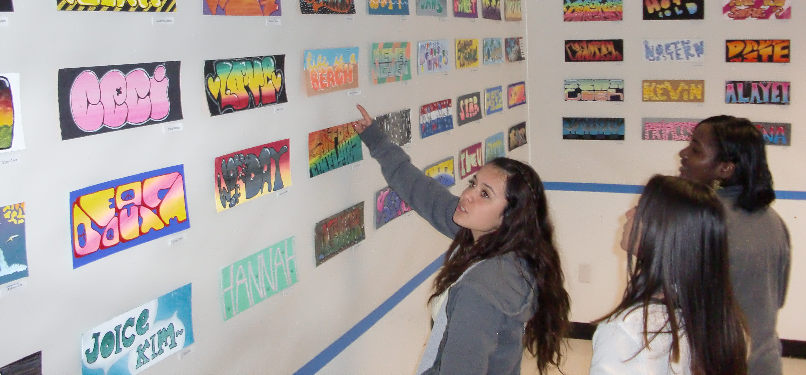
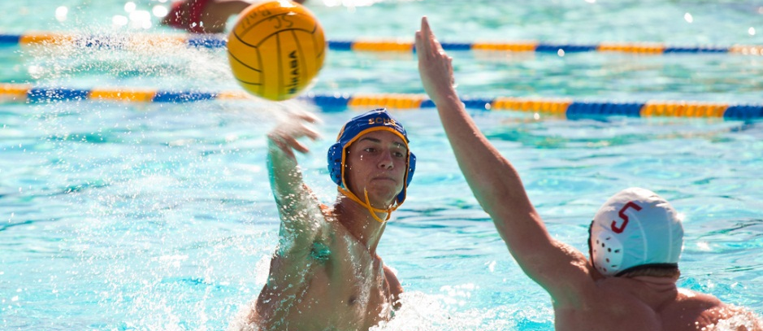
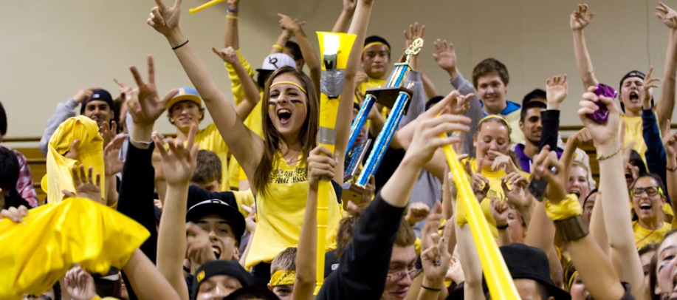
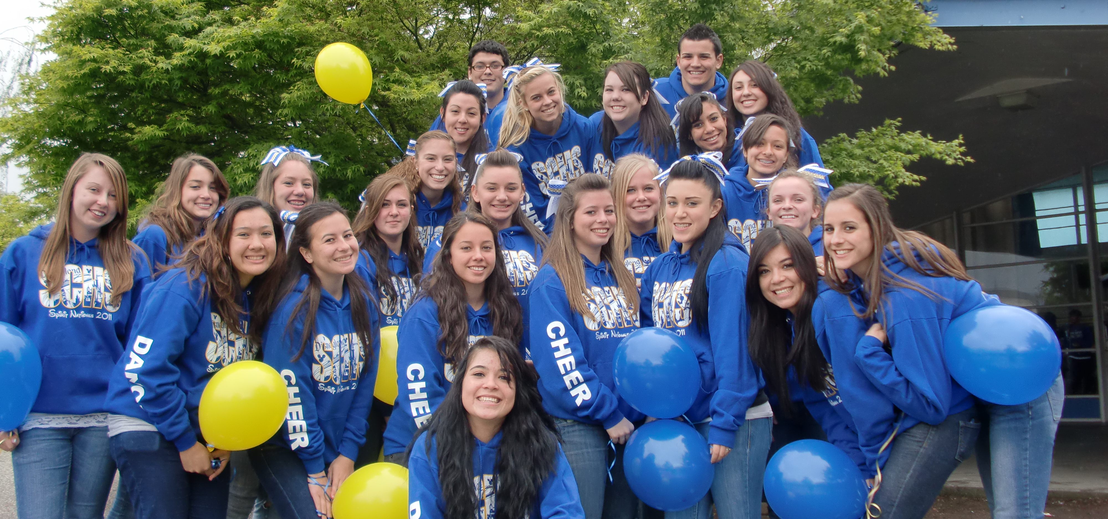
WASC Chapter IV
Self-Study Findings

Category A: Organization: Vision and Purpose, Governance, Leadership and Staff, and Resources

A1. Organization Criterion
To what extent a) does the school have a clearly stated vision or purpose based on its student needs, current educational research and the belief that all students can achieve high levels and b) is the school's purpose supported by the governing board and the central administration and further defined by expected school-wide learning results and the academic standards?

Vision – ESLRs – Profile
Prompt: Comment on pertinent student/community profile data that has impacted the development of the vision and the expected school-wide learning results.
Findings | Supporting Evidence
The Santa Clara High School staff has been operating under the expected school-wide learning results that were developed in the past. In the 2010-2011 school year, the staff analyzed these and re-wrote them to make them more “student-friendly.”  - There are inconsistencies amongst the staff in regards to how explicitly the ESLRs are used in the classrooms. There are implicit uses of the ESLRs in classrooms daily.  - The inclusion of the whole faculty in the new ESLRs will hopefully increase teacher “buy-in”  - There are efforts to require staff to print ESLRs onto each syllabus  - More ways to communicate and make visible ESLRs to students need to be explored  The Santa Clara High School staff developed, over two years, mission and vision statements that have been shared with students during their class orientation meetings, online, and in their student handbook.  - A video was created in which the staff communicated the statements to the students as a whole and with individual cameos of teachers in their classrooms saying the statements. | - Teacher syllabi  - Parent-student handbooks  -ESLRs classroom posters  -ESLRs post-its for use on student work  - Orientation meetings for each graduating class at the start of the year  - santaclara.schoolloop.com /mission  - Staff vision video
Development/Refinement of Vision/ESLRs
Prompt: Examine the effectiveness of the processes to ensure involvement of representatives from the entire school community in the development/refinement of the vision and expected school-wide learning results.
Findings | Supporting Evidence
Our development of our vision and mission statements occurred in focus group meetings and in school-wide planning teams.  - All administrators and teachers were involved in this process. There was limited student, parent, and classified involvement in this process.  Our refinement of our expected school-wide learning results occurred in interdisciplinary groups of teachers during two professional development days.  - There has been limited student, parent, and classified involvement in this process so far.  - There are intentions to involve students, parents, and classified staff in the development and approval of the school’s ESLRs. | - 2008-2009 and 2009-2010 planning team meeting agendas  - January, August 2011 professional development agenda

Understanding of Vision and ESLRs
Prompt: Examine the effectiveness of the processes to ensure involvement of representatives from the entire school community in the development/refinement of the purpose and expected school-wide learning results.
Findings | Supporting Evidence
The process to ensure that our students, parents, and other members of the community understand our commitment to and contribute in the development of our vision and expected school-wide learning results is not consistent.  - At the start of the school year and in Back-to-School meetings, there are some teachers who effectively communicate the expected learning results of the school and the class.  - Students who are in classrooms which post academic standards and ESLRs and whose teachers refer back to them have the highest likelihood of understanding our commitment to our vision.  - The Orientation Meetings for each graduating class are effective in introducing our vision and mission to students, but further ways to incorporate our vision and mission into our school need to be explored. | - Freshmen orientation agenda  - Teacher classroom posters and Back-to-School presentations
Regular Review and Revision
Prompt: Examine the effectiveness of the process for regular review/revision of the school purpose and the expected school-wide learning results based on student needs, global, national and local needs, and community conditions.
Findings | Supporting Evidence
School Site Council annually reviews the school’s purpose and goals in approving the Single Plan for Student Achievement.  - The School Site Council ensures that student needs are being addressed in the school’s goals for the year.  As the staff and students review the current school purpose and ESLRs, their conversations cover the degree to which these meet the students’ needs and the larger community’s needs. It is found through these conversations that our ESLRs ought to emphasize the value of “21st Century Skills” than they currently do. | - School Site Council meeting agendas  - January, August 2011 Professional Development Day conversations

A1. Organization: Additional Findings
Prompt: From examining additional relevant evidence, what has been learned regarding the extent to which this criterion is being addressed?
Findings | Supporting Evidence
Students in and teachers of the wide variety of vocational classes on campus report a higher degree of connection between daily classwork with the ESLRs. | - Anecdotal evidence from students in and teachers of band, theater, arts, CCOC
Prompt: Comment on the degree to which this criterion impacts the school’s addressing of one or more of the identified critical academic needs.
Findings | Supporting Evidence
It is understood by most teachers that the extent to which the students who measurably have the most critical academic needs- our English-only Latino(a) students in particular- succeed best in the classes that explicitly align themselves with the goals of the ESLRs. | - Success of students in Biotechnology

A2. Governance Criterion
To what extent does the governing board a) have policies and bylaws that are aligned with the school's purpose and support the achievement of the expected school-wide learning results and academic standards based on data-driven instructional decisions for the school; b) delegate implementation of these policies to the professional staff; and c) regularly monitor results and approve the single school-wide action plan and its relationship to the Local Educational Association (LEA) plan?

Governing Board
Prompt: Comment on the clarity of the policies and procedures regarding the selection, composition and specific duties of the governing board, including the frequency and regularity of board meetings.
Findings | Supporting Evidence
The policies and procedures regarding the selection, composition, and duties of the governing board are communicated in the Teacher Handbook and the SCUSD website.  District-published calendars, newsletters, and the Schoolloop calendar indicate the dates of board meetings.  - There are district board meetings the second and fourth Thursdays of the month, typically. | - Teacher handbook  - SCUSD website  - District calendars and newsletters
Relationship of Governance to Vision and ESLRs
Prompt: Comment on the clarity of the policies and procedures regarding the selection, composition and specific duties of the governing board, including the frequency and regularity of board meetings.
Findings | Supporting Evidence
The school board meets twice monthly, is an elected body by the residents of the city of Santa Clara, and oversees and approves policies and procedures of the district. Each year, the district approves the school’s Single Plan for Student Achievement (SPSA). | - SCUSD calendar

Understanding Role of Governing Board
Prompt: To what degree does the school community understand the governing board’s role, including how parents can participate in the school’s governance?
Findings | Supporting Evidence
Parents can learn through the SCUSD newsletter that goes out to residents on a quarterly basis or the SCUSD website how to participate in the school’s governance and the role of the governing board. Members of the school community can find clear information on how to participate in the school’s governance when they seek this information out.  Santa Clara High School has a Student School Board Representative who reports to the school board at each school board meeting and the superintendent carries on a luncheon with student representatives four times a year. There are few other students who understand the way to participate in the governance of the board. | - SCUSD website

Governing Board’s Involvement in Review/Refinement
Prompt: How is the governing board involved in the regular review and refinement of the school’s vision and purpose and expected school-wide learning results?
Findings | Supporting Evidence
The school’s vision and purpose and expected school-wide learning results are reviewed and approved (and refined if necessary) by the school board and the adherence of the school to these will be indicated on SCHS’s SPSA, which the school district also oversees and approves. | - Yearly submission of, and approval by, SPSA to SCUSD School Board
Professional Staff and Governing Board
Prompt: To what degree is there a clear understanding about the relationship between the governing board and the responsibilities of the professional staff?
Findings | Supporting Evidence
The professional staff and governing board’s relationship is best understood by the teacher’s union, the department chairs, and those whose experiences have led them to attend board meetings and speak in front of the board on a manner being voted on.  As is helpful to creating a sense of community with SCHS, School board members tend to attend SCHS events, like our Crab Feed, some sporting events, Open House. Many of our school board members are parents of students at SCHS. | - Santa Clara Teachers Union representatives on campus  - School board membership

Board’s Evaluation/Monitoring Procedures
Prompt: Comment on the clarity of the evaluation and monitoring procedures carried out by the governing board, including review of student performance, overall school operations, and fiscal health of the school.
Findings | Supporting Evidence
The fiscal health of the school and the monitoring procedures carried out by the governing board are best understood when the superintendent and/or the principal have presented on these topics to the staff or community.  - With recent budget cuts, former Superintendent Steve Stavis reported out to the community in multiple events about what the priority cuts were and the status of the district. He has also reported to the staff almost every other year on the fiscal health of the district.  - Email reports from Steve Stavis to the members of the SCUSD email network often report on the health of the district and any issues being faced.  - The new superintendent, Bonnie Plough, held an all-district meeting on the first day back from school in which she detailed her target areas of concern and in which she recognized the academic growth of all schools within the district.  It is understood that the district is in charge of approving the SPSA and reviewing student performance, but it is less clear to the wider staff what the evaluation criterion are for these elements of our school. | - Superintendent reports and presentations  - 2011 district fiscal status meetings  - Minutes from district meeting August 2011

Complaint and Conflict Resolution Procedures
Prompt: Examine and comment on the established governing board/school’s complaint and conflict resolution procedures as they apply to your school’s shareholders.
Findings | Supporting Evidence
The school board’s complaint and conflict resolution procedures are posted in all classrooms.  - The procedures are not always followed, but the administrative team ensures that they are posted in all classrooms at all times each year. | - All SCHS classrooms

A2. Governance: Additional Findings
Prompt: From examining additional relevant evidence, what has been learned regarding the extent to which this criterion is being addressed?
Findings | Supporting Evidence
The school board often sets broad policies and instructions for individual schools, departments, and thus teachers, parents and students, though it often lets school leaders and teachers set particular policies and plans of action. In approving our plans and particular policies, the school board often accepts the professional judgment of SCHS personnel. | - School board policies on district wide testing  - School board approval of SPSA
Prompt: Comment on the degree to which this criterion impacts the school’s addressing of one or more of the identified critical academic needs.
Findings | Supporting Evidence
There have been many opportunities for professional development and acquisition of technology for the teachers in the Mathematics department; as these were provided by the district, it is their way of assisting SCHS in moving students towards levels of achievement. | - Technological tools provided to mathematics department by the district

A3. Leadership and Staff Criterion
To what extent based on student achievement data, does the school leadership and staff make decisions and initiate activities that focus on all students achieving the expected school-wide learning results and academic standards?
To what extent does the school leadership and staff annually monitor and refine the single school-wide action plan based on analysis of data to ensure alignment with student needs?

Broad-Based and Collaborative
Prompt: Document that the school planning process is broad-based, collaborative and has commitment of the shareholders, including the staff, students, and parents.
Findings | Supporting Evidence
School Planning Team is made up of a voluntary, multidisciplinary, multi-profession team of teachers, a counselor, a librarian, the English Language Learner Coordinator, the School Site Council Chairperson, and a Vice Principal.  - Each of these teams, during the WASC Self-Study process, met with at least one classified staff, one parent, and two students.  - The teachers are from the English, Foreign Language, Mathematics, and Social Sciences departments.  - This team meets monthly before meeting in their multidisciplinary groups with the rest of the staff (in Focus Groups) on one Thursday each month.  The Department Chair meetings are held monthly, with a Department meeting each month as well.  - In attendance include at least one member (the elected chair) of all departments on campus, including Special Education, and the School Site Council Chairperson, one Vice Principal, and the English Language Coordinator. Often all of the administrative team can be found at the Department Chair meeting.  The School Site Council is made up of a voluntary, elected group of parents, students, classified personnel, teachers, the chairperson, and the principal. It is held each month and reviews the progress of the school towards the Single Plan for Student Achievement (SPSA). | - School Planning Team meeting membership  - Department Chair meeting membership  - School Site Council Membership
School Plan Correlated to Student Learning
Prompt: What evidence supports that there is a correlation between the Single Plan for Student Achievement and analysis of student achievement of the critical academic needs, expected school-wide learning results, and academic standards?
Findings | Supporting Evidence
The SPSA includes within in the critical academic needs as derived by an analysis of yearly data and sets goals and tasks that are aligned with them. In addition, the goals of the SPSA align with our school-wide learning results and the academic standards. | - Goal 1 of the SPSA is “Improve Literacy Scores”  - Goal 2 of the SPSA is “Increase Mathematics Proficiency”  - Goal 3 of the SPSA is “English Learner Support”

Correlation between All Resources, ESLRs and Plan
Prompt: What evidence supports the correlation between allocation of time/fiscal/personnel/ material resources, expected school-wide learning results, and the improvement school-wide action plan?
Findings | Supporting Evidence
The SPSA lays out a budget that allocates time and material resources to each of the goals. Since these goals are aligned with our school-wide learning results and our critical academic needs, we ensure that our resources go to those areas which are most critical to improving our school.  - School and Library Improvement Plan funding items highly aligned with our school-wide learning results in the recent past include (but are not limited to) the following: funding for Journalism course materials; purchase of ALEKs program for CAHSEE math preparation; the training and supplemental materials needed for the Link Crew Program. Each of these are through programs initiated by teachers and adopted into new or existing courses.  - Some programs are widely embedded in the curricular program and most on campus know about it and its value: AVID; Teen Read Week; Math Tutoring; CAHSEE Preparatory Courses; the ELL Coordinator; and the Link Crew Program; the Day of the Arts Exhibit. It is the strength and professionalism of our staff that carry on these programs to the capacity that funding allows them. Most individuals on campus would attest to the value these programs attribute to our school.  - Funding items highly aligned with our critical academic needs in the past include (but are not limited to) the following: field trip of ELL students to the San Jose Musical Theater accompanied by reflection and letter writing experiences; provide reading-level appropriate books to ELL courses during SSR; provide and furnish with materials and personnel, the READ 180 classroom for 6 periods of the day. | - Budget in the SPSA  - SPSA Evidence Binder

A3. Leadership and Staff: Additional Findings
Prompt: From examining additional relevant evidence, what has been learned regarding the extent to which this criterion is being addressed?
Findings | Supporting Evidence
While the School Site Council is most directly involved with the Single Plan for Student Achievement, the implementation of this plan happens because of the initiative of individual staff members working within a structure that has diversity in its leadership groups. | - Make-up of Department Chair, Planning Team, and School Site Council meetings  - SLIP Funding Requests submitted by teachers
Prompt: Comment on the degree to which this criterion impacts the school’s addressing of one or more of the identified critical academic needs.
Findings | Supporting Evidence
The funding initiatives paid with SLIP funds have been directed towards ELL students, students reading below grade level, and students on free- and reduced-pay lunch. In addition, they have gone to funding the ALEKs interactive online program in the CAHSEE Preparatory courses. | - SLIP Budget

A4. Leadership and Staff Criterion
To what extent does a qualified staff facilitate achievement of the academic standards and the expected school-wide learning results through a system of preparation, induction, and ongoing professional development?

Employment Policies/Practices
Prompt: Evaluate the clarity of the employment policies/ practices related to qualification/statutory requirements of staff.
Findings | Supporting Evidence
Staff who apply to positions at SCHS who are already within the district formally apply for a district transfer.  - Classified personnel who are within the district are given priority in hiring processes, but still they must interview in front of a committee.  - Certificated personnel who are within the district must interview in front of a committee and are considered with the same level of priority as those who are from outside the district.  The practice of hiring a new staff member generally includes considerations of the following, in order of preference:  - Experience (including experience outside of the realm of education)  - Professional clear credential (for teachers)  - Status as a person of color  - Has a master’s degree in the subject being taught (for teachers)  Before an applicant can be seen for an interview, all classified personnel must first submit through EdJoin.org a letter of intent, their resume, and at least one letter of recommendation.  It has also been a common practice to give preference in hiring individuals who have already taught in some form at SCHS before formally joining the staff and who have attended SCHS as students themselves. | - District transfer application  - Classified personnel contract  - Anecdotes of staff members and administrators  - SPSA goal to hire staff members of color  - Lindsey Couto (English teacher for 2010-2011 school year) was a long-term substitute at SCHS during the 2009-2010 school year.  - Emily Burton and Kristina Ravo were student teachers in the Social Sciences Department before being hired.  - Jason Bumbaca (P.E.), Paul Fuller (Math), and Chandra Fraizer (English) are SCHS alumni, among many others.
Qualifications of Staff
Prompt: Evaluate the procedures to ensure that staff are qualified based on staff background, training and preparation.
Findings | Supporting Evidence
Interviews of prospective staff and faculty members occur in a committee format to ensure that all hires are highly qualified in the capacity for which they will serve the students at SCHS.  - Certificated personnel have at least one member of the administrative team and one classified personnel on their interview committee.  - Classified personnel have in their interview committee at least one person from the administrative team, one person from his/her prospective department who is almost always the department chair, and one other person on staff.  - The interview committees read through applications before an interview, ask standardized questions of all interviewees, and then discuss their impressions of the interviewee before seeing the next applicant.  - Due to the rigorous application required, the interview committees held, and the questions asked during interviews, it is ensured that all potential staff members have the qualifications required for their position and that all hires are a good fit for the students at SCHS.  Teachers who have not received Beginning Teacher Support and Assessment training when they begin at SCHS are automatically enrolled in the district’s program.  - This ensures that all teachers on campus either have or are working towards having a Professional Clear credential.  - BTSA mentors are all teachers or former teachers in the SCUSD and all have experience teaching the subject matter that the beginning teachers currently teach.  All hires are either CLAD/BCLAD certified or have a SB422 credential; they are otherwise not considered for their prospective position.  All new teachers attend a district orientation before the first days of school.  SCHS follows the district policies in conducting observations of staff members to ensure that staff members are continually utilizing their background, training, and preparation in the capacity for which they were originally hired.  - Informal “drop in” observations are done of teachers by the administrative team. Administrators look for the degree to which learning goals are made clear for students and the degree to which students are engaged in achieving their learning goals.  - Staff who have been hired on probationary status are observed twice a year by an administrator. Each observation consists of a pre-observation, the observation, and a post-observation. A lesson plan is presented to the administrator at the time of the pre-observation.  - Staff who are tenured in the district for their first ten years are observed on a two-year cycle, in which one of the years they participate in a formal observation with an administrator.  - After completing first ten years of teaching at SCHS, the administrative team can opt to switch a teacher to an observation cycle that is based in a five-year cycle.  - All observations of teachers are in terms of the degree to which they are in accordance with the California Standards for the Teaching Profession.  - Certificated members can opt for an alternative evaluation in which they conduct a cycle of inquiry and report on their findings with their evaluator.  - Classified staff are evaluated every year based on their performance of their job and their adherence to the policy terms of their employment. | - Department chair and administrative team anecdotes  - BTSA roster  - Number of certified staff with a Professional Clear credential  - District calendar  - District website for administrators to input observational evidence
Maximum Use of Staff Expertise
Prompt: How effective is the process to assign staff members in order to maximize the use of their expertise in accomplishing quality student learning?
Findings | Supporting Evidence
All teachers and paraprofessionals are fully qualified for their assigned areas based on district and site requirements.  Teachers who are assigned AP courses, AVID classes, CSU Expository writing courses, and READ 180 classes are given subject-specific training before they can teach their class to ensure students are getting the appropriate learning experiences for these classes.  - All AP teachers have gone through a College board-approved training in the AP course they teach.  - All AP teachers have had their syllabi for their courses audited and approved by the College Board.  - All READ 180 teachers and CSU Expository writing teachers have attended specific training for these courses.  - AVID teachers have attended weeklong summer training in addition to other conferences before teaching AVID.  - When Link Crew was a class (last year it was a class was 2010-2011), the Link Crew teacher was ASCD-trained  Department chairs take into account teachers’ teaching and industry experience when assigning teachers to classes after the master schedule has been set.  - Consistency occurs often from one year to the next to ensure that each teacher builds upon his/her experience in each course s/he teaches. | - Classified staff credential data  - SPSA Evidence Binder  - College board course ledgers for all AP courses  - Chandra Frazier, Kristina Ravo, and Dave Smedley have attended the READ 180 training  - Hugo Cortes, Kristina Flores, Jennifer Herrera, Krista Kenneman, Elizabeth Molnar, and Amanda Palasky have all attended the AVID summer training.  - Master schedule for the 2008-2009, 2009-2010, 2010-2011, 2011-2012 school years
Defining and Understanding Practices/Relationships
Prompt: Evaluate the administrator and faculty written policies, charts, and handbooks that define responsibilities, operational practices, decision-making processes, and relationships of leadership and staff. Determine the clarity and understanding of these by administration and faculty.
Findings | Supporting Evidence
Teachers receive a copy of school handbook and district policies each year to ensure that all teachers are informed of vital information regarding operational practices, decision-making processes of the school, and relationships of leadership and staff.  - School handbook contains flow chart of responsibilities for school administrators so that teachers know where to direct questions regarding the operational practices in the school.  - The alphabetical “splitting up” of students between discipline administrators and counselors assist staff members to know where to direct questions or referrals regarding individual teachers.  Many school policies and procedures are printed out in a way that allows them to be posted by teachers in their classroom so that they may reference them easily in discussing or implementing these procedures with students.  - The newest poster was “What SSR Does / Does Not Look Like” and others include the electronic policy, the bell schedule, and the “no hat” policy. | - 2011-2012 Faculty Handbook  - Posted policies in classrooms
Internal Communication and Planning
Indicator: The school has effective existing structures for internal communication, planning, and resolving differences.
Findings | Supporting Evidence
“Late start” Thursday meetings throughout the year generally consist of the following monthly schedule:  - First Thursday: Department Meetings  - Second Thursday: Professional Development / Focus Group Meetings  - Third Thursday: Staff Meetings  - Fourth (and, if applicable, Fifth) Thursday: Teacher Collaboration  All teachers are expected to attend the entire duration of these meetings and an administrator is present and available to answer any questions at the department, focus group, and staff meetings.  Department Chair Meetings occur after-school on the Wednesdays before Department Meetings and are conducted by Vice Principal Lynne Ewald.  - Information that must be communicated to all teachers is conveyed to department chairs at that time.  - Administrators use this time to get feedback on potential courses of action that are being considered.  - Department Chairs are given ample opportunity to represent the interests of the members of their department during this time.  The administrative staff has a long tradition of deferring to Department Chairs and/or the School Planning Team to make decisions regarding the proper use of time of Thursday “late schedule” meetings and regarding the content of SIP days.  - The World Studies and American Studies teachers have had the flexibility to use collaboration time to co-plan.  - The Math Department uses collaboration time to engage in course-level meetings.  - Past SIP day agendas have been set by departments and the planning team to meet the school-wide goals of analyzing data and of selecting and articulating Expected School-wide Learning results, amongst other goals.  Focus Group leaders, who together make up the School Planning Team, meet with Vice Principal Jenny Baldwin after-school on the third Wednesday of the month to set goals and communicate the activities of their group.  - Each leader reports out on the agenda carried out by their group that month and their anticipated agenda for the upcoming month.  - Issues that came up within the group or by the group are discussed in the group as a whole during these meetings.  The whole staff participates in yearly surveys to communicate what went well that year, the differences they see that need to be resolved, and the areas of growth they find in the school to be in need of. The School Planning Team topics are derived from these surveys and from SPSA and WASC goals.  - At the start of each school year, the leaders of the School Planning Team Focus Groups present to the staff what the goals of their group are and teachers select for themselves the group they want to join based on their own interest or teaching assignment.  - Each Focus Group is ensured to have at least one person of each department in it.  - The Communication Focus Group focuses its time on conveying the information from the yearly survey to the appropriate entity. The Communication Focus Group leader meets with the principal on a monthly basis to ensure communication between the staff and the administrative team.  At the start of every school year, the school site orientation meeting consists of the administrative team communicating to the staff their goals for the year and the school-wide policies that are to be implemented.  - Vice Principal of Discipline Jennifer Baldwin holds an ad-hoc committee meeting at the end of each year to hear from interested teachers about how the school-wide policies and disciplinary procedures went that year. This informs the policies that are implemented the next year.  - Most policies receive time during this meeting for teachers to give input and suggestions to both the administrators and other teachers.  Throughout the school year, it has become a practice of the Student Activities Director to maintain a highly updated website, using administrative controls to ensure the appropriateness of messages sent to the SCHS community and to communicate important events and information on an almost-live basis.  E-mail is used on a daily basis by staff to communicate amongst one another.  - Student Body Office secretary Patrice Anderson compiles both a weekly calendar and the school’s daily announcements each day and this is posted on School loop and emailed out to each teacher each day.  - Principal’s secretary Peg Tushak provides staff with as needed information regarding issues that come up from day-to-day.  - The principal Dave Grissom writes an almost-weekly email to the staff called “Bruins or Bust” that often gives “kudos” to staff members for their positive contributions and that communicates vital information that was not communicated in meetings or other forms previously.  - Staff communicates information to one another using “NE” in the subject line to communicate that their email is regarded “non-essential” information. This has meant that teachers feel free to email the whole staff information that may not be vital, but that might highlight a student, issue, problem, event, or other piece of information others might find useful.  School loop is used by teachers to communicate information to parents and students, but yet also by the Special Education Department to post student IEP information and by teachers to communicate with one another regarding individual students.  The PTSA, Athletic Boosters, Music Boosters, and School Site Council meet monthly, have the principal in attendance, and have parents as members.  - The PTSA creates a quarterly newsletter that contains a message from the principal and communicates vital information to parents and students. This is posted electronically on School loop and some copies are printed out for pick-up in the SCHS office. | - SCHS site calendar  - Department Chair Meeting calendar  - SIP Day agendas  - Planning team calendar and agendas  - Yearly staff survey  - SCHS Site Orientation Day Agenda  - Focus group rosters  - Communication Focus Group agenda  - Principal’s schedule  - SCHS Site Orientation Day Agenda  - SCHS School Policy Emails, Agendas  - SCHS’s School loop website  - SCHS internal staff emails  - SCHS’s School loop website  - SCHS staff internal emails  - SCHS staff internal emails  - SCHS staff internal emails  - SCHS librarian, groups, and teachers’ individual School loop websites  - Meeting minutes for the PTSA, Athletic Boosters, Music Boosters, and School Site Council  - PTSA digital and hard-copy Quarterly Newsletter

Staff Actions/Accountability to Support Learning
Indicator: The school evaluates the effectiveness of the processes and procedures for involving staff in shared responsibility, actions, and accountability to support student learning. This includes an evaluation of the kinds of collegial strategies used to implement innovations and encourage improvement, such as shadowing, coaching, observation, mentors, and group presentations.
Findings | Supporting Evidence
Staff meetings are used for group presentations by individual teachers and by Focus Groups to involve staff in shared actions to support student learning. While there is no process to measure the degree to which this impacts teachers’ practice, it does validate individual teachers and it provides staff with ideas of good practices.  - Administrators select one or two teachers a year to present out on best practices they use in their classroom. These teachers then are able to field questions on implementation when curious teachers ask them during time outside of these meetings.  - Focus Groups inform the staff of their findings or resources they are making available to others and how to go about using these resources.  The tenth grade English teachers were a part of a grant during the 2009-2010 school year that allowed them to collaborate and observe each other, focusing on evaluating student engagement and effective teaching strategies.  It is expected of all teachers who attend conferences and trainings to share the strategies they learned in department meetings.  - Follow-through to ensure that teachers do indeed share out afterwards is not formally in place as of yet.  To encourage teachers to implement strategies effective to a “block” schedule, the principal arranged for and the School Site Council paid for a number of teachers to observe Homestead High School in Cupertino in 2009-2010.  At a staff meeting in the 2010-2011 school year, the staff voted on the criterion against which they would like the administration to use as they informally visit classrooms. The list that was voted on was in its entirety from the school district.  - The staff decided that it would be most effective for the learning of students at SCHS if the administration looked for ___ when visiting classrooms.  Observations by department chairs and by teachers are made possible by administration’s willingness to cover a class or to provide a substitute teacher.  - Department chairs tend to utilize this resource to observe new teachers within their department.  - This resource is not used on a consistent enough basis to contribute a great deal to the sense of shared responsibility amongst staff. | - English teachers Naomi Hatter Ansaldo and Waleska Mendoza shared out on teaching vocabulary and keeping track of student progress, respectively.  - Foreign language teacher Mary Mackey shared out on implementing games within the curriculum.  - The Literacy Focus Group presented out on best practices and shared a poster on Latin / Greek roots and on commonly misspelled words.  - The Grant writing Focus Group presented Grant Writing Resources for teachers, a handout for teachers to use.  - Department meeting agendas  - SLIP Evidence Binder  - Staff meeting agenda  - New observational standards used by administrators  - District observational information input website
Evaluation of Existing Processes
Prompt: To what extent does the school leadership regularly review the existing processes to determine the degree to which actions of the leadership and staff focus on successful student learning?
Findings | Supporting Evidence
The administration team meets every Monday morning to address any school-wide issues and to discuss the agendas for the meetings of the week. The leadership team addresses issues of communication and staff at this time. | - Administrative meeting agendas
A4. Leadership and Staff: Additional Findings
Prompt: From examining additional relevant evidence, what has been learned regarding the extent to which this criterion is being addressed?
Findings | Supporting Evidence
The Planning Team structure allows for a number of informal and formal interdisciplinary discussions regarding educational research and the learning opportunities that would be best for the students of SCHS.  Informal and peer observations could be utilized better so as to create a culture where collegial sharing and mentoring is collaboratively developed and supported by all professional staff. | - School Planning Team agendas
Prompt: Comment on the degree to which this criterion impacts the school’s addressing of one or more of the identified critical academic needs.
Findings | Supporting Evidence
The attention, staff, and resources assigned to the School Planning Team, READ 180, EL Support Classes, and AVID program assist in our goal to increase the educational opportunities for and connection of English-only and English Learner Latino males to SCHS as they tend to be served in these different courses.  The subject matter of the Focus Groups that make up the Planning Team is chosen so as to address the school’s critical academic needs. This is why we have an English Language Learner group, a Literacy group, and an Achievement Gap group. These groups assist teachers and the administration in understanding the learning needs and experiences of students and see to it that needs the less-served learners are kept at the forefront as we make school-wide decisions. | - Focus Group topics (i.e. Achievement Gap, EL Learners)  - SPSA Goals  - SLIP Budget

A5. Leadership and Staff Criterion
To what extent are leadership and staff involved in ongoing research or data-based correlated professional development that focuses on identified student learning needs?

Support of Professional Development
Prompt: How effective is the support of professional development with time, personnel, material, and fiscal resources to facilitate all students achieving the academic standards and the expected school-wide learning results?
Findings | Supporting Evidence
The professional development opportunities that have been made available through SCHS and the SCUSD were approved because of their alignment with their reputation for improving instruction of our underachieving population (as shown by our school-based data).  - To increase the number of first generation and minority students eligible for four-year universities, SCHS has implemented a larger number of AVID courses and ensures that all AVID teachers are nationally trained to teach AVID.  - The Social Sciences Department and the English Language Learner Support Focus Group worked with the district consultant, Ray Garcia, to address the needs of our English Language Learners. This time was spent on focusing on academic language needs in the World History and U.S. History courses (for the former) and on developing an English Language Learner Support class (for the latter).  - While the district has put a moratorium on spending money on professional development conferences and training, the few for which they will approve to be funded are those that will better allow teachers to serve their English Language Learner populations.  All teachers who are assigned an AP course are provided with, and are expected to attend, a College board-certified AP training in the course they will be teaching.  Classified staff rarely is offered professional development opportunities. | - AVID Summer Institute Training  - ½ day substitutes for Social Science teachers  - AP training workshops attended by all AP teachers
Supervision and Evaluation
Prompt: How effective is the school’s supervision and evaluation procedures in order to promote professional growth of staff?
Findings | Supporting Evidence
There is an open-door, drop-in policy amongst the administrators and the notes they leave for teachers may contribute to professional growth of teachers if a suggestion is made and carried out. | - Staff anecdotal evidence
Measurable Effect of Professional Development
Prompt: Comment on the processes and their effectiveness in determining the measurable effect of professional development on student performance.
Findings | Supporting Evidence
The process in place at SCHS to measure the effectiveness of professional development on student performance is in development. When called upon to report out on the measureable effect of a particular professional development activity, this information is provided, but there is not a central structure in which this information is held.  - The SPSA records the tasks set out to be accomplished and the status of student performance at the time, but does not quite analyze the effect of past projects.  - The School Site Council Coordinator is in the process of developing a feedback system in which evidence can be collected in accordance with the SLIP funding requests so that the measures of student performance that are indicated on funding requests are carried through with, since professional development opportunities are, at times, funded by the School Site Council. | - 10th Grade English Grant Analysis  - SCHS SPSA  - SLIP Evidence Binder

A5. Leadership and Staff: Additional Findings
Prompt: From examining additional relevant evidence, what has been learned regarding the extent to which this criterion is being addressed?
Findings | Supporting Evidence
If there is to be any professional development provided by and/or approved of by the district in the near future, it will be in areas highly aligned with our academic needs as indicated in data or to AP teachers. | - SCUSD Professional Conference Moratorium
Prompt: Comment on the degree to which this criterion impacts the school’s addressing of one or more of the identified critical academic needs.
Findings | Supporting Evidence
As the district faces funding cuts, our ability to pay for the training for AVID teachers, to have more counselors with less students and smaller classrooms is making it harder for us to provide high quality services to the students who most need them. | - SLIP budget

A6. Resources Criterion
To what extent are the human, material, physical, and financial resources sufficient and utilized effectively and appropriately in accordance with the legal intent of the program(s) to support students in accomplishing the academic standards and the expected school-wide learning results?

Allocation Decisions
Prompt: Evaluate the relationship between the decisions about resource allocations, the school’s vision and purpose and student achievement of the expected school-wide learning results and the academic standards. Additionally, comment on the extent to which leadership and staff are involved in the resource allocation decisions.
Findings | Supporting Evidence
Decisions about resource allocations in the recent past at SCHS were made by a diverse body of individuals who were looking toward our school vision, ESLRs, and standards so as to improve the performance of students in math, Chemistry, reading, and English literacy.  Math department has subscriptions for students to the ALEKS online program and laptop resources to help achieve academic standards and work to improve passing CAHSEE rates.  - This was piloted then adopted in the CAHSEE Preparation Courses by teaching staff in the math department in conjunction with the entire department, school administration, and the School Site Council.  Summer school courses currently being offered to improve skills needed in future classes. Online courses were piloted in summer school in the 2010 summer. These are programs to utilize the summer time for students who are academically struggling  - This was developed by the summer school staff and principal, the SCHS principal, and the Math and Science Departments  The decision to fund READ 180 came from the administration, with teachers willing to attend training and pilot the program at SCHS and with the partial oversight of School Site Council.  All SLIP funding decisions are first approved by the diverse body of the SCHS School Site Council. | - CAHSEE Preparation Class technological materials, student and teacher ALEKS webpages  - Algebra 2/Chemistry Bridge class in the 2011 Summer School curriculum and roster  - Meetings between READ 180 teachers, administration  - School Site Council minutes
Practices
Prompt: Evaluate the school’s processes in relationship to district practices for developing an annual budget, conducting an annual audit, and at all times conducting quality business and accounting practices, including protections against mishandling of institutional funds. (Note: Some of this may be more district-based than school-based.)
Findings | Supporting Evidence
The annual budget comes from the district and the use of the monies is audited by the district.  The school bookkeeper keeps track of monies on campus. | - Bookkeeper’s duties
Facilities
Prompt: Determine if the facilities are adequate to meet the school’s vision and purpose and are safe, functional, and well-maintained.
Findings | Supporting Evidence
The school is currently undergoing construction and modernization so as to better meet the comfort, functional, and safety needs of the students and staff.  SCHS is made up of classrooms that were built in the 70s. The age of these rooms in comparison to other parts of campus sometimes results in their mistreatment.  The auxiliary gym, the theater, and the administration building are all modern facilities that are well-maintained. | - “A-D Wings” and portables  - “E-F Wings”

Instructional Materials and Equipment
Prompt: Evaluate the effectiveness of the procedures for acquiring and maintaining adequate instructional materials and equipment, such as textbooks, other printed materials, audio-visual, support technology, manipulatives, and laboratory materials.
Findings | Supporting Evidence
Every teacher is guaranteed an overhead projector, a TV set, a DVD player, a computer with a monitor and printer, and a locking cabinet. The facilities under these standards are not adequate to prepare students with technological skills and awareness, however, the additional technologies obtained and/or personally owned by teachers help create a more “tech-friendly” environment on campus.  - If a teacher needed help obtaining or using one of the guaranteed pieces of technologies, s/he has effective venues of relief- either through the IT department or the department chair.  Many of the instructional textbooks, printed, and audio-visual materials available to students and teachers are acquired and maintained by the school librarian.  Grant monies have helped the school acquire new technologies, but the money to maintain the equipment is not readily available.  Manipulatives and laboratory materials that are specific to mathematics and science are generally maintained and acquired through the respective department chairs.  To obtain textbooks, there is a textbook adoption process the department goes through with the other teachers in the district in order to ensure proper texts are used.  A Grant writing / Technology Focus Group has been created on-campus to assist in the acquisition and distribution of information on free and new technologies for the classroom. | - SCUSD technology policy  - Duties of school librarian  - Math and Science departments’ storage rooms  - SCUSD textbook adoption policy  - Grant writing Focus Group meeting agendas

Well-Qualified Staff
Prompt: Determine if the resources available enable the hiring and nurturing of a well-qualified staff, including ongoing professional development.
Findings | Supporting Evidence
While operating with the restrictions on ongoing professional development as described above, the adequate resources are available to hire a well-qualified staff, though that staff could be paid more competitively. The district does not require SCHS to hire teachers with less credentials, units, nor years due to fiscal needs.  - The SCUSD offers teachers within their first five years of working with the school district below-market rent in an apartment complex built within the community. This is meant to nurture a connectedness amongst new staff members and a higher retention rate of staff.  - Professional development days, though at risk of being lost to furlough days, help departments continue work towards their ongoing professional development goals and to fulfill district mandates.  - Collaboration time used during the Thursday meetings | - Casa Del Maestro in Santa Clara with 5 SCHS teachers as residents  - Department agendas for Staff Development Days

Long-Range Planning
Prompt: Evaluate the district and school’s processes for regular examination of a long-range plan to ensure the continual availability and coordination of appropriate resources that support student achievement of the academic standards and the expected school-wide learning results.
Findings | Supporting Evidence
At the current point in time, the district and the school is more focused on acquiring and making available instructional resources that support student learning, but the processes to ensure long-term continual resources towards some of these resources is not understood.  - While all classrooms will be receiving a built-in projector, what will be done with older projectors and how the bulbs will be paid for is not understood.  The resources to provide students with standards-aligned textbooks are planned for by the district, though the adoption process for each department to receive new textbooks for their courses has been delayed due to budgetary issues.  The Student Body Office and academic departments (and the School Site Council, as of recently) operate with annual budgets that do not have the ability to be saved towards the next year. This makes long-range planning a bit difficult. | - Acquisition of technologies through district grants for the math department  - SCUSD textbook adoption policy
A6. Resources: Additional Findings
Prompt: From examining additional relevant evidence, what has been learned regarding the extent to which this criterion is being addressed?
Findings | Supporting Evidence
There is a great deal of transparency in how and why funds are used at SCHS. What is not so transparent, however, is what the measured results are of some of the programs and who is supposed to be keeping track of this information. | - SLIP Budget and Evidence Binder  - Resource allocation decisions for READ 180, ELL Support Class
Prompt: Comment on the degree to which this criterion impacts the school’s addressing of one or more of the identified critical academic needs.
Findings | Supporting Evidence
In the case of SLIP funds and professional development, ELL-focused activities and AP teacher training are usually granted the resources they request. | - SLIP Requests  - SLIP Budget
WASC Category A. Organization: Vision and Purpose, Governance, Leadership and Staff, and Resources:
Strengths and Growth Needs
Category A: Organization: Vision and Purpose, Governance, Leadership and Staff, and Resources: Areas of Strength
SCHS staff members are highly qualified, credentialed in the subjects they teach in, and are working professionals. They often have professional development experience beyond that which is required for a teaching credential.

Funds spent at SCHS are often directed towards those students who are not performing at grade level and the decisions to make these expenditures are made in a collaborative, transparent manner.

The mission and vision statements were developed in a collaborative manner by the staff and were shared with the students in an effective way (by video).

The SCHS staff regularly and effectively communicate vital information with one another via school email.

The construction SCHS is undergoing will provide more modern and technologically equipped classrooms to all teachers and students.

The school board sets broad policies but lets individual teachers, departments, and/or leadership teams develop specific action plans.

Category A: Organization: Vision and Purpose, Governance, Leadership and Staff, and Resources: Areas of Growth
Parents need to be effectively integrated into the school structure and modes for student input sought. More staff could participate on committees and with volunteer work than currently do.

Effective integration of technologies- and the resources allocated to provide and maintain them- are needed to bring instruction and student learning into the 21st century. Focus on technology is more on acquisition than on effective use thereof; technology use, skills, and availability varies widely amongst staff on campus.

Communication with the District Office and utilization of the personnel there can be improved so as to better use current resources.

The peer-to-peer and mentor relationships developed on-campus are usually as a result of individual teachers’ initiatives, work with student-teachers, and/or BTSA- there is not an existing structure in the school-wide program that allows for this professional development strategy.

The ESLRs need to be further refined by the staff and need to be shared widely with the larger SCHS community in order to create consensus and commitment to said ESLRs. The ESLRs ought to better reflect the need for 21st century skills.
Category B: Standards-based Student Learning: Curriculum

B1. Curriculum Criterion
To what extent do all students participate in a rigorous, relevant, and coherent standards-based curriculum that supports the achievement of the academic standards and the expected school-wide learning results? [Through standards-based learning (i.e., what is taught and how it is taught), the expected school-wide learning results are accomplished.].

Current Educational Research and Thinking
Prompt: Provide examples that document the use of current educational research related to the curricular areas in order to maintain a viable, meaningful instructional program for students.
Findings | Supporting Evidence
Core curricular departments have curriculum maps to plan the scope and sequence of all classes  - Math has articulated the scope and sequence of skills for each math course and actively works to improve the adherence of teachers to the district pacing guides through the use of site check-ins.  - Social Studies has World History and U.S. History curriculum maps and is in the process of adopting parallel maps for ELD and Special Education courses in the department  Teachers on Special Assignment (TOSA), or in-house district secondary curriculum specialists, support teachers and students in the classroom and are available in the following departments:  - Sheldon Piumarta, Mathematics  - Christy Gutierrez, English  - Mary Mackey, Foreign Language  These TOSAs also happen to be SCHS teachers, so their availability is greater for our staff than for teachers at other sites.  The Basic courses in the core curricular areas for students in the Special Education Department have textbooks and courses that are aligned with state content standards. | - Department curricular maps  - TOSA position duties  - Textbooks used in the Special Education department
Academic Standards for Each Area
Prompt: To what extent are there defined academic standards for each subject area, course, and/or program?
Findings | Supporting Evidence
All subjects and courses that are college preparatory are aligned with California State Content Standards and/or they are included in the California Framework for their respective subject matter.  - For many of the courses, the district has allowed teachers of both schools determine a priority level for each standard and create a curricular map to ensure that all classes are aligned with the highest priority standards at the same time.  - The goals made for students in the Special Education department distinguish the academic standards for which students need and do not need accommodations.  - All subjects and courses of the college preparatory curriculum are aligned with state academic standards.  Support classes, the leadership class, the Freshmen Foundations course, the Technology course, and auto shop all have standards by which they assess student learning. | - Proficiency of students in California Standards Tests

Congruence
Prompt: To what extent is there congruence between the actual concepts and skills taught, the academic standards and the expected school-wide learning results?
Findings | Supporting Evidence
It is conceptualized by staff that the academic standards are the “what” that gives us content to cover each day, while the expected school-wide learning results inform the “how” of the skills and concepts used while students are learning the “what.” In practice, however, much emphasis is put on covering the “what”- or the content as established by the standards- than on the “how” in many courses at SCHS.
Student Work — Engagement in Learning
Indicator: The school’s examination of representative samples of student work and snapshots of student engagement in learning demonstrates the implementation of a standards-based curriculum and the school-wide student goals (ESLRs).
Prompt: How does the examination of representative samples of student work and snapshots of student engagement in learning demonstrate the implementation of a standards-based curriculum and the school-wide student goals (ESLRs)?
Findings | Supporting Evidence
All representative samples of student work and levels of student engagement in learning demonstrate that a standards-based curriculum is being implemented on campus and that the ESLRs are being achieved. | - Evidence workroom
Accessibility of All Students to Curriculum
Prompt: What have you learned about the accessibility of a rigorous, relevant and coherent curriculum to all students? What did you learn from examining the demographics and situation of students throughout the class offerings? How do the instructional practices and other activities facilitate access and success for special needs students?
Findings | Supporting Evidence
In order to facilitate access to the curriculum and success for our English Learner population, the following practices are implemented at SCHS:  - The English Learner Facilitator and counselors utilize CELDT data to monitor students to make sure they are appropriately placed in courses and measure students’ LEP level gains from year to year.  - The English Learner Focus group uses data from semester grades and a teacher survey to monitor reclassified students’ success in mainstream courses.  - Each department designates one annual goal to focus on improving the learning of EL students  - Focus on building academic vocabulary among students is embedded in most teachers' pedagogy  - A support period for ELL students who are achieving below proficiency is provided. This extra class period involves skill building, language acquisition, and core subject support and it provides expert tutoring to mentor students in rigorous coursework. “Reading Detective” computer software and whole-class SSR reading materials are made available to students in the support period to develop their literacy skills.  - SDAIE classes for ELL students who are not ready to be completely mainstreamed.  In order to facilitate access to the curriculum and success for our Special Education population, the following practices are implemented at SCHS:  - An instructional aid is assigned to classes when a number of resource students have this teacher and this course.  - Students have the option of taking an elective study skills class.  - A basic curriculum is provided for students whose learning needs dictate their enrollment in the course.  - Implementation of accommodations in mainstream classrooms as outlined on IEPs or 504s are carried through and monitored by individual teachers and students.  - A Social Cognition class available for students to teach social pragmatics and behavior on campus.  The Foreign Language, Math, and Science departments all have posted tutoring schedules with designated teachers and classrooms where they may receive additional help.  AP course contract, AP Parent Night, and summer assignments are given to express expectations of upper-level classes before these classes even begin.  - While this contract exists, the reality of the workload required for AP courses usually is not understood by students until they are already enrolled in the course. Ways to prepare students for the workload and time management requirements therein are needed. | - Improved GPA of ELL students  - Improvement in English Language Arts, Science, Social Science, and Math CST scores for the EL subgroup  - Annual department goals of all core departments  - EL Support Class roster  - EL Support Class teacher credentials  - “Reading Detective” participation by students in EL support class  - SDAIE classes in Science, Social Science, English  - In-class covered schedule for assistants  - Master schedule  - Master schedule  - Teacher accommodation materials  - Social Cognition class syllabus  - Science, Foreign Language, Math tutoring schedules  - AP course contract  - AP Parent Night presentations

Integration Among Disciplines
Prompt: To what extent is there integration among disciplines?
Findings | Supporting Evidence
Social Science and English collaborate to create block class to align curriculum.  Science and Math work together to test students for readiness for Science and Algebra and align curriculum. | - World Studies and American Studies course syllabus  - Science Bridge courses  - ALEKS  - Science and Math curriculum maps
Curricular Development, Evaluation, and Revisions
Prompt: Comment on the curriculum review, evaluation, and review processes for your program area, including graduation requirements, credits, grading policies, and homework policy. Comment on the impact of these processes on providing a challenging, coherent, and relevant curriculum for all students.
Findings | Supporting Evidence
Every year, each department has the opportunity to alter courses, propose new courses, and/or propose amendments to graduation requirements to the school board. The district otherwise sets the credit and graduation requirements students are required to abide by.  - The district homework policy has been reviewed with the staff most years. In 2007, an outside speaker was brought in by the district who discussed theories behind homework policies. This ensures that teachers who attended this discussion have a theoretical framework behind their individual decisions in creating homework assignments.  - It is understood that, due to the demands of AP courses, the homework load of a student taking an AP course will not abide by normal workloads designated by district policy.  In order to ensure a relevant curriculum to the needs of students with learning needs, every incoming 9th grader in the Special Education department attends a transition meeting for twenty minutes with the Special Education Department Chair before meeting with his/her counselor.  - In addition, yearly annual reviews for IEPs are held and are attended by parents and at least one general education staff member.  - A tri-annual evaluation process for all Special Education students ensures their appropriate placement and that they are in the appropriately challenging environment. | - SCUSD homework policy  - AP course contract  - Transition meeting schedule and paperwork  - Students’ IEPs
Policies-Rigorous, Relevant, Coherent Curriculum
Prompt: What have you learned about the accessibility of a challenging, relevant and coherent curriculum to all students? What have you learned from examining the demographics and distribution of students throughout the class offerings, e.g., master class schedule and class enrollments?
Findings | Supporting Evidence
While there are a higher proportion of students of color in our READ 180 courses than there are in our AP and Honors courses, we have programs such as AVID designed to help increase the enrollment and success of students of color and first-generation college students in the more rigorous courses.  - Many of the AP courses, particularly within the Social Sciences department, have seen a huge increase in student enrollment. In addition, although there have been more students of color and first-generation college students in AP courses, the AP scores and passing rates of the classes offered on campus have not decreased, but have increased.  The Foreign Language Department has undergone numerous changes to adapt the curriculum to be relevant to all types of language learners.  - Approximately five years ago, the Foreign Language department tried to address the issue of too many students failing Spanish 1 by offering a “Restart” Spanish 1 course for students who had failed the first semester of Spanish 1. While it tried to meet the needs of those students who failed the first time around by offering an extra opportunity to meet the foreign language requirement for high school graduation, we found that most students did not want to retake the course in the spring or retook the course and failed it again. The program was not successful, and was abandoned after two years.  - Two years ago we began offering a class in Spanish for Native Speakers to meet the needs of students who may already speak Spanish but may not be literate or have a low level of literacy in their own language. We hoped that by offering this class, students who may be too advanced for a regular level one course but too illiterate in Spanish for a regular level two class could get the necessary knowledge to allow them to be successful in the upper level courses of Spanish. While some students have come out of that class and skipped a level or two directly into Spanish 3 or AP Spanish, the course does still have a high failure rate due to many students not doing or turning in work. We will continue to monitor and adjust this class in the hopes that it can better meet the needs of our native speaking population.  - The Foreign Language requirement for Special Education students can be met by the student’s enrolling and passing of the Basic French class | - AP scores and passing rates and enrollment statistics for the past four years  - Spanish for Native Speakers Syllabus  - Basic French class syllabus
Articulation and Follow-up Studies
Prompt: Share examples of articulation with feeder schools and local colleges and universities, including comments on the regularity of their occurrence. What has been revealed through the follow-up studies of graduates and others regarding the effectiveness of the curricular program?
Findings | Supporting Evidence
Special Education has good articulation with feeder middle schools; they have four meetings a year with the feeder schools through the district office.  Counselors go to each feeder middle school for two days every year to give an orientation and assist teachers in giving placement tests, if needed.  The Middle College program, which is a joint program of SCUSD and Mission City College, gets many student referrals and teacher recommendations from SCHS. The Middle College program presents to sophomores in an all-class meeting during an SSR period in the Spring that informs them of their nature and the application process.  The College and Career Center’s Coordinator by tradition puts on a yearly panel of local community colleges wherein representatives at each speak to students about the virtues and differences offered at their respective sites.  There are of yet no processes in place to conduct follow-up studies with graduates and others to review our curricular program. | - Special Education meeting agendas  - Counselor scheduled dates with middle schools  - Middle College Program Presentations  - Community College Panel Presentations

B1. Curriculum: Additional Findings
Prompt: From examining additional relevant evidence, what has been learned regarding the extent to which this criterion is being addressed?
Findings | Supporting Evidence
The curriculum of most subjects and classes are widely guided by state and district-developed standards and SCHS has seen a large increase in the number of students enroll in the AP and honors courses. The textbooks in these courses are aligned to said standards. | - Teacher syllabi  - AP course enrollment
Prompt: Comment on the degree to which this criterion impacts the school’s addressing of one or more of the identified critical academic needs.
Findings | Supporting Evidence
The services beyond the normal program at SCHS allows more students access to a rigorous curriculum and the academic standards, particularly those students whose data indicate their academic needs are not being thoroughly fulfilled at SCHS.  The AVID Program courses’ growth contributed to the growth of the number of students enrolled in AP and Honors courses, thereby increasing the proportion of students of color and/or first-generation college students in these rigorous courses. | - Support courses for ELL students  - READ 180  - Special Education Program  - Enrollment and passing rate of AVID students in AP courses

B2. Curriculum Criterion
Do all students have equal access to the school’s entire program and assistance with a personal learning plan to prepare them for the pursuit of their academic, personal and school-to-career goals?

Variety of Programs — Full Range of Choices
Prompt: What have you learned regarding the extent to which all students have opportunities to make appropriate choices and pursue a full range of realistic career and educational options? How does the school provide for career exploration, preparation for postsecondary education and pre-technical training for all students?
Findings | Supporting Evidence
Counselors develop a Personal Learning Plan with students during the Freshmen Foundations course.  - Students are assisted in exploring their strengths, skills, aptitudes, and interests  - Counselors provide math-focused students with guidance in curricular options  - GAINS program encourages female involvement in math- and science-oriented careers  - Basic instruction in post-high school planning, including career and college research, is provided to students in Freshmen Foundations and Study Skills  - AVID program encourages students to pursue college educations.  - Tech Literacy course teaches students word processing skills and introduces Kuder navigator to aid in career planning.  There is an extensive Visual and Performing Arts Program at SCHS which includes Digital Art and Video Production. In addition, juniors and seniors have the ability to choose to be in the CCOC program, which allows them to have intensive vocational training for half of the day on most school days in careers from medical assisting to paralegal services to cosmetology. | - PLPs of all students  - Student career / college research projects from Freshmen Foundations  - GAINS meeting agendas  - AVID lesson plans/curriculum  - Tech Literacy syllabus  - Kuder registration  - SCHS Course Catalog  - CCOC offerings
Student-Parent-Staff Collaboration
Prompt: To what extent do parents, students and staff collaborate in the development and monitoring of a student's personal learning plan, based upon a student's learning style and career and educational goals?
Findings | Supporting Evidence
School loop has allowed for clear communication between students, staff, and parents about grades and attendance.  - Teachers require that students show their course syllabus with their parent and that they receive parent and student signature.  The students whose career and educational goals are reviewed in a systematic and cyclical manner are those with 504s, IEPs, in the AVID Program or a Latino Advisory group, and/or those whose parents initiate these meetings. Otherwise, there are no systems in place to regularly review the rest of the student populations’ movement towards their career and educational goals.  - The Achievement Gap Focus Group is developing a program to help students develop a better understanding of their educational options and give them the ability to continuously revisit and modify their four-year plan throughout their career at SCHS.  AVID classes bring in counselors and other staff members to work with students to monitor their progress of staying on the track to a four-year college. | - School loop registration  - Teacher syllabi  - Latino Advisory group leader meeting agendas  - AVID Program parent meetings with counselor  - 504, IEP documentation signatures  - Achievement Gap Focus Group meeting agendas  - AVID course curriculum and syllabi
Monitoring/Changing Student Plans
Prompt: What processes are utilized for monitoring and making appropriate changes in students' personal learning plans (e.g., classes and programs)? How effective are these?
Findings | Supporting Evidence
Counselors meet with students in a small-group setting before they register for the following year’s classes. During these meetings, students re-visit their PLPs with the counselors and adjust their 4-year plans accordingly.  - These meetings have recently become more effective as counselors have begun to call students with similar GPA and graduation statuses so that the message tailored to each group fit the goals and needs of everyone.  Special Education students meet with their case manager and parents every year to review and adjust goals and PLP according to student needs. Tracking of extended school year is also completed by students’ case managers. | - Student PLPs and 4-year plans  - Counselor “call-out” meetings  - Student IEP and 504 plans
Post High School Transitions
Prompt: How effective are strategies and programs to facilitate transitions to post high school options?
Findings | Supporting Evidence
The most established and effective programs on campus to facilitate transitions to post-high school options are our counseling services, Middle College option, the career, technical, arts, and vocational training possible through our course and program offerings, and our AP program.  - The level of effectiveness these programs have had in assisting in students’ transitions is not currently measured.  One of the programs implemented to assist in the post-high school transition for students who qualify has been the AVID Program. It has expanded to two full class sizes per graduating class and has helped our students better utilize their resources and study skills when in college. | - Counselors survey seniors’ post-high school plans  - VAPA course offerings  - Vocational Education course offerings  - AP course offerings  - CCOC and Middle College option availability  - AVID college acceptance and retention rate

B2. Curriculum: Additional Findings
Prompt: From examining additional relevant evidence, what has been learned regarding the extent to which this criterion is being addressed?
Findings | Supporting Evidence
SCHS has a wide range of program and course offerings that are suitable for our diverse student body, from the arts to college-level courses to career-based training.  There are systematic ways in which a student develops an individualized learning plan and a post-high school plan in his or her freshman year at SCHS, but collaboration on and a revisiting of this plan usually only occurs under the request of a student or parent and/or during an IEP or 504 meeting, due to the nature of the discussions at these meetings. | - SCHS course catalog  - Samples of student-developed PLPs
Prompt: Comment on the degree to which this criterion impacts the school’s addressing of one or more of the identified critical academic needs.
Findings | Supporting Evidence
The intervention course offerings at SCHS and the evaluation and the reworking of existing curricular structures done at SCHS help our underperforming populations have better avenues to become grade-level readers and mathematicians.  The AVID Program has given more students access to the rigorous AP curriculum and has helped prepare SCHS students for the study and time management skills necessary in professional life and college. | - READ 180  - Spanish for Native Speakers course  - EL Support Class  - AVID 4-year university acceptance rate

B3. Curriculum Criterion
To what extent are students able to meet all the requirements of graduation upon completion of the high school program?

Real World Applications — Curriculum
Indicator: All students have access to real world applications of their educational interests in relationship to a rigorous, standards-based curriculum.
Prompt: To what extent do all students have access to real world applications of their educational interests in relationship to a rigorous, standards-based curriculum?
Findings | Supporting Evidence
All students have access to real-world applications in their standards-based curriculum. | - Evidence workroom

Meeting Graduation Requirements
Indicator: The school implements academic support programs to ensure students are meeting all requirements, including the CAHSEE.
Prompt: How effective are academic support programs to ensure students are meeting all requirements, including the CAHSEE?
Findings | Supporting Evidence
SCHS offers to students whose CELDT language levels test at a “3” who are in mainstream courses the opportunity to take an academic support class that helps them cope with the academic language requirements of their classes by employing effective strategies. The effectiveness of this program, started in the 2010-2011 school year, has not yet been determined.  SCHS currently has a Latino Advisory Program underway in which one teacher selects four to eight students who are not scoring to their potential on standardized exams and whose progress will be monitored by the teacher during weekly meetings during SSR. While the effectiveness of this program, began in the 2009-2010 school year, has not yet been determined, it has helped provide these students with an on-campus ally and has kept them on better track to graduate.  The CAHSEE Preparatory courses offered at SCHS have helped make it such that the number of students who cannot graduate due to failure of the CAHSEE is down to 0. | - EL Support Class  - Teacher and student roster for Latino Advisory Program  - Binder of resources for Latino Advisory Program  - CAHSEE Preparatory passing rate
B3. Curriculum: Additional Findings
Indicator: Consider other information that impacts the degree to which the school is meeting this criterion.
Prompt: From examining additional relevant evidence, what has been learned regarding the extent to which this criterion is being addressed?
Findings | Supporting Evidence
Through counseling “callouts,” grade-level presentations of expectations every year, GPA-oriented class registration meetings with small groups of students, the Latino Advisory, CAHSEE Preparatory classes, and appropriate Special Education accommodations, SCHS implements a systematic approach to ensure that all students have access to the courses they need to graduate, information they need to know to fulfill graduation requirements, and appropriate interventions implemented to make sure that all students enrolled at SCHS graduate in a timely fashion. | - SCHS counselor activities  - Master schedule  - Latino Advisory roster  - SCHS retention and graduation rate
Prompt: Comment on the degree to which this criterion impacts the school’s addressing of one or more of the identified critical academic needs.
Findings | Supporting Evidence
To ensure our Special Education population receives the services necessary to provide the accommodations necessary to graduate in a mainstreamed program, SCHS implements a variety of courses and institutional supports. The communication of and success of this group continues to be an area of concern for SCHS, though.  The staff and material resources put towards ensuring the graduation of all students has resulted in higher graduation rates at SCHS. | - Graduation rate of SPED students  - Graduation rate
WASC Category B. Standards-based Student Learning: Curriculum:
Strengths and Growth Needs
Category B: Standards-based-Student Learning: Curriculum: Areas of Strength
With very few exceptions, all courses at SCHS are aligned with state, national, and/or district content standards and have accompanying standards-aligned textbook resources that are available to all students. In addition, most students in most courses are taught in accordance with a curriculum pacing guide common to all students in that course and undergo common benchmark assessments with these peers as well.

SCHS staff and administration has been innovative and flexible in creating and adopting proven methods to provide courses and supports for students to fit their particular academic situation and to help them see more success. From providing two EL Support classes to implementing READ 180 on campus, there are a number of ways in which resources at SCHS are directed towards typically-underserved students.

SCHS students have a uniquely large amount of career-, art-, and vocation-based courses they may enroll in such that no matter what their interest may be, we most likely have class or program options for them.

Category B: Standards-based-Student Learning: Curriculum: Areas of Growth
While students do carefully craft their personalized learning plan in their freshman year, a systematic refining and modifying of these plans would benefit students, particularly in post-high school planning and in our ability to gather data on graduates.

The particular duty of overseeing the effectiveness of our intervention courses and initiatives, including the collection and analysis of this data, is not currently assigned to anyone at SCHS.

To prepare students who are not in the AVID program with the study and time management skills needed for AP courses and post-high school options, SCHS can explore offering programs like Summer Bridge.

SCHS staff could further explore ways to conduct follow-up studies of our graduates and possibilities for more cross-curricular opportunities amongst classes.

Category C: Standards-based Student Learning: Instruction

C1. Instruction Criterion
To what extent are all students involved in challenging learning experiences to achieve the academic standards and the expected school-wide learning results?

Results of Student Observations and Examining Work
Prompt: To what extent did the observations of student working and the examining of student work provide information on the degree to which all students are involved in learning to assist them in achieving the academic standards and the expected school-wide learning results? Particularly, comment on the degree of involvement in the learning of students with diverse backgrounds and abilities.
Findings | Supporting Evidence
All students of diverse backgrounds and abilities are involved in achieving the academic standards and the ESLRs.

Student Understanding of Performance Levels
Prompt: To what extent do students know beforehand the standards/expected performance levels for each area of study?
Findings | Supporting Evidence
All teachers present students and their parents with a course syllabus that details information on the standards and the expectations for each course of study they teach.  Students enrolled in AP courses can, with their parents, attend AP Parent Night to learn more about the expected levels of performance for the AP course they plan to take. In addition, all AP courses have summer work and a contract they must sign before they begin their AP course, both of which help orient students to the workload and level of rigor expected in these courses.  An “elective video” recorded and edited by the district is played for all students during the registration process and on the community channel so that they may better understand the levels of performance and standards of these classes before they enroll in them.  There are differing degrees to which teachers introduce the learning standards and objective of each day and the degree to which students are oriented to the expected levels against which they are judged when their performances are evaluated. | - 3rd day of the week as scheduled “Green Sheet” day in schedule for the first week of school  - Teacher syllabi  - AP Parent Night agenda and presentations  - SCHS Elective Video
Differentiation of Instruction
Prompt: To what extent is differentiation of instruction occurring and what is the impact on student learning?
Findings | Supporting Evidence
Differentiation occurs most vividly in the SDAIE and EL courses as well as in those classes to which a Special Education instructional aid is assigned.  - The wide range of accommodations employed by SCHS staff for students with IEP and 504 plans indicates that the staff and students work together to individualize ways specific to students in order to support the success of all students.  - The language-based supports provided in SDAIE and EL courses, in addition to mainstream courses, has had an impact on student learning, though a quantitative measure of this impact has not been taken.  Most differentiation occurs in the reading materials provided by teachers for students; most readings challenge students at the reading level appropriate for their abilities. | - 504 and IEP accommodations in student plans
Student Perceptions
Prompt: Through interviews and dialogue with students that represent the school population, comment on a) their level of understanding of the expected level of performance based on the standards and the school-wide learning results and b) their perceptions of their learning experiences.
Findings | Supporting Evidence
Students agreed that absolutely or usually they are made aware of the content standards to be mastered in their class and that they have challenging learning experiences at a rate of 58% (an additional 36% said “sometimes”).  Students feel like their learning experiences involve relevant and interesting lessons “absolutely” or “usually” at a rate of 53% (an additional 36% said “sometimes”). | - 2012 SCHS Student Survey Question # 8  - 2012 SCHS Student Survey Question # 7
C1. Instruction: Additional Findings
Prompt: From examining additional relevant evidence, what has been learned regarding the extent to which this criterion is being addressed?
Findings | Supporting Evidence
Our AP, Special Education, and EL populations have institutional supports that allow them instructional support to ensure their success. Most students are aware of the need to meet state content standards. Communication differs across the staff of the expected levels of performance.

C2. Instruction Criterion

To what extent do all teachers use a variety of strategies and resources, including technology and experiences beyond the textbook and the classroom, that actively engage students, emphasize higher order thinking skills, and help them succeed at high levels?

Current Knowledge
Prompt: Provide a range of examples that demonstrate teachers are current in the instructional content taught and research-based instructional methodology.
Findings | Supporting Evidence
There can often be a number of student teachers found on campus at SCHS and the work that SCHS staff performs with these student teachers keep our staff current in instructional methodology.  - Stanford Teacher Education Program student teachers have worked with staff in the Social Sciences department for the last three years in a row and for five of the last six years.  - San Jose State student teachers have worked with the English, Math, and the Social Sciences departments each year.  - There are a number of staff at SCHS who were former student teachers and interns at SCHS.  Many SCHS teachers seek out and participate in professional development opportunities to keep current in the content they teach.  - A large number of our AP teachers attended the National AP Conference in 2011. One teacher was chosen to and presented at the conference on the AP English Language course.  - Two of our teachers attended the Stanford Climate Change Program and implemented the curriculum in their courses during the 2010-2011 school year.  - The Science Department attended the National Science Teachers Association conference in 2011.  - A SCHS Social Sciences teacher was chosen as the only California fellow for the James Madison Fellowship and is currently participating in the program by completing a Master’s Degree.  - Two teachers from the Social Sciences department were chosen to and attended the William R. Coe American History Workshop for teachers at Stanford University in the summer of 2011.  - The leader of the Technology / Grant writing Focus Group was chosen for and participated in the Making Education Relevant through Interactive Technology Program, a competitive program held by the Krause Center for Innovation at Foothill College.  A panel that interviewed student, staff, and administrators chose a SCHS teacher to be the SCUSD Teacher of the Year.  A number of teachers on campus have administrative credentials. | - Jean Liao (3 student teachers), Emily Burton (2), Krista Keneman (1)  - Chandra Frazier (1), Christy Gutierrez (2), Gilbert Montiel (1), Kristina Flores (1), Krista Keneman (1), Daniel Skapinsky (1)  - Paul Fuller, Justin Stenger  - Carrie Lynn Haedtler, presenter  - Kristin Castillo, Hugo Cortes, Christine Drago, Patrick Parker,  - Ken Chase, Emily Burton  - SLIP Budget  - Dominic Caserta  - Jean Liao, Emily Burton  - Emily Burton  - Christine Drago  - Chandra Frazier, Jennifer Herrera, Robert Hansen, Andy Waddell, Christina Mehl, Laura McGeachy, Sheldon Piumarta
Teachers as Coaches
Prompt: To what extent do teachers work as coaches to facilitate learning for all students?
Findings | Supporting Evidence
Teachers work most as coaches to facilitate learning most in the Physical Education, Visual and Performing Arts, Yearbook, Technology Skills, vocational courses, and Leadership classes and during laboratory times. The nature of these courses allows for teachers and students to envision and assume the role of the teacher to be coaches most appropriately.  The Math Department utilizes a wide range of technologies to assist them in assuming the role of coaches of learning in their classroom.  - The ALEKS computer program is available to students, which diagnoses student skills in fundamental algebraic concepts and allows for teachers to work with students on the skills they still have yet to master in a more personalized manner.  - There are sets of Clickers in the Math Department and one in the Science Department which allows teachers to live-poll students and thus gauge student learning instantly.  SCHS teachers make themselves widely available to students and provide office and tutoring hours for students to drop in. This time best allows teachers to work as coaches because they are able to answer particular questions in detail to students to the extent that they need this.  - Many AP teachers hold review sessions after-school for their classes to prepare students for the national exam.  - The Math Department publishes a tutoring schedule each year for students to utilize.  - There are many lunches when students seek teachers for assistance.  - Many teachers are in attendance at the Link Crew Cocoa and Cram study session at the end of the first semester. | - Number of ALEKS subscriptions and anecdotes of student success  - Clicker usage anecdotal evidence  - Math Department Tutoring Schedule in counselors’ offices  - Link Crew Thank You card list

Examination of Student Work
Prompt: To what extent do the representative samples of student work demonstrate: a) structured learning so that students organize, access and apply knowledge they already have acquired? b) that students have the tools to gather and create knowledge and have opportunities to use these tools to research, inquire, gather, discover and invent knowledge on their own and communicate this?
Findings | Supporting Evidence
English  Most of the evidence, though particularly the work of juniors, from the English department demonstrates that students have opportunities to use tools to inquire, gather, discover, and invent knowledge on their own and communicate this.  In English Learner Development courses in this department, students access their knowledge of American cultural customs and develop their understanding of these while learning curricular standards.  Math  Aside from teacher introduction to material, there are some projects in which students are introduced to concepts by applying their knowledge (creating a story and drawing pictures) to learn no material (corresponding parts of figures).  The AP Statistics courses particularly provide examples of students gathering and creating knowledge and communicating this. Students have to create a hypothesis, survey, and gather information. They then draw conclusions on their data and present it to the class.  History / Social Sciences  Representative samples of student work in the History / Social Sciences department show that students apply knowledge they have already acquired, particularly when new concepts are being introduced.  - Introduction of political parties and voter perspectives involve students reviewing their current knowledge of political ideologies  - Teachers use K-W-L brainstorming, class discussions, and pre-writing activities to apply knowledge they have already acquired  - Information from previous units of study are applied to later units to show students the building of concepts  Representative samples in American, World History, and Civics and Economics indicate that students utilize a variety of technologies and resource materials to create and communicate new knowledge.  - The library, newspapers, and resources on the internet are utilized by students in the department to gather knowledge.  - In all classes on at least one occasion during the course, word processing and presentation-creating software are used on computers so that they may communicate their knowledge.  Science  The Biology, Physics, and Chemistry courses all provide opportunities for students to access their prior knowledge in learning new concepts and in gathering and communicating their understanding.  - All labs and projects draw on student prior knowledge.  - Projects made and presentations given by students give students in these classes the opportunities to invent knowledge and communicate it. Students use technologies to create their projects and presentations.  Special Education  There is at least one example of an extensive project in each BSC course in the Special Education department in which students organize and apply knowledge they have already acquired and in which they gather, create, and communicate knowledge.  Physical Education  Many of the activities in the Physical Education department demonstrate that students organize, access, and apply knowledge they have already acquired.  The Health courses in particular demonstrate evidence that students have the tools to gather and create knowledge and that they use these tools to invent knowledge and communicate it.  Visual and Performing Arts  There are a number of representative samples that demonstrate that, to teach students a new concept in many VAPA courses, students first begin by trying the skill / concept out without any prior instruction to access what they already know about the skill.  Students are constantly gathering and creating knowledge and concepts about projects and communicating those ideas in visual or performing form. | - Honors English 10 Research PowerPoint Presentation, 11th Grade I-Search Project  - Writing a Myth, Making the Sale, Outside Reading Book Project; Literary Circles  - Corresponding Buddies Project (Geometry)  - AP Statistics Cookie Project  - Political Parties Project  - Rise of Democracy Initial Assessment  - AP US History Unit K-W-L charts  - Political cartoon analysis  - Political candidate student research  - Major WWII Battles research project  - Cumulative World History storybook, Free Enterprise District, Glorious Revolution picture timeline, French Revolution and Imperialism photojournalism projects  - Essays on American Revolution, Slavery and the Declaration of Independence, DBQ, “Roaring 20s”  - Human Body Book  - Atwood lab, Copper Sulfate Lab  - Science Resume Project, Chemistry research project, Skin disorders PowerPoint  - Bill of Rights project (BSC Government); Introduction to Literary Analysis project; French Vocabulary activity; American Revolution organizer (BSC Social Sciences); Hero’s Journey Project (BSC English); Layers of the Atmosphere (BSC Earth Science); Let’s Make Pie project (BSC Math); Cells Alive Internet Lab; American Revolution simulation  - Tinikiling Routine in Core 9 Dance; PE / PE Sem. Aerobics Routine  - Student-made brochures and posters; HIV Activity in Health courses  - Musicianship workbook (Band); Art workbook (Intro. To Art); Shazam Lettering Project (Digital Media); Photoshop Portrait (Digital Media)  - School-based website group project (Digital Media); Graphic Novel Group Project (Digital Animation); Animation Projects (Digital Animation); Contact Sheet (Video Production)  - Plaza Suite Project; Xonic Snowboards Branding (Digital Media); Ceramics projects
Prompt: To what extent do the representative samples of student work demonstrate that students are able to think, reason, and problem solve in group and individual activities, project, discussions and debates and inquiries related to investigation?
Findings | Supporting Evidence
Students feel like they try to use several methods and present their solutions creatively when they solve problems “absolutely” and “usually” at a rate of 52% (an additional 36% said “sometimes”).  English  Some of the evidence from the English Department demonstrates that students think, reason, and problem solve in group and individual activities.  Math  In Algebra I, students work on Performance-Based Problems like the Conference Tables Problems, on a consistent basis.  In courses that use the ALEKS program, students are able to reason and problem solve in activities that are highly individualized to their needs. Students can decide which skill set they want to work on given their results.  History / Social Sciences  Representatives samples of student work from this department indicate that students problem solve in activities related to investigation at least once per course.  - Group work projects are used for almost each academic unit to require students to think and problem solve to better understand the material.  - Group work discussions and debates are used extensively in some courses in the departments  Science  Representative samples show that most students taking courses in this department participate in extensive group projects related to investigation.  - Elaborate labs and projects in all courses assist students in understanding complex concepts.  Physical Education  Students think, reason, and problem solve within groups when completing Physical Education activities.  Visual and Performing Arts  A great deal of the activities in this department require students to think, reason, and problem solve in groups. The collaborative nature of video production and theater in particular require the development of students’ ability to problem solve alongside a group, though all courses encourage students to work with others on projects. | - 2011-2012 SCHS Student Survey Question # 18  - AVID tutorial techniques are used in some courses;  - MAC questions (Algebra 1)  - Student Declaration of Independence, Creation of a Political Party, Student-led Conference projects  - Political philosophy interview  - AP US History group debate project  - Liver, Gas Laws, and Ocean labs  - Rollercoaster Conservation of Energy and Faulting / Folding projects  - Core 9 Dance Tinikiling Routine, PE / PE Sem. Aerobics Routine; Health posters and brochures  - All videos from Video Production are produced collaboratively  - Plays such as “Back to the 80s” are entirely student-run productions  - In order to complete the abstraction and repetition and darkroom prints in Photography, students must work in groups  - Line drawing in Introduction to Art and Digital Media are group projects
Prompt: To what extent do the representative samples of student work demonstrate that students use technology to assist them in achieving the academic standards and the expected school-wide learning results?
Findings | Supporting Evidence
English  The English Department has a number of examples that demonstrate that students use material beyond the textbook to achieve academic standards. They either utilize free online websites or they create projects using computer programs.  Math  In the Geometry courses, students utilize computer software programs to explore proofs, figures, and theorems.  History / Social Sciences  Representative samples of student work display that all students have an opportunity in their courses in this department to use technology to achieve the standards and ESLRs. Student work in Civics and Economics courses show that students utilize edu-games, online databases of political information and commercials, and government-run websites to achieve the standards. Students in most history courses use technology particularly to assist them as they learn and meet the standards and ESLRs.  Science  Some representative samples of student work indicate the use of technology in achieving the standards and ESLRs. Some labs and projects in Physics and Chemistry, and all projects in Biotechnology, require active student use of technology to understand course content.  Special Education  Many of the extensive projects in the Special Education department require that students use technology to achieve the standards. In particular, students are using Microsoft Office programs to communicate their knowledge.  Physical Education  When completing informational brochures and posters in their Health courses, students use technology to communicate their ideas. In particular, students are using websites to gather information and Microsoft Office programs to communicate their knowledge.  Visual and Performing Arts  There are a number of software and occupational technologies that students utilize to complete projects in the VAPA department. | - Personal Heritage Story for 9th Grade and ELL Support uses www.studentpublishing.com and the computer lab  - Podcast creation in 12th Grade English, AP English Language  - Geometer’s Sketchpad  - iCivics game scores, Dispute over the Potomac River project, Political Parties, Campaign Commercials projects  - PowerPoint projects on Key Leaders of WWII, Major Battles of WWII, Topic of Choice for AP US History  - PHET Simulations, Law of Universal Gravitation, Venier labs  - Chemistry PowerPoint project  - Active Art for Enzymes project  - Bill of Rights project (BSC Government); Introduction to Literary Analysis project; French Vocabulary activity; American Revolution organizer (BSC Social Sciences); Hero’s Journey Project (BSC English); Layers of the Atmosphere (BSC Earth Science)  - Health posters and brochures  - Adobe Illustrator to create Masks (Intro to Art, Digital Media), Final Cut to make “You’re Awesome Interview” (Video Production); Darkroom prints and chemicals used in Photography
Prompt: To what extent do the representative samples of student work demonstrate student use of materials and resources beyond the textbook, such as utilization and availability of library/multimedia resources and services; availability of and opportunities to access data based, original source documents and computer information networks; and experiences, activities and resources which link students to the real world?
Findings | Supporting Evidence
English  In a large number of classes in this department, students are involved in reading outside of class for pleasure as an assignment so that they develop a habit of reading.  As a part of the English 11 I-Search project, students maintain a current events journal to keep track of how their issue develops over the year.  Math  In order to review for standardized tests and to discuss test-taking strategies, students in this department utilize clickers and see immediate results of which answers were most commonly selected.  In addition, the ALEKS program is used in all math levels to supplement students who are struggling in particular skill areas.  History / Social Sciences  Examples of student work from this department demonstrate that there are a number of ways in which students utilize resources beyond the textbook. Most of the projects in these courses require students to find information beyond the textbook and complete assignments outside of those provided by the textbook publisher.  Special Education  The Special Education department uses technology extensively when working with students whose learning plans require the usage of such resources. Students use computers to type responses to questions rather than write them, for example, and the READ 180 courses are geared for some students in the Special Education department.  There are some representative samples from the Special Education department that demonstrate that students have access to materials beyond the textbook, and these often take the form of computer-based educational resources. These resources allow students access to material that present the information in ways which appeal to students’ learning strengths.  There is at least one class set of examples from every course in the Special Education department which demonstrate that students have experiences that link them to the real world. In each, students are taught extensively that the skills or concepts they are learning have impacts on the world around them.  Physical Education  The Physical Education exercise class exposes students to the real-world exercise options like Pilates, yoga, and stretch, while lectures and guest speakers in Health courses expose students to the real world consequences of health-related decisions.  Visual and Performing Arts  The nontraditional format of courses in this department makes it such that students often utilize a number of materials beyond the textbook. When putting on plays, their materials are costumes and construction materials; when developing their skills, they use workbooks and computer software programs. | - Outside Reading Book Project  - Current Events Journal Project  - Clicker usage during CST review  - ALEKS usage of struggling students  - Major Battles, Third Grader Teaching, Modern Day Imperialism projects  - Typed in-class student essays  - READ 180 student roster and IEP data  - Bill of Rights Project (BSC Government); Hero’s Journey project (BSC English); Cycles in Earth Systems Project (BSC Earth Science)  - Let’s Make Pie Project (BSC Math); American Revolution Simulation and Project (BSC U.S. History); Bill of Rights Project (BSC Government); Hero’s Journey (BSC English); Reading of Night Presentation (BSC English); French Vocabulary Development (BSC Foreign Language)  - P.E. exercise class material; Health class guest speakers and lectures  - Workbook used in Intro. To Art; Back to the 80’s posters (paint and poster paper); Stagecraft stage for Back to the 80s set (construction materials); Public Service Announcement Collage (Photoshop)

Real World Experiences
Prompt: To what extent are opportunities for shadowing, apprenticeship, community projects and other real world experiences and applications available to all students?
Findings | Supporting Evidence
Math  The AP Statistics project in which students test a hypothesis and present their findings is presented in such a way as to teach students real world skills of surveying, presenting, and working with others.  The GAINS program brings in people from the industry world to come and speak to girls about achieving in the mathematics field.  Science  There are some opportunities for students enrolled in this department to participate in community projects and real world experiences.  - Biotechnology students see numerous guest speakers and go on field trips to explore employment opportunities and practices in the real world.  - Chemistry students were afforded the opportunity through a teacher connection to participate in an internship opportunity at Stanford University studying climate change.  - Students in some biology courses participate in an annual science fair.  Special Education  In setting IEP goals for students, there are vocational goals always set and services recommended by the Special Education department. In fact, the Vocational Education department provides consultations for Special Education courses often. Students are recommended to the CCOC program at a much higher rate from this department and students also have workability apprenticeships available to them. The Education Transition class visits places to orient students and provide them skills to assist with everyday living.  Visual and Performing Arts  All of the classes in the Visual and Performing Arts introduce students to skills needed for jobs in their respective courses. There are a wide range of examples in which students carry out activities which they would had these courses been their occupation. | - AP Statistics Cookie Project  - Presentation by AP Statistics student to staff on SCHS student views of LGBT community  - Vocational Goals and Services on Sample IEPs  - Tran Access talks  - Vocational Education in-class consultations  - CCOC and Special Education rosters  - Visits to Laundromat, DMV, grocery store  - Sweeney Todd Production Postcard (Drama); Live Concert Review Project (Band / Choir); Performance for the Santa Clara Sister Cities Association (Band / Choir); Entries into Blue Coat Art Showcase and production of SCHS Digital Animation Film Festival

C2. Instruction: Additional Findings
Prompt: From examining additional relevant evidence, what has been learned regarding the extent to which this criterion is being addressed?
Findings | Supporting Evidence
“Real world” experiences and the concept of teachers as coaches manifest themselves most clearly in courses that are naturally more kinesthetic and product-based. Knowing that students would have more access to achieving the ESLRs if they had more of these types of experiences in their mainstream courses, it is imperative that SCHS adopt a course of action that may provide more students with a wider range of experiences in their normal instructional day. | - Musicals / plays by Drama department  - Band recitals  - Artwork displayed at Day of the Arts
WASC Category C. Standards-based Student Learning: Instruction: Strengths and Growth Needs
Category C. Standards-based Student Learning: Instruction: Areas of Strength
The staff at SCHS is current in their knowledge of instructional content and in their understanding and implementation of current instructional methodology and this is especially true for those who have taken on student teachers, who have attended teaching conferences and participated in curriculum program.

The wide range of courses in our curricular program gives students the ability to have instructional experiences that are real-world, relevant to their lives, and in which their teachers act as coaches.

Category C. Standards-based Student Learning: Instruction: Areas of Growth
The SCHS staff implements all modifications and accommodations necessary for students with IEP and 504 plans. The need for staff to be better informed of the needs of the students in their classes in a timely and efficient manner is an area of concern that has been expressed and is currently under review, as indicated in the 2011-2012 administrative goals.

Real world experiences and experiences where teachers act as coaches are not as available to students in the core instructional program as is desired.

A mode by which the SCHS staff can take snapshots of student work and student perceptions and examine it on a school-wide and multidisciplinary basis can be explored to further provide students with a unified educational program.

Category D: Standards-based Student Learning: Assessment and Accountability

D1 & D2. Assessment and Accountability Criterion
To what extent does the school use a professionally acceptable assessment process to collect, disaggregate, analyze and report student performance data to the parents and other shareholders of the community? D2a. To what extent do teachers employ a variety of assessment strategies to evaluate student learning? D2b. To what extent do students and teachers use these findings to modify the teaching/learning process for the enhancement of the educational progress of every student?

Professionally Acceptable Assessment Process
Prompt: Comment on the effectiveness of the assessment process to collect, disaggregate, analyze and report student performance data to the parents and other shareholders of the community.
Findings | Supporting Evidence
The major assessment processes that occur at SCHS happen in conjunction with Wilcox High School and are effective as measures of students' achieving the standards and expected learning results because they are: normatively / objectively assessed, they are reported out to parents in some fashion, and they are analyzed to differing extents on campus.  - District assessments are understood widely on campus as being more reliable measures than the California Standardized Tests because students' performance on these assessments often is recorded in their grade.  - The English department uses a common district prompt and rubric every winter to collect and analyze data on students' level of mastery.  - The English department has committed to developing a Professional Learning Community that meets during Thursday collaboration time to analyze data.  - The Math department has common quarterly and semester-long assessments.  - The Science department has common assessments.  - The Social Science department is in the process of refining its common district assessments, which are multiple choice and occur twice a year for U.S. and World History.  - Each department has spent department meeting time analyzing data from both these district assessments and CST and other testing data.  - School loop is the main mode of communicating performance on the district assessments to parents.  The data from CAHSEE, CST, and CELDT testing of students is made available to teachers on a district website, School City. All teachers have accounts at this site and have spent time analyzing student data on this site each year during staff development time.  - In the 2010-2011 school year, a process was established in which departments had each teacher determine which standard strand her/his students were seeing success and in which they were struggling and the departments spent time reflecting on their findings.  At the start of the year, the whole staff reviews school wide CST data from the previous year and discusses the results.  - The principal also shares this data with the School Site Council and the PTSA.  The API and AYP scores of the school are reported out to all staff and to the student body during a principal's announcement on the PA system. This data also is in the principal's report in the quarterly PTSA newsletter.  The performance of students on and the importance of CSTs to SCHS has been an issue continually explored. There is a STAR incentive program to reward students for performance and progress, but information to parents is needed. | - District-developed common assessments in the core curricular areas  - District writing prompts  - District writing rubrics  - Collaboration time for English  - Math common assessments  - Science common assessments  - Social Sciences common assessments  - School City training and professional development time  - School loop usage  - 2010-2011 professional development day agendas  - Meeting minutes from School Site Council and PTSA  - Fall quarter PTSA newsletters  - STAR incentive program

Basis for Determination of Performance Levels
Prompt: Upon what basis are students’ grades, their growth and performance levels determined and how is that information used?
Findings | Supporting Evidence
The determination of students' grades is based on the guidelines set forth by teachers in their individual course syllabus. In addition, the measuring of student growth and performance is based on the requirements set forth by and assessing thereof by teachers. The grades determined by teachers are used to give student academic credit in that course. The following are cases in which collaborative processes drive the determination of student performance.  - Often teachers stress the importance of student performance on district assessments as measures of what the students should know along with their grade-level peers.  - Math teachers have determined the level of skill requisite before a student can be determined to have mastery and have developed assessments mandatory for all students at each course level to pass. | - Common assessments  - Math common assessments

Appropriate Assessment Strategies
Prompt: To what extent do teachers use appropriate assessment strategies to measure student progress toward acquiring a specific body of knowledge or skills? Examples of these strategies include essays, portfolios, individual or group projects, tests, etc.
Findings | Supporting Evidence
All teachers on campus utilize more than one mode of assessing student progress. The following are systematic ways in which student progress is measured over time:  - The English department has each student create and maintain writing samples in a portfolio throughout their high school career.  - The American and World Studies courses have culminating end-of-year student-led conferences of presenting and defending of theses in front of their peers.  - Juniors in college preparatory English courses write a yearlong I-Search paper. | - Examples of student English portfolios  - Copies of past student presentations  - Handout of assignment details  - Handout of assignment details

Demonstration of Student Achievement
Prompt: Provide a range of examples of how student work and other assessments demonstrate student achievement of the academic standards and the expected school-wide learning results, including those with special needs.
Findings | Supporting Evidence
English  Typically, students do a number of vocabulary development activities and comprehension checks throughout the reading of a novel and are expected to write culminating essays throughout an English course. However, there are a number of even more diverse ways in which the English Department requires students to show their achievement of the academic standards- everywhere from illustrations and projects to extensive text annotation.  Math  Beyond traditional samples of student achievement of the standards in this department are examples like the poster of the quadratic formula created in Algebra 1. Students then able to present it their poster and sing a song to help the class memorize the formula.  Physical Education  In all Physical Education courses, students are assessed against a rubric scale that is aligned with the course standards and the expected school-wide learning results.  Special Education  Aside from utilizing written and multiple choice tests, the Special Education Department also has projects in which students are assessed in their achievement of the standards. These projects allow students to demonstrate that they understand the course material and to develop skills in creating presentations and projects.  Visual and Performing Arts  In addition to creating projects or giving performances, in a number of courses in this department, students are required to also take traditional forms of tests to show their knowledge of the standards. | - Novel-based essay assignments at all levels of English courses  - Antigone Speech Annotation, illustration, and paragraph assessment for English 10  - Quadratic Formula Poster Assignment  - P.E. and Health rubrics  - Bill of Rights project; Hero’s Journey project; Let’s Make Pie Project; American Revolution Project; French Vocabulary Lesson; Reading of Night  - Final Exam for Choir; Intro to Art Rubric; Ceramics Quizzes
Curriculum Embedded Assessments
Prompt: Provide examples of standards-based curriculum embedded assessments in English Language and math, including performance examination of students whose primary language is not English.
Findings | Supporting Evidence
Many teachers who teach EL and SDAIE provide a number and a range of assessments that are rigorous and aim at gauging student understanding.  Students in the EL Department take the same district exams as all other students.  The ALEKS program used in math can have their instruction changed to Spanish. | - Antigone SDAIE 9/10 English test

Student Feedback
Prompt: To what extent is student feedback an important part of monitoring student progress over time based on the academic standards and the expected school-wide learning results?
Findings | Supporting Evidence
English  Peer editing and student goal-setting in their writing is crucial to the writing process assigned by many of the teachers in the English Department.  Special Education  There are some examples which demonstrate that the Special Education Department uses student feedback to monitor student progress. This particularly occurs during discussions, but also takes the format of peer edits in this department.  Visual and Performing Arts  There is an extensive amount of student feedback and ways in which it is used to monitor students that is informal and undocumented in many of the courses in this department. In creating productions, students give their input- and proceed to move forward- when they want to carry out a vision. When students make art, the teacher and student discuss the piece, skills needed, and feedback is incorporated into the final product. | - English 9 / 11 daily agenda questions on student progress and pacing on projects  - Hero’s Journey Project; Peer Edit and Discussion in French Vocabulary Lesson; Discussion in English Night Lesson  - Back to the 80’s Production; Final Grid Drawing in Intro. To Art; Ceramics project, test, and workbook

Modification of the Teaching/Learning Process
Prompt: Evaluate the effectiveness of how assessment data is collected, analyzed, and used as the basis to make decisions and changes in the curricular and instructional approaches.
Findings | Supporting Evidence
Assessment data is collected effectively by all departments.  - Common assessment testing sheets from students need to be scanned into a district database on School City and all teachers who use this system are competent in its use.  Assessment data is analyzed by each department at least once a year, which means that while modifications to the curricular and instructional approaches in the classroom are made, they are made on a yearly basis.  - Standards strands where students struggle with the instructional approach or curricular content are explored by each department.  The English Department has the most developed and the most regularly occurring approach to analyzing data and using this analysis to make decisions and changes in the classroom. This is because they regularly use collaboration time to come together in Professional Learning Communities to review this data and make these decisions on a grade-level basis. | - School City training  - Professional development days  - PLCs in the English Department

Monitoring of Student Growth
Prompt: Provide representative examples of how progress of all students toward meeting the academic standards and expected school-wide learning results is monitored.
Findings | Supporting Evidence
All teachers know how to access School City to analyze personal data and to monitor student progress toward meeting academic standards.  - School City compiles data on statewide and district wide assessments.  - Staff professional development time in 2010-2011 allowed teachers to navigate the School City program so that they may monitor their personal strengths and areas of concern.  - Conversations in each department afterwards informed the annual goals and collaboration agendas set by the departments.  The Achievement Gap Focus Group utilizes school data to determine racial inequalities for our students and provides suggestions and conclusions for helping our students of color succeed on our campus to the rest of the staff.  At the start of every year, they administrative team meets with the staff as an introduction to the new year. The latest CST scores are always reviewed during these meetings and each department gets a general sense of student success from the year prior. | - School City anecdotal evidence from teachers  - Achievement Focus Group purpose and agendas  - Administrative Presentation PowerPoint

D1 and D2. Assessment and Accountability: Additional Findings
Prompt: From examining additional relevant evidence, what has been learned regarding the extent to which these criteria are being addressed?
Findings | Supporting Evidence
The common assessments created at the district level and the availability of School City to teachers allows for the information needed to be in the hands of teachers. In order to ensure a higher degree of modification of the teaching and learning process as a result of an analysis of this information, more time needs to be devoted by each department more regularly to looking at and indeed analyzing this data. | - Success of English PLCs in comparison to departments not using this approach
Prompt: Comment on the degree to which these criteria impact the school’s addressing of one or more of the identified critical academic needs.
Findings | Supporting Evidence
Each year the staff of SCHS is presented with the assessment data from the previous year, which allows the staff to have the goal of the year and an idea of the students who are struggling before the school year starts. | - Administrative goals and meetings at the start of the school year

D3 and D4. Assessment and Accountability Criterion
D3. To what extent does the school with the support of the district and community have an assessment and monitoring system to determine student progress toward achievement of the academic standards and the expected school-wide learning results?
D4. To what extent does the assessment of student achievement in relation to the academic standards and the expected school-wide learning results drive the school's program, its regular evaluation and improvement and usage of resources?

Assessment and Monitoring Process
Prompt: To what extent are the following shareholders involved in the assessment and monitoring process of student progress: district, board, staff, students and parents?
Findings | Supporting Evidence
The greatest extent that SCHS involves all shareholders in the process of assessment and monitoring progress is mainly in being presented with the assessment data over a short-term span and by discussing the implications of the data.  - School Site Council often holds discussions each year on the school-wide data from the previous years and parents, students, and staff can provide their input.  - The district receives our SPSA each year, which details the data goals we set and our own analysis of the data.  There is an Assessment Coordinator at the district who assists departments in executing and, at times, developing and analyzing data from, common assessments. | - School Site Council Meeting minutes  - Duties of Shannon Potts

Reporting Student Progress
Prompt: How effective are the processes to keep district, board and parents informed about student progress toward achieving the academic standards and the expected school-wide learning results?
Findings | Supporting Evidence
The district and the board receive data regarding student progress from the data included in each year's SPSA as well as through reports given by the principal.  Parents are informed of progress via their individual student's School loop account and through school-wide information published in the PTSA newsletter.  - Parents may also attend Back to School night or Open House for information on student progress towards academic standards. | - SCHS SPSAs  - PTSA Parent Newsletters

Modifications Based on Assessment Results
Prompt: Provide examples of how assessment results have caused changes in the school program, professional development activities and resource allocations, demonstrating a results-driven continuous process.
Findings | Supporting Evidence
Assessment results have caused many changes to our school program so that we are best meeting our students’ needs.  - General Math data on Special Education students and the CAHSEE passage rate of SPED students has caused the success of this population to be one of the top priorities for SCHS administration for the 2011-2012 school year.  - The struggles of our “Stuck 3s” or CELDT-level 3 students on a number of assessment measures have caused SCHS to implement a number of changes to the instructional program to better meet the needs of this group. The EL Support Class was instituted for this exact reason. | - 2011-2012 administrative goals  - CAHSEE preparatory courses and READ 180  - EL Support Class

WASC Category D. Standards-based Student Learning: Assessment and Accountability: Strengths and Growth Needs
Category D. Standards-based Student Learning: Assessment and Accountability: Areas of Strength
Collaboration with Wilcox High and the SCUSD has resulted in the creation and execution of common assessment and common measures of student performance district-wide, which in turn has aligned SCHS teachers with a common pacing schedule and has provided a supplemental set of data with which individual teachers are given professional growth time to analyze.

Students at SCHS, through teacher-provided encouragement and the implementation of refined Renaissance rallies/carnivals and movie ticket incentives, understand the reporting methods used on the CSTs and the importance the staff places on proficient, advanced, and improved scores on these tests.
The English department is the most well-developed in their methods of analyzing student performance data and setting action plans for curriculum accordingly. Their method of retaining student work in career-long portfolios provides for long-term glimpses of student progress.

The SCHS curricular program and faculty are open to making changes to the program based on the results of achievement data, making us a results-driven school.

Category D. Standards-based Student Learning: Assessment and Accountability: Areas of Growth
Analysis, explanation, and reporting out of district assessment data needs to be further systematized at SCHS so that teachers’ instruction could be better informed and so that parents and students understand the implications of their results.

Category E: School Culture and Support for Student Personal and Academic Growth

E1. School Culture and Student Support Criterion
To what extent does the school leadership employ a wide range of strategies to encourage parental and community involvement, especially with the teaching/learning process?

Regular Parent Involvement
Prompt: Evaluate the strategies and processes for the regular involvement of parents and the community, including being active partners in the teaching/learning process. Comment on the effectiveness of involving non-English speaking parents.
Findings | Supporting Evidence
Newsletters are distributed to parents and the community bimonthly that informs them of upcoming programs, policies, procedures, and deadlines. The newsletter is produced by the PTSA and includes input by the principal always and counselors and vice principals periodically.  School loop is used to communicate with parents and the community.  - Back-to-School Night provides parents with assistance in signing up for School loop; also, a computer in the administration building is always available for parents to use to sign-up for or access School loop. More ways to encourage parental registration on School loop is sought.  - School loop’s functions have expanded to now allow parents to track student attendance in addition to grades.  - There are functions on School loop that allow parents to receive an email on their student’s grades and their assigned homework.  - School loop has a “Loop mail” function that allows for a parent to easily send out email communications to teachers.  Major school documents are translated into other languages.  A number of informative events are put on by the school staff for parents to assist them in their support of their child’s development and learning.  - A Freshman Parent Orientation sponsored by the counseling and guidance department informs parents of school-wide expectations and policies and to answer any questions.  - There is a “Freshman,” “Sophomore,” “Junior,” and “Senior” Night for parents to learn about the achievement requirements expected of their student at each grade level.  - There is a PSAT Night where students who signed up for the PSAT can go over results with their parents. This is run by the counseling department.  - An AP Parent Night is held yearly that allow for parents of students who signed up for an AP class to hear from the AP teacher about expectations for that year and to ask any questions.  The Athletic Boosters Parent Group has many parents regularly volunteering to support the athletic activities on campus.  - Parent Booster volunteers run the ticket sales at all home Football, Volleyball, Basketball, Softball, and Track and Field events. They also sell concessions at each event.  - Funds help provide scholarships to graduating student athletes and assistance to cheerleaders and football players.  - An Arts and Crafts Faire put on by the club helps to highlight local artisans and raise money for the athletic program.  The Music Boosters have fundraising nights, garage sales, car washes, and award band picnics. They are also a presence at the Back-to-School nights as they sell dinner for families that are unable to eat beforehand.  - The proceeds assist band members in the costs for participating in the competitions and events the band attends.  The PTSA Board meets every month and has a large constituency.  - At Back-to-School Night, they put on an auction that is made up of goods and donations provided by parents and businesses in the community.  - PTSA has a Grad Night Committee which raises money to provide a cheap rate for students to attend an alcohol-free celebration of their high school graduation.  - PTSA began participating in 2010-2011 in the National Reflections Art Competition and two entries made it to the state-level of the competition.  - PTSA members are regularly presented with volunteer opportunities that are emailed out by the PTSA President.  - PTSA puts on teacher luncheons at least twice a year using donations from local eateries.  - There are educational nights provided to parents on issues such as “cyber bullying” and current issues in educational reform.  To improve parent/guardian involvement in school activities such as Awards Night, parent group meetings and extra-curricular activities, invitations are used  - Sports Awards Nights for each season have seen an increase in parent turnout  Annual Open House for incoming and current families showcases the work and successes in our departments  - “Day of the Arts” Tour at the Open House particularly showcases the successes of our art students  The Parental Involvement Focus Group created “Bruin Boost” postcards for teachers to use as motivational tools  - Positive messages sent home for parents to read | - PTSA newsletters  - Number of parent sign-ups for School loop  - Parent / Student handbook  - Parent attendance at school activities  - Anecdotal information on the motivational impact of “Bruin Boosts”

Use of Community Resources
Prompt: How effective is the school use of community resources to support students, such as professional services, business partnerships, and speakers?
Findings | Supporting Evidence
There is an annual Crab Feed held that involves an extensive number of donations acquired from local businesses for the raffle at the event and often sells tickets to a number of alumnae. This is the largest community event of the year.  The Literacy Focus Group and various teachers on campus find writers to perform book talks and members in the community to speak to students  - Interfaith Panel presentations have been made from the ING nonprofit group for the World Religions and Ethnic Studies course over the past two years  - Law School students at Santa Clara University and Stanford presented on law-related careers to a Civics course in 2011  - Authors Sarwat Chadda and Rachel Hawkins performed book talks in the SCHS Library in March, 2011  - FIDM, a local for-profit educational institution, provides a few presentations to classes through contacts with particular teachers.  The Rotary Club works with SCHS to provide our students with opportunities to prepare them for the business world.  - After a presentation given to all Juniors in their U.S. History course, students in SCUSD can apply to participate in the three-day Enterprise Leadership Conference they hold in Asilomar, CA. This gives them the ability to develop their own “virtual” business and develop an understanding of the major functions of a company.  - A speech competition is held by the club and SCHS students have earned high marks in this competition.  The GAINS Coordinator has a number of mentors come in each year to discuss their successes with female student members.  The Santa Clara Arts and Wine Festival regularly has booths ran by various sports programs and the Athletic Boosters to help bring money into the student body from the community.  SAT information is provided by a community business, Revolution, to parents. | - Teacher lesson plans from Civics, Ethnic Studies, and World Religions  - Library records  - Social Sciences teacher lesson plans  - Enterprise Leadership Conference presentation schedule and purpose  - GAINS mission and purpose  - School sports funding  - Revolution business
Parent/Community and Student Achievement
Prompt: How does the school ensure that the parents and school community understand student achievement of the academic standards/expected school-wide learning results through the curricular/co-curricular program?
Findings | Supporting Evidence
API, AYP, and CST scores are available to parents and community members who seek them out. SCHS understands the need to provide clear explanations of these scores and their meanings to the larger community. | - School loop postings of SCHS data

E1. School Culture and Student Support: Additional Findings
Prompt: From examining additional relevant evidence, what has been learned regarding the extent to which this criterion is being addressed?
Findings | Supporting Evidence
Resources and support for “Teen Read Week” and “Bruin Book Club” have assisted in creating a culture of reading at SCHS  - An extensive number of books were purchased that are of high interest to students and that students will want to read  - Large numbers of students are exposed to books they might otherwise know nothing about  - English teachers bring their students into the library to hear “book talks”  - Teachers, staff, and members of the community give “book talks” to students to communicate the intergenerational connections books can make  - Books purchased for Teen Read Week become available afterwards for Literature Circle books in English courses  - Bruin Book Club encourages students to read and discuss books in a supportive and welcoming atmosphere  - Three genre-specific book groups exist to allow students to focus on the books they are most interested in  The Math Department maintains and regularly adheres to a tutoring schedule  - Efforts are currently behind communicating more clearly and publicizing better the math tutoring schedule  - Continued use and publicity of the “late bus” allows students to attend tutoring or seek additional support in mathematics after school  The “Day of the Arts” art show put on by the Visual and Performing Arts Department to improve cultural proficiency of students and to showcase student artistic achievement | - SLIP Evidence binder  - Increase in the number of books checked out during and after Teen Read Week  - Student participation in Bruin Book Club  - Math department tutoring schedule  - “Day of the Arts” pictures and anecdotes

Prompt: Comment on the degree to which this criterion impacts the school’s addressing of one or more of the identified critical academic needs.
Findings | Supporting Evidence
To address our low literacy scores and our high numbers of failing grades in one or more classes amongst our English Learner populations and our Latino populations, we have implemented the following programs to provide a social support for these populations:  - AVID has increased the involvement of parents and increased the number of students enrolled in AP courses who are of Latino heritage and/or who are English Learners.  - The English Language Advisory Committee has seen an increase in the number of parents who attend quarterly meetings, making them more comfortable at SCHS and as advocates for their students.  - Our Latino Advisory Groups are led by teacher volunteers and provide academic and social accountability to Latino students identified as not meeting their full potential | - Data collected from district office Needs Assessment  - ELAC meeting minutes  - AP enrollment numbers of AVID students  - AVID parent meeting rosters  - Latino Advisory Group rosters  - Anecdotal information provided by Advisory students  - Evaluation of Latino Advisory students’ GPA and CST scores for 2009-2010 and 2010-2011  - Pre- and post-advisory orientation surveys

E2. School Culture and Student Support Criterion
a) To what extent is the school a safe, clean, and orderly place that nurtures learning? b) To what extent is the culture of the school characterized by trust, professionalism, high expectations for all students, and a focus on continuous school improvement?

Safe, Clean, and Orderly Environment
Prompt: Comment on your analysis of a) the existing policies and use of resources to ensure a safe, clean and orderly place that nurtures learning and b) all aspects of the school with respect to safety regulations.
Findings | Supporting Evidence
The construction SCHS is undergoing makes conditions less orderly, but conditions are still safe, clean, and teaching and learning has not been seriously negatively impacted.  SCHS is a safe and orderly place, particularly for freshmen on their first day of school, in part due to the Link Crew program that we continue to build.  - Link Crew helps build junior and senior students’ leadership capacities  - Link Crew launches a comprehensive summer orientation for all entering freshmen  - Link Crew, along with the Student-Staff Camaraderie Focus Group, provides a school-wide program for studying for finals that is available to all students  - Link Crew was not able to provide an orientation for freshmen in 2011-2012, but the leadership students and the Vice Principal gave freshmen a tour before the first day of school to help students feel safe and orderly before their classes begin.  The Freshmen Foundations program helps students with their transition to high school and supports skill areas in Social Science, Math, and English  - The importance of inclusion in our diverse community is stressed in this course  - Basic technological skills taught to students  The administrative team takes each class level into the theater and reminds the students of the school policies they must follow to ensure that the school is a safe, clean, and orderly place.  - Dress code and gang color expectations are clarified during this time. | - Staff anecdotal evidence  - Link Crew orientation attendance  - Healthy Kids survey results  - Healthy Kids survey results

High Expectations/Concern for Students
Prompt: To what extent does the school demonstrate caring, concern, and high expectations for students in an environment that honors individual differences and is conducive to learning?
Findings | Supporting Evidence
SCHS’s continued development, support, and growth of the AVID program supports first-generation college-bound students enrolled in college-preparatory or college-level courses  - All AVID teachers have attended the AVID Program’s summer training  - The number and percentage of UC/CSU eligibility and the enrollment numbers of students in AP, honors, and college-preparatory courses has increased since the start of AVID at SCHS  - The AVID tutoring program assists students in AP and Honors courses  Academic achievement is honored and celebrated at the two Renaissance Rallies and at the Academic Awards Night that encourages parent attendance.  - Not only are students who are earning honor roll and Principal’s List honored, but those who have seen a large improvement in their GPAs are also recognized.  - Achievement on CSTs is rewarded with recognition at rallies and with movie tickets for improvement or high achievement. | - AVID student demographic figures  - AVID student enrollment and their GPA, AP, and CST scores

Atmosphere of Trust, Respect and Professionalism
Prompt: To what degree is there evidence of an atmosphere of trust, respect and professionalism?
Findings | Supporting Evidence
Amongst the staff, there are many ways we foster respect and professionalism with one another. Having teachers as the leaders of Focus Groups means that staff respect one another and work cooperatively towards common goals. Many of the SCHS staff members consistently attend gatherings of the staff, which happen on the first Friday of every month, at the start and end of the school year, and during the winter holidays; these events help build the trust and respect the staff has towards one another.  The 2010-2011 staff survey indicated that teachers want the administration to hold all staff accountable for implementing the school-wide policies, so that is one of the administrative goals for the 2011-2012 year.  A large number of students on campus have a staff member they feel they can personally trust. In almost every classroom, a high to basic level of respect teachers hold for students and vice versa is apparent. | - SC Social Committee and Teacher Support Focus Group activities  - 2011-2012 administrative goals  - Student anecdotes

E2. School Culture and Student Support: Additional Findings
Prompt: From examining additional relevant evidence, what has been learned regarding the extent to which this criterion is being addressed?
Findings | Supporting Evidence
In conjunction with the Santa Clara Police Department, SCHS holds an “Every 15 Minutes” program every two years which provides for an intensive experience of about 15 students and their families which brings them through a fake representation of their death in an alcohol-related automobile crash. The memorial service is attended by juniors and seniors and helps students make healthy and safe decisions about driving and drinking alcohol.  - It is likely that there will not be a 2011-2012 Every 15 Minutes program and that this program will be extended to every 3 years in the short-term future. | - 2009 implementation of “Every 15 Minutes” coordinated by Krista Keneman

E3 and E4. School Culture and Student Support Criterion
E3. To what extent so all students receive appropriate support along with an individualized learning plan to help ensure academic success?
E4. To what extent do students have access to a system of personal support services, activities and opportunities at the school and within the community?

Adequate Personalized Support
Prompt: To what extent does the school have available adequate services, including referral services, to support students in such areas as health, career and personal counseling, and academic assistance? How direct are the connections between academic standards and expected school-wide learning results and the allocation of resources to student support services, such as counseling/advisory services, articulation services, and psychological and health services or referral services?
Findings | Supporting Evidence
There is a College and Career Center on campus that is staffed with a highly knowledgeable coordinator who works with colleges and local members of the community to provide students with up-to-date information on applications and available jobs.  - A Community College Panel is held each year that gives seniors an introduction to the different campuses in the area.  - Students can sign up for events ran by the College and Career Center during which representatives from different schools hold presentations or they may take an ASVAB test.  - Brochures and other informative resources are available to students who would like to research schools or branches of the armed forces.  - Here, students can sign up for PSATs and mock ACTs, get their work permit, and can get information on scholarships or other forms of financial aid.  The Counseling Office provides students with a “Community Service” board that has opportunities available to help them in fulfilling their community service graduation requirement. | - College and Career Center calendar of events  - College and Career Center resources and services  - Counseling Office resources
Direct Connections
Prompt: How direct are the connections between academic standards and expected school-wide learning results and the allocation of resources to student support services, such as counseling/advisory services, articulation services, and psychological and health services or referral services?
Findings | Supporting Evidence
Student support services offered at SCHS have been modified so as to best meet the needs of students and their ability to excel in meeting the academic standards.
- A counselor was added particularly to work with AVID students so that their transition to rigorous classes and their course load requirements could be accommodated.
- The EL Coordinator and the Latino Advisory program both monitor and track the achievement of some students of Latino(a) heritage.

Strategies Used for Student Growth/Development
Prompt: Evaluate the types of strategies used by the school leadership and staff to develop personalized approaches to learning and alternative instructional options which allow access to and progress in the rigorous standards-based curriculum. Examples of strategies include: level of teacher involvement with all students, a curriculum that promotes inclusion, processes for regular review of student and school-wide profiles, and processes and procedures for interventions that address retention and redirection.
Findings | Supporting Evidence
Alternative instructional options, like an advisory period, were explored and found to be unadvisable at SCHS by the SSR Focus Group for the years 2009-2011.
- A student and staff surveys indicated that the majority wanted SSR and the schedule to remain as it is.

The school-wide profile, particularly the number of students in the school and student assessment results on the CSTs, along with (later on) the school’s API and AYP scores, are reviewed by the principal with the entire school and on teacher-student levels.
- An announcement of the school’s progress is always made right when the information is released and again during the Renaissance Rally by the principal to show and reinforce student growth.

Support Services and Learning
Prompt: To what extent does the school leadership and staff ensure that the support services and related activities have a direct relationship to student involvement in learning, e.g., within and outside the classroom? Particularly, evaluate this with respect to the EL, GATE, special education and other programs.
Findings | Supporting Evidence
The EL Coordinator’s support services directly affect student learning because due to these services, teachers are more informed of who is in their classrooms, parents are more informed of how to support students at home, and students are instructionally supported because their teachers have ability-specific strategies that they employ.

The Special Education support services directly affect student learning because due to these services, students have aides in the classroom, students have teachers who are informed of their necessary accommodations, and students have access to study skills classes if necessary.

Equal Access to Curriculum and Support
Prompt: What have you learned about the accessibility of a challenging, relevant and coherent curriculum to all students? What have you learned from examining the demographics and distribution of students throughout the class offerings (e.g., master class schedule and class enrollments)? What type of alternative schedules are available for repeat or accelerated classes (e.g., summer, class periods beyond the traditional school day)?
Findings | Supporting Evidence
There is a wide range of curricular possibilities available to students in order to allow them to a challenging, relevant, and coherent curriculum.
Co-Curricular Activities
Prompt: To what extent does the school leadership and staff link curricular and co-curricular activities to the academic standards and expected school-wide learning results?
Findings | Supporting Evidence
Most co-curricular activities on campus require students involved to achieve in their curricular courses with a “C” grade average.
- In the 2010-2011 school year, an academic tutorial was started for football players to ensure that they maintain an adequate grade point average.
- Students on the Swim Team have an hour in the afternoon when they are expected to study.
- During the athletic season, many sports coaches opt to have their players get a “Grade Check” signed by each teacher so as to ensure student eligibility.

Before a student can participate in a field trip or out-of-class activity, that student must receive the signature of the teachers from all of their impacted classes.

Student Involvement in Curricular/Co-Curricular Activities
Prompt: Comment on the effectiveness of the school process for regularly evaluating the level of student involvement in curricular/co-curricular activities and student use of support services.
Findings | Supporting Evidence
The SCHS ASB Leadership makes a marked attempt to make school-wide events that would appeal to different types of students to ensure a higher level of involvement.
- A post-event survey is posted on School loop to gain feedback on parts of activities students liked most and which they disliked.
- For the Battle of the Classes competition, there is a flag design portion for artistically-inclined students, athletic events during the “battle” for the active students, and spirit days throughout the week. In the Spirit Days alone, about 500 students participate.
Student Perceptions
Prompt: Comment on the student view of student support services after interviewing and dialoguing with student representatives of the school population.
Findings | Supporting Evidence
Students feel that their counselor knows them, gives them timely information, and responds to their appointment requests “absolutely” or “usually” at a rate of 44%. An additional 27% claim “sometimes.”  Students feel as though the College and Career Center and the library provide them with useful resources and a good study atmosphere “absolutely” and “usually” at a rate of 67%. An additional 26% claim “sometimes.” | - 2011-2012 SCHS Student Survey Question #6  - 2011-2012 SCHS Student Survey Question #9
E3 and E4. School Culture and Student Support: Additional Findings
Prompt: From examining additional relevant evidence, what has been learned regarding the extent to which these criteria are being addressed?
Findings | Supporting Evidence
In order to support student achievement and students’ relationships with teachers, SCHS is exploring alternative(s) for the Silent Sustained Reading period  - Possibilities considered include advisories or tutorials  - SSR Focus Group created that surveyed students’ perceptions and use of the SSR period  - Better articulation of SSR expectations provided by classroom poster created by the SSR Focus Group | - SSR Focus Group agendas  - SSR expectations poster
WASC Category E. School Culture and Support for Student Personal and Academic Growth: Strengths and Growth Needs
Category E. School Culture and Support for Student Personal and Academic Growth:
Areas of Strength
Our library, ASB, and College and Career Center programs appeal to a wide range of interests and are well-developed and staffed with competent and purpose-driven leaders.

Support services for students, ranging from providing the AVID Program to an EL Coordinator, has helped provide students with a more personalized education.

The SCHS staff has made strides towards involving the community more into the school and this can be seen by the number of guest speakers and community programs that are brought to campus each year.

AVID, Sports and ASB activities contribute a great deal to communicating and reinforcing high standards for students at SCHS.

Category E. School Culture and Support for Student Personal and Academic Growth:
Areas of Growth
While there are a number of very active parent clubs on campus at SCHS, there is still a need to incorporate more parents and provide them with different roles into the school community.

Professionalism amongst the staff and the amount of care taken of school facilities continue to be an area of concern at SCHS.

Prioritized Areas of Growth Needs from Categories A through E
Prioritize the growth areas from the five categories.
- More attention and effort needs to be given to providing students with access to after-high school planning and to revising this plan on a yearly basis.
- Further development of real world applications and projects for the Geometry and Chemistry courses may improve student performance in these areas.
- Curriculum and instruction improvement on behalf of the staff to address the needs of English-only Hispanic and Filipino population at SCHS is needed.
- Staff morale and student services are constantly in need of attention in light of budget reduction stresses.

WASC Chapter V
School-wide Action Plan
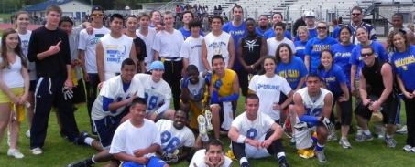

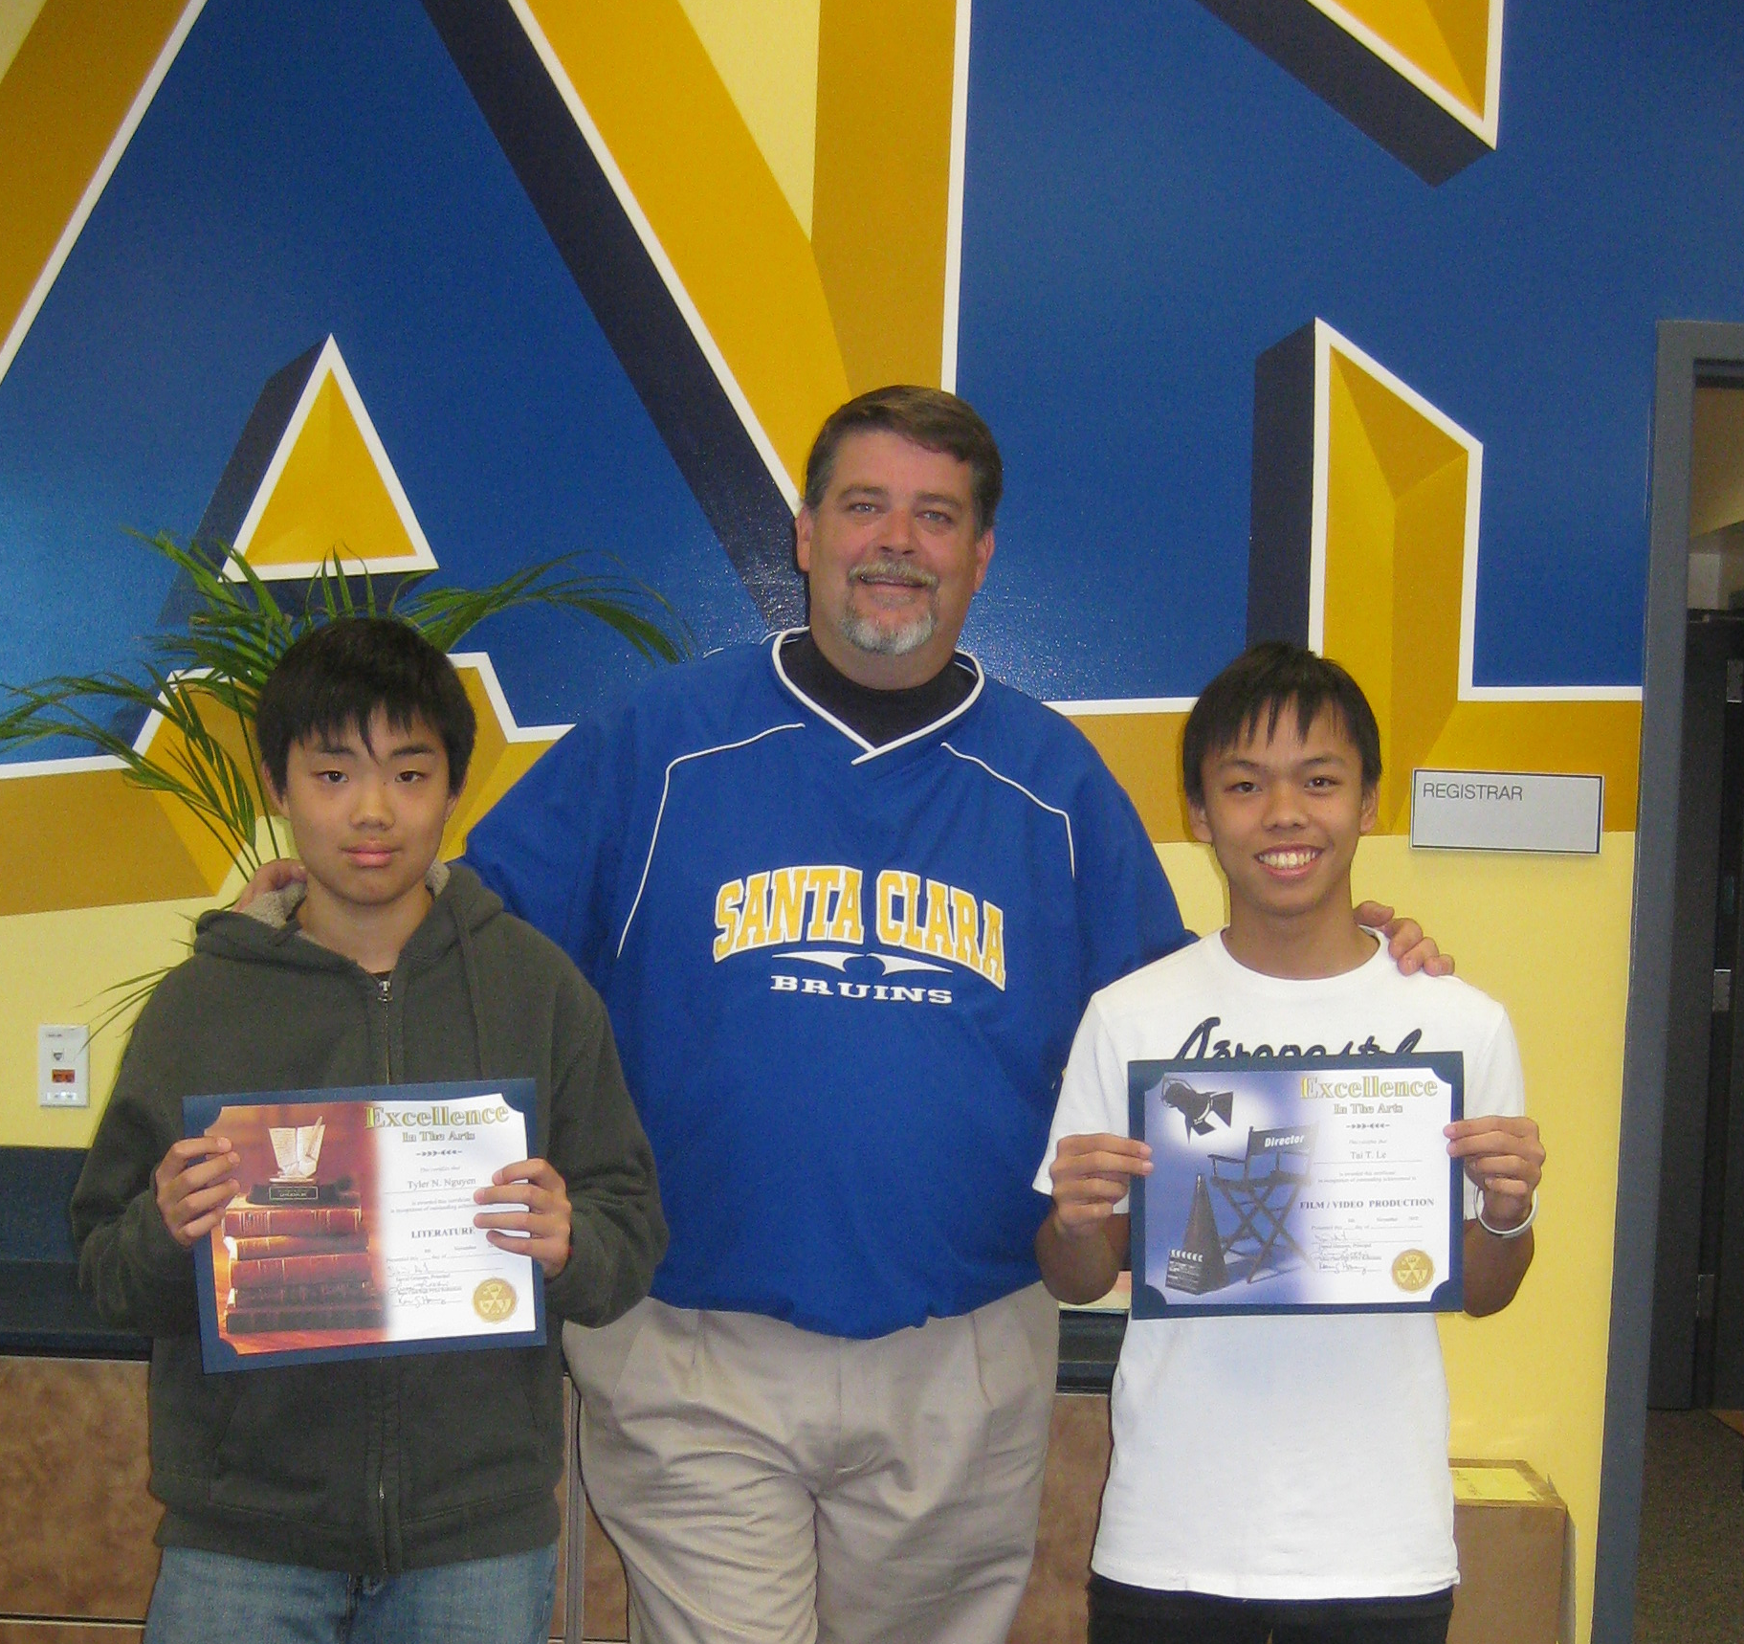
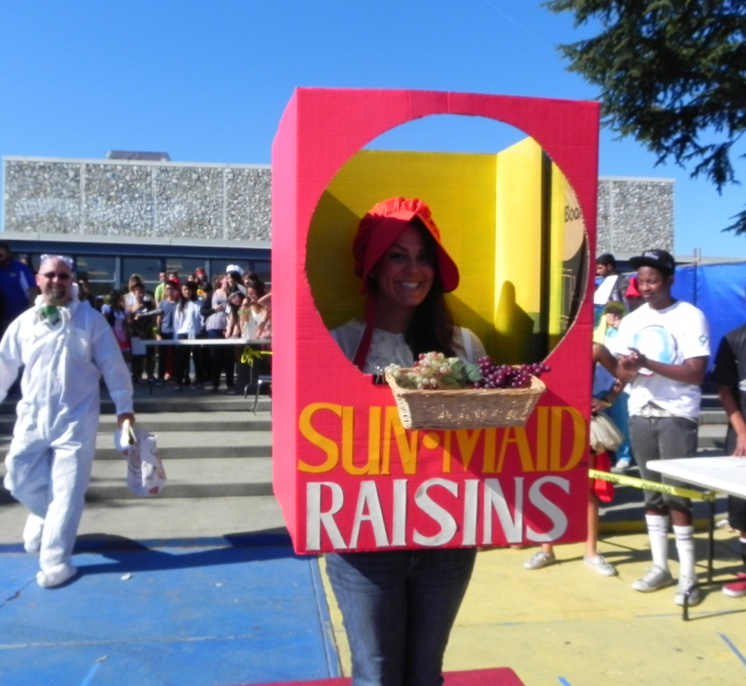

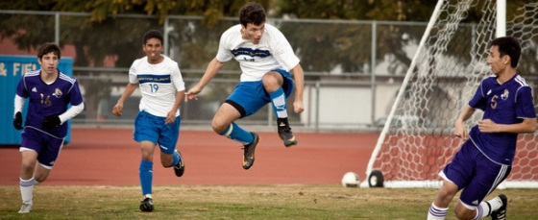

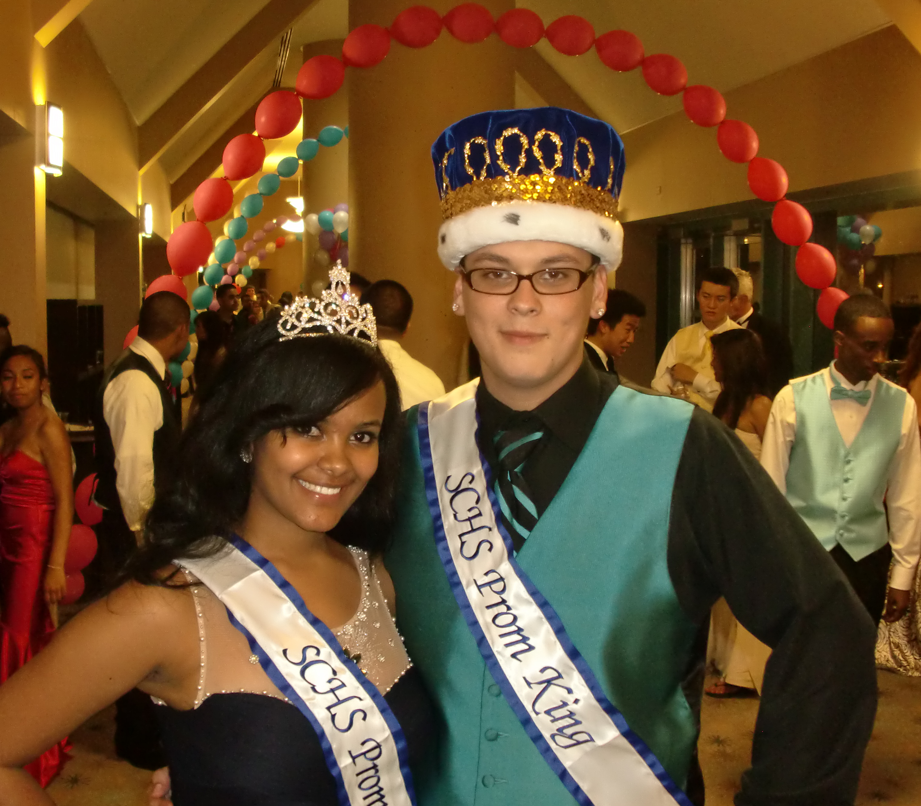


CHAPTER V: School-wide Action Plan

GOAL #1: Close the Achievement Gap
Strategies/Actions to Reach This Goal  (e.g., standards-based curriculum, instructional programs and practices, aligned formative and summative assessments) | Timeline  By when will the strategy or action be taken? | Monitoring Implementation  How will we know the strategy/ action is being implemented? What data will be collected? | Measuring Effectiveness  How will we know the strategy/action is working? What data will we collect? When will we collect this data? | Funding  Sources
Increase parental involvement (i.e. Latino Parent night, Sign up for School Loop night, continue with Bruin Boosts). Create more opportunities to educate parents on supporting students in school and preparing them for graduation and beyond. | Continuous: Have a parent night in September 2012 | Monitor number of parents enrolled in school loop. Data of attendance and participation at planned events. | Receive feedback from parents and students through surveys. Document attendance at events. | Counseling budget and general funds.
Revamp and refine Advisory group (i.e. use student mentors, peer mentors, subject matter/teacher training) | October 2012 -Meet with teachers to implement before the first Latino advisory. | Give teachers forms, note taking, accountability | Improved statistics of participants as evidenced by GPA and CST scores. | EIA and general funds.
Create/Continue Support classes (ie. Algebra Support, Read 180, etc.) | Continuous: Study new options 2012-13 | Master Schedule, department and focus group meeting minutes and agendas. | GPA, CAHSEE and CST scores | EIA and general funds.
Training and resources to supplement special needs students’ education. | Begin implementation  August 2012 | Agenda, minutes, and administrative supervision/support. | Improvement of special needs students in GPA, CAHSEE and CST scores | EIA, SPED funds.
Implement a program to help students create and monitor a four-year plan with educational options that will continuously be revisited throughout the students’ careers at SCHS. | Created/developed during 2011-12 and implemented 2012-13ongoing | Achievement Gap focus group working with counselors to implement and continue program. | More students on track to graduate with less at-risk students by their senior year. | Counseling budget and general funds.
AVID techniques used in classes with struggling students-- become an AVID school | Begin in 2011-12 and continue as needed. | Focus group agendas, department agendas, staff development minutes. | Classroom observations, GPA, CAHSEE and CST scores | AVID, general fund

Planned Improvements in Student Achievement
GOAL #2: Utilize data to improve student performance.
Strategies/Actions to Reach This Goal  (e.g., standards-based curriculum, instructional programs and practices, aligned formative and summative assessments) | Timeline  By when will the strategy or action be taken? | Monitoring Implementation  How will we know the strategy/ action is being implemented? What data will be collected? | Measuring Effectiveness  How will we know the strategy/action is working? What data will we collect? When will we collect this data? | Funding  Sources
Work towards common assessments written by teachers to guide instruction (common questions on tests, common finals) | SIP days, collaboration days, and other possible flexible times. Ongoing. | Collect data from school city which will show us how our students are doing. Through collaboration, analyze answers. Evaluate question fairness and effectiveness. | Investigate individual results and determine from multiple sources if there is an increase in performance data and general readiness. | Maintain collaboration schedule. Possibly link prep periods
Use Apperson Scanner to align the standards to content of course assessment questions (class or individual); gives initial assessment and progress of student’s knowledge and skills and provides instant feedback to the student of strengths and needed improvements and data reports for teacher to guide instruction for student’s progress; assists in measuring whether the standard(s) are being addressed in assessment/question development. | Implement training August 2012. Develop further use continuously. | Teachers are using the process, collecting the data reports (save electronically), and department chairs are collecting monitoring reports; data reports collected at the end of each unit. | Class and state test scores will increase/improve; at the end of the state testing period, the scores from the CSTs will align with the grade the student earned in the course | Already funded; general fund for future needs.
Increase access to technology to improve formative assessments. (ie;SMART Response Clickers) | Begin 2011-12 setting goals. Ongoing thereafter. | Purchase and/or implement the use of Clickers and technologies into lessons for formative assessments. | GPA and CST scores  Compare classrooms with and without. | Technology grants, general fund.
Improve writing skills across curriculum. | Begin August 2012. Ongoing. | Agenda and minutes of literacy focus group. | CST ELA, CAHSEE ELA, and District English PBAs. | General Fund
Use test and common tests to target struggling students for tutoring/credit recovery. | Begin August 2013. If pilot works, continue | Department agendas, minutes, logs of credit recovery. | Improvement in quarter, semester grades. CST improvements. | Extended learning categorical.
Develop SMART measureable goal protocol. | Begin August 2012. Ongoing | Documentation of protocol and its usage. | Evidence of improvement surveys and data. | General fund

Planned Improvements in Student Achievement
GOAL #3: Improve performance of Algebra, Geometry, and Chemistry students
Strategies/Actions to Reach This Goal  (e.g., standards-based curriculum, instructional programs and practices, aligned formative and summative assessments) | Timeline  By when will the strategy or action be taken? | Monitoring Implementation  How will we know the strategy/ action is being implemented? What data will be collected? | Measuring Effectiveness  How will we know the strategy/action is working? What data will we collect? When will we collect this data? | Funding  Sources
Align math problems to “real world” problems to allow for transitory set of skills | Begin planning 2012-13. Begin implementation of strategies August 2013. | Math department meeting minutes, career center activities, list of guest speakers, and data on projects involving “real world” problems. | Improved GPA, CAHSEE and CST scores in the realm of mathematics. More students choosing math related careers. | General fund.
Increase reading comprehension and stress reading in subject areas | Ongoing | Agenda and minutes of literacy focus group. | Improved CST ELA, CAHSEE ELA, and College Board testing. | General fund.
Articulate with the middle schools on what skills are needed for students when they come to high school math or science | Begin process 2012 -13. Continue as needed. | District SIP day agendas, department communication, district standards and pacing guides. | Improved readiness for High School math and science. Improved overall grades in the 3 subjects. | District math grant.
Establish an evaluative placement or readiness test focusing on Algebra 1 skills for success in chemistry that assesses math, reading, and problem solving skills levels. | Plan 2012-13 and implement August 2013. | District math meetings and site department chair meeting minutes and agendas. The actual evaluative placement document created. | Improved readiness for High School math and science. Improved overall grades in the 3 subjects. | District math grant.
Have bridge classes to prepare students for next level. (ie; A bridge program for summer, between biology and chemistry, to develop skills for struggling students). | Explore, research, and prepare 2012-13. Begin implementation 2014. | Math department meetings, district math meetings, and the curriculum developed for the class. The actual class exists and students receive credit for it. | Improved readiness for High School math and science. Improved overall grades in the 3 subjects. | Extended learning categorical.

Planned Improvements in School Culture and Climate
Goal #4: Improve the academic success of students by supporting the support structures that enable them to learn.
Strategies/Actions to Reach This Goal  (e.g., standards-based curriculum, instructional programs and practices, aligned formative and summative assessments) | Timeline  By when will the strategy or action be taken? | Monitoring Implementation  How will we know the strategy/ action is being implemented? What data will be collected? | Measuring Effectiveness  How will we know the strategy/action is working? What data will we collect? When will we collect this data? | Funding  Sources
Find ways and develop protocols to address the increase in anxiety and depression in our students. | Begin planning in 2012-13 and implementation as appropriate. | Further present and develop the more than sad program. Actual protocol document developed. | Number of students provides appropriate referrals and interventions. | Counseling and general fund.
Build pride and respect for our facilities. | Initiate August 2012 and continuous thereafter. | Define and demonstrate what measures were done to accomplish this goal. | Observations and walk-throughs. Reports from custodians. | General fund and ASB.
Find ways to close the opportunity gap and create a college and career oriented atmosphere. | Begin discussion and planning 2012-13 and implementation thereafter. | Evidence of field trips, college and career fairs attended, and number of students having | Increased number of students graduating with firm plans to attend college or career training after high school. | EIA, college and career, and general fund.
Continue to grow connectedness to school of all students. | Ongoing | Agendas of leadership and student staff camaraderie meetings. | Increase in the number of students participating in all activities. | General and ASB funds.
Address the drug use issue and curb the drug culture in and around school. | Research and plan 2012, implement after | Documented presentations, drug groups in counseling, and other interventions. | Number of drug related offenses decrease. | School safety funds.
Build and support staff morale. | Ongoing | Document events and activities that occur. | Increase participation. Staff survey. | Staff

