
MERRILLVILLE HIGH SCHOOL
STUDENT ANNOUNCEMENTS
December 1, 2022

CAFETERIA information

Everyone must have money in their skyward account and have an ID in order to purchase any extras such as ice cream, cookies, chips, etc. Directions to Add Funds:

Log in Skyward- Use drop down box Home- Click Ed. Access Plus- Click Food Service- Click My Food Service- Click arrow next to your name- Make online payment.

DUE TO SHORTAGES THE MENU MAY BE SUBSTITUTED.

“V” – Vegetarian
# - Contains Pork

Lunch today- Pasta Bar, Stromboli***, Pepperoni Pizza.*
Garden Salad, Popcorn Chicken Salad, Taco Salad, and Sub Sandwich.
Fresh Fruit, Hot Vegetable.
Breakfast Tomorrow-
Yogurt Parfait, Pirate Bagel Sandwich, , Pop tarts, Mini Cinnis, Fruit or Juice and Milk.
SENIOR ANNOUNCEMENTS-
Attention seniors! Jostens Cap and Gown orders!
If you prefer to order online, you may follow the below link to Merrillville High School's landing page on jostens.com.

https://www.jostens.com/apps/store/customer/1072671/Merrillville-High-School/

Jostens ordering – Jostens will be here December 9th during lunch hours to take cap and Gown orders.

Club Announcements-

Freshman Mentors meeting 12-1-22 in the main arena from 2:30-3pm

Art Club will meet in Friday Dec. 2 after school until 3:30pm in FA201.

The JV mock trial team is meeting tomorrow in M108 after school from 2:30 to 3:45. Please be on time

YES Interact is meeting on Thursday 12/1/22 from 2:30 - 4:00 in M 104. Please plan to attend and bring any art supplies you may have. New members are always welcome.

Freshman class meeting on Tuesday December 6th from 2:20 until 3:00 in ROOM 9C109. All freshmen are welcome.

Men on a Mission will be meeting after school on today, December 01, 2022 at 2:15 pm

Educators Rising meeting on Wednesday Dec 7th, from 2:20 until 3:00, in room 9C109. Students, if you are thinking of going into the field of education, come out for this meeting.

Senior Class of 2023-
T-shirt sales begin on November 15th, 2022- December 15th, 2022. You can purchase through our treasurer before school, after school, or during your lunch hour. Short sleeve-$12 Long sleeve- $18 and Hoodies are $30. Our next meeting is November 21st, 2022 from 2:30-3:15 in Mrs. Rothbauer's room F213.
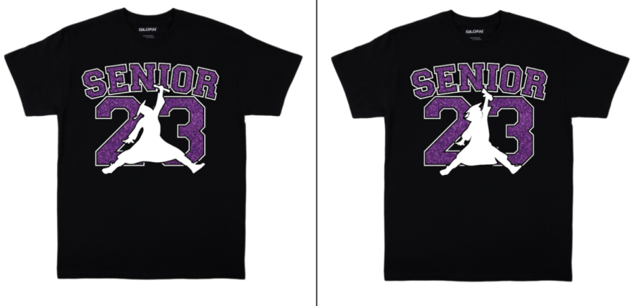
The Good News Bible Club will meet each Wednesday after school in room A110. Are you interested in Bible study, lively discussions, service to your community, and fellowship with other students? Come find us in A110 on Wednesdays! Please join us beginning on September 7th! (contact Hanna Trzupek at M230092@student.mvsc.k12.in.us or Mrs. Beasley at jbeasley@mvsc.k12.in.us or at 219-650-5307, Ext. 7126.)
GSA CLUB- Anyone interested in joining the Gay Straight Alliance is welcome to stop by every Wednesday in E205. Meetings are usually from 2:15-3pm unless otherwise stated and new members are always welcome! This is a community for members and allies of the LGBTQ+ community to have a safe space to be yourself and discuss current events in the community.
The MASH program (Merrillville After-school Safe Haven)- Is held in the Main Media Center Library after school.MASH creates a safe place for you to complete homework, or makeup missing assignments from your class. You can study – alone or with a friend, read or playboard games… there are many different opportunities in MASH! You must have your own transportation home.

 Scrooge

Merrillville Choir and M&M Productions present the holiday classic SCROOGE the Musical on Friday, Dec 2 and Saturday, Dec 3 at 7:30PM and Sunday, Dec 4 at 3pm.

Tickets are available online @ https://our.show/scrooge22 or from MHS choir members. By popular request, concessions will be open prior to the start of the show and may be enjoyed in the lobby as you are serenaded by MHS Choir members previewing their Sounds Of the Season Concert December 15.

Kick off your Holiday season by supporting the Arts!

ATHLETICS Annoucements –

.
There will be a boy's track and field call-out meeting Thursday December 1st right after school in Coach Coffey's room IAW104. The meeting should only last about 10 minutes, so please plan your rides accordingly.

Any girls interested in playing on the Girls' Golf team next fall should come to a call out meeting on Thursday December 1, 2022 after school in Mr. Belko's room BC109. The meeting should only take 15 minutes and will discuss the offseason schedule. No playing experience is necessary. The meeting will begin promptly at 2:20 PM

Interested in the medical field? There will be a callout meeting THIS Friday after school in the school athletic training room, by the athletic office!

Social Worker information-

 Our Social Workers: BC114
Ms.Dr. Carol Dahlen-7292
Mr. Brandon Freeland -5338
Ms. Annette Brown- Gilliam-5452

ATTENDANCE INFORMATION-

Excused absence notes can be emailed to mhsattendance@mvsc.k12.in.us or
Faxed to 219-650-5391 ATTN: Attendance

TECHNOLOGY INFORMATION-


Student Email Address:
Your Student ID numbers@student.mvsc.k12.in.us

Passwords are:
First 2 letters of first name (CAP first letter)
+ First two letters of last name (lowercase)
+ 4 digits of their birthday.

Skyward help line -650-5307 ext.7258
Tech Help Line -650-5307 ext. 5376

