
MERRILLVILLE HIGH SCHOOL
STUDENT ANNOUNCEMENTS
September 7, 2022

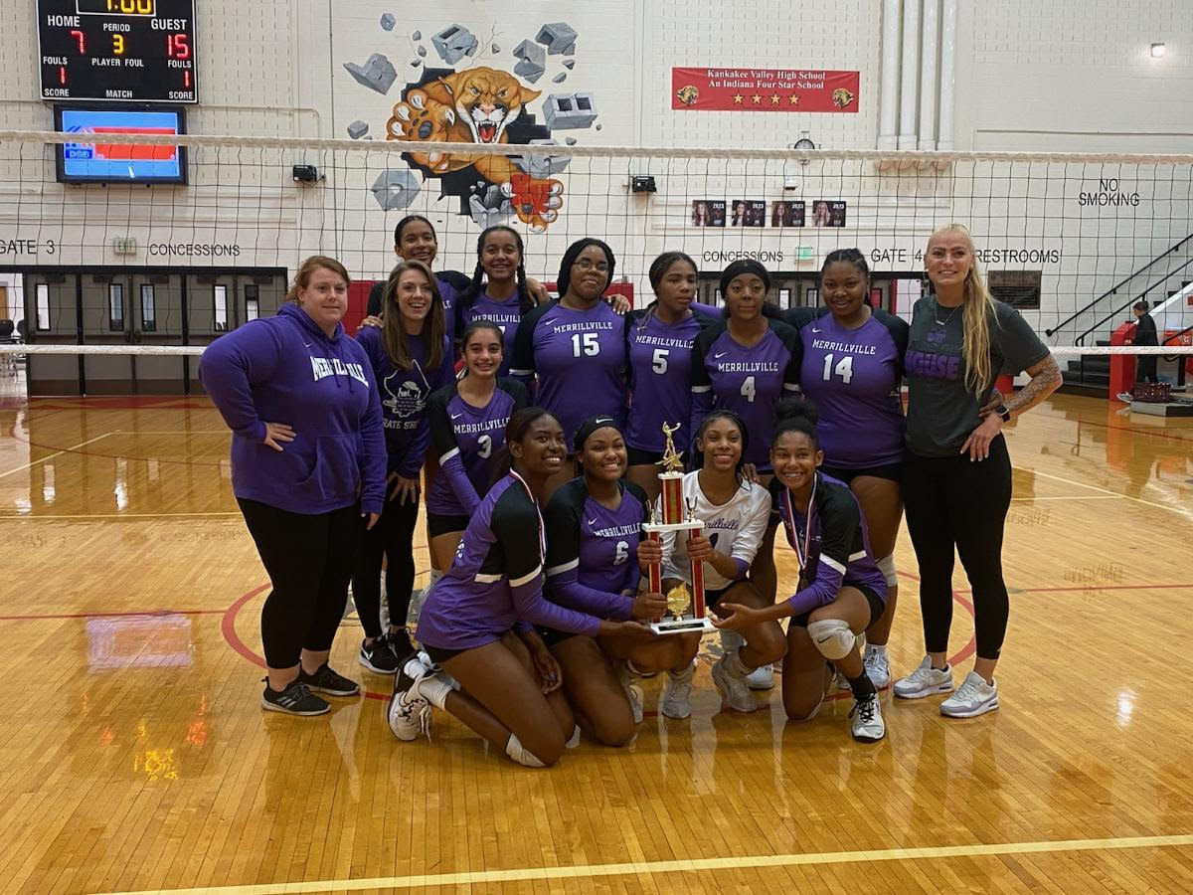

Winners! Congratulations to the girls Volleyball team. They took first place at the KV Tournament last weekend. Way to go Girls!

CAFETERIA
Everyone must have money in their skyward account and have an ID in order to purchase any extras such as ice cream, cookies, chips, etc. Directions to Add Funds:
Log in Skyward- Use drop down box Home- Click Ed. Access Plus- Click Food Service- Click My Food Service- Click arrow next to your name- Make online payment.

DUE TO SHORTAGES THE MENU MAY BE SUBSTITUTED.

“V” – Vegetarian
# - Contains Pork

Lunch today- Chicken Breast Sandwich, Stromboli***, Buffalo Chicken Pizza.
Garden Salad, Popcorn Chicken Salad, Taco Salad, and Sub Sandwich.
Fresh Fruit, Hot Vegetable.
Breakfast Tomorrow- Yogurt Parfait, Pirate Bagel Sandwich**, Confetti Pancakes Muffin or Cereal Bar, Pop tarts, Fruit or Juice and Milk.

ANNOUNCEMENTS -
Mini College fair - This Friday, Sept. 9th MHS will be hosting a mini day time college fair in the basketball concession area. Jrs. & Srs. will have an opportunity to come down with their 3rd hr. teachers and visit with college representatives. You MUST pre-register for the event using STRIVESCAN. Registration will take place in your homeroom or by stopping in the Guidance Office and scanning the QR code. Please stop and see Mrs. Maldonado if you have any questions or to see what colleges will be attending.
There is a call-out meeting for the VOICES OF REASON on Monday, Sept 12 from 2:45 to 3:15 in the choir room FAC103. If you like to sing and make new friends, come join us! See Mrs. Reinhart for more info!
Freshman Class Sponsor, Mrs. Minov is having a call out for all freshmen on Monday, September 12 from 2:30 until 3:15 in room 9c109 all members of the freshman class are welcome to come!
There will be a Junior Class meeting in Mr. Belko's Room BC109 on Friday September 9 after school from 2:20-2:35. We will be discussing homecoming activities. All are welcome to attend.
ART CLUB- Art Club will be meeting on Friday Sept. 9 after school until 3:15 pm in FA201.
STAND is having a call-out meeting Wednesday at 2:20pm - Mr. Taylor’s Room IAM108
The Spanish Club will meet this Wednesday September 7th to discuss the field trip this weekend on September 10th from 11-3pm to the Empanada Festival.

Freshman Mentors will meet this Thursday to finalize Homerooms and go over the lesson plan for homeroom. It will also be our ice cream social.
Mock Trial - There will be a call out meeting for the Mock Trial team Wednesday after school in M108. The meeting will last from 2:30 to 3:30.
Attention all past and present ESL or ENL students: The ENL Club will be having their call out on Monday, September 12, 2:30-3:00. If you have any questions about whether this is the club for you, please stop by and see Miss Czuba in A101.
HOMECOMING-
Students planning to attend Homecoming, please use the following link to vote for the theme: https://forms.gle/mrdtnpdJ4GNiRa547
Attention Seniors! Jostens will be here on Thursday, September 8 during Parent-Teacher Conferences ( 3:30 – 6:30 pm) to take grad products and cap & gown orders. Please bring your completed form and deposit to the Jostens Rep at that time. If you have any questions regarding your order, please call 1-800-JOSTENS or see the representative on September 8!
Pro Start aka Culinary Club will be having a callout Sept 7th from 2:15-4:00 in room D102. Anyone who enjoys cooking, baking and gardening are welcome to join us.
The Good News Bible Club will meet each Wednesday after school in room A110. Are you interested in Bible study, lively discussions, service to your community, and fellowship with other students? Come find us in A110 on Wednesdays! Please join us beginning on September 7th! (contact Hanna Trzupek at M230092@student.mvsc.k12.in.us or Mrs. Beasley at jbeasley@mvsc.k12.in.us or at 219-650-5307, Ext. 7126.)
Merrillville Community Center – The Dean and Barbra White Community Center has open gym Monday through Friday from 3-5pm. Please bring your student ID to enter.
GSA CLUB- Anyone interested in joining the Gay Straight Alliance is welcome to stop by every Wednesday in E205. Meetings are usually from 2:15-3pm unless otherwise stated and new members are always welcome! This is a community for members and allies of the LGBTQ+ community to have a safe space to be yourself and discuss current events in the community.

Attention Students
The MASH program (Merrillville After-school Safe Haven)
will begin after school on Tuesday, September 6th in the
Main Media Center Library after school.
MASH creates a safe place for you to complete
homework, or makeup missing assignments from your
class. You can study – alone or with a friend, read or play
board games… there are many different opportunities in
MASH! You must have your own transportation home.

ATHLETICS –
GIRLS Wrestling Team
This is a callout meeting for any student-athletes interested in being a part of the "Emerging Sport" Girls Merrillville HIgh School Wrestling Team. We are having a call out meeting on Friday after school in the Merrillville High School Wrestling Room. The meeting will be to discuss the procedures and practices for this upcoming year. Any girls interested please attend the meeting or see Coach Maldonado in the Freshmen Cafeteria before school or at lunch. Also, you can speak to him during the Freshmen Office. Please inform parents and arrange rides!

 Our Social Workers: BC114
Ms. Carol Dahlen-7292
Mr. Brandon Freeland -5338
Ms. Annette Brown- Gilliam-5452

Excused absence notes can be emailed to mhsattendance@mvsc.k12.in.us or
Faxed to 219-650-5391 ATTN: Attendance

Student Email Address are:
Student ID numbers@student.mvsc.k12.in.us
Passwords are:
First 2 letters of first name (CAP first letter)
+ First two letters of last name (lowercase)
+ 4 digits of their birthday.
Skyward help line -650-5307 ext.7258
Help Line -650-5307 ext. 5376



Are you ready to travel abroad in July 2023? This 13 day trip is one of the best yet with stops in Italy, France, Switzerland, and Spain! Think Lake Cuomo, the French Riviera, the Swiss Alps, Madrid, Barcelona, and Toledo! Join now and make monthly payments!.
The price includes airfare, transportation, hotel, two meals per day, excursions (Flamenco night and Swiss Alps experience included as well as others listed), and a full-time tour guide. Let's go!!!
Link to trip information and itinerary: eftours.com/2497302jn
This trip is not Merrillville exclusive. Anyone who can pass a background check and is vaccinated may go (company rules), so be sure to invite your friends and family members!
I am sending a reminder that there will be an informational VIRTUAL meeting regarding this trip on Thursday, September 14 at 6 pm.
Please join the Google classroom created specifically for those interested in the trip.
Google Classroom: https://classroom.google.com/c/NDQxMDYxNDgwMDI4?cjc=mefw77x
Code: mefw77x

See Mrs. Bedwell in A108 or Mrs. Monix A107 for further information.

