
LITTLE TOR ELEMENTARY
CODE OF EXCELLENCE
We will do our best to learn every day.
We will respect everyone and everything.
We will display acceptable behavior in all areas of the Little Tor community.
We will help make Little Tor a school of excellence!

GENERAL RULES
I will walk appropriately in the hallways and classrooms.
 I will use appropriate noise level in all areas of the school.
I will always get permission from an adult and use a pass to leave a
supervised area-classroom, cafeteria, playground, specials.
I will respect school property and the property of others.
I will use appropriate language at all times.
I will be considerate of other people’s feelings by not using hurtful words.
I will respect all staff and follow their directions.
I will keep Little Tor safe by not threatening or scaring others.
I will be safe and not hurt others by keeping my hands and feet to myself.
I will not share my food with others because it may be unsafe.

LITTLE TOR ELEMENTARY
CODE OF EXCELLENCE
We will do our best to learn every day.
We will respect everyone and everything.
We will display acceptable behavior in all areas of the Little Tor community.
We will help make Little Tor a school of excellence!

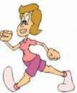
RECESS RULES
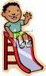
I will walk safely in a line until I am outside on the
playground.
I will use all equipment in a safe manner.
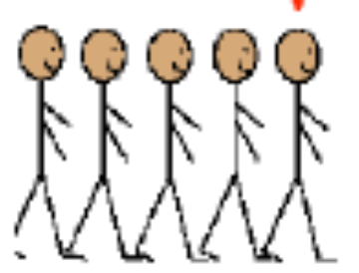
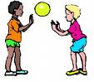
I will take turns when playing a game
(or using equipment) that others want to play.
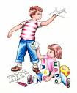
I will quickly and quietly line
up at the teacher’s signal.
I will play in a manner that will not
scare or hurt others around me.
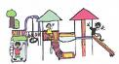
 I will always play in the designated playground area. If I can’t see a teacher, then a teacher can’t see me.

LITTLE TOR ELEMENTARY
CODE OF EXCELLENCE
We will do our best to learn every day.
We will respect everyone and everything.
We will display acceptable behavior in all areas of the Little Tor community.
We will help make Little Tor a school of excellence!

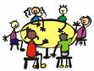
CAFETERIA RULES
I will sit appropriately in my
designated area.


I will throw away food in the trash
and recycle whenever possible.

I will be quiet and line up at the teacher’s signal.

