
How to download the Directions for Administration (DFA) for the practice test
& practice test scoring guide

The purpose of the ELPAC Practice Test is to familiarize students and test examiners with the testing interface, item types, and to provide students with the opportunity to practice a full-length test. The Directions for Administration document contain directions and the specific scripts you will need to administer the Practice Test for the ELPAC. It is a companion document to the online Practice Test. The Scoring Guide offers details about the items, student response types, correct responses, and related scoring considerations for the included samples of practice items.
- Go to elpac.org and click the Practice and Training Tests Tile in blue. | 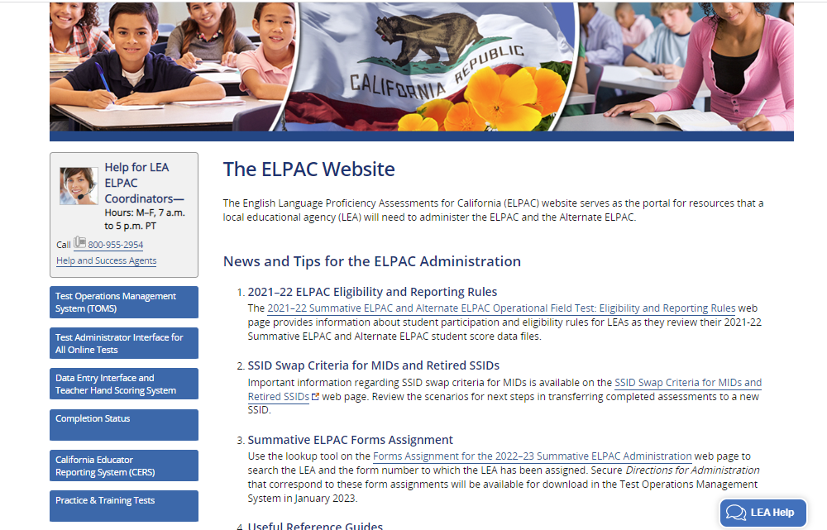
- Click on the Resources for Practice and Training Tests. | 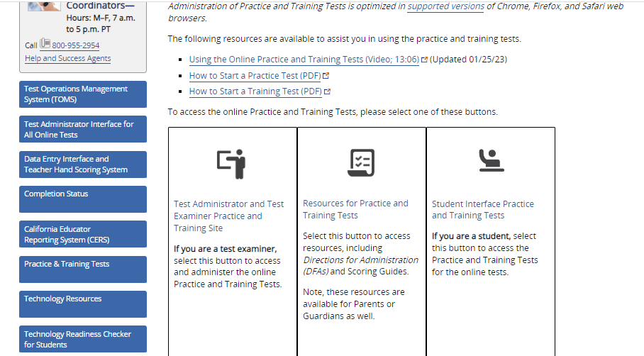
- Under the Initial and Summative ELPAC, find and click on the appropriate grade. | 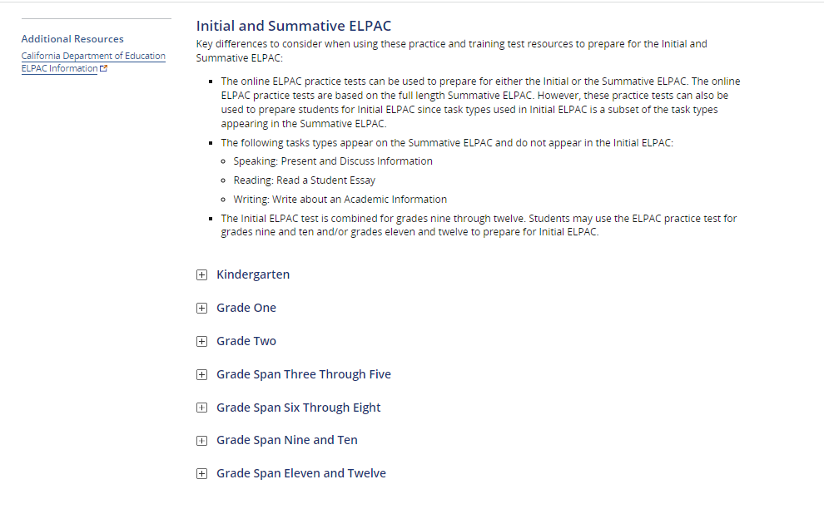
- The grade specific practice Test DFAs and Practice Test Scoring Guides can be downloaded from here. | 