Laurelwood School Site Council Agenda
November 8th, 2022 @ 6:00 PM
Video call link: https://meet.google.com/omb-qduy-qao

Attendees: Paul Fuller, Steven Ivy, Prateek Khanna, Paul Sunderland, Effie Tabor, Elizabeth Colby, Jennifer Lewis

- Meeting called to order at 6:03 PM

- Welcome, call to order and review of agenda
  - Parent Rep - Lizzy Smith
  - Parent Rep - Elizabeth Fitch
  - Parent Rep - Amy Sargent
  - Parent Rep - Prateek Khanna
  - Parent/ELAC Rep - Jennifer Lewis
  - Principal - Paul Fuller
  - Teacher Rep -Effie Tabor
  - Teacher Rep - Barry Sunderland
  - Teacher Rep - Steve Ivy
  - CSEA Rep - Magali Torres-Castillo

- Reviewed and approved meeting minutes from October 11, 2022
  - Motion approved by Mr Fuller

- Opportunity for public input and comments
  - No update

- SCUSD News
  - No update

- Laurelwood Site News
  - 1st trimester ended, report cards will be available via the portal
  - i-ready assessment is now open
  - Finishing up the first round of academic intervention, will start the second round on Nov 28th
  - Getting round 2 requests from staff now
  - Trying to understand the needs of all different student classifications

- [Jennifer] ELAC Report
  - Had our first meeting; focus was on EL and training parents/staff
  - More details about scoring to be discussed in future forums

- SPSA Goals/Budget
  - STEAM: Went over the various aspects of the program & the budget dedicated
  - ELD/ELA: Went over a summary of the program & the budget dedicated
  - Positive School Climate: Went over the program details & the budget dedicated
  - Plan to use the targeted funds first and will reevaluate later
  - Mr Ivy made a motion to approve this budget & allocation; motion approved

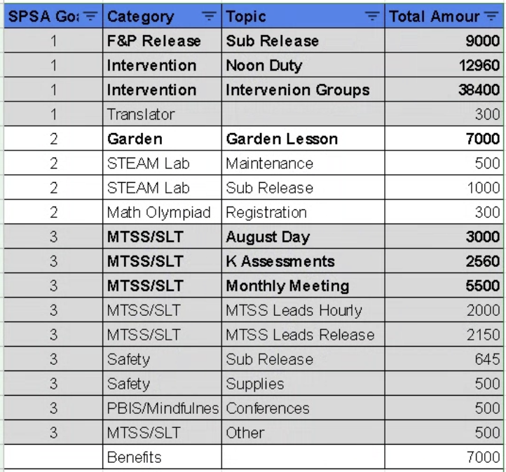

- Announcements
  - Next meeting is scheduled Dec 6th

- Adjournment
  - Meeting adjourned at 6:22 PM

