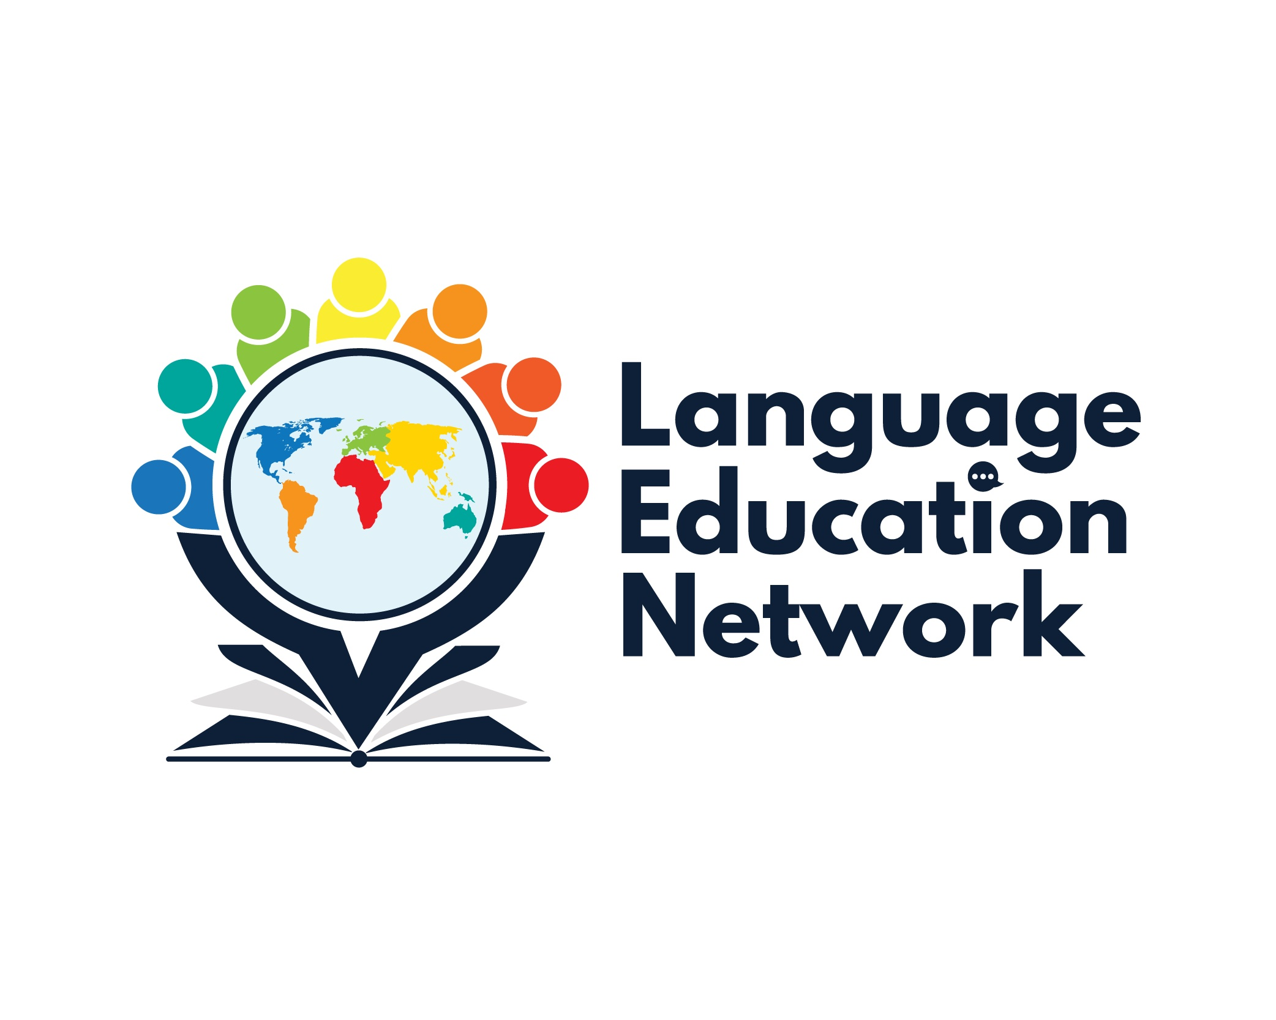
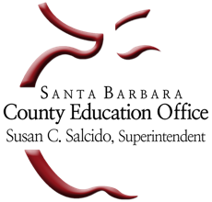
Language Education Network (LEN)
March 3, 2023
1:00 – 2:30 PM
AGENDA

Purpose: The purpose of our network is to come together to align current research and policy with the work that is required to prepare our English learners for college and career.
Facilitators
Carlos Pagán: cpagan@sbceo.org
Melissa Garcia: mgarcia@sbceo.org

SBCEO LEN Webpage Link | 2022-2023 Meeting Dates
Language Education Network | - September 16, 2022  - December 2, 2022  - March 3, 2023  - May 19, 2023

TOPIC |  | NOTES/LINKS

WELCOME & INTRODUCTION
Grounding Activity
RESOURCES FROM NETWORK MEMBERS
ELPAC Chats (Elementary Edition) – Maria Licon from Peabody Charter School will share how she adapted the ELPAC Chats for secondary schools to conduct a similar process at the elementary level.  ELPAC Teach! (Updates) – Martiza Olguin from Santa Maria Joint Union HSD will share with us the updates she has made to the ELPAC Teach! document. | ELPAC Chats Documents (elementary)  ELPAC Teach! Document
BILINGUAL COORDINATORS NETWORK (BCN) REPORTS & UPDATES
DAY 1: February 16, 2023  - ELPAC Updates (Melissa Garcia)  - Summary: Authentic Language Development: Integrating English Language Development into Content Areas – Jeff Zweirs, Stanford School of Education  - Accountabiltiy Updates  - Support for Newcomer and Refugee Students  DAY 2: February 17, 2023  - Legislative Updates  - Ethnic Studies Model Curriculum |  | Books by Jeff Zweirs on Amazon  CDE Newcomers Resource Webpage  Californians Together Support for Immigrant and Refugee Students
UPDATES & ANNOUNCEMENTS
Bilingual Authorization Program (Summer 2023) |  | SBCEO BAP WEBPAGE
INSTRUCTIONAL RESOURCES & PROFESSIONAL LEARNING OPPORTUNITIES

Instructional Resources:
- EL Toolkit of Strategies
- Designated & Integrated English Language Development Videos
- California ELD Standards
Professional Learning Opportunities:
