2022-2023 ELPAC Chat Form
Student Name: | Date:
ELD Teacher: | Grade:

Purpose: The purpose of this conversation is to review your most recent ELPAC scores, and to guide you into setting specific learning goals to help improve your English language skills for the 2023 ELPAC.

What is the ELPAC?
The ELPAC shows your progress in learning English. Because your primary language is other than English you must take this state test each year until you earn an Overall Score of Level 4. Once you receive an overall Level 4 you will be considered for reclassification as Fluent English Proficient.

What is reclassification? Reclassification is when you demonstrate or show language proficiency and no longer need English support such as ELD classes.

What will the ELPAC test me on?
The test is made up of four parts and you will be tested on the following English language skills.

Oral Language
 | Listening domain | You will hear a variety of conversations, presentations, and stories. Then, you will answer questions about what you heard.
 | Speaking domain | You will speak in English for a variety of purposes: talk about a scene, summarize an academic presentation, support your opinion, present and discuss information.
Written Language
 | Reading domain | You will read a student essay, informational passages, and literary passages of various lengths. You will answer questions about what you have read.
 | Writing domain | You will write for different audiences and for different purposes, including give and justify your opinion, describe a scene and edit a paragraph, and write about an experience or academic information.

Why is it important to improve my ELPAC scores?

There are many reasons to care about improving your English language skills land earning an Overall 4 on the ELPAC:

You will show yourself how You will have access to You will have more academic,
smart you are. elective classes in Jr. High. job, and career opportunities.
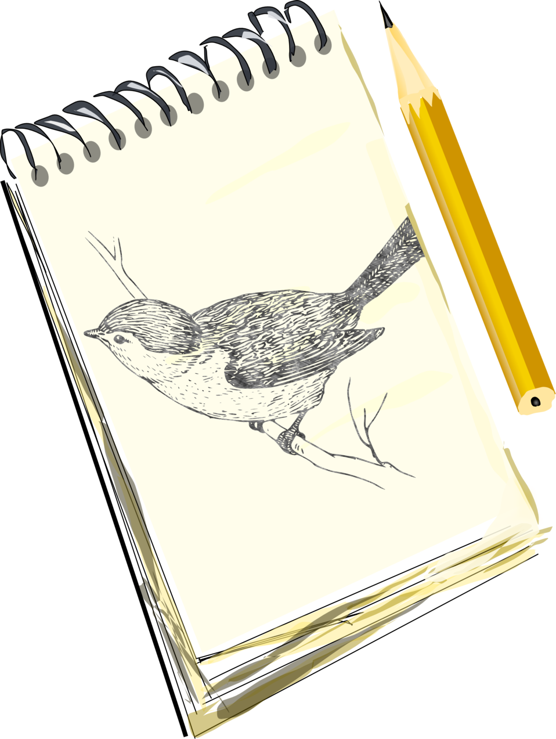

GOAL Setting: My goal this year is to earn an ELPAC Overall Score of ____ because _____________________________________________________________________________________
________________________________________________________________________________________________________
________________________________________________________________________________________________________
_______________________________________________________________________________________________________

An area or areas of growth for me is/are: Reading, Writing, Speaking, Listening
(Circle )
I will work on improving in the following area(s) by_____________________________________________

__________________________________________________________________________________________

_________________________________________________________________________________________

My ELPAC scores from last year:

Overall Score  LEVEL | Your score.  ____________  Circle level: Beginning to Develop, Somewhat Developed, Moderately Developed, or Well Developed  ________________________________________________________________________
Oral Language  Score  LEVEL | Draw the on the gauge below.  Your score.  _____________  Your level.  _____________________  _____________________ |    | Mark the correct circles.  Listening  Beginning Somewhat/ Well  to Develop Moderately Developed  Speaking  Beginning Somewhat/ Well  to Develop Moderately Developed
Written Language Score  LEVEL | Draw the on the gauge below.  Your score.  ______________  Your level.  _____________________  _____________________ |    | Mark the correct circles.  Reading  Beginning Somewhat/ Well  to Develop Moderately Developed  Writing  Beginning Somewhat/ Well  to Develop Moderately Developed

