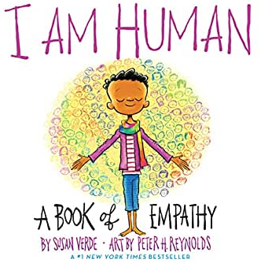
Laurel Mill Elementary School

Title I Home-School Compact
2020-21

As a parent/guardian, I will:
- Ensure my child’s regular attendance and prompt arrival.
- Check my child’s backpack and folders daily.
- Establish a time for homework and review it regularly.
- Model appropriate dress, language, and behavior on campus.
- Communicate regularly with my child and the school.
- Respect the school staff, students, and other families.
- Sign in at the office prior to any visit on campus.
Parent/Guardian’s Signature_________________________________

As a student, I will:
- Come to school each day ready to learn, try my best, and ask for help when needed.
- Follow the school expectations, be a good example to others, and be accountable for my actions.
- Practice and return all homework assignments.
- Help create a positive environment by practicing respect, accepting responsibility, working together, and following the rules of safety.
Student’s Signature_______________________________________

As a school, we will:
- Provide an academic program that is rigorous and challenging for each child.
- Communicate with parents on a regular basis regarding the child’s academic process.
- Provide opportunities for parent conferences.
- Create a safe learning environment that allows for positive communication between the home and school.
- Convene an annual meeting to explain the Title I program to parents and inform them of their right to be involved in the program.
- Make our school an accessible and welcoming place for students and families.
- Participate in professional development opportunities that improve teaching and learning.
Teacher’s Signature_______________________________________

Principal’s Signature_______________________________________

