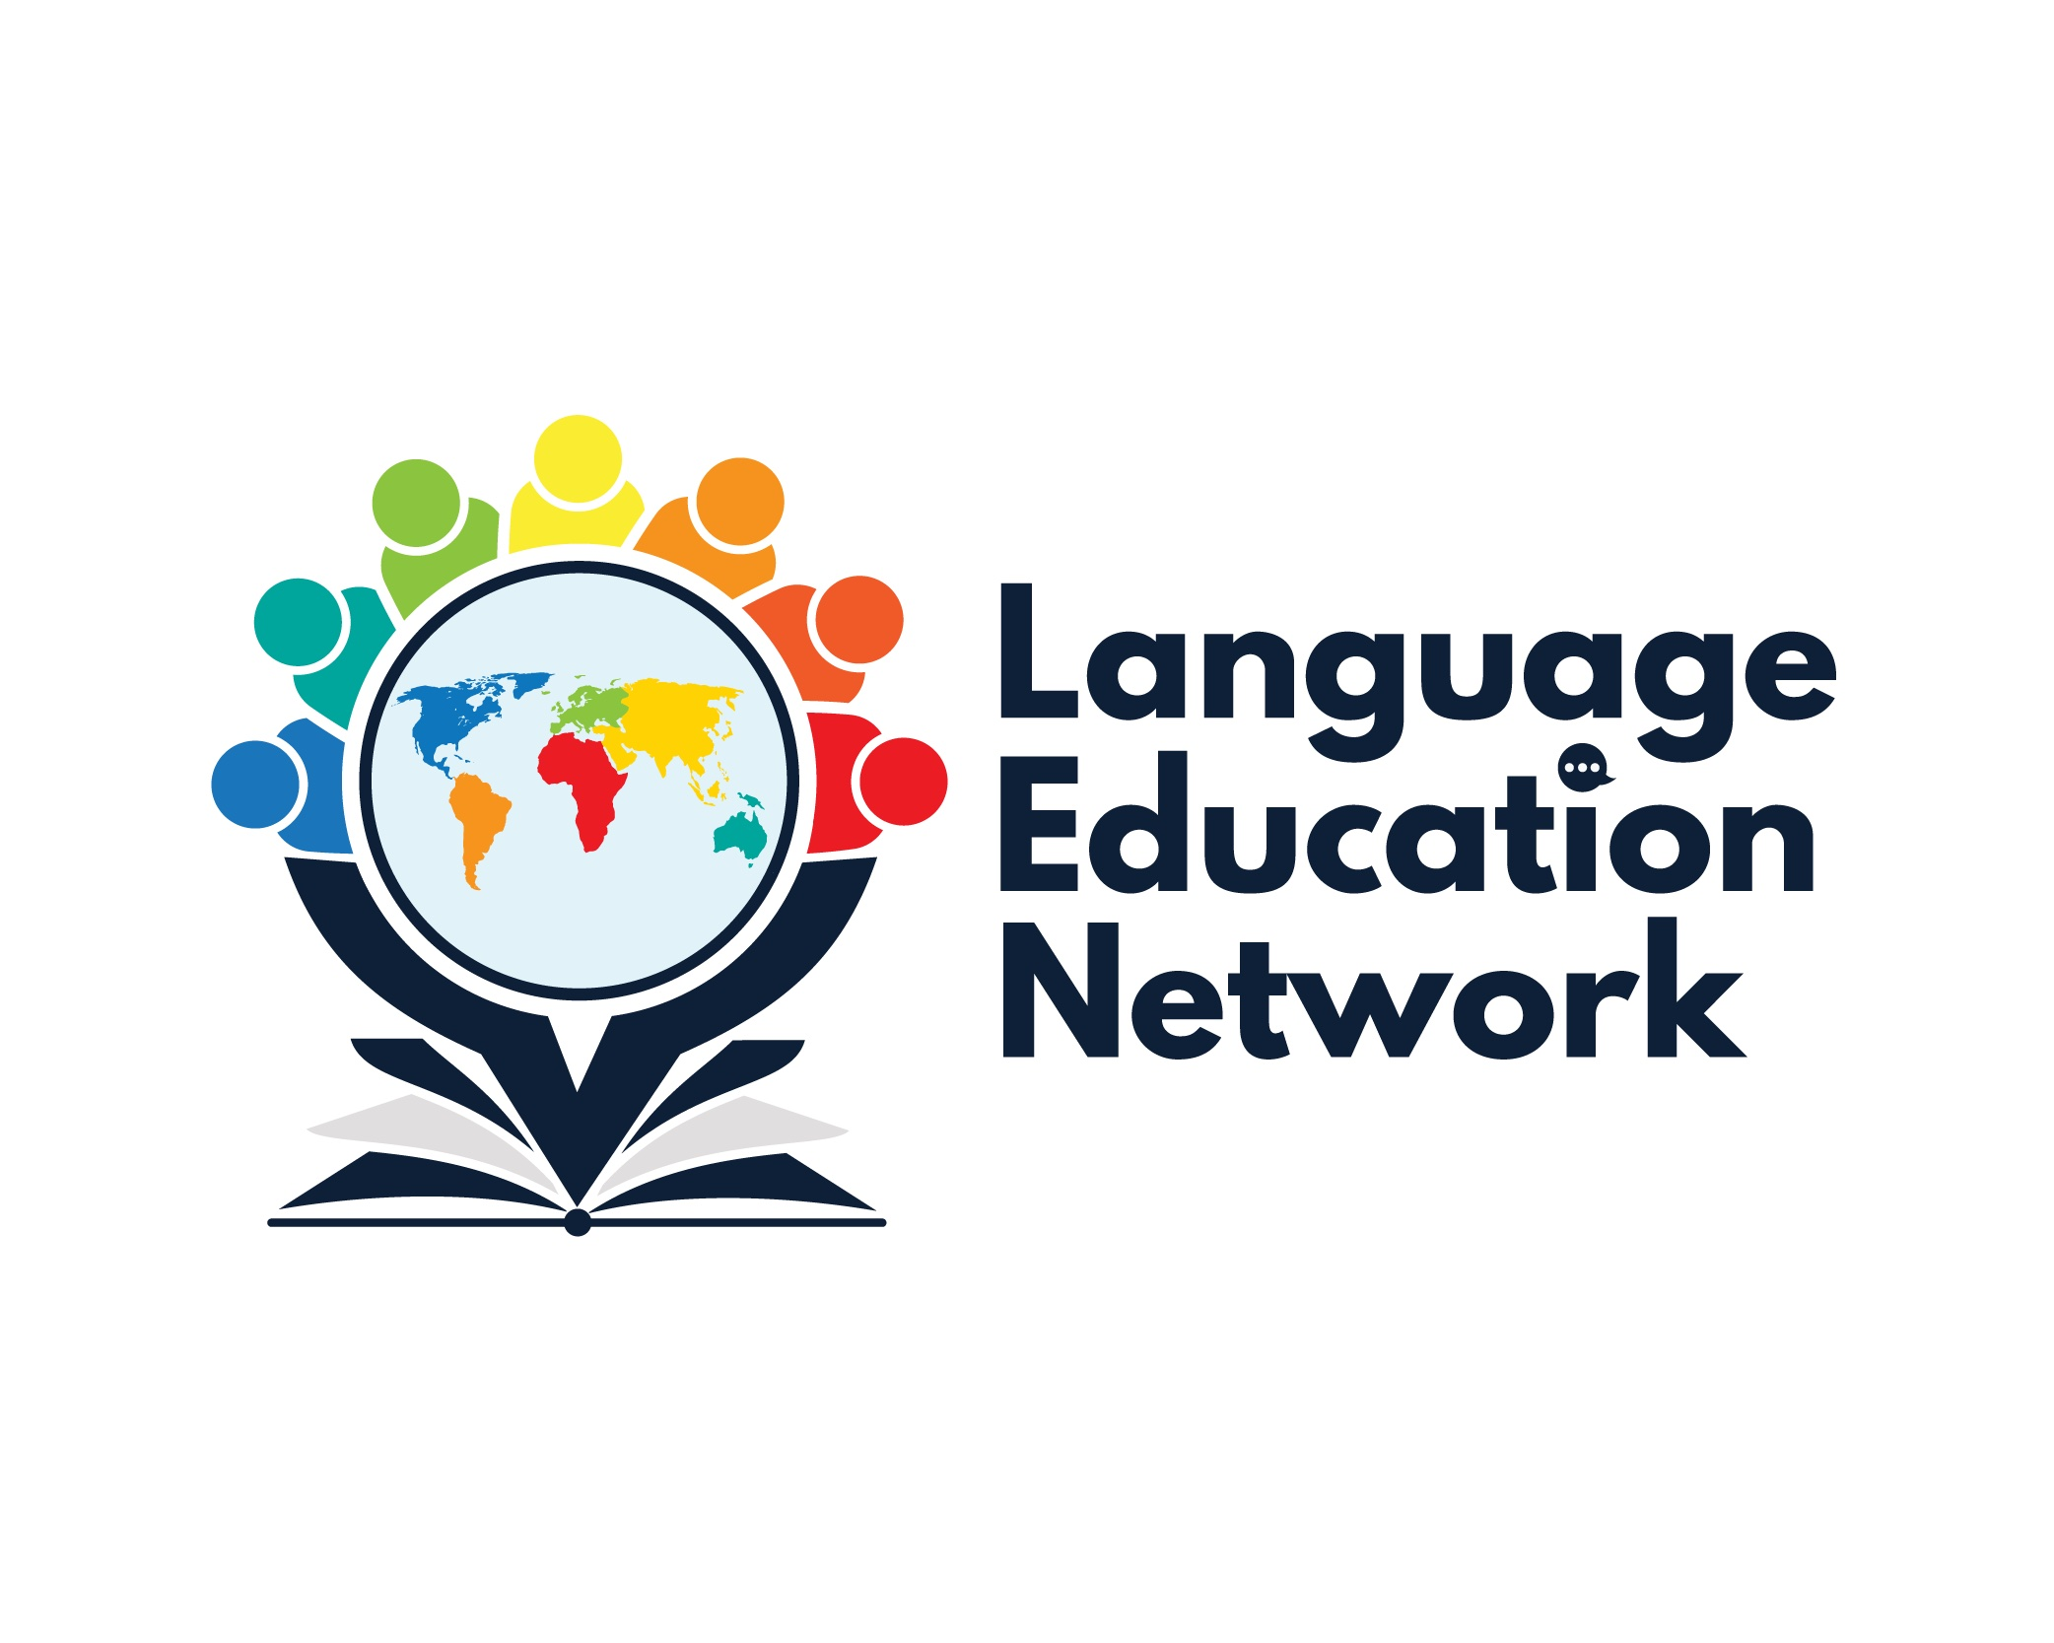
March 11, 2022
1:00 – 2:00 PM

ZOOM Link
Passcode: LEN

AGENDA

WELCOME!

SBCEO WEBSITE – LEN PAGE

ANNOUNCEMENTS

BCN UPDATES

ASSESSMENTS
- ELPAC UPDATES - Melissa

INSTRUCTIONAL RESOURCES
- ELPAC Practice Tests - Melissa
- EL Toolkit of Strategies
- Designated & Integrated English Language Development Videos

STANDARDS
- California ELD Standards

PROFESSIONAL LEARNING OPPORTUNITIES
- SBCEO Website
- Initial ELPAC Training – May 17, 2022
- Instituto de escritura en español – miércoles el 13 de abril, 27, y el 11 de mayo

NEXT MEETING: May 13, 2022
1:00 – 2:00 PM
