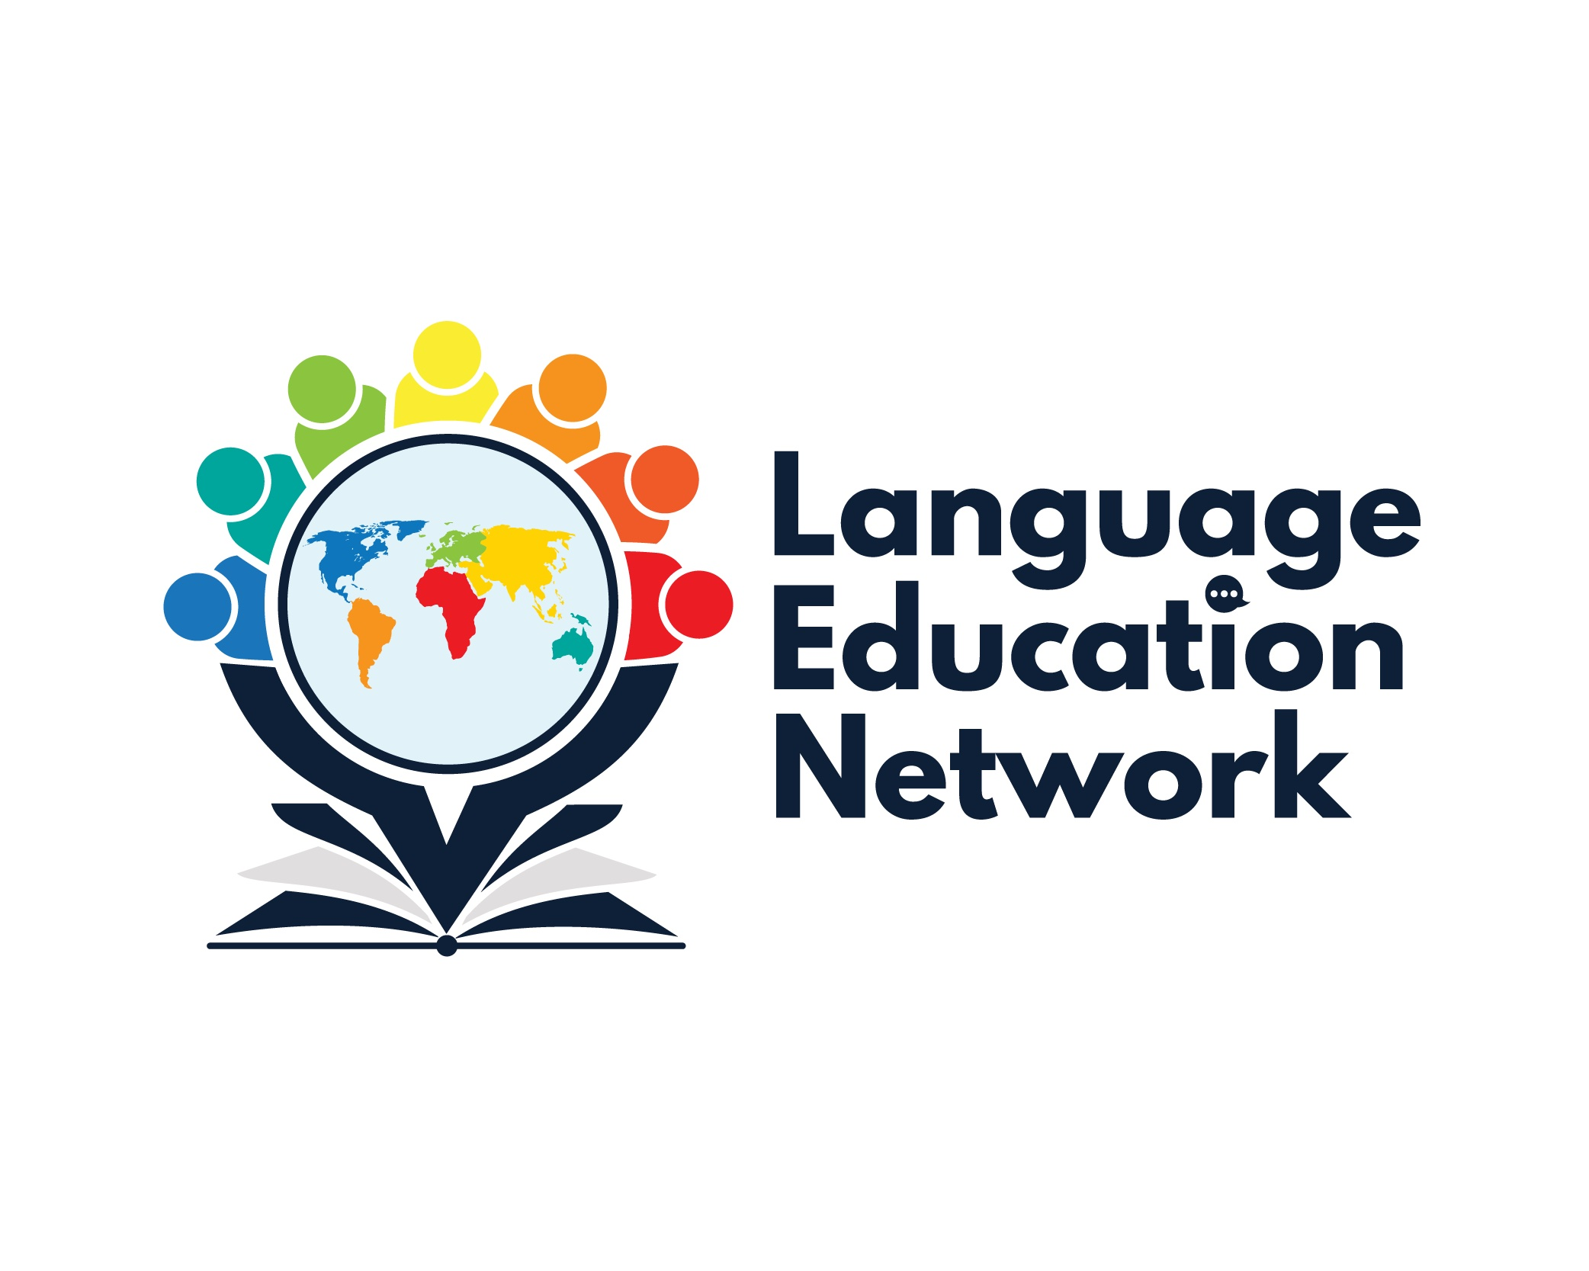
December 3, 2021
1:00 – 2:00 PM

Zoom Link
Passcode: LEN

AGENDA

WELCOME!

SBCEO WEBSITE – LEN PAGE

ANNOUNCEMENTS

BILINGUAL COORDINATORS NETWORK (BCN) UPDATES

ASSESSMENTS
- ELPAC UPDATES-- Melissa

INSTRUCTIONAL RESOURCES
- World Languages Adopted Materials (K-8) -- Melissa
- High Impact Literacy Tutoring -- Melissa
- EL Toolkit of Strategies
- Designated & Integrated English Language Development Videos

STANDARDS
- California ELD Standards

PROFESSIONAL LEARNING OPPORTUNITIES
- SBCEO Website
- Myron Dueck, Grading Smarter, Not Harder
- Summative ELPAC – December 9, 2021

NEXT MEETING: January 28, 2022
1:00 – 2:00 PM

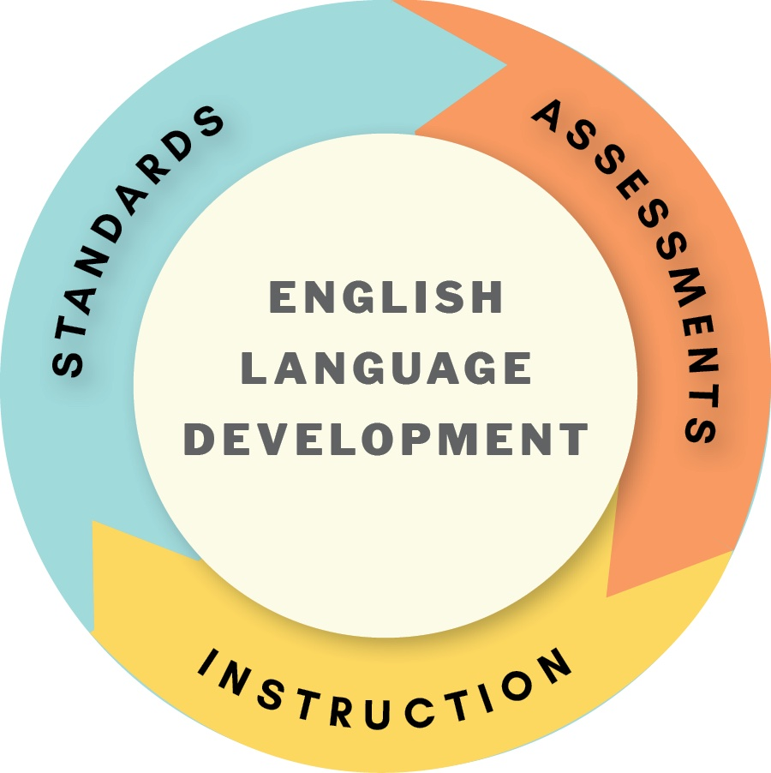
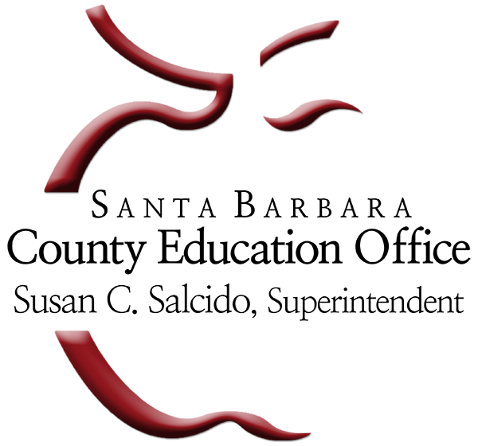
HAPPY HOLIDAYS!

