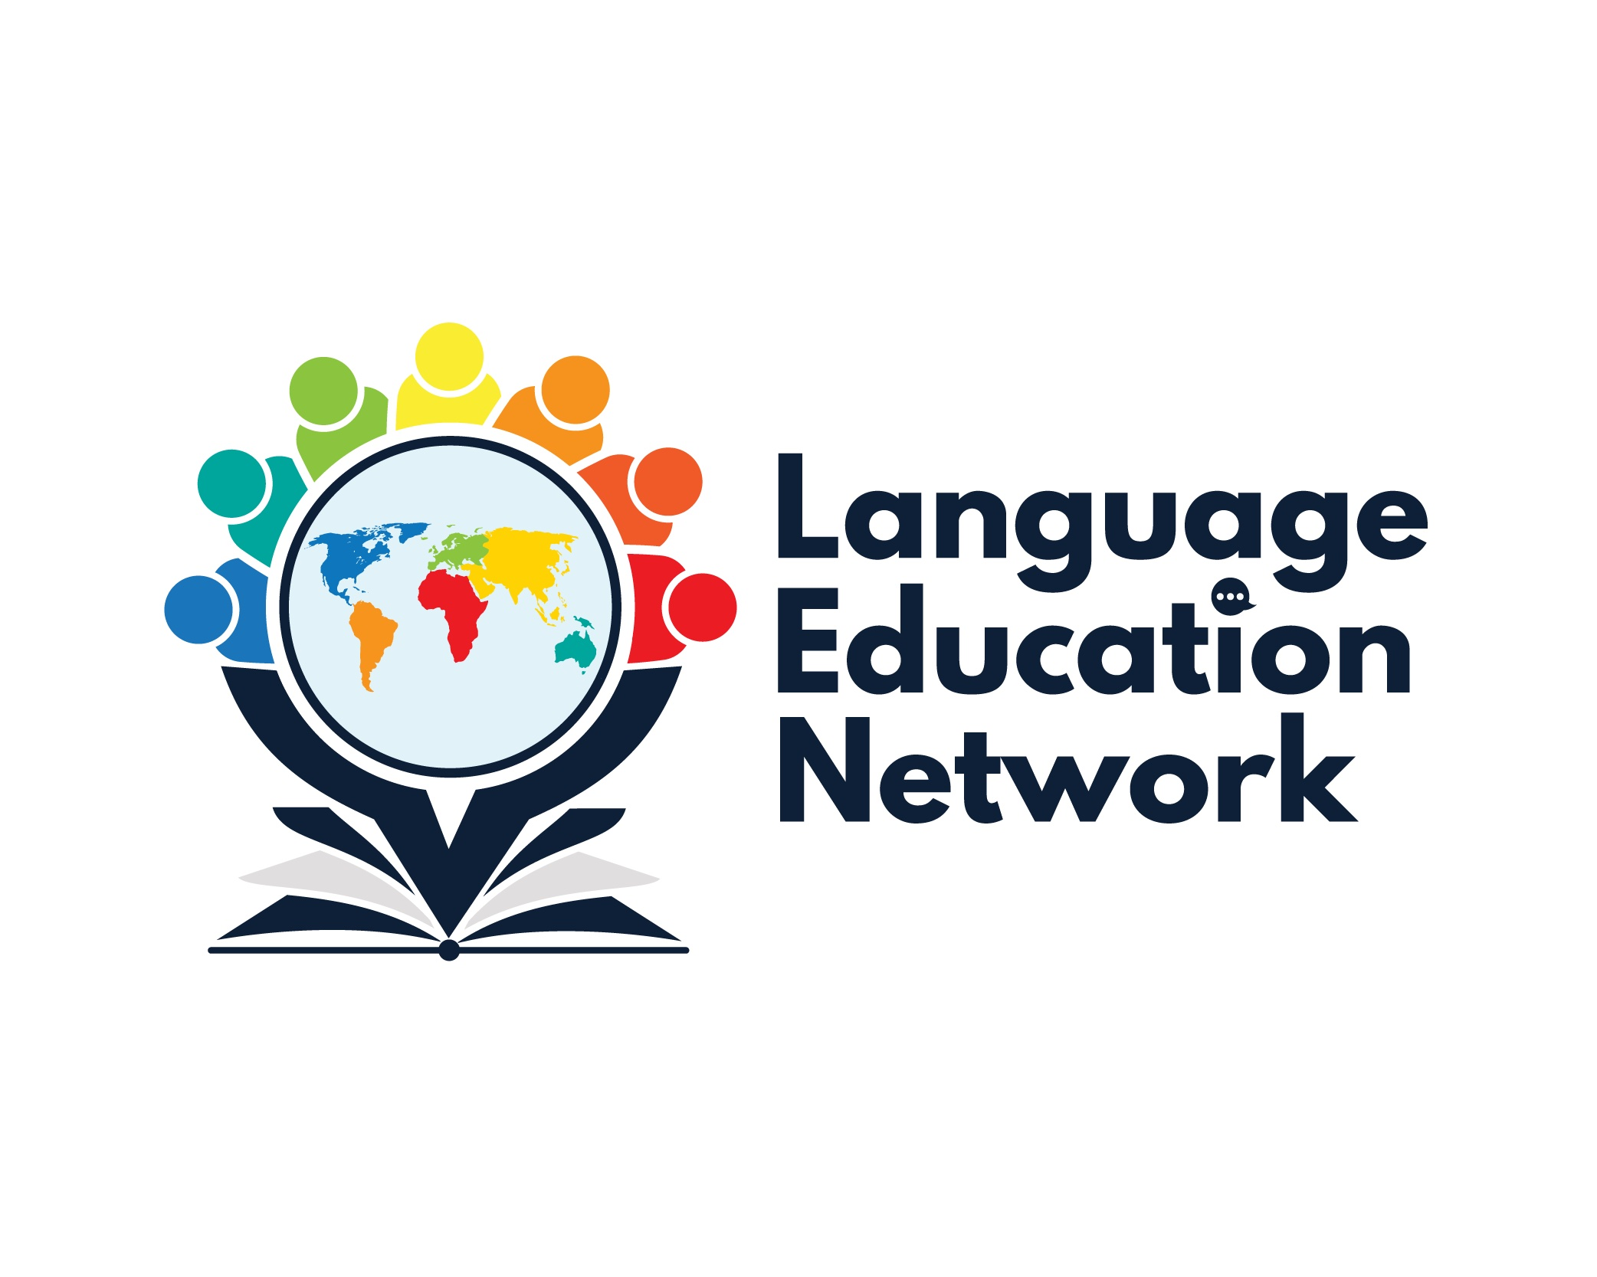
October 22, 2021
1:00 – 2:00 PM

ZOOM LINK
Passcode: LEN

AGENDA

WELCOME!

INTRODUCTIONS

SBCEO WEBSITE – LEN PAGE

ASSESSMENTS
- ELPAC UPDATES: Melissa Garcia, Coordinator, Language Education Services

INSTRUCTIONAL RESOURCES
- EL Toolkit of Strategies
- Designated & Integrated English Language Development Videos

STANDARDS
- California ELD Standards

PROFESSIONAL LEARNING OPPORTUNITIES
- SBCEO Website
- Myron Dueck, Grading Smarter, Not Harder
- Summative ELPAC – December 9, 2021
- “Overview of Efffective Literacy Practices”, Melissa Garcia, Coordinator, Language Education Services

NEXT MEETING: December 3, 2021
1:00 – 2:00 PM
