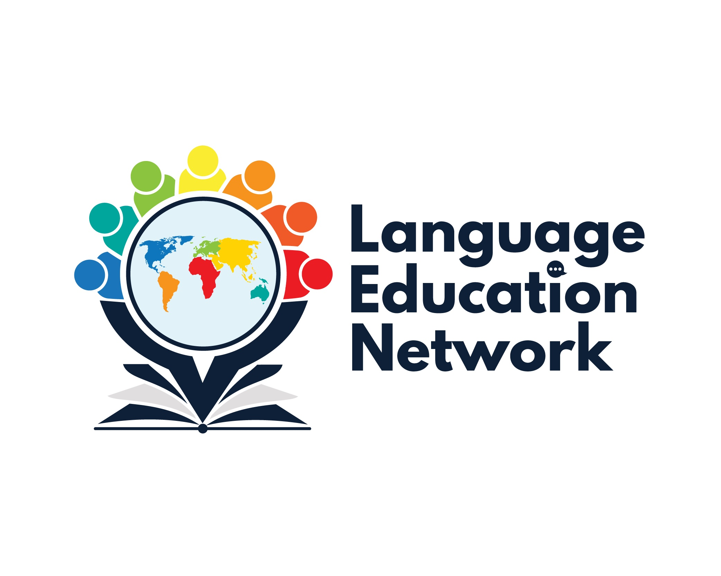
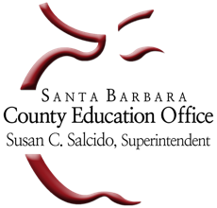
Language Education Network
December 2, 2022
1:00 – 2:30 PM

Purpose: The purpose of our network is to come together to align current research and policy with the work that is required to prepare our English learners for college and career.
Facilitators
Carlos Pagán: cpagan@sbceo.org
Melissa Garcia: mgarcia@sbceo.org

SBCEO LEN Webpage Link | 2022-2023 Meeting Dates
Language Education Network | - September 16, 2022  - December 2, 2022  - March 3, 2023  - May 19, 2023

AGENDA TOPIC |  | NOTES

WELCOME & INTRODUCTION
Grounding Activity
TITLE III – ENGLISH LEARNER ADVISORY COMMITTEE (ELAC)
Anna “Lisa” Vargas  Director of Humanities & Multilingual Education/Title III English Learner Specialist  Division of Curriculum, Instruction & Accountability  Kern County Superintendent of Schools | anvargas@kern.org
BILINGUAL COORDINATORS NETWORK (BCN) REPORTS & UPDATES
DAY 1: November 17, 2022  - Observation Protocol for Teachers of English Learners (OPTEL)  - Accountability Updates – English Learner Progress Indicator (ELPI)  - Expository Reading & Writing Course (EWRC) – ELD  - State Seal of Biliteracy  DAY 2: November 18, 2022  - California Spanish Assessment (CSA) Opportunity  - Legislative Updates  - ELPAC Updates – Melissa Garcia |  | OPTEL  EWRC-ELD  CDE Seal of Biliteracy Resources  CSA
UPDATES & ANNOUNCEMENTS
- Bilingual Authorization Program
(Summer 2023)
INSTRUCTIONAL RESOURCES & PROFESSIONAL LEARNING OPPORTUNITIES
Instructional Resources:
- EL Toolkit of Strategies
- Designated & Integrated English Language Development Videos
- California ELD Standards
Professional Learning Opportunities:
