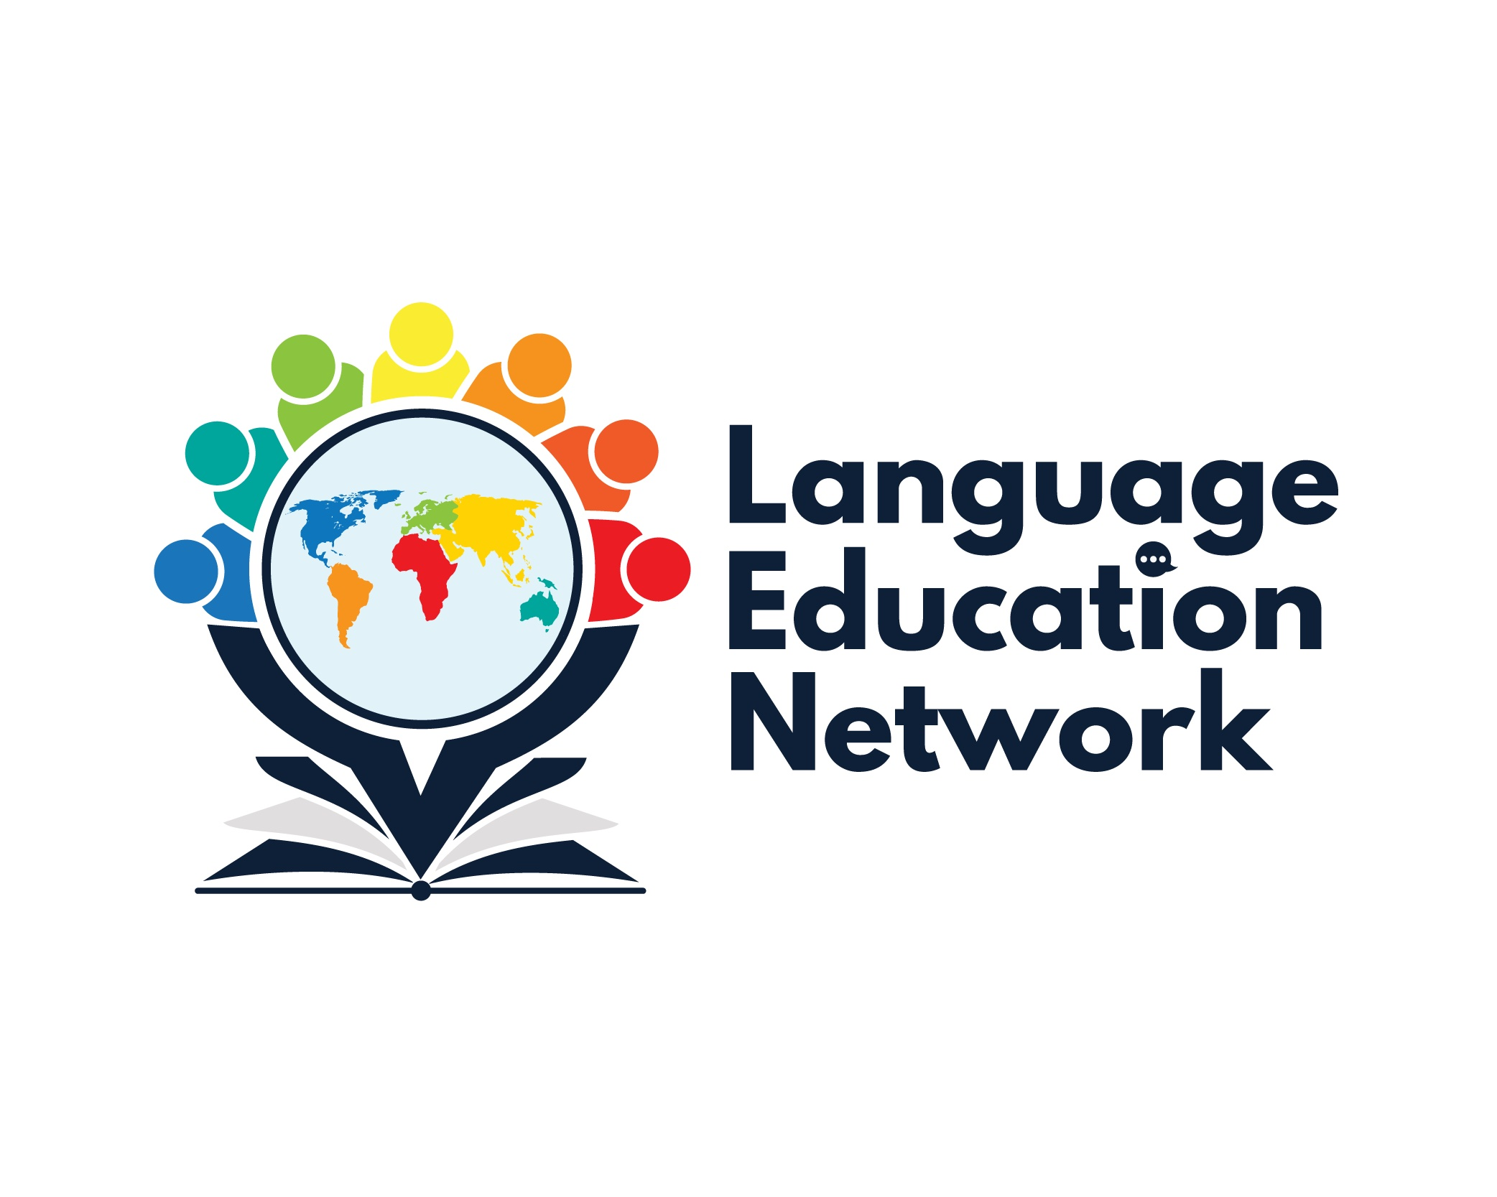
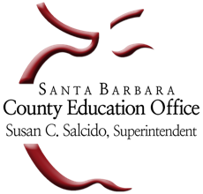
Language Education Network
September 16, 2022
1:00 – 2:30 PM

Purpose: The purpose of our network is to come together to align current research and policy with the work that is required to prepare our English learners for college and career.
Zoom Link  Passcode: LEN | Facilitators  Carlos Pagán: cpagan@sbceo.org  Melissa Garcia: mgarcia@sbceo.org

SBCEO LEN Webpage Link | 2022-2023 Meeting Dates
Language Education Network | - September 16, 2022  - December 2, 2022  - March 3, 2023  - May 19, 2023

AGENDA TOPIC | NOTES

WELCOME & INTRODUCTION
- Grounding Activity
BILINGUAL COORDINATORS NETWORK (BCN) UPDATES
DAY 1: August 25, 2022
- Federal Program Monitoring (FPM)
- Regional Technical Assistance Sessions
- State Seal of Biliteracy (new SSB Implementation Guide)
- Biliteracy Pathway Recognition
- Long-Term and At-Risk English Learners

DAY 2: August 26, 2022
- Legislative Updates
ELPAC UPDATES
- Initial and Summative
- Alternate ELPAC
- California Spanish Assessment
ANNOUNCEMENTS
- Bilingual Authorization Program (Summer 2023)
INSTRUCTIONAL RESOURCES & PROFESSIONAL LEARNING OPPORTUNITIES

Insructional Resources:
- EL Toolkit of Strategies
- Designated & Integrated English Language Development Videos
- California ELD Standards
Professional Learning Opportunities:
