Alameda Community Learning Center
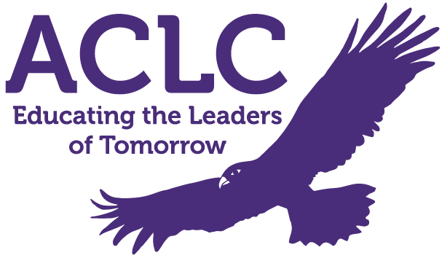
WASC SELF-STUDY REPORT
Alameda Community Learning Center
1900 Third Street
Alameda, California 94501
(510) 995 - 4300

Visit Dates: March 27th - March 29th, 2023

TABLE OF CONTENTS
Preface p. 03
Chapter I: Progress Report p. 07
Chapter II: Student/Community Profile and Supporting Data and Findings p. 51
- Data
Chapter III: Self-Study Findings p. 90
A: Organization: Vision and Purpose, Governance, Leadership, Staff, and Resources
- Category A Synthesis p. 130
B: Curriculum: Rigorous and Relevant Standards-Based Curriculum, Equity and Access to Curriculum p. 131
- Category B Synthesis p. 141
C: Learning and Teaching: Student Engagement in Challenging and Relevant Learning, Student-Centered Instruction through a Variety of Strategies and Resources p. 142
- Category C Synthesis p. 150
D: Assessment and Accountability: Reporting and Accountability Process, Using Student Assessment Strategies to Monitor and Modify Learning in the Classroom p. 151
- Category D Synthesis p. 169
E: School Culture and Support for Student Personal, Social-Emotional, and Academic Growth: Parent and Community Engagement, School Culture and Environment p. 170
- Category E Synthesis p. 182
Prioritized Areas of Growth Needs from Categories A through E p. 183
Chapter IV: Summary from Analysis of Identified Major Student Learning Needs p. 184
Chapter V: Schoolwide Action Plan/SPSA p. 191
Appendices p. 202

Preface
Explain the school self-study process used to accomplish the outcomes of the self-study, i.e., timeline, stakeholder involvement, any modifications from the model self-study process. By addressing these outcomes of the self-study, the school will have accomplished:
- The involvement and collaboration of all staff and other stakeholders to equitably support high-quality student achievement
- The clarification and measurement of what all students should know, understand, and be able to do through schoolwide learner outcomes/graduate profile and academic standards
- The analysis of the California Dashboard indicators and additional data about students and student achievement
- The assessment of the entire school program and its impact on learning for all students in relation to the schoolwide learner outcomes/graduate profile, academic standards, and ACS WASC/CDE criteria
- The alignment of a schoolwide action plan/SPSA to the LCAP and the school’s areas of need; the capacity to implement and monitor the accomplishment of the schoolwide action plan/SPSA goals.

Self-reflection is an important value and practice of any effective community. If Alameda Community Learning Center (ACLC) is to keep up the tradition of a continuous improvement cycle, we must reflect on previous challenges and accomplishments, examine data, and design systems and processes to meet our needs. For the past two years, we have been using our updated Action Plan and the Schools to Watch framework as the “lenses” for our self examination. The Schools to Watch framework provides a host of tools, including rubrics, that are very effective in self assessing our school and in creating action steps aligned with our mission and vision.

At the beginning of each school year, the faculty is given a presentation on the school’s LCAP goals and how they are aligned to WASC. With incoming staff, a discussion with what LCAP and WASC are and why they should directly align is essential. Staff are assigned committees and are also separated into departmental groups to read over the specific goals for school improvement and also the WASC Self Study Report. Discussion around changes, improvements and differences they have seen over the past 3-5 years (since the last self study) are noted by the administrative team. The process is ongoing. Professional development time was allotted once per month, specifically for committee meetings and WASC self study analyses and writing. During the report writing process, staff met at least four times to provide feedback and direct input.

All stakeholders, including student leadership, board members, community members and parents, were invited to discuss the LCAP goals (aligned to WASC improvement) and provided their input and views. Rich conversations around findings and data analysis facilitated a deeper understanding of our areas of improvement. An update on the self-study process was presented throughout the year at our ACLC Governing Board meetings (as reflected in the Lead Facilitator Reports).

Starting this year in 2022-2023, we have begun unifying our high school program with our sister school, Nea Community Learning Center. As they phase out their high school program, we are enrolling 1 additional section of approximately 25 high school learners each year, so that by the end of the 2025-2026 school year we will have grown our high school by about 100 - 125 learners. As part of this unification, we are also slowly bringing on the Nea high school facilitators to teach classes at ACLC. By the time the transition is complete, those facilitators will become full-time ACLC employees to support our larger learner population.

In our last full WASC visit, the visiting team shared the following commendations, recommendations, and comments:

Commendations:

ACLC continues to achieve a graduation rate of 94% and a 90% 4 acceptance rate to 4 year colleges. 64% of our seniors intend to accept and attend four year colleges. Some learners are opting for Junior college or military. Implementation and analysis of data throughout the school. Close knit community where facilitators are supportive and caring, and motivate students to excel personally and academically. Observable, measurable success rate in dropping failure rates, rising classroom testing scores, and overall successful course completion due to interventions such as Office Hours / MAS and Learning Labs. Cultivating a culture where students and staff feel belonging and take responsibility in their own actions and education.

Recommendations:

- Continue implementing the onboarding program to retain highly qualified staff.
- Continue to narrow the achievement gap between subgroups.
- Continue committee dialogue to review end of unit, course, and semester benchmarks to measure Common Core State Standard progress.

Comment on any critical areas for follow-up/action plan sections that have not yet been completely addressed, if applicable. Identify any new areas of concerns, if applicable.

The VC did not identify any new critical areas for follow-up during the visit. What the VC experienced is that ACLC has made significant progress in addressing the critical areas for follow-up. A main focus of their report was on the collection of data and programmatic changes based on the previous VC findings. ACLC continues to collect data and make adjustments to their programs, and for some of these it may be too early to measure trends. However, the school has done a great job in collecting and analyzing data from various subjects and grade levels.

Since that visit, staff, learners, and families have actively participated in the school improvement process and the school is better because of this participation level. Because our learners deserve the best possible education, because our parents expect the best, and because our staff deserve to be part of a thriving school as quickly as possible, we have continued implementing many elements of the Schoolwide Action Plan in Chapter 5.

As State indicators highlight, COVID had a significant impact on student achievement. We had to make some big shifts to support our community during the Covid pandemic, including having a Family Liaison position created during Distance Learning. That said, we continued with our goals and constantly continue working to make improvements and take action for the benefit of all. Many of these actions outlined in the Action Plan align with the school’s LCAP and Strategic Plan. Using input from all of our stakeholders, we have consolidated, simplified, and updated our WASC and LCAP goals to be the same 3 overarching goals:

SCHOOLWIDE GOAL 1: Data Collection, Analysis, & Response
Rationale and Growth Areas Addressed:
ACLC values our democratic model and participation by all stakeholders in our community as well as data-based decision-making. As such, we will regularly collect, analyze, & respond to data from multiple stakeholder sources as well as academic data in order to increase program effectiveness and respond to community need.

This will happen in the instructional program via the use of our ACLC Instructional Model, or “AIM.” Our AIM includes 5 components: (1) Opening Routines and warm ups, (2) Content Delivery, (3) Classwork time (includes group and individual work), (4) Accountability/Assessment Strategies, and (5) Closure. We will also continue to use the Schools to Watch (S2W) framework and associated rubrics to examine and improve in the domains of Academic Excellence, Social Equity, and Developmental responsiveness. Specifically, we will work to refine and improve our Project Period and Learning Lab structures to better meet the needs of our learners.

We will also continue to use curriculum-embedded assessments as well as external, standards-aligned assessments like MAP & SBAC/CAASPP. We will use Staff Professional Development and supervision / instructional coaching time to make meaning of, plan around, and respond to this data. We will continue to work with our staff in using formative assessments as well as summative assessments in determining instructional moves and refining our “AIM.”

We will continue use school-wide structures like our Leadership class and schoolwide events like “ConCon Day” (“Constitutional Convention Day”) as well as surveys of our staff, learners, and guardians to gather information about other aspects of ACLC’s programming, and use the ACLC Board as a vehicle to make meaning of and respond to this data.

SCHOOLWIDE GOAL 2: College & Career Readiness
Rationale and Growth Areas Addressed:
ACLC will align resources - human, financial, and programmatic - to ensure that all learners are given access to standards-aligned instruction that will prepare learners for the diverse rigors of college as well as receive information and personalized support in learning about college and career success for all.

Through a relentless focus on Common Core Standards and a continual push to combine appropriate rigor and scaffolding supports, we will work to ensure our staff deeply understand and are actively teaching relevant standards. Given our Project-Based Learning (PBL) approach, this means focusing on standards-aligned projects that engage learners in authentic demonstrations of learning.

Through a combination of staffing, curriculum choices, scheduling, and schoolwide events, we will ensure that learners graduate eligible and prepared for 4 year college and meaningful career options. We will also expose learners to a variety of career choices and their associated pathways by the time they graduate from ACLC via curriculum, special education, and counseling staff activities.

SCHOOLWIDE GOAL 3: Effective Interventions & Supports
Rationale and Growth Areas Addressed:
ACLC values our diverse community. As our demographics change and we increasingly accept learners who are behind in literacy and numeracy skills, it is crucial that we meet their needs.

ACLC will use Staff Development time to support all facilitators in increasing their toolkit of effective Tier 1 strategies for use in the general education classroom setting. Administration will examine master schedule and staffing to refine existing Tier 2 supports.

ACLC has created Learning Labs for learners who are not passing their courses. These learners are pulled from one or more Project Periods each week and assigned to Learning Labs - a small-group setting where learners set goals, reflect on progress, and work on project management. An instructional aide takes attendance, monitors learner progress, and provides support during Learning Labs. Facilitators are also required to host two support sessions after school each week that we call MAS (More Academic Support). ACLC assigns learners to these office hours based on the grades and skills in their courses with a monthly data pull of Jupiter and MAP data. We also use web and app-based digital supports like IXL and Vocabulary.com to support our struggling learners.

As a group of professionals who make up the Alameda Community Learning Center, we look forward to the many challenges that lie ahead and the opportunity to impact the lives of the learners and parents who choose to send their learners to ACLC.

Recognition must be given to the students, parents, faculty, and administration for their involvement and cooperation in this Self-Study process. Recognition must also be given to the Community Learning Center Board of Directors for their high expectations of the school and insistence that the school continue to grow and excel as we continue the unification process with our sister school.

Chapter I: Progress Report
- Describe any significant developments that have had a major impact on the school and/or specific curricular programs since the last full visit.
- Comment on the process for implementing and monitoring the schoolwide action plan/SPSA aligned with LCAP goals.
- Summarize progress on each section of the current schoolwide action plan/SPSA that incorporated all schoolwide critical areas (growth areas for continuous improvement) from the last full self-study and all intervening visits.
- Comment on the original critical areas for follow-up (growth areas for continuous improvement) not in the current schoolwide action plan/SPSA.

Describe any significant developments that have had a major impact on the school and/or specific curricular programs since the last full visit.

Global Pandemic - Covid 19
- Like all schools, we had to shift into Distance and then Hybrid learning with the onset of the Covid Pandemic in March of 2020 before being able to re-open safely for in-person learning in August of 2021. This shift in learning approach resulted in reduced instructional and interaction time for learners and has created an ongoing set of challenges in relation to supporting learner academic and social development and in teacher recruitment and retention. Several decisions have been made in response to COVID/Distance Learning and the loss of learning and engagement. ACLC moved to a 1:1 computer for all learners and offered a hotspot for all families that were in need. The school is still committed to offering this for those learners who have limited access outside of school for homework etc. Programs like IXL and Lexia were initially purchased for Distance/Hybrid learning.

- Recognising the achievement gap since 2020-21, ACLC continues to use these as part of instruction/intervention. Recognizing the need for re-engagement, Camp Hawk was piloted during the summer of last year (2022). Learners in need of credit recovery were invited to participate in summer school that ran over three weeks, at no cost to families. The feedback we received from families sharing their gratitude for camp and the opportunity it gave their child to be engaged in school and recover from distance learning waa very positive. We have continued to offer Camp Hawk during our intercession breaks, opening it to all Middle School learners and those at risk of graduating High School.

Curriculum Shifts
- This year marks the second year of adopting Illustrative Mathematics in our math department. We had previously used CPM (College Preparatory Mathematics). The decision to adopt Illustrative Math was unanimous for the Math Department and curriculum committee. The lessons align with the standards and have a strong review process before moving to the next unit. Our Math Department felt that this component for reteaching and intervention was critical as we came back to school following COVID.
- This year marks year 2 of adopting CommonLit and EngageNY for our English department (CommonLit in grades 6-10, EngageNY in grades 11-12). We had previously used facilitator-created unit and lesson plans that were not consistently tied to state and national standards.
- Lastly, our Spanish Team moved away from Vista Higher Learning to adopting Voces Digital Curriculum. They have found this to be a more engaging, interactive platform.

Equity Through Mastery-Based Grading (MBG)
- This year marks our 2nd year of our move to MBG, underpinned by researcher and author Joe Feldman’s “Grading for Equity” framework. This approach aims to make learning and feedback more equitable for all learners, with a particular focus on ensuring that traditionally underserved learners have a more equitable experience of grading and feedback at our school. This work has happened at the CLCS Board Level as well as through committees, staff meetings, and staff leadership via our Department Leads

High School Unification with our sister school, Nea Community Learning Center
- In Spring of 2022, the CLCS (Community Learning Center Schools) Board voted to unify the 9-12 programs of Nea with ACLC. Over the course of the next three years, ACLC will add one more section of 9th grade to each incoming class and Nea will graduate its current learners. After three years of this gradual transition, all high school learners will be at ACLC and Nea will shift to being a K-8. High school facilitators’ teaching loads will also gradually shift from Nea to ACLC. These changes will make both schools financially stable for the ongoing future, and are in alignment with recommendations from our chartering agency, AUSD (Alameda Unified School District).

Facilities
- An ongoing challenge for the school is our facilities and lack of classroom space for a K-12 program. ACLC shares our school site with our sister school, Nea Community Learning Center, since the fall of 2014. Since the last visit, money and effort have resulted in a school that looks, works and feels better for staff, learners and families. Arguably, the greatest change and improvement came by way of seven new portable classrooms on our blacktop. Three are assigned to ACLC, and one ACLC/Nea restroom. This has helped alleviate a little the complexity of our master schedule. Whilst administration worked hard to creatively find short term solutions, the lack of classroom space limited the number of electives we could offer. As noted below, the additional classroom availability has allowed us to offer more electives to both Middle and High School learners. Over the summer of 2022, a perimeter fence was finally installed after years of negotiations with AUSD (Alameda Unified School District).

- That said, as our school has grown with the inclusion of additional learners from Nea, we relied on 4 office spaces (10’ x 12’ or 10’ x 14’) in bungalows for in-house staff like Special Education team members as well as contract providers (like speech and occupational therapists, and our Instructional Coach, for example). Recently, AUSD has told us we cannot use these spaces for anything other than storage, and required us to remove 2 of the 4 spaces off site. This has made it challenging for staff and contractors to find quiet spaces to work and have confidential meetings. We continue to seek creative solutions for lack of space outside the classrooms..

Staff Changes/Reconfiguration - Since our last accreditation process, ACLC has made a number of adjustments to staffing needs to provide for a higher and far more effective level of support for learners, families and our staff. The following include our more recent changes:
- Addition of Full-Time Campus Supervisor
    - Recruited, hired and on-boarded a full time campus supervisor. This has facilitated a safer campus, assisted learners in returning to class, and thereby increasing instructional minutes and time spent on learning. This addition has also helped ACLC to meet increased mental health needs coming out of Covid, as the addition of this role means we have another caring adult who can build relationships with learners and families in support of our school’s mission.
- Increased Hours For College Counseling - We have increased the number of hours our College Counselor is contracted to work directly with our High School from 8 to 20 hours per week. College and career readiness 1:1 meetings can be scheduled by any learner, in addition to push in support during Senior and Junior Seminars.
- Addition of Part-Time Mental Health Counselor
  - In order to better serve our learners with mental health counseling needs, we have added a .4 FTE mental health counselor that parents, learners, and staff can access for referrals / self-referrals for additional support.

NAU & Collective Bargaining
- Since our last accreditation process, an important area of focus is concerning staff retention. Nea and ACLC United (NAU) was formed in December of 2013 and after much internal negotiation, the schools finally ratified their union contract in the Spring of 2016. The contract clarified many areas that were previously contentious, including work hours, class size, grievance and dismissal procedures, and a salary schedule. The Collective Bargaining Agreement (CBA) is annually opened and three articles can be negotiated, including salary. This has provided greater transparency for staff and fosters the ability to work in collaboration. Since the last WASC self-study visit, the salary schedule was revised to better reflect years of teacher service, and there have been salary increases every year despite budget challenges. In 2020-21, NAU were reinstated on the CLCS governing board after employees had been prevented from representing following a lawsuit. One representative from each school (ACLC and Nea) are now appointed each year.

Updated ACLC Website
- In the last 2 years, we have worked to modernize and update our school website, alamedaclc.org - this has helped us make resources more readily accessible to the wider community and has made it easier for us to attract new families and facilitators for enrollment and recruitment purposes. We also have worked diligently to make sure that all legally required documents are easily accessible on our website and through a quick search of our website.

New / Additional Course Elective Course Offerings
- Creative Technologies
        - Maker/Engineering/STEM elective.
        - Meets twice a week, 2 classes.
        - MW 1st section, Tu/Thur - 2nd class
        - Learners start by assembling the benches for the class out of T-slot aluminum.
        - Learners form groups and document project progress using an online platform, makeprojects.com
        - Learners apply the iterative process going through the brainstorming, prototyping, testing, retesting, recreating in order to produce functional projects.
        - Projects include building a rideable device using a hoverboard, creating an arcade or carnival style game using a makey makey, recreating an exhibit from the exploratorium, and designing functional parts and both 3d printing and laser cutting their designs.
- Astronomy
        - Elective illustrating Earth, the solar system and beyond
        - Meets twice a week: Mondays and Wednesdays
        - Course is all year
        - Learners start with Big Bang Theory, our Solar System, and beyond our solar system including how to read and navigate the night sky
- Java Programming
        - A more advanced computer science class based on the AP Java Curriculum but at a slower pace than for the AP to allow it to fit in the 2 day a week schedule, Learners get practice creating Java programs with an online IDE.
- Music
  - UC approved electives Beginning Guitar (HS) and Musical Theater (HS) *New 2022-23
  - Introduction to Music (Middle School) *New 2022-23

Change | Impact these changes and/or developments have had on the school and/or specific curricular programs
Professional Development  For the 19-20 school year, all-staff  professional development has focused on  rigor and equity in Project-Based  Learning--specifically, staff have  worked on how to design challenging  projects that incorporate skills tied to state  standards and how to promote equitable  access to project-related resources and full  engagement in project work by all  students, including those from  under-represented groups or with special  educational needs. | In Professional Development, we continue to focus on our key tenets of Project-Based Learning, becoming a more equity-focused school (using these last 2 years to focus on Mastery-Based Grading), and ensuring that our curriculum is standards and mastery-focused. As a result of this push, we have adopted 3 new curricula (Illustrative Mathematics in our math department, a combination of CommonLit and EngageNY in our English department), and Voces Digital in Spanish. We have added a JEDI (Justice, Diversity, Equity, & Inclusion) committee to our PD structure. You can see our Professional Development Scope & Sequence document HERE for more details.
Charter Renewal  Based on The WASC Lead Team and  ACLC Board review and our internal  reflection, ACLC is in the process  of revising our program goals to  incorporate the following  recommendations:  - Continue professional development to improve standards-based instruction  - Develop a sustainability plan to train new teachers on how to implement Project-Based Learning  - Conduct student survey regarding Judicial Committee (JC) and adjust model based on student feedback  - Train judicial committee clerks and facilitators in restorative practices  - Review and revise EL instructional program to include designated  ELD | Based on these recommendations, we have adjusted our Professional Development Scope & Sequence document HERE.  We continue to host 2 days of New Facilitator Orientation for our new facilitators, and pair all of our new facilitators with our Instructional Coach for weekly or bi-weekly meetings. This results in new facilitators being better supported in the classroom as they settle into teaching at ACLC.  Our new Judicial Committee lead, Daniel Freedman, is currently trying to streamline the process, working with JC clerks to improve the running of JC and how it works. This includes creating electronic versions of relevant forms and write-ups and making the process of serving as a juror more transparent for the ACLC community.  After having the position posted for almost 2 years and budgeting accordingly, as of October 2023 we have hired an ELD Coordinator to better support our emerging English Language Learners. The person in this role will do direct work with our ELLs as well as support with administrative tasks like testing and family engagement.
Change in School Leadership  Michael McCaffrey is an exceptional  communicator and has a deep belief in the  importance of quality instruction for every  classroom.  One impact of this regular communication  is that the majority of stakeholders report  feeling more informed and in touch with  ACLC than in the past. This is according to Lead Facilitator surveys from the Spring of 2021. This will help with everything from attendance at Learner Led Conferences to food donations for school events, and  ultimately serves as a place to capture our  common experience in writing and share  with the community. | Our Lead Facilitator is now in his 18th year in education, and his 4th year at ACLC, and has slowly worked to build the ACLC community, paying particular attention to growing our PAC (Parent Action Committee, similar to a traditional PTA). This group was essentially non-participatory when Mike joined the school, and Covid didn’t help. Through regular Zoom meetings, weekly updates, and a push to do things “in real life,” PAC now has 2 established co-leads and a grade-level liaison at each grade level (6th-12th) who have set up coffee meetings, happy hours, and work sessions to support Mike and all of our facilitators. These have all been well-attended, and on our recent 6th grade “Hannah Camp” camping trip, there were 70+ guests for our 6th grade potluck (about 55 learners on this trip). This shows the increasing commitment of our parent/guardian community to supporting the school and to feeling invested in all things ACLC.
ACLC Sustainability Plan  To continuously monitor the progress on the  implementation of this program and to  continuously re-evaluate the effectiveness of that implementation, a series of monthly check-ins with the primary person responsible for the Action Steps was set up with the Lead facilitator. The progress and any revisions will be reported back to the CLCS board in the ACLC Lead Facilitator Reports.  Additionally, ACLC adopted a new calendar model for the 2018-19 and 2019-20 school years that includes a day in March set aside for long term planning and program revision. This day included staff-wide meeting time for yearly progress review and new goal setting for the Sustainability Plan, LCAP, and WASC goals. | The monthly ACLC Finance Committee as well as the ACLC and CLCS Board meetings serve as a regular accountability step for the Lead Facilitator and the school to keep on track with stated goals. The Lead Facilitator meets weekly with the Executive Director to ensure that our sustainability plan is followed, and the use of the Schools to Watch framework for continuous self improvement ensures that staff, learners, and families are keyed in and able to participate in making ACLC a better school year over year.  Since 2021-22 two intercession breaks have been built into the school calendar to provide intervention (one week in October and February). Camp Hawk is offered to all Middle School Learners and those who are at risk in High School. Credentialed facilitators are stipend to provide intervention and instruction in Math and ELA.
Revised ACLC Logo  In May 2019, a draft of the new ACLC logo was chosen via vote by learners and facilitators. The possible logos were submitted by ACLC learners. In fall 2019 the logo revision discussion was continued by the ACLC Board and Lead Facilitator, Michael McCaffrey. He brought school sketches to a graphic designer and a logo was finalized and placed on school shirts and letterhead. | We’ve used this learner-created logo to update our school signage, our website, and all marketing materials. We have this logo on community and staff T-shirts, hoodies, coffee mugs, and more. This unified marketing approach gives parents, learners, and faculty a sense of unification, under one logo, one body. A sense of familiarity and pride.
Changing Learner Enrollment  Due to the continuous increase in school choice throughout Alameda, the school has experienced a significant increase in this Low Socio-Economic Status demographic category (11% in 2014, 32.3% in 2018). Our LSES is now higher than our sister school Nea Community Learning Center. Our faculty has made adjustments in their teaching to  provide effective instruction for these learners.  This change has pushed our staff to evolve its  practices to meet the needs of our learners.  Universal Design for Learning, Positive Behavior Systems, Instructional Aide and more effective Learner of Concern time are just a few of our most recent responses to support the wide variety of learners who come to ACLC. | 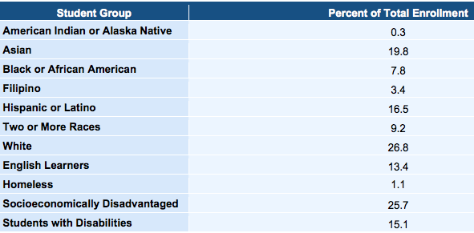  This year, as we expand our 9th grade to include our sister school’s 8th grade class, we have increased our enrollment and shifted our demographics a bit. We are hovering around 405 learners (up from about 360 in the last few years) due to the extra section of 9th graders and backfilling empty spots in other grade levels.  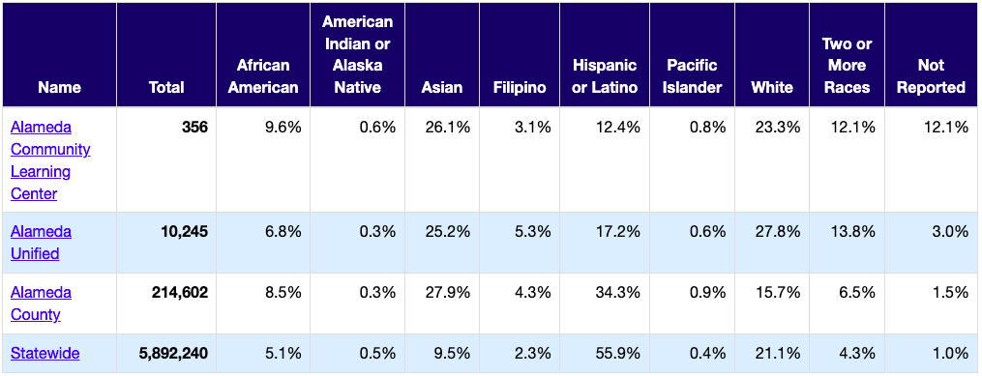  We continue to work in Professional Development and in supervision and 1:1 coaching to support our facilitators in differentiating to meet the needs of all learner profiles in their classes.
Committee Restructuring and Communication  Our previous committees rarely focused on  progress on goals or emphasis on schoolwide  initiatives. They often took a life of their own  based on the facilitators on the committee. While current committees retain the autonomy to identify and pursue goals in addition to WASC Goals and school initiatives, there is now an increased  emphasis on pre-existing schoolwide goals.  This transition was a foundational shift in mindset towards collaboration with administration and accountability targets such as WASC. We realized that ACLC needed an ongoing approach to WASC work.  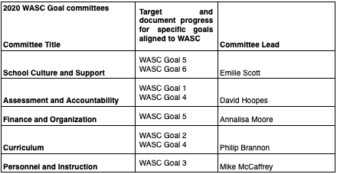  In addition, each committee is now reporting to the ACLC Board on a bi-monthly basis. This Board requirement has increased accountability for our committee Leads and has provided the Board an opportunity to ask follow up questions and direct the committee to move in valuable directions. | This change in committee structure continues and is now part of the fabric of committees. Each year, facilitators opt in to our various committees, and can sign up to lead a committee for a leadership stipend. This year, we have added in a JEDI Committee (Justice, Equity, Diversity, & Inclusion) to better support our CLCS Equity Statement and keep a focus on creating a more equitable school for our learners, families, and staff.
WASC Bi-monthly updates to the ACLC and CLCS Board  Similar to the ACLC Board, CLCS wanted to ensure that ACLC was showing appropriate progress on goals. They directed our Lead Facilitator to provide regular WASC goals and progress on those goals.  These reports have continued. Our Executive Director and Lead Facilitator constantly update both the boards with progress on LCAP and WASC. This is a required standing item at both boards to ensure that WASC goals are pursued and WASC expectations are consistently considered by school leadership and board members.  At ACLC, each Committee Lead reports every other month on their progress including goals and methods to achieve those goals. Each committee is responsible for supporting and monitoring detailed progress on goals.  Finally, the ACLC Lead facilitator has identified LCAP Goals in alignment with WASC goals. Ensuring these are aligned and progress is being made is always on the front burner. | During the ACLC Board meeting the Lead  Facilitator, Michael McCaffrey, presents WASC updates to the board members and all public attendees. Board members are able to view WASC updates and ask questions.
School Site Modifications  In the past two years ACLC has made a number of facility changes. Those include the addition of two classrooms, a portable bathroom and the addition of some Nea classrooms being shared with ACLC learners and facilitators.  The new room 43 has provided a dedicated place for staff to serve our learners in Special Education in a dedicated private space. Room 43 is better suited to work with kids as it is bigger than the previous location and feels more like a classroom, providing the same consistent access to technology and allowing for stronger implementation of the PBL model of the school in Special Education as well. It has also improved learner behavior and performance as it is a welcoming environment creating a sense of respect and responsibility to the space. Room 43 is also proving to be conducive to stronger communication among staff in the moment, making collaboration more feasible resulting in authentic and meaningful reflection for best serving our learners. | This year, as ACLC expanded by 1 section of 30 learners to support the ACLC / Nea unification, we were given Room 24, are able to use Room 12 as part of our Center again, and have our learners use Room 43 for their elective music classes. The CLCS administration has moved to Room 37 and our learners who receive special education services get support in Room 27.  As of October 2022, we are losing 2 of 4 bungalows (10’ x 12’ or 10’ x 14’) as the district requires their removal, and we are no longer able to use any of the bungalows as work or meeting spaces for adults or learners. This will create a challenge in providing confidential and/or quiet work spaces for adults on prep. periods or who need a space to work with learners in small groups or 1:1.
ACLC Marketing  When WASC was last here, the executive director and the CLCS teams were deeply involved in reconsidering Marketing and investing in a Web Page redesign. The CLCS Team worked in collaboration with ACLC parents with expertise in these areas.  The redesigned website launched in January of 2021, resulting in a much more mobile-friendly and ADA-compliant website.  Marketing for the 21-22 and 22-23 school years has included:  - online information sessions held monthly between October and February,  - in-person tours held regularly between October and May,  - mailers announcing information sessions and tour dates sent to all Alameda residents in October,  - mailers and social media ads to all new residents moving to Alameda,  - Mobile phone ads sent to persons patronizing a local Safeway store,  - a premium account with Niche.com,  - banners hung at local parks,  - ACLC pens and car magnets for distribution to parents and staff  The admissions events--tours and information nights--have been retooled to include more time and voices in the room.  Marketing material is universally focused on the pillars of the Sustainability Plan and the Mission Statement. | ACLC continues to use the learner-created logo for marketing purposes. The redesigned website has made it easier for current families to find important information via their smartphones and for interested families to find programmatic, application and enrollment information, as well as for job seekers to link to our current openings.  Here are links to some of our recent marketing materials:  ACLC Visit and Apply webpage  Recorded ACLC information session  ACLC Mailer 22-23  ACLC New Residents Mailer–Front  ACLC New Residents Mailer–Back  ACLC Mobile phone advertisement  ACLC on Niche.com  ACLC Street Banners  ACLC Car Magnet  ACLC administration continues to work with our marketing manager and get board input to spend our marketing budget in ways that will promote the long-term financial stability of the school. We have been able to grow our enrollment while many other schools have been combining, closing, or losing enrollment as a result of the Covid Pandemic and changing economic climates.
Revised Goals  ACLC revised WASC Goals and LCAP to align. Staff, CLCS and Lead Facilitator worked in collaboration to focus and align these vital targets.  2019 LCAP goals:  Goal 1:  Collect and analyze data to drive instruction and curriculum access for learners.  Goal 2:  Support learners in becoming college and career ready.  Goal 3:  Ensure that learners have access to basic services, supports, and intervention. | Goal 1: Collecting and analyzing data allows us to make the necessary adjustments to our teaching strategies. It is helpful to see where our kids are at and if it is necessary to speed up, slow down, keep the same pace, etc.  Goal 2: Always a good idea for learners to think about their future, make sure they can see themselves at a higher education institution. Additionally, it is fun when the faculty get to glow about their alma mater.  Goal 3: With the addition of an ELD Coordinator (posted for 1.5 years), we are now better able to support all learners at ACLC. We also continue to offer a full-time Academic Intervention Aid whose job it is to support struggling learners based on academic, behavior, and attendance data pulled by our counselor and suggested by facilitators.
New Courses at ACLC  New Computer Science Elective - ACLC has a large number of learners interested in our new Computer Science course: We were able to take advantage of a new Computer Science curriculum and professional training offered by CPM in order to establish this class at ACLC. This is the first year it is being taught.  New High School Digital Media Electives - ACLC has expanded the offering of digital media and digital music in high school at ACLC. In the past these classes have been rotated. Currently, ACLC is able to offer High School Visual Communications, High School Digital Video Studios and High School Digital Music. All three of these classes are UC approved.  New Creative Writing and Poetry Electiv- ACLC is fortunate to have the Alameda Poet Laureate Cathy Dana as a facilitator at ACLC. In this class learners write narratives to develop real or imagined experiences or events using effective technique, well-chosen details, and well-structured event sequences; develop and strengthen writing as needed by planning, revising, editing, rewriting, or trying a new approach, focusing on addressing what is most significant for a specific purpose and audience; and use technology, including the Internet, to produce, publish, and update individual or shared writing products, taking advantage of technology's capacity to link to other information and to display information flexibly and dynamically.  History moves to five days a week: In the 2019-20 school year, History has been expanded to five days per week. In the past, History was offered three days per week. Starting in the 2019-20 school year, these classes are 5 days/week in order to respond to lagging reading scores in middle school. | New Creative Writing, Creative Tech, Computer Science and Poetry Elective  In this class learners write creatively to develop real or imagined experiences or events using effective technique, well-chosen details, and well-structured event sequences; develop and strengthen writing as needed by planning, revising, editing, rewriting, or trying a new approach, focusing on addressing what is most significant for  a specific purpose and audience.  Guitar  This year, guitar is newly offered at ACLC. This is a UC Approved course that meets 2 days a week (Tues/Thurs). In this class, learners will explore each string of the guitar. The course takes learners through each individual string, with playing tests gradually increasing in difficulty and complexity. We cover chords and start learning full songs, based on skill level and learner interest. The class focused heavily on music literacy (being able to read, write, and play notes and rhythms in standard notation, as well as composition. The class aligns with the California Standards for Music.  Musical Theater  Musical theater, which meets 3 days a week, is a high school level performance class culminating in a showcase (first semester) and full musical (second semester). Learners practice acting and singing, and research theater shows and actors. The class is heavily learner-led, with opportunities to pick songs and scenes, and lead improv games, acting exercises, and vocal warm ups..  Intro to Music  Intro to music is a middle school, exploratory-style music class which meets two days a week. In this course, learners are taught how to read, write, and play notes on the treble and bass clef. Learners have the opportunity to explore several different instruments, including: piano, guitar, ukulele, and drums.  Visual Communications (HS): VisCom is a high school course which meets twice a week, and studies contemporary advertising and propaganda techniques in order to critically analyze media content, as well as create original multimedia products. Learners use Photoshop and Adobe Premiere software to create projects that examine how media influences our beliefs and behavior.  Astronomy  Elective illustrating Earth, the solar system and beyond. Learners start with Big Bang Theory, our Solar System, and beyond our solar system including how to read and navigate the night sky.  Creative Tech (HS): Creative Tech is a new course taught at ACLC by Michael Kim. The class is a next level maker class that emphasizes technology and innovation. Learners use a variety of tools to accomplish tasks and build products. This is a wildly fun class that asks learners to think out of the box.
Positive Negotiations - CTA and CLCS  In the past, CTA and CLCS Schools have not had positive negotiations. Last year’s CTA team and CLCS successfully negotiated the contract and a raise. This resulted in an increase in salary for ACLC staff in each of the last two years. As part of its negotiations process, in the 2018/19 CLCS and the NAU agreed to an Agreement that provides a 5% raise for 2019-20 school year. The morale between CTA and CLCS was greatly improved as a result of these successful negotiations and settlement. Measure A is a local ballot initiative that both charters and AUSD are working together on. Should Measure A pass, for 2019-20, beginning in 2020-21, salary increases would bring ACLC facilitator salaries in line with the county average. | As of the 2022-2023 school year, ACLC and CLCS administration continue to work with our labor partners to negotiate contracts. This year, we moved to a new schedule which significantly impacted our Wednesday Professional Development time. This was done in agreement with the union.  Since our last accreditation process, an important area of focus is concerning staff retention. The Collective Bargaining Agreement (CBA) is annually opened and three articles can be negotiated, including salary. Since the last WASC self-study visit, the salary schedule was revised to better reflect years of teacher service, and there have been salary increases every year despite budget challenges. In 2020-21, NAU were reinstated on the CLCS governing board after employees had been prevented from representing following a lawsuit. One representative from each school (ACLC and Nea) are now appointed each year.
GiveThx  GiveThx is a non-profit that uses a web-based platform that allows users to share gratitude with each other. The founder & CEO has agreed to let ACLC use this software for free as a trial this year, and more than a ¼ of our facilitators are using this program in some capacity.  The research behind this suggests that when people give and receive gratitude on a more regular basis they will feel more connected to their peers and community members, ultimately will have better attendance and outcomes with GiveThx as a meaningful component of their school day. | We do believe this curriculum is helpful in fostering a community once the learners grasp the extent of gratitude is not just about being nice.
Learning Lab & Instructional Aide Shift  With Katherine Anderson moving to be a full-time Education Specialist supporting ACLC learners, we hired a bilingual Spanish-speaker and credentialed teacher. She has taken on the support of learners with NC/Ds & NC/Fs through improved parent contact as well as structured goal-setting and reflection with learners that is ultimately helping learners to build their own skills in these areas.  These changes, though recently underway, have already had an impact. Learners, facilitators, and parents have reported that Learning Lab feels effective, and research shows that engaging young people in the processes of goal-setting and reflection helps them take those skills for themselves. Grade data is evidence of this. | The new facilitator of the Learning Lab is Jessica Lindfors. In the Learning Lab learners have a structured hour of studying in which they choose assignments to work through that they may be struggling with and Jessica offers them academic support. Each day learners set up to three goals they wish to achieve by the end of the period and then assign themselves a daily grade based on how well they feel they used their time to achieve these goals. A portion of this daily grade also reflects how well they feel they upheld the behavioral norms of the classroom, as many of these students struggle participating in classroom environments in a healthy way. If Jessica feels the students have left grades that do not accurately reflect how the learner did that day, they have a one on one discussion.
Coaching Dashboard  As Michael interviewed staff at the beginning of his tenure, it was clear from staff feedback that keeping documentation around the administrative coaching and observations that they received was an area for growth. Michael created an observation form via Google documents that populates a “Coaching Dashboard” where records of all observations and meetings are housed.  This re-assures staff that we take instructional  leadership to heart, and that we are “in the know” when it comes to what’s happening in our classrooms and with our facilitators. This helps us modify our ACLC PD Scope & Sequence to better meet the needs of learners and staff. | ACLC administration continues to use this system, and all observational and meeting data / notes are housed in one central document for each facilitator and for the whole school. This helps make our supervision process more transparent and allows for facilitators to check all supervision-related documentation quickly and easily. This system also helps create accountability for the ACLC administrative team, as the data is visible to all administrators at the ACLC and CLCS levels.  In the 2021 staff survey, administrative instructional coaching was identified as an area of strength.
Community Dialogue  During 2017-2018 Constitutional Convention learner leaders offered a popular session on “Project Periods” in which they shared WASC’s concerns with other learners, brainstormed the difference in language between “free period” and “project period,” and defined the Center in terms of use of time and behaviors. That fall, the LLC prompt for the entire community involved purpose, behavior, and physical space of the Center.  The list of changes is extensive and attests to the school’s progress to make continuous improvements since the last visit. The ultimate goal of these developments is to improve the school and contribute to the school’s college going culture.  On February 22nd, the Culture Committee unveiled its pre-proposal to Leadership to design the Center, working to make the physical space better suited to fit the needs of Project Periods.  The Culture Committee then implemented this redesign on May 4, 2019. The tables, chairs, and furniture were moved to allow for more collaboration. The computers and cords were replaced with new technology and also placed in ways easier to monitor as the floor monitor. Since the Center has been updated, learners have better  access to the internet and computers during their Project Periods whereas previously the computers did not always work or have broken keyboards.  Learners voted to ban gaming at ACLC in January. The cultural shift in the Center has already been incredibly evident. | 2021-22 First Constitutional Convention since January 2020 due to Covid.  Learners are elected to Leadership, not chosen by adults/staff.  In the Center, there are still a mix of desirable and undesirable behaviors and actions. Many learners use the time as was intended - to collaborate with peers and adults, to get necessary projects and homework done to allow them to participate in extracurriculars, and to build relationships within and across grade levels. There is still, however, a fair amount of gaming on school computers and personal devices that goes against ACLC rules.  This year (2022-2023), The Center is still an area of focus for the school, and data in our Schools to watch instructional rounds and learner days (where each facilitator had a sub. for a day in order to follow a learner from class to class to see the learner experience more fully) suggests that we have more work to do in maximizing the intention and use of Project Periods and the Center.
Changes to The Center  The WASC visiting committee called on ACLC to reflect on our Center and how it is utilized in regards to safety and encouraging self-efficacy during project periods. ACLC started to take attendance in the center last year. In regards to safety, we have increased supervision in the Center and we have adopted safety protocols for the Center to increase our ability to lockdown quickly and safely. Also, staff have created a job description that includes supervision of the Center in order to increase our presence and proximity during those periods.  In January of 2019, David Hoopes presented a grant proposal to CCEF for $20,000 for new computers, keyboards and monitors. It was approved and those funds were provided to ACLC. | We continue to take roll in the Center, assign more facilitators to support larger Project Periods, and supervise/monitor learners during this time. The addition of a Campus Supervisor also helps promote a safer and more organized Center experience.  Looking ahead to the future, One important recommendation from parents and facilitator feedback is that the Center is both cherished and underutilized. The committees are investigating changes that include assigned seats for the first ½, assignment boards to act as a reminder of what to do and moving to a scanned sign in system.  All of which are intended to provide support for learners that need more structure and academic reminders.

Summarize progress on each section of the current schoolwide action plan/SPSA that incorporated all schoolwide critical areas (growth areas for continuous improvement) from the last full self-study and all intervening visits.

SCHOOLWIDE GOAL 1: Data Collection, Analysis, & Response
Rationale and Growth Areas Addressed:
ACLC values our democratic model and participation by all stakeholders in our community as well as data-based decision-making. As such, we will regularly collect, analyze, & respond to data from multiple stakeholder sources as well as academic data in order to increase program effectiveness and respond to community need.

This will happen in the instructional program via curriculum-embedded assessments as well as external, standards-aligned assessments like MAP & SBAC/CAASPP. We will use Staff Professional Development time to make meaning of, plan around, and respond to this data. We will continue to work with our staff in using formative assessments as well as summative assessments in determining instructional moves.

We will continue to use school-wide structures like our Leadership class and schoolwide events like “ConCon Day” (“Constitutional Convention Day”) as well as surveys of our staff, learners, and guardians to gather information about other aspects of ACLC’s programming, and use the ACLC Board as a vehicle to make meaning of and respond to this data.

2018-2020 changes | 2021-2022 continued changes with updates
Implementation Measures of Academic Progress (MAP)  Prior to the end of the 2016 school year, staff identified that Illuminate was insufficient to provide the assessments and data needed to get ACLC to a place where data could be used in a more meaningful way. Starting in the fall of 2017, ACLC implemented NWEA MAP testing in our math, science, and ELA departments. Our goal was to gather more quantitative data on the progress and skills of our learners so that we could adjust our curriculum and support to best meet their precise educational needs. Before we began using MAP, facilitators in these three departments had a great deal of freedom to design and carry out benchmark analysis however they saw fit. It was challenging to turn this wide variety of analyses into a coherent and helpful set of data that could provide us with the tools we needed to assist our learners.  After our first round of testing in the fall of 2019-20, facilitators were able to take the data collected and begin to look at both individual learner needs as well as grade and class wide trends. In particular, this allowed facilitators to identify learners who fell below or above grade level skills and institute necessary supports or additional challenges. We are now in our second year of MAP testing, and as we continue to gather data we are building a data record on learners as they progress through our school towards graduation | During the pandemic we used the MAP as our primary tool to assess learning and growth schoolwide. Learners took these assessments remotely and did the best they could. Our results reflected some positives but true efficacy was not arrived at given the testing circumstances.  In the 2022 school year, our science department is including MAP (Measures of Academic Progress) as a Benchmark in high school classes.  Now the science, math and ELA teams all have a tool to measure our learners NGSS learning as well as an accurate predictor of CAASPP performance. Facilitators use this data to understand the abilities of those learners and their growth throughout the year. The data collected is put into categories that support facilitators to address their learners strengths and weaknesses.  The team has experienced a good deal of turnover during and just after the pandemic. Consistent utilization of data is weighing. Training and thoughtful utilization of classroom data remains a growth area and we plan to keep this in our action plan.
ACLC established a partnership with EDTec to warehouse our SBAC results  ACLC had lacked a strong tool to view and analyze CAASPP data prior to our last visit. As a small school, paying for that expertise has always been overlooked. The WASC findings clarified the urgent nature of our need. ACLC is a far better school than that self study reflected. We needed a tool that would allow the WASC visiting committee and ourselves the ability to view results in a more informative and meaningful manner. Comparison of the last three years of data. Analysis of performance changes for the cohorts tested over the past three years. Calculation of CA School Dashboard Distance from Level 3 (DF3). Each student's CAASPP scores, with comparison data, if available | In the 2022 and 2023 school year, EdTec continues to take SBAC and MAP data generated each round of testing to make presentations and help illuminate trends and patterns in the data. This in turn allows the ACLC administration and facilitator team to tailor Professional Development, coaching, and teaching to the data-based needs of our learners. These reports are shared in ACLC and CLCS board meetings as well as with staff.  The EdTech CAASPP Analysis service allows us to interpret and visualize our school's data. They were able to prepare an easy-to-read analysis and graphical representations of the last three years of your raw CAASPP data Performance display by achievement level, subject area, or claim area, with option to filter by year, grade, and subgroup.
WASC updates for ACLC Board meetings  In April 2016 the ACLC Board requested regular WASC Goal updates. Previously, the board received Lead Facilitator updates that included school events and new initiatives.  The new direction was to update the Board on progress on WASC Goals. This has been helpful as ACLC has remained far more focused on goal progress than it had previously. | In the 2022-2023 school year, updates are scheduled and presentations are included in the Lead Facilitator’s Board Reports.  Michael McCaffrey, ACLC’s Lead Facilitator, provides bi-monthly updates to the ACLC board in regards to progress on WASC goals. These updates include official Lead Facilitator reports that include suspension data, facilities updates, school events / culture updates, and more. Sample Lead Facilitator report HERE.
Learner of Concern (LoC) / LST (Learner Success Team) Discussions become Data Driven  The staff at ACLC has traditionally held discussions around LOC or LST (interchangeable names) discussions during staff meetings. ACLC now has a great deal of data that helps us to be intentional about our learners' needs. This includes attendance, MAP, Grades, CAASPP and benchmark results. | In the 2022-2023 school year our team continues to utilize vital data during these meetings to help us streamline our common learners. We can discuss and track accommodations or communication as needed. In addition we now have CAASPP data early in the year. MAP data is also utilized after benchmark testing cycles, Learner of Concern discussions are now more results oriented and targeted.  LST meetings now happen every Monday instead of once/month. The benefit of these meetings is that a Learner can get direct feedback from facilitators on how they can better support them. These meetings discuss the Learners strengths and are done in a positive nurturing way. Families and guardians are invited as well as learners.
Culture Committee  The Culture Committee, consisting of facilitators, learners, and guardians, has been core to the school since the beginning, and continues to re-examine our school culture through surveys and information-gathering. This team then designs and enacts plans to improve school culture.  Upon finishing their plans to redesign the Center, the Culture Committee has begun work redesigning the School Climate Survey. The new survey will be sent out later this Spring and the results shared at a future board meeting.  Sustainability Plan developed in the 2018-2019 school year in conjunction with the ACLC Board | The Culture Committee continues to meet as a key stakeholder group in our Wednesday staff meetings. They are in charge of the learner, family, and staff surveys as well as making recommendations to the administration based on their analysis of the culture surveys. This team is also working on the Developmental Responsiveness aspect of our Schools To Watch (S2W) self-analysis plan.  Learner survey SAMPLE  Family/Guardian Survey SAMPLE  Staff survey SAMPLE  Sustainability
Discipline  ACLC adopted a progressive, streamlined discipline system based in restorative practices. The discipline matrix was drafted and adopted by the ACLC Board in May of 2018  Suspension rate declines. We established a discipline matrix and progression, adding elements based on restorative practices. This progression has been a work in progress, and more evaluation and revision needs to occur. The system is 100% established, but far from fully revised and implemented.  Suspension rates declined in every subgroup except for Asian learners, and overall the rates declined from 5.6% in 2016-17 to 4.1% in 2017-18. We are on pace for a slight decline (to 4%) for 2018-19 overall. | This year, we continue with our ACLC discipline matrix. It is currently being updated by Becky Freeman (CLCS Project Manager) has been working to modernize this tool. Effort has been made to better align our discipline documentation with EdCode and Powerschool.  Starting in 2022-2023, we’ve also changed Friday detention to be more restorative and re-named it “Restorative Community Time” or RCT. We send the following message home when learners are assigned to RCT: Your learner has RCT (Restorative Community Time) after school on DATE. They are to meet in the Center (Room 10) to serve this RCT from 3:10 - 4:00pm. Your learner has this RCT for REASON. In RCT, learners write a reflection (what happened? What were you thinking at the time? What have you thought about since? Who has been affected by what you have done? In what way have they been affected? what can you do to make things right?), send a message home through Jupiter, and then they have the option to do community service, do homework, or have silent time in the Center.  This new process has been more successful with both attendance and parent/guardian buy-in to our approach, and we are proud that this revised model better reflects our school’s mission and belief in equity.  On the suspension front, we have suspended more learners this year than in previous years. We’ve seen much more online / social media bullying, and responding to these instances of bullying and harassment has been the primary reason for our uptick in suspensions.
Addition of a Truancy Officer  Our Truancy Officer position has aligned Practices to Support Efforts to Reduce Chronic Absenteeism, Truancy, and Dropouts. It is a priority for ACLC to reduce chronic absenteeism and prevent/recover dropouts. Her duty as the attendance supervisor is to promote a culture of attendance and to establish a system that accurately tracks attendance in order to ensure that ACLC learners with attendance problems are identified as early as possible to provide applicable support services and interventions.  On a weekly basis, our Truancy Officer, runs attendance reports and personally contacts families and learners for learners with poor attendance. | Last year, David Hicks acted as our Truancy Officer to continue these same roles and responsibilities. When he left mid-year last year to support his family, we increased hours for Heather Mahaffey, our Office Manager, to full-time and handed her these roles and supported her with training and mentorship in executing this role.  Heather is also receiving ongoing support in supporting our McKinney Vento and unhoused youth.  Heather also provides support to our homeless families via care packages, bus and BART tickets to ensure school access. As you will see, attendance is a challenge for the first time at our school.
New Learner Orientation  At the start of the 2018 school year, the Lead Facilitator worked with learners to revise the New Learner Bridge orientation to ACLC. The full day immersive orientation was learner led and facilitators were there to assist and get to know our new learners.  ACLC has established a new learner orientation program through Learning Labs in September. New learner Learning Labs were established and ran during the first month of school. | New Learner Orientation continues to be a tradition that invites new learners to meet each other and staff and form connections before Day 1 of school. This program continues to help learners “land” at ACLC and feel confident on Day 1.  Two important events help us to do this: ACLC hosts the Ice Cream Social and  New Learner Bridge.  Starting in the 2022-2023 school year, we have an especially large ninth grade as a result of the NEA and ACLC Unification. Ninth grade Current Life Issues is an important window for us to coalesce our ninth grade. They are made up of ACLC returning learners, Incoming learners from Nea and Incoming learners from AUSD and other nearby districts.
Family Information Nights  Hosting prospective (and current) families at twice-monthly information nights has long been part of the school’s recruitment and retention strategy.  With the onboarding of a new Lead Facilitator, ACLC has been revising and updating parent family information nights and offering to translate into Spanish. These information evenings include facilitators and learners who are willing to answer questions and provide insight. In addition, current parents are invited to talk about PAC and CCEF to interested families. This improvement isn’t merely a revised powerpoint. It is inherently more accessible to folks who have deeper questions. | This year, we are able to host campus tours in person again as we slowly come out of Covid. We still host Zoom Info. Sessions for families interested in our school, and have recorded previous Zooms and posted them on our updated website. A calendar of sessions can be found HERE.  Our Lead Facilitator, Michael McCaffrey, continues to translate into Spanish for live sessions when needed, or when parents request a follow-up.
Equity and Inclusion training and discussions  ACLC has begun an intentional focus on equity through the World Trust organization. We offered all parents and guardians an opportunity to join a discussion on September 27th. We showed the film Cracking the Code and participated in dialogue about what we can do to support equity for all.  All staff are participating in year long workshops, both led by World Trust and by our facilitators that explore social impact through film and dialogue. Staff have grappled with both the intellectual and emotional complexities of race.  ACLC has continued this training in the 2019-2020 school year. Four full staff development sessions have been devoted to providing PD on Culturally Responsive Pedagogy and Discipline.  Throughout the year staff have looked at the interconnection between internal and external/structural components of racial inequity, unconscious bias and how it relates to learner performance, and work to understand how self-perpetuating systems reinforce disparities in institutions. | The Equity Committee has been working for a number of years to make suggestions to the school. Last year, the equity committee was renamed the JEDI (Justice, Equity, Diversion, Inclusion) committee and was moved to the ACLC, CLCS, and Nea Board levels. This proved a challenge for scheduling purposes, and the work did not move forward as we would have liked.  For the 2022-23 school year, we have moved JEDI work back to each site to be contained in their Committee Meetings. You can see our PD Scope & Sequence for Committee Meetings HERE.  Products from this recent JEDI work are forthcoming. This is an action item for ACLC. There is a strong appetite to continue these important conversations across our school.

SCHOOLWIDE GOAL 2: College & Career Readiness
Rationale and Growth Areas Addressed:
ACLC will align resources - human, financial, and programmatic - to ensure that all learners are given access to standards-aligned instruction that will prepare learners for the diverse rigors of college as well as receive information and personalized support in learning about college and career success for all.

Through a relentless focus on Common Core Standards and a continual push to combine appropriate rigor and scaffolding supports, we will work to ensure our staff deeply understand and are actively teaching relevant standards. Given our Project-Based Learning (PBL) approach, this means focusing on standards-aligned projects that engage learners in authentic demonstrations of learning.

Through a combination of staffing, curriculum choices, scheduling, and schoolwide events, we will ensure that learners graduate eligible and prepared for 4 year college and meaningful career options. We will also expose learners to a variety of career choices and their associated pathways by the time they graduate from ACLC via curriculum, special education, and counseling staff activities.

2018-2020 changes | 2021-2022 continued changes with updates
Counseling  In 2017 the College counselor position was added. The goal was to ensure every senior receives support and expert counseling. Also, one required sophomore meeting was scheduled.  In 2018 ACLC has more than doubled the hours we are providing to the college counselor position. Starting last year, ACLC moved from 4 hours per week to 10 hours per week. With the additional time, ACLC has greatly increased our ability to support learners as they strive to graduate and move on to college and/or careers.  In the past two years, with additional hours, senior meetings continue with the addition of juniors and sophomores.  College visit planning continues for the sophomore and juniors. This will be the third year in a row that CCEF has funded these college tours. | Last year, we increased the hours of the College Counselor from 8 hours/week to 20 hours/week, and this year, we increased hours for our College Counselor to 60% (or 24 hours) at ACLC. Celeste Howard continues in this role, and with this increase in hours, is better able to support our learners with college and career readiness. She is supporting both a Junior and Senior Seminar class with the administration, holds financial aid nights, and organizes college field trips. This addition greatly supports the college-going culture at ACLC.  We’ve also adopted PowerSchool’s Naviance program for supporting college applications. This is Year 1 of implementation and this effort is headed by our two counselors.
New College and Career Preparation High School Class  In direct alignment with our WASC goal, ACLC has developed a course for high school learners to explore college and career.. The class includes surveys, research : career interest survey, on O*NET’s My Next Move, career research using the Bureau of Labor Statistics’ Occupational Outlook Handbook, interviews with adults about their jobs, cover letter and resume writing, college research, and visioning.  This class continues at ACLC. It remains an important elective in our program.  85% of graduating seniors who took the course were satisfied. | This course is an A-G approved elective and has been for a few years. It continues under the guidance of Molly Fenn, one of our senior facilitators with 10+ years at ACLC.  This class has been widely successful and will be implemented for all Juniors next year.  In 9th grade, another elective called Current Life Issues (CLI) is taught by Dan Mader, and this course introduces learners to college and career options as well.
College Tours for 10th and 11th Grades  In the 2017-18 school year, Our Lead facilitator worked with the parent group Creative Community Education Foundation to fund to college tours. All of our tenth graders went to Stanford and the University of Santa Clara. All of our Juniors went to Cal Berkeley and Cal State East Bay.  College tours have begun for 10th and 11th graders, and our College Counselor has been pushing into classes throughout our high school. A preliminary discussion has occurred with the Sophomore English facilitator about taking a walking field trip to COA to show learners how to register for classes. | We continue to offer college tours and can consistently count on our parent fundraising group to support additional tours and trips. As we come out of Covid, our goal is to have all 10th and 11th graders go on a college tour (we did this last year and have plans to do it this year). These efforts are lead by our College Counselor, Celeste Howard.
Grading Policy Modifications  ACLC operates on an A • B • C grading model, with no credit given for classes in which the final grade falls below a C (below 70%). Receiving no credit for a class requires a learner to retake that class. Learners who earn 60% - 69% receive a grade of NC/D. Learners who earn 0%-59% receive NC/F.  This policy remains current and ensures that each learner applies their best effort to every class, has competency in the subject matter of completed classes, and has a broader range of college options available to them.  95% of learners are college bound, 64% plan to attend a four year university, and 84% felt the college counseling at ACLC was adequate. | ACLC has moved to a Mastery-Based Grading (MBG) model over the last two years. We piloted this initiative based on Joseph Feldman’s “Grading for Equity” framework. In the past two years, we’ve moved to a different grading scale (see below or click HERE):  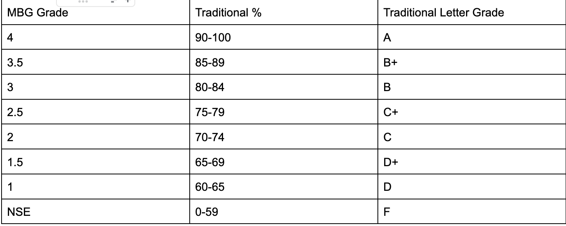  We find this move to MBG to be in line with our CLCS Equity Statement but the change has come with real challenges as young people, families, and staff have had to wrestle with what it means to give and receive feedback based on skills and knowledge that they must “master” with MBG.  We continue to meet about this during staff meetings and get feedback from all stakeholders.
Learning to Learn Classes  ACLC has traditionally offered Learning to Learn in the sixth grade. The middle school staff wanted to do more to support and guide our seventh graders on key topics such as executive function, social and emotional development and career and college readiness. This class is taught twice a week to our 6th and 7th grade learners.  Topics include:  - Confidence Building  - Communication  - Decision Making  - Studying Effectively  - Resolving Conflicts  - Looking To The Future  The 7th grade learners now have further in depth practice with taking notes, preparing for a test, using their planners and Jupiter to check assignments in Learning to Learn. They practice one day a week on academic skills and another day on social and emotional skills. The learners also continue their social and emotional development by covering topics such as mental health, personal identity and expression, exploring and questioning stereotypes, sexual health, and how to de-stress. They end the school year with a service project to foster community involvement. | L2L is focusing more on how to be successful in Middle School following and incorporating our Learner Norms/Outcomes.  As our school expands, we have moved L2L to focus on 6th grade only this year.  The 6th grade learners now have further in depth practice with taking notes, preparing for a test, using their planners and Jupiter to check assignments in Learning to Learn. They practice one day a week on academic skills and another day on social and emotional skills. The learners also continue their social and emotional development by covering topics such as mental health, personal identity and expression, exploring and questioning stereotypes, sexual health, and how to de-stress. They end the school year with a service project to foster community involvement.

SCHOOLWIDE GOAL 3: Effective Interventions & Supports
Rationale and Growth Areas Addressed:
ACLC values our diverse community. As our demographics change and we increasingly accept learners who are behind in literacy and numeracy skills, it is crucial that we meet their needs. As such, we will continue to align resources to better support all learners in becoming college and career ready.

ACLC will use Staff Development time to support all facilitators in increasing their toolkit of effective Tier 1 strategies for use in the general education classroom setting. Administration will examine master schedule and staffing to refine existing Tier 2 supports.

ACLC has created Learning Labs for learners who are not passing their courses. These learners are pulled from one or more Project Periods each week and assigned to Learning Labs - a small-group setting where learners set goals, reflect on progress, and work on project management. An instructional aide takes attendance, monitors learner progress, and provides support during Learning Labs. Facilitators are also required to host two support sessions after school each week that we call MAS (More Academic Support). ACLC assigns learners to these office hours based on the grades and skills in their courses with a monthly data pull of Jupiter and MAP data. We also use web and app-based digital supports like IXL, NoRedInk, Vocabulary.com, and Khan Academy to support our struggling learners. We have also begun a pilot of Lexia’s Power Up Literacy, an online adaptive software program targeted specifically at English Language Learners and learners who are behind in reading comprehension and fluency skills.

2018-2020 changes | 2021-2022 continued changes with updates
Professional Development Strands  The Lead Facilitator took feedback from staff to establish Professional Development strands. The intention is to create professional development that is more intimate and provides an area of focus that the facilitator will appreciate and engage with. The three PD strands this year are Classroom Management, Project Based Learning and Differentiation.  For the 19-20 school year, each teacher has chosen one of the following professional development strands--Equity & Inclusion, Classroom Management, or an Inquiry Collaborative that self-selects a professional development focus. | For the 19-20 school year, each teacher has chosen one of the following professional development strands--Equity & Inclusion, Classroom Management, or an Inquiry Collaborative that self-selects a professional development focus.  This year, our staff are collectively working on our Schools to Watch (S2W) framework which includes the 3 lenses: Social Equity, Development Responsiveness, and Academic Excellence. Through a self-study that has included facilitators observing each other, following students for a “day in the life of” experience, and through discussion and data analysis in PD, facilitators have identified several “low hanging fruit” in each of these domains. This year, our task in PD is to select thes best of these options and then make a plan for implementation going into the 23-24 school year. Look for Schools to Watch (S2W) on our PD Scope & Sequence document HERE for more details.
Facilitator Coaching  A new coaching and supervision model was introduced in 2017-18. Starting in 2017 the admin hired an instructional coach.  The effectiveness was evaluated in January 2019. The results were mixed, with veteran teachers giving positive feedback, and newer teachers wanting additional coaching added to the program.  An outline for an extended onboarding program has been created based on staff feedback in a survey and focus group. This is based on current practices and identified needs. | Over the 21-22 and 22-23 school years, we’ve increased the amount of coaching for our facilitators significantly as we try to better support facilitators and learners coming out of Covid. Caitlin Schwarzman is our Instructional Coach, with over 20 years of experience in education. We increased her hours from approximately 8 hours a week to 20 hours in the school year and have kept these hours at 20 this year. This additional time allows her to meet with all new-to-ACLC facilitators as well as any Year 2 and 3 facilitators. She offers optional support to our veteran facilitators, and at this point, almost all of our facilitators receive some sort of coaching from Caitlin in addition to the support they receive through the Supervision process with the administrative team.
New facilitator induction days and ongoing PD  Working with staff, the Lead Facilitator advocated for a stipend for two facilitators to come and introduce new facilitators to our school. In addition all new staff were stopped to attend. This was a great expense but seemed essential based on feedback from the WASC visiting committee and staff surveys. They were given significant curriculum development time .  In the 2019-2020 school year, the orientation was expanded to two days. This additional day was intended to provide additional time to setting classrooms and to arrange a meeting with our instructional coach. We expect that our retention will remain strong as a direct result of this aspect of our onboarding program. | ACLC continues to offer new facilitator orientation each year. This is led by 1-2 facilitators and an administrator. Here is a sample of the PD onboarding tools:  - Orientation Slide deck  - How to take Attendance  - New Facilitator Onboarding Resources - Here  - 2022-2023 Academic Calendar - Here  - Staff event - Here  - ACLC( Inward facing) page - Here  - Web Page Staff Resources - Here - Password = Facilitators  - ACLC Teaching Practice Library - Here  - Summer info Packet sent to families - Here  - Admissions slidedeck - here  In addition to this support, ALL new facilitators to ACLC receive weekly coaching and onboarding.
Equity and Inclusion Training and Discussions  ACLC has begun an intentional focus on equity through the World Trust organization. We offered all parents and guardians an opportunity to join a discussion on September 27th. We showed the film Cracking the Code and participated in dialogue about what we can do to support equity for all.  All staff participated in year long workshops, both led by World Trust and by our facilitators that explore social impact through film and dialogue. Staff have grappled with both the intellectual and emotional complexities of race. Throughout the year staff have looked at the interconnection between internal and external/structural components of racial inequity, unconscious bias and how it relates to learner performance, and work to understand how self-perpetuating systems reinforce disparities in institutions.  For the 19-20 school year, all-staff professional development focused on rigor and equity in Project-Based Learning--specifically, staff have worked on how to design challenging projects that incorporate skills tied to state standards and how to promote equitable access to project-related resources and full engagement in project work by all students, including those from under-represented groups or with special educational needs. | Given the racial awareness and urgency to address inclusion here at ACLC, our CLCS Equity Statement captures our belief in equity for our learners and families. In the last two years, we’ve started a JEDI (Justice, Diversity, Equity, Inclusion) committee at the ACLC, CLCS, and Nea Board levels and this year, we’ve continued that work with addition of the JEDI Committee to our standing ACLC staff meeting committees. Look for Committees on our PD Scope & Sequence document HERE.  We piloted our Mastery-Based Grading (MBG) initiative based on Joseph Feldman’s “Grading for Equity” framework. In the past two years, we’ve moved to a different grading scale (click HERE) and a different approach to feedback in service of equity for all learners. This model of grading rewards learners for learning the skills and knowledge - whether on the first, 2nd, or 3rd time, and enables learners to “come back” from low scores and re-engage. This approach to feedback and grading is a large example of how we are putting equitable practices into play.  CLCS MBG Grading Policy HERE  Draft notes HERE  MBG grading chart HERE
PD Feedback Forms and Surveys  The Lead Facilitator has established informal communication paths and formal surveys to reflect on Professional developments. He has initiated periodic surveys to get input on the quality of PD as well what folks would like to receive in the weeks to come. In addition, he has created a professional development plan template under the guidance of the Executive Director. She provided a school template to administrators to assist in providing a focus on school improvement efforts.  In the 2019-2020 school year, Professional development was intentionally focused on the needs and direction of the school. It is led by data and our goals within the Charter, LCAP, WASC, and Sustainability Plan. | Staff surveys now happen at minimum once a year, and this year, it will be twice a year. These surveys from the Lead Facilitator serve to gather input from staff on PD (Professional Development) and help change course for the school. A focus on classroom management for 9th grade facilitators, for example, came from this survey, as well as an ongoing focus on Mastery-Based Grading.  ACLC Mid Year Survey 2022
MTSS - Multi Tiered Systems of Support  In alignment with the revised WASC goal the focus of MTSS is to align support systems such that all students are provided the opportunity for academic, behavioral and social success. MTSS implementation creates systemic change through the intentional design of services and supports, allowing for quick identification of and support for the needs of all students. ACLC’s implementation of our MTSS plan began in 2016-17.  3 hours of PD for staff on MTSS systems, creating norms, and IEP review has occurred. A PD strand attended by 1/3 of the faculty met twice in the fall and four times in the spring of the 2018-2019 school year.  The MTSS Team continues to meet weekly. We were bolstered by CAASPP data that shows many of the learners we have targeted are now succeeding. | In the 2022-23 year, our MTSS team continues to meet weekly, and is composed of a rotating team - the Lead Facilitator, Counselor, Truancy Officer, Curriculum & Instruction Lead, and Campus Supervisor all play a role. We again reviewed our MTSS systems in Summer PD and in New Facilitator Orientation training to ensure that all facilitators know how to advocate for support for their learners.  The team consults on the progress of individual learners and potential candidates for Tier 2 and Tier 3 interventions.  MTSS - Flow Chart
Learners of Concern  Learners of Concern is staff-wide time dedicated to identifying learners for additional support, and using collective time to design and implement effective interventions for struggling learners.  In response to feedback from staff, we have retooled our Learners of Concern time to make it more efficient and impactful. Facilitators now come to the meeting ready to collaborate, and a new form has helped create a feedback loop with the MTSS team/admin.  This year, we are also inviting families to these meetings so that we are involving all stakeholders in the process of supporting learners. | This structure is much improved over years past where we would waste time discussing LoC as a whole staff even when only a portion of that staff had that learner. In the past the facilitators would talk in circles about LoC without parents, guardians, or the learners themselves being present, which was a waste of time. Current structure (when applied) asks the learner to take the lead.  We now hold WEEKLY middle and high school LST (Learner Success Team) meetings where we invite learners (and their families) to attend a meeting with their facilitators to share areas of pride and growth before making commitments. These meetings happen Mondays after school. A sample agenda is HERE. This change allows for more of the team to be present and the learners are now leading these discussions.
Credit Recovery  Learners who do not pass a class at ACLC took online credit recovery classes through Edgenuity. As a UCOP-approved provider, Edgenuity offered ACLC a full suite of core curriculum, honors, AP®, credit recovery, and elective courses through. Middle and high school students used a combination of our rigorous online curriculum and face-to-face instruction for initial credit or credit recovery.  In the 2019-2020, ACLC uses BYU extension for credit recovery classes. advancement, or alternative placements. These courses are teacher-led and can be just the right fit if the class can be taken over a full semester. With either option, these partnerships are vital for a small school such as ACLC to be able to offer a full range of courses at the required or desired stage in a learner’s academic career. This program allows us to better track and support learners in the independent courses. | We continue to offer credit recovery for our learners who fail classes, and for the 22-23 year we’ve implemented intersessions in summer, October, February, and April for learners to make up credits in person and online. Now that Covid is largely behind us, we’ve left BYU exclusively for EdGenuity credit recovery courses. This process is overseen by our Guidance Counselor, Amanda Stoner.
Tech Across the School  ACLC is now a 1 to 1 school. We have 30 Chromebooks in every classroom. In addition, we have 45 computers in the Center for every learner to use during project periods. Computers and Chromebooks are maintained by ACLC’s IT specialist.  ACLC’s increase in computers has facilitated learning around the school in many ways. Our tech team has done an exceptional job maintaining computers across the school. They help us to have learners working on one project as they move from room to room to the Center. | ACLC continues to be a 1:1 school, with more than 1 device (Chromebook or desktop) for each learner.  ACLC has added a full-time IT support member (team of 2 now) to support all technology issues. A great example of learners using technology was ACLC’s involvement in the eCYBERMISSION contest, where we’ve had teams take 1st, 2nd, and 3rd place in the past 2 years.
Implementation of the Mandatory Academic Support (MAS)  ACLC has implemented mandatory after-school homework and support. Learners can complete homework and get tutoring from their facilitators. In many cases they are taking test upgrades or getting a chance to review or get support with a project. MAS operates from the end of 6th period until 4:00 Monday, Tuesday, Thursday, and Friday. Each facilitator holds MAS at least twice a week. Also, we now provide facilitators with flexibility on the day MAS is provided. This has provided a great deal of flexibility to assign as many as four days of after school support per week.  These changes support us in progress towards goals 1, 4 and 6. Learners can both voluntarily attend MAS and can be assigned by facilitators or the Instructional Aide. Staff use Jupiter reports and MAP test scores to trigger assignment to MAS. Our new campus supervisor holds learners accountable for their attendance.  MAS has been expanded to four days each week, offering two additional chances for learners to stay for extra support.  Every four weeks, Learning Labs and Mandatory Academic Support (MAS) are reassigned based on grades, MAP Assessment data, and facilitator recommendations.  In consultation with the counselor and the instructional aide, the scheduling process for Learning Labs and MAS has been updated to include distributing paper copies and messaging learners via Jupiter to let them know of schedule changes. This has led to more consistency and clarity at the beginning of each cycle.  We continue to see improvement in GPAs, passing rates, and MAP scores in the vast majority of our learners. Data has shown that more work still needs to be done to help our lowest performing learners. Learners are now earning As and Bs at higher rates and NC/Fs at lower rates. | All teachers/ facilitators have office hours to help out with the students who need some extra help every Monday to Friday. Facilitators help learners before school from 8:10-8:30, during MAS/Office Hours from 3:30-4pm, and often on their lunch or prep. periods as well as during Project Periods.  We still struggle with attendance at Office Hours, and have shared template emails and phone call scripts with facilitators to help them with parent contact and have started an Office Hours Tracker this year to give us better information on attendance.  The switch to Mastery-Based Grading has played a role in our failure rate as well, with fewer learners earning NSEs than Fs in previous years. We will have to see if this is a stable trend.  When we meet with middle and high school families every Monday, we often require Office Hours/MAS for learners for a 4-6 week cycle while they are working to improve their grades. A sample agenda is HERE.
Learning Labs during Project Periods  With the addition of an Instructional Aide, ACLC is able to assign Learning Labs during individual learners project periods. We use grade data and learners schedules to make the assignments. All Labs have between 3 and 7 learners. In Learning Labs, Jessica is able to establish a rapport with learners given the small numbers.  In addition to expanded Learning Labs, Math Labs have also been added to ACLC’s program. Learners have been identified through test scores and facilitator recommendations. | For the 21-22 and 22-23 school years, the Instructional Aide hours are now full time. This allows us to offer Learning Labs throughout the week, and our counselor continues to pull grades quarterly to assign and re-assign learners into Learning Labs. These courses go on schedules and are shared with learners and their families. This role and this process ensures that no learners are “slipping through the cracks” and learners also receive coaching in time management and self-advocacy during this time. Learners will have between 1-5 Learning Labs depending on their schedules each week
Math Labs During Project Periods  Our Instructional Aide is exceptional at math and is able to run intervention classes for learners struggling in math. She coordinates with the math facilitators to preview or review concepts learners need to be successful in their math class. In some cases she is able to provide learners an opportunity for a test upgrade. Learners utilize project periods to work with Jessica in math labs. In other cases she assigns learners math lab during project periods in order to ensure the support is happening.  In the 2019-2020 school year we are not using specific math labs. The individual math lab assignments proved to be nearly impossible to schedule learners with our math specialist.  This year we have expanded learning labs to the first four periods of every day. Our new instructional aid continues to network with math facilitators and provide specific support and tutoring. Just is a room that has learners assigned from other subjects as well. | For the 22-23 school year, we have new math facilitators at the middle school level. As a result, we are holding off on starting Math Labs until Semester 2, or possible the 23-24 school year. We want to ensure our new facilitators have adequate time to plan, grade, teach, and communicate as they start with us. These learners still get support in MAS/Office Hours and Learning Labs, and our high school math facilitators support struggling math learners in Project Periods as well.
Addition of ELD classes for English Language Learners  ACLC has never had more than a few level 1 and 2 learners. With our changing demographic, our Lead Facilitator created an ELD enrichment and courses for emerging language learners. In addition he worked with our neighbor school to enroll our learners into ELD1 or ELD2 classes at Nea Community Learning Center.  In 2019-2020 ACLC continues this partnership with our Nea partner.  ELD classes continued throughout the 2018-19 school year, and our dashboard results show a 73% increase over the state average for Level 4. | After having the job posted for almost 2 years, we were able to hire a qualified ELD Coordinator & Facilitator in October of 2022. This allows us to provide direct support to our emerging bilingual learners in 1:1, small group, and push-in settings, as well as to provide administrative support in terms of testing, family engagement, and other legal requirements. We are committed to continuing with this position and refining the role to best meet the needs of our English learners.
Provide Academic Support for English Learners  ACLC has appointed an EL teacher and implemented 2 sections for English Learners enrichment regardless of the low number of students, with class size usually under 10 students. The facilitator monitors EL student progress and assists with administering EL state assessment for ACLC reclassification and conducts meetings with EL parents. In addition, we are partnering with our sister school Nea Community Learning Center to provide ELD courses for our level 1 and 2 learners.  Lexia: Begin using Lexia software in Semester 2. Lexia is a computer-based, adaptive reading instructions program that has built in assessments and independent, engaging work that meets learners at their level, teaches them new reading skills, and generates easily accessible data around reading growth. We will be using Core5 Reading for learners with elementary reading skill levels, and PowerUp Literacy for learners with 6-12 skill levels.  - Signed up for 60 licenses and included professional development for adults  - Training for EL facilitators and administrators before Winter Break (12/20/2019)  - We will begin using program with English Learners after break in EL sections for learners, Project Periods for designated ELD | After having the job posted for almost 2 years, we were able to hire a qualified ELD Coordinator & Facilitator in October of 2022. This allows us to provide direct support to our emerging bilingual learners in 1:1, small group, and push-in settings, as well as to provide administrative support in terms of testing, family engagement, and other legal requirements. We are committed to continuing with this position and refining the role to best meet the needs of our English learners.
MAP Screening Assessment used for math placement  ACLC math department has begun to use the NWEA screening assessment to assess learners for the best math placement when learners enter ACLC.  This assessment provides valuable data to place learners into the appropriate middle school class on day one. Previously, ACLC math facilitators would recommend math advancement sporadically. These assessments were offered to learners before the school year began so that learners class placements were made prior to day one. | ACLC continues to give learners a chance to move up to the next grade level or math class at the start of the year and the semester mark. Cut-off points are determined by facilitators based on previous success of learners moving up. Space and ability to move up is dependent on union contract (class sizes) and schedule of individual learners.
Addition of an Instructional Aide  ACLC has hired an Instructional Aide to support struggling Learners. She leads Learning Labs and Math Labs during the day.  Our Instructional Aide identifies learners using course grade, MAP data, and is integral to our Multi-Tiered Systems of Support (MTSS) Team that meetings weekly | ACLC continues with a full-time Instructional Aide who supports struggling learners in Learning Labs. Learners are moved into/out of Learning Labs once/quarter based on grade data.
Addition of a Campus Supervisor  ACLC Campus Supervisor facilitates campus sweeps, supports our hot lunch program, performs yard supervision during lunch, works with learners as an after school supervisor, and collaborates daily with leadership learners to ensure they are fulfilling responsibilities assigned to them. In addition, the Campus Supervisor will run reports on attendance and tardies to provide interventions with learners that need reminders and positive reinforcement.  In the 2019-2020 school year we have continued to work with the campus supervisor to reach learners and keep them on campus. | ACLC continues with a full-time Campus Supervisor. In 2022, our Campus Supervisor left us in the middle October to work closer to home. As of this date (11/15/2022) the job is still posted.  We have also hired a Center Supervisor, who will support full time in ACLC’s Center with Project Periods.
Addition of a Truancy Officer  Our Truancy Officer position has aligned Practices to Support Efforts to Reduce Chronic Absenteeism, Truancy, and Dropouts. It is a priority for ACLC to reduce chronic absenteeism and prevent/recover dropouts.  Her duty as the attendance supervisor is to promote a culture of attendance and to establish a system that accurately tracks attendance in order to ensure that ACLC learners with attendance problems are identified as early as possible to provide applicable support services and interventions. | Our Office Manager continues in this role, as we increased her hours from 80% to 100% FT to take on these additional tasks, which include running attendance reports and setting up / facilitating SART (Student Attendance Review Team) meetings with administration.
Universal Design for Learning (UDL)  ACLC partnered with our SELPA to provide a full-day Professional Development and two follow-up workshops on UDL. We were taught how to plan through the lens of the Universal Design for Learning framework in order to reach all learners by planning for their learning barriers before the instruction begins. Staff utilize the three principles of UDL to create lesson plans.  In our most recent charter renewal the team at AUSD recommended that we continue with UDL professional development for the team.  Subsequently, our director of Special Education worked with the MTSS Team and Michael McCaffrey to provide more opportunity to think about providing various ways to present information, choice in assessment, common and consistent management strategies. | ACLC continues to incorporate UDL stragegies into Professional Development threads - both with New Facilitator Orientation and within our weekly Wednesday meetings. ACLC also continues to offer support from the Special Education team to teach Tier 1 support strategies to all facilitators.  ACLC Scope & Sequence HERE
Professional Development on Trauma Informed Practices  Our SELPA provided two trainings on Trauma Informed Practices. When we originally planned this, we were thinking we would focus on providing this training to our counselors, ed. specialists and paraprofessionals. We decided that it would be a good idea to strategically add some facilitators to the group.  Examine the definition of trauma and the impact on a student's social-emotional functioning, learning, and development  Explore ways to transform school culture through the use of trauma-informed approaches to understanding and responding to student behavior  Review how Positive Behavioral Interventions and Supports (PBIS), mindfulness, and restorative practices can be utilized to enhance existing school-wide approaches to supporting students who have experienced trauma  Discover the importance of ongoing training and self-care for educators, service providers, and families | ACLC continues to incorporate UDL strategies into Professional Development threads - both with New Facilitator Orientation and within our weekly Wednesday meetings. ACLC also continues to offer support from the Special Education team to teach Tier 1 support strategies to all facilitators.  ACLC Scope & Sequence HERE
New Learning to Learn Classes  ACLC has traditionally offered Learning to Learn in the sixth grade. The middle school staff wanted to do more to support and guide our seventh graders on key topics such as executive function, social and emotional development and career and college readiness. This class is taught twice a week to our 6th and 7th grade learners.  Emilie Scott and Beth Cutright are facilitating these courses. Topics include:  - Confidence Building  - Communication  - Decision Making  - Studying Effectively  - Resolving Conflicts  - Looking To The Future  The 7th grade learners now have further in depth practice with taking notes, preparing for a test, using their planners and Jupiter to check assignments in Learning to Learn. They practice one day a week on academic skills and another day on social and emotional skills. The learners also continue their social and emotional development by covering topics such as mental health, personal identity and expression, exploring and questioning stereotypes, sexual health, and how to de-stress. They end the school year with a service project to foster community involvement. | ACLC continues to offer Learning to Learn in the 6th grade only. Topics continue to include previous topics, with course facilitators including new material to meet current need.
New Current Life Issues (CLI) for all 9th Graders  ACLC needed a specific place to nest Health and Wellness and career and college readiness topics. The health material itself focuses on Health from a Wellness approach. The class is taught by our middle school humanities facilitator who has a credential in counseling.  Current Life Issues (CLI) focuses around 6 core units that align with California State health education standards. Learners will complete units on Nutrition and Physical Wellness, Substance Abuse, Non-Communicable Diseases, Comprehensive Sexual Education, and other topics pertaining directly to what learners are eager to learn.  In addition, learners will complete more technical units on College and Career readiness. They will complete projects on their goals after highschool and research both colleges and job opportunities in depth. Learners will be able to identify their college and career goals as well as have an introductory understanding of the college process. | ACLC continues to offer Current Life Issues (CLI) for all 9th graders. Course topics are similar but range from year to year depending on facilitator-assessed need for learners.  The sexual health unit is a staple of this course, and is ACLC’s way of ensuring that all high school learners receive sexual health instruction.
Implementation of online remediation and acceleration classes (BYU and EdGenuity)  We often have had the need to support learners with course remediation. Given that we do not have summer school, learners needed a place other than the Junior College to remediate a semester class.  ACLC is currently working with EdGenuity, and will begin working with BYU effective June 2020 to support learners as they retake academic classes for credit recovery.. These programs are UC approved and provides utility for our counselor to follow and track the progress of learners. | ACLC continues to offer course remediation opportunities via online sources. After Covid, we moved away from BYU but continued with EdGenuity. These courses and credit remediation are overseen by the school counselor, and include regular updates to and meetings with families and learners.  We have started offering these courses earlier in the high school trajectory so learners are not struggling with a lot of “catch-up” work to do in Junior and Senior year of high school.

Comment on the process for implementing and monitoring the schoolwide action plan/SPSA aligned with LCAP goals.

ACLC has a variety of processes to implement and monitor our plans and related goals. These are outlined briefly below:
- ACLC Board
  - The Lead Facilitator makes bi-monthly reports at the ACLC Board meeting, which has facilitator, learner, parent, and community members. These reports include LCAP and WASC goals as well as related action or staffing items as we work towards these goals. These reports also include relevant academic testing data.
- CLCS Board
  - The Lead Facilitator makes quarterly reports at the CLCS Board, which has facilitator, learner, parent, and community members from across both CLCS schools - Nea and ACLC. These reports include LCAP and WASC goals as well as related action or staffing items as we work towards these goals. These reports also include relevant academic testing data.
- Schools to Watch
  - Since the end of the 2019-20 school year, Lead Facilitator Michael McCaffrey has been implementing the Schools to Watch self analysis tools. This nationally recognized organization studied thousands of schools with middle school programming, and created a set of rubrics and criteria for continual self improvement of schools so that they may become “Schools to Watch.” ACLC continues to use this Schools to Watch “lens” as part of our ongoing self-study process.
- Committees & Departments
  - Within our Professional Development trajectory each year, our committees (Personnel, Finance, Assessment & Accountability, Curriculum, Culture, and JEDI - Justice, Equity, Diversity, Inclusion) and departments (English & Language, History, Math, Science, Arts & Activities) work with the administration to move our goals and initiatives forward. Our committee leads present regularly at ACLC Board meetings to keep our wider community apprised of progress and next steps.

Comment on the original critical areas for follow-up (growth areas for continuous improvement) not in the current schoolwide action plan/SPSA.

All areas indicated for growth and continuous improvement were built into our current schoolwide action plan / SPSA. Using input from all of our stakeholders, we have consolidated, simplified, and updated our WASC and LCAP goals to be the same 3 overarching goals for this WASC accreditation cycle and until the data tells us these goals are met or no longer the priority focus areas:

SCHOOLWIDE GOAL 1: Data Collection, Analysis, & Response
Rationale and Growth Areas Addressed:
ACLC values our democratic model and participation by all stakeholders in our community as well as data-based decision-making. As such, we will regularly collect, analyze, & respond to data from multiple stakeholder sources as well as academic data in order to increase program effectiveness and respond to community need.

This will happen in the instructional program via curriculum-embedded assessments as well as external, standards-aligned assessments like MAP & SBAC/CAASPP. We will use Staff Professional Development time to make meaning of, plan around, and respond to this data. We will continue to work with our staff in using formative assessments as well as summative assessments in determining instructional moves.

We will continue to use school-wide structures like our Leadership class and schoolwide events like “ConCon Day” (“Constitutional Convention Day”) as well as surveys of our staff, learners, and guardians to gather information about other aspects of ACLC’s programming, and use the ACLC Board as a vehicle to make meaning of and respond to this data.

SCHOOLWIDE GOAL 2: College & Career Readiness
Rationale and Growth Areas Addressed:
ACLC will align resources - human, financial, and programmatic - to ensure that all learners are given access to standards-aligned instruction that will prepare learners for the diverse rigors of college as well as receive information and personalized support in learning about college and career success for all.

Through a relentless focus on Common Core Standards and a continual push to combine appropriate rigor and scaffolding supports, we will work to ensure our staff deeply understand and are actively teaching relevant standards. Given our Project-Based Learning (PBL) approach, this means focusing on standards-aligned projects that engage learners in authentic demonstrations of learning.

Through a combination of staffing, curriculum choices, scheduling, and schoolwide events, we will ensure that learners graduate eligible and prepared for 4 year college and meaningful career options. We will also expose learners to a variety of career choices and their associated pathways by the time they graduate from ACLC via curriculum, special education, and counseling staff activities.

SCHOOLWIDE GOAL 3: Effective Interventions & Supports
Rationale and Growth Areas Addressed:
ACLC values our diverse community. As our demographics change and we increasingly accept learners who are behind in literacy and numeracy skills, it is crucial that we meet their needs. As such, we will continue to align resources to better support all learners in becoming college and career ready.

ACLC will use Staff Development time to support all facilitators in increasing their toolkit of effective Tier 1 strategies for use in the general education classroom setting. Administration will examine master schedule and staffing to refine existing Tier 2 supports.

ACLC has created Learning Labs for learners who are not passing their courses. These learners are pulled from one or more Project Periods each week and assigned to Learning Labs - a small-group setting where learners set goals, reflect on progress, and work on project management. An instructional aide takes attendance, monitors learner progress, and provides support during Learning Labs. Facilitators are also required to host two support sessions after school each week that we call MAS (More Academic Support). ACLC assigns learners to these office hours based on the grades and skills in their courses with a monthly data pull of Jupiter and MAP data. We also use web and app-based digital supports like IXL, NoRedInk, Vocabulary.com, and Khan Academy to support our struggling learners. We have also begun a pilot of Lexia’s Power Up Literacy, an online adaptive software program targeted specifically at English Language Learners and learners who are behind in reading comprehension and fluency skills.

Chapter II: Student/Community Profile and Supporting Data and Findings
Tell the story of your school through the use of data and information. This thorough examination of the school includes:
- The history and background of the school
- A description of the school programs

Alameda Community Learning Center (“ACLC”) operated by Community Learning Center Schools (“CLCS”) will follow any and all federal, state, and local laws and regulations that apply to the Charter School. The school is centered by one large one-room schoolhouse space with 16 break-out classrooms. We currently share our campus with Nea Community Learning Center, which is a K-12th-grade charter school. We are chartered through the Alameda Unified School District (AUSD).

The Alameda Community Learning Center is an educational model that seeks to create a dynamic learning community by embodying the best practices of teaching and learning in a noncompetitive manner, supporting individuals to actively discover their own potential, recognize their own value and worth, and practice responsibility to the community. ACLC believes in the importance of participatory governance to empower learners, parents, and facilitators to create a great educational program. ACLC is dedicated to a self-directed project-based learning experience to achieve its educational goals. To this end, ACLC provides a safe, connected, and flexible learning community. The program places emphasis on developing reading, writing, and speaking skills to enhance understanding and effective communication; using the tools of art, math, and science to become aware of how the universe works and to create novel tools; and developing an understanding of how government, economics, and the social sciences impact individual and global interactions. Based on their knowledge and developmental level, learners design their own goals and life plans, including responsibility to others and active citizenship. We embrace the idea that this is an ongoing process of continual change and improvement, and we seek to provide each learner with the support needed to succeed.

We believe that an approach that empowers learners, provides them individualized support (from adults, older learners, and peers), and sets the highest academic, social, and ethical expectations, is by far more likely to achieve these goals than a more traditional educational practice. We provide all learners with a rigorous, common core based curriculum, that promotes the practice and mastery of California’s Common Core State Standards (“CCSS”) by offering self-directed, project-based learning opportunities that address multiple interdisciplinary standards.

Community Learning Center Schools (CLCS) is a Nonprofit Public Benefit Corporation (prior to 2006, the name of the corporation was Alameda Community Learning Center) and operates the Alameda Community Learning Center, a 6-12 grade program. The school has been located on the previous Woodstock Elementary School site, in the City of Alameda, for five years.

This period of stability has been welcomed by the community. In context, ACLC was moved at the end of 2012-13 and again in 2013-14. After 18 years on the Encinal Campus, ACLC was relocated by Alameda Unified in 2013, clearing the way for a new middle school. Encinal is now a 6-12 community-based school. Although we were proud that our successful model was replicated, it was terribly sad to be moved from the large center that our school was formed around. The community came together in negotiations with the district, but ultimately accepted the only viable offer presented. ACLC was moved across town to Wood Middle School.

After an emotional and challenging summer, ACLC opened the new campus on Grand Avenue. Wood Middle School was an extremely difficult neighbor, as many of their classrooms were relocated in order to make room for ACLC. We moved, painted, and decorated a worn-down facility only to learn that the district would be making a different facilities offer the next year in February of 2014. The community was once again devastated.

Following the move to the current location in the 2014-15 school year, the community has worked extensively to improve the campus and make it a home. 1900 Third Street was another challenging transition for the entire community. We are back on the west end of town and now are forced to compete directly with our sister school, Nea Community Learning Center, and another neighbor charter middle school, The Academy of Alameda. In addition, Encinal High School expanded its program to include a middle school named Junior Jets. This high concentration of school options has affected enrollment, school culture, learner retention, and our capacity to attract Alameda residents.

Still, there are benefits from the close proximity to other schools. After our simultaneous move to one site in 2014, ACLC and Nea have worked collaboratively to make a series of changes that have empowered both schools. The collaboration has been fueled by Executive Director Annalisa Moore. She has brought in two exceptional school leaders who have been charged with implementing collaboration and a spirit of teamwork. ACLC’s Lead Facilitator Michael McCaffrey leads ACLC’s communication with Nea and the CLCS office. Most recently, the addition of a CLCS office, 2 ACLC classrooms, 3 Nea classrooms, and a new set of bathrooms demonstrates how well the schools have been on the same page financially and culturally.

ACLC Vision and Mission

The Alameda Community Learning Center Mission Statement:
The Alameda Community Learning Center is an educational model that empowers all youth to take ownership of their educational experience, to celebrate their diverse community, and to actively participate as members in a democratic society.

One of the most unique aspects of ACLC is its method of governance, which establishes a power structure in which decision-making authority is shared between learners, parents, and facilitators. The broad array of organizational functions – legislative, judicial, and executive – is deeply embraced within the community. This approach is congruent with the ACLC philosophy that learning is experiential and incorporates not only the content but also the process of the learning experience.

The ACLC board acts as the primary programmatic governing body of the school and is charged with development and oversight of policy, budget, personnel, organizational development, strategic planning, and maintenance of the vision of the ACLC charter. The governing board is comprised of two facilitators, two learners elected from the whole body of learners, two parents appointed by the learners and facilitators, one member from the school administration, and two community members. All decisions of the governing board are made by a majority vote of its members unless otherwise specified by the charter or in bylaws.

ACLC facilitators are not traditional subject matter instructors. They provide a combination of direct classroom instruction and facilitation of self-directed learning experiences. Classes are designed so that substantial amounts of learning take place outside the classroom and at learners’ individual direction. Facilitators have scheduled “floor time” in their workweek to meet individually with learners and interact with the learner community. Learners have “project periods” that allow them to accomplish a number of self-directed goals. Similar to time between classes in college, ACLC learners have time to get organized, collaborate with peers, work on projects, communicate with facilitators via Jupiter Grades or talk to facilitators directly in the Center or in a classroom.

Project Based Learning is the strongest feature of our assessments at ACLC. In PBL, students are active, not passive; a project engages their hearts and minds, and provides real-world relevance for learning. The Common Core and other present-day standards emphasize real-world application of knowledge and skills, and the development of the 21st century competencies such as critical thinking, communication in a variety of media, and collaboration. PBL provides an effective way to address such standards. After completing a project, students remember what they learn and retain it longer than is often the case with traditional instruction. Because of this, students who gain content knowledge with PBL are better able to apply what they know and can do to new situations.
As a PBL school, ACLC has worked with the Buck Institute, now called PBL Works, to encourage facilitators to utilize projects to create authentic and meaningful learning experiences that involve:
- Challenging and relevant problems/questions
- Inquiry
- Learner choice and voice
- Reflection
- Revision and Critique
- Going beyond the classroom to a greater audience
http://www.bie.org/object/document/pbl_essential_elements_checklist
Empowering the learner body is central to our mission. Learners are encouraged to direct their own learning and take on leadership roles at ACLC. For example, learners:

- Call Facilitators by their first names
- Have their own self-created school rules and Bill of Rights
- Write up others for violating ACLC rules and serve JC jury duty
- Plan most major school-wide events
- Organize and plan school-wide seminars
- Choose how to spend their Project Periods
We strive to have a culture were adults and youth are equal, based on the core belief that we are educating people, not children. With that stated, learner empowerment is well-witnessed in two programs at ACLC: the Judicial Committee and Leadership. First, the Judicial Committee (JC) is a learner-run process of helping the community abide by the rules. Patricia Williamson was facilitator of JC for almost a decade, and upon her retirement our counselor and a facilitator then took this on. Elected learner clerks run the proceedings.

If a community member is written up for rule breaking by another community member, JC pulls the community member from class and holds a hearing and guilt or innocence is determined. If guilty, a consequence designed to give back to the community or to help the community member is given.

In addition to JC, Leadership is a class in which learners review and decide the outcome of proposals (learners and facilitators may propose to change or add existing ACLC rules), assist in supervising the Center, and plan community events, such as CCC each Wednesday, ConCon (Constitutional Convention), Gain Some Knowledge Day, etc. Molly Fenn, a veteran facilitator, is the facilitator for Leadership. Learners in grades 7-12 are represented in the course.

ACLC’s Expected School-wide Learning Outcomes

Empowering our learners to achieve is at the core of the ACLC ESLRs. Alameda Community Learning Center began as an idea and dream of the founders to create a school that would be open to all students, many who were not engaged or challenged in their current educational settings. It was the founders’ contention that exposing the learners to a college prep curriculum, providing them with a collaborative environment in the Center, cultivating democratic values within the school and exposing them to college life would result in graduates motivated to go on to college and be successful. This dream has pervaded ACLC; learners, staff and parents all believe in the purpose for the school; it is the “DNA” of the school and we all take direct ownership for the fulfillment of this dream and theses School-wide Learner Outcomes.

Our goal is that all graduates will:

Demonstrate the personal qualities, work habits and attitudes that promote lifelong learning
- Ability to effectively plan and manage time and tasks
- Knowledge of career options and pathway to their achievement
- Effective self-reflection, assessment and revision of actions and products
Demonstrate competency in academic measures
- Exceed AUSD graduations requirements
- Succeed on traditional assessment measures
- Achieve subject matter competency
- Successfully meet college entrance requirements
Demonstrate critical thinking and reasoning skills
- Use efficient learning techniques to acquire and apply new knowledge and skills
- Generate new ideas; dreams and plan for the future
- Recognize and solve problems
- Understand underlying rules and principles and draw logical conclusions
Demonstrate superior interpersonal and collaborative abilities
- Produce high quality group projects for a variety of audiences
- Function in various group roles
- Contribute cooperatively to a group effort
- Exercise leadership and work with diversity
- Help others learn
Demonstrate technological literacy
- Be able to select and apply appropriate technology to task
- Effectively use technology to critically gather information
- Choose appropriate technology to communicate ideas
Demonstrate the ability to engage in a participatory democracy
- Give back to the community and recognize the needs of others
- Participate in democratic process, including judicial and governance structures
- Take ownership and responsibility for well-being of the community and themselves
- Participate in decisions that affect their own learning experience

California School Dashboard Performance Overview and other local measures

Due to the COVID-19 pandemic, state law has suspended the reporting of state indicators on the 2020 and 2021 Dashboards. Thus, our most recent Dashboard data is from 2019 (see screenshot below), and summarized in our previous WASC report. Given the lack of Dashboard information, ACLC used a variety of other data points to make decisions in guiding the school (after screenshots).

2019 Dashboard Screenshot:
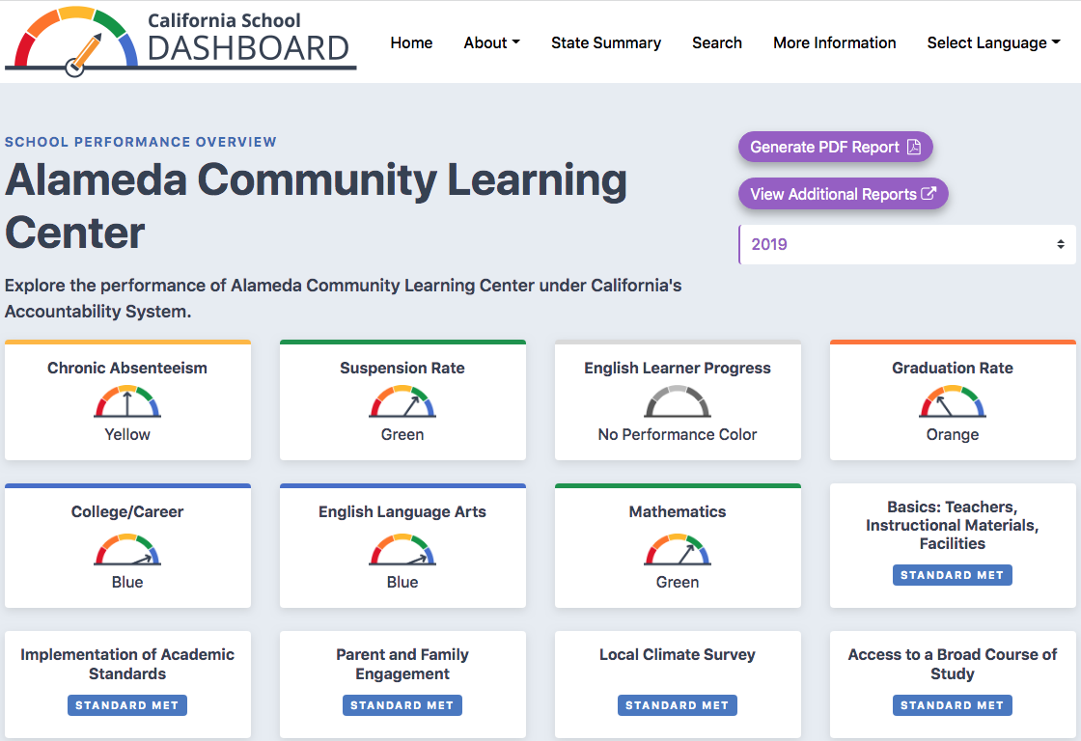

2021 Dashboard Screenshot:
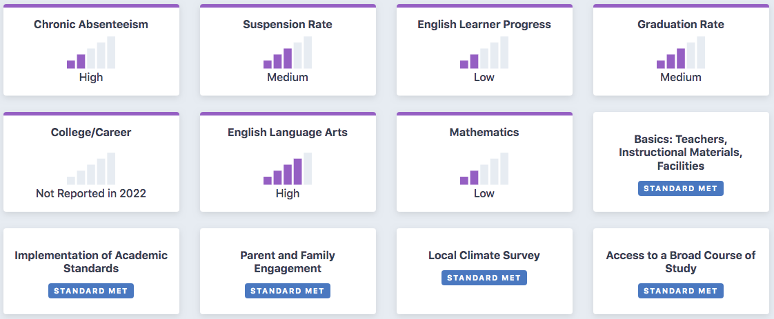

Enrollment: ACLC is diverse and we reflect the diversity from across the Bay Area and State of California
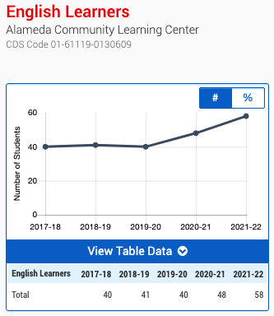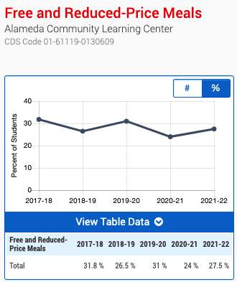
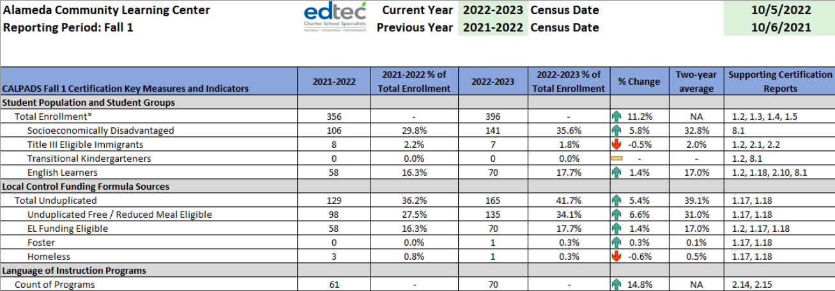
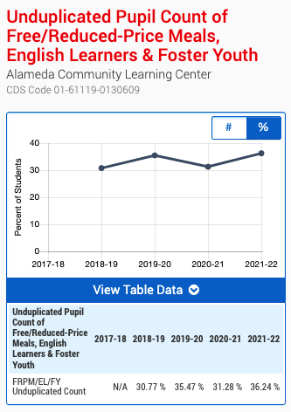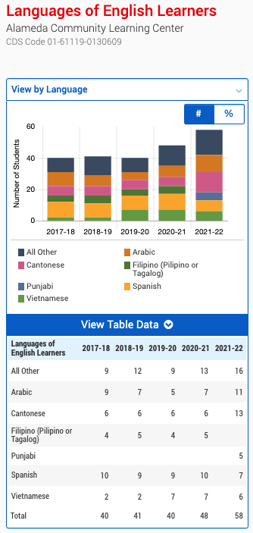

CAASPP Data:
In the absence of Dashboard indicators, ACLC relies on a variety of local measures and data. The first set of screenshots is of our CAASPP data from most recent testings at the end of last school year (2022) and from the previous administration in 2019. In some cases, there was no data available for one or more testing administrations - this is indicated in the labels of each piece of data.

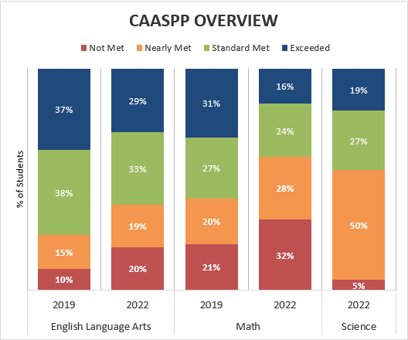

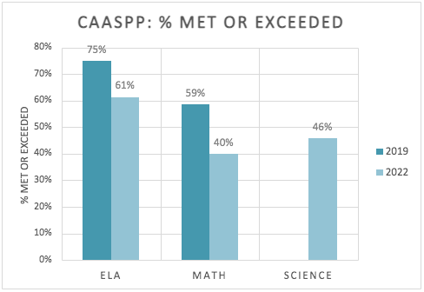

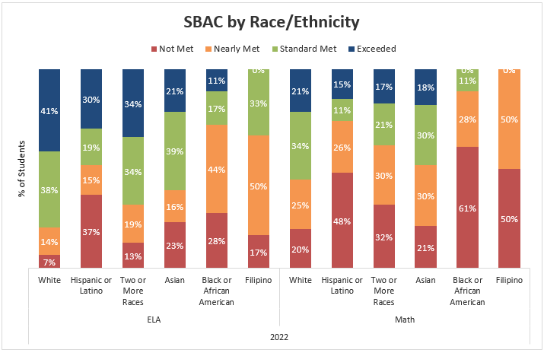

a

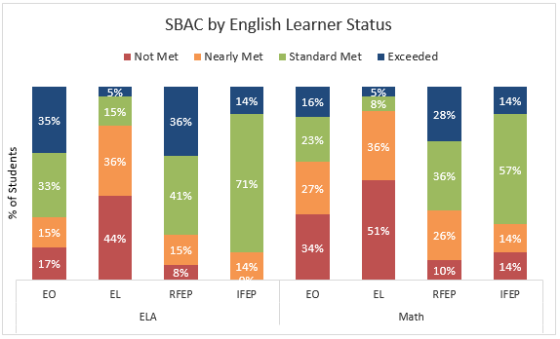

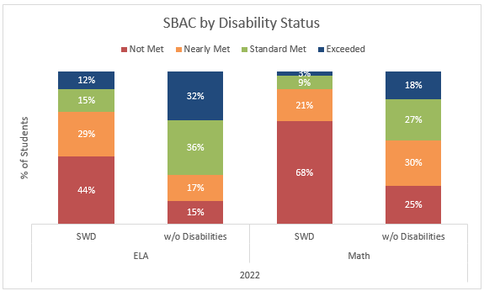

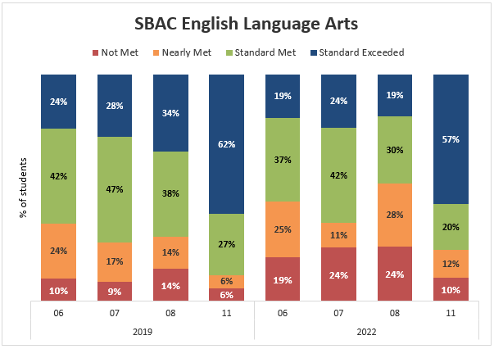

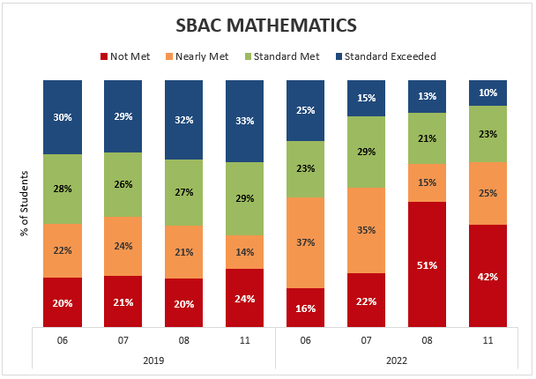

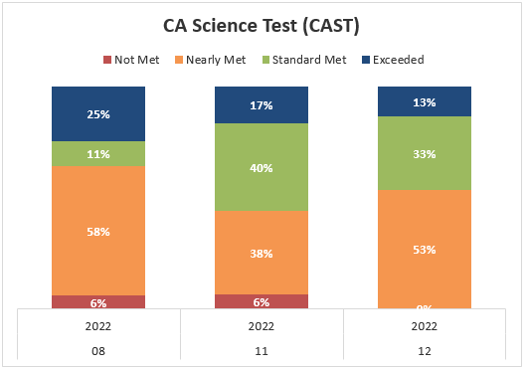
CAASPP
- Trends & Exceptions (what do you notice?)
White and Asian (non Filipino) learners are over-performing all other ethnic groups. Learners with disabilities and English language learners are performing below non-ELL or learners without disabilities.

- Summary (what is this data showing overall?)
Learners overall are performing lower than they were 3 years ago; only in ELA are the majority of learners meeting or exceeding standards.

- Implications (why does this data matter?)
It shows the areas that should be improved such as mathematics and science, particularly for students of color, learners with disabilities, and ESL. We need to do a better job supporting these subgroups at our school.

- Takeaways:
  - What are 2 or 3 learner needs that this info surfaces?
    - Regarding standardized tests, learners are struggling with the STEM aspects of the test.
    - Learners of color, learners with disabilities, and ESL test results show that the material mastery or knowledge thereof is not being met.
  - What questions should we discuss further?
    - How can we bridge the gap between performance among identified groups?
    - What school-wide, and individual interventions are capable for us to implement effectively?
    - What structural adaptations do we need to make to our existing interventions?
    - How do we equitably implement interventions given the bias shown by the data? And do so in a culturally appropriate manner?
    - Why are these gaps happening?
    - How can the transfer of success happen for all groups of learners?
    - Class of 2024 may statistically outperform previous groups, how do we prevent that from blurring the data?

MAP Data:
This next set of screenshots is from NWEA’s MAP (Measures of Academic Progress®) data for the past few years. Please note the labels at the bottom of each data point. Where no data is present or specific sub-groups are not called out, this is because there is no statistically significant data from these groups.

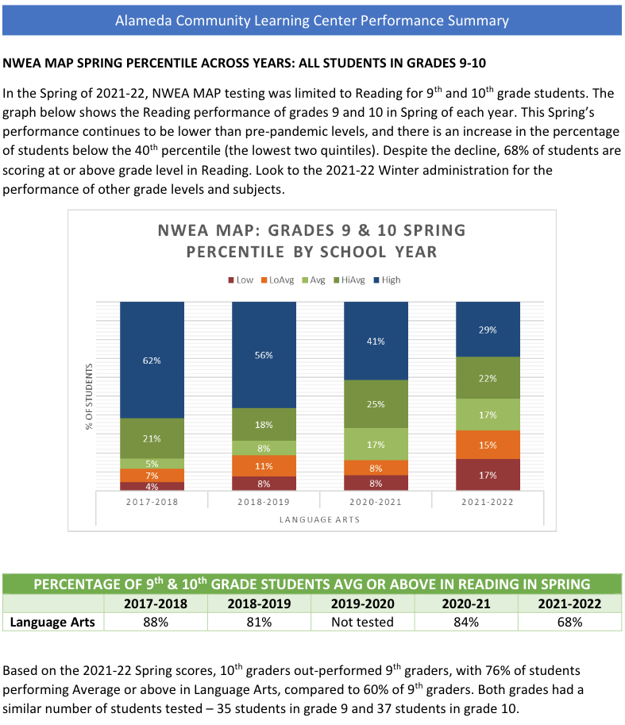

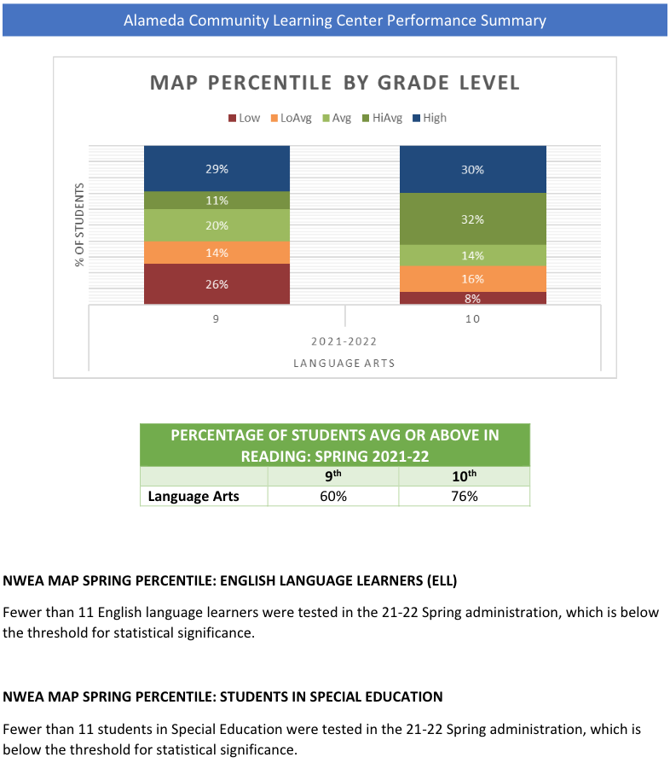

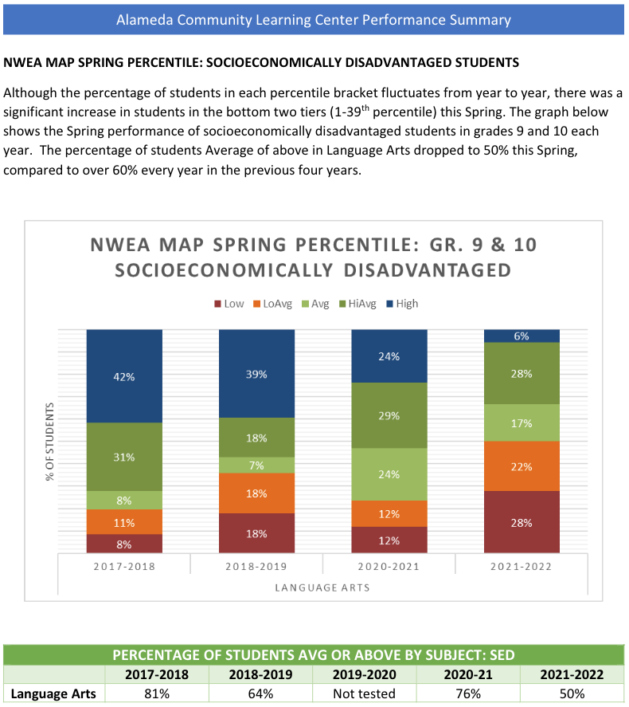

Fall => Winter => Spring - gradelevel schoolwide results 2020 to 2022
- Reading Schoolwide Results
- Science Schoolwide Results
- Math Schoolwide Results

MAP Data
- Trends & Exceptions (what do you notice?)
  - MAP Math, Reading, and Science test scores during the 2020-2021 school year were higher than they have been since, though the most recent MAP Math scores are improving.
  - The current 6th grade class tests well across the board.

- Summary (what is this data showing overall?)
  - Performance continued to decline as the shelter-in-place period extended to months and into additional school years. In later years older and younger learners seemed less impacted than those that experienced Covid and shelter-in-place in their middle school years.

- Implications (why does this data matter?)
  - The scores from 2020-21 might not be reliable because the tests were administered over Zoom. It is possible disproportionately higher performing learners took the tests.
  - It is probable that learners, especially those who were in middle school during quarantine, experienced learning loss in all subjects.

- Takeaways:
  - What are 2 or 3 learner needs that this info surfaces?
    - In general, our learners are behind where they should be academically and suffered learning loss during the past few years. We need to continue to support them academically as well as emotionally and continue to build skills over time.
  - What questions should we discuss further?
    - What are the needs of learners who were in middle school (6th and 7th grades) during quarantine and experienced significant learning loss?

Other Local Measures
The SARC (School Accountability Report Card) - Below are links to ACLC's most recent SARCs:

ACLC 2021-22 SARC: ENGLISH SPANISH

ACLC 2020-21 SARC: ENGLISH SPANISH

ACLC 2019-20 SARC: ENGLISH SPANISH

Teacher Credentials / Teacher Assignments and Mis-Assignments
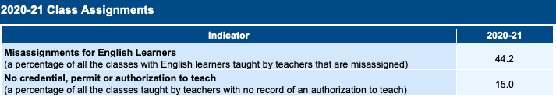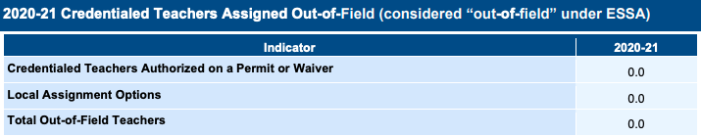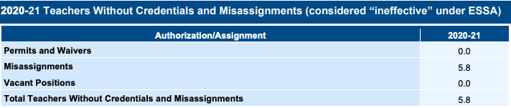
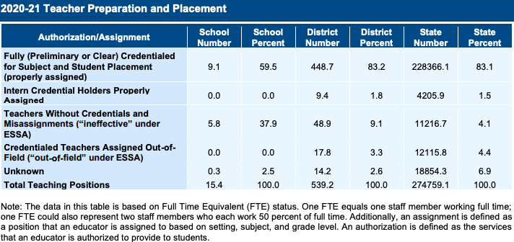

SARC
- Trends & Exceptions (what do you notice?)
  - We have 59% fully credentialed facilitators compared to the state average of 83.1% for the state
  - We have 37.9% facilitators teaching without credentials compared to 4.1% for the state
  - We have 1.8% drop out rate for the 2020-2021 school year compared to 9.4% at the state level
  - We have been increasing our graduation rate over the past 3 years, currently at 89.1% compared to the state average of 83.6%

- Summary (what is this data showing overall?)
  - ACLC has facilitators who are not fully credentialed for the subject area they teach and facilitators teaching classes where they do not hold a certification. The data shows that we are below the state average in all credentialing criteria.
  - The data shows that ACLC has a significantly lower dropout rate compared to the state average.

- Implications (why does this data matter?)
  - We recognize that we have challenges hiring credentialed teachers. Teacher hiring is both a state and national crisis, and California continues to make it more challenging for teachers to become certified. There is also an inherent challenge in running a smaller school, as our facilitators are required to teach 2+ courses to varying grade levels. We also have significant percentages of new facilitators or facilitators in credentialing programs, and though these facilitators are following the correct and legal requirements, we are still considered out of compliance since they do not have preliminary credentials yet.

- Takeaways:
  - What are 2 or 3 learner needs that this info surfaces?
    - We need to hire credentialed facilitators, and help our existing facilitators become correctly certified.
  - What questions should we discuss further?
    - How are similar charter schools at the state and national level attracting and retaining credentialed facilitators? What can we learn from these schools if they exist?

ELPAC Results
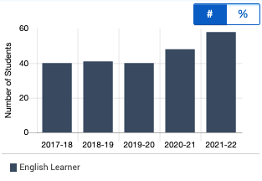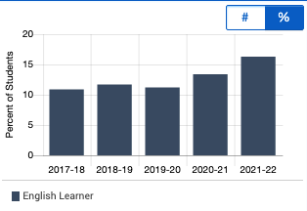

Summative ELPAC Assessment Summary by grade

Languages of English Learners

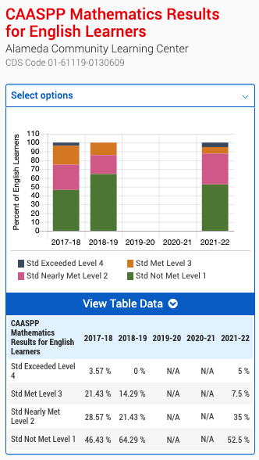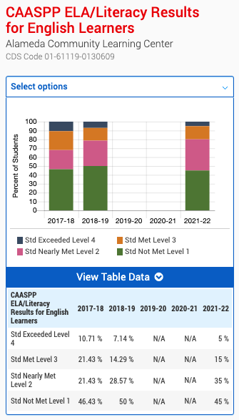

ELPAC
- Trends & Exceptions (what do you notice?)
  - ACLC showed improvement in CAASPP across the school. The school increased level 2,3 and 4 while decreasing in total level 1 learners.
    - Math - 64% Std not met to 52% Std not met. Largest increase is an uptick in Exceeds (5%) and Std Nearly met (24%)
      - State Math - Std not met = 69%
      - State ELA - Std not met = 60 %
    - ELA - 50% Std not met to 45% Std not met. Largest increase is a small uptick in Std met (1%) and Std Nearly met (7%)
  - There are still far too many EL learners who are not meeting standards. The number of EL learners at the school is continuing to increase.
  - ACLC had 58 ELPAC assessments. As many as 13 in the sixth grade and 1 senior. This indicates that learners are being reclassified and learners are acquiring English at ACLC.

- Summary (what is this data showing overall?)
  - The need for targeted support of English learners grows by the year.

- Implications (why does this data matter?)
Although there are improvements in both ELA and math and we are higher than the state average, this subgroup of learners needs continued intervention and support. ACLC ELL data is interesting because of its diversity. Many of these English learners are Mandarin, Aramaic, Mongolian and Spanish speakers. Content area classes at ACLC are taught by qualified SDAIE (Specially Designed Academic Instruction in English) facilitators who use strategies such as providing increased number of visual materials, active/physical responses, graphic organizers, leveled reading materials, multimedia presentation and equipment, computer programs, peer tutors, and cooperative learning. These strategies were especially difficult to implement in Remote learning. This cohort of learners has performed at a level more consistent with ACLC’s historical averages.

- Takeaways:
  - What are 2 or 3 learner needs that this info surfaces?
    - ACLC has just a few level 1 and 2 learners. With our changing demographic, Lead Facilitator hired an ELD teacher and courses for emerging language learners. In addition he worked with our neighbor school to enroll our learners into ELD1 or ELD2 classes at Nea Community Learning Center.
    - Are the needs of these learners surfacing early enough? Many of our ELL learners are strong speakers but they are not proficient enough with reading and writing. ACLC needs to adapt to their learning needs earlier in the school year and provide them timely support.

  - What questions should we discuss further?
    - Would more language support help?
    - Was the West Ed cycle of professional development effective?
    - Was Lexia helping learners grow?
    - How will the addition of an ELD specialist add to our ability to support these learners.
    - Should we be focusing on languages other than just English and Spanish?

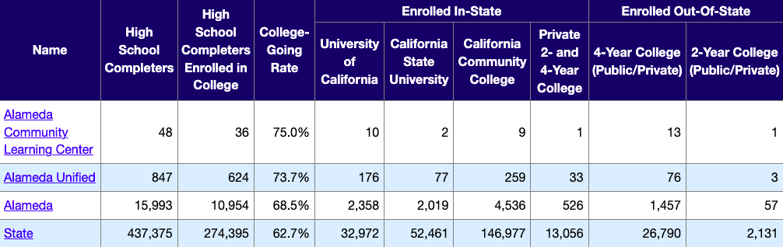
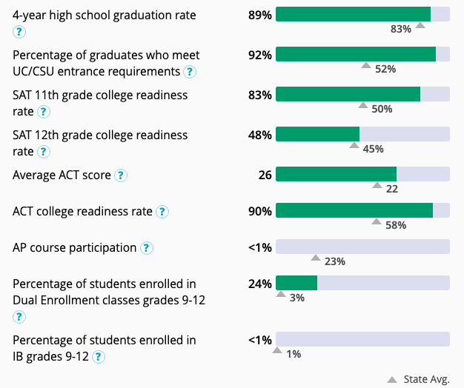
GPA data categories

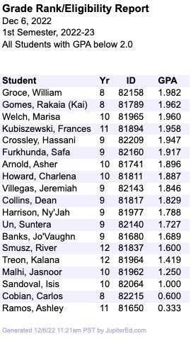

College & Career Readiness / GPA Data:
- Trends & Exceptions (what do you notice?)
  - Learners are showing their interest in higher education by taking advantage of the various levels of U of California educational opportunities-Community College, CSU and UC opportunities.
  - Pg 63 92% ACLC students meeting UC/CSU entry requirement compared to the marker average of 52%
  - also pg 63 low% for AP and IB is explained by high dual enrollment (24% ACLC vs 3% marker average). Students at ACLC that want more challenging classes take college classes as opposed to AP/IB courses.
  - College categories are comparable percentage-wise in
20/21 vs 15/16.
  - CC- 26%. v. 19%
  - CSU- 15%. v. 15%
  - UC- 26%. v. 33%
  - P- 11%. v. 13%

- Summary (what is this data showing overall?)
  - There is an increase in interest in Community College in comparison to pre-pandemic numbers. This is a key criteria to watch closely. Our school does encourage learners to pursue the four year college path. We embrace that that path often runs through a community college.

- Implications (why does this data matter?)
  - The pandemic has affected learners path to 4 year colleges in the short term
  - ACLC learners have welcomed the no AP philosophy. However, challenging academic classes are desired.
  - There has been a logjam in the UC system that affected traditional UC and State school acceptance.

- Takeaways:
  - What are 2 or 3 learner needs that this info surfaces?
    - Community College demand is up and our counseling program can adjust to support the learner's needs.
    - ACLC continues to dramatically outperform averages in traditional four year eligibility and college going rates.

  - What questions should we discuss further?
    - How can we get college counselors to visit ACLC? How can we get on Naviance? Send learners to college fairs. How can we encourage learners to visit colleges farther away?
    - Do students know what the graduation requirements are?

SPED minutes/services increase - more services, paras, minutes

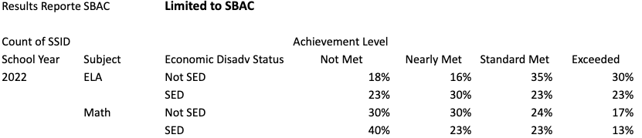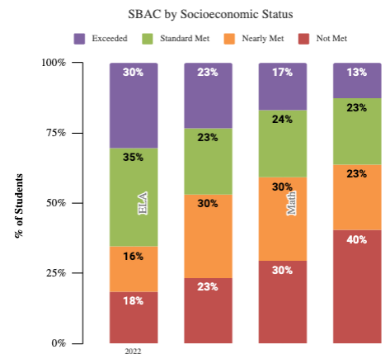

Discipline Data
Suspension Rate
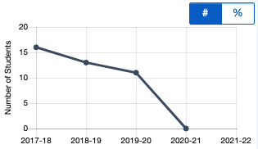

Suspension for Defiance only
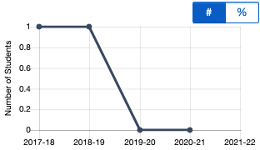

Chronic Absenteeism Rate
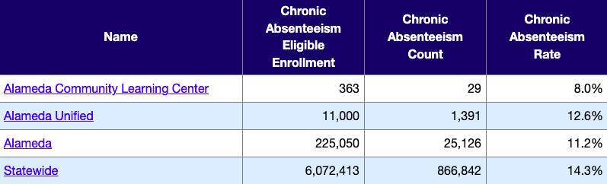

Expulsion Data
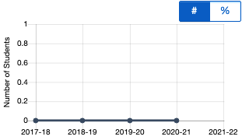
Discipline Data:
- Trends & Exceptions (what do you notice?)
Suspensions were down 2019-2022 due to online learning.
We are below the state average when it comes to chronic absences.
No expulsions since 2017.
There had been 80-100 cases in JC (Student Judicial Committee).
Students have miscommunications with each other that lead to derogatory slurs.
Students have built up frustrations that lead to disruptions in class.
JC holds teachers and students accountable with school culture.

- Summary (what is this data showing overall?)
Students' area of growth is to understand the impact of their words and how it impacts the school culture.
The same students are repeating the same behavior and consistently in JC.

- Implications (why does this data matter?)
It helps build the school culture and accountability of how the staff and students are interacting with each other. It helps reflect on our practices and how we can improve.

- Takeaways:
  - What are 2 or 3 learner needs that this info surfaces?
Students need to learn conflict resolution practices in order to navigate hard conversations.

  - What questions should we discuss further?
When is JC irrelevant when it comes to certain incidents?
Can JC language (trial, guilty, not guilty, and etc) be changed to restorative language?

Attendance Data:

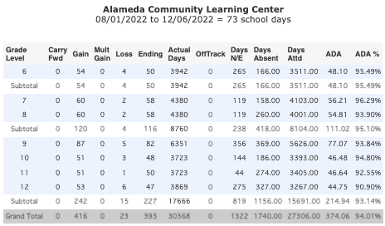
2022-2023 Attendance Data (as of 12/6/2022)

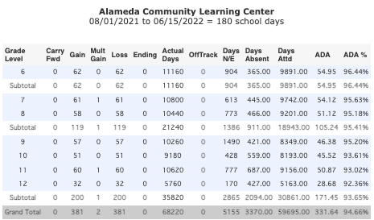
2021-2022 Attendance Data

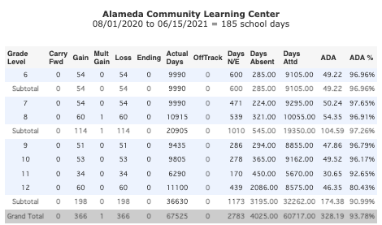
2020-2021 Attendance Data

Attendance Data:
- Trends & Exceptions (what do you notice?)
As learners move through the grades, absences increase with the exception of 9th grade
Senior absences are far more than any other grade.
- Summary (what is this data showing overall?)
  - As learners move through the grades, their attendance drops.

- Implications (why does this data matter?)
  - There are many lost days for Seniors - this implies that older learners are more comfortable being absent, which results in lost academic time.

- Takeaways:
  - What are 2 or 3 learner needs that this info surfaces? Learners need more buy in and we, as a school, need to hold older learners accountable
  - What questions should we discuss further? Is the project period system playing into this paradigm

Examination of perceptual data, such as surveys

ACLC’s 2021-22 Parent Survey:
These next screenshots are from our most recent parent/guardian survey.

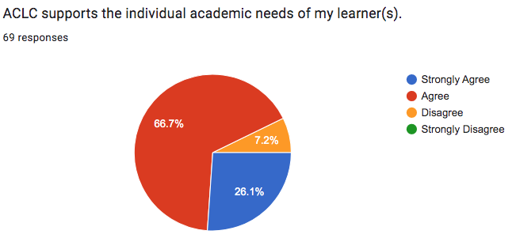

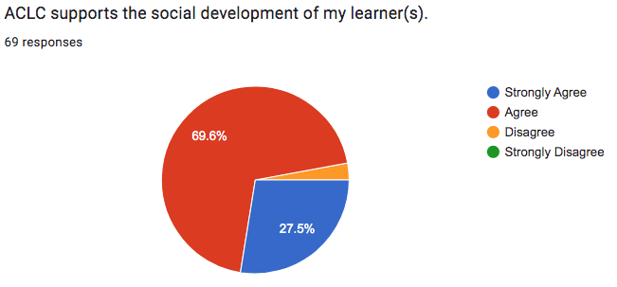

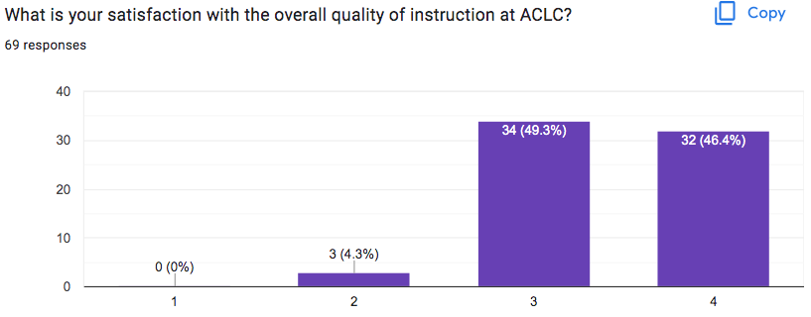

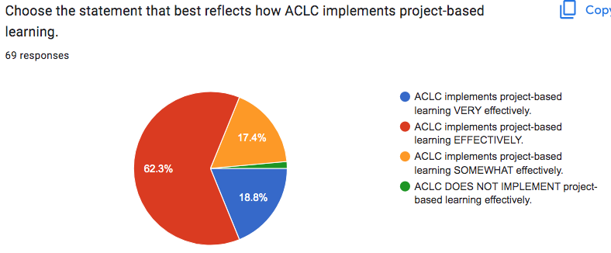
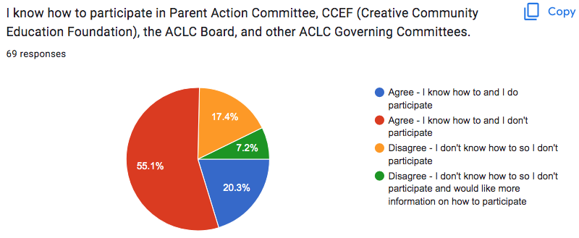

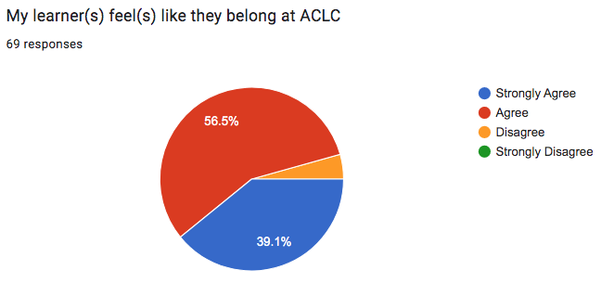

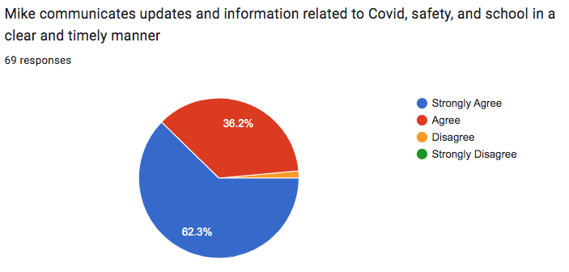

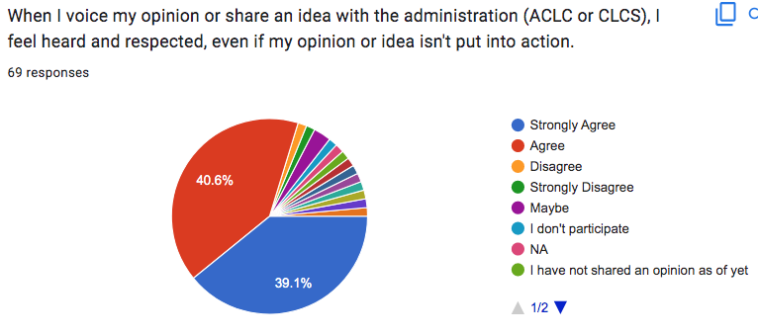

Parent Survey Data:
- Trends & Exceptions (what do you notice?)
For most areas, parents and guardians feel they know how to participate, feel heard, and believe their students are learning as well as valued. There were three major areas of exception. The first being in the category of Project Based Learning. Approximately 20% of parents and guardians believe that ACLC does not implement, or only somewhat implements, Project Based Learning effectively. Similarly, when asked if they felt respected and heard when they shared opinions or ideas, 20% did not choose strongly agree or agree. The third exception was when asked if they knew how to get involved in parent action committees, and 24% responded that they did not feel they knew how to get involved.

- Summary (what is this data showing overall?)
In summary, most parents and guardians are fairly happy with ACLC. They feel that it supports their students academically and socially. It should be taken into account that only 69 parents and guardians responded out of a school of more than 300 students.

- Implications (why does this data matter?)
As a school, we have worked hard to make sure our entire school community, from parents to learners, feel heard, respected, and that their opinions and ideas are validated and implemented when possible and applicable. This data reveals that our school needs to do more work around fully implementing Project Based Learning. In addition, we need more training and time for our facilitators to develop their skills in utilizing the Project Based Learning model into curriculum and classes.
Some parents and guardians need more support in getting involved in school governance. This survey data was only based on 69 responses, and our school has a population of more than 300 learners, and the concern is how effectively this data reflects the wider base of parent and guardian opinions and responses. We may also have a need to translate parent communication into additional languages to ensure their respective opinions are heard and recorded.

- Takeaways:
  - What are 2 or 3 learner needs that this info surfaces?
    - Learners need more effective project based learning. The entire school community needs a more robust understanding of what project based learning should look like.

  - What questions should we discuss further?
    - How can we increase parent response to survey questions to have a wider base of views reflected in our data?
    - How can we improve project based learning at ACLC?

Learner Survey Data
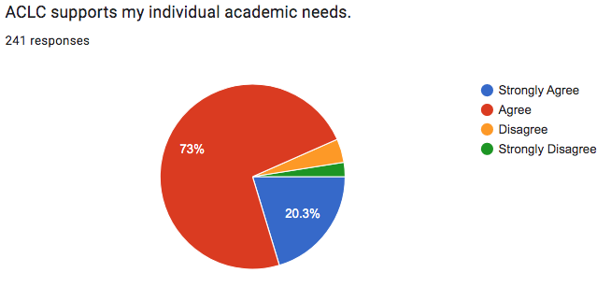

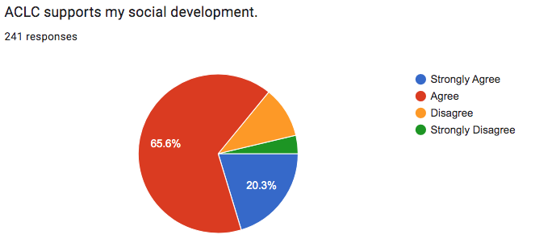

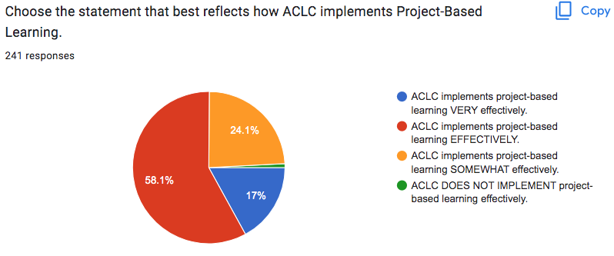

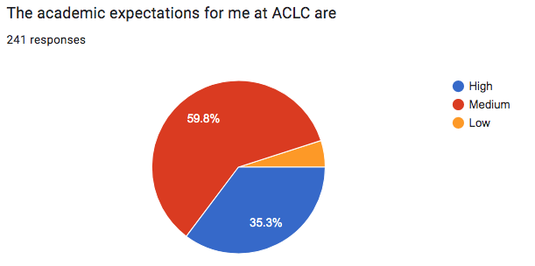
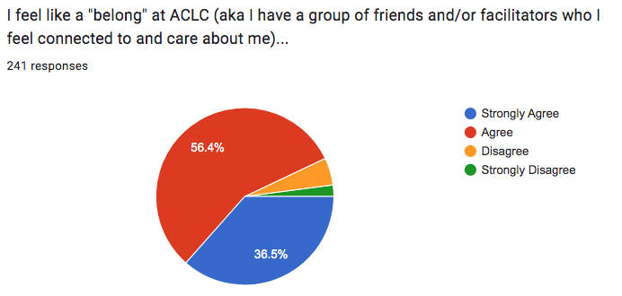

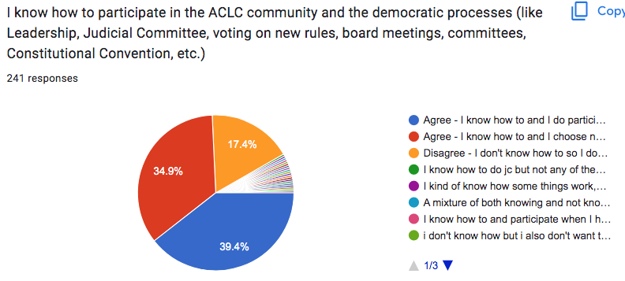

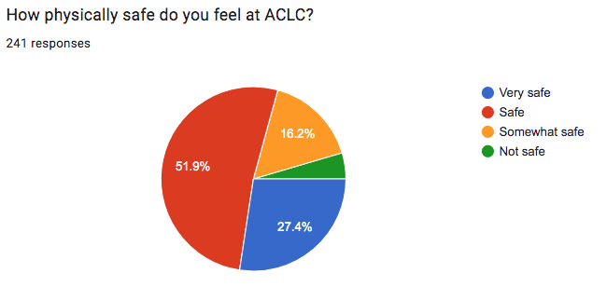

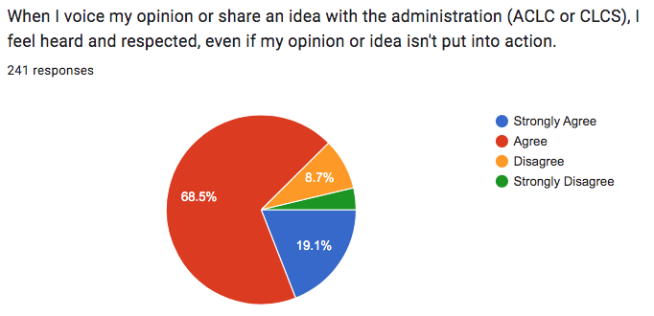

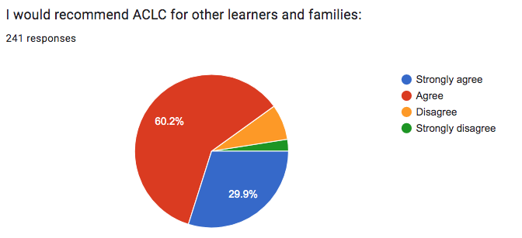
Learner Survey Data:
- Trends & Exceptions (what do you notice?)
The learner survey data is very positive (strongly agree and agree) for all questions. The majority of respondents reporting that they feel ACLC:
- Supports their academic needs (93.3%)
- Supports their social development (85.9%)
- Implements Project-Based Learning effectively or very effectively (75.1%)
Learners also feel that:
- ACLC has high (35.3%) or medium (59.8%) academic expectation of them. (TOTAL 95.1%)
- They “belong” at ACLC (92.9%)
- They feel physically safe at ACLC (79.3%)
- They know how to participate in ACLC’s democratic model (74.3%)
- They feel heard and respected by ACLC administration (87.6%)
- They would recommend ACLC to other learners and families (90.1%)

Within this overall positive feedback, the questions with less than 80% positive have to do with knowing how to participate in ACLC’s democratic model, project-based learning, and feeling physically safe.

- Summary (what is this data showing overall?)
Overall, this data indicates that most learners are happy with their ACLC experience, and that there are a few areas of refinement. These will be important to address as the high school grows to include 3 sections of each grade level.

- Implications (why does this data matter?)
Listening to the voices and feelings of our learners is a critical part of what makes ACLC who we are. Knowing that the majority of learners feel as positive as they do about ACLC is a great validation of the strength of our program. The areas where the positive data is less than 80% are areas we can continue to work to refine.

- Takeaways:
  - What are 2 or 3 learner needs that this info surfaces?
The main needs that the learner data surfaces is a refinement of how, and how consistently we do project-based learning, how we educate and include learners in our democratic model, and how we make sure everyone feels physically (and emotionally) safe on our campus.

  - What questions should we discuss further?
In order to most fully understand this data, it will also be important to disaggregate it by racial, economic, gender, and sexual identity. Especially in the areas of physical safety and feeling that their voices are heard and respected by our administration, having that level of detail about the data will help us address any unconscious biases that may be operating.

Lexile and Quantile Data
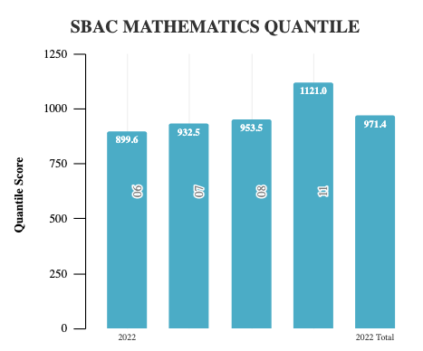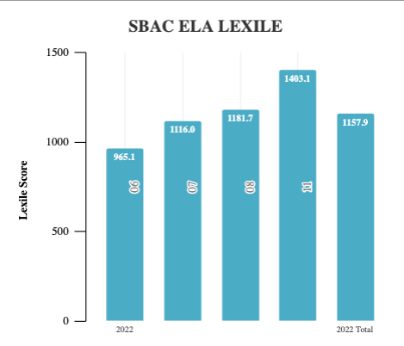

CAASPP Lexile and Quantile Data:
- Trends & Exceptions (what do you notice?)
  - Quantile: There is an increase in score for each ascending grade level. Between 6th, 7th, and 8th, there is about a 33 point increase. The jump between 8th and 11th grade scores is much larger than the jump between 6/7/8, proportionally. Grades 6 and 7 fall above the 50th percentile, but below the 90th, and 8th and 11th grades fall below the 50th percentile.
  - Lexile: 7th, 8th, and 11th grades fall above the 50th percentile, and 6th grades’ scores do not. Each sequential grade is increasing in score, with a large increase between 6th and 7th, and 8th and 11th.

- Summary (what is this data showing overall?)
  - Quantile: The data is showing the average score for grades 6, 7, 8, and 11 on the NWEA Map Test. The jump between 8th and 11th grade scores is much larger than the jump between 6/7/8, proportionally. Grades 6 and 7 fall above the 50th percentile, but below the 90th, and 8th and 11th grades fall below the 50th percentile.
  - Lexile: The data is showing that none of our learners are above the 90th percentile, but most are above the 50th. There is growth needed, but the increasing scores by grade is promising.
  - Both: For both Lexile and Quantile, our students are less than 100 points below the 50th percentile in any grade, meaning they are not too far off. Across the grades, our students score higher on the Lexile scales than the Quantile scales.

- Implications (why does this data matter?)
  - Each grade is showing an increase in math skill levels. This implies that the department is successful in growing students’ knowledge each year. While all grades are below the 90th percentile, we are still feeling the effects of COVID and recovering, as all schools are. While the goal is to be in the 90th percentile or higher, it is hopeful that each of grades’ scores increase. Our English Lexile scores shed light on the need for improvement in reading skills, especially in 6th grade.

  - What are 2 or 3 learner needs that this info surfaces?
    - Quantile: More focus on math skills, increased attention to upper grades, math tutoring
    - Lexile: more time spent on reading comprehension, especially for 6th grade

  - What questions should we discuss further?
    - How can we increase our students’ reading comprehension levels across subjects?
    - What programs can we use to support students’ growth and understanding in math.

Chapter III: Self-Study Findings
For each category of criteria include:
1. A list of strengths
2. A list of prioritized growth areas for continuous school improvement.
Note: The five criteria categories are:
A. Organization: Vision and Purpose, Governance, Leadership, Staff, and Resources
B. Curriculum
C. Learning and Teaching
D. Assessment and Accountability
E. School Culture and Support for Student Personal, Social-Emotional, and Academic Growth.
Provide pertinent evidence for review by visiting committee through hyperlink or Dropbox.
Category A: Organization: Vision and Purpose, Governance, Leadership, Staff, and Resources

A1. Vision and Purpose Criterion
The school has a clearly stated vision and mission (purpose) based on its student needs, current educational research, including equity, diversity, and inclusion, the district Local Control and Accountability Plan (LCAP), and the belief that all students can achieve at high academic levels. Supported by the governing board and the district LCAP, the school’s purpose is defined further by schoolwide learner outcomes and the academic standards.
Indicators
A1.1. Vision – Mission – Schoolwide Learner Outcomes – Profile: The school has established a clear, coherent vision and mission (purpose) of what students should know and demonstrate; it is based upon high-quality standards and is congruent with research, practices, the student/community profile data, a belief that all students can learn and be college and career ready, and aligned with district goals for students.
A1.2. Development/Refinement of Vision, Mission, Schoolwide Learner Outcomes: There are effective processes in place to ensure involvement of all stakeholders in the development and periodic refinement of the vision, mission, and schoolwide learner outcomes.
A1.3. Understanding of Vision, Mission, Schoolwide Learner Outcomes, District LCAP: Students, parents, and other stakeholders of the school and business community demonstrate understanding of and commitment to the vision, mission, the schoolwide learner outcomes, and the district LCAP.
A1. Prompt: Evaluate the school’s effectiveness in addressing the criterion and each of the above indicators; include supporting evidence.

Findings | Supporting Evidence
A1.1 - Vision – Mission – Schoolwide Learner Outcomes – Profile  The Alameda Community Learning Center Mission Statement:  The Alameda Community Learning Center is an educational model that empowers all youth to take ownership of their educational experience, to celebrate their diverse community, and to actively participate as members in a democratic society.  One of the most unique aspects of ACLC is its method of governance, which establishes a power structure in which decision-making authority is shared between learners, parents, and facilitators. The broad array of organizational functions – legislative, judicial, and executive – is deeply embraced within the community. This approach is congruent with the ACLC philosophy that learning is experiential and incorporates not only the content but also the process of the learning experience.  The ACLC board acts as the primary programmatic governing body of the school and is charged with development and oversight of policy, budget, personnel, organizational development, strategic planning, and maintenance of the vision of the ACLC charter. The governing board is composed of two facilitators, two learners elected from the whole body of learners, two parents appointed by the learners and facilitators, one member from the school administration, and two community members. All decisions of the governing board are made by a majority vote of its members unless otherwise specified by the charter or in bylaws.  ACLC facilitators are not traditional subject matter instructors. They provide a combination of direct classroom instruction and facilitation of self-directed learning experiences. Classes are designed so that substantial amounts of learning take place outside the classroom and at learners’ individual direction. Facilitators have scheduled “floor time” in their workweek to meet individually with learners and interact with the learner community. Learners have “project periods” that allow them to accomplish a number of self-directed goals. Similar to time between classes in college, ACLC learners have time to get organized, collaborate with peers, work on projects, communicate with facilitators via Jupiter Grades or talk to facilitators directly in the Center or in a classroom.  During our self study, staff and parents discussed project periods as a place to improve academic excellence at our school. Revising project periods to include clear changes to support and structure all learners. The Assessment and Accountability Committee and Culture Committee have taken that input to make recommendations. Those are:  - Project Period improvements could include:  - Improve clear expectations for Project Periods and be clear about what learners need to DO--then enforce expectations regardless of grade level  - Utilize Project Periods as an opportunity for older learners to teach skills to younger learners.  - Consistent communication & expectations for middle schoolers in the Center by establishing improved communication systems.  - Learning Lab improvements could include  - Move LL into Center to additional facilitators for these periods and more study-focused Center time.  - Experiment with Labs in the quiet area to promote quiet place to work  Project Based Learning is the strongest feature of our assessments at ACLC. In PBL, students are active, not passive; a project engages their hearts and minds, and provides real-world relevance for learning. The Common Core and other present-day standards emphasize real-world application of knowledge and skills, and the development of 21st century competencies such as critical thinking, communication in a variety of media, and collaboration. PBL provides an effective way to address such standards. After completing a project, students remember what they learn and retain it longer than is often the case with traditional instruction. Because of this, students who gain content knowledge with PBL are better able to apply what they know and can do to new situations.  As a PBL school, ACLC has worked with the Buck Institute (now called PBLWorks) to encourage facilitators to utilize projects to create authentic and meaningful learning experiences that involve:  - Challenging and relevant problems/questions  - Inquiry  - Learner choice and voice  - Reflection  - Revision and Critique  - Going beyond the classroom to a greater audience  http://www.bie.org/object/document/pbl_essential_elements_checklist  Empowering the learner body is central to our mission. Learners are encouraged to direct their own learning and take on leadership roles at ACLC. For example, learners:  - Call Facilitators by their first names  - Have their own self-created school rules and Bill of Rights  - Write up others for violating ACLC rules and serve JC jury duty  - Plan most major school-wide events  - Organize and plan school-wide seminars  - Choose how to spend their Project Periods  We strive to have a culture where adults and youth are equal, based on the core belief that we are educating people, not children. With that stated, learner empowerment is well-witnessed in two programs at ACLC: the Judicial Committee and Leadership. First, the Judicial Committee (JC) is a learner-run process of helping the community abide by the rules. Daniel Freedman is facilitator of JC. Elected learner clerks run the proceedings.  If a community member is written up for rule breaking by another community member, JC pulls the community member from class and holds a hearing and guilt or innocence is determined. If guilty, a consequence designed to give back to the community or to help the community member is given.  In addition to JC, Leadership is a class in which learners review and decide the outcome of proposals (learners and facilitators may propose to change or add existing ACLC rules), assist in supervising the Center, and plan community events, such as CCC each Wednesday, ConCon (Constitutional Convention), Diversity Day, etc. Molly Fenn is the facilitator for Leadership. Learners in grades 7-12 are represented in the course. | ACLC Website Link  ACLC Learner Outcomes  Notes from Facilitator input on Project Periods and Labs  Sample PBL Staff Professional Development Agenda  PBL Project Workshopping Protocol  PBL Collaboration PD  JC Write-Up Form  JC Rules  JC Referral Form  Sample Weekly Leadership Plan for CCC
A1.2. Indicator: There are effective processes in place to ensure involvement of all stakeholders in the development and periodic refinement of the vision, mission, and schoolwide learner outcomes.  ACLC’s personalized, learner-focused educational model, by its very nature, demands and encourages stakeholder engagement. Since the last visit, the engagement of stakeholders has been an ongoing and evolving endeavor. ACLC evaluates the effectiveness of the process from the first visit to the mid-cycle visit to the current self-study. The administration has developed a comprehensive LCAP Stakeholder Engagement Plan to implement and monitor the school-wide action plan. During the Fall, staff were given a presentation on the school’s LCAP goals and how they aligned to WASC. We discussed how and why we would be adjusting the goals for the cycle utilizing pertinent data based on the California State Dashboard Performance Indicator. Over a series of meetings, staff were separated into departmental groups to read over the specific goals for school improvement and also this Self Study Report. At a later meeting, they reviewed the WASC and LCAP goals included in the Lead Facilitator Report, discussed the changes, improvements, and noted the differences they had seen in the school.  In the 2021-2022 year the process took a different approach. Under the leadership of our Lead Facilitator, he took the Schools to Watch framework he is familiar with, and applied those rubrics to ACLC in order to activate the community in a self-study.  ACLC has also utilized professional development time to review the vision and mission to align with the LCAP goals. This is an ongoing process. In a 2020-21 staff survey, almost 89% of respondents agreed or strongly agreed that PD time is used effectively.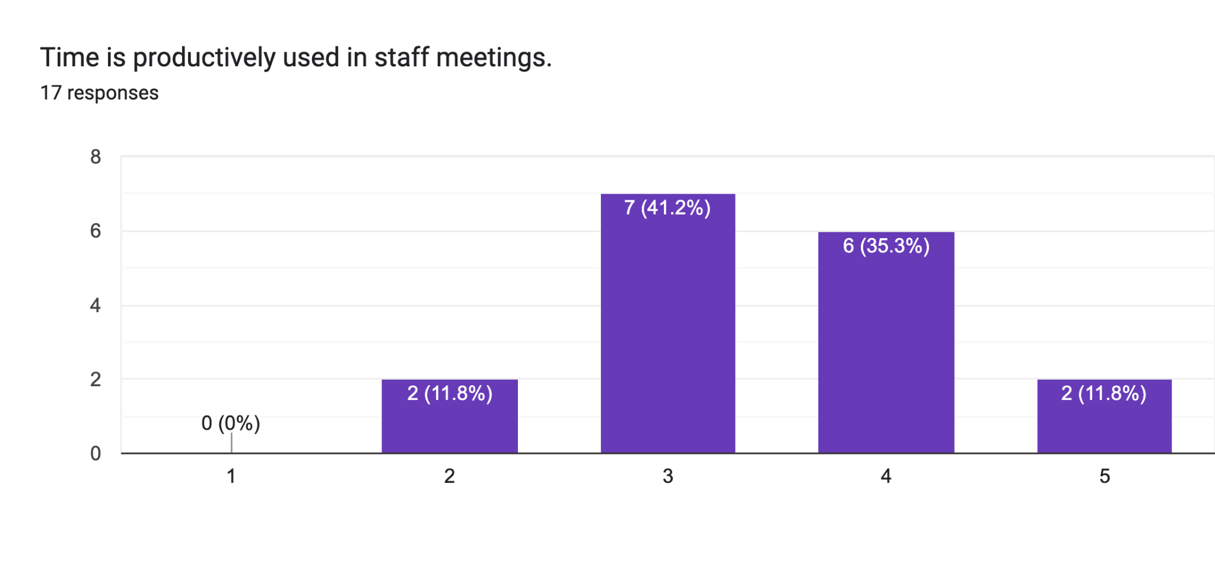  Following conversations with our WASC visiting committee we discussed better means to utilize our committee structure, which was ultimately restructured and participation from all staff was required at least once a month. Curriculum; School Culture; Assessment & Accountability; Equity; Personnel and Finance. Lead’s ensure that there is an alignment between committee goals and those of LCAP/WASC recommendations. Committee’s provide updates and share their action items/findings to the entire staff for review and discussion. Recommendations and requests for utilizing funds from the budget are presented to the governing board quarterly. Our school governing board meetings are open to the public and this past year have been held via zoom.  With an influx of new staff, committee work has been impacted by lack of continuity these past two years. ACLC addressed this by creating a live document in the shared drive entitled “EOY Committee Goals and Notes”. Each committee sets goals and summarizes work from one year to the next. This received positive feedback from committee leads and we intend to continue utilizing this document moving forward.  Student leadership takes an active part and has a voice. The Leadership Council, consisting of grades (6-12) met with both the Lead Facilitator and the Leadership Facilitator to discuss changes and input with school initiatives like Schools to Watch. They provided their input in line with LCAP guiding questions and ACLC mission central issues. Student surveys were also circulated among the learners. Their input and views are also provided to the school administration and staff.  Parents who gave their input in the Schools to Watch goal setting showed up to provide input and share their voices. Rich conversations around findings and data analysis facilitated a deeper understanding of our areas of improvement. Online, parent surveys were filled out as per administration requests. Those answers were given to the administration for incorporation into the final goal determination. | Community Survey results  And S2W parent and learner input  Slides on Goals and ELCAP alignment  S2W results and process Slides  PD Scope & Sequence  ACLC Governing Board Minutes  Committee EOY Notes and goals  Great Schools comments  Leadership lunch meeting invitation and schools to watch learner input  S2W Focus Group Schedule
A1.3. Understanding of Vision, Mission, Schoolwide Learner Outcomes, District LCAP: Students, parents, and other members of the school and business community demonstrate understanding of and commitment to the vision, mission, the schoolwide learner outcomes, and the district LCAP.  ACLC is committed to making sure that learners, parents, and other members of the school’s community know and understand the school’s vision, mission, and schoolwide learner outcomes. We believe in the importance of a participatory governance model.  Our Graduating Learner Outcomes guide the program, which represents our core values. These are also incorporated into our grading policy These align with our overall learning outcomes of ACLC Graduates (who are required to reflect on these as part of their senior presentations), and operate as the backbone for our school culture.  For our 6th-12th grades, Learning to Learn (L2L) is similar to an advisory period that includes weekly lessons. L2L has a curriculum and facilitators deliver in their L2L classes. These lessons assisted learners with the familiarization of the school’s vision, mission, and culture. The lessons and activities help promote ACLCs core values, and allow learners to familiarize themselves with the school’s philosophy and expectations. Parent/learner handbooks are given at the beginning of the year, and agreements are signed by both to ensure all stakeholders are informed of the school’s practices.  All learners lead Learner Led Conferences (LLCs) every year in which they present information to parents/guardians and peers (6-12) regarding their goals and academic progress. They reflect on their academic progress, their achievements, learning styles, and are asked to highlight strengths and pinpoint areas for future growth. In preparation, learners are given a series of learner created prompts that inspire learner voice. They are learner led so they vary some but almost all ask learners what their understanding/perception of ACLC’s engagement processes to better inform facilitators instruction. Following distance learning after a pandemic, learner feedback during LLCs indicates a need to get back to school and do activities as a group. As a response, ACLC went on numerous field trips last year. Some of our learner population have never visited our classrooms or site, as they remained in distance learning throughout the year. ACLC is committed to making sure that ACLC’s learners for 2022-23 school year have an experience encompassing academic and social-emotional criteria.  As part of our self study, ACLC staff participated in meetings to engage in the understanding of our school statements and to write segments of the report that reflect their expertise. To ensure staff members felt that they had an equal voice in the process, the WASC Leadership Team wrote in departments, with partners and in committees. In an effort to meet the expected school goals, our faculty and staff used collaboration time to identify ways to integrate these goals into the daily routine of teaching and learning. Staff participated in instructional rounds to provide perspective in their writing and to develop their instructional practice. Staff did a peer walkthrough, taking notes on the awareness of the targets in the classrooms and in the delivery of instruction.  The vision, mission and WASC goals are discussed on a yearly basis and reflect the changing needs of learners, community and faculty. | ACLC Learner Outcomes  L2L Curriculum  Fall 2022-23 LLC Prompts and rubrics

A2. Governance Criterion
The governing board (a) has policies and bylaws and the school’s purpose is aligned with them to support the achievement of the schoolwide learner outcomes, academic standards, and college- and career-readiness standards based on data-driven instructional decisions for the school; (b) delegates implementation of these policies to the professional staff; and (c) monitors results regularly and approves the single schoolwide action plan/SPSA and its relationship to the Local Control and Accountability Plan (LCAP).
Indicators
A2.1. Understanding the Role of the Governing Board and District Administration: The school community understands the governing authority’s role, including how stakeholders can be involved.
A2.2. Relationship between Governing Board and School: The school’s stakeholders understand the relationship between the governing board’s decisions, expectations, and initiatives that guide the work of the school.
A2.3. Uniform Complaint Procedures: The school leadership understands and utilizes the Uniform Complaint Procedures from the district.
A2. Prompt: Evaluate the school’s effectiveness in addressing the criterion and each of the above indicators; include supporting evidence.
Findings | Supporting Evidence
CLCS has found that structuring governance so that community members actively participate develops learners and engages families, resulting in a stronger community. The following structure maintains overall control, while delegating segment responsibility to people involved in the activities.  ACLC Charter School Governance Structure  CLCS, Inc. Board of Directors  ACLC Board  Lead Facilitator  Program and Financial Evaluation Committee  Committee Personnel Committee  Standards and Curriculum Committee  ACLC Staff  Contemporary Community Citizenship (CCC)  The Community Learning Center Schools, Inc. Board of Directors is the senior governing authority for the Alameda Community Learning Center. The CLCS Board of Directors has the following responsibilities:  • To ensure alignment of the ACLC with its mission and vision  • To monitor student performance  • To approve the strategic and long-term plans of the ACLC  • To approve all policies  • To ensure that all internal controls are effective  • To provide fiduciary oversight, including receipt of ongoing financial reports  • To approve budget and contracts (including MOU, charter revisions, etc.)  • To supervise the audit process and secure audit report approval  • To serve as the final authority on expulsions, personnel firing decisions, and legal actions.  • To serve as the appeal board for any ACLC Governing Board recommended expulsions.  • To be responsible for any official interactions with AUSD and state, including the approval of funding applications and reports.  • To serve as the employer of all ACLC staff and to approve employee contracts, pay schedules, benefits, and other employee financial transactions.  • To serve as a review board, as approved by board policy, related to employee dismissal.  The Alameda Community Learning Center charter school shall be operated by CLCS, Inc., a California non-profit public benefit corporation with 501(c)3 status that was granted in 2006. The CLCS Board of Directors is made up of community business and educational leaders. The CLCS Board of Directors will oversee the work of the ACLC Board. The school is operated as an independent charter school and is directly funded. CLCS is a “separate legal entity” for the purposes of liability for the debts and obligations of the charter school. Current CLCS Board of Directors biographies and qualifications are available on our website (www.clcschools.org) along with all board policies related to “Conflict of Interest”.  The ACLC charter school’s method of governance substantially incorporates the Learners, families and Facilitators in a broad array of organizational functions – legislative, judicial and executive. This approach is totally congruent with the ACLC philosophy that the learning is experiential and incorporates not only the content but the process of the learning environment.  ACLC Committees Overseen by Lead Facilitator and CLCS Executive Director  Financial Committee Each year the CLCS Executive Director convenes and chairs an ACLC Financial Committee whose membership is constructed to include parents, Facilitators and Learners. The committee works to develop the budget, monitor the budget and monitor other financial activities under the direction of the Executive Director. Each month the Financial Committee makes a report to the CLCS Board of Directors and ACLC School Site Council, making financial recommendations as necessary. The Executive Director is responsible for setting up a purchase order system for all purchases with EdTec, ACLC’s business services management organization. Internal financial controls are well-established.  Personnel Committee Each year the Lead Facilitator convenes and chairs a Personnel Committee whose membership is constructed so that there are parent, Learner, and Facilitator representatives. The committee conducts the annual Learner survey to evaluate staff and this information is considered during yearly Facilitator evaluations. Under the direction of the Lead Facilitator, the Personnel Committee conducts personnel interviews as directed by CLCS Board policy on hiring. Under the direction of the Lead Facilitator, the Personnel Committee carries out the personnel evaluation agreement.  Curriculum and Standards Committee Each year the Lead Facilitator consults with the Facilitators and appoints another Facilitator to chair the Curriculum and Standards Committee and supervises its work. The Curriculum and Standards Committee membership is constructed so that there are parent, Learner, and Facilitator representatives. The committee collects and documents all course outlines for compliance with California State University standards and UC a-g requirements. They also do appropriate WASC work and evaluate new courses before being submitted to the board for approval. Each month the Curriculum and Standards Committee makes a report to the Governing Board and make recommendations as necessary.  Assessment and Accountability Committee  Each year the Lead Facilitator consults with the Facilitators and appoints chairs the ACLC Assessment and Accountability Committee and supervises their work. The Assessment and Accountability committee membership is constructed so that there are parent, Learner, and Facilitator representatives. The committee works to develop the Annual Report, WASC accreditation report, and conduct the annual parent and Learner surveys. Each month the Assessment and Accountability Committee makes a report to the Governing Board and makes recommendations as necessary.  The Financial Committee, Personnel Committee, Assessment Committee and Curriculum Committee all operate under the oversight of the Lead Facilitator and CLCS Executive Director. The committees make recommendations on policy that are reviewed and approved by the ACLC Board.  Contemporary Community Citizenship (CCC)  The CCC is comprised of the entire community of Learners. The CCC elects the two Learners to the ACLC Board. Learners at the ACLC are not passive bystanders; they are integrated into the highest levels of decision making.  The ACLC CCC meets weekly and is charged with being the primary communication matrix of the school. This means that the entire group of Learners is regularly present and is provided an opportunity to discuss ongoing issues of importance to the school – from issues as mundane as noise levels and cleanliness to issues such as how money is spent in the educational program. In addition to these communication and process issues, the CCC is responsible for legislative action – that is, for making, discussing and voting on formal proposals that relate to the daily operations of the school. This includes the creation and amendment of the Rule Book – that is, the document which clarifies the rules and code of conduct for the entire ACLC Charter School community, including Learners, Facilitators, parents, and community visitors. Many of these actions may be within the purview of the CCC and will not require any review or approval by the School Site Council. However, issues which reflect a change in basic mission, philosophy, budget and personnel matters will require review and approval by the CLCS Board of Directors before they take effect.  It is important to note that, although some actions of the CCC may require the approval of other bodies, the bulk of the decision-making processes related to self-management is in the hands of the community of Learners. In this way the Learners of ACLC are being empowered to establish the operational rules of their learning community and to make decisions about the use of some resources (e.g., purchase of specific equipment, use of funding for field trips, etc.) that are within the purview of the learning community. The CCC also conducts annual surveys that evaluate the Facilitators, the academic program, the Leadership Committee and the operation of the school and makes recommendations for change in operational practices. The CCC is the focus for the annual Learner Convention, an opportunity for the entire community to review the operations of the year and make changes to the ACLC Rulebook.  Judicial Committee (Learner Disciplinary Policies)  The Judicial Committee (JC) for students in grades 6-12 is comprised of five Learners who are elected by the Learners and one Facilitator designated by the Lead Facilitator. They meet 3-4 times each week to consider issues related to infringement of rules codified in the Rule Book. The Rule Book has been developed by the ACLC’s CCC serves as the foundation document for ACLC, to be revised and updated on a regular basis by the ACLC CCC. The Judicial Committee is responsible for enforcing the rules of the school by hearing cases submitted by Learners and Facilitators and deciding on appropriate consequences to specific actions. The JC also mediates disputes and assists parties who are engaged in some type of conflict to find common ground so that they can move forward in a cooperative manner. This role is particularly important since, generally, after some form of dispute the parties will remain in the same learning community and will interact regularly in some way.  The JC is a particularly important part of the governance of the school since it places the responsibility for self-management clearly with the learners. Although our JC (Judicial Committee) is a cornerstone of our learner-led community and works well for the great majority of our middle school learners, Our high school learners are not using it as much.(This is validated by the JC log) .  - The critical need is to increase the use of the JC system especially with the high school learners.  - The second area to work on is to track the community’s trust and buy in into the JC system over time to ensure the system is perceived to be a trusted and effective system.  During this WASC self study, we recognized that the pandemic and turn over in the facilitator running JC has had an impact on our execution and data tracking. Patricia Williamson, who retired at the end of 2021, held this process close for over a decade.  Leadership Committee  The Leadership Committee is a class in which students in grades 6-12 may enroll that takes on the executive functions of the community of Learners. The ACLC will seek to have 25-40 of our Learners involved in the Leadership Committee.  This group will meet 2-3 times each week and work very closely with the Leadership Facilitator who is appointed by the ACLC Lead Facilitator. Leadership is primarily charged with implementing proposals passed by the CCC. This may include codifying recommended changes in the Rule Book, promulgating and enforcing rules in the community, coordinating center activities, supporting the smooth operation of day-to-day affairs of the community, and coordinating and facilitating the annual Learner Convention. Many functions such as coordinating field trips, CCC meetings, notification of scheduling changes, and other facilitative and communication roles are best accomplished by Leadership because they provide opportunities for students to engage in self-management and organization of their own learning community.  Leadership in many ways gives Learners extensive experience in management and facilitation of operations and mitigates the necessity of hiring support staff to perform these functions. This maintains operations of the school on a cost-effective basis and provides meaningful roles and experience for Learners. This is one of the many ways in which ACLC Charter will use its resources to better accomplish learning objectives and to empower Learners.  Day-to-Day Operational Governance  The ACLC Lead Facilitator is responsible for the day-to-day operation of the school and makes all necessary decisions to provide a safe and constructive learning environment. As an educational leader, the Lead Facilitator seeks to empower the Learners to take control of their educational experience through the Contemporary Community Citizenship class, the Leadership class, and the Judicial Committee.  The governance of the ACLC Charter School is uniquely constituted to maximize the role of the Learners in self-management and governance at the 6-12 level. We deeply involve Learners in governance because our school is comprised of students who reach that time in their lives when self-determination within a guiding system of law and community relationships is much more important to learn than a system that is devised and imposed by adults – whether they be parents, guardians, or educators.  However, because no community has full self-determination and must be subjected to the laws of the broader community – whether that be state, national or international law – we make sure that our Learners understand that their self-determination, while real, is limited by the regulations and laws that govern the larger community of which we are part.  Decision-making Process  The ACLC Charter School will work to achieve consensus in making decisions. However, if consensus is not possible in a reasonable timeframe, the various decision-making groups will vote and a simple majority will rule unless otherwise specified by our Charter or through Bylaws adopted by the CLCS Governing Board. This procedure can be modified in the future as determined by the CLCS Governing Board.  Parent/Guardian Participation  The ACLC will promote effective communication between parents/guardians and Facilitators, the Lead Facilitator, and counselors by involving parents in two parent driven organizations, the Creative Community Education Foundation and the Parent Asset Committee. Parent involvement will be crucial to the operation of ACLC. In 2001, the ACLC parent community created a 501(c)(3), the Creative Community Education Foundation (CCEF), to support the vision of ACLC. The CCEF will welcome parents from ACLC and work to support and fundraise for ACLC. Also, parents will serve on the school’s Governing Board, governing committees, the CCEF Board of Directors, and the Parent Action Committee (PAC). A new PAC has formed specifically for ACLC to organize the parents to provide leadership for lunch programs, new parent mentoring, volunteer tutoring, planning the graduation event, support for sports teams and other extra curricular activities and field trip programs. Parents will also serve on the WASC Focus on Learning Committees.  During the Pandemic we truly lost momentum with parent engagement in the school. We had parent leaders graduate from the school without the natural handoff to newer families. This school year, The Parent Action Committee is back and meeting once again. Also, CCEF, PAC and ACLC Board meetings are meeting in person once again.  ACLC acknowledges that pursuant to Article XVI section 8.5(e) of the California Constitution, sections 2(e), 6, and 8 of Proposition 98, and sections 33126.1(b), 35256(c), and 35258 of the Education Code require schools, including ACLC to provide certain information in certain formats in certain ways to the general public and specifically to parents of students at ACLC and of the District. ACLC further acknowledges that it has the obligation to provide all of such information to the District that is required by these referenced authorities in a timely manner so that the District may meet its obligations under those authorities as well. To the extent that there is information that the District has, but that ACLC does not have that ACLC needs in order to meet its obligations, the District shall provide the same to ACLC in a reasonably timely manner upon request.  ACLC, in accordance with Education Code Section 47604.3, shall promptly respond to all reasonable inquiries, including but not limited to, inquiries regarding financial records, from the District and shall consult with the District regarding any such inquiries. ACLC acknowledges that it is subject to audit by AUSD if AUSD seeks an audit of ACLC, it shall assume all costs of such audit. This obligation for the District to pay for an audit only applies if the audit requested is specifically requested by the District and is not otherwise required to be completed by ACLC by law or charter provisions.  Members of ACLC’s Governing Board, any administrators, managers or employees, and any other committees of the School shall at all times comply with federal and state laws, nonprofit integrity standards and AUSD’s Charter School policies and regulations regarding ethics and conflicts of interest so long as such policies and regulations are not in conflict with any then-existing applicable statutes or regulations applicable to charter schools.  ACLC and/or its non-profit corporation will be solely responsible for the debts and obligations of the charter school. | Uniform Complaint Procedures  CLCS Governance Structure  CLCS Policies and Procedures  CLCS Boards  Committee notes HERE  Sample Weekly Leadership Plan for CCC  JC Write-Up Form  JC Rules  JC Referral Form  Sample Weekly Leadership Plan for CCC  CLCS Governance Structure  CLCS Policies and Procedures  CLCS Boards  ACLC Board Webpage  CCEF Board member lists  PAC Sign ins at recent back to school night  ACLC Board Documentation  ACLC Board Website page
A3. Leadership: Data-Informed Decision-Making and Continuous School Improvement Criterion
Based on multiple sources of data, the school leadership, parent/community, and staff make decisions and initiate activities that focus on all students achieving the schoolwide learner outcomes, academic standards, and college- and career-readiness standards. The school leadership and staff annually monitor and refine the schoolwide action plan/SPSA and make recommendations to modify the LCAP as needed.
Indicators
A3.1. Broad-Based, Inclusive, and Collaborative: The school’s broad-based, inclusive, collaborative planning process is a continuous improvement cycle that a) assesses data to determine student needs, b) collaboratively determines and implements strategies and actions and c) monitors results and impact on student success.
A3.2. School Action Plan/SPSA Correlated to Student Learning: The school’s schoolwide action plan/SPSA is directly correlated to and driven by the analysis of student achievement data and other data and aligned with district LCAP.
A3.3. Collective Accountability to Support Learning: The school leadership and staff demonstrate shared decision-making, responsibility, and self-reflection on actions and accountability for implementing practices, programs, actions, and services that support student learning.
A3.4. Internal Communication and Planning: The school has effective existing structures for internal communication, planning, and resolving differences.
A3. Prompt: Evaluate the school’s effectiveness in addressing the criterion and each of the above indicators; include supporting evidence.
Findings | Supporting Evidence
A3. Leadership Continuous Planning and Monitoring  A3.1 Broad-Based and Collaborative Indicator: The school’s planning process is broad-based, collaborative, and has commitment of the stakeholders, including the staff, students, parents, and business community.  Prompt: Evaluate the school’s effectiveness in addressing the criterion and each of the above indicators; include supporting evidence.  Administration, WASC leadership team, and whole staff meetings occur regularly to ensure staff is consistently evaluating progress on school wide annual goals. Because of the organization’s commitment to continual improvement, the level of dedication to collaboration among all stakeholders is a priority. Parent and student surveys are sent out to get feedback on our program and WASC and LCAP aligned goals. Facilitators make recommendations to the Lead Facilitator and Assistant Lead Facilitator about topics for professional development.  A3.2 Single School Plan for Student Achievement Correlated to Student Learning Indicator: The school’s Single Plan for Student Achievement (SPSA) is directly correlated to and driven by the analysis of student achievement data.  Prompt: How do staff ensure that the analysis of student achievement of the critical learner and college- and career-readiness needs, schoolwide learner outcomes, and academic and career-readiness standards are incorporated into the SPSA and impact the development, implementation, and monitoring of the SPSA and the LCAP.  ACLC does not currently have a SPSA. We have worked to streamline our goals and objectives into a combined set of WASC and LCAP goals. This has been our primary focus and has been at the core of our instructional work in the past few years.  Each week our staff meet to talk about learners of concern. Those concerns are captured in Google tracking documents for individual learners. Each learner is given specific accommodations or support by our facilitator team. This gathering of data and evidence is vital to our process of collaboration and support for learners. If a learner is not responding to our accommodations or strategies, the learner is eligible for a SST meeting.  At the beginning of each year our staff reflects on state data in order to know who is thriving and where adjustments in their instruction needs to be made. Our hope is to cross pollinate Best Practices for our own instruction and with each other.  All facilitators on the Alameda community learning center team use benchmarks to assess and reflect on their instruction. We have agreed that three benchmarks will be given every year with the intention of using holistic data to reflect on instruction. This is an achievement with in our small school where data has not been the norm.  ACLC facilitators are provided with extensive staff development opportunities, and funds are available for facilitators to pursue individual professional development interests, upon request to and approval by the Lead Facilitator. In addition, there are six (6) full days of professional development for ACLC facilitators scheduled during the school year.  Staff Actions/Accountability to Support Learning  Indicator: The school evaluates the effectiveness of the processes and procedures for involving staff in shared responsibility, actions, and accountability to support student learning throughout all programs. This includes an evaluation of the kinds of collegial strategies used to implement innovations and encourage improvement, such as shadowing, coaching, observation, mentoring, group presentations.  Prompt: How effective are the processes and procedures for involving staff in shared responsibility, actions, and accountability to support student learning throughout all programs? Provide representative examples and data regarding impact on student learning.  Staff is involved in all shared responsibility, actions, and accountability to support student learning throughout all programs. The procedures for Learner Study Team (LST) meetings are clear to all staff members who may have a concern about students. Learners on the “Learner of Concern” list are monitored by a coordinator who communicates with the students’ teachers and arranges meetings regarding the student. Tutoring sessions and office hours are available for all students.  ACLC staff have participated in inter-visitations for the past three years. This is an example of a data gathering rubric used in these rounds from two years ago. More recently, our rounds have been aligned with gathering data for WASC.  Evaluation of Existing Processes  Indicator: The school leadership regularly reviews the existing processes to determine the degree to which actions of the leadership and staff focus on successful student learning.  Prompt: To what extent does the school leadership regularly review the existing processes to determine the degree to which actions of the leadership and staff focus on successful student learning?  Actions of the leadership and staff emphasize a focus on successful student learning. Reviews of student data by teachers focus on identifying areas of student growth and need during various intervals of time. The data from these reviews provide teachers with information needed to review lesson plans and reteach content to students. Aside from the review performed by an individual teacher, departments collaborate to identify areas of interest that need to be addressed in each grade level and/or subject.  The Lead Facilitator and Curriculum & Instruction Lead visit various classrooms to observe teachers and witness students’ work.  In addition, staff meeting hours are allocated to analyze the CLCS Facilitator Evaluation System rubric in order to clarify educators’ understanding of the process and expectations.  Internal Communication and Planning  Indicator: The school has effective existing structures for internal communication, planning, and resolving differences.  Prompt: How effective are the existing structures for internal communication, planning, and resolving differences?  Communication on campus is mainly carried out via email. A “Weekly Update” weekly newsletter provides staff members with essential information and news on campus. Weekly staff meetings on minimum days address topics that pertain to all staff members on campus.  Staff meetings are held weekly. In addition to the meeting’s function as an administrative clearing Department and a forum for various discussions, the weekly staff meeting may serve as a professional development opportunity.  The following systems are used to communicate and collaborate: email, The newsletter, Meeting Agendas/ staff meetings, Jupiter Grades and Community Surveys  Criteria Conclusion  Prompt: Comment on the degree to which this criterion is being addressed.  The ACLC staff meets regularly to collect and evaluate data within our MTSS process. This work is consistent and ongoing. Furthermore, the ACLC staff has made tremendous progress towards a data driven culture. This includes data gathering for learners of concern, benchmark development and data evaluation in most classes. We have taken steps but the transition is moving in the right direction.  Prompt: Comment on the degree to which this criterion impacts the school’s ability to address one or more of the identified critical learner needs.  - Academic performance of learners with 504s and IEPs is lower than the rest of the population (CAASPP and GPA).  - African American/Black and Hispanic/Latino learners are not performing as well as their White/Caucasian counterparts, especially in Math (CAASPP, Math Final Grades).  - Although our JC (Judicial Committee) is a cornerstone of our learner-led community and works well for the majority of our middle school learners, our high school learners are not using it. They are also not using Peer Mediation. There needs to be something that will support our high school learners.  - Although we have many supports in place, our learners will benefit from additional support preparing for college and considering future careers.  Growth Areas:  - Internal communication amongst staff is vital to successful PBL design and implementation.  - Staff will benefit from a common understanding and language around differentiation, to develop a common vocabulary around what differentiation means and how we implement it. | College eligibility rates  LST sample agenda  LST sample agenda

A4. Staff: Qualified and Professional Development Criterion
Qualified staff and leadership facilitate achievement of the student academic standards and the schoolwide learner outcomes through a system of preparation, induction, and ongoing professional development. There is a systematic approach to continuous improvement through professional development based on student performance data, student needs, and research.
Indicators
A4.1. Qualifications and Preparation of Staff: The school has confidence in district and school procedures to ensure that leadership and staff are qualified based on staff background, training, and preparation. The processes to assign staff members and provide appropriate orientation for all assignments maximizes the expertise of the staff members in relation to impact on quality student learning.

A4.2. Professional Development and Learning: The school effectively supports professional development/learning with time, personnel, material, and fiscal resources to facilitate all students achieving the academic, college- and career-readiness standards, and the schoolwide learner outcomes.
A4.3. Measurable Effect of Professional Development on Student Learning: There are effective processes in place to assess the measurable effect of professional development on teacher practice and the impact it has on student performance.
A4.4. Supervision and Evaluation: The school implements effective supervision and evaluation procedures in order to promote professional growth of staff.
A4.5. Communication and Understanding of School Policies and Procedures: The school implements a clear system to communicate administrator and faculty written policies, procedures, and handbooks that define responsibilities, operational practices, decision-making processes, and relationships of leadership and staff.
A4. Prompt: Evaluate the school’s effectiveness in addressing the criterion and each of the above indicators; include supporting evidence.
Findings | Supporting Evidence
A4.1. Qualifications and Preparation of Staff: The school has confidence in district and school procedures to ensure that leadership and staff are qualified based on staff background, training, and preparation. The processes to assign staff members and provide appropriate orientation for all assignments maximizes the expertise of the staff members in relation to impact on quality student learning.  CLCS has specific protocols in place to ensure that all staff members are qualified in their responsibilities. Job postings are posted on Edjoin.org. Once the posting closes, we conduct thorough pre-screening, interviews, check applicant references, conduct a background check, as well as a skills and credentials check. Since ACLC’s full WASC visit, the hiring process has been expanded to ensure the candidate has a clearer understanding of ACLC’s educational model and its differences with more traditional schools. Our COO does this in a follow up interview before a job offer is made.  Once hired, ACLC’s Lead Facilitator determines appropriate teaching assignments for certificated employees. All of our facilitators are in classes for which they have the appropriate credential. ACLC provides additional support to new hires with an orientation over three days prior to the beginning of the school year. Existing facilitators receive a stipend for training/supporting new staff over the orientation. There is also an additional stipend offered for those who mentor facilitators new to teaching in our BTSA program.  Looking at the data from chapter 2, we Recognize there are not enough candidates with preliminary or clear credentials. There are inherent challenges CLCS and ACLC face at this time. Some of those are universities/colleges not graduating teachers in significant numbers. At our last job fair at the local university they graduated 2 science teachers and no math teachers. We are experiencing a critical shortage of all teachers. The result is that in Math, Science, Language and SPED – schools sometimes are unable to find viable candidates much less credentialed candidates. Here is what were are doing:  - Act quickly when credentialed and qualified candidates apply.  - Priorities: credentialed CA teacher, out of state teacher with out of state credential, university intern, charter school/private school teacher with 18/9 units; out of country trained teachers, university/college teachers, others with subject matter expertise  - Credential review begins with the candidate's initial phone screen.  - LF enters into an individual document that triggers credential check.  - Discussion occurs between HR and LF if a person has no credential to determine requirements and possibilities.  - Assist Subs and Classified Staff for Road to Credential Program  - Added $1000 per year for staff to go to college programs  - Buy-Out Staff from Agencies who have Clear Credentials  - Wellness Program for Staff  - Activities to strengthen community (hikes/staff dinners)  - Celebrations of Employees’ birthdays  - Access to EAP  - Open Door Policy with all Administration  All staff, classified and credentialed, are required to complete trainings on CPR/First Aid, online sexual harassment in the workplace, and mandated reporting. Ongoing professional development is offered covering a range of topics/issues so that it is relevant to all personnel. Our Curriculum and Instruction Lead also works on program development to support facilitators and advises on best practices around classroom management. Opportunities to work with a coach are provided for all new facilitators. The coach provides one-on-one coaching, and also works with departments throughout the year, as needed, to ensure cohesion and continuity.  Following the 2013-14 WASC visit, stipend committee and department lead positions were introduced. They are charged with the task of providing guidance and instruction, so that each facilitator has the necessary expertise and support in the courses they are currently teaching. | Edjoin.org  CLCS  Human Resources onboarding checklist  New Staff Orientation  Professional Development Scope & Sequence  Online Trainings  Reach Teacher Induction
A4.2. Professional Development and Learning: The school effectively supports professional development/learning with time, personnel, material, and fiscal resources to facilitate all students achieving the academic, college- and career-readiness standards, and the schoolwide learner outcomes.  ACLC provides robust PD before the school year begins, during weekly PD sessions, and on specially designated days set aside for PD each semester. Below are the recent PDs that have been especially meaningful to staff:  - All facilitators participated in instructional rounds in SY 21-22 (on four separate occasions, looking at different components of our instructional model; additionally, each facilitator spent a day shadowing a learner) and in SY 22-23 (once so far this year). In the PD debriefs reported finding the experience very. Subs were provided for staff to facilitate these extended observations. Observing how other facilitators run their classrooms, seeing how each other uses instructional resources, and then engaging in discourse around these topics has allowed us to take what we see has been effective for the learners and used that to improve our own teaching in our classrooms.  - The English department has engaged in curriculum training that helped them familiarize themselves with CommonLit, a key curriculum framework we’ve adopted, and were able to have several department research meetings to determine which curriculum would be best suited for our school. This allowed English facilitators to have input on which curriculum would be the best fit for our learners.  - During the 2021-2022 school year, all ACLC facilitators participated in a Professional Development series provided by WestEd with a focus on pedagogy for English learners. Through this PD training we learned and practiced various skills for scaffolding for our English learners in the classroom.  - Universal Design for Learning PD and additional PD designed by our SPED department helped us to make meaningful changes in practice to support all our learners.  - The Math Department has implemented PD based on Zaretta Hammond’s Culturally Responsive Teaching and the Brain to understand how her research on the intersection of culture and brain research can help us in our classrooms.  - The entire faculty participated in an Equity PD by an outside provider to develop better responses to behavioral issues and to help understand the trauma responses displayed by learners because of COVID. This helped us to learn how to best support our learners when coming out of a pandemic. Supporting social-emotional learning helps students achieve academically.  - The school also funded multiple facilitators across several departments to attend PBL World to help develop projects to help align us to our project based education model. The physics department was referred to attend a training to integrate 21st century computational modeling skills into the Freshman level physics curriculum so that the Learners now develop some programming skills. Several PDs provided by our Instructional Coach and Curriculum and Instruction Lead have offered the whole staff training on PBL and have provided dedicated time to allow for cross curricular planning and implementation to help make the learning more relevant.  - During the 2020-2021 school year, and in response to the distance learning the school engaged in, ACLC facilitators took part in a year-long inquiry learning PD. This PD supported each facilitator to ask meaningful questions about their own practice, focusing on student learning outcomes and student experience during distance learning. Facilitators investigated questions around engagement, UDL, differentiation and SEL. Facilitators gathered data, both quantitative and qualitative, and completed cycles of inquiry to see what changes to practice supported student learning during distance learning.  - Every new facilitator is provided year-long, weekly instructional coaching. Every second year facilitator is offered ongoing coaching on an opt-in basis. All facilitators, regardless of how long they have been with the school, may request coaching sessions with the instructional coach as one offs or shorter term coaching cycles. | Instructional Rounds 21-22  TAKEAWAYS from the 21-22 Instructional Rounds  Instructional Rounds 22-23  CommonLit  WestEd –Pedagogy to support ELLs  UDL PD  UDL in the classroom  Culturally Responsive Teaching and The Brain: Promoting)  ACLC Equity PD Slide Deck  PBL World PD  PBL PD  Staff Development Strands  Staff PBL discussions  Year-long Inquiry Collaborative PD
A4.3. Measurable Effect of Professional Development on Student Learning: There are effective processes in place to assess the measurable effect of professional development on teacher practice and the impact it has on student performance.  All PD at ACLC includes opportunities for debriefing as a staff and often explicitly invites feedback on its efficacy on teacher practice. Included below are some examples of that kind of feedback for some of the PDs staff named as important in Section A4.2 above. Making a direct connection between a particular PD session and student learning outcomes is harder, as the number of variables affecting teaching and learning–and thus student performance–is enormous. That said, measurable effects on student performance are included below where possible. Implementing processes to better measure the impact of PD on student performance is an area of growth.  Effects of Instructional Rounds  See document at right for the notes from the staff debrief. Additionally, staff highlight the effects of instructional rounds in determining best practices for the ACLC Instructional Model (AIM): through observing facilitators and learners during classes, we were able to determine areas of strength and areas of growth for our Instructional Model. One of the areas we focused on was developing strategies for increased success in transitions and opening activities. The instructional coach has noted significant growth and increased consistency in the opening sequence in classrooms across the school since this PD.  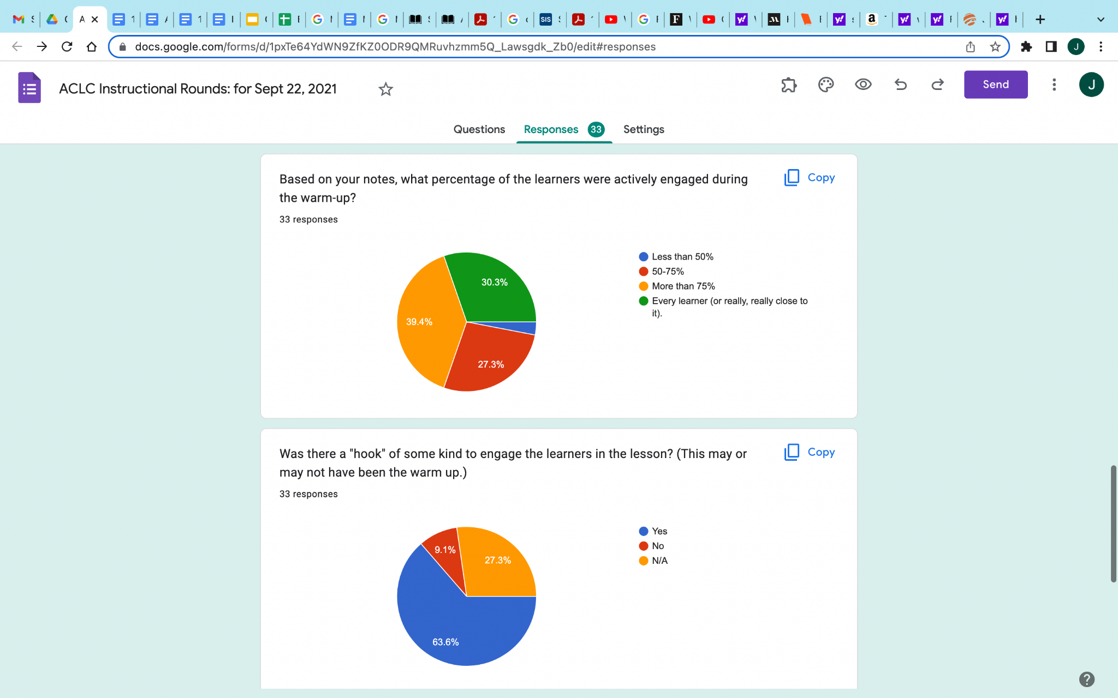  The data revealed to us that student engagement at the beginning of class was strong, but that there was room for improvement. As a result, we shared strategies and emphasized the significance of incorporating these strategies at the beginning of each class.  Effects of English Department Curriculum Training: The English department switched to using CommonLit as the main curriculum for grades 6-10 at the end of the 2021-2022 school year, with a plan to expand to 11-12 as CommonLit builds the curriculum. A CommonLit representative led a Professional Development seminar for the facilitators at our school over Zoom on how to operate and utilize the various resources on the website. The English department also worked together at the end of the school year to map out curriculum and set goals for the 2022-2023 school year with CommonLit. Student progress has been significantly easier to track using CommonLit as a tool.  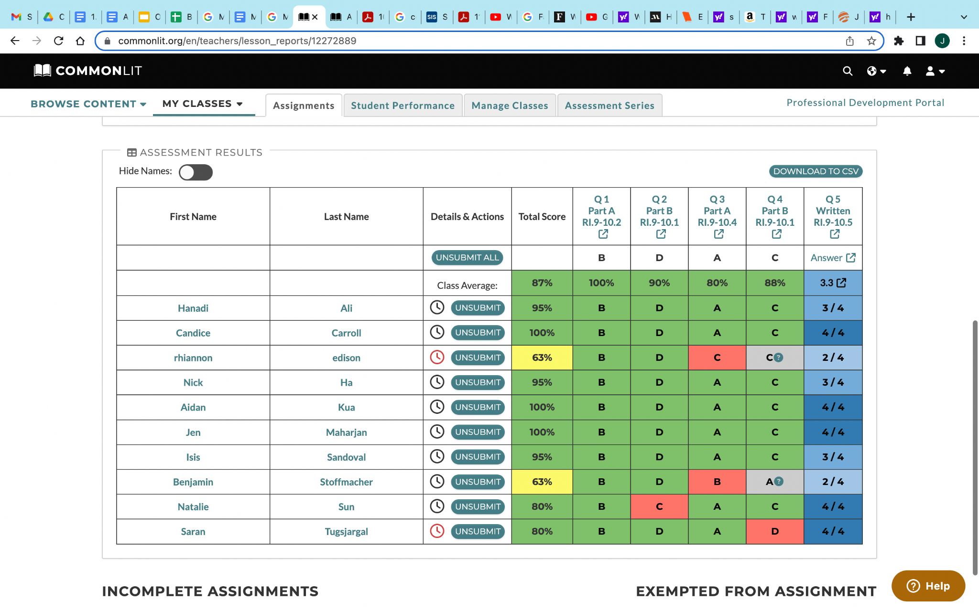  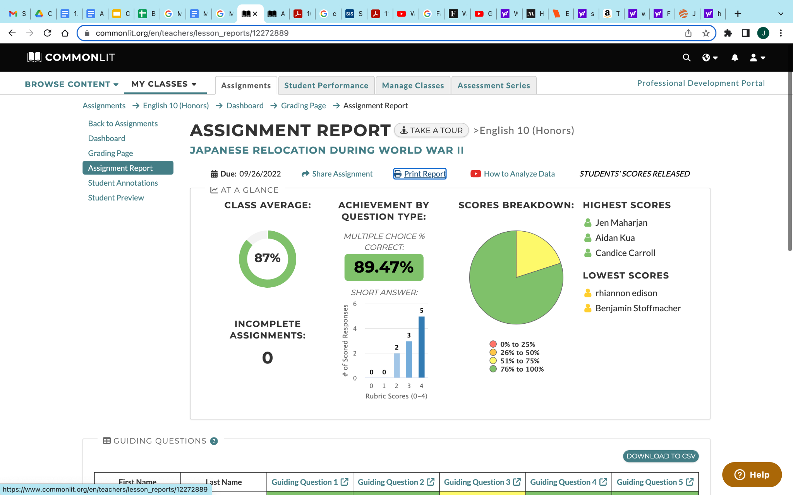  CommonLit allows the English facilitators to track progress on an individual assignment for an entire class and provides tangible feedback supported with data to help guide instruction. Progress based on standards and over time is also provided to demonstrate learners’ progress over time.  The English department has been satisfied with learner receptiveness to CommonLit; it has proven to be a valuable resource in tracking student progress.  The PD on Universal Design for Learning helped facilitators backwards plan units based on the results we are hoping to see the learners achieve. For the Math Lead, it has helped her to design portfolio assessments which give learners some choice in how they show mastery of the unit standards. The focus on mastery and choice has led to more learner confidence and engagement in the work. Overall there is a trend of more growth in understanding and scores in MAP and IXL Assessments.  Effects of math department’s internal PD: We have talked about building relationships with our learners and shifting classroom culture to be more inclusive of various ways of engaging material. Becoming more culturally responsive is a strong goal for the math department. We also adopted Illustrative Math as a curriculum in 2021-22. We are monitoring MAP assessments, and IXL Assessment growth as a means of measuring how the roll out of Illustrative Math is going.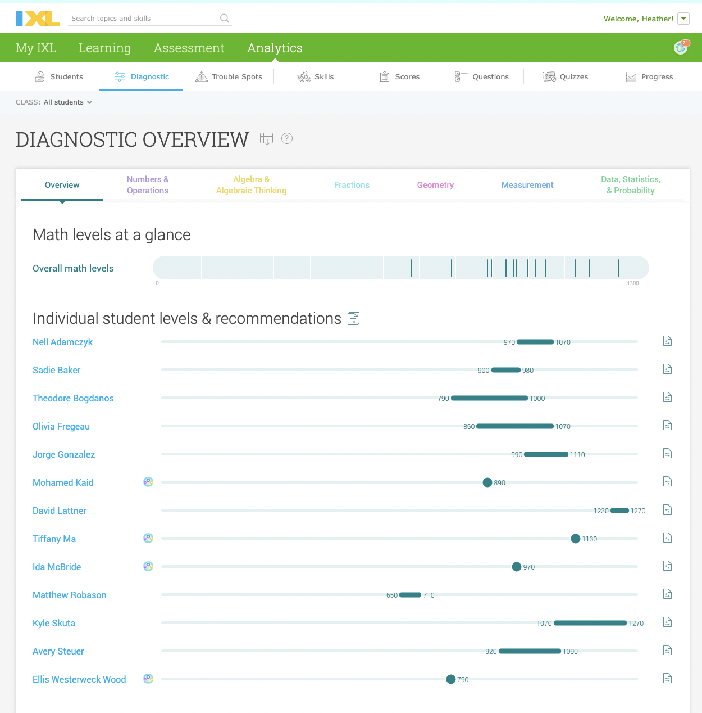  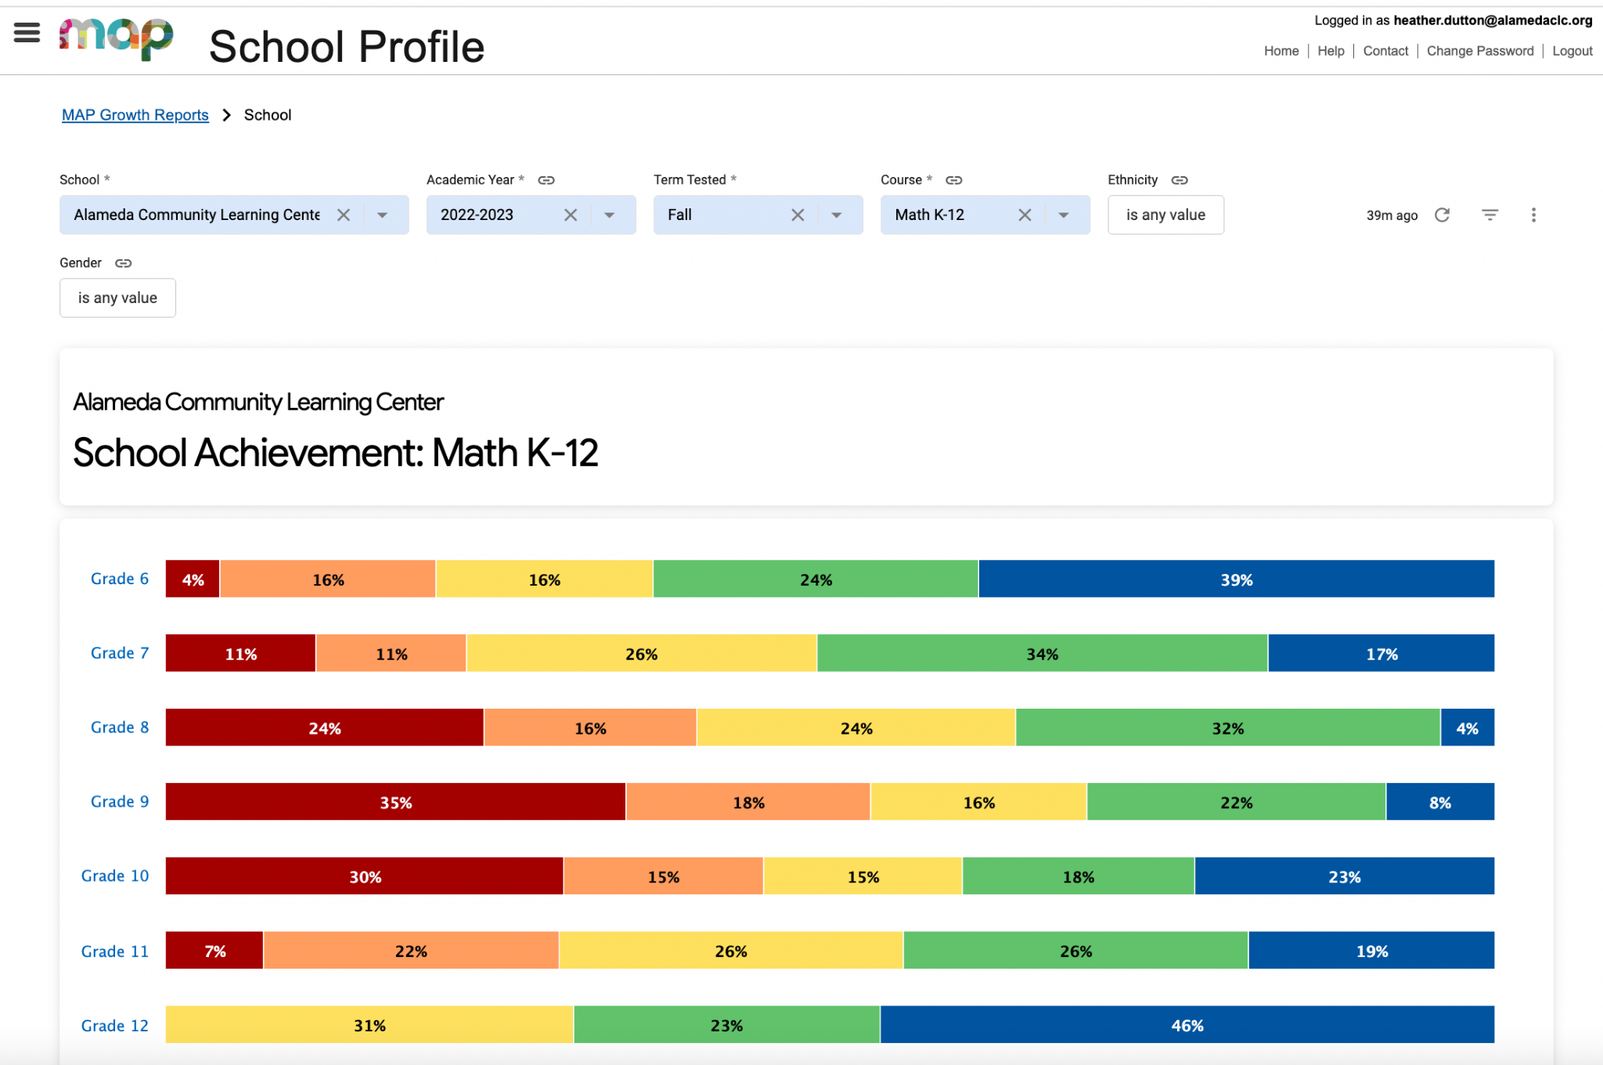  Project Based Learning PD time has helped us to develop stronger cross-disciplinary projects which has improved learner engagement. For example, the Precalculus class facilitator developed Tuition and Savings Projects for the Fall semester that learners will use for their Economics Budget Project in the Spring semester.  Having the choice of one of three PD strands, let facilitators choose to deepen their practice of Inquiry, Management, or Cultural Responsiveness. Groups met multiple times throughout the years and so had a chance to explore, apply, and then refine their practices based on what actually worked well with their learners. | TAKEAWAYS from the 21-22 Instructional Rounds  HERE is the schedule from Instructional Rounds  AIM PD  PD on Exit tickets  AIM PD and Implementation  PD on Engagement
A4.4. Supervision and Evaluation: The school implements effective supervision and evaluation procedures in order to promote professional growth of staff.  ACLC administration effectively supervises and evaluates professional growth of staff. The Lead Facilitator and Curriculum and Instruction Lead supervise various departments within the school. Administrators conduct facilitator evaluations on a regular basis. As outlined in our Collective Bargaining Agreement (CBA), evaluations occur every year for probationary staff, and every other year for those who are post probationary provided they receive a “highly effective” rating for at least two consecutive years. Evaluation rubrics are used to evaluate staff in various areas. After a formal observation, the administration holds a post observation meeting with the facilitator to review their performance, discuss any findings, and suggest areas of growth. Informal observations are done regularly and often at ACLC, and is meant as a reflective process that provides actionable feedback on content and pedagogy. They are both announced and unannounced and vary in length.  If a facilitator’s performance average falls below Effective in any domain, the facilitator will be placed on an Improvement Support Plan (ISP). Although placement on an ISP generally occurs at evaluation intervals, staff can be placed on one at any point during the school year. This is part of the process to retain staff that are effective in their practices.  Weekly faculty meetings often contain a short professional development or best practice session. Although attendance is not taken at meetings, staff are expected to attend. The last four years, instructional rounds have taken place and are devoted to observing multiple classrooms. One main goal in the rounds is for the participant to discover strategies to use in their own teaching practice. Staff and administrators reported that the experience was a highly effective professional development session and a good way to evaluate their own pedagogy. | CBA  Classroom Observation & Evaluation Schedule  Evaluation Rubrics/Forms  CLCS Facilitator Effectiveness Measurement System  Staff survey data
A4.5. Communication and Understanding of School Policies and Procedures: The school implements a clear system to communicate administrator and faculty written policies, procedures, and handbooks that define responsibilities, operational practices, decision-making processes, and relationships of leadership and staff.  Information regarding the responsibilities, operational practices, decision making processes, and relationships of leadership and staff are defined in the CLCS Employee Handbook. CLCS and ACLC policies are disseminated at faculty meetings, through email, and via the website. Administration communicates any information needed, changes, and any other mandates in the departments they supervise as well as in a weekly email from the Lead Facilitator (a weekly newsletter).  Departments maintain a google drive repository with pacing guides, lesson plans and curriculum maps are all linked on the Class Landing Page. Regularly scheduled safety drills and emergency procedures are practices to ensure correct safety measures are adhered to throughout the year. | Employee handbook  Examples of lesson plans, curriculum maps, pacing guides.  Emergency procedures, maps and backpacks  School Calendar  See Course Landing Pages HERE

A5. Resources Criterion
The human, material, physical, and financial resources are sufficient and utilized effectively and appropriately in accordance with the legal intent of the program(s) and LCAP to support students in accomplishing the schoolwide learner outcomes, academic standards, and college- and career-readiness standards.
Indicators
A5.1. Resource Allocation Decisions: The school leadership and staff are involved in the resource allocation decisions. There is a relationship between the decisions about resource allocations, the district’s LCAP and the schoolwide action plan/SPSA, the school’s vision, mission, the schoolwide learner outcomes, major student learner needs, academic standards, and college- and career-readiness standards.
A5.2. Practices: There are district processes and practices in place for developing an annual budget, conducting an annual audit, and at all times conducting quality business and accounting practices.
A5.3. Facilities Conducive to Learning: The school’s facilities are safe, functional, well-maintained, and adequate to meet the students’ learning needs and support the educational program (i.e., accomplish the vision, mission, and the schoolwide learner outcomes).
A5.4. Instructional Materials and Equipment: The policies and procedures for acquiring and maintaining adequate instructional materials and equipment, such as textbooks, other printed materials, instructional technology, manipulatives, and laboratory materials are effective.
A5.5. Resources for Personnel: Resources are available and used to enable the hiring, nurturing, and ongoing professional development of a well-qualified personnel for all programs.
A5. Prompt: Evaluate the school’s effectiveness in addressing the criterion and each of the above indicators; include supporting evidence.
Findings | Supporting Evidence
A5.1. Resource Allocation Decisions: The school leadership and staff are involved in the resource allocation decisions. There is a relationship between the decisions about resource allocations, the district’s LCAP and the schoolwide action plan/SPSA, the school’s vision, mission, the schoolwide learner outcomes, major student learner needs, academic standards, and college- and career-readiness standards.  Resources are effectively allocated to support the site and LCAP goals/school action plan. The goals focus on closing the achievement gap while preparing our learners for their post high school paths. LCAP’s WASC goals drive the school’s budgets. ACLC’s leadership team, staff and parents participate in the LCAP development in order to ensure that resources support the needs of the school. The ACLC Finance Committee and Governing Board monitors progress throughout the school year, making funding adjustments as needed. Our parent fundraising group - the Creative Community Education Foundation - supports teaching and learning with significant resources, as well as with active engagement in decision making around resource allocation. ACLC’s budget is developed in concert with the Executive Director and Lead Facilitator who ensure the funding aligns with the school’s goals. Department leads submit requests in order to meet their department goals. The requests are reviewed by the Lead Facilitator and any purchases greater than $500 require CLCS Executive Director’s final approval. Our budget provides funding for staff, professional development and conference attendance across all content areas, curriculum, technology, and instructional materials.  School staff are involved in resource allocation decisions at the department level by making purchase requests for curriculum and other supplies. The departments meet regularly to identify necessary platforms and materials. For example, after a yearlong trial of another curriculum and a six-month pilot of CommonLit360 the English Department decided to start using CommonLit’s 360 curriculum and made requests to purchase the necessary novels to accompany units for facilitators’ individual classes. Even though everyone on the team uses CommonLit, each facilitator also has autonomy to supplement that curriculum with other texts and projects of their choosing. For example, the 9th and 10th grade facilitator has created a mock trial project that is outside of and complementary to CommonLit. The Visual and Performing Arts and other departments also meet regularly to make collaborative decisions about which curriculum, materials, and software they need to teach the standards in their disciplines.  From the perspective of two ten-plus-year veterans on staff, “Our requests for curricular materials have never been denied, and we have always been given freedom within the structure of Common Core and other state standards to develop our courses.”  The impact of COVID-19 has meant that additional funds were used for upgrading online curriculum, purchasing licenses and programs (IXL, Lexia, TCI, Star Renaissance Testing, Illustrative Mathematics, and Vista Higher Learning Spanish). We also developed new staff roles to narrow the academic achievement gap. ACLC invested considerably in adding and updating technology to ensure learners had access to devices and connectivity to support distance learning and hybrid learning. All of the funds are allocated with an eye on effectively supporting learner outcomes and experiences so that we can uphold ACLC’s vision and mission, and meet WASC goals for 2022-23. | LCAP  Finance Committee Meeting Minutes/notes  Sample CCEF documents, budget, etc.  CCEF - Agenda
A5.2. Practices: There are district processes and practices in place for developing an annual budget, conducting an annual audit, and at all times conducting quality business and accounting practices.  A business plan has been developed to ensure that ACLC will be financially viable. The plan rests on state revenue limits and categorical funding sources that are ensured through state laws and regulations governing charter school funding. LCAP effectively develops annual budgets in concert with all stakeholders, including staff and parents. The finance committee meets monthly to review the budget and monitor expenditures. The Executive Director & Chief Operating Officer of CLCS oversees the audit, and audit findings are shared with the CLCS governing board. ACLC’s administrative team receives training sessions from Ed Tech on quality business and accounting practices, and receives budget advice. As part of the bargaining process with our union, Ed Tech also provides a finance presentation annually to NAU’s representatives. The CTA (California Teachers Association) has also been present to ask questions as deemed necessary. | LCAP  Ed Tech budget presentations  Finance Committee Meetings
A5.3. Facilities Conducive to Learning: The school’s facilities are safe, functional, well-maintained, and adequate to meet the students’ learning needs and support the educational program (i.e., accomplish the vision, mission, and the schoolwide learner outcomes).  ACLC maintains a learning environment that meets the educational health and safety of learners. ACLC is equipped with 10 brick and mortar classrooms, 5 portable classrooms and a multi purpose space (“the Center”). Each classroom has the appropriate workspace for each learner by furnishing desks, tables, and collaborative seating. The school is equipped with smoke detectors and fire extinguishers, an AED station (located in the office), first aid kits, emergency backpacks, and specialized rooms are equipped with safety equipment (ie. science labs). Since returning to campus in hybrid learning, classrooms are equipped with PPE, HVAC and air filters, and plexiglass to provide barriers when close contact is likely. The campus is well maintained by the custodial and maintenance staff both day and night to create a positive learning environment. Alameda Unified School District is responsible for repairs and ensuring that work orders are completed in a timely manner.  Learners and staff are required to know the procedures for a variety of emergency situations. All guests to the campus checked in at the school office and obtained a visitor pass to identify them for all staff and learners. | School Site Map  Emergency Procedures/drill schedule  Emergency backpacks  Visitor Sign in System
A5.4. Instructional Materials and Equipment: The policies and procedures for acquiring and maintaining adequate instructional materials and equipment, such as textbooks, other printed materials, instructional technology, manipulatives, and laboratory materials are effective.  ACLC has an effective process for acquiring and maintaining adequate instructional materials and equipment. Generally, the administrative team works in tandem with department leads to identify and prioritize instructional materials. Each department/house receives a supply list and is responsible for requesting materials to meet the needs of the department based on enrollment/courses offered. Every learner is provided with supplies throughout the year. Once the Lead Facilitator approves, the office is responsible for purchasing materials through approved vendors, and maintaining a stock inventory. All receipts are provided to our HR Assistant. The CLCS Technology Manager is responsible for maintaining and providing chromebooks for learners, laptops for staff and smartboards for the classrooms. To support distance learning in 2021-22, ACLC offered both pick up and drop off options for learners to get Chromebooks, Wi-Fi hotspots and supplies, to increase access for all learners at home. To improve communication and instruction, every facilitator has utilized Jupiter Grades in order to organize classwork, allow learners access to work, work with groups on shared google drives, and communicate with facilitators and peers using professional online platforms. Smartboards were installed in the Spring of 2021 so facilitators could use zoom and in person instruction simultaneously (our ‘hyflex’ model). Many of our computers were updated to support the demands of virtual learning.  Since ACLC’s last full WASC visit  - Illustrative math  - TCI  - CommonLit  - Lab Aids  Online resources  - Turn it in  - IXL  - Lexia | Chromebooks for learners/computer carts for classrooms  Upgraded technology (ie. smartboards)  New textbook/literature adoptions  CCEF funded materials  Purchase Order/Supply Forms  Sample Department Ordering spreadsheet
A5.5. Resources for Personnel: Resources are available and used to enable the hiring, nurturing, and ongoing professional development of a well-qualified personnel for all programs.  ACLC administrators work with Human Resources to determine staffing needs. All potential hires are reviewed by our Chief Operating Officer, interviewed, and complete background and reference checks. We use a personnel committee that in the past has included certificated and classified staff, administration, learners and parents to select qualified facilitators and staff. A budget is prepared every year and used for bargaining salary negotiations with NAU.  New employees are given a three day orientation prior to the beginning of school work days for returning staff. And all new facilitators are provided with weekly coaching by our instructional coach. For brand new teachers who need to clear their credentials, ACLC provides a Teacher Induction & Clear Credentialing Program. We also collaborate with local colleges and universities to place interns and learner teachers. Department leads and our instructional coach also support new facilitators to write and edit curriculum maps based on Common Core Standards.  All facilitators and staff are encouraged to attend conferences to further their educational practices. They also have access to site level professional development. In alignment with LCAP, resources will be used in 2022-23 for training with equity and inclusion, PBL and MTSS. Professional development to build site capacity in mathematics and literacy will continue. | LCAP  Hiring protocols/ procedures  New facilitator orientation  Learning Library for Staff  MTSS PD onboarding  IEP onboarding PD

A6. Resources Criterion [Charter Schools only]
The governing authority and the school leadership execute responsible resource planning for the future. The school has developed policies, procedures, and internal controls for managing the financial operations that meet state laws, generally accepted practices, and ethical standards. The school is fiscally solvent and uses sound and ethical accounting practices (budgeting/monitoring, internal controls, audits, fiscal health, and reporting).
Indicators
A6.1. Long-range Financial (and Other Resources) Plan and Stakeholder Involvement: The school regularly involves stakeholders in the review of its long-range plan/capital needs (and other resources) in relation to the school’s vision, mission, and schoolwide learner outcomes. Decisions about resource allocation are directly related to the school’s vision, mission, and schoolwide learner outcomes.
A6.2. Regular Accounting and External Audit Procedures: The school has written policy that defines internal controls, contracts, regular accounting, and external audit procedures.
A6.3. Processes for Implementation of Financial Practices: The school employs accountability measures to assure that personnel follow fiscal policies and procedures.
A6.4. Budgeting Process — Transparency: The school develops and monitors its annual budgeting process to ensure transparency and stakeholder involvement.
A6.5. Adequate Compensation, Staffing, Reserves: The school governing body provides adequate compensation to faculty, administrators, and staff; adequate staffing for the school’s program; and reasonable accumulation of reserves.
A6.6. Marketing Strategies: The school has marketing strategies to support the implementation of the developmental program, including research and information to help develop future planning.
A6.7. Informing the Public and Appropriate Authorities: The governing authorities and school leaders inform the public and appropriate governmental authorities about the financial needs of the organization.
A6. Prompt: Evaluate the school’s effectiveness in addressing the criterion and each of the above indicators; include supporting evidence.
Findings | Supporting Evidence
A6.1. Long-range Financial (and Other Resources) Plan and Stakeholder Involvement: The school regularly involves stakeholders in the review of its long-range plan/capital needs (and other resources) in relation to the school’s vision, mission, and schoolwide learner outcomes. Decisions about resource allocation are directly related to the school’s vision, mission, and schoolwide learner outcomes.  ACLC and CLCS includes stakeholders in a number of ways to determine long range planning, mission, SLOs and decisions about how finances will be used to support program improvement. Each year ACLC hires an outside agency to conduct an audit.  Financial Committee  Each year the CLCS Executive Director convenes and chairs the ACLC Financial Committee whose membership is constructed to include parents, Facilitators and Learners. The committee works to develop the budget, monitor the budget and monitor other financial activities under the direction of the Executive Director. Each month the Financial Committee makes a report to the CLCS Board of Directors and ACLC School Site Council, making financial recommendations as necessary. The Executive Director is responsible for setting up a purchase order system for all purchases with EdTec, ACLC’s business services management organization. Internal financial controls are well-established.  Assessment and Accountability Committee  Each year the Lead Facilitator consults with the Facilitators and appoints chairs the ACLC Assessment and Accountability Committee and supervises their work. The Assessment and Accountability committee membership is constructed so that there are parent, Learner, and Facilitator representatives. The committee works to develop the Annual Report, WASC accreditation report, and conduct the annual parent and Learner surveys. Each month the Assessment and Accountability Committee makes a report to the Governing Board and makes recommendations as necessary.  Personnel Committee  Each year the Lead Facilitator convenes and chairs a Personnel Committee whose membership is constructed so that there are parent, Learner, and Facilitator representatives. Under the direction of the Lead Facilitator, the Personnel Committee conducts screening, hiring, and provides recommendations on coaching needs for new hires, new hire monthly meetings, and the onramping program.  Curriculum and Standards Committee  Each year the Lead Facilitator consults with the Facilitators and appoints another Facilitator to chair the Curriculum and Standards Committee and supervises its work. The Curriculum and Standards Committee membership is constructed so that there are parent, Learner, and Facilitator representatives. The committee collects and documents all course outlines for compliance with California State University standards and UC a-g requirements. They also do appropriate WASC work and evaluate new courses before being submitted to the board for approval. Each month the Curriculum and Standards Committee makes a report to the Governing Board and makes curricular recommendations as necessary.  The Financial Committee, Personnel Committee, Curriculum and Standards Committee, and Program Evaluation Committee all operate under the oversight of the Lead Facilitator and CLCS Executive Director. The committees make recommendations on policy and resource allocation that are reviewed and approved by the ACLC School Site Council. | Fiscal policies  Finance reports  Board fiscal reports  Assessment & Accountability Board Report  Culture Committee sample report HERE
A6.2. Regular Accounting and External Audit Procedures: The school has written policy that defines internal controls, contracts, regular accounting, and external audit procedures.

The CLCS Governing Board selects an independent auditor through a request for proposal format. The auditor will have, at a minimum, a CPA and educational institution audit experience, and will be approved by the State Controller on its published list as an educational audit provider. The audit is conducted in accordance with applicable provisions within the California Code of Regulations governing audits of charter schools as published in the State Controllers K-12 Audit Guide.

The annual audit must be completed by December 15th of each year and a copy of the auditor’s findings are forwarded to AUSD, the California Controller, the ACOE Superintendent of Schools, State Board of Education, CDE, or other agency as the State Board of Education may direct.

A6.3. Processes for Implementation of Financial Practices: The school employs accountability measures to assure that personnel follow fiscal policies and procedures.  CLCS conducts several accountability measures to assure that personnel follow fiscal policies and procedures. This includes monthly financial committee meetings, bi-monthly fiscal reports to the CLCS Governing Board, internal audits, and management from our contract with Edtec our back office. | Board reports
A6.4. Budgeting Process — Transparency: The school develops and monitors its annual budgeting process to ensure transparency and stakeholder involvement.  Each year budget planning begins with the site administration, Admissions and Enrollment consulting, and our consultants at Edtec. From there the draft budget flows through the school Fiscal Committee which is constructed to include parents, Facilitators and Learners. The committee works to develop the budget and brings the first drafts to the ACLC Site Council and then to the CLCS Governing Board where feedback is provided. This process repeats three times until the final budget is approved. These are all public meetings and documents are published for the union and public to view. | Board meeting minutes  Budget drafts  School Site Council reports
A6.5. Adequate Compensation, Staffing, Reserves: The school governing body provides adequate compensation to faculty, administrators, and staff; adequate staffing for the school’s program; and reasonable accumulation of reserves.  The school provides adequate compensation to faculty, administrators, and staff; adequate staffing for the school’s program; engages in yearly bargaining negotiations with our union, NAU, which includes financial presentations by EdTech outlining the budget and reserves. Regarding bargaining, compensation is and has been an open process. Salary schedules for all parties (admin, certificated and classified staff) are provided and discussed with NAU annually. CLCS ensures that the school does not exceed its revenues, nor encroach on reserves of the school while also being fair and adequate for the positions required.  When facilitators are absent substitutes are sourced from:  - Internal teachers want to teach the class and receive sub pay.  - Subs from third party vendors:  - ▪ Teachers On Reserve ▪ The Educational Team  ACLC consistently maintains a reasonable accumulation of reserves based on California State requirements. | Salary Schedule 20201-22  Job Posting Sites (ie. EdJoin)  Budget
A6.6. Marketing Strategies: The school has marketing strategies to support the implementation of the developmental program, including research and information to help develop future planning.  Since the last WASC Visit, ACLC has completed a recent website revamp. Our current platform is easier to navigate and effectively communicates key events and program purpose.  Research to inform annual marketing plans includes:  - Asking all info session attendees, tour attendees and applicants to report how they heard about the school.  - Conducting parent/learner satisfaction surveys  - Hiring a third party school marketing consultant through SchoolMint to review our marketing plan and processes. | ACLC Homepage  See Marketing Materials (in Marketing section of this document)  Admissions Slides  Parent/Learner satisfaction surveys  School Mint
A6.7. Informing the Public and Appropriate Authorities: The governing authorities and school leaders inform the public and appropriate governmental authorities about the financial needs of the organization.  As with all California public schools, ACLC must meet state requirements for fiscal stability. With this in mind, the school uses the LCFF and LCAP for planning fiscal budgetary needs. These are reviewed by the administration, ACLC Governing Board, and CLCS Board.  Budgets are presented at board meetings for review, input and final approval. Board meetings are open to the public and public comment. Final budget is available to view on the website.  The final step in all of the financial planning is the yearly audit completed by an independent CPA firm. This, too, is available at both the school and state level for public review, showing how ACLC implemented those approved financial plans. | Finance Policies  LCFF  LCAP  Budget  Website

ACS WASC Category A. Organization: Vision and Purpose, Governance, Leadership, Staff, and Resources:
Synthesize Strengths and Growth Needs
Prioritize and list the strengths and growth areas for the criteria and indicators in Category A.*
Areas of Strength
- ACLC adheres to all laws and requirements for state and federal reporting and retains legal counsel to support with this
- Unification with sister school Nea’s high school program protecting CLCS financial outlook
- Use of and transparency around outside resources like EdTech for financials - budgeting and budget forecasting serves to ensure the school remains fiscally responsible
- CLCS works with facilitator union via yearly negotiations for annual salary and benefits
- CLCS and ACLC boards have regular reporting around school performance, budget, and long range planning
- ACLC’s use of standing committees to ensure ongoing work in key areas in support of the school

Areas of Growth
- ACLC can work to ensure greater participation in ACLC board meetings in an ongoing effort around transparency and accountability for school leadership decisions
- Academic performance of learners with 504s and IEPs is lower than the rest of the population (CAASPP and GPA).
- Improve Learning Lab effectiveness
- Improve Project Period effectiveness and supervision
- JC write-up process consistency and data tracking for effectiveness.
- Develop a SPSA
- Continue to build Parent participation in
  - PAC
  - CCEF
  - ELAC
  - ACLC Board
- ACLC does not currently have an SPSA.

Category B: Curriculum
B1. Rigorous and Relevant Standards-Based Curriculum Criterion
All students participate in a rigorous, relevant, and coherent standards-based curriculum that supports the achievement of the schoolwide learner outcomes, academic standards, and the college- and career-readiness standards in order to meet graduation requirements.
Indicators
B1.1. Current Educational Research and Thinking: The school provides an effective, rigorous, relevant and coherent curriculum based on current educational research and thinking that supports the academic standards.
B1.2. Academic and College- and Career-Readiness Standards: The school has defined academic standards and college- and career-readiness indicators or standards for each subject area, course, and/or program that meet or exceed graduation requirements.
B1.3. Congruence with Student Learner Outcomes and Standards: There is congruence between the actual concepts and skills taught, the schoolwide learner outcomes, academic standards, and the college- and career-readiness indicators or standards.
B1.4. Integration Among Disciplines: There is integration and alignment among academic and career technical disciplines at the school.
B1.5. Community Resources and Articulation and Follow-up Studies: The school engages with community partners and resources, articulates regularly with feeder schools, local colleges and universities, and technical schools. The school uses follow-up studies of graduates and others to learn about the effectiveness of the curricular program.
B1. Prompt: Evaluate the school’s effectiveness in addressing the criterion and each of the above indicators; include supporting evidence.
Findings | Supporting Evidence
B1.1 Current Educational Research and Thinking  Alameda Community Learning Center (ACLC) is committed to maintaining a rigorous, relevant, and coherent curriculum based on a Project Based Learning (PBL) model. The school's emphasis on project collaboration and project design changed towards remote teaching and hybrid instruction during the pandemic. Newer and returning staff need training, support and PD time to continue PBL as the cornerstone instructional strategy for the school.  The school’s goal to develop extensive Course Landing pages with resources stored on Google Drive is ongoing; the goal is to provide cohesive content for all courses with the ability to reflect, expand, and adapt based on students’ needs. Each subject area works with a research based curriculum, expanding on that curriculum to respond to our learners’ needs. For example, the English department has adopted CommonLit 360 as a foundational curriculum for grades 6-10, expanding to grades 11-12 as more content is produced. The CommonLit model is based on current educational research to support growth in reading, writing, and language development using data to support the facilitation of skills. The ACLC English department incorporates the materials on CommonLit 360 fluidly into our PBL model.  The Math department has adopted Illustrative Mathematics and involved the wider school community in engagement sessions starting in 2021-22 school year. Facilitators of mathematics are provided with ongoing training and support in implementing the Illustrative Mathematics curriculum. This decision was made with input and advice from the Curriculum Committee.  The Spanish department used the Covid pandemic as an opportunity to reflect on curriculum, and decided to switch gears to a more modern, digital curriculum called Voces Digital. This curriculum has traditional components but also offers learners the opportunity to hear spoken Spanish in a variety of forms and engages learners with video, sound, and games as well as writing and reading comprehension activities. | Projects @ ACLC  Project Collaboration and planning time PD  PBL onboarding Slides  English 1 Course Landing  English 3/4 Course Landing  Geometry Course Landing  World History Course Landing  Physics Course Landing  Spanish 3 Course Landing  Middle School Art Course Landing  CommonLit  Illustrative Math  Voces Digital
B1.2 Academic and College- and Career-Readiness Standards:  ACLC has an extensive Academic and College and Career curriculum beginning in Middle School and continuing through graduation. In the 6th grade, learners take a Learning to Learn course designed to promote a growth mindset, practice goal setting, and develop skills to manage emotional wellbeing.  In the 9th grade, learners take Current Life Issues, a course designed to promote study skills, provide familiarity with graduation requirements, introduce components of College and Career Readiness, and teach the basics of financial literacy.  Throughout grades 10-12, learners take the following elective courses: College and Career Prep, Junior Seminar, and Senior Seminar. These three courses prepare learners for the college application process, develop resume and interview skills, allow learners to explore career options, and build financial literacy.  ACLC exceeds the graduation requirements for the State of California. Beyond the A-G requirements, learners must also complete a digital graduation portfolio, complete at least 1 college course, complete 20 hours of community service each year, and complete a 20 hour internship in a professional setting. | ACLC Graduation Requirements  College and Career Prep  L2L  Current Life Issues  Junior Seminar  Senior Seminar  EVERFI  Naviance  Career Event 2022  Junior Information Night  Senior Information Night  Financial Aid Night  College Search Presentation  Senior Web Pages
B1.3. Congruence with Student Learner Outcomes and Standards:  At ACLC we value the Project Based Learning (PBL) model as a method for learners to learn by doing. An example of PBL in practice is the 9th grade English Of Mice and Men Unit. The end of the Unit project for this unit is a Mock Trial covering the murder of Lennie Small by George Milton. Over the course of the project, learners work together to get a better understanding of the legal system, gather evidence from the text, and plan for a trial. Learners are divided into lawyers, witnesses, and jurors based on a role preference survey. Each role has specific preparation and participation that must be completed over the course of the project. This aligns with all seven of the Essential PBL Elements by providing a challenge question, sustained inquiry, student voice and choice, reflection, critique and revision, and a public product.  Other examples of PBL projects are in the resources on the right. | Project Based Learning Model  Mock Trial Role Preference  Mock Trial Project  Additional PBL Units  8th Grade History “Show Me the Money” Unit Planner  8th Grade Science Cardboard Boat Race Photos
B1.4. Integration Among Disciplines  ACLC strives to incorporate cross-curricular projects that promote career technical skills throughout the school year. An example of this is in 9th grade Physics and English, where a unit on Qualitative Energy was aligned with a CommonLit unit on People and the Environment. As learners studied environmental issues and interpreted data, they were also tasked with a joint project creating a sustainability solution for our local community with data to support their conclusions. Another example is an English and History Project centered around the book Farewell to Manzanar and World War II. For this particular project, learners analyzed the effects of displaced populations during the Japanese Internment and the Holocaust. They must then produce a website demonstrating their understanding of the text as well as the socio-economic impact of displaced populations.  ACLC also holds a yearly STEAM Fair where all learners, grades 6-12, can showcase their technical and artistic skills with personalized projects.  This year, ACLC has also started the process of designing a Maker Lab with the introduction of a Creative Technologies course. The course allows learners to use their knowledge in science and mathematics to create individual or group designed projects.  The Art Department has collaborated with the Spanish Department over the past 2 years. Learners were taken in the fall of 2022 to the SFMOMA to see the Diego Rivera Exhibit. The highlights of this field trip were the exploration and movement i.e. we took 40 learners on the Ferry from Alameda, walked to the Yerba Buena Center for the Arts where we witnessed and experienced the Martin Luther King Fountain then spent the afternoon at the Diego Rivera Exhibit. Spanish 3 had studied Diego Rivera in the fall and this was a chance for them to experience his art in person. The interdisciplinary aspect of this trip was for Spanish and Art Learners to cultivate an appreciation of Latin American Art. The previous spring the Spanish and Art Department collaborated on a trip to see the works of El Greco at the Legion of Honor to cultivate an appreciation of how language and art intersect in the world.  The Art Department has interdisciplinary and intersectionality in our respective Art disciplines of digital and Fine Art. The cross current curricula covers contemporary art in Hip Hop and Graffiti. Learners have overlapping exposure through projects. | Sustainability Project (English)  Sustainability Project (Physics)  Beyond Manzanar Project  Beyond Manzanar Project  Learner Example  STEAM Fair Sample Project  Creative Technologies  Project Collaboration and planning time PD  Project Calendar and grade level planning tabs for the 22-23 start of the school year
B1.5. Community Resources and Articulation and Follow-up Studies  ACLC has a strong partnership with the Peralta Community Colleges. All learners are required to take one college course throughout their high school experience, but many opt to take more than one course. For the class of 2022, 30% of learners took 2 or more college classes. And for the current class of 2023, 40% of learners took 2 or more college classes. Our primary partner is the College of Alameda, located a few blocks from our campus. Learners are encouraged to take classes beginning in their 10th grade year and are supported in the process by our college and career counselor.  ACLC actively maintains a connection to the UC and CSU colleges in Northern California. Each year, 11th and 12th grade students are invited on college tours of a selection of the following schools: UC Berkeley, UC Santa Cruz, UC Davis, UC Sacramento, San Francisco State, San Jose State, and CSU East Bay. As interest grows for schools in Southern California, we hope to expand our college tour options.  ACLC is actively expanding our alumni network. In the fall of each school year we conduct a College Talk Night with recent graduates for the 12th grade learners. This night provides a great opportunity for learners to engage with their peers about college academics and opportunities. The alumni have also given great feedback on the effectiveness of ACLC’s college preparation curriculum. | College Courses at ACLC  College Talk Night with ACLC Alumni  Alumni Summary Tracker
B2. Equity and Access to Curriculum Criterion
All students have equal access to the school’s entire program and are provided assistance with a personal learning plan to meet the requirements of graduation and are prepared for the pursuit of their academic, personal, and career goals.
Indicators
B2.1. Variety of Programs — Full Range of Choices: All students are able to make appropriate choices and pursue a full range of realistic college and career and/or other educational options. The school provides for career exploration, preparation for postsecondary education, and pre-technical training for all students.
B2.2. Accessibility of All Students to Curriculum, including Real World Experiences: A rigorous, relevant, and coherent curriculum that includes real world applications is accessible to all students through all courses/programs offered. Course enrollment patterns reflect the diversity of the school’s students.
B2.3. Student-Parent-Staff Collaboration: Parents, students, and staff collaborate in developing and monitoring a student’s personal learning plan, including college and career and/or other educational goals.
B2.4. Post High School Transitions: The school implements strategies and programs to facilitate transitions to college, career, and other postsecondary high school options and regularly evaluates their effectiveness.
B2. Prompt: Evaluate the school’s effectiveness in addressing the criterion and each of the above indicators; include supporting evidence.
Findings | Supporting Evidence
B2.1: ACLC offers a wide range of educational options beyond the core curriculum.  As our high school continues to grow, we hope to build more elective opportunities and experience for our learners. This year, as we’ve included more facilitators in our high school program, we’ve been able to offer more electives like Musical Theater and Introduction to Music. In the coming years, several facilitators from our sister school Nea will join the ACLC staff, and our course offerings will increase.  College & Career Prep: Learners educate themselves about their professional interests using career surveys, detailed career exploration, and career projects to understand the process for transitioning into the workforce and pursuing their goals.  Digital Arts: Middle and high school learners have access to digital arts courses, where they can explore their interest in video and music design.  Leadership: Middle and high school learners have access to a class on leadership, which promotes their organizational and collaborative skills as they are tasked with discussing school policies and managing community events.  Creative Technologies: High school learners have access to hands-on learning focused on engineering standards centered around problem solving and design. In this course, learners have the opportunity to work with tools and develop their own projects.  Community College Partnerships: High school students are offered a wide range of college classes through our partnership with the Peralta Community College District | ACLC Program Overview  Career Research  Digital Music Course Landing  Creative Technologies Course Landing  College Classes
B2.2: Accessibility of All Students to Curriculum, including Real World Experiences  At ACLC, 9th grade learners are introduced to the A-G graduation requirements and course planning during the 1st unit in Current Life Issues. Throughout highschool, learners meet with the academic counselor and college counselor to track their graduation progress and college courses. Our special education team closely monitors our learners with 504s and IEPs to ensure that the curriculum is accessible for all by providing support in classes, working with facilitators to construct accommodations, and developing organizational practices for success.  The ACLC curriculum is focused on collaboration and real world applications. Group work is an integral part of ACLC’s educational model. It is our goal that learners develop strong skills in teamwork, accountability, critical thinking, and problem solving. Our model also relies heavily on digital skills, with the Google Workspace being utilized in the majority of classes.  As part of the ACLC’s graduation requirement, all learners must complete a 20-hour internship in a professional setting between 10th grade and graduation. Learners are responsible for setting up their internships, managing their hours, and writing a reflective essay on their experience. The Senior Seminar facilitator and College & Career counselor act as advisors for these internships.  ACLC offers honors classes that are truly open enrollment. The same is true for all electives. Honors courses can help learners achieve competitive eligibility for admission to the University of California and other top universities. ACLC offers the following Honors courses:  - Honors Biology  - Honors English 2  - Honors English 3  - Honors English 4  - Honors Physics  - Honors Pre-Calculus  - Honors US History  - Honors US Government  High School Electives include:  - Art and Studio Art  - College and Career Planning  - Computer Science  - Creative Writing & Poetry  - Digital Music  - Digital Video Studio  - Environmental Science  - Leadership (Student Government)  - Judicial Leadership  - Musical Theatre  - Pre-calculus  - Spanish 3  - Visual Communication | Current Life Issues  ACLC Internship Program  Internship Opportunities  ACLC Internship Overview  Senior Website Internship Example  ACLC Courses
B2.3: ACLC was designed and built on community collaboration.  In order for the school model to operate successfully, we rely on contributions from staff, students, and parents. The groups that best exemplify our commitment to community collaboration are our school board, Creative Community Education Foundation (CCEF), and the Leadership class.  ACLC Board: The board is made up of the school principal, two staff representatives, two learner representatives, two parent representatives, and one alumni representative. Together, the board oversees school operations and educational planning. Some responsibilities of the board members include overseeing the school budget, evaluating graduation standards, and setting educational goals. Last year, the board set goals around school culture and teacher diversity, recruitment, support, and retention. With input from all representatives, action plans were established and carried out throughout the school year.  CCEF: This parent-led group is similar to a traditional PTA, but the board at ACLC includes learners as well. This group raises money for the school through donations and events to fund educational opportunities at the school. Any staff member or learner in the community can apply for a grant to provide opportunities to the ACLC community. Recently, this group has helped to fund materials for class projects, field trips, college tours, and school sponsored events.  Leadership: This is a learner-led course at ACLC with a staff advisor. This group is responsible for planning and leading our weekly school meetings, known as Contemporary Community Citizenship, hearing school proposals, and organizing an annual Constitution Convention, which allows learners and facilitators to review ACLC’s educational and community experiences. | ACLC Board Documents  ACLC Board Minutes  CCEF Budget  CCEF Agenda  CCEF  Leadership Model
B2.4 ACLC actively promotes post-secondary transitions to college, career, and other options.  Although we pride ourselves on being a rigorous college-preparatory program, we encourage learners to pursue interests they are passionate about and career options that do not require a Bachelor's degree.  In our college & career courses we provide continuous resume workshops and interview skills. High school learners are introduced to resumes in their 9th grade Current Life Issues course and will continue to develop their own resumes in College & Career Prep, Junior Seminar, and Senior Seminar. A completed resume is a part of the graduation portfolio for all 12th grade learners.  The interview process is covered in various courses using interview tutorials, mock interview projects, and learner-led interviews of professionals in a field of interest. Through these practices, learners become better prepared to represent themselves in any professional interview setting.  At the beginning of 12th grade, all learners must submit a post-secondary plan essay detailing their personal goals after graduation and the steps they plan to take over the year to achieve those goals. As part of the 12th grade graduation portfolio, all learners must include a personal vision essay, which details their career and life aspirations over the next 20 years. These assignments act as motivation and reflection tools for learners to utilize as they plan out not only career paths, but also life goals. | Resume Building  Interview Project  Interview Narrative  Career Exploration  Senior Website Resume Example  Personal Vision Essay  Senior Website Personal Vision Example
ACS WASC Category B. Curriculum
Summary, Strengths, and Growth Needs
Prioritize and list the strengths and growth areas for the criteria and indicators in Category B.*
Areas of Strength
- Project Based Learning
  - All facilitators facilitate Projects and work collaboratively on Project interdisciplinary assignments.
- Nationally recognized, standards-aligned curriculum in key content areas
  - Mathematics: Illustrative Mathematics (IM)
  - English: CommonLit 360 and Engage New York (EngageNY)
  - Science: Lab Aids
  - History: Teacher’s Curriculum Institute (TCI)
  - Spanish: Voces Digital (VD)
- College & Career Focus:
  - Counseling
    - Academic planning and support
    - College and Career planning and support
  - Courses:
    - College & Career Prep. (high school learners)
    - Junior and Senior Seminar classes to prepare learners for college and career readiness
    - Current Life Issues (CLI) in 9th grade

Areas of Growth
- Continue to provide effective supports and training for new and returning facilitators to further their ability to effectively use high quality curriculum with our learners
- Work to create a structure for and find/create a curriculum for an Advisory structure at ACLC. This can happen in CCC (Contemporary Community Citizenship - meets once/week for 45 minutes with mixed grade-level groups)
- Continue to build and refine curriculum for Junior and Senior Seminar classes to best support ACLC’s mission and Career and College readiness goals.
- Facilitator turnover and the pandemic have set the school back in regards to PBL. The school is retraining and rebuilding some institutional projects and new projects with many brand new facilitators.

Category C: Learning and Teaching
C1. Student Engagement in Challenging and Relevant Learning Criterion
To achieve the schoolwide learner outcomes, academic standards, and college- and career-readiness standards, all students are involved in challenging and relevant learning experiences in an equity-centered learning environment.
Indicators
C1.1. Results of Student Observations and Examining Work: All students are involved in challenging and relevant work as evidenced by observations of students working and the examination of student work.
C1.2. Student Understanding of Learning Expectations: All students understand the standards/expected performance levels for each area of study in order to demonstrate learning and college and career readiness.

C1. Prompt: Evaluate the school’s effectiveness in addressing the criterion and each of the above indicators; include supporting evidence.
Findings | Supporting Evidence
C1.1. Results of Student Observations and Examining Work  ACLC staff routinely engage in observations and examinations of student work. This happens both informally as well as formally. Some recent structures to support this work include:  - In 2022, each staff member was released to shadow a learner for the day. Learner shadowing gave facilitators a chance to experience the day from a learner’s perspective. Each facilitator interviewed the learner ahead of time, wrote notes and reflections throughout the day, debriefed with the learner at the end of the day, and participated in a full staff conversation at the end of the process. The purpose was to understand learners’ experiences at ACLC so that we can respond and shift practice to best meet learners’ needs.  - Additional opportunities for student observation include regular departmental observation rounds. Linked at right is an observational tool used for these rounds. This observation was done within the Arts and Activities department by the department lead.  - Student work is examined using protocols both at the departmental level and with the instructional coach. | Shadow-a-Learner Facilitator Packet  Department Observations  Observation Tool for Department Instructional Rounds
C1.2. Student Understanding of Learning Expectations  A key to helping learners understand expectations is to be consistent on our own understanding as a staff. Over summer of 2022, six ACLC facilitators and administrators met as the Standards Based Grading committee. This committee helped create resources for standards based grading and the committee members along with the Department Leads helped staff members align standards, units and gradebooks.  In order to make sure learners understand what it means to be an ACLC student, we have developed clearly articulated “Success Skills,” categorized as Personal Responsibility and Social Responsibility. These success skills are based on ACLC’s Student Learning Outcomes and are taught and evaluated in each class. We use come rubrics to provide consistency in our expectations. These success skills have been introduced and explicitly taught in each class.  We have begun the work to create aligned rubrics across departments. Facilitators have had the opportunity to work with an instructional coach to improve and norm rubrics on multiple occasions. This work has just begun and will be ongoing.  In order to communicate expectations on subject area assignments, facilitators create clear assignment sheets and use student work exemplars whenever possible. This work is supported by the instructional coach and the department leads. | Supporting Consistency of Staff Expectations:  Department Collaboration  Subject Standards PD 4.21  Standards & Gradebook PD 4.24  Articulating Success Skills clearly to students:  Success Skills Grading Slides  Success Skills Rubrics  Examples of assignment sheets:  7th grade History project  9th Grade Physics Project  MS Art Assignment

C2. Student-Centered Instruction through a Variety of Strategies and Resources Criterion
All teachers use a variety of strategies and resources to create an equity-centered learning environment, including technology and experiences beyond the textbook and the classroom, to actively engage students and emphasize creative and critical thinking skills and applications.
Indicators
C2.1. Teachers as Facilitators of Learning: Teachers facilitate learning as coaches and are current in the instructional content taught and research-based instructional methodologies including differentiation and the integrated use of technology.
C2.2. Creative and Critical Thinking: All students demonstrate creative and critical thinking within a variety of instructional settings, using a variety of materials, resources, and technology beyond the textbook.
C2.3. Application of Learning: All students demonstrate that they can apply acquired knowledge and skills at higher levels and depths of knowledge to extend learning opportunities.
C2.4. Career Preparedness and Real World Experiences: All students have access to and are engaged in career preparation activities.
C2. Prompt: Evaluate the school’s effectiveness in addressing the criterion and each of the above indicators; include supporting evidence.
Findings | Supporting Evidence
C2.1. Teachers as Facilitators of Learning: Facilitators at ACLC are well versed in various instructional methodologies and use of technology in the classroom. We use a project based learning model at ACLC, therefore much of the curriculum focuses around group work, class projects, and personal self reflection. The humanities department utilizes Socratic Seminars as a method to facilitate learning by guiding learners to develop a better understanding of a topic through group discussion. Socratic Seminars are learner driven and allow for participants to collectively get a better understanding of a topic and provide an opportunity for self reflection.  ACLC is striving to provide consistency from classroom to classroom. There are different IDMs (Instructional Delivery Models). All agree that there are clear pedagogical moves that best facilitate learning. The ACLC staff participated in common readings that included brain science & learning (Reduce cognitive load and Support learning new content using existing structures and processes), trauma-informed practices (Consistency, consistency, consistency), equity & access (poverty, disability, language learners, minority groups and Common framework, vocabulary, and research-backed best practices associated with AIM components. We landed on the following components:  - ACLC Instructional Model or “AIM”  - Opening Routines and warm ups  - Content Delivery  - Classwork time  - Group work  - Individual  - Accountability/Assessment Strategies  - Closure  Why have an Instructional Delivery Model (IDM). IT IS DESIGNED to create consistency, develop a library of research-backed best practices to select from that will benefit our learners; define the “ACLC Way” and what best practices make this up. IT IS NOT designed to have everyone in “lock step” doing the same thing day in/day out, having every lesson be the exact same.  ACLC is a small school and our courses are not sectioned based on ability. In order to allow for more differentiation within a class, many facilitators build both accommodations and an honors component into the curriculum. In English, to support learners with 504s and IEPs, a length and time accommodation is provided to support all learners with writing accommodations on all major written assignments. Scaffolding techniques are often utilized to support all learners for projects and longer written assignments, such as the graphic organizer used for the Of Mice and Men Essay.  ACLC strives to make learners accountable for their own learning by providing voice and choice for major projects. In Creative Technologies, learners are encouraged to design their own projects based on the techniques used in the classroom and will be guided by the facilitator to plan and execute their projects. In English 1, learners select their own project topic based on the book Farewell to Manzanar after extensive discussion about the impact of dispersed populations. In small groups, learners must select a topic, research, and build a website to demonstrate their findings. On the website directions, the facilitator has provided an honors extension for learners in need of a more rigorous curriculum. Websites, such as the example on the right, as well as various other research based projects demonstrate ACLC’s commitment to utilizing technology in the classroom.  The College & Career counselor facilitates Junior and Senior seminar classes where learners are exposed to various resources and platforms where they can explore their own interests and possible career options. College Counselor oversees the creation of college lists in preparation for the college application season. Learner’s individual needs are taken into consideration when searching for and researching post high school options. | AIM Components Jamboard  PD for AIM  AIM PD  PD on Exit tickets  AIM PD and Implementation  PD on Engagement  Socratic Seminar Observation Form  Of Mice and Men Essay  Of Mice and Men Essay Guide  Beyond Manzanar Website Directions  Website Example  Instructional Rounds Slides
C2.2. Creative and Critical Thinking: ACLC learners are asked to engage in creative and critical thinking in each class. Examples from several disciplines are below:  All participate in a science fair each year. Our lower grade learners’ work is scaffolded using the ecybermission.com platform (6th grade participants earned an Honorable Mention and a team of 9th graders won a 1st place at the statewide level). Upper grade learners may conduct either traditional investigations of research questions using experimental methods or may design projects to meet specific needs. The science fair is a community event in which creative and critical thinking is celebrated by families.  In ACLC science classes, learners are often tasked with applying scientific knowledge to solve real-world problems. In chemistry, learners are challenged to determine the ideal stoichiometric ratio of zinc to sulfur powder to power a small rocket. In biology, learners researched niches of specific birds to design and build a better birdhouse. In middle school science, learners design and create life-sized cardboard boats that they then use to cross a swimming pool. ACLC learners design and create arcade games to demonstrate their understanding of electrical conductivity. ACLC learners also build small drivable vehicles powered by 2-wheeled hoverboards. In all these classes, the learners are the primary driving force for the design, implementation, and overall final products that demonstrate the learners understanding of how to solve-real world problems.  Our history facilitators work to provide opportunities for learners to go beyond the text in a book to engage in investigative learning. An example can be found in the WW2 Unit in World History where learners work to find solutions and answers to philosophical, cultural, governmental and military issues that arose from the conflicts in WW2. The learners search for evidence as they look through artifacts, photos, news footage, personal diaries, first hand accounts, maps, archival film, and declassified government documents to help formulate answers to these deeper questions. The learners select the questions they are most interested in researching and fill out evidence sheets as they examine the primary sources to gain knowledge and a wider perspective on issues. Then using debate and further questioning with other classmates, learners form a response to the larger issues presented in the questions that stem from this time period and still are impacting our actions and beliefs in conflicts today.  Creative and critical thinking is taught in every class: In PE learners are asked to think critically about our school lunch menu and use creative and critical thinking to redesign a healthier menu; in Geometry, learners are asked to create paper vases in various shapes that hold exactly one liter of sand and then present these vases, with flowers, to facilitators of their choice, and in 8th grade humanities, learners are redesigning currency to create bills with images of historical figures that reflect their criteria for “American Heroes.” | Science Fair Document Folder  Biology Presentation Example  Hoverboard Photo 1  Hoverboard Photo 2  WW2 Investigation Questions  World War II Stations Slides  WW2 Class Station Pictures
C2.3. Application of Learning & C2.4. Career Preparedness and Real World Experiences  Opportunities to apply learning and prepare for life beyond ACLC are built into the school’s structure:  Graduation Requirements: The ACLC graduation requirements exceed the University of California A-G entrance requirements.  Community Service Requirement: All learners are required to complete 20 hours of community service each year in settings of their choice. This has been a long-standing component of our program. Office staff keep records of the learners’ documented community service and the work is part of the requirements for the learners’ CCC class. In grades 6 through 8, this requirement forms 25% of their Spring Semester CCC grade. In grades 9 through 11, this requirement is 25% of the Spring CCC grade and is also a graduation requirement. Learners must complete 60 hours of community service to graduate high school. In grade 12, the community service requirement is fulfilled through the senior project, which is a graduation requirement tracked through our Senior Seminar class.  Clubs: Clubs to allow learners the opportunity to pursue their interests in more depth. These clubs can be facilitator or learner led. Some of the popular selections are Poetry Club, Business Club, Robotics, Gender-Sexuality Alliance, Guitar Club, Soccer Club, and Debate. As ACLC continues to grow, we hope to expand club offerings and elective classes to allow even more opportunities for our learners.  Community College Classes: All learners at ACLC are required to take at least one community college class and are strongly encouraged to take more. Counselors assist learners in applying for classes and are available to assist with any issues they may encounter along the way. Learners are encouraged to take classes in subjects that interest them as possible future careers to explore the field further and learn if it is in fact a good fit for them. ACLC is fortunate to have the College of Alameda a short walk away and we strive to utilize the resource as much as possible. Some popular courses learners take are Career & Life Planning, Intro to Psychology, Intro to Biology, Calculus II and III, Statistics, Welding, Spanish, and American Sign Language.  Additional Specific College & Career Preparation throughout learners’ years at ACLC includes:  - 6th & 7th grades: Learners are enrolled in “Learning to Learn” (L2L), which supports building ACLC “Success Skills.”  - 9th grade: Freshmen learners are all enrolled in Current Life Issues, where they are introduced to the A-G requirements, learn organizational skills, begin their resumes, and take a career assessment, as well as engage in health and financial literacy units.  - 10th & 11th grade: ACLC provides and hosts the PSAT for all 10th and 11th grade learners.  - 10th-12th grade: Between their Sophomore and Senior year, all learners must complete an extensive 20 hour internship in a field of interest.  - 11th grade: The college counselor facilitates Junior Seminar, which is focused on career and college exploration.  - 12th grade: The college counselor facilitates Senior Seminar, which is focused on career and college exploration, as well as completing their senior portfolios are part of the curriculum. All learners research various potential careers, explore majors, create cover letters, practice interview skills, and finalize their resumes. Senior learners also take part in a financial literacy unit where they are taught about credit scores, interest rates, and different types of financial institutions and investments. Financial Aid for college is also explored and students are encouraged and supported in filling out the FAFSA and scholarships.  Senior Projects  They also have to complete a senior project, which is something that is for the betterment of the school or local community.  Senior Portfolios  All seniors create a web-based portfolio of their time at ACLC. The portfolio includes a reflective essay, a personal vision, examples of some of their best work, a synopsis of their internship, and their resume. The ACLC Board of Directors reviews each of the pages, and learners must be approved to graduate. | Graduation Requirements  Bevy (Club) Sign Up Form  Bevy (Club) List  9th Grade CLI Overview  ACLC Internship Program  Senior Seminar running agenda  Senior Project Example  2022 Senior Presentation Night  Senior Project Example  Reflective Essay Guide  Senior Portfolio Example

ACS WASC Category C. Learning and Teaching:
Synthesize Strengths and Growth Needs
Prioritize and list the strengths and growth areas for the criteria and indicators in Category C.*
Areas of Strength
- ACLC Instructional Model or “AIM”
  - Opening Routines and warm ups
  - Content Delivery
  - Classwork time
    - Group work
    - Individual
  - Accountability/Assessment Strategies
  - Closure
- College course access via Peralta Community College partnership
- Project-Based Learning
- College Counseling
  - Junior and Senior Seminar classes
- Special Education supports and collaboration with general education and special education facilitators
- Office Hours structure

Areas of Growth
- Ensure more consistency in use of Project-Based Learning (PBL) across all grade levels and subject areas; continue to train new and returning facilitators on components of PBL using frame provided by PBLWorks.
- Ensure more consistent use of ACLC Instructional Model or “AIM” across all grades and subject areas
  - Opening Routines and warm ups
  - Content Delivery
  - Classwork time
    - Group work
    - Individual
  - Accountability/Assessment Strategies
  - Closure

Category D: Assessment and Accountability
D1. Reporting and Accountability Process Criterion
The school leadership and instructional staff use effective and equitable assessment processes to collect, disaggregate, analyze, and report schoolwide student performance data to the school staff, students, parents, and other stakeholders. The analysis of data guides the school’s programs and processes, the allocation and usage of resources, and forms the basis for the development of the schoolwide action plan/SPSA aligned with the LCAP.
Indicators
D1.1. Professionally Acceptable Assessment Process: The school leadership and instructional staff use effective and equitable assessment processes to collect, disaggregate, analyze, and report student performance data to all stakeholders.
D1.2. Basis for Determination of Performance Levels: The school leadership and instructional staff have agreed upon the basis for students’ grades, growth, and performance levels to ensure consistency across and within grade levels and content areas.
D1.3. Monitoring of Student Growth: The school has an effective system to determine and monitor all students’ growth and progress toward meeting the schoolwide learner outcomes/graduate profile, academic standards, and college- and career-readiness indicators or standards.
D1.4. Assessment of Program Areas: In partnership with district leadership, the school leadership and instructional staff periodically assess programs and expectations, including graduation requirements, credits, course completion, and homework and grading policies, to ensure student needs are met through a challenging, coherent, and relevant curriculum.
D1.5. Schoolwide Modifications Based on Assessment Results: The school uses assessment results to make changes in the school program, professional development activities, and resource allocations demonstrating a results-driven continuous school improvement process.
D1. Prompt: Evaluate the school’s effectiveness in addressing the criterion and each of the above indicators; include supporting evidence.
Findings | Supporting Evidence
D1.1. Professionally Acceptable Assessment Process: The school leadership and instructional staff use effective and equitable assessment processes to collect, disaggregate, analyze, and report student performance data to all stakeholders.  ACLC leadership and instructional staff uses Powerschool and Jupiter learner database and NSE lists to collect and analyze learner performance data. Counselors meet with learners with NSE’s individually and provide feedback on their graduation status by sending letters home. Learners are supported in Learning Labs and office hours to get their work done.  MTSS and staff analyze and interpret CAASPP, CAST, MAP, IXL, PSAT and Lexia results. However, consistent distribution of these results would allow for a deeper analysis of performance by department. This data informs us of learners who should be invited to intervention intersession.  Systemic distribution and use of this data during department time with facilitators would be beneficial at the instructional level.  Facilitators use classroom assessments to guide lesson plans.  Departments meet to discuss common assessments, pacing, and common lessons to guide pacing.  In the past three years, ACLC has taken significant strides towards progress and success with effective assessment, data collection, and analyzing of data. Along with the use of MAP, ACLC also coordinated with EdTec to house learner SBAC achievement data. All achievement data, grades, performance on state assessments, and our local assessments are housed in these systems. Training on the use of the program has been given to staff; but continuing training is needed to ensure full utilization of the program by teachers to inform their instruction.  These systems have been implemented as our assessment tools and Jupiter Grades as our gradebook system. We use MAP assessment data for Math, English, and Science. Staff in other disciplines have adopted and implemented assessments to measure learning and reflect on their instruction in other subjects. Most important, the staff have embraced looking at a variety of data points to reflect on our curriculum, instruction and school wide support systems.  The Assessment and Accountability Committee have conducted surveys in the past two years to track and reflect on the assessment implementation progress.  Data is used to directly determine support for individual learners and to guide critical education decisions by departments, ACLC Site Council and site administration. Mike McCaffrey guides and facilitates these decisions to be in alignment with WASC and LCAP. Some of those supports happen directly in the classroom. Others are implemented during Mandatory Academies, Learning Labs, Learning Labs or through SPED interventions.  - Discussions in Professional Development with CAASPP results  - Free or Reduced Lunch data  - Homeless data  - Demographic data –Ethnicity, gender, parent education  - Language data  - Analyzing benchmark data in department meetings,  - Gender  - By class and facilitator  - Grade level  - Ethnicity  - Identify and Track learners within the MTSS process using  - Grades  - MAP (Measures of Academic Progress)  - Attendance  - Truancy  - CAASPP  - Utilizing grade and MAP data to assign  - Academies  - Learning labs  - Office Hours  - Utilize Staff surveys to improve professional culture  - Professional Development  - Implementation of benchmark assessments and accountability  - Utilize surveys in Committee work in order to support discussions on  - Curriculum  - School Culture  - Assessment and Accountability  - Personnel and Staff Morale  - Analyze LCAP data to:  - Better understand our learners within the classroom  - Support ELL learners in Enrichment classes  - Assign the to an appropriate ELD class  - Analyze Discipline data to  - Understand trends and measure engagement  - Reflect on unconscious bias  - Identify longitudinal inequity not be easily seen in the day to day  MAP (Measures of Academic Progress), IXL, and Lexia assessments: One of ACLC’s most significant shifts towards data-driven decision making is our adoption of NWEA, IXL, and Lexia assessments. These growth assessments measure what learners know and inform what they’re ready to learn next. By adjusting to each learner’s performance, MAP Growth creates a personalized assessment experience that accurately measures performance—whether a learner performs on, above, or below grade level.  Facilitators use reports to differentiate instruction and pinpoint individual learner needs. Higher-level reports give administrators the context to drive improvement across entire schools and systems.  These assessment systems use anonymous assessment data from over 10.2 million learners to create national norms. Educators compare their learner’s performance against norms to evaluate programs and improve instruction—in individual classrooms and throughout school systems.  Every question on a MAP Growth assessment is calibrated to a Ready for Instruction Today (RIT) scale. Because the equal-interval scale is continuous across grades, educators can trust it to track longitudinal growth over a learner’s entire career. Staff were given three NWEA led professional development workshops on the Measures of Academic Progress assessments for English and Math in the 2020-2021 school year. | Benchmark and planning calendar  Jupiter Gradebook  MAP Data Sample  CAASPP Data (See Below)  Edtec analyzed data  IXL reports  Lexia reports  Learners of Concern  ELPAC Testing Results (See Below)  EL Coordinator Schedule HERE  ELPAC Presentation HERE  PSAT Results
D1.2. Basis for Determination of Performance Levels: The school leadership and instructional staff have agreed upon the basis for students’ grades, growth, and performance levels to ensure consistency across and within grade levels and content areas.  Common Core Standards are used as the basis for curriculum and assessment decisions. This is reinforced this year as we switched to a Mastery Based Grading System. The curriculum is being adjusted to meet learners where they are and assess them accordingly. Facilitators rely upon rubrics to standardize their Mastery Based Grading practices. Department teams utilize standardized tests like MAP and IXL as a benchmark area and areas for growth.  Rubrics are used across the content areas; many courses feature a common rubric to norm teacher expectations. Facilitators review ELPAC, and Lexile scores of English Learners to assess their reading, writing, comprehension, and overall English proficiency levels. Special education staff meet to discuss IEP goals and learner progress across classes determining best practices for providing learner feedback and grades.  ACLC has moved to mastery grading. ACLC has been successful with this in our first semester. The decision to adopt mastery grading was made by admin to begin a slow rollout to move to full adoption by Fall 2022. The complete switch was made this school year. This system holds learners responsible for completing all of their work in a timely manner but also allows for more learners to receive a mark based on their mastery of a skill rather than the time it took them to get there. Families and learners can see what has been completed as well as mastered in a clear and transparent way. | English 10 Final Vocabulary Test  Essay Rubric  Accommodated Grading Rubric  CAASPP Results (See Below)  CELDT/ELPAC/Lexile Scores  EL Coordinator Schedule HERE  ELPAC Presentation HERE  Jupiter Individual Grade Report
D1.3. Monitoring of Student Growth: The school has an effective system to determine and monitor all students’ growth and progress toward meeting the schoolwide learner outcomes/graduate profile, academic standards, and college- and career-readiness indicators or standards.  ACLC uses a combination of Jupiter Grades and Power School as an effective system to determine and monitor all learners’ growth and progress toward meeting the schoolwide learner outcomes/graduate profile, academic standards, and college- and career-readiness indicators or standards.  At ACLC we have been using MAP assessment data and two online platforms - IXL (for Math) and Lexia (for Reading and Language Usage) - to monitor learners’ growth and progress toward college and career readiness goals. We also get PSAT and SAT data for our high school learners who take those exams as well as CAASPP data each year.  Our learners take the MAP assessments in Math, Reading, and Language Usage two to three times per year. The grade, class and individual learner data is analyzed in department meetings and is used to plan reteaching, projects, and future units. MAP data is longitudinal and now that we have been using it since Spring 2018 it gives us very valuable data on grade level, class, and individual trends. While MAP, PSAT, SAT, and CAASPP scores give us an overall snapshot of where we are, we monitor our week to week, unit to unit progress with Lexia and IXL.  Lexia. Beginning in the Spring of 2020, the Humanities Department has used the Lexia platform to individualize learner practice in ELL classes. This year we have hired an ELD teacher who is creating a curriculum and has not utilized it yet.  IXL. For mathematics practice and differentiation, we began using IXL in the 2018-19 school year in just a few classes. As of last year we have purchased IXL and it is used by several facilitators across the school. Learners began the year by completing the Diagnostic Arena questions to receive an overall math score as well as scores that correlate with the MAP exam and state exam mathematics strands. MAP assessment, IXL diagnostic. With these assessment results, facilitators were able to individualize learners' learning experiences. Learners work and focus on their weak areas in reading and mathematics. This helps the learners improve their academic performance and narrow the achievement gap.  Departments held meetings regularly and discussed appropriate and vigorous expected usage on these platforms. There are Lexia and IXL PD trainings for facilitators to familiarize themselves with the platforms and make better use of learner achievement data. Additionally, the special education department also conducts PD training and support for school personnel to use the platform and data efficiently when working with learners with IEPs, 504s, or English language learners.  Seniors at ACLC must complete a graduate portfolio and Senior Project, which demonstrate their progress while attending ACLC as well as their completion of all graduation requirements. This includes:  - A reflective essay reviewing their academic, social, and technical progress  - A completed resume  - A 20 hour professional internship  - A personal vision essay to plan out their professional and life goals  - Three best work samples  - A 20 hour community service project | Jupiter Progress Reports  IXL Report  Lexia Report  MSE and 1 List  Department Meeting  CAASPP Results (See Below)  College and Career Planning  Career Fair Presentation  Senior Portfolio Sample  Senior Project Sample
D1.4. Assessment of Program Areas: In partnership with district leadership, the school leadership and instructional staff periodically assess programs and expectations, including graduation requirements, credits, course completion, and homework and grading policies, to ensure student needs are met through a challenging, coherent, and relevant curriculum.  ACLC uses department meetings, staff meetings, and our Friday updates as an effective way to dispense school-wide information. We also meet each Wednesday for Professional Development time for 70 minutes after school. Each meeting includes department teachers, classified staff, counselors, and administrative staff.  ACLC uses department meetings as an effective opportunity for teachers to compare learner data and align unit pacing. At course/level meetings, teachers work effectively to create streamlined rubrics for classes. Learners are given rubrics in tandem with the assignments and are better informed of expectations.  Most ACLC facilitators use collaboration time to provide a convenient dialogue regarding curriculum, learner needs, and school-wide concerns. Through new curriculum adoption, ACLC has created opportunities to incorporate relevant and up to date sources for learners. ACLC facilitators also rely on learner feedback to instruct best practices for lessons and projects.  ACLC facilitators effectively utilize technology to keep learners organized with materials, dates, and upcoming information. The team stepped up during Distance Learning and took time to learn new platforms to improve their learner engagement.  ACLC graduation requirements align with UC A-G standards. Additionally, all learners must take one college course at the local community college to graduate.  Counselors meet individually with learners to review course strengths and weaknesses to help select future courses based on successful completion of the current year's course load. This is to ensure that learners do not take on a class schedule that is not conducive to their mental health, affective skills, and resiliency.  ACLC is effective at identifying struggling learners and often holds Learner Success Team (LST) meetings to determine appropriate support for the learner. | Department Meeting Agenda  Faculty Meeting Agenda  Essay Rubric  Short Story Unit Learner Feedback  Art Course Scope & Sequence  English Macbeth Unit Syllabus  Faculty Websites  ACLC Graduate Profile  ACLC Board Agendas
D1.5. Schoolwide Modifications Based on Assessment Results: The school uses assessment results to make changes in the school program, professional development activities, and resource allocations demonstrating a results-driven continuous school improvement process.  ACLC uses assessment results, such as CAASPP, MAP, SBAC, Surveys, NSE rates, and classroom-based assessments to make changes in the school program, professional development activities, and resource allocations demonstrating a results-driven continuous process.  The English department has begun using CommonLit as the main resource for curriculum, which provides data to instruct best practices for facilitation to develop learners’ reading and writing skills.  Over the past year, ACLC has been implementing instructional rounds for facilitators to observe instruction and learner behavior in other classrooms. The data collected gave us a better understanding of our overall instructional strengths and areas of growth.  One area we are striving to improve is our Project Based Learning instruction. Thus, we have added additional PBL workshops over the course of this school year to provide facilitators with models, examples, and resources to effectively implement projects in their classrooms. We are also striving to incorporate more Universal Design for Learning (UDL) in the classroom and have incorporated workshops during professional development on how to build UDL into assignments and projects.  Upon review of assessment data and grade reports, it became apparent that many learners were slipping through the cracks, primarily in work completion. In an attempt to resolve this issue, we held a discussion meeting around ACLC’s Project Periods and Learning Labs, which are study periods with a facilitator to support struggling learners. As a result, we increased the number of Learning Labs and mandated that any learner not passing a class would be added to a Learning Lab class.  The facilitators at ACLC also focused more attention onto facilitator office hours held after school on Monday, Tuesday, and Thursday. Noting low attendance over the 2021-2022 school year, facilitators acted more intentionally to publicize their office hours and assign office hours to struggling learners.  Upon review of our MAP data, it is apparent that we have a wide range of ability levels at ACLC within single grade levels. For benchmark assessment and projects, we have incorporated Honors extensions and Learner Accommodations in several classes. With an increase in learners with IEPs and 504s, it is clear that we must continue to build UDL across the curriculum.  Counselors meet with learners to determine why they are not doing well; they examine internal and external factors to achievement.  Special Education learners are assigned a case manager to monitor their achievement and growth throughout their school career. Case managers track growth on a regular basis by having general education teachers complete follow up forms that identify the learner’s growth, as it pertains to the academic standards. | CAASPP Data (See Below)  MAP Data (See Below)  SBAC (See Below)  CommonLit Student Performance Data  ACLC Instructional Rounds  PBL Project Planner  UDL Presentation  Learning Labs and Project Periods Discussion Notes  Accommodated Grading Rubric

ELPAC Results
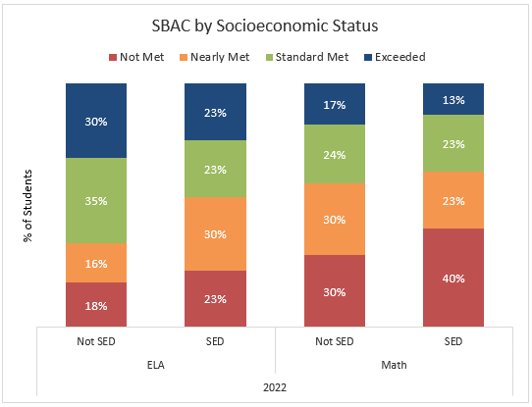
D2. Using Student Assessment Strategies to Monitor and Modify Learning in the Classroom Criterion
Teachers employ a variety of appropriate assessment strategies to evaluate student learning. Students and teach
Indicators
D2.1. Demonstration of Student Achievement: Teachers use the analysis of formative and summative assessments to guide, modify, and adjust curricular and instructional approaches.
D2.2. Teacher and Student Feedback: Teachers provide timely, specific and descriptive feedback in order to support students in achieving learning goals, academic standards, college- and career-readiness standards, and schoolwide learner outcomes. Teachers also use student feedback and dialogue to monitor progress and learn about the degree to which learning experiences are understood and relevant in preparing students for college, career, and life
D2.3. Prompt: Evaluate the school’s effectiveness in addressing the criterion and each of the above indicators; include supporting evidence.
Findings | Supporting Evidence
D2.1. Demonstration of Student Achievement: Teachers use the analysis of formative and summative assessments to guide, modify, and adjust curricular and instructional approaches.  Assessments are used formally and informally to get an understanding of where learners are at with the content. After administering and grading the assessments, facilitators are alerted to the mastery or non-mastery of the content. Following the grading of assessments a review of commonly missed questions is administered to a class of learners to get a further understanding of where learners are regarding the content and if revision or reimplementation of lessons are needed. For instance, using CommonLit in English classes, facilitators can determine which learners are struggling to understand the concepts as well as which question types are presenting difficulties to an entire class. This can help direct review instruction to support learners’ reading comprehension.  Learners are given formative assessment in writing during a unit to practice their writing skills and receive feedback from peers and facilitators. Samples are used to demonstrate expectations before and after these assignments.  Learners are given summative assessments in the form of essays, tests, and projects. These assignments are scaffolded, with examples, study guides, and graphic organizers, to support learners throughout the process of the assignment. Learners are given clear guidelines and expectations of these assignments. Based on the results of the summative and formative assessments, facilitators modify instruction and target areas to better support the learners.  MAP assessments are utilized to identify learners that score below the grade level RTI. These students are assigned to a Learning Lab, which may include Lexia and IXL, to support reading comprehension. | CommonLit Assignment Report  Writing Formative Assessment  Sustainability Project  Essay Rubric  MTSS Agenda HERE
D2.2. Teacher and Student Feedback: Teachers provide timely, specific and descriptive feedback in order to support students in achieving learning goals, academic standards, college- and career-readiness standards, and schoolwide learner outcomes. Teachers also use student feedback and dialogue to monitor progress and learn about the degree to which learning experiences are understood and relevant in preparing students for college, career, and life  Facilitators strive to provide timely, descriptive, and intentional feedback to learners at ACLC. Feedback can be provided on our grading platform, Jupiter, written comments, individual meetings, and whole class review. During a whole class review, a model learner example is often displayed as an example of mastery.  Parents access Jupiter grades and they are often communicated via email whenever possible, typically around the quarter mark of the semester. Parents are alerted with phone calls after three verbal warnings/conversations with learners are administered. Following the verbal warnings/conversations is an email home. If the issue continues, parents receive a phone call home from the facilitator. Our grading, messaging, and assignment center allows for text communication between facilitator and parent.  ACLC learners demonstrate their college & career readiness through their graduate portfolio. Although they routinely work on college and career exploration, during Senior Seminar is where they complete their portfolio. From the beginning of the school year until the end of March, learners build their portfolio; they receive feedback and support from both the College & Career Counselor and the Senior Seminar Facilitator. In April, the ACLC Board evaluates each learners’ portfolio and assigns a grade. If a learner does not meet expectations, a meeting is held with the learner to make a plan to complete the missing tasks by graduation. Once a learner has satisfied all requirements, they have fulfilled their ACLC graduation requirements, thus proving they are ready for the next stage of life.  ACLC is a democratic model and relies heavily on learner feedback to help guide the learning experience, culture, and college & career exploration. At the beginning of the school year, 9th grade learners are given a quick survey evaluating their learning style and writing ability. This tool can help facilitators adjust their instruction to better suit the learners’ needs on a day to day basis.  At the end of units and projects, ACLC facilitators receive feedback from learners, ranking their satisfaction with the material and gather ideas for instructional improvement. This feedback is integral to keep projects engaging and efficient.  Learners are also actively involved in College & Career planning. Because we are a small school, seniors vote and help organize college and technical school visits based on interest. The location of our school allows us access to an extensive network of opportunities, which is supported by both parents and alumni. Each year, ACLC hosts a college talk with recent ACLC alumni to discuss college expectations and advice. The seniors preselect key topics to help the alumni prepare before the event to maximize efficiency and cater to the learners’ interests.  Learner Support Team (LST) meetings occur weekly. LST focuses on the needs of a learner who may be struggling academically, socially, or behaviorally. Each of the learner’s facilitators are invited and expected to attend, the learner, the learner’s parents, and a member of the administration meet to discuss areas of pride, areas the learner could grow, and further commitments by the learner and the facilitator in order to best support the learner in succeeding at ACLC. Learner Support Teams (LSTs) have input from parents and the learners themselves in determining what’s working and what are opportunities and strategies for growth for individual learners.  Behavior contracts are administered at ACLC when a learner has had several instances of poor behavior, including tardies, phone use, and class disruption. The administration and family meet to discuss the behavior of the learner and come up with a solution to resolve the behavior. This resolution is typically through a behavior log or contract in which the learner receives feedback on their behavior from their facilitators for an agreed upon amount of time.  The school leadership and facilitators have end of semester surveys to collect information on learner and family perspectives. At least monthly the very active and engaged learner elected leadership team brings up and considers changes to school policy based on their educational experiences. These can be submitted by any learners. Leadership class facilitates discussion between contributors from both Learner and Staff communities during a scheduled lunch. These discussions help dictate academic policies for the school, such as Project Period norms and guidelines.  The school had a meeting with Staff, Faculty, learners and their parents, identifying strengths and areas for growth with respect to the ‘Schools to Watch’ values. That feedback was incorporated into the staff’s action items and direction.  Aggrieved learners can submit to a learner-led Judicial Council (JC) complaints about their colleagues or adult staff. That deliberative body that adjudicates received complaints, based on witnesses, etc., and renders judgments toward creating restorative justice. | Writing Student Sample  Jupiter Grades  Senior Portfolio Rubric  Senior Website Final Grades  9th Grade Learning Survey  Unit Learner Feedback Sample  College Talk Night  LST Agenda  Behavior Contract  Facilitator-Learner Lunches  School to Watch Night Discussion  JC Referral Form  Sample LST agenda
D2.3. Prompt: Evaluate the school’s effectiveness in addressing the criterion and each of the above indicators; include supporting evidence.  D2.1: ACLC has demonstrated effectiveness in this criteria with intentional formative and summative assessments throughout the school year to help guide instruction. Our incorporation of Project Based Learning has proven to be successful through quality learner products and feedback. ACLC successfully maintained a high level of academic rigor during distance learning and was quick to reacclimate the community to in person instruction. Surveys conducted by learners and families demonstrate a strong satisfaction with both academic and social development at ACLC. The staff survey demonstrated satisfaction in use of Professional Development and support at ACLC.  D2.2: Some ACLC facilitators do need to improve on timeliness of feedback to learners as indicated by the learner survey. However, we are intentional about addressing our areas of growth and actively involve the whole community in addressing learner needs. | Learner survey SAMPLE  Family Survey SAMPLE  Staff survey SAMPLE  Assignment Feedback and Support Survey (See Below)

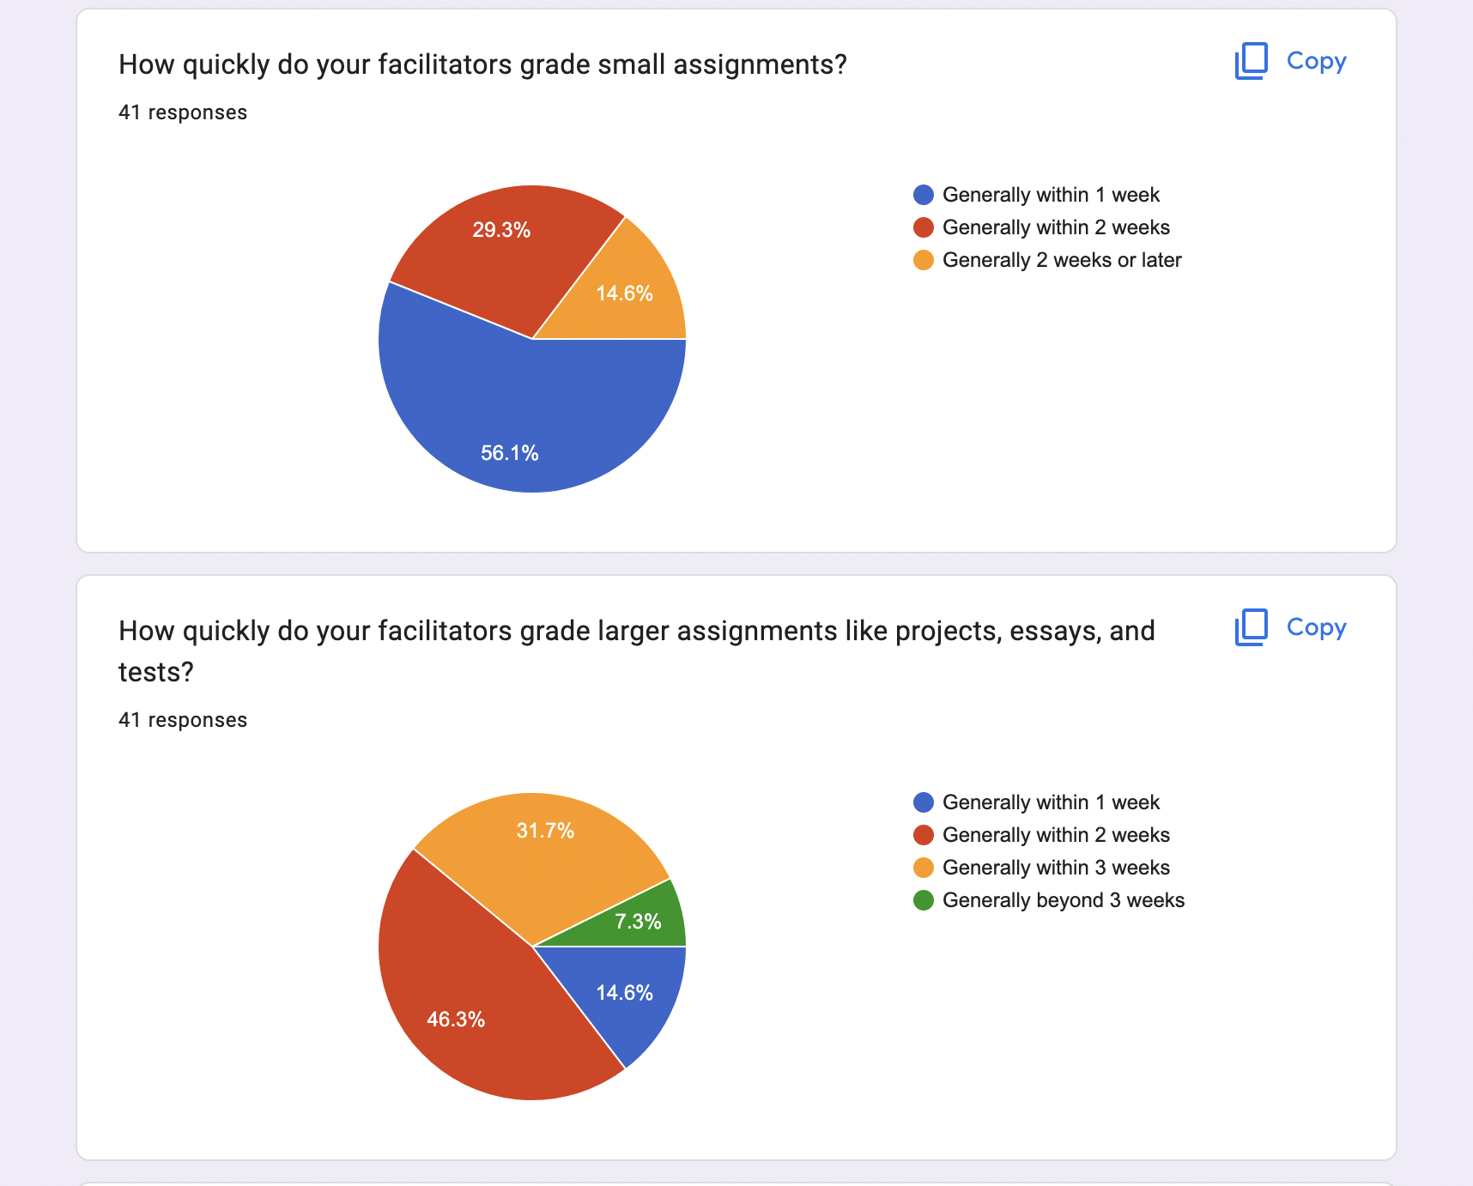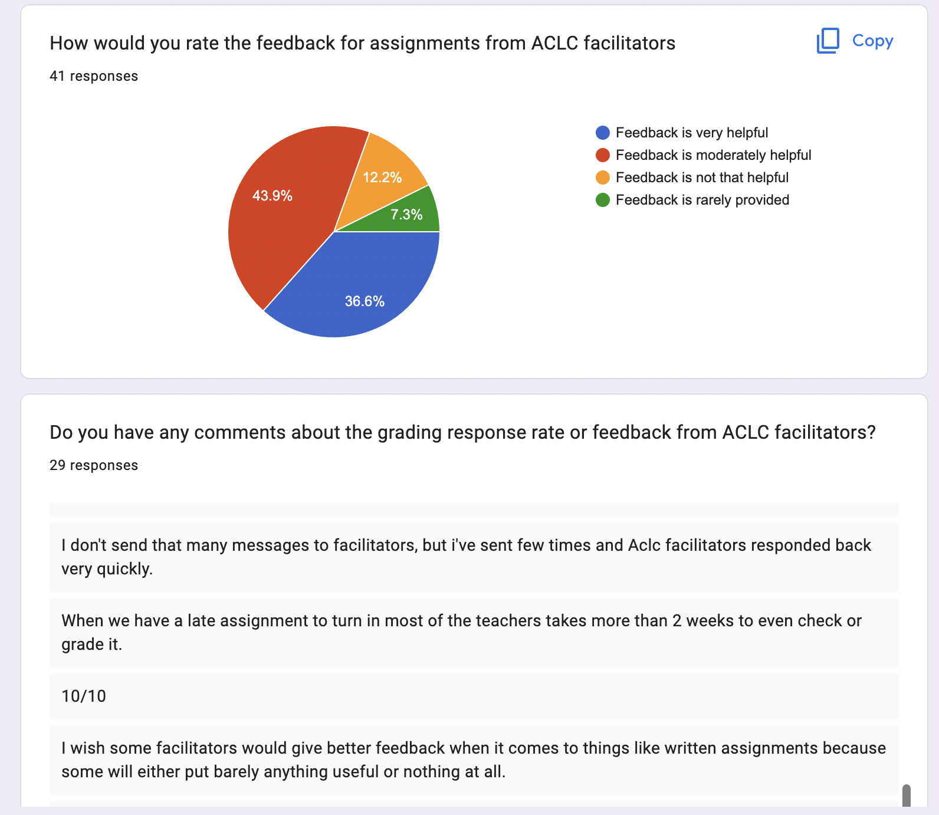
ACS WASC Category D. Assessment and Accountability:
Synthesize Strengths and Growth Needs
Prioritize and list the strengths and growth areas for the criteria and indicators in Category D.*
Areas of Strength
- MAP testing, preparation, and follow-up
- Curriculum-embedded assessments that are standards aligned and grade-level appropriate in mathematics (Illustrative Mathematics), science (Lab Aids), English (CommonLit and EngageNY), history (Teacher’s Curriculum Institute), Spanish (Voces Digital)
- ACLC Instructional Model or “AIM”
  - Opening Routines and warm ups
  - Content Delivery
  - Classwork time
    - Group work
    - Individual
  - Accountability/Assessment Strategies
  - Closure
- Surveys to learners, families, staff
- LST (Learner Support Team) meetings every Monday for middle and high school
- Learning and Math Lab structure
- Use of supplementary resources like IXL and Lexia

Areas of Growth
- Create a more consistent re-teaching and follow-up plan for MAP instruction
- Ensure facilitators have proper training and support in use of curriculum-embedded assessments
- Continue to refine the MTSS process to meet learner needs.
- Ensure a more consistent use of “AIM”
  - ACLC Instructional Model or “AIM”
    - Opening Routines and warm ups
    - Content Delivery
    - Classwork time
      - Group work
      - Individual
    - Accountability/Assessment Strategies
    - Closure

Category E: School Culture and Support for Student Personal, Social-Emotional, and Academic Growth
E1. Parent and Community Engagement Criterion
The school leadership employs a wide range of culturally sensitive strategies to encourage family and community involvement, especially with the learning/teaching process.
Indicator
E1.1. Parent Engagement: The school implements strategies and processes for the regular involvement of all stakeholder support groups in the learning and teaching process for all students.
E1. Prompt: Evaluate the school’s effectiveness in addressing the criterion and each of the above indicators; include supporting evidence.

Findings | Supporting Evidence
E1.1. Parent Engagement: The larger ACLC community is regularly involved in the life of the school, and especially in the learning and teaching process. Families are involved in the learning process in four primary ways:  - Family participation in demonstrations of learning:  - Schoolwide:  - Science Fair (2nd semester)  - Learner-led conferences (cross-grade small groups, twice each year)  - Individual class invitations throughout the year  - Example: 6th & 7th grade History  - Family participation in LST meetings, IEP and 504 meetings, individual meetings with facilitators.  - Family participation in PAC and CCEF:  Post-Covid, ACLC’s “Parent Action Committee” was re-imagined and re-invigorated. The new parent leaders have a 2-year plan to provide more opportunities for guardians to be involved with the school. PAC currently has monthly “work sessions” to explain upcoming engagement opportunities and planning facilitator appreciation events. All opportunities are shared with the ACLC community on a Google Spreadsheet, making it easy for parents to get involved in a way that works for them. Currently engagement opportunities include volunteering at school events and donating supplies for student projects. For example, parents supported learners during their “Constitutional Congress” by donating food and serving lunch to the entire student body, teachers and staff.  Learners are invited to attend PAC work sessions to share their ideas for community-building events and solicit volunteers for class projects. For example, a freshman came to one meeting to ask for help painting a new modular stage she was building for the school. Four families showed up the following weekend to help.  After two years of parent disengagement during Covid, it was important to PAC leaders to provide plenty of opportunities for guardians to connect with each other. PAC recognized that on-campus involvement is not always compatible with guardian’s work schedules, so PAC launched monthly evening happy hours and pre-work “Coffee Klatches” to reach more people. These events are held in outdoor public places that do not require the purchase of food or beverage to attend, making them accessible to all. At Coffee Klatches, PAC leaders facilitate discussions around parenting topics such as screen use or dating. Happy hours are more informal, giving parents time to build relationships with each other. ACLC’s Lead Facilitator and Curriculum and Instruction Lead make a point to attend happy hours as well, giving parents the opportunity to ask questions and learn more about school happenings.  Next year, PAC plans to expand engagement opportunities for guardians to include participating in ACLC’s career exploration program and classroom projects. PAC also plans to start providing opportunities for guardians and learners to engage with each other outside of the classroom, while building connections with other ACLC families.  - Opportunities to provide feedback, participate in ACLC Self-Study, and shape ACLC’s priorities:  - Annual Parent Survey  - Almost 40 family members gathered at the school for Stakeholder Engagement Night to engage in conversation about the ACLC’s strengths and areas for growth in the three Schools to Watch domains of Social Equity, Developmental Responsiveness and Academic Excellence. Family input was especially rich around strengths and areas for growth in the domains of Developmental Responsiveness and Academic Excellence, and those became data points for priority-setting by the staff for the 22-23 school year.  Conclusions: Structures at ACLC provide a variety of meaningful opportunities for authentic family involvement in teaching and learning at our school. This key strength can be further leveraged by increasing access to families who might not be able to access these opportunities.  Questions we need to continue to ask: Where might additional translation services be most helpful in increasing access for families who speak a language other than English?  What other ways might we increase underserved families' sense of agency and ownership in the school? | Family participation in demonstrations of learning:  Learner-Led Conference schedule for 20-21  Families attend 6th & 7th grade “museum panels”  Family participation in PAC and CCEF:  PAC calendar  CCEF calendar  Family participation in ACLC direction:  ACLC Stakeholder Engagement Night Slide deck  Notes from 5/18/22 staff discussion following Stakeholder Engagement Night.  Running PAC Agenda HERE  Stakeholder Engagement Slide Deck HERE  Stakeholder Engagement Handout HERE  Parent/Guardian Survey HERE  Learner Survey HERE  Language Scientific User Guide HERE (for translation services with non-English speaking families)

E2. School Culture and Environment Criterion
The school leadership focuses on continuous school improvement by providing a safe, clean, and orderly place that nurtures learning and developing a culture that is characterized by trust, professionalism, equity, and high expectations for all students.
Indicators
E2.1. Safe, Clean, and Orderly Environment: The school has existing policies and regulations and uses its resources to ensure a safe, clean, and orderly place that nurtures learning.
E2.2. High Expectations/Concern for All Students: The school culture demonstrates caring, concern, and high expectations for all students in an environment that honors individual differences, social emotional needs, and is conducive to learning.
E2.3. Atmosphere of Trust, Respect, and Professionalism: The entire school community has an atmosphere of trust, respect, equity, and professionalism.
E2. Prompt: Evaluate the school’s effectiveness in addressing the criterion and each of the above indicators; include supporting evidence.
Findings | Supporting Evidence
E2.1 Safe, clean, and orderly environment  ACLC Facilitators understand that a safe environment is critical not only to learners’ well-being, but also to excellent learning outcomes. Facilitators:  - Keep doors locked during class,  - Put behavior expectations in place (often in collaboration with learners) consistent with either the agreed on “HS Common Expectations” or the “MS Common Expectations.” During Hybrid learning, Hybrid teaching norms were established and used.  - Establish routines and procedures for regular functions (eg. how to get materials, chromebooks, etc), as well as safety rules for where necessary (labs, PE, etc.).  - Use JC process to support learners to adhere to rules in handbook  - Are familiar with the Emergency Site Plan and actively participates in drills.  - Assign learners computers and monitors student activity during assignments while using chromebooks  - Use behavior contracts as needed.  - Is supported by the union and can access the Uniform Complaint Procedures.  E2.2 High expectations/concern for all students  We operate in a small school model that prizes relationships, and works to make sure that learners’ needs are known and attended to. Acceptance and inclusion are closely held values at ACLC.  - Facilitators regularly ask learners to attend office hours or to meet at lunch so that extra support can be given. Learning Labs are assigned with a low student:teacher ratio for additional individual academic support.  - Our counselor holds our 504 plans and meets regularly with learners, families, and staff to support learners with professional diagnosed mental or physical health needs that require additional support at school.  - Our Director of Special Education works with the special education team and general education facilitators to ensure that Individualized Education Plan (IEPs) are transparent to staff and followed for the benefit of learners. The special education team holds all required IEP meetings and sends out regular surveys gathering feedback on learner progress. This information is used in conjunction with the IEP team’s assessments to revise and implement IEP plans to ensure the success of learners with IEPs.  - Our Curriculum and Instruction Lead sets up weekly middle and high school meetings with learners, families, and facilitators to support struggling learners. These meetings are called Learner Support Team (LST) meetings and are conducted in person or via Zoom at the family’s request. In these meetings, learners, families, and facilitators share areas of pride and growth and the administrative facilitator ensures that concrete agreements are made to support the learner and family moving forward. These currently happen on Monday afternoons.  - A significant portion of our learners identify as members of the LGBTQ++ community. ACLC staff work to use learners’ chosen name and pronouns at all times and support gender-affirming policies, including use of learner-facing software that allows learners to self identify their chosen pronouns and gender status. Staff do not tolerate teasing or bullying of learners.  - Our JEDI committee is identifying specific goals around inclusion this year. These specific SMART goals will shape our actions in the 22-23 school year.  - Our office staff ensures the safe and effective operations aspects of the school. From teacher supplies to copiers to attendance to learners getting scraped elbows, the office team is the first line of support for the school’s mission. They are the “face” of ACLC and interact with our parents/guardians and the wider community, delegating or redirecting questions or needs to the appropriate place.  Questions we are currently asking to grow in this area:  - How can restorative justice principles support our work with learners? We currently have a discipline process that takes some cues from restorative justice programs. Admin and department leads met in January 2023 to begin the process of training faculty around restorative conversations. We are hiring our first Dean of Students this year to advance this work of caring for learners and holding them to high expectations.  - How can we reshape our Wednesday CCC class to serve as an advisory–a safety net of sorts–in which learners can be known and supported? As part of our self-study process, our staff voted to elevate this work as a priority. Our Culture Committee has taken up this work.  - How can we best use our Learning Labs and Project Periods to support high expectations? As part of our self-study process, our staff voted to elevate this work as a priority. Our Curriculum Committee has taken up this work.  E2.3 Atmosphere of trust, respect, and professionalism  - As new facilitators, the staff were very accepting and are willing to help and meet whenever available. It is an environment that is very accepting to new ideas in learning methods and activities that may be adopted to existing curriculum | HS Common expectations  MS Common Expectations  Hybrid teaching norms  JC process - Handbook  Safety Process  Emergency Site Plan - Evacuations and drills  Internet filters at the server  Tech agreement signed by learners  Uniform Complaint Procedures.  Office Hours schedule HERE  Sample 504 HERE  Sample LST agenda  22-23 Committee WORK (Inclusion goal work, Advisory structure work, and Project Period Structure work)  Clearing Conversations Protocol DRAFT  Friday Restorative Community Time (RCT) reflection questions and process  Committee notes HERE

E3. Personal, Social-Emotional, and Academic Student Support Criterion
All students receive appropriate academic, social-emotional and multi-tiered support to help ensure student learning, college and career readiness and success. Students with special talents and/or needs have access to an equitable system of personal support services, activities, and opportunities at the school and in the community.
Indicators
E3.1. Academic Support Strategies for Students: School leadership develop and implement strategies and personalized, multi-tiered support approaches to meet academic student needs
E3.2. Multi-Tiered Support Strategies for Students: School leadership develop and implement alternative instructional options and personalized, multi-tiered approaches to student support focused on learning and social emotional needs of all students.
E3.3. Multi-Tiered Systems of Support and Impact on Student Learning and Well-Being: The school leadership and staff assess the effectiveness of the multi-tiered support system and its impact on student success and achievement.
E3.4. Co-Curricular Activities: The school ensures there is a high level of student involvement in curricular and co-curricular activities that link to schoolwide learner outcomes, academic standards, and college- and career-readiness standards.
E3.5. Student Voice: Students deepen their sense of self and make personal and community connections that are meaningful and relevant and allow students to become advocates for their own needs and supports.

E3. Prompt: Evaluate the school’s effectiveness in addressing the criterion and each of the above indicators; include supporting evidence.
Findings | Supporting Evidence
E3.1. Academic Support Strategies for Students: School leadership develop and implement strategies and personalized, multi-tiered support approaches to meet academic student needs.  - Using valuable data, there are clear individualized academic IEP goals to enhance learners' academics to support Tier 1.  - Using core instruction and differentiated learning for Tier 2 and Tier 3 learners in Foundational Math and Literacy Foundation Classes.  - Learners with Section 504 Plans which include counseling check ins for social emotional support meet with the school counselor or counseling intern. Sessions may occur weekly, bio-weekly and or as needed. The counseling offered is short term with the focus on personal and or social issues which impact school attendance and school performance. | Learner IEP plans (held by Special Education team)  Sample 504 HERE
E3.2. Multi-Tiered Support Strategies for Students: School leadership develop and implement alternative instructional options and personalized, multi-tiered approaches to student support focused on learning and social emotional needs of all students.  - Learners who have special social and emotional needs are offered services via the Mental Health Services Manager and Educational Psychologist. Students may also have behavior goals and/or a behavior plan. Specialists collaborate directly with general education facilitators, parents, learners, and paraprofessionals on how to best service the needs of special education students and meet these goals.  - Educational Specialists are trained into programs that are used to support learners with special needs such as IXL Live Virtual training and attending Teacher Academy at Oakland to be familiar with the SEIS program.  - Learners with Section 504 Plans which include counseling check ins for social emotional support meet with the school counselor or counseling intern. Sessions may occur weekly, bio-weekly and or as needed. The counseling offered is short term with the focus on personal and or social issues which impact school attendance and school performance.  - Paraprofessionals complete paraeducator training modules via online materials from AFIRM and SELPA. Paraprofessionals also receive Behavior intervention training and trauma awareness training. For instance, Paraprofessionals learn how to de-escalate and offer alternative choices to learners who need immediate support.  - Special Education Management meets on a one-to-one basis with Specialists on a weekly basis with regards IEPs and updates. Specialists meet directly with paraprofessionals on a weekly basis as well and communicate directly with paraprofessionals to provide feedback and discuss how best to implement push-in classroom services and address other concerns.  - Services Providers, Educational Specialists, and Paraprofessionals document service data and observations via Special Education Information System (SEIS), a web-based system that allows centralized access of service tracking for Special education services and information.  - LST meetings: Teachers and parents are able to talk about any concerns they may have. This time is used to help understand any “extra need” the learner may have outside of their IEP. Examples would be that a teacher finds out that it may be best to send some work home to do with parents. They may be filled in on strategies that have worked well with their learner in the past. Facilitators can also be told about situations learners have not disclosed themselves. Seating charts are adjusted to meet the needs of learners.  - Para or Ed specialist in the classroom: The math teacher and Para work together to scaffold assignments and quizzes by providing detailed notes, and allowing for use of notes during quizzes. They acknowledge when a learner needs a classroom break, or time outside of the classroom. Extra time is given (according to their IEP). The Para often works one on one with IEP learners. Credit is given to answers that show that the Learner understands the concept (if the answer is wrong, they can still receive credit). Learners can sit with their paraprofessional and be guided to stay on task and get immediate help when necessary. | MTSS PD onboarding  IEP onboarding PD  IXL website HERE  Sample 504 HERE  Sample LST agenda
E3.3. Multi-Tiered Systems of Support and Impact on Student Learning and Well-Being: The school leadership and staff assess the effectiveness of the multi-tiered support system and its impact on student success and achievement.  ENGLISH - Some learners are supported in class, getting assistance in class assignments. Some get support on assignments during their learning lab or project hours. Finally, some are supported through Zoom or after school when they need to catch up on work.  We offer grammar, syntax and writing workshops to middle school students in order to improve their writing skills. We support learners with 504s and IEPs based on their accommodations. We support Learners who are first generation born Americans who do not speak English at home. Our emphasis is to get our learners at grade level both in reading and writing. We reclassify EL learners based on ELPAC rubrics, last semester grades and teacher recommendations.  SPANISH - We support Second language acquisition by making sure they know syntax in English so they can learn a second language. We use the digital platform VOCES that provides our curriculum. Voces offers geographical and cultural information through listening, reading, video and writing exercises. We also share personal experiences and cultural differences. We also compare and contrast American and European lifestyles to those in Spanish speaking countries We link South Western American historical events to their hispanic origins. We created and managed a Spanish club. The goal of the Club is to educate anyone in our community (parents, teachers, administrators and learners) about hispanic heritage past, present and future. | MTSS Agenda HERE  EL Coordinator Schedule HERE  ELPAC Presentation HERE  Voces Digital curriculum HERE
E3.4 Co-Curricular Activities  All ACLC learners participate in co-curricular activities. All learners are part of a “bevvy,” our name for the student-run clubs held monthly on Wednesday mornings, and many learners take advantage of the additional co-curricular opportunities ACLC and our partners provide:  Sports -  - Middle School Sports League  - High School sports participation through AUSD  - ACLC was the birthplace of organized Ultimate Frisbee for youth in Alameda. The middle school and high school Ultimate teams are now overseen by the Bay Area Disc Association and are open to all Alamedans. The teams practice on a nearby field and ACLC learners participate at both middle and high school levels.  Clubs - ACLC Facilitators create clubs for Learners to join based on the interest of the Learners. Clubs are 1-2 times a week. Some of the clubs that are available are Spanish Club, Chest Club, Poetry, Board games, and so much more.  Bevvies - ACLC gives Learners the opportunity to decide what clubs they are interested in making and being a part of. To create a Neoteric Bevy, one or more learners submits a proposal to Leadership. Leadership invites discussion about the proposed bevy and assesses learner interest. If the proposal passes, a new bevy is born. Because bevies are created by learners based on their interests, they are an ever-evolving part of ACLC's school culture.  Additional after school opportunities  - Musical theater performances run by our performing arts facilitators are open to all learners and are enrolled by audition. Learners just signed up to audition for this year’s musical, “Little Shop of Horrors.” The auditions are open to 6-12th graders.  - Partnership with B&G Club - ACLC has a partnership with the local Boys & Girls Club where many Learners can be involved with extra programs and tutoring opportunities.  - Community Service work - Every Learner is required to earn 20 hours of community service, which can be beautifying the ACLC campus, helping Facilitators, or helping with school events. | Middle School Sports League  ACLC/NEA Athletics Program  Alameda Ultimate program  Clubs and Activities  Community Service Opportunities  Girl Basketball 10  Boys Basketball 20  Coed Volleyball 18  Track and Field 25  Poster for tryouts  ACLC Community Service Digital Log HERE
E3.5. Student Voice: Students deepen their sense of self and make personal and community connections that are meaningful and relevant and allow students to become advocates for their own needs and supports.  - JC write-ups: JC write-ups allow learners to “stand-up” for themselves in a democratic way. Instead of an ugly conflict, they learn to go through a judicial process in order to solve a problem.  - Rule proposals: Learners can propose rules they feel are necessary by filling out a proposal form and having the school judicial system vote whether it should be a rule of not.  - Voting members at ACLC and CLCS Boards  - Leadership  - Committees  - Hiring process  - Walk outs  - Clubs: Learners can propose for certain clubs (ex: chess, math, basketball). If the leadership class approves the club, it becomes official and is led by a facilitator.  - CCEF grant proposals: Learners or staff members in need of money can make proposals to the CCEF members. The members decide if the proposal passes and will receive money. | Judicial Committee (or “JC) Website Page  Useful JC Rules  JC Write-Up Form  ACLC Learner Handbook (includes proposal form)

ACS WASC Category E. School Culture and Support for Student Personal, Social-Emotional, and Academic Growth:
Synthesize Strengths and Growth Needs
Prioritize and list the strengths and growth areas for the criteria and indicators in Category E.*
Areas of Strength
- CLI and L2L focused around this
- Learner Led Conferences
- Mastery Based Grading
- Leadership opportunities at ACLC (both formal and informal)
- Feedback surveys largely positive
- Office Hours structure
- Learning & Math Labs structure

Areas of Growth
- Create advisory structure and time for SEL lessons/components in CCC
- Revise and improve Project Periods
- Revise and improve Learning Lab
- Define what it means to be an inclusive school and set goals around this

Prioritized Areas of Growth Needs from Categories A through E
Prioritize the growth areas from the five categories.
- ACLC Instructional Model or “AIM”
  - Ensure more consistent use of ACLC Instructional Model or “AIM” across all grades and subject areas
    - Opening Routines and warm ups
    - Content Delivery
    - Classwork time
      - Group work
      - Individual
    - Accountability/Assessment Strategies
    - Closure
- Project-Based Learning
  - Ensure more consistency in use of Project-Based Learning (PBL) across all grade levels and subject areas; continue to train new and returning facilitators on components of PBL using frame provided by PBLWorks.
- Achievement Gap
  - Academic performance of learners with 504s and IEPs is lower than the rest of the population (CAASPP and GPA).
- Learning Lab
  - Improve Learning Lab effectiveness
- Project Period
  - Improve Project Period effectiveness and supervision
- Advisory Structure
  - Work to create a structure for and find/create a curriculum for an Advisory structure at ACLC. This can happen in CCC (Contemporary Community Citizenship - meets once/week for 45 minutes with mixed grade-level groups) Create advisory structure and time for SEL lessons/components in CCC
- College & Career Readiness
  - Continue to build and refine curriculum for Junior and Senior Seminar classes to best support ACLC’s mission and Career and College readiness goals.

Summary of all areas for growth HERE

Chapter IV: Summary from Analysis of Identified Major Student Learner Needs
Summarize the identified major student learner needs based on profile and Focus Group findings and California School Dashboard Results for student groups.

Throughout the last year the faculty and staff at ACLC have analyzed and reflected on our school with the help and guidance of the ACS WASC Focus on Learning Self-Study Guide. Our process began with reflecting upon our progress in light of our prior action plan as an activity as an entire staff. Staff utilized rubrics published by the Schools to Watch organization to evaluate our progress on goals and areas of need. From this discussion came the first iteration of our Critical Student Learning Needs (at that time based on some post pandemic data and pre pandemic results).
Over the course of the year we have spent many hours of time discussing and refining our Critical Student Learning Needs as an Administrative Team, WASC Lead Team, committee team, in Focus Groups (composed of learners and facilitators), as an entire staff, and with learners and parents in a schoolwide forum looking at data. Our final identified Critical Student Learning Needs are the product of reflection on a myriad of data regarding ACLC, the Focus Group discussions that led to final Areas for Growth, input from all stakeholders based upon observation and anecdotal data, and reflection on our current school and CLCS goals. Through our collaborative process, we arrived at our Critical Learner Needs aligning closely with ACLC 2021-22 LCAP goals. We realized through our process that our learner needs truly were best addressed aligning ACLC LCAP Goals to address our site specific learner needs and methods of addressing those needs.

Outline:  - Academic Excellence  - Project Periods  - Structure  - Developmental appropriateness for middle schoolers  - Attendance  Center period inaccuracies with multiple people taking attendance  - Lack of things to do  - Learning Labs  - Attendance  - Structure  - AIM (ACLC Instructional Delivery Model)  - Opening Routines and warm ups  - Content Delivery  - Classwork time  - Group work  - Individual  - Accountability/Assessment Strategies  - Closure | Schools to Watch committee notes HERE  AIM PD  PD on Exit tickets  AIM PD and Implementation  PD on Engagement
The first major student Learning need is to aspire for academic excellence. Goal 1 in our Action Plan outlined in chapter 5, aligns to that need. We have determined that Data Collection, Analysis, & an informed and thoughtful response will increase student learning with learners across our school.
ACLC is building a culture that embraces the sharing of data where facilitators utilize data to identify trends and solutions to areas of growth. We are looking at MAP academic growth data three times per year, CAASPP data, attendance data, classroom grade data, discipline data, culture survey data, assessment survey data, and observation data. In addition, facilitators have worked collaboratively to create programs that have improved school culture and learner achievement. Learner of Concern meetings and department meetings are all facilitator-led, helping improve learner achievement.
State testing scores have been a focus and continue to be. We showed growth in 2018 and 2019 CAASPP scores in most areas. However, ACLC faced drops across the board in post pandemic CAASPP in 2021-2022. Continued focus should be placed on supports with an emphasis on providing a guaranteed and viable curriculum aligned to standards and proficiency in all core content areas. The Lead Facilitator working in tandem with the JEDI (Justice Equity Diversity and Inclusion) committee will lead the process of interrupting mindsets and systematic behaviors that have contributed to lower achievement rates, graduation rates, and higher numbers of learners with disabilities, African American and Latino learners.

Grade level standards mastery continues to be a focus for ACLC and is especially critical after the impact of the pandemic. As we prepare our learners to be college and career ready, we must have academic data to drive our decisions around instruction and to monitor learner progress essential for goal 3.
In 2021-2022 after returning from COVID our focus groups and informal assessments showed a greater need to utilize Project Periods and Learning Labs to increase engagement and independent learning at ACLC. This emerged in facilitator and parent input. Committee discussions have also targeted these structures as underutilized. In particular, the ACLC facilitators would like to see a targeted shift in the Center and the unstructured nature of that time. Additionally, given the unification of ACLC and the Nea High School Programs, our school needs to evolve to accommodate an increased number of learners in our program. Simply put, the facilitators, learners and parents see an opportunity to alter the disposition of the Project Period to support struggling learners more effectively. This inherently includes the consistency and regularity of assigning Learning Labs to support particular learners based on data.
Structures that have been put in place to hold us accountable for continuing to identify learners who are in need of academic support to master standards, and to support our teams with consistent data analysis are:
- The practice of using department leads to promote data analysis has continued.
- Ed Tech data analysis was provided to departments in the first few weeks of the school year. They were given time in staff development to reflect and adjust for the coming year.
- Bi-monthly presentations to the ACLC Board from the Assessment and Accountability committee.
- Classroom assessment and performance feedback shared with learners in individual settings and also through mailings and goal setting.
- Professional development for staff on curriculum, with clear expectations and outcomes to align assessment practices to standards taught and regularly examine learner performance within each department.
- A systemic way to regularly distribute standardized test results to facilitators to assist in the development of instructional practices that respond to the learning needs of learners based on their individual performance data.
- The LST process was devised to have a more systemic approach to working with learners and their parents/guardians to find their respective paths to improvement. Meetings now follow a structured agenda in which the learner leads a discussion focused on their areas of pride, areas of growth, and ways to support them.
Specific findings and data diving the identification of this goal are:
- Data collection is critical given the varied instructional dynamics both during and after the pandemic.
- Given the varied languages taught in our school, tracking the needs and successes of the varied groups should provide a read map for critical demographic groups.
- Learner needs are not surfacing early enough. Protocols and systems are needed to evaluate results and implement accommodations.
- Project periods make up a large percentage of unexcused absences. Learners need more buy in and we, as a school, need to hold older learners accountable. Cutting and lack of urgency during these periods are observable.
- Learning Labs are impactful but more sustained data and improved consistency is needed to quantify effectiveness.
- Consistency from classroom to classroom is pedagogically appropriate to reduce stress and distraction while increasing understanding and executive function.
- Improve Learning Lab effectiveness and improve Project Period effectiveness and supervision if needed.

Outline  - Developmental Responsiveness  - Advisory structure & SEL Learning  - No identified space for this outside of CLI (Current Life Issues) in 9th grade and L2L (Learning 2 Learn) in 6th grade.  - MBG  - Use CCC (Contemporary Community Citizenship) |  | Schools to Watch committee notes HERE
The second Major Student Learning need is to increase developmental responsiveness so that all learners have Career and College Readiness skills. Goal 2 in our Action Plan, outlined in chapter 5, aligns to that need. We have determined that enriching our counseling and standards alignment while keeping an experiential centered instructional approach is key to Educating the Leaders of Tomorrow.

Part of this work began last year when our administration implemented Mastery-Based Grading (MBG) for the 2022-2023 school year. We believe that learner achievement occurs through clearly defined standards and authentic learning opportunities. In a review of our grading system, and best practices in education, we shifted to fully adopt MBG as a district after our 2021-2022 pilot year. Refining and implementing MBG in practice at ACLC is NOT complete and it is essential that our learners, facilitators and staff continue its implementation over the next two to three years. While we recognize that with change comes challenges, this approach to grading will benefit all stakeholders including learners, facilitators, and parents/guardians.
MBG allows learners and families to be more aware of what they are expected to learn and their progress through the California or nationally recognized standards in each subject area. It will provide families with a more detailed outline of their learner’s growth and achievement.
MBG reports what learners should know and be able to do within each content area at each grade level. The real-time monitoring of learner performance reflects a more accurate picture of learner achievement. Additional reasons for MBG include:
- MBG is equitable grading and has three pillars: accuracy, bias-resistance, and intrinsic motivation.
- Other methods of grading do not accurately indicate what a learner knows and is able to do.
- Learners will be able to explain what they learned or did not learn in relation to a standard, rather than recite a percentage.
- It can benefit all learners - learners who struggle and learners whose learning is accelerated, and everything in between. Learners’ progress towards standards can assist staff in determining intervention or enrichment opportunities.
- Parents are provided information on specific standards.

Furthermore, ACLC’s use of Instructional Rounds revealed a need for consistency from room to room. Through observing facilitators and learners during classes, we were able to determine areas of strength and areas of growth for our Instructional delivery. There are different IDMs (Instructional Delivery Models). All agree that there are clear pedagogical moves that best facilitate learning. The ACLC staff participated in common readings that included brain science & learning (reduce cognitive load and Support learning new content using existing structures and processes), trauma-informed practices (consistency, consistency, consistency), equity & access (poverty, disability, language learners, minority groups and common framework, vocabulary, and research-backed best practices associated with AIM components. We have articulated the following components:
ACLC Instructional Model or “AIM”
  - Opening Routines and warm ups
  - Content Delivery
  - Classwork time
    - Group work
    - Individual
  - Accountability/Assessment Strategies
  - Closure

Our Instructional Rounds indicated that AIM is inconsistent in its implementation. Common language, routines and belief will help our team ensure ALL learners are Career and College ready. Over the next two to three years we will align and build a cohesive model.

Course lists and curriculum maps are updated on an annual basis to ensure continued alignment with the Common Core and English Language Development (ELD) State Standards, the Next Generation Science Standards (NGSS), the History-Social Science Framework (HSS), and the UC ‘a-g’ requirements. ACLC has developed core content and course curriculum maps, tools, and guides, in alignment with common core standards. Our curriculum committee worked with the math team and the decision was made to pilot and adopt Illustrative Math for all classes.

Specific findings and data driving the identification of this goal are:
- Academic performance of learners with 504s and IEPs is significantly lower than the rest of the population (CAASPP and GPA).
- Although we have many supports in place, our learners feel that they are not always getting enough guidance, especially in preparing for college and considering future careers.
- Standards alignment and Master Based Grading will support equity at ACLC.
- Instructional Rounds reflection showed a need for consistency from room to room.
- Instructional Rounds indicated that rigor and engagement is deeply varied across the school.
- ACLC needs to continue to build and refine curriculum for Junior and Senior Seminar classes to best support ACLC’s mission and Career and College readiness goals
- The ACLC staff needs support to create a more consistent re-teaching and follow-up plan for MAP instruction
- The team will benefit from ensuring that facilitators have proper training and support in the use of curriculum-embedded assessments.

Outline:  3. Social Equity  - Define and set inclusion goals - what does it mean to be inclusive at ACLC?  - English Learners and SPED learners  - Math, specifically  - Attendance  - Chronic absenteeism |  | Schools to Watch committee notes HERE
The third Major Student Learning need is to increase social equity at ACLC. Specifically, we have determined that improved support for English Learners, students with learning differences, and chronic absent learners are necessary at ACLC. Goal 3 in our Action Plan, outlined in chapter 5, aligns to that need. We have determined that a major student need is to improve our Effective Interventions & Supports for those demographic groups.
A Major Learner Student Need identified by ACLC over the past year and a half is the need to increase academic performance and social equity for the specific subgroups mentioned above. In response to ACLC’s population becoming more diverse and our academic data showing achievement gaps, our team will define and set inclusion goals - and work to answer the question: What does it mean to be inclusive at ACLC? ACLC is committed to fostering an anti-racist and humanistic environment that is inclusive and welcoming for all. We recognize that the diversity within our community is both visible and invisible, therefore we adopt practices that are essential to inclusive teaching and learning. We are working at the administrative and staff levels to create and sustain an inclusive, equitable and respectful environment where each person feels welcomed, is supported, and thrives. This is especially critical given the ongoing unification of ACLC and Nea high school programs that will complete by 2026.
ACLC’s attendance is dipping and this has a specific impact on the success of important learner groups. We are investigating the many components to chronic absenteeism. Establishing vital systems to identify these learners and partner with families is essential. These learners are being identified as needing additional support to engage in school and learning. A Family & Learner Liaison position was established; Heather Mahaffey does that role at our school. The Family & Learner Liaison provides coordinated and collaborative support services to youth in transition (homeless, foster, refugee) and monitors academic progress, attendance rates, and behavioral data. Working alongside a new administration position focused on school culture, she will communicate with and support unhoused learners and learners who are truant.
Tiered interventions and resources aligned to Multi-Tiered Systems of Support (MTSS) were developed and continue to be adjusted to address the unique needs of youth in transition, such as safety, attendance, basic needs (i.e., food, clothing), transportation and other barriers to educational success. Academic progress is monitored, along with attendance rates, and behavioral data. ACLC provides trauma-informed care for learners and professional development for staff to ensure effective implementation. All learners receive support and intervention in the General Education classroom setting.
While ACLC has systems in place to promote positive school culture and support for learner personal and academic growth, we are currently looking at our MTSS supports to adjust and improve our offerings and Tier 1 classroom supports, specifically looking at our English Learner community, consistency of our restorative practices, and continuing to develop alternative learning opportunities for struggling learners.

Specific findings and data diving the identification of this goal are:
- Increase in the number of English Language Learner population at ACLC.
- CAASPP results indicate a learning gap. White and Asian (non-Filipino) learners are over-performing all other ethnic groups. Learners with disabilities and English language learners are performing below non-ELL or learners without disabilities. In addition, Learners of color, learners with disabilities, and English Learner test results show that the material is not being mastered. Unfortunately, we mirror state and national trends in that our learners are behind where they should be academically and clearly suffered learning loss as a result of the pandemic.
- As learners move through the grades, absences increase with the exception of 9th grade. Senior absences are far more than any other grade.
- Instructional Rounds indicated that the implementation of assessments and educational strategies and academic plans varies across the school.
- ACLC will work to create a structure for and find/create a curriculum for an Advisory structure. This will happen in CCC (Contemporary Community Citizenship - meets once/week for 45 minutes with mixed grade-level groups) for the pilot year of 2023-2024.
- Though the Judicial Committee (JC) process has been part of ACLC for 25 years, learner surveys show that JC can improve in its implementation and effectiveness.

Chapter V: Schoolwide Action Plan
A. Revise the single schoolwide action plan, i.e., Single Plan for Student Achievement. Ensure the plan is aligned with the Local Control and Accountability Plan.
B. State any additional specific strategies to be used by staff within each subject area/support program to support sections of the schoolwide action plan.
C. Describe the school’s follow-up process, ensuring an ongoing improvement process.
Formal action plans from each Home Group are not necessary; the critical emphasis is the consensus and commitment from all shareholders to implementing the various sections of the schoolwide action plan.

Previous Schoolwide Action Plan starting on p. 170 of our 2019-2020 Academic Year WASC Report HERE.

Revised Schoolwide Action Plan for 2022-2023 Academic Year:

SCHOOLWIDE GOAL 1: Data Collection, Analysis, & Response
Rationale and Growth Areas Addressed:
ACLC values our democratic model and participation by all stakeholders in our community as well as data-based decision-making. As such, we will regularly collect, analyze, & respond to data from multiple stakeholder sources as well as academic data in order to increase program effectiveness and respond to community need.
This will happen in the instructional program via the use of our ACLC Instructional Model, or “AIM.” Our AIM includes 5 components: (1) Opening Routines and warm ups, (2) Content Delivery, (3) Classwork time (includes group and individual work), (4) Accountability/Assessment Strategies, and (5) Closure. We will also continue to use the Schools to Watch (S2W) framework and associated rubrics to examine and improve in the domains of Academic Excellence, Social Equity, and Developmental responsiveness. Specifically, we will work to refine and improve our Project Period and Learning Lab structures to better meet the needs of our learners.
We will also continue to use curriculum-embedded assessments as well as external, standards-aligned assessments like MAP & SBAC/CAASPP. We will use Staff Professional Development and supervision / instructional coaching time to make meaning of, plan around, and respond to this data. We will continue to work with our staff in using formative assessments as well as summative assessments in determining instructional moves and refining our “AIM.”
We will continue use school-wide structures like our Leadership class and schoolwide events like “ConCon Day” (“Constitutional Convention Day”) as well as surveys of our staff, learners, and guardians to gather information about other aspects of ACLC’s programming, and use the ACLC Board as a vehicle to make meaning of and respond to this data.

NEW for 2022-23 and beyond…
Action Steps | Responsible Person(s) Involved | Professional Development / Resources | Means to Assess Improvement | Timeline | Reporting
Use Schools to Watch® lenses of Academic Excellence, Social Equity, and Developmental Responsiveness for ongoing school improvement | Lead Facilitator  Curriculum & Instruction Lead  Committee Leads  Facilitators | Use of Schools to Watch® self assessment rubrics, release days for peer observations and learner experience days (following learners for a day), PD time on Wednesdays and release time in committees to work, and community engagement sessions | Schools to Watch® self assessment rubrics and feedback from stakeholder groups, test scores  Survey feedback from families, learners, staff  Committee evaluation | Beginning in Spring of 2020-2021 school year,  2023-2027 continuing as yearly self study lens | Staff  ACLC Board  CLCS Board
Implement and assess the success of an Instructional Delivery Model (AIM) to improve academic results for all learner groups. | Lead Facilitator  Curriculum & Instruction Lead  Department Leads  Facilitators | Instructional Rounds to see AIM and promote best practices  Professional Development time to develop, share and analyze consistency of AIM  Professional Development time to align AIM with PBL practices | Instructional Rounds and walk-throughs to track and improve implementation percentages  Add question to Mid- and End-of-year surveys to reflect on effectiveness of AIM with room to room consistency and increased academic results | Beginning 2021-22  Additional training needed yearly with new staff | ACLC Board  ACLC Committees  Staff Meetings  Administration
REVISED & ONGOING
Action Steps | Responsible Person(s) Involved | Professional Development / Resources | Means to Assess Improvement | Timeline | Reporting
Gather stakeholder input via formal and informal surveys | Lead Facilitator  Curriculum & Instruction Lead  Culture Committee Lead(s)  Facilitators | Use of survey platforms, Google Forms, and similar tools | Survey results trend upwards year over year and 80% of participants indicate “satisfactory” or equivalent score | Annually at least once a year | ACLC Board  Culture Committee  PD agendas  Site Administration
Continue to build meaningful classroom benchmarks in all subjects. | Lead Facilitator  Curriculum & Instruction Lead  Department Leads  Facilitators | Collaborative discussions and planning time to develop meaningful benchmarks. | Classroom benchmark data exists in a useful warehouse tool for staff | Pilot 2023-24  Complete by 2025-2026  (As of 2021-22, significant progress made with MAP implemented in Science, English and Math) | Administration  Benchmarks submitted with data in Professional Development  Professional Development Agendas
Establish ongoing Professional Development that increases staff skill around data gathering, analysis, sharing, and pedagogical action. | Lead Facilitator  Curriculum & Instruction Lead  Department Leads  Facilitators | Training needed to support staff in disaggregation and response to MAP and other data platforms  Leadership of experienced facilitators in departments | Improved levels of performance on benchmarks  Survey staff to assess their confidence and ability to gather and evaluate classroom data | Ongoing  (initially completed) Additional training needed yearly with new staff | ACLC Board  Administration  Assessment & Accountability Committee  Professional Development agendas
Create and maintain an archive of critical data that includes vital demographic and academic data including:  -State testing (CAASPP)  -College going tests -(SAT/ACT)  -College Acceptance rates  -Graduation rate  -College acceptances  -Attendance annually  -GPA  -Drop out  -Discipline  -Retention | Lead Facilitator  Counselors  School Operations Manager | PD meeting/ planning time to review and discuss our program effectiveness based on data review | Improved levels of performance for targeted demographic groups | Jan 2017 - June 2018  (initially completed)  Ongoing data reviews | Site Administration  Warehouse reflects assessments and results exist.

SCHOOLWIDE GOAL 2: College & Career Readiness
Rationale and Growth Areas Addressed:
ACLC will align resources - human, financial, and programmatic - to ensure that all learners are given access to standards-aligned instruction that will prepare learners for the diverse rigors of college as well as receive information and personalized support in learning about college and career success for all.

Through a relentless focus on Common Core Standards and a continual push to combine appropriate rigor and scaffolding supports, we will work to ensure our staff deeply understand and are actively teaching relevant standards. Given our Project-Based Learning (PBL) approach, this means focusing on standards-aligned projects that engage learners in authentic demonstrations of learning.

Through a combination of staffing, curriculum choices, scheduling, and schoolwide events, we will ensure that learners graduate eligible and prepared for 4 year college and meaningful career options. We will also expose learners to a variety of career choices and their associated pathways by the time they graduate from ACLC via curriculum, special education, and counseling staff activities.
NEW for 2022-23 and beyond…
Action Steps | Responsible Person(s) Involved | Professional Development / Resources | Means to Assess Improvement | Timeline | Reporting
Use Schools to Watch® lenses of Academic Excellence, Social Equity, and Developmental Responsiveness for ongoing school improvement | Lead Facilitator  Curriculum & Instruction Lead  Committee Leads  Facilitators | Use of Schools to Watch® self assessment rubrics, release days for peer observations and learner experience days (following learners for a day), PD time on Wednesdays and release time in committees to work, and community engagement sessions | Schools to Watch® self assessment rubrics and feedback from stakeholder groups, test scores  Survey feedback from families, learners, staff  Committee evaluation | Beginning in Spring of 2020-2021 school year,  2023-2027 continuing as yearly self study lens | Staff  ACLC Board  CLCS Board
Implement new math curriculum (Illustrative Mathematics), new English curriculum (CommonLit 360 for grades 6-10 and EngageNY for grades 11-12), and new Spanish curriculum (Voces Digital) | Lead Facilitator  Curriculum & Instruction Lead  Curriculum Committee Lead  English and Math Department Leads  English, Math, & Spanish Facilitators | Starting in 2021-22 school year, provide ongoing PD time over summer and as part of school year | Testing scores after initial implementation, facilitator feedback surveys | Pilot year 2021-22 school year, continuing for 3 years at a minimum for assessment  Full implementation 2024-2025 | Department Leads  ACLC Board  CLCS Board  Parent/ Guardian Engagement Session  ACLC Curriculum Committee
Adopt and begin using PowerSchool’s Naviance Program within our Counseling Program. | Lead Facilitator  Curriculum & Instruction Lead  Counseling Staff | Trainings and support for counseling staff with Naviance program representatives; provide technology support for implementation as needed via CLCS I.T. department. | Counselor, learner, and family/guardian feedback re: Naviance and college preparation | 2022-23:  Begin trainings for counseling staff, initial implementation with learners in Semester 2  End of year - counseling assessment of potential pros/cons of program; select aspects worth building on  2023-2025: Selecting relevant Naviance components that support school mission | Lead Facilitator  Curriculum & Instruction Lead  ACLC Board
Involve counseling team in planning for and participating in Junior and Senior Seminar classes | Lead Facilitator  Curriculum & Instruction Lead  Counseling Staff | Trainings and support for counseling staff  Collaboration time between counseling staff and Junior/Senior Seminar facilitators | Increased course offerings for high school learners  Learner and family/guardian survey questions re: college and career preparation | 2022-23 and beyond | Lead Facilitator  Curriculum & Instruction Lead  ACLC Board
Successfully complete the implementation of Mastery Based Gradebooks | Executive Director  Lead Facilitator  Curriculum & Instruction Lead  Department Leads  Facilitators | PD time 3-4 times per year to collaborate with our CLCS partners at Nea as we move through the unification process to ensure consistency and equity  Department collaboration time to evaluate standards and vertical articulation of standards in the gradebook | Assessment and Accountability report and survey  Department Leads report to ACLC Board | 2022-2023: Pilot year  2023-2024  Initial year:  Common standards across CLCS, gradebook weightings identical  2024-2025:  Alignment of all gradebooks and rubric development  Rubric alignment and CLCS gradebook standardization | Executive Director to report progress to the CLCS Board  Lead Facilitator to report to ACLC Board  Department Leads report to Lead Facilitator on MBG alignment as well as rubric development
REVISED & ONGOING
Action Steps | Responsible Person(s) Involved | Professional Development / Resources | Means to Assess Improvement | Timeline | Reporting
Ensure all facilitators are knowledge- able about and operating from relevant curriculum standards for their content area(s) and that they have a strong understanding of the core principles of Project-Based Learning | Lead Facilitator  Curriculum & Instruction Lead  Department Leads | Professional Development time dedicated to learning about and unpacking relevant standards as well as learning core principles of Project-Based Learning  1:1 coaching  Use of external Professional Development opportunities when appropriate (aka Standards Institute or similar) | State & national exams  Curriculum maps exist, are linked to Course Landing Pages, and are aligned to relevant state or national standards  Curriculum- embedded formal assessments and benchmarks | Yearly, ongoing as part of Professional Development Scope & Sequence  Minimum of 1 whole-staff standards- focused PD each semester | ACLC Board  Site Administration  Leadership Team  State & national exam results  CA School Dashboard
Continue to prioritize hiring & retaining effective counseling and instructional staff member(s) | Executive Director  Lead Facilitator  Personnel Committee  Counseling Staff  Chief Operations Officer | Budgeting for well qualified and certified counseling and instructional staff  Ongoing professional development opportunities at conferences, online, and with role-alike peers | Increase in learners graduating UC eligible and on time  Stakeholders report access to and support from certified staff | Yearly, ongoing, as part of budgeting process | SARC (School Accountability Report Card)  ACLC Board  Administration  Personnel Committee  Weekly Updates from Lead Facilitator

SCHOOLWIDE GOAL 3: Effective Interventions & Supports
Rationale and Growth Areas Addressed:
ACLC values our diverse community. As our demographics change and we increasingly accept learners who are behind in literacy and numeracy skills, it is crucial that we meet their needs.

ACLC will use Staff Development time to support all facilitators in increasing their toolkit of effective Tier 1 strategies for use in the general education classroom setting. Administration will examine master schedule and staffing to refine existing Tier 2 supports.

ACLC has created Learning Labs for learners who are not passing their courses. These learners are pulled from one or more Project Periods each week and assigned to Learning Labs - a small-group setting where learners set goals, reflect on progress, and work on project management. An instructional aide takes attendance, monitors learner progress, and provides support during Learning Labs. Facilitators are also required to host two support sessions after school each week that we call MAS (More Academic Support). ACLC assigns learners to these office hours based on the grades and skills in their courses with a monthly data pull of Jupiter and MAP data. We also use web and app-based digital supports like IXL and Vocabulary.com to support our struggling learners.
NEW for 2022-23 and beyond…
Action Steps | Responsible Person(s) Involved | Professional Development / Resources | Means to Assess Improvement | Timeline | Reporting
Use Schools to Watch® lenses of Academic Excellence, Social Equity, and Developmental Responsiveness for ongoing school improvement | Lead Facilitator  Curriculum & Instruction Lead  Committee Leads  Facilitators | Use of Schools to Watch® self assessment rubrics, release days for peer observations and learner experience days (following learners for a day), PD time on Wednesdays and release time in committees to work, and community engagement sessions | Schools to Watch® self assessment rubrics and feedback from stakeholder groups, test scores  Survey feedback from families, learners, staff  Committee evaluation | Beginning in Spring of 2020-2021 school year,  2023-2027 continuing as yearly self study lens | Staff  ACLC Board  CLCS Board
Increase effectiveness of Learning Lab facilitator | CLCS Executive Director  Lead Facilitator  Curriculum & Instruction Lead  Personnel Committee | Include in staff professional development and supervision structures | Reduction in number of learners receiving multiple non-passing scores (Ds/Fs/INC and NSEs/1)  Reduction in amount of time / sessions that learners are assigned to Learning Lab | 2022-23:  Budget for position; offer position to new Learning Lab facilitator  2023-25:  Budget for continued position at full time status  2023-26 & beyond:  Build yearly budget with full-time position in mind | Staff  Lead Facilitator  Curriculum & Instruction Lead  ACLC Board
Budget, post for, and hire a Dean of Students or AP of Student Culture or equivalent | CLCS Executive Director  Lead Facilitator  Curriculum & Instruction Lead  Personnel Committee | Include in staff professional development and supervision structures; provide opportunities for professional development with outside resources as well as 1:1 coaching | Increase in number of school events (both during school day and evenings/  weekends)  More positive responses in learner survey around school culture and safety  Decrease in yearly suspensions  Increase in Tier 1 strategies to support all learners remaining in class and promoting a learning environment | 2022-23 hire, onboard and begin culture work  2023-2025 improve and increase effectiveness of this role on the administrative team and across the school. | Staff  Lead Facilitator  Curriculum & Instruction Lead  ACLC Board
Budget, post for, and hire an English Learner Support Facilitator | CLCS Executive Director  Lead Facilitator  Curriculum & Instruction Lead  Personnel Committee | Include in staff professional development and supervision structures; provide opportunities for professional development with outside resources as well as 1:1 coaching | Responses from ELPAC surveys  Increase in number of learners reclassified in ELPAC  Increase in EL success in general education classes (reduction in non-passing grades) | 2022-23 hire, onboard and begin EL improved program.  2023-2025 improve and increase effectiveness of this role on the facilitator team | Staff  Lead Facilitator  Curriculum & Instruction Lead  ACLC Board
Budget, post for, and hire a Center Supervisor | CLCS Executive Director  Lead Facilitator  Curriculum & Instruction Lead  Personnel Committee | Include in staff professional development and supervision structures; provide opportunities for professional development with outside resources as well as 1:1 coaching | Increase in accurate attendance in Project Periods as reported by office staff  Stakeholder surveys | 2023-2025 improve and increase effectiveness of this role on the facilitator team | Staff  Lead Facilitator  Curriculum & Instruction Lead  ACLC Board
REVISED & ONGOING
Action Steps | Responsible Person(s) Involved | Professional Development / Resources | Means to Assess Improvement | Timeline | Reporting
Use data to diagnose and correctly place learners in math classes | Math facilitators  Site Administration  Math Department Chair  Counseling staff | Support with proctoring and data examination from NWEA’s MAP test | NWEA’s MAP  Benchmark data  CAASPP/SBAC scores  Math course grades  Transcripts | Twice a year, at start of S1 and again at start of S2  2023-2027 | Math Facilitators  Site Administration  ACLC Board  Counseling staff
Improve the MTSS process to accurately assess learners who are struggling, behind, or failing and offer appropriate supports and interventions | Lead Facilitator  Curriculum & Instruction Lead  Facilitators  Counseling staff | Utilize Staff development and 1:1 coaching to look at data with facilitators.  Increase data tracking and schoolwide intervention focus.  Attend Training and incorporate MTSS methods (UDL and Tiered intervention strategies) | NWEA’s MAP  Benchmark data  CAASPP/SBAC scores  Grades  Transcripts | Monthly, for grades data  2-3x/year for NWEA’s MAP  22-23 improved data tracking mentioned in Goal 1  2022-2023 Staff development  2023-2027 - Data reviews and intervention including UDL and individual intervention strategies | Site Administration  ACLC Board  Counseling staff

Appendices:
A. Local Control and Accountability Plan (LCAP): This includes a five page summary at the beginning of the plan. The district LCAP is posted on each district’s website; provide link
B. Results of student questionnaire/interviews
C. Results of parent/community questionnaire/interviews
D. Master schedule
E. Approved AP course list: https://apcourseaudit.epiconline.org/ledger/
F. UC a–g approved course list: https://doorways.ucop.edu/list/app/home/
G. Additional details of school programs, e.g., online instruction, college- and career-readiness programs, partnership academies, IB, AVID
H. California School Dashboard performance indicators
I. School accountability report card (SARC)
J. CBEDS school information form (ACLC 22-23 CBEDS)
K. Graduation requirements
L. Any pertinent additional data (or have on exhibit during the visit)
M. Budgetary information, including school budget
N. Glossary of terms unique to the school.

