Farmington 1st Grade: Mrs. Dobson and Mrs. Bobbi
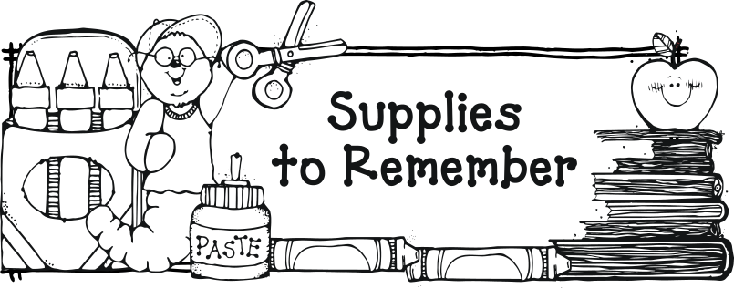

spiral notebook
2 plastic pocket folders
1 plastic BLUE pocket folder
small plastic pencil box-(Mrs. Bobbi’s Class only)
40 plain wooden pencils -(no cute plastic wrapped pencils!)
3 boxes of crayons
glue sticks
scissors
large boxes of tissues
expo dry erase markers
index cards-white or colored

Optional Teacher Wish List:
Clorox wipes
markers
prize box items

* Be prepared to pay $3.00 for Primary Writing Journal
on Back to School Night.

