A-Z Senior Post-Secondary Glossary of Terms

Class of 2023

Looking Towards the Future from the Top of Eagle Mountain!

As a senior preparing to make post-secondary choices, student services have compiled this reference guide, which we hope will aid you in your college search and planning. In the following pages, you will find an alphabetical list of terms that you may encounter during your college search. We have also included some dates and other EHS Class of 2023-specific information for your benefit.
Please know that we are here to help, and we look forward to helping you with your post-secondary planning. EHS Counselors

Academic Common Market
For more than 35 years, the Southern Region Education Board’s Academic Common Market has enabled students to pursue specialized degrees (not available at Georgia Institutions) at out-of-state colleges for discounted (in-state) tuition rates. For more information and qualification requirements see: www.sreb.org/page/1304/academic_common_market.html/ http://www.usg.edu/academics/academic_common_market/

- ACT (American College Testing)
This college admissions test is accepted by all state colleges and universities in Georgia as well as many private and out-of-state schools.
  - Etowah HS will host the ACT during the 2022-2023 school year on October 22, December 10, and February 11
  - Local Test Centers – All Cherokee County High Schools are local test centers as well as most schools in surrounding counties.
  - Registration – Registration bulletins, which contain helpful information, are available in the Counseling Office and on the ACT website. To register for the ACT, students should go online. EHS cannot register a student for an ACT. www.actstudent.org
  - Registration deadlines – See the chart below
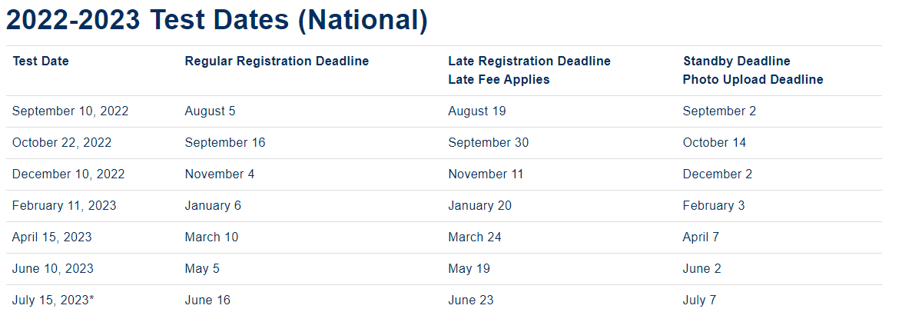

- ASVAB (Armed Services Vocational Aptitude Battery)
This aptitude test is available to any interested student. Although it is used for job placement by the military, it can give all students good information about their abilities. ASVAB testing at EHS is TBD.

Academic Grade Point Average (GPA)
ETOWAH does not calculate GPA; we calculate Numeric Grade Average (NGA). Most colleges request a GPA on applications rather than the NGA which appears on the Etowah HS transcript. The Academic Grade Point Average is calculated by assigning points for grades that can be calculated on a 4.0 scale A=4, B=3, C=2, D=1, F=0. The grades are converted to this numeric system and divided by the number of grades being calculated.

Some colleges calculate all grades posted on a transcript; others may choose to only count core curriculum grades (English, Math, Science, Social Studies, and Foreign Language classes). Students
should be aware that bonus quality points awarded for AP and honors level classes will probably not be recognized by colleges and universities when calculating academic grade point averages unless it is their policy to factor in honors & AP level courses for any student from any high school. For example, Cherokee County may have given you 3.5 quality points for making a "B" in AP UNITED STATES HISTORY, but many colleges will only give you 3.0 quality points for this class. Ask the college to verify how they will calculate your grades. GPA Calculators are available on the Internet and can be found with a google search.

Class Rank
Class rank is determined by the cumulative overall weighted numeric grade average (weighted NGA on the transcript). The student with the highest NGA is ranked #1; the second highest NGA has the class rank of #2 and so on. Class rank is an important indicator in college admissions, especially for more competitive colleges. Class Rank can be found on the Etowah HS transcript.

College Admissions Requirements
2-year Technical College System of Georgia
The Board of Regents, which governs the University System of Georgia's 2-year colleges and technical programs require entering freshman to graduate from an accredited high school to gain entry to a 2-year college or technical program. A minimum COMPASS, ACCUPLACER, ACT or SAT score will be required for admission. Two years of a foreign language is not required for admission.

23 Credits Required for Graduation
4 Units of English: 9th Lit & Amer. Lit required 1 Unit of Health (.5) and Personal Fitness (.5) 4 Units of Math: Algebra 1, Geometry & Algebra 2 required 3 Units of required electives: any combination 4 Units of Science: Biology, Physical Science OR Physics, Foreign Language, Fine Arts and Career Tech
Chemistry, Earth Systems OR Environmental required 4 Units of any elective chosen 3 Units of Social Studies: World History, U.S. History
& Gov’t/Econ required

4-year University System of Georgia Colleges and Universities
The Board of Regents, which governs the University System of Georgia's 4-year colleges and universities requires entering freshmen to complete a College Preparatory Curriculum (CPC) and graduate from an accredited high school to gain entry to a 4-year college/university. Minimum ACT and SAT scores and a Minimum High School GPA will be required in addition to the high school diploma.

CPC REQUIRED COURSES
4 units Mathematics: Algebra, Geometry, Algebra 2 and a fourth approved unit of mathematics 4 units English: Literature integrated with grammar and usage and advanced composition skills 4 units Science: The four science units should include two courses with a laboratory component
Students graduating from a Georgia public high school should have at least one unit in biology, one unit of physical science or physics, one unit of chemistry, earth science or environmental science, and a fourth science.
3 units Social Science: Must include US History and World History
2 units Foreign Language: Same language emphasizing speaking, listening, reading, and writing

A unit refers to a Carnegie Unit and represents a full academic year of credit. These are minimum requirements & do not guarantee admission to a college or university. University System of Georgia CPC courses/units completed in middle-school grades is acceptable for meeting USG admission requirements. For more information visit: http://www.usg.edu/assets/student_affairs/documents/Staying_on_Course.pdf

College Admissions Representatives
College admissions representatives are a good source of information about the college and are the link between the college and the applicant. Students may speak with them by attending one of the PROBE College Fairs (See PROBE COLLEGE FAIRS), visiting college campuses, or meeting with them when they visit the Etowah campus during lunch periods.

College Application Procedure
For each college to which you think you may apply, read the application requirements thoroughly and completely before you begin. Generally, the admissions process is found on the Admissions webpage of the university’s website. Look for the “application/apply” “undergraduate,” “prospective students” or “freshman” links. The requirements and processes vary from college to college. Follow their instructions to apply.

College & Scholarship Essays
Proofread – Proofread – PROOFREAD!! AND FOLLOW DIRECTIONS! Be who you are. Don’t change what you do to impress the college. Ask your friends how you come across – funny, serious, inquisitive, etc. That’s how you should come across in your essay. The essay should exemplify how you think, and what you think about, and show how well you write.
  - Remember the intent of the essay question. It’s not about the “right answers.” Show your willingness to delve into topics, demonstrate intellectual curiosity, and show off your writing prowess.
  - NO McEssays! No five-paragraph essays that contain mostly abstractions and unsupported generalizations. Pick a topic you are genuinely interested in. You cannot fake it! College admissions reps have read so many college essays they will see right through a contrived interest.
  - If you can put any other person’s name in your essay in place of yours and it makes sense, go back to the drawing board. Use anecdotes and stories from your life that are yours and yours alone. Detail is what differentiates one essay from another, one applicant from another.

Common Application
This is a comprehensive college application form used by 500+ independent colleges that is available online. Generally, you need only fill out one application to submit to any participating post-secondary institution. You may be required to complete a supplemental application for a college. For more information visit www.commonapp.org.

Counselor Recommendation Form
A counselor recommendation is a personalized letter of recommendation written by the school counselor on behalf of the student to help them gain college admission. Not all colleges require a counselor recommendation as a part of the application procedure. Read the college application completely and thoroughly to determine if there is a requirement for a Counselor Recommendation. Counselor Recommendation Packets are available in the counseling office (RM 3108) and online on the EHS website or online at https://tinyurl.com/du9rsk4w. Packets should be filled out completely and returned electronically to the student’s counselor with 2 weeks’ notice to complete the letter.

*** ALL REQUESTS FOR COUNSELOR RECOMMENDATIONS MUST BE ON THE RECOMMENDATION REQUEST FORM AND RECEIVED IN THE COUNSELING OFFICE NO LATER THAN TWO WEEKS PRIOR TO THE DEADLINE! ***

- EFC (Expected Family Contribution)
EFC is the "magic number" of the financial aid process. This is the amount of money you and your parents are expected to contribute to paying for college. The EFC is based on the income and other financial assets of you and your parents.

The point of any financial aid form is to figure out your EFC. Calculating the EFC is not so simple, though, because it requires extremely detailed financial information about each applicant. That is where the FAFSA (Free Application for Federal Student Aid) and other financial aid forms come in. The information from your completed financial aid form is plugged into a series of formulas to calculate how much money your family can afford to pay for college.

Final Transcript
If you will be attending a college, university, technical institute, or other types of school next fall, that school will require that you send a final transcript to the institution as proof that you have graduated. Seniors will be told when to complete the request for final transcripts through the counseling department. Transcripts can be sent to participating colleges and universities in-state for free through www.GAFutures.org Out of state transcripts can be sent using https://www.parchment.com/u/registration/9435/account for a $5.65 fee. Final transcripts will not be sent unless they are requested. After you have graduated if you need a final transcript, you can request it through either of these websites.

Financial Aid
There are two types of financial aid: need-based and merit-based. Financial aid does not necessarily mean “free money.” A financial aid package can include any combination of grants, loans, work-study, and EFC. The biggest mistake most families make is not completing a FAFSA. Parent income is only 1 of 7 pieces of information considered when constructing a financial aid package. More information is online at https://studentaid.gov/.

Financial Aid Forms
There are several forms that are used to apply for need-based financial aid:
  - Free Application for Federal Student Aid (FAFSA) - This form is used by all colleges to determine eligibility for need-based financial aid. It is also used to establish eligibility for the HOPE Scholarship and HOPE Grant. The application is online at https://studentaid.gov/h/apply-for-aid/fafsa.
  - FAFSA will be available on October 1, 2022, using 2021 tax information.
  - GSFAPPS - This application may be used in lieu of the FAFSA for HOPE Scholarship if your college accepts it. Check with the Financial Aid Office at your college for more information, they may require additional paperwork. This application may be found at https://apps.gsfc.org/gsfa/gsfapps_index_ng.cfm.
  - CSS PROFILE - This form is also required by some colleges as a supplement to the FAFSA. Check with the college’s financial aid office about the requirement for completing the CSS Profile. Forms are available https://cssprofile.collegeboard.org/

Freshman Index Number
The University System of Georgia colleges and universities use a standardized calculation to determine appropriate college placement for students in the state of Georgia. This is known as the Freshman Index Number. The Freshman Index is calculated by combining the core high school grade point average (GPA on a 4.0 scale) with the highest earned SAT or ACT test scores. The high school GPA is calculated from the grades earned in the 17 Required High School Curriculum (RHSC) courses for those students graduating in 2012 or later.

The following formulas are used to calculate a student's freshman index:

The formula for SAT Test Takers | The formula for ACT Test Takers
Freshman Index =  500 x (High School GPA) + 1.06 x (SAT Reading & Writing + SAT Math)  - 74 | Freshman Index =  500 x (High School GPA)  + (ACT Composite score x 42) + 88

A full list of the individual institution requirements is available online here https://www.usg.edu/student_affairs/prospective_students/freshman_index_requirements

GAfutures.org
This website is provided by the Georgia Student Finance Commission. The site provides students with valuable information on college and career opportunities. Your HOPE GPA is found on this website.

Grade Point Average
See Academic Grade Point Average.

Graduation Ceremony
Saturday, May 27, 2023, at 1:00 pm.

Graduation Regalia and Announcements
Visit Herff Jones to order online https://www.herffatlanta.com/. Herff Jones will visit the school in the Fall to take orders and answer questions for students as well.

Honor Graduates
Any student completing high school with a cumulative weighted NGA of 90 or above will be designated an honor graduate. Honor graduates will be announced during graduation practice and will receive an honor cord that is distributed at practice to wear at graduation. https://www.gafutures.org/hope-state-aid-programs/hope-zell-miller-grants/hope-grant

HOPE Grant
The HOPE Grant program is for students attending a Technical College, regardless of the student's high school grade point average or graduation date. The HOPE Grant Award Amount will cover a portion of a student's tuition. Full-time enrollment is not required, but you must be making satisfactory academic progress to maintain eligibility. For more information, visit https://www.gafutures.org/hope-state-aid-programs/hope-zell-miller-grants/hope-grant.

- HOPE CAREER GRANT
Students interested in entering a field in which there are plenty of job openings can choose to enroll in one of 17 programs of study for which FREE TUITION is available! https://tcsg.edu/free-tuition/

HOPE Scholarship
The HOPE Scholarship program is for students that have demonstrated academic achievement and are seeking a college degree. Currently, the HOPE scholarship covers approximately 90% of tuition at
Georgia’s public colleges and universities. For the most up-to-date HOPE Scholarship information, please visit https://www.gafutures.org/hope-state-aid-programs/hope-zell-miller-scholarships/hope-scholarship/.
  - Basic Eligibility
The HOPE Scholarship program requires students to meet basic eligibility requirements to be awarded initially after high school graduation and maintained while enrolled in an eligible college or university (postsecondary institution). An eligible student must:
    - Meet U.S. citizenship or eligible non-citizen requirements;
    - Meet the postsecondary institutions Georgia Residency requirements;
    - Be enrolled as a degree-seeking student at a USG, TCSG or eligible private HOPE eligible college or university in Georgia;
    - Meet federal Selective Service registration requirements, per Georgia state law. The requirement to register applies to males who were born on or after January 1, 1960, are at least 18, are citizens or eligible non-citizens who came to the United States prior to age 26;
    - Meet academic achievement standards;
    - Be in good standing on all student loans or other financial aid programs;
    - Be in compliance with the Georgia Drug-Free Postsecondary Education Act of 1990;
    - Not have exceeded the maximum award limits for any HOPE program
Full details and more information is available online https://www.gafutures.org/hope-state-aid-programs/hope-zell-miller-scholarships/hope-scholarship/basic-eligibility/.

- NCAA (National College Athletic Association)
Potential student-athletes who need to register with the NCAA Clearinghouse may do so online at www.ncaaclearinghouse.net.The NCAA will require official transcripts to be sent once you are registered with the Clearinghouse. Students should discuss NCAA rules and eligibility with their coach and/or the EHS Athletic Director’s office. The EHS Counseling Office is aware of NCAA eligibility rules; however, students are advised by the Counselors based on graduation and college admission requirements only. It is the responsibility of the student and parent to ensure that NCAA eligibility rules are being followed.

Numeric Grade Average
Cherokee County School District uses numeric grade averages to rank students. Numeric grade averages are the sum of all grades with the total being divided by the number of courses taken. Extra points for honors and AP courses are included in the weighted numeric grade average. The weighted numeric grade average is the average that determines the class rank.

Parchment
Parchment is a third-party vendor that electronically sends transcripts to in and out-of-state colleges and other entities for $5.65 per transcript. Request an official transcript online https://www.parchment.com/u/registration/9435/account.

Probe College Fairs
Learn more about post-secondary options after high school. Probe is a resource to connect you with the right school to meet your individual needs and career goals. Find out more information regarding dates at http://www.gaprobe.org/. Cherokee County Probe Fair is scheduled for Monday, October 24, 2022 at 6 pm at Cherokee High School, 930 Marietta Highway, Canton GA 30114.

- SAT (Scholastic Aptitude Test)
This college admissions test, given multiple times each year, is accepted by most colleges and universities.
Etowah HS will host the SAT during the 2022-2032 school year on October 1, November 5, and December 3
- Local Test Centers – All Cherokee County High Schools are local test centers as well as most other high schools.
  - Registration – Registration bulletins, which contain helpful information, are available in the Counseling Office. To register for the SAT, students should go online to https://sat.collegeboard.org/register (EHS cannot register a student for an SAT).
  - For registration deadlines, see chart:

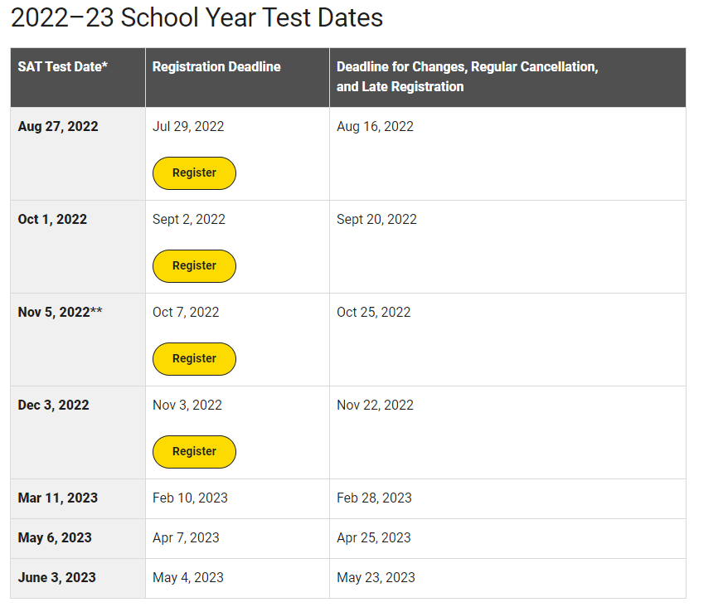

Scholarships Information
To keep seniors aware of current scholarship information, the EHS Counseling Office posts scholarships on the Counseling webpage, and send alerts using Twitter @EHSStudServ. A binder is also available in the Counseling Office in room 3018 for students.

Social Security Number
These numbers are used as student ID numbers by Etowah High School as well as most colleges. It is imperative that students check their transcripts to make sure that the correct social security number is on their transcript—ONLY THE LAST 4 DIGITS WILL BE DISPLAYED FOR SECURITY PURPOSES. Incorrect numbers can cause significant delays in college acceptance and HOPE Scholarship qualification! If the last four digits of your SSN are incorrect, please see Ms. Silvia Holmes in the Counseling office with your original social security card.

Teacher Recommendation
If a college or scholarship requires a teacher recommendation, coordinate this directly with the teacher. Each teacher has their own process, so they will tell you what they need. If the recommendation is electronic, follow up with the teacher to make sure they received a link from the college. Imperative: Follow up with a “thank you” note to the teacher when they have completed the recommendation.

Transcripts
A transcript is a history of your academic record and Georgia Academic Assessments for grades 9-12. It also shows your numeric grade average and class rank. A profile of Etowah High School is always sent with the official transcript when sent from Etowah. Official transcripts are required for college applications. Transcripts sent electronically through www.gafutures.org (Georgia schools only) are free. Paper copies must be ordered using the transcript request form found on the Counseling website or in the Counseling office. Parents may NOT request transcripts for students who are over the age of 18.
Electronic copies may be sent to out-of-state colleges using https://www.parchment.com/u/registration/9435/account. and cost $5.65 each.
  - Official transcript – Has a signature and the school seal. Required when applying to college. The Counseling Office can send it electronically (through GAFutures.org if a Georgia school), mail it directly to the college, or it can be given to students or parents in a sealed envelope.
  - Unofficial transcript – no signature or school seal. May not be used to apply for college. Any teacher or the counseling office can print a copy of your unofficial transcript.

Verification of Lawful Presence
In October 2010, the Board of Regents passed Policy 4.1.6, Admission of Persons Not Lawfully in the United States, and Policy 4.3.4, Verification of Lawful Presence. Policy 4.1.6 states the following:
- A person who is not lawfully present in the United States shall not be eligible for admission to any University System institution which, for the two most recent academic years, did not admit all academically qualified applicants (except for cases in which applicants were rejected for non-academic reasons).
- Any student requesting to be classified as an in-state student for tuition purposes will be required to provide verification of their lawful presence in the United States in order to be classified as an in-state student. Learn more about these policies at: https://www.usg.edu/student_affairs/prospective_students/verification_of_lawful_presence

Zell Miller Scholarship
The Zell Miller Scholarship program is for students who have demonstrated academic achievement and that are seeking a college degree. Generally, to become eligible, a student must graduate from an eligible high school with a 3.70 GPA and a minimum score of 1200 in Language and Math on the SAT or earn a 26 on the ACT. https://www.gafutures.org/hope-state-aid-programs/hope-zell-miller-scholarships/zell-miller-scholarship/

- Z End! (almost)
  - COMMON BLUNDERS OF COLLEGE APPLICANTS
The Six Most Common Blunders of College Applicants. Advice from Jeremy Spencer, Former Director of Admissions at Alfred University: For more detail see: https://www.thoughtco.com/college-applicants-most-common-blunders-788846
- Missing deadlines.
- Applying for Early Decision when it’s not the right choice.
- Using the wrong college name in an application essay.
- Applying to college online without telling school counselors.
- Waiting too long to ask for letters of recommendation.
- Failing to limit parent involvement.
  - USEFUL CAREER/COLLEGE PLANNING WEBSITES
- COLLEGE ADMISSIONS TESTS
  - https://satsuite.collegeboard.org/sat: Online SAT registration and test dates are available at this site. It also has college databases, a financial aid registration site, and a career questionnaire plus career information.
  - www.actstudent.org: Register for the ACT. This site also provides “information for life’s transitions” including career planning, applying to college, and financial aid need estimator.
- COLLEGE & CAREER INFORMATION
  - www.gafutures.org Founded in 1965, the Georgia Student Finance Commission has become one of the most successful state student aid operations in the nation. First created to provide loans, the agency progressed to state- and lottery-funded scholarships, grants, service cancelable loan programs and providing free financial aid consultation. GSFC's mission is to ensure Georgians have an opportunity to access education beyond high school.
  - https://www.nacacnet.org/advocacy--ethics/initiatives/steps/ The National Association
for College Admissions Counseling’s “Steps to College” is loaded with good information.
  - https://www.usnews.com/rankings (click on best colleges) Information about colleges, including rankings.
  - https://www.bls.gov/ooh/ Occupational Outlook Handbook: Provides career information based on keyword searches and contains an index of occupations. Revised every 2 years, the Handbook describes what workers do on the job, working conditions, training, and education needed, earnings, and expected job prospects in a wide range of occupations.
- FINANCIAL AID OR SCHOLARSHIPS
  - https://studentaid.gov/ Free Application for Federal Student Aid (FAFSA), use this site to complete your federal financial aid application
  - www.gafutures.org: You can use this site to complete applications for GA colleges, research career planning, and financial aid. The electronic application for HOPE, GSFAPPS, is available at this site.
  - www.gsfc.ga.gov: GEORGIA STUDENT FINANCE COMMISSION – Information on the HOPE Scholarship and other financial aid
  - www.fastweb.com: Scholarship search database of over 350,000 scholarships.
  - www.studentaid.ed.gov Information about financial aid, including links to other financial aid sites.
  - https://www.petersons.com/ With Best College Deals (for U.S. citizens looking for information on U.S. colleges) you get personalized financial aid guidance.
- TECHNICAL COLLEGE SYSTEM OF GEORGIA
  - www.tcsg.edu: This website contains information about the technical colleges and programs offered in Georgia, as well as information about the HOPE Grant (specific to technical school students).
- UNIVERSITY SYSTEM OF GEORGIA
  - www.usg.edu: contains information about all public colleges and universities in the State of Georgia (Research, Regional, State Universities, State Colleges, and 2-year College)

