Triad PTA supports all of Triad School District…Yes all three (3) buildings! As a way to cut back on family expenses during the school year, PTA raises funds that are used to purchase materials and cover expenses needed for the success of our staff and students. Help us make a difference in our schools by supporting the Triad PTA.
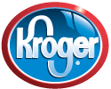Kroger’s Rewards… keep your reward points, coupons, and gas discounts, but list us as your non-profit organization of choice and help us earn money! 5% of the total you spend at Kroger’s will go to us every time you scan your card. Register your Kroger’s Rewards card today at www.krogers.com, select Triad Elementary PTA. All funds received from the Kroger’s Rewards are used district wide. Must be renewed every year
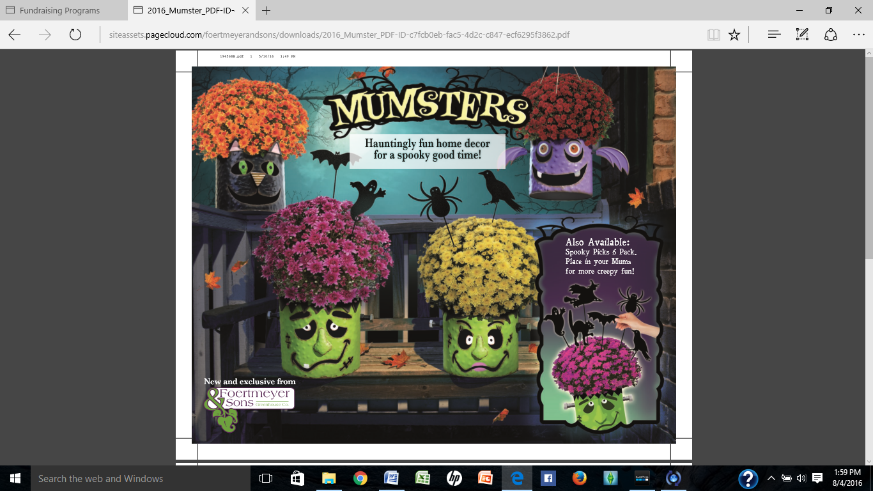

Mumkins and Mumsters 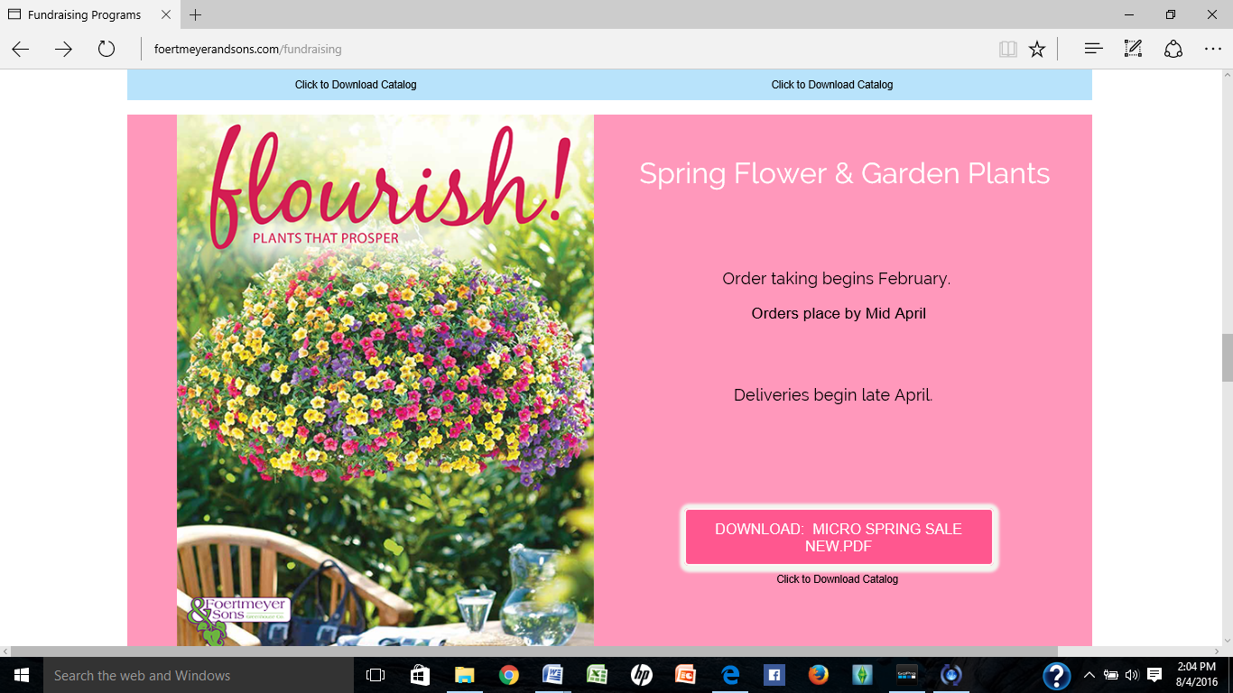
Secret Santa Shop Spring Flower sale TBA

Find out more information by clicking on our link located on the Homepage of the school website
Like us on Facebook (Triad PTA – Parent Teacher Association)
Thank You to the local businesses that supported this years summer reading program!!

