Checklist for College-Bound Student-Athletes
from NCAA Eligibility Center

- Register at the beginning of your sophomore year at www.eligibilitycenter.org.

- Ask your high school counselor to send your transcript to the NCAA Eligibility Center at the end of your junior year.

- Take the ACT or SAT and use the code “9999” to have your official scores sent directly to the NCAA Eligibility Center.

- Check with your high school counselor to make sure you are on track to graduate on time with your class and have the required amount of core courses.

- Request final amateurism certification during your senior year (beginning April 1).

- Ask your high school counselor to submit your final transcript with proof of graduation.

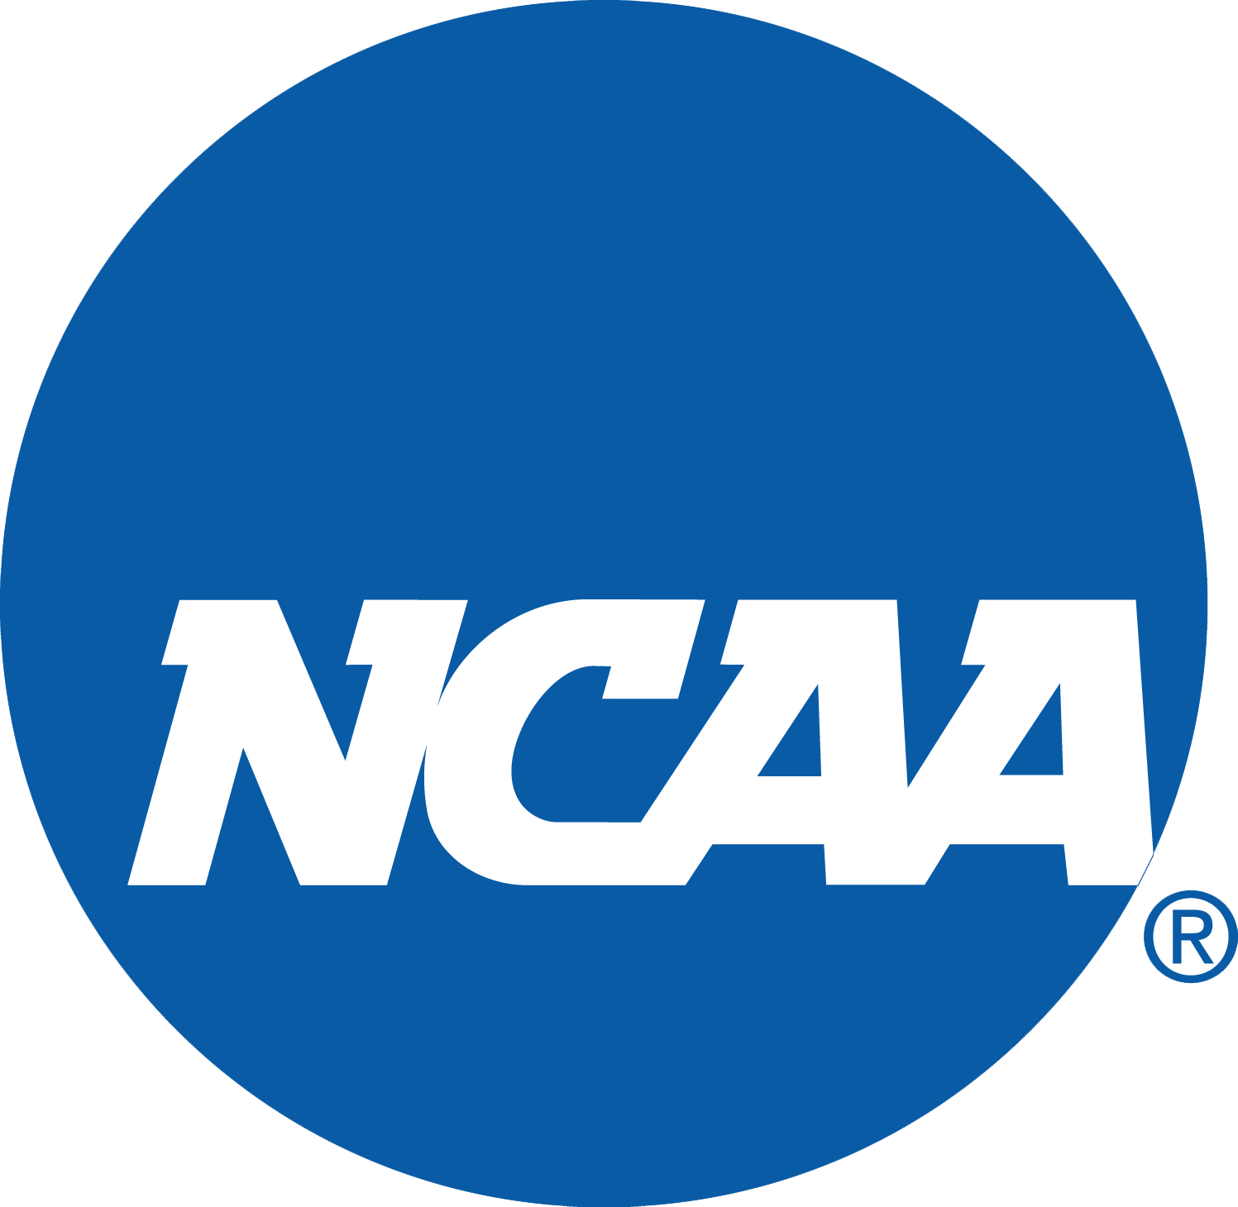
You are responsible for achieving and protecting your eligibility status!

