Denver Metro Teen Driver
Driver’s Education Scholarship

Fall 2022 Application Packet – due no later than February 28, 2023.

Scholarships will be awarded until all funds are awarded.

Thank you for your interest in the Denver Metro Teen Driver’s Driving scholarship program. A group of local organizations is collaborating to offer scholarships for teen drivers to ensure they have access to comprehensive driver’s training education. Our organizers have a common goal: to reduce the incidence of teen injuries and death caused by motor vehicle crashes, especially crashes related to distracted driving.

Each scholarship covers the cost of 30 hours of class time, 6 hours of driving time, and the written permit test. A limited number of scholarships, valued at to $475 each, are available and the process is competitive. If awarded, scholarships are paid directly to the driving school. Once the scholarship is awarded, it is the recipient’s responsibility to enroll in the training program and submit an invoice to our committee for payment within 180 days of the date of the award notification. We will not reimburse students or parents directly.

Upon completion of your training course, a representative from Denver Metro Teen Drivers will request a brief written statement on how the experience impacted you as a new driver.

If you have any questions about the application process, please contact Jan Bonner at Good Samaritan Medical Center Foundation at jan.bonner@imail.org.

Please note: Farmers Insurance employees and their family members are not eligible for scholarships.

Thank you again for your interest and good luck on your submission!

Denver Metro Teen Drivers Program is generously supported by a grant from
Farmers Insurance and coordinated by representatives from:

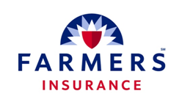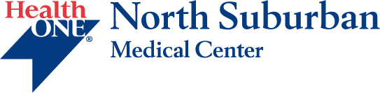
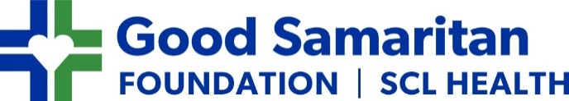

Denver Metro Teen Driver
Driver’s Education Scholarship

The Denver Metro Teen Driver (DMTD) Scholarship is an opportunity for future teen drivers to gain important driving skills through an approved Drivers Education training course. This scholarship is funded in part through grant funds received from the Farmers Insurance Group Foundation.

We believe all teen drivers benefit from completion of a formal driver’s education training course, and that training improves their safety. Our goal in providing this scholarship is to ensure that all future drivers gain the knowledge and experience to keep them and their community safe. The scholarships, up to $600.00, will be paid directly to the driver’s education school of the student’s choice (for example, Drive Safe, Top Cops, Affordable Driving School, etc.). The selected program must include 30 hours of classroom training, and 6 hours of on-road driving time. They may also include the cost of the written permit test.

The number of scholarships are limited and the process is competitive. Judging will be based on each applicant’s demonstrated ability to meet the application criteria.

Scholarship applications are accepted and reviewed on a rolling basis until all scholarship funds are awarded.

Requirements:

Applicants must submit the attached application along with a written essay (500 words) answering the following question:

What are the dangers of distracted driving and what are some practical ways we can reduce distracted motor vehicle crashes caused by distracted driving?

Please consider the following when writing your essay:

- Impact – how does distracted driving impact you as an individual, your peers, your school and your community as a whole?
- Data – what data can you cite to support your statement on impact?
- Change – what changes do you think can be made to reduce the incidence of distracted driving? Please consider changes that you can make, and those that can be made by your peers, your school, and your community.

Helpful tips:

- Be creative, innovative and thoughtful in your answers.
- Consider new solutions to the problem of distracted driving that you don’t think have been explored yet.
- Interview someone who has been impacted by distracted driving (for example, law enforcement or someone who has been impacted by a distracted driver) to learn their experience and perspective

Employees of Farmers Insurance and their family members are not eligible for scholarships.

Denver Metro Teen Driver
Driver’s Education Scholarship Application

Please complete this form and return it with your essay.

Applicant Information

Name: ____________________________________________________________________________

Address: ____________________________________________________________________________

____________________________________________________________________________

Phone #: ____________________________________________________________________________

Email: ____________________________________________________________________________

School: ____________________________________________________________________________
High School name and location

Grade Level: □ Freshman □ Sophomore □ Junior □ Senior □ HS Graduate

Name & Address of Driving School: ________________________________________________________________________________________

How did you learn about the DMTD Scholarship? ________________________________________________

□ If I am selected as a scholarship recipient, I agree to respond to future DMTD communications and
provide feedback about the program.

Parent or Guardian Information

Name(s): ____________________________________________________________________________

Address: ____________________________________________________________________________
(If different than applicant’s address)

Phone #: ____________________________________________________________________________

Email: ____________________________________________________________________________

□ I certify that neither the student applicant’s parents/guardians work for Farmers Insurance.

I have given my teen listed above permission to apply for this scholarship and support their participation in a driver’s education course. I understand the maximum scholarship amount is $600 and I will be responsible for any additional costs to complete the driver’s training program.

____________________________________________________________________________
Parent Signature Date

Applicant Essay

Please write a 500 word essay that answers the following question:

What are the dangers of distracted driving and what are some practical ways we can reduce distracted motor vehicle crashes caused by distracted driving?

Please consider the following in your response:

- Impact – how does distracted driving impact you as an individual, your peers, your school and your community as a whole?
- Data – what data can you cite to support your statement on impact?
- Change – what changes do you think can be made to reduce the incidence of distracted driving? Please consider changes that you can make, and those that can be made by your peers, your school, and your community.

Please submit your application form and completed essay to Jan Bonner, Good Samaritan Medical Center Foundation – jan.bonner@imail.org – with DMTD Scholarship Application in the subject line. If you have questions, please feel free to email as well.

Please note:

- Applications are reviewed until all scholarship funds have been awarded.

- Incomplete applications will not be considered.

- Maximum scholarship amount is $475.00 to cover the cost of basic driver’s education training which must include 30 hours of in-person training and 6 hours of on-road training and may include the cost of the driver’s permit exam.

- Scholarship recipients are responsible for any costs exceeding the scholarship amount awarded.

- Scholarship awards will be paid directly to the driver’s training program, not the scholarship recipient. The payment process may vary depending on the program selected.

- Recipients must be registered for their driver’s ed program within 45 days of award notification - even if the course begins later - or the scholarship will be rescinded.

- The Denver Metro Teen Driver’s Program is generously sponsored by Farmers Insurance with support from The Medical Center of Aurora, North Suburban Medical Center, and Good Samaritan Medical Center/Foundation.



