Aeries Academic Plan – Student Instructions

The Aeries Academic Plan helps students map out their 4-year academic High School journey. It’s also used to allow students to participate in choosing their courses for the following school year. A window for updating the Academic Plan will be available on an annual basis. Students and parents may view the plan at any time.
To get started log into the Aeries Family Portal:
If you are a student who has never accessed the Aeries Portal:
You must activate your Aeries Portal account:
- Log into your AUSD Google account (student’s username@ausdg.us) and find an email sent from alamedausd@alamedaunified.org
- Follow the instructions in the email to activate your Aeries Portal account.
Note: If you can’t find the email, please go to the Aeries Portal login screen and click on ‘Forgot Password’. This will generate a new activation email from alamedausd@alamedaunified.org sent to your AUSD Gmail.

Once your Aeries Portal account has been activated you may log in anytime by going to your school’s website and clicking on the Aeries Family Portal link. Your username is your AUSD Gmail address (username@ausdg.us).
Note: If you can’t remember your password click on ‘forgot password’ and an email will be sent to you with instructions on how to reset it.

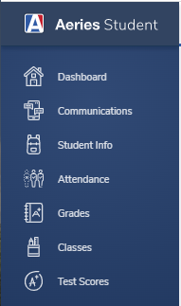
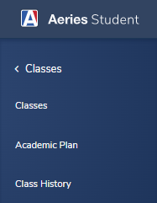
Accessing Your Academic Plan:
Once you’re logged in you will see the Aeries Home screen.
To start the process, go to Classes and select Academic Plan:

The Academic Plan allows you to track progress towards graduation and college requirements by showing past, current, and planned future courses. It also keeps track
of the credits needed to meet the requirements:
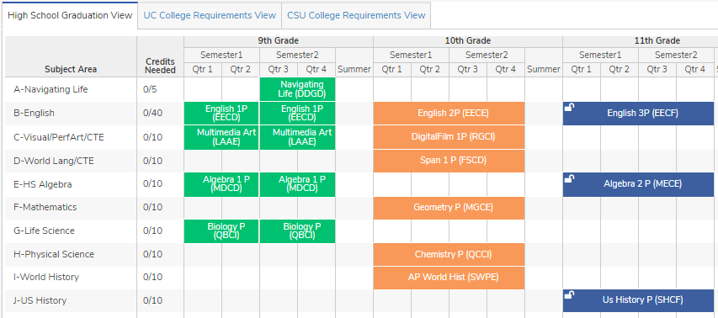
Orange – Current Courses Green – Courses that have been added to your transcript Blue - Planned Courses
Updating Your Academic Plan:
When the window is open for students to edit their Academic Plan, they will see a new section of the Academic Plan page where they can add courses to the plan.
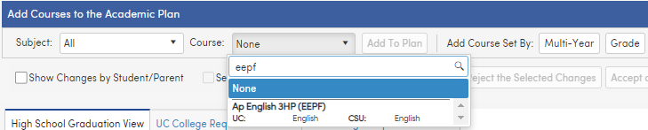
Before you get started here are some guidelines for course entry:
- Only add courses once.
- Do not add alternative elective choices! That’s what your Course Request Form is for.
- Only choose 6 yearlong courses for each grade level. Exception: senior year a semester each of Government and Economics for a total of 7 courses, 6 per term.
To add a course, select the “Subject” or leave on “All,” then start to type the course title or code into the “Course” dropdown search box. Once desired course is found, click the course title, then click “Add to Plan”:

A box will appear, asking you to select the “Grade Level” and “Term.” Select which grade you would like to take the course. Do not select “Summer” for any course term. Continue this process until the plan has 6 classes per grade level.
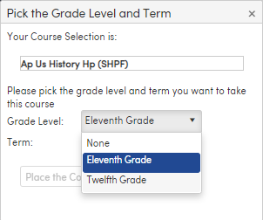
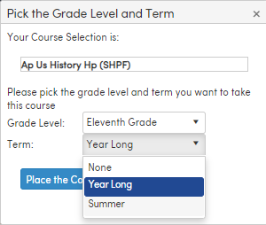

Once choices are selected, click “Place the Course”. Courses will then pop up on the Academic Plan, under the corresponding grade level, and aligned with the subject area.
Tips for entering courses:
- Course titles in Aeries are abbreviated, so typing the whole course title will rarely work. For example, Modern World History P is listed as MW History P, so typing “MW” will bring up the course, but “Modern W” will not.
- You can filter classes by subject. This can help with adding core subjects like English, Math, and History. However, it is recommended that you leave the subject to “All” when searching for Electives, or by searching for classes based on course code.
- We recommend that you use grade level course selection sheets to determine the classes you would like to take, then type the course codes you’ve selected in the “Course” search box to add to your plan.

Add classes one grade at a time, starting with next year’s. This will help ensure a full schedule before moving on to the next grade level.
There are some course sequences available for you to choose from by clicking on “Multi-Year”
Here you can choose a CTE pathway (ex. Digital Media) or a language. If you have already taken one or more of the courses in the sequence only those you haven’t taken yet will be placed.
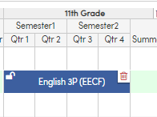
Grade Level Header
You can move a blue “planned course” to another grade level by dragging and dropping it on the grade level header.

Trashcan
Remove a course you are replacing or unwanted course by hovering over the course box, then clicking on the trashcan. Confirm your choice to remove the course.

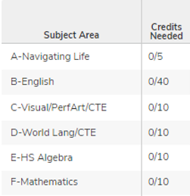
Be sure to check the “Credits Needed” column of the academic plan to view how many credits are needed in each subject area for graduation and that you have chosen courses that fulfill all of the requirements.
Examples:
10/10 means 10 credits are required in that subject area (bottom number) and 10 credits are still needed (top number)
0/10 means the 10 credits for the subject area have been met or are planned.

Check the UC and CSU tabs to see if you are meeting their subject area requirements.

Your entries are saved in a “Pending Status” until you are ready to submit your plan for counselors to review.
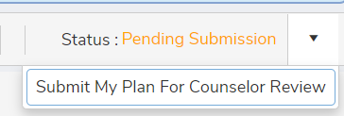
When you’re done selecting your courses click on the drop down in the
upper right corner next to “Pending Submission” and select
“Submit My Plan”.

Always remember to log out (upper right corner) and close your internet browser (if using a public computer this prevents others from seeing your information). Your information is saved automatically.

