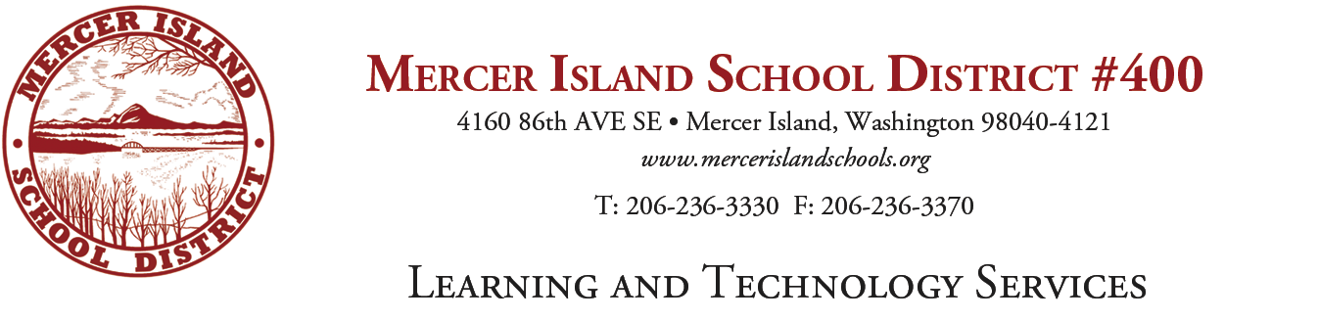
K-5 Writing Adoption Committee
Agenda

- Rubric Review
Team reviewed the rubric for a final go-ahead and made some minor changes. Rubric to be included in summary links.

II. Review of next steps

Team reviewed the candidate titles that will be examined at the release day and selected two release days. One day for the review of materials and another for vendor presentations.

Next Meeting on:

February 13, 2017
This day will be a review of the current proposals to select finalists for vendor presentations.

