Tyler SIS Student 360 Mobile

Overview
School districts should modify this document by removing the sections for features that are disabled in your district prior to posting.
Tyler SIS Student 360 Mobile is a mobile phone app version of the Tyler SIS Student 360 Parent Portal available on both iOS and Android. It can be downloaded from the Apple iTunes iOS App Store and the Google Play App Store.
The app is compatible with iPhones and iPads running iOS 8.4 or later and Android devices running Android 4.4 and later. While Tyler SIS Student 360 Mobile is compatible with larger devices, it contains a subset of the features available in the browser application. You can use the browser app on larger devices with Chrome on Android and Safari on iOS.
The Android and iOS versions are similar, but differences in hardware and platforms will result in slightly different appearances on some screens. Such differences are highlighted in this document.

Installing Tyler SIS Mobile
Download Tyler SIS Student 360 Mobile from Apple iTunes or Google Play. The app is free.
- Android (Phone and tablet)
- iOS (iPhone and iPad)

Logging in
The first time you launch Student 360, you will be prompted to search for your district either by name or by ZIP code. If you select the wrong district or need to change districts, you will be able to do so later from the Settings screen.
If for any reason you cannot find your district on the search screen, please wait until you receive an announcement from your district that Tyler SIS Student 360 is available.
Upon tapping Continue, enter at least the first three letters of the district’s name or the first three digits of the district’s ZIP code. Tap the Search button to search for districts. Tap the district where your student is enrolled to proceed to the login page.

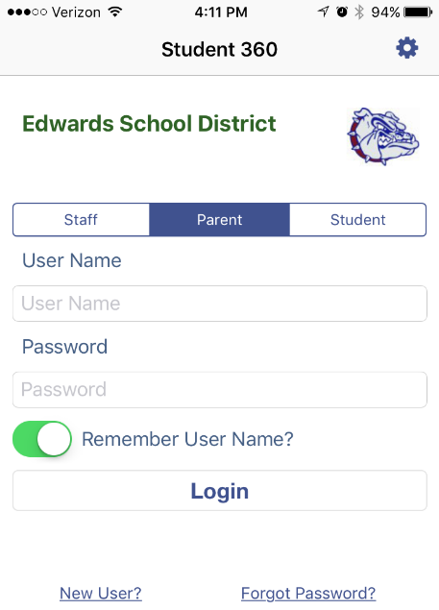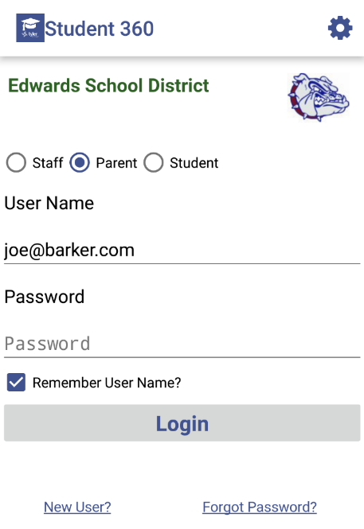
Left: iOS, Right: Android
At the top of the login screen, the gear icon provides access to the settings screen. To log in, use the radio buttons (Android) or tabs (iOS) to select Staff, Parent, or Student login. Use the same User Name and Password that you use to log into the Tyler SIS Student 360 Parent Portal website. Use the checkbox (Android) or toggle switch (iOS) to save your User Name if you want, then tap Login.

Navigating Tyler SIS Student 360 Mobile

Left: iOS, Right: Android
Within Tyler SIS Student 360, the Top Bar of the application will have some icons that help you navigate the app.
-  - return to the list of students (hidden if logged in as a student, or if only one student is found in the household)
-  - access user preferences. The preferences available depend on the options enabled by your district, and whether you are logged into Student 360 as a parent, student, or staff member.
Android devices have a built-in Back button, either at the bottom of the screen or as a hardware button on the device. Tyler SIS uses this built-in Back functionality to return to the previous screen. On iOS, since there is no Back button, a standard left-pointing arrow at the top of the screen with a label will take you back to the previous page.

Student List View
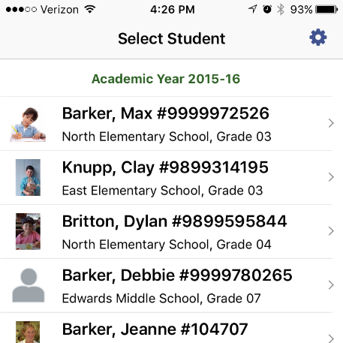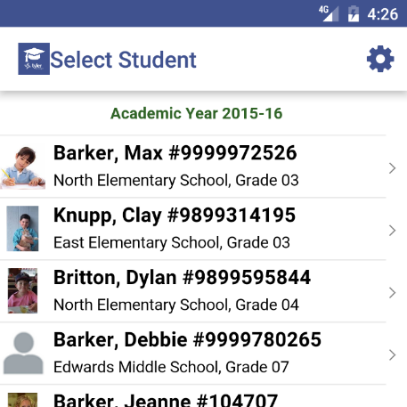
Left: iOS, Right: Android
If you are logging in as a parent and your household has more than one student, the first screen will be the Student List view. A student login will only see their own information, regardless of how many other students are in the household.
All of the actively-enrolled students will display with their photos (or a placeholder if their photo isn’t in Tyler SIS) along with their name, grade level, enrolled school, and student number. Tap a row to see that student’s Student Summary screen.

Student Summary
The Student Summary screen shows all of the areas available in Tyler SIS Student 360 for the selected student. Note that some of these items may not appear if they are not enabled by your district.
At the top of the screen, the student’s name, number, primary enrollment school, and grade level are displayed on the left, while the student’s photo appears on the right.
Some tiles may appear yellow to indicate that there is an alert to see. In this case, the Attendance tile is yellow to indicate that the student was absent for all or part of the current day.
To see more detail about an area, tap the tile to be taken to that screen.

Announcements
The Announcements screen displays any District-wide, School-specific, and Course-specific announcements. Each announcement appears on a single line with an arrow icon to the left. Tapping an Announcement’s row will expand that announcement to show the text. Tapping the row again will collapse the announcement.

New Announcements
When you first log into Student 360, you will be automatically taken to a screen that shows any new announcements that have been added since your last login. Simply press the Home icon in the upper left (iOS) or Back button (Android) to return to the student listing.

Assignments
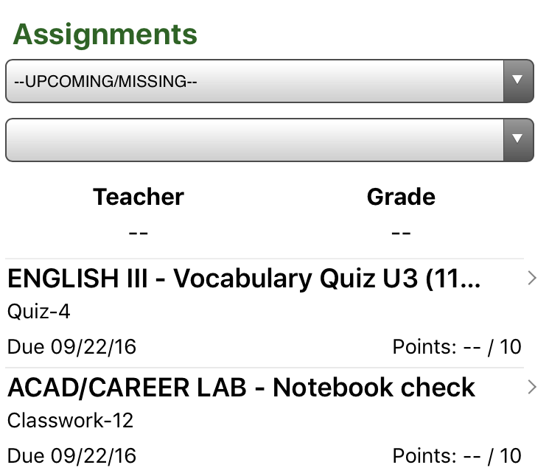
The Assignments screen shows the assignments that have been given to students. This screen has two drop-downs:
- Select Course: by default, all upcoming and missing assignments from any course are displayed. To see all assignments for a course, choose that course here.
- Select Term: after selecting a specific course, you can select which term you want to see assignments for. By default, the current term will be selected.
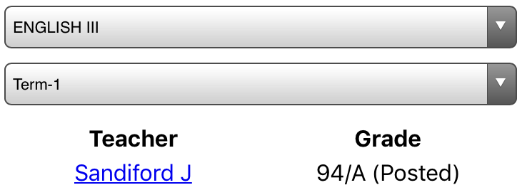
When a course is selected, the teacher name and student’s current term grade is displayed above the assignment list.

Each assignment that has not received a grade from the teacher will show a color-coded status.
- Due tomorrow: green
- Due today: orange
- Missing: red
- No score yet recorded (not marked missing): blue
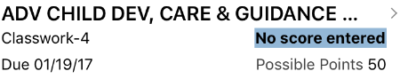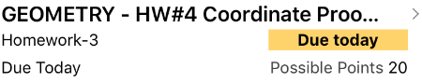
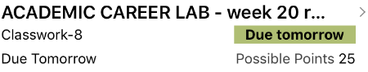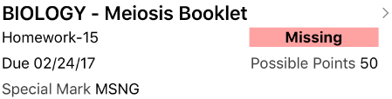

Tap an assignment to see the details for that assignment. If the assignment has a file attachment, you can download it and view it here. Any standards-based grades for this assignment will also display. Switch between assignments using the Previous and Next buttons.
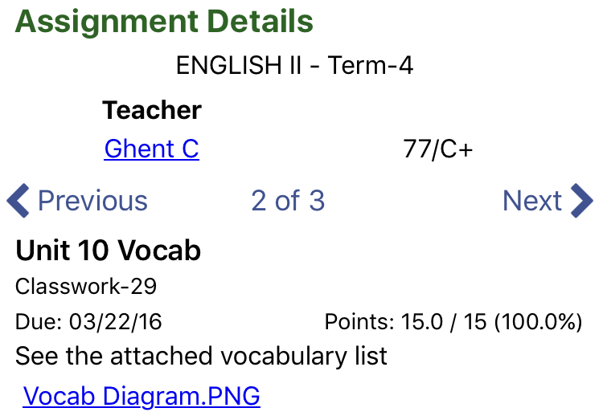

Attendance
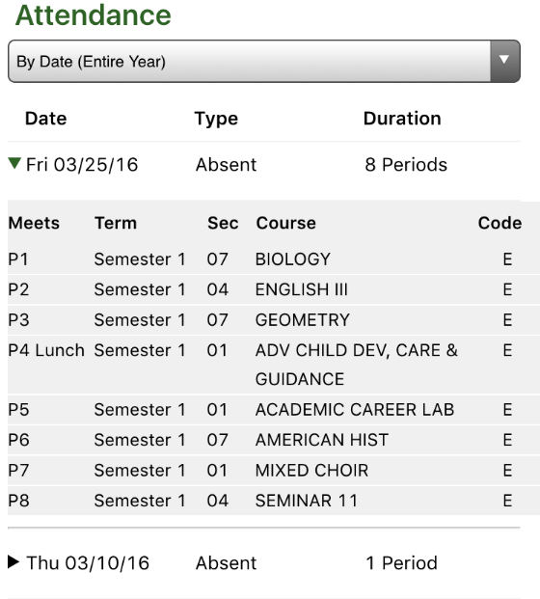
The Attendance screen shows all of the dates where the student was absent for all or part of the day. You can view the absences sorted By Date (Entire Year) or By Course Schedule for a specific term. Use the drop-down at the top to switch between views.
When viewing attendance By Date, each date is listed. Tap a date to see the courses where the student was marked absent. When viewing attendance By Course Schedule, tap a course and all of the dates where the student was marked absent in the course will display. Regardless of the view you choose, the period, term, and absence code will display.

Course Schedule
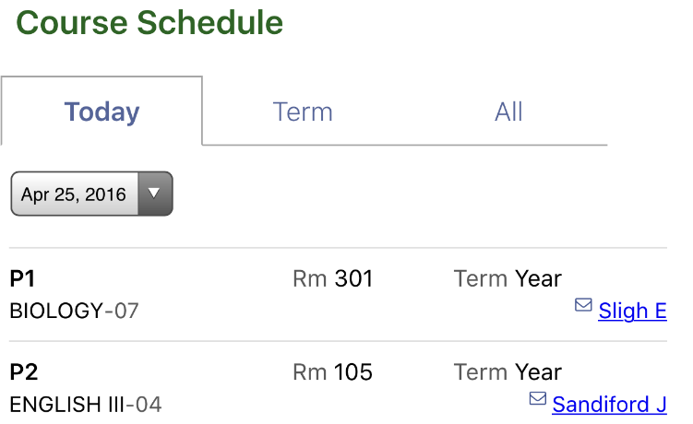
The Course Schedule screen shows the courses in which the student is enrolled for three time periods. Switch between these views using the tabs at the top of the screen.
- Today – shows only the courses that meet today
- Term – shows only the courses that meet in the current term
- All – shows all courses on the student’s schedule
Each course displays with the room number, term, name, and teacher. If the teacher has an email address, an icon appears and the name will be underlined. Tapping a teacher’s name will start an email to the teacher.

Discipline
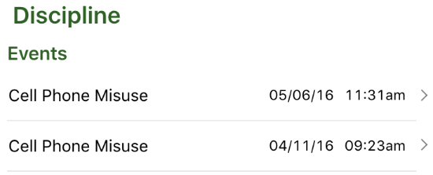
The Discipline screen shows any discipline events where the student was involved. Each event shows the incident, date, and time.
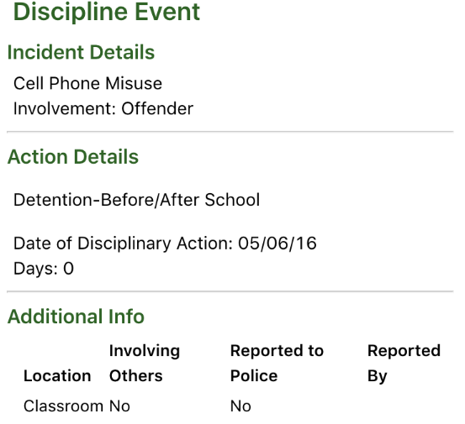
Tapping on a row loads additional information about the event, including any disciplinary actions.

Fees & Billing
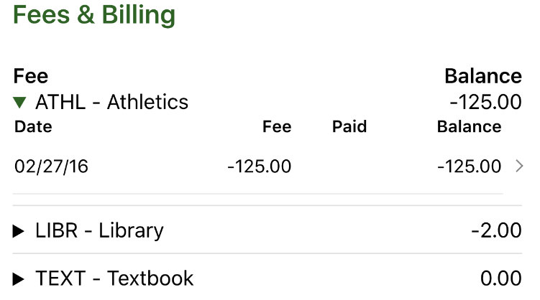
The Fees & Billing screen shows any fee accounts where the student has had activity for the school year. Fee balances owed to the school display as negative amounts, and fee credits (usually in the form of overpayments) display as positive balances.
Tap the disclosure triangle to see the transaction history for an account. Tap a transaction to see more detail about that transaction.
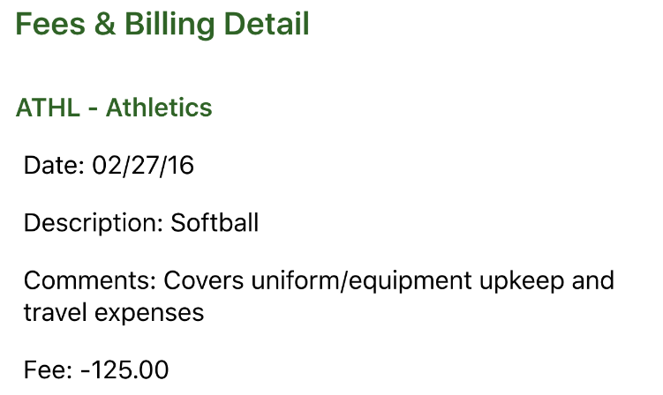
If your district does not use online payment through PayPal, then remove this paragraph. Otherwise, just remove this text. You can pay Fees & Billing accounts through Online Payment using PayPal using the Online Payment button at the top of this screen or from the Online Payment tile on the Student Summary. See the Online Payment section for details.

Grades
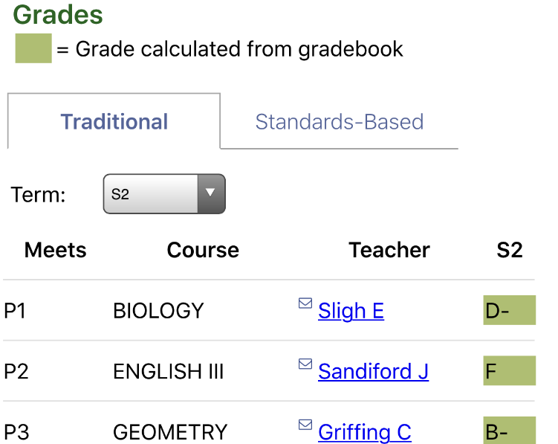
The Grades screen shows both posted report card grades as well as in-progress grades from the gradebook for terms that have not yet been posted. Each course displays with its name, the period it meets, the teacher, and the term grade. If the teacher has an email address, an icon appears and the name will be underlined. Tapping a teacher’s name will start an email to the teacher.
Use the Term drop-down to select a term. Grades that are calculated in-progress from the gradebook display in green, while posted grades for past terms display with no highlight.

Meal Service
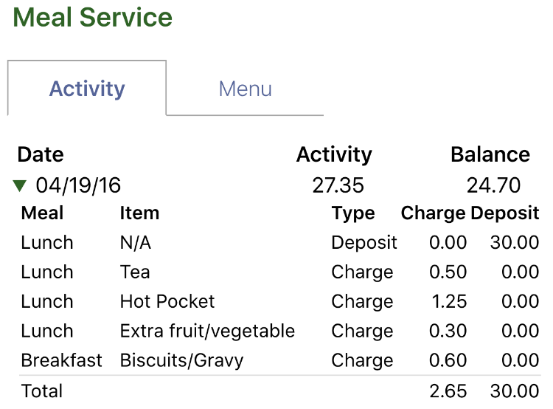
If your district does not use the Meal Planner in Tyler SIS, the tabs on this screen will be hidden. You should crop them out of the images, too, and remove the second image and its accompanying paragraph.
The Meal Service has two views: Activity and Menu. The Activity screen shows a list of all account activity for the student. Each date displays with an activity total and the running balance. Tap a date to see all of the transactions for that date.
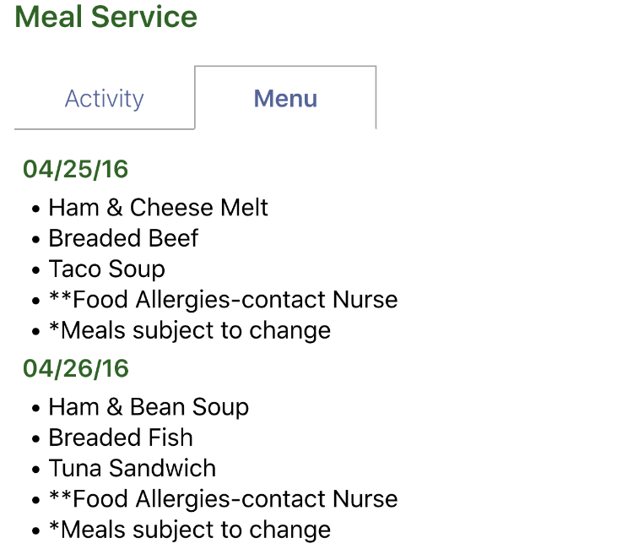
The Menu tab shows what will be served for school lunch in the cafeteria for the next 30 calendar days.

Online Payment
Note: you may need to edit this text if you only allow payments for either Fees & Billing or Meal Service. This text and the accompanying screenshots assume you use both. You can pay fees owed and deposit money into student meal service accounts by using the Online Payment screen. The Online Payment process has three steps, as shown in the following screenshots.
- Enter the amounts you want to pay on each line. All students display together so that one payment can cover all of the students in your family. Select Proceed to Verification.
- Verify that the payment details and total are correct. If not, select Edit Payment. If you’re ready, select Proceed to PayPal.
- Use a credit or debit card, or log into PayPal to complete the payment. No money will be credited to students until the payment is completed. This page is provided by the PayPal website. Tyler SIS Student 360 does not store your card or PayPal account details.
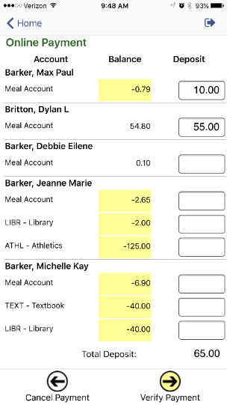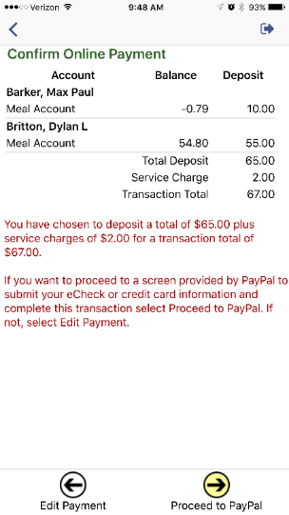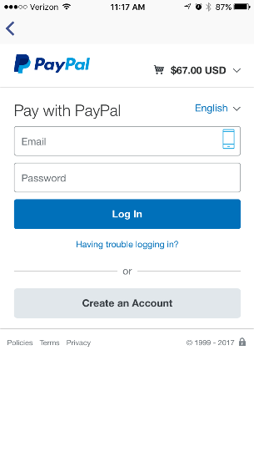

Student Details
The Student Details screen shows contact and personal information about the student. This screen shows the student’s enrollment status and birthdate at the top. All The remainder of this screen is split into four sections:
- Current Location – the course and room number where the student is currently (during the school day)
- Contacts – Household Parents – the contacts that live at the student’s mailing address
- Contacts – Additional – the nonresident parents
- Contacts – Emergency – the emergency contact information for the student
Note that Household and Additional contacts will only display if you are a contact of that type.

Transportation
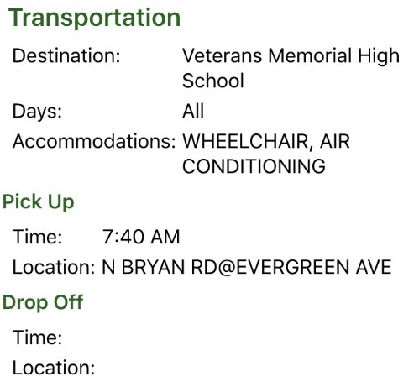
The transportation screen works with Tyler’s Versatrans RP transportation system to display pick-up and drop-off times, locations, and route numbers. If the student rides multiple buses on different days of the week, that information will display as multiple records. If your district is not using Tyler Versatrans, remove this section from the document.

User Preferences
User preferences vary depending on the logged-in user type and the options enabled by the district. Not all options may be available. This section may require heavy editing depending on your district.
All options are saved automatically when pressing the Back button (Android) or using the back icon (iOS). To cancel changes, press the  icon at the top of the screen.

Change Password
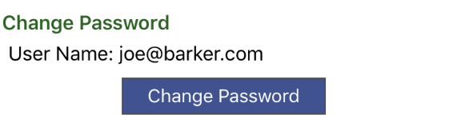
You can change your password by tapping the Change Password button.
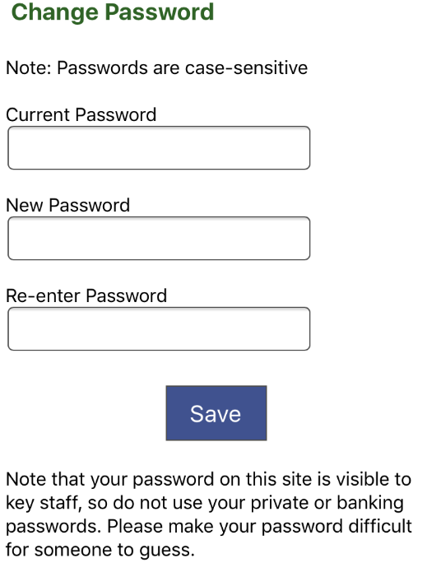
On the next screen, any password complexity rules that are in place will display. You will need to enter your current password and type your new password twice to make sure it’s correct. Press Save to save the password. Note that your password on Student 360 is visible to key staff, so do not use your private or banking passwords. Please make your password difficult for someone to guess.

Email Notification Settings
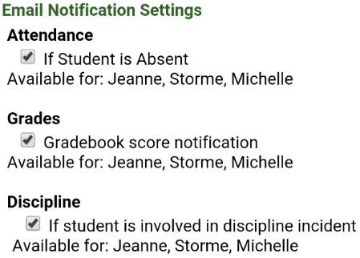
Email notifications are sent daily or weekly, depending on the option set for Parent Notification on the Automated Export screen. You can receive email notifications for Attendance, Grades, and Discipline. These options may vary between schools. The students who could potentially have a notification are listed with each option.

Phone Notification Settings
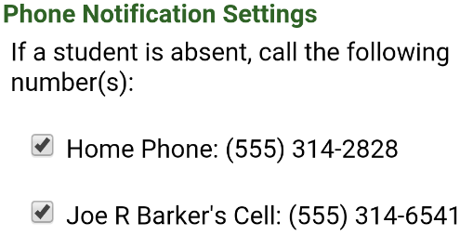
Phone Notifications Settings are only available if your district is using SchoolMessenger and you have turned on the option to allow parents to choose which phone numbers to call in the Parent Portal Configuration screen. Up to two home phone numbers and two parent cell phone numbers can receive automated phone messages from the district. Check the box for the displayed phone numbers if you want to receive broadcasted voice notifications at that number.

Version and Log Out
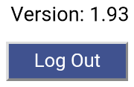
To make sure you’re running the most recent version of Student 360 from Google Play (Android) or iTunes (Apple) compare the version number listed to what is on the app store.
If you want to log out of Student 360, press the Log Out button at the bottom of the screen.

