Backing up your Favorite’s:
Open Internet Explorer and select File then click Import and Export:


Select to export a file:
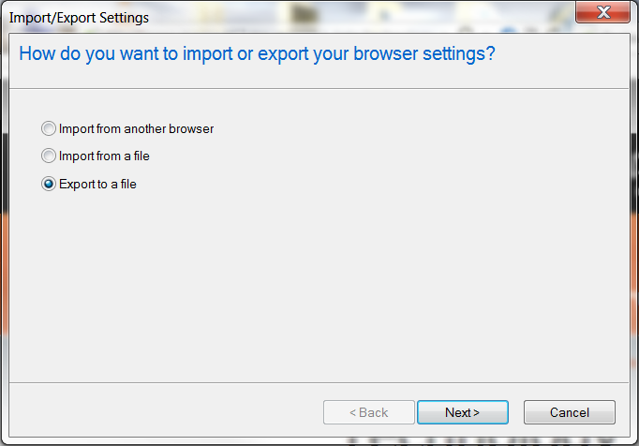

Select to export Favorites:
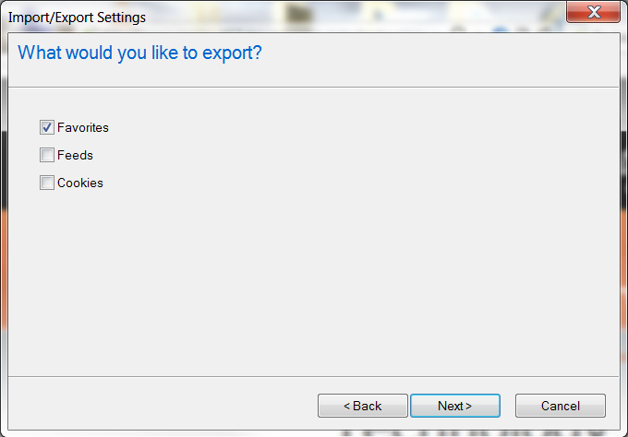
Make sure that favorites are selected in the next pop up window. This will save all of your
Favorites:
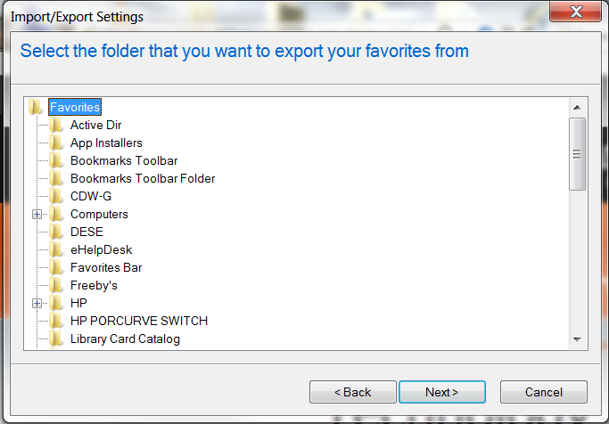

Use the Browse button to select where you want to save your book marks to: You will want
to save the file to your H:\ Drive. The default filename is bookmark.htm you can rename it to something you will remember or save as the default. The select next:
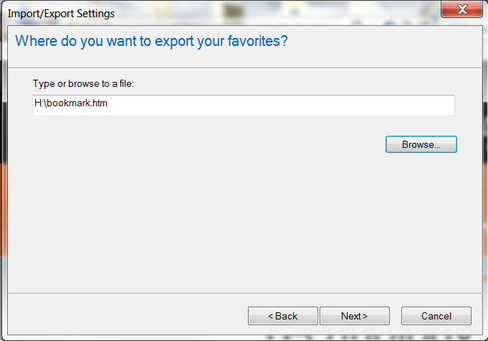
This window pops up and you have finished backing up your favorites.
Click finished:

