Quarterly Grade Reporting Information
1. The first step to access your child’s quarterly reporting information (“Report Cards”) is to log into the PowerSchool Parent Portal.
2. Once in the portal, click on “Grade History” on the left menu panel.
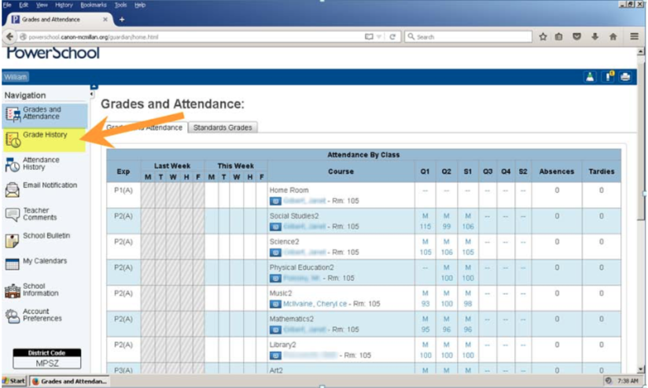
3. To access your child’s performance in a particular class that contributed to the final grade, simply click on his/her grade in the class. This will allow you to see all the assignments, tests, etc. that made up this particular grade.
4. To access the standards associated with each grade, choose the Standard Grades Tab and Expand All.

