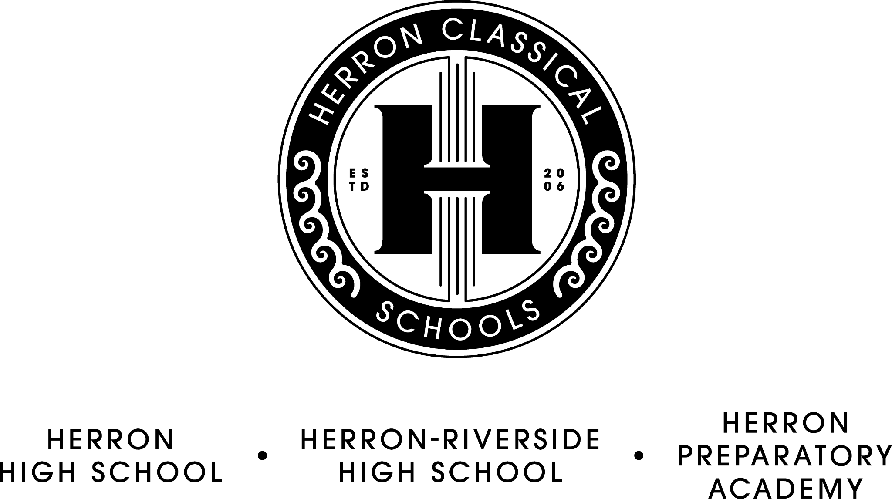

Herron Classical Schools Board Meeting Agenda
December 13, 7:30am
HRHS Lyceum

Agenda

Breakfast and Meet and Greet Cody Whitesell, new Head of School, HPA

- Call meeting to order (Roy)

- Approve minutes (Sullivan)

- Executive Committee report (Roy)
- Facilities update
- Risk Assessment and Safety Protocol Policy

- Treasurer’s report/Fiduciary Committee report (Miller)
- Financials
- Vouchers

- Development Committee report (Sternberg)
- Department updates

- Education Committee Report (Roy)
- 2023 Enrollment update
- Spring state testing academic supports
- Site Visit/evaluations
7). President’s Report (McNeal)
- Dr. Cooney’s upcoming retirement and new hire
- IPS referendum

Adjourn

The next board meeting will be February 21st, 7:30 AM

