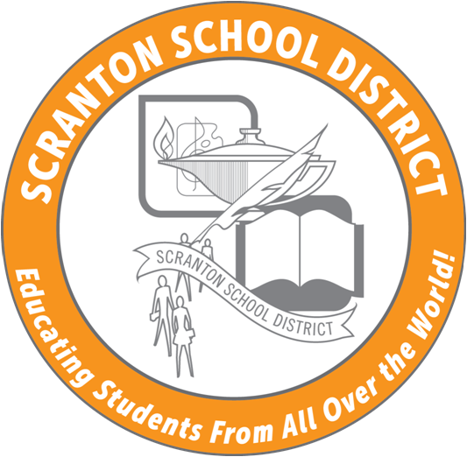

425 North Washington Avenue
Scranton, Pennsylvania 18503

SCRANTON SCHOOL DISTRICT
Educating Students From All Over The World

SAFETY COMMITTEE MEETING
ZOOM SESSION
Tuesday, March 23, 2021
3 PM-4 PM

AGENDA
- Welcome
- Google Form for Today's attendance/pay/ACT 48(only 7 as of 3/15)
- Minutes (January)
- Annual workplace safety training webinar
  - Certifications:
    - M. Abdalla
    - G. Bennington
    - M. Cosgrove
    - R. Davis
    - B. Gentilezza
    - C. Horne
    - L. Hubshman
    - P. Lukasiewicz
    - L. McConlogue
    - M. Montoro
    - A. Musto
    - T. Natale
    - M. Noldy
    - J. Sinclair
    - N. Valenzano
    - S. Volpe
- Building Inspections
  - Whittier (2)
  - Sumner
  - Prescott
  - Bancroft
  - ITE
  - JFK
  - Morris
- SSD Capital Improvement Requests
- Vaccination update
- Report from Mr. Pugliese
  - PK-2 return-3/29
  - Grades 3-8-4/12
  - Grades 10-12-4/19
- KEEPING KIDS SAFE: Raising our Awareness Virtual Seminar
  - Keynote Speaker: Dr. Lina Alathari, Chief, U.S. Secret Service National Threat Assessment Center (NTAC), DATE: Thursday, April 15, 2021, TIME: 10:00 a.m. – 11:00 a.m. Registration link:
file:///C:/Users/rgentilezza/Downloads/KeepKidsSafeInvite_031221%20(2).pdf
Dr. Alathari will highlight relevant past incidents and include findings and recommendations from the National Threat Assessment Center's latest research publications on targeted school violence and averted school attacks at K-12 schools in the United States. It will also focus on how communities can use a multidisciplinary approach to identify, assess, and intervene with students exhibiting concerning or threatening behaviors as early as possible. Dr. Alathari will discuss the two NTAC publications: Protecting America’s Schools, The US Secret Service Analysis of Targeted School Violence and Enhancing School Safety Using A Threat Assessment Model.
This virtual one-hour event is a precursor to a full day conference continuing the discussion for Keeping Kids Safe: Raising our Awareness - Threat Assessment, School Safety and Work Climate, which will be held on Tuesday, October 19, 2021, at the DoubleTree in Reading.
- 2021 School Safety and Security Preparedness Survey
- New Business
- Next Meeting Tuesday, April 27, 2021-3 PM-Invite will be sent including NEIU link for ACT 48 credit-1 hour
Tentative 2020-21 SY monthly meeting dates-3:30 PM start-Ad Building or ZOOM.
    - May 25, 2021
    - 2021 Summer dates-10 AM-ZOOM-4th Tuesday of the month
      - June 22, 2021
      - July 27, 2021
      - August 24. 2021

Links for 2020-21 SY meetings
2020-21 SAFETY IN-SERVICE LINKS

SSD - Safety Committee Meeting (4/27/2020)
https://www.edulinkinc.com/iu19registration/Default.aspx?tabid=1&mid=349&ctl=CourseDetails&csid=21630&courseName=(4/27/2021)&Semester=&CourseType=0&StartDate=&EndDate=&CORW=H-Registration deadline (4/23/2021)

SSD - Safety Committee Meeting (5/25/2021)
https://www.edulinkinc.com/iu19registration/Default.aspx?tabid=1&mid=349&ctl=CourseDetails&csid=21631&courseName=(5/25/2021)&Semester=&CourseType=0&StartDate=&EndDate=&CORW=H-Registration deadline (5/21/2021)

SSD – Safety Committee Meeting (6/22/2021)
https://www.edulinkinc.com/IU19REGISTRATION/Default.aspx?tabid=1&mid=349&ctl=CourseDetails&csid=24905&courseName=(6/22/2021)&Semester=&CourseType=0&StartDate=&EndDate=&CORW=HRegistration closes 6/18/2021

SSD – Safety Committee Meeting (7/27/2021)
https://www.edulinkinc.com/IU19REGISTRATION/Default.aspx?tabid=1&mid=349&ctl=CourseDetails&csid=24906&courseName=(7/27/2021)&Semester=&CourseType=0&StartDate=&EndDate=&CORW=HRegistration closes 7/18/2021

SSD – Safety Committee Meeting (8/24/2021)
https://www.edulinkinc.com/IU19REGISTRATION/Default.aspx?tabid=1&mid=349&ctl=CourseDetails&csid=24907&courseName=(8/24/2021)&Semester=&CourseType=0&StartDate=&EndDate=&CORW=HRegistration closes 8/20/2021

