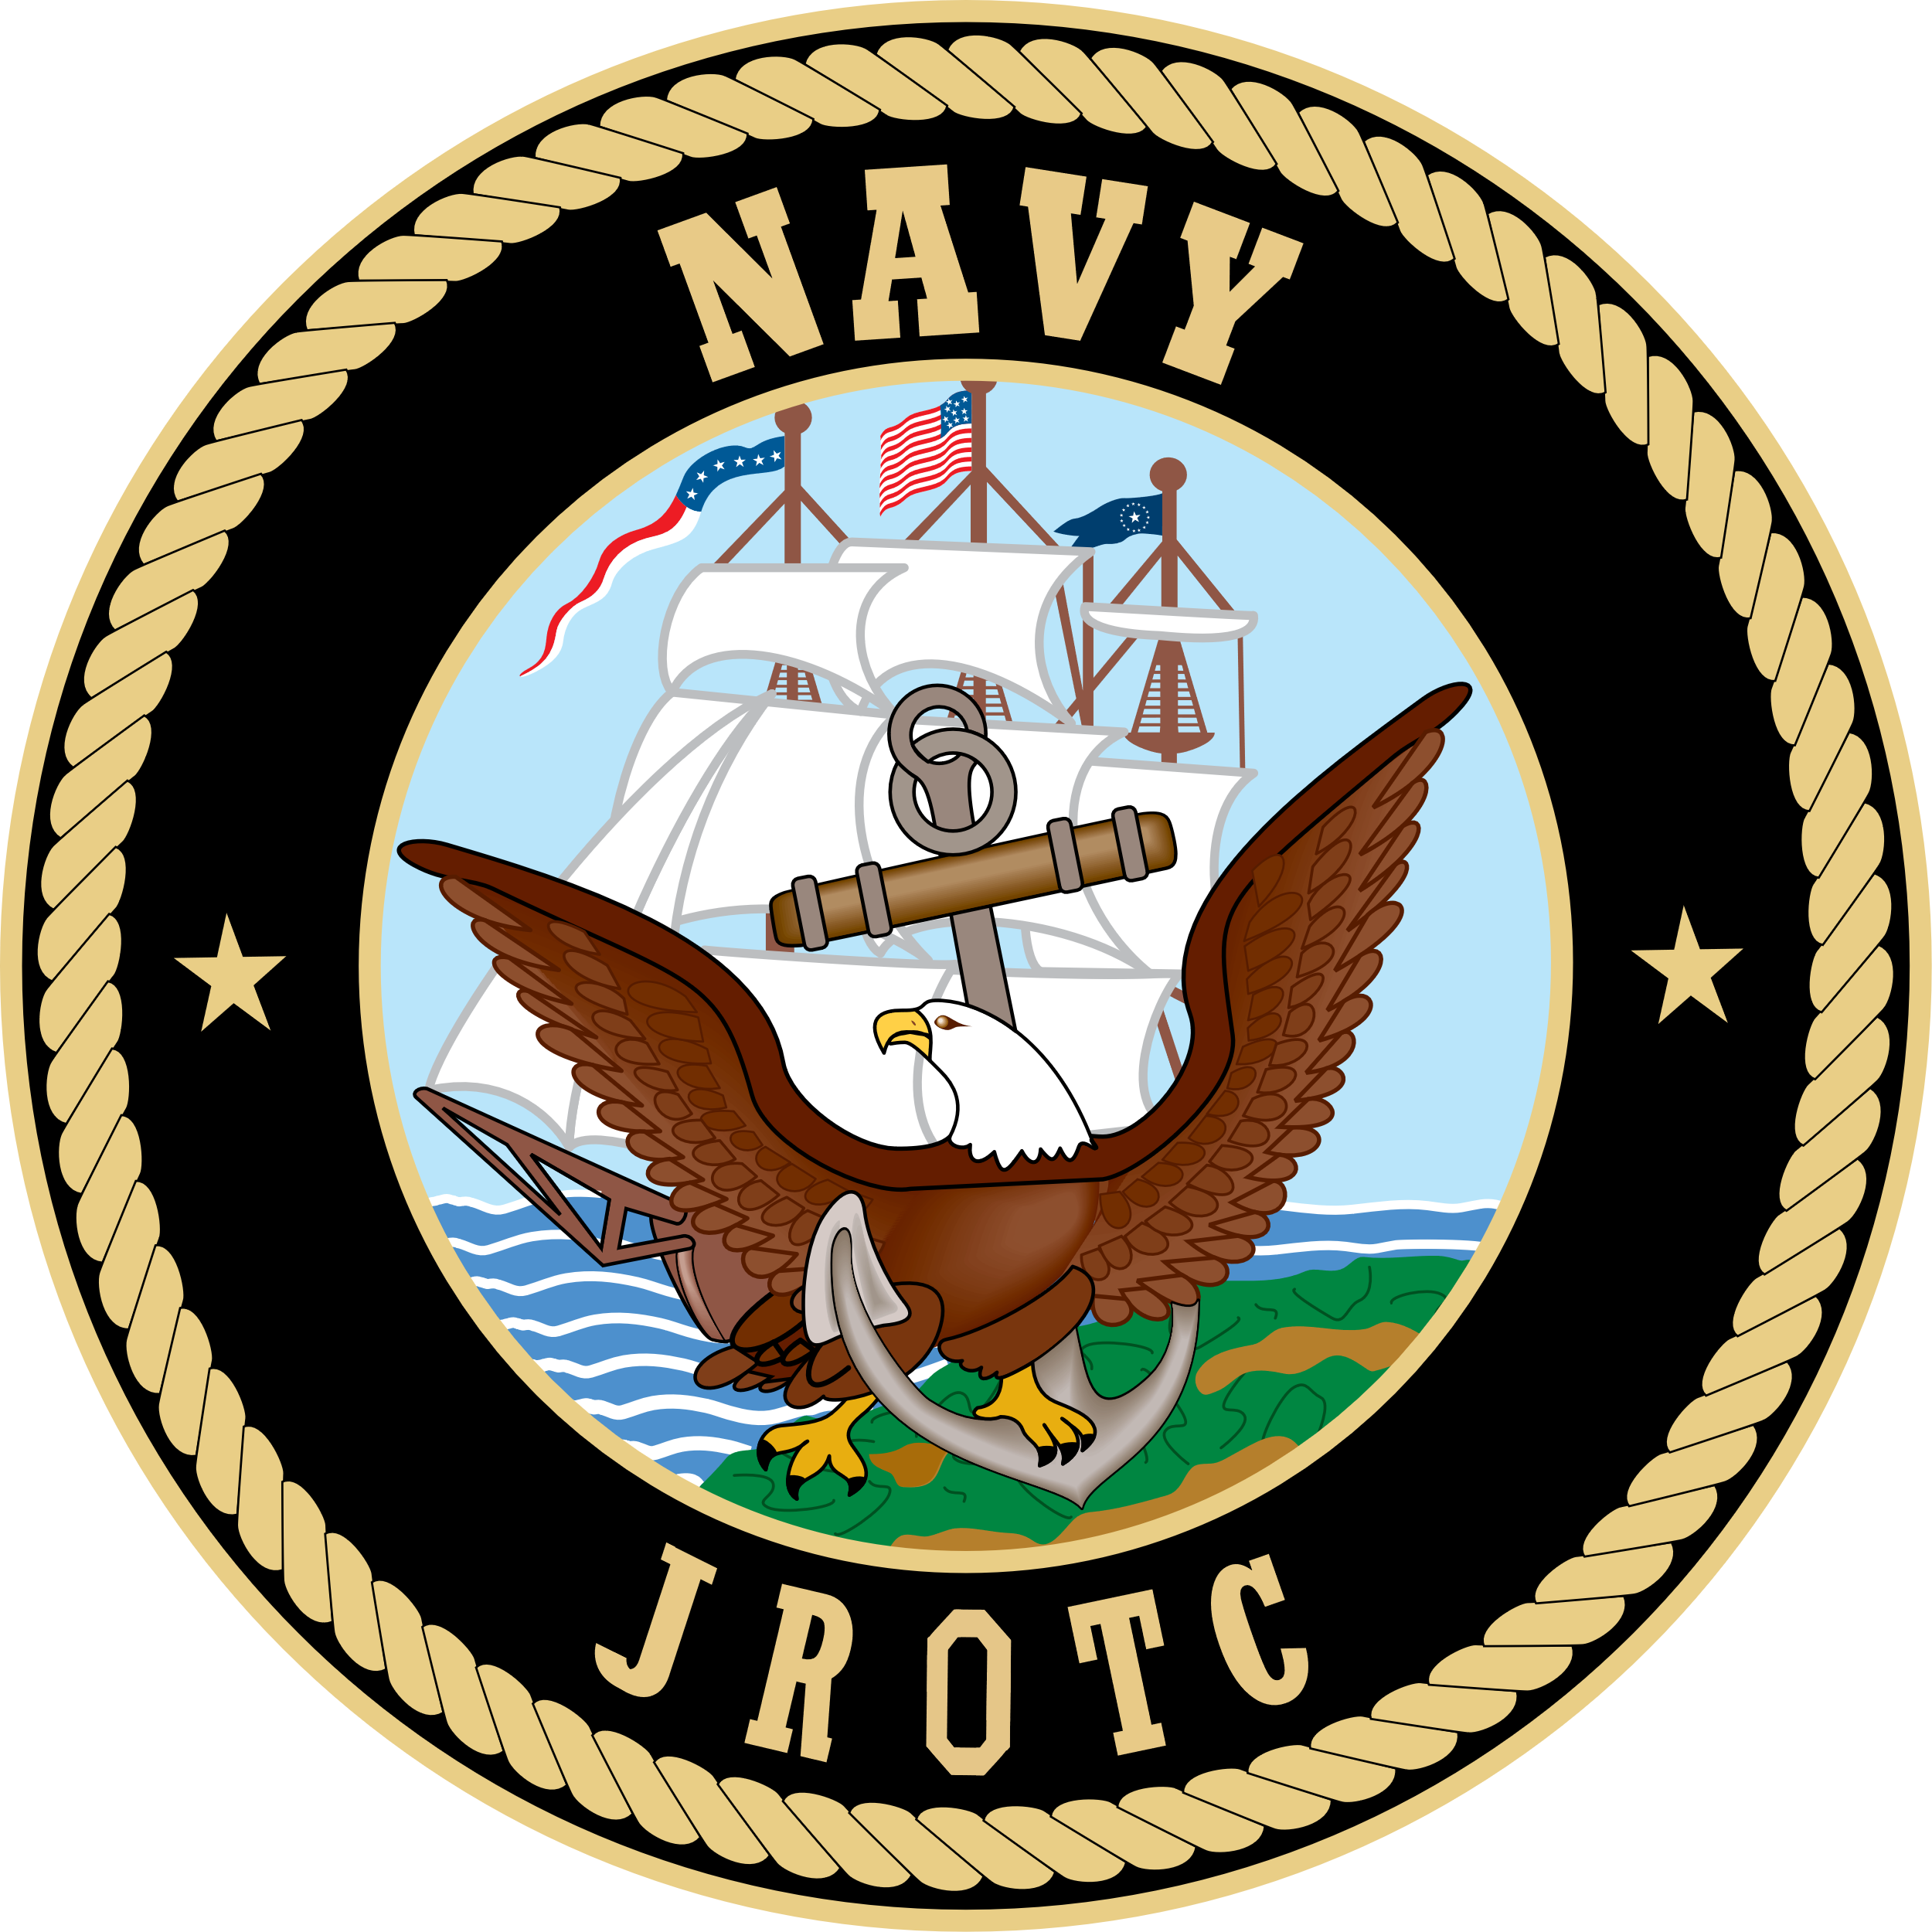

Meeting Minutes
Parents Association Meeting
Tuesday, April 19, 2022

In Attendance:
- In Person: Oscar and Deb Guttormsen, Cari Gavin, Captain Picker, Senior Chief Beck, Wicus and Michelle McGuffey, Brent and Meghan Maggard, Kelly Sanders, Clay Rife, Makayla and Joe DeScala, Melissa and Devin McBride, Craig Fulton, Heather Ghrist, Christina Matson, Luke Gavin, Angie Raycraft, Catherine Copass
Meeting Called to Order at 1804
Minutes from March 15 meeting were emailed to Board for approval after last meeting
New Business
Parent Volunteer Opportunities
- Senior Chief reviewed needs for events below. Sign ups are available on Signup Genius through the link on the ROTC page of the HS website
  - Navy Ball Set Up – Saturday May 14 at the Elks
  - Field Trip to Museum of Flight – Friday May 20 all day. Will need 3 chaperones
    - If cadet has F on day of trip – not eligible to attend
    - Bus paid for by CTE
    - Cafeteria on site, will add snacks to Signup Genius
    - Captain motioned for Parent Group to pay $7/cadet to attend and Deb Guttormson seconded. All were in favor except 1 opposed. Motion carried
  - NJROTC Family Picnic – Saturday June 4
    - Senior Prom is same day, all Seniors know of this and are OK with date. Cadets preferred Lincoln Park instead of Salt Creek so location has been changed to Lincoln Park
Nominations for Board Officers for 2022/2023 Academic Year
- Vice President Wicus McGuffey and Secretary Cari Gavin will be leaving as they has Seniors
- All positions are open as Oscar and Deb Guttormson will do whatever
- Terms are one year; no term limits
  - President, Vice President, Secretary, Treasurer
  - Nominations are open until May 17 meeting. Can nominate yourself at this meeting (none) or by email to Oz Guttormson. Voting will occur at the May meeting. Contact Oz for any questions
Unit Status Update
- Received official letter today that Navy will NOT continue program
- It is up to school district to continue with Cadet Program
  - Parent proposed getting in touch with or attending School Board Meeting to advocate for program.
- Navy will only give curriculum/books
- Senior Chief has been squirlling away uniforms, etc in anticipation of this
- Will need lots of fundraising as Navy subsidized many things
  - Nationals of which we had cadets attend
  - Uniforms
  - Dry cleaning/alterations
  - 50% of salaries
- Discussed cost of uniforms, etc
- Inventory was brought up. This is a school issue, not Parent Assoc
- Captain and Senior Chief will not be returning next year. Both have accepted jobs elsewhere
- Hope district will get job posting up quickly
- Will hopefully know more by May meeting
Financial Report
- Deb reviewed our financials
- Letter writing campaign and Air Rifle Postal brought in a fair amount
- Expenses have been light the last couple of years due to COVID
- We are approximately $4000 ahead compared to this time last year
- Savings account which was opened last year still have $10,000. Haven’t touched it
- Won’t have as many teams next year so those expenses will be less
- Current budget is available to be emailed if requested
Scholarship Committee
- Committee met and had no problem coming up with candidates
- Able to decide easily on 3 awards but there was a tie for the 4th award (George HW Bush Scholarship for Outstanding Service)
- Much discussion for and against giving a 2nd George HW Bush award for this year only
- There was an unclaimed scholarship from last year, must use with in 6 months of being awarded
- Each is for $750
- Metrics for award were discussed
- Wicus McGuffey motioned for a 2nd award to be given for this year only, Brent Maggard seconded and motion was passed with all approved except 1 opposed
Next meeting set for Tuesday, May 17, 2022 at 1800
Minutes and financials from this meeting will be emailed to Board for approval
Meeting adjourned at 1902

