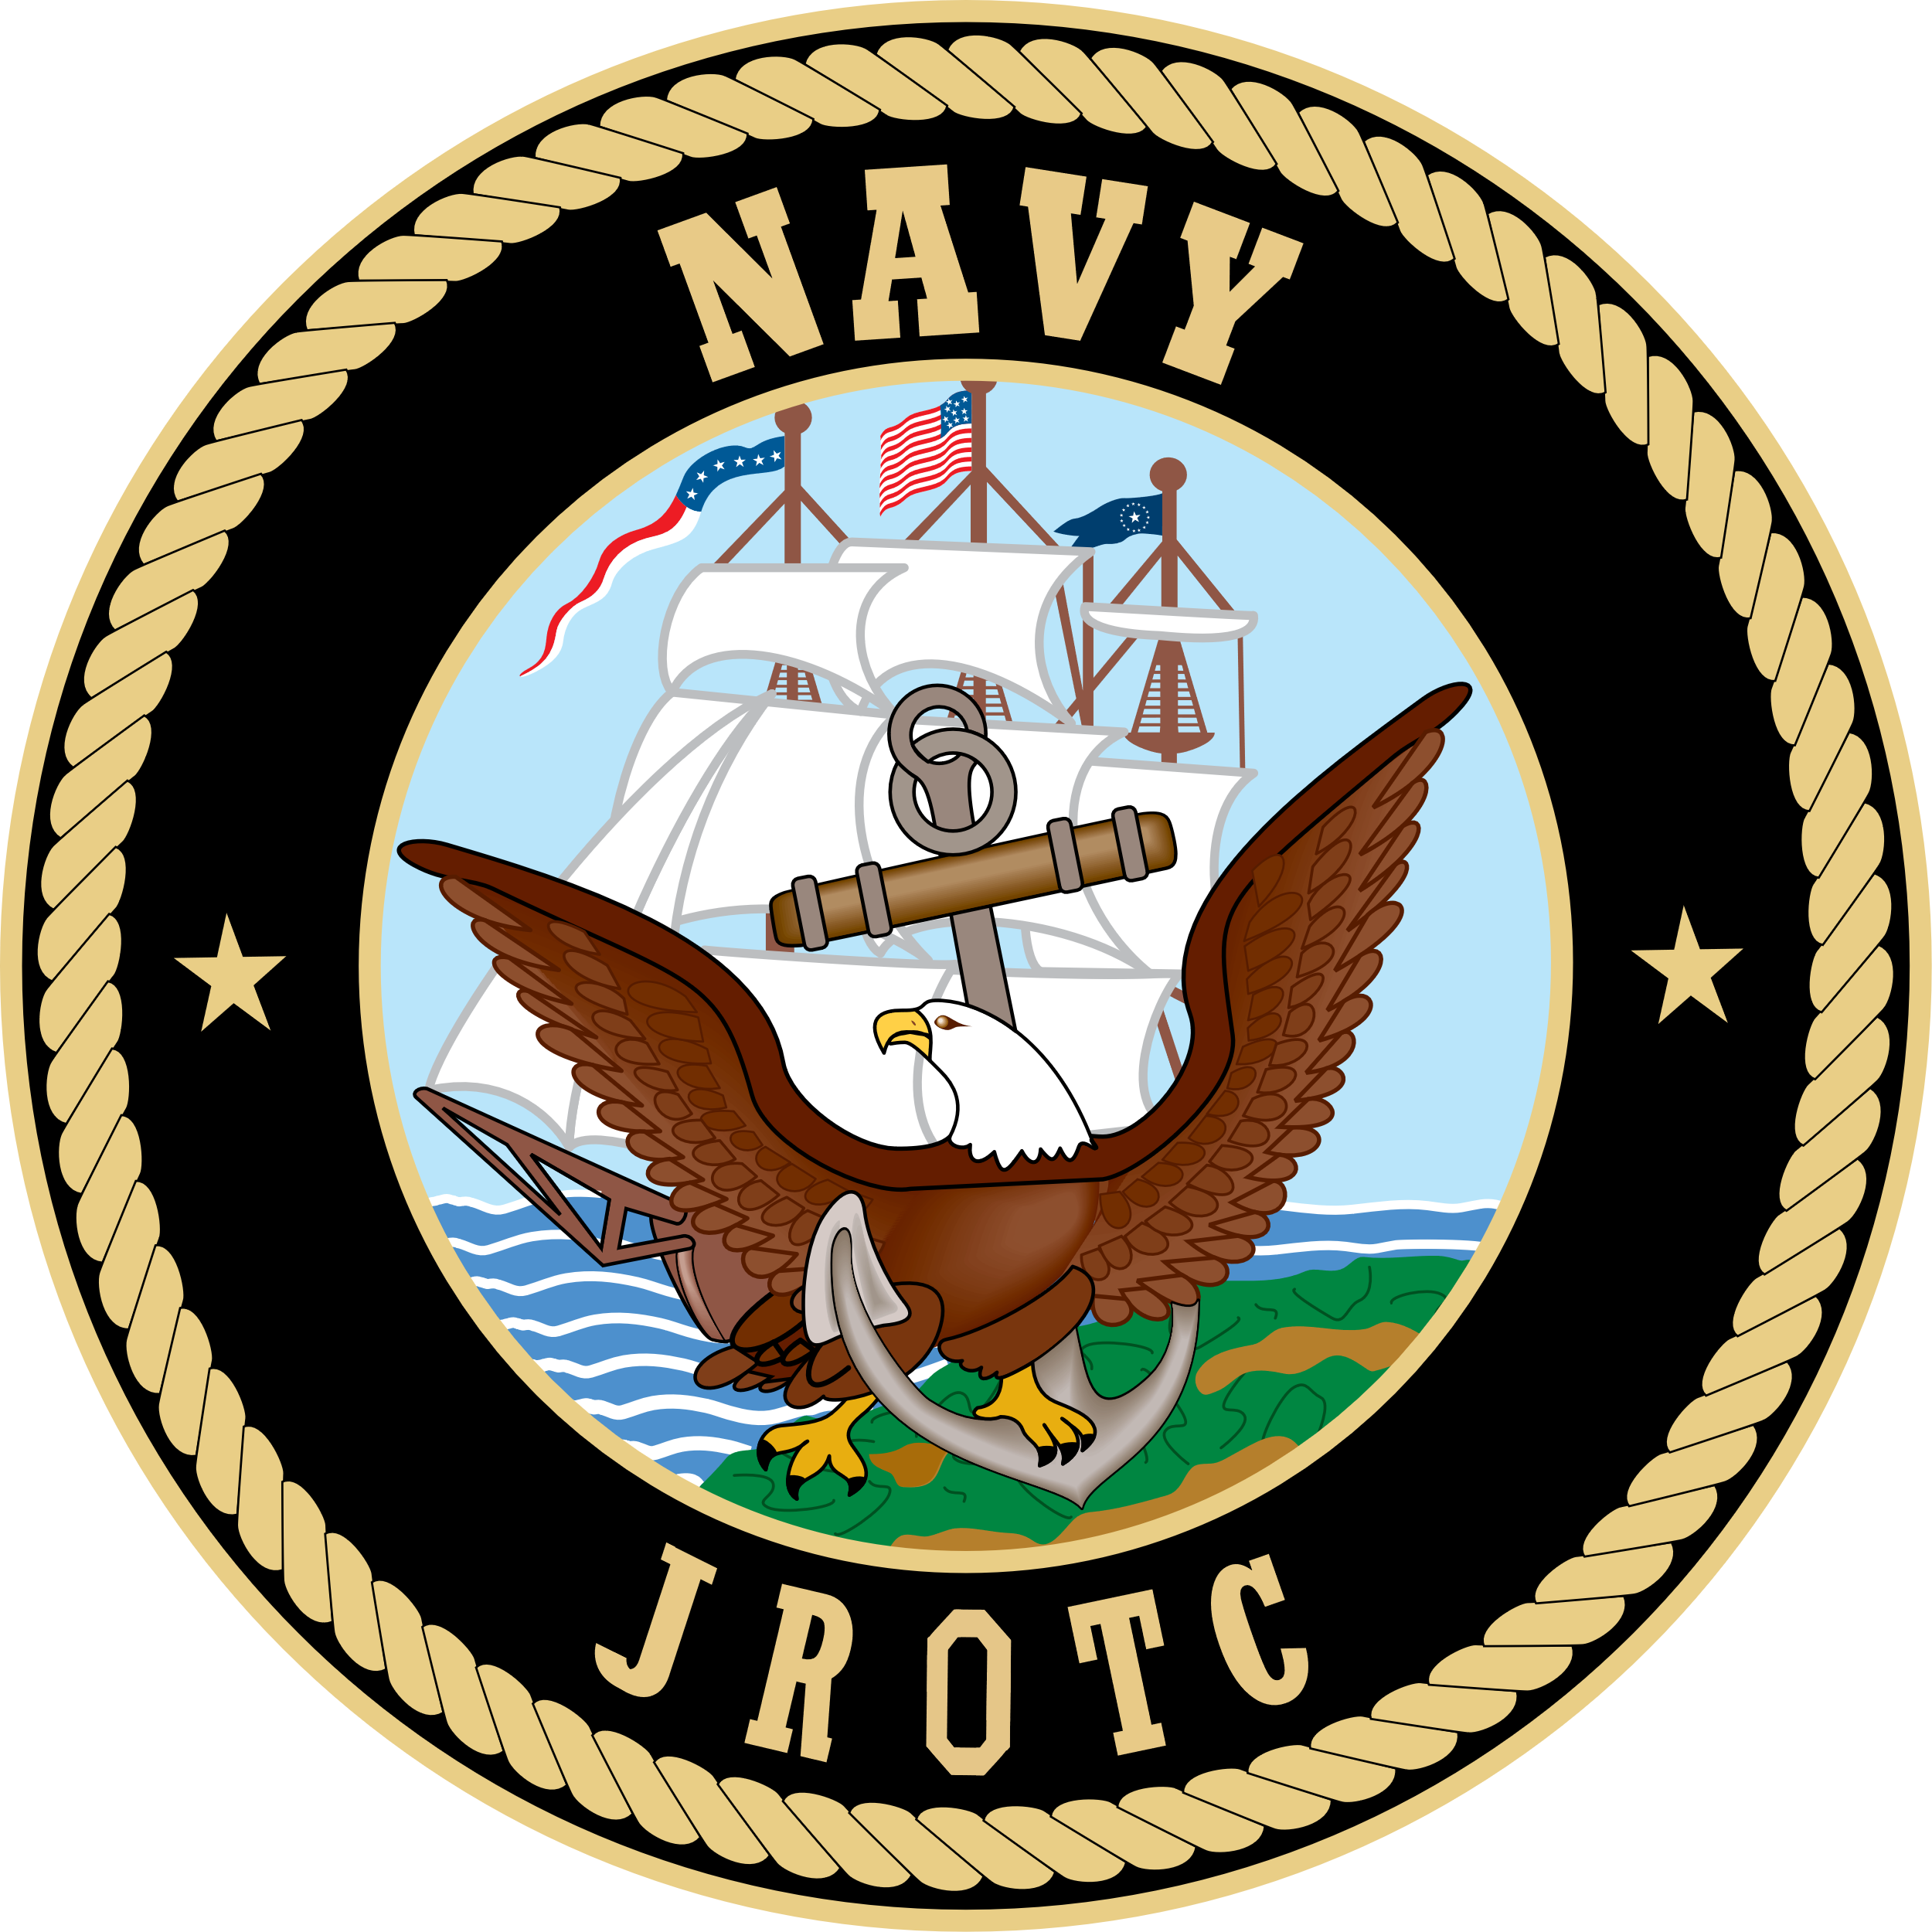

Meeting Minutes
Parents Association Meeting
Tuesday, Nov 9, 2021

In Attendance: Oscar Guttormsen, Deborah Guttormsen, Cari Gavin, Captain Jonathon Picker, Senior Chief Justin Beck, Angela Raycraft, Elrick Matson, George Thompson, Mr and Mrs Craig Fulton
Meeting Called to Order at 1801
Minutes unavailable to review from last meeting. Deborah to get notes to Cari so can be posted
Old Business
- BLT
  - Will be held this Saturday, Nov 13, one day only
  - Lunch will be 1030-1100 and dinner 1630-1730
  - Parent group will provide sack lunches
    - Alyona Guttormsen solicited donations from Grocery Outlet and has put together 55 sack lunches, was decided to make a total of 60
    - Items includes bottle of water, protein pack, granola bar, and other snacks
    - Guttormsens will make and provide sandwiches
    - Will need someone to pick up from their house Saturday morning
  - Dinner
    - Senior Chief will order 15-16 pizzas from Dominoes in the am
    - Elrick Matson volunteered to pick up at 1600
  - Will 2 parents at each meal to help handout/serve
  - Fultons volunteered to bring paper plates/napkins
  - Senior Chief will put together SignUpGenius for volunteers
  - Awards Ceremony at 1900 in main gym
  - Cadets to have paperwork for BLT handed in by tomorrow, Nov 10
Financial Report
- See attached report from Deborah
- As of Oct 31
  - ~$4000 operating
  - $10,110 savings
  - Total just over $14,000
  - Down $2000 from this time last year
  - Promote generating income
Letter Writing Campagne
- Letter soliciting donations to NJROTC Roughrider Company
- Cadets provide addresses
  - 5 or > addresses = 1 community service hour
- Usually generates about $4000-$6000
Wreaths Across America
- Anita (last year’s president) organizing this
- Unable to sell at Swains
- Website on HS website under NJROTC, also on Facebook page
Volunteer Income
- Swains – help offload Christmas trees
  - Will receive donation from Swains
- Crabfest
  - Received $1000 for volunteer work
- Big Hurt
  - Received $350 for volunteer work
New Business
- Look at changing meeting 2nd Tuesday of the month as VP Wicus McGuffey has conflict
- Poll will be sent to all to determine best night – Oscar or Senior Chief to send out
- Follow up with results
- Try to resolve before next meeting
Dec 4 Comp
- No chaperones needed as only 1 day comp, no overnight involved
- Check with cadets to see which parents going so can maybe help provide food as no food available at com site
- Possibly set up table at ?parking lot with food
- About 28 cadets go
Thanksgiving Baskets
- Each class will provide items for baskets so a family may have a nice dinner
- About 4-5 baskets total
- Have food in by Nov 22
- Will draw names for baskets and they may take or pass on to next family
AMI
- Big inspection for unit
- Happening Dec 3
- Inspects cadets
- CO Gavin will spend most of day with them
- Checks out the program
- Happens every other year
- It’s how unit has won Unit Achievement and Distinguished Unit awards
Next Meeting
- Dec 14 at 1800 unless decided to change after the poll
Meeting Adjourned at 1830 by Deborah Guttormsen and seconded by Cari Gavin

