Hilton Head Island Middle School
School Improvement Council
Report to the Parents
April 2022
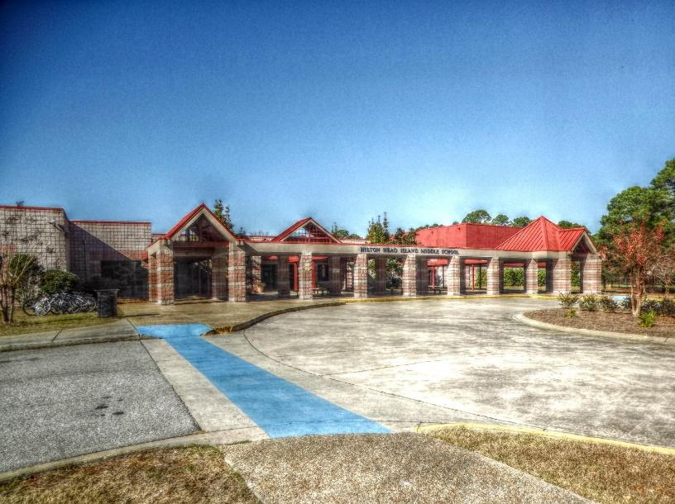
Dr. Chad Cox, Interim Principal
Ms. Angela Bellantone, Assistant Principal
Ms. Maelda Chalk, Assistant Principal
Mr. Brantley Wilson, Assistant Principal

Hilton Head Island Middle School
55 Wilborn Road
Hilton Head Island, SC 29926
843-689-4500 (phone)
843-689-4624 (fax)

https://hhims.beaufortschools.net/
Beaufort County School District
http://beaufortschools.net/

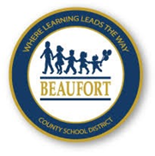

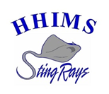

HILTON HEAD ISLAND MIDDLE SCHOOL
VISION AND MISSION STATEMENT
VISION STATEMENT
We envision the Hilton Head Island Middle School community working together to build a culture that supports diversity in a safe, nurturing, and engaging environment.

MISSION STATEMENT
The mission of Hilton Head Island Middle School is to provide challenging curricula with high expectations for learning that develop productive citizens who can solve problems and contribute to a global society.

CORE
The vision and mission of Hilton Head Island Middle School makes it imperative to implement the following objectives:

- To provide a safe environment.
- To provide academic excellence by incorporating researched-based effective practices and rigorous programs.
- Through high expectations, develop in each student the ability to think, be responsible, respectful, and honest in order to positively impact academic achievement.
- To encourage stewardship of the environment.
- To stimulate each student’s creativity and problem-solving ability.
- To encourage students to respect the attitudes, values, and culture of others as well as their own.
- To provide students with experiences that promote meaningful relationships, and the development of social problem-solving skills.
- To develop a positive self-image and self-efficacy in students by providing them with individual acceptance, encouragement, and recognition when appropriate.

SCHOOL RENEWAL PLAN GOALS

GOAL 1: By 2021-2022, we will reduce the percentage of students in gap populations scoring 'not met' on SC Ready, including the following groups:

African-American students will reduce the percentage of students not meeting standards from 49.33% to 47.33% in ELA and from 59.47% to 57.47% in math;
Limited English Proficiency students will reduce the percentage not meeting standards from 35% to 33% in ELA and from 46.47 to 44.47 in math.
Students with disabilities will reduce the percentage not meeting standards from 75.8% to 73.8% in ELA and from 76.7% to 74.7% in math.

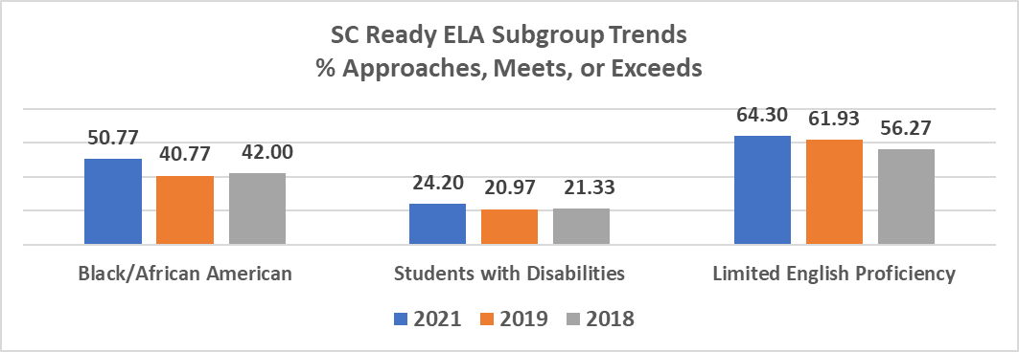

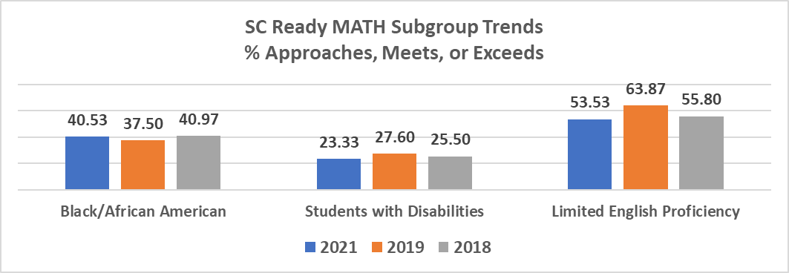

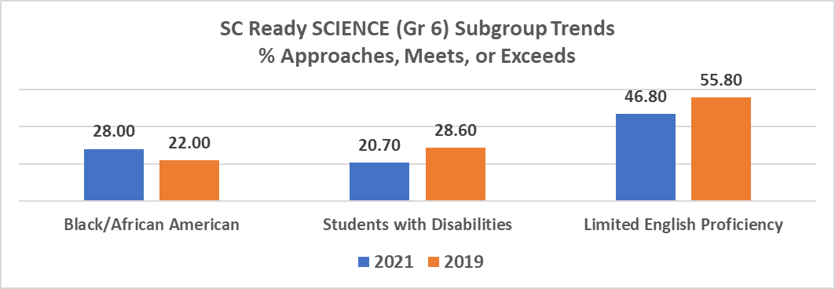

GOAL 2: Teacher/Administrator Quality – By 2021-2022, 65% of teachers will include a lesson framework that includes an opener, mini-lesson, gradual release practice, and closure as measured by administrator weekly walk-throughs.

GOAL 3: School Climate – By 2021-2022, we will increase the percent of students satisfied with the learning environment from 49.4% to 60%.

SCHOOL IMPROVEMENT COUNCIL GOALS AND ACHIEVEMENTS
GOAL 1: Continuing to operate, stock and bring awareness to the HHIMS SIC’s Main Initiative -The Stingray Support Circle.
Achievements: Through the end of April 2022, the Circle logged over 225 student visits for clothes, school supplies, food items and toiletries. The SIC held a holiday gift bag distribution where over 100 gift bags were distributed to identified students. Free Stingray hoodies were also supplied to students in need. We increased awareness of the Circle in the community and received both monetary and kind donations to the Circle as a result of increased awareness.

GOAL 2: Communicating with HHIMS families/community
Achievements: We continue to communicate with families and the community through our Facebook page. The updates provided information about meetings, programs, volunteer opportunities and encourage involvement.

GOAL 3: Supporting Teachers and Staff
Achievements: We increased awareness of the Stingray Support Circle among HHIMS Staff; we continued the “Teacher’s Corner” at SIC meetings, so that elected reps felt free to share with the Board any concerns or questions from the HHIMS teaching staff; the SIC secured a volunteer to donate a pizza party to all students that met or exceeded their MAP testing goals allowing teachers to use this as a motivational tool, the SIC established an Adopt a Classroom Program and is matching donors with teachers ensuring that all needs and wants of the teachers for supplies and projects are met.

GOAL 4: Increase community and local business support of HHIMS
Achievements: We launched the Mentoring the Middle Program in the 8th grade class. The program invites professionals from the community into the classroom to inspire the students in their middle school learning. The professionals were educated about HHIMS and the students had an interactive experience showing the importance of middle school education. The program strengthened partnerships, increased awareness of HHIMS and SIC and helped build community. The goal is to expand the program into all classes in the next school year.

POSITIVE BEHAVIORAL INTERVENTIONS & SUPPORTS (PBIS)
PBIS is an approach for assisting school personnel in adopting and organizing evidence-based behavioral interventions. The approach enhances academic and social behavior for all students. PBIS is not a packaged curriculum or scripted intervention. PBIS is a prevention-oriented way for school personnel to (a) organize evidence-based practices, (b) improve their implementation of those practices, and (c) maximize academic and social behavior outcomes for all students. At HHIMS, effective classroom management and preventive school-wide discipline are essential for supporting teaching and learning. PBIS emphasizes that effective classroom management and school-wide discipline must be integrated and working together with effective academic instruction in a positive and safe school climate to maximize success for all students.

INTERNATIONAL BACCALAUREATE MIDDLE YEARS PROGRAMME
Hilton Head Island Middle School is an IB World School and implements the Middle Years Programme instructional framework.

The MYP includes 8 subjects: Language & Literature, Language Acquisition (world language), Mathematics, Sciences, Individuals & Societies (Social Studies), Design (career & technical education), Arts (visual & performing), and Health & Physical Education.

In each of these subjects, inquiry-based instructional units are developed. The IB framework emphasizes conceptual learning and seeks to help students make connections between local issues and global concerns. In addition, interdisciplinary connections are made to make learning relevant and meaningful to students.

Authentic assessment takes place, in addition to traditional assessment, and students are expected to demonstrate learning and understanding in ways that go beyond multiple-choice tests. Projects, presentations, and collaborative activities are part of each instructional unit.

Community Service is a component of an IB student, and each grade level develops service projects that align with lines of inquiry and state standards. All students are able to participate in these activities.

Character education is also a major component of the MYP and the IB focuses on 8 traits – called the Learner Profile, with the aim of developing learners who are knowledgeable, thinkers, communicators, principled, open-minded, caring, risk-takers, balanced, and reflective. IB learners are expected to be scholars who take action to make the world a better place!
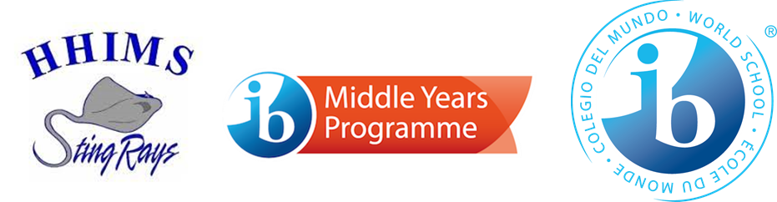

Building Enrollment and Capacity
Capacity |  |  | 2021-2022  Enrollment | % Capacity Usage
1006 |  |  | 831 | 82.60%
2021-2022 Demographics
% White | % Hispanic or Latino | % African American |  | % Asian/Pacific Islander/Am.Indian | % of 2 or more races | % Subsidized Meals
33.80 | 47.60% | 14.00% |  | 1.30% | 3.30% | 60.19

Hilton Head Island Middle School students participate in both norm-referenced (MAP) and criterion-referenced (SC Ready and PASS) testing. Parents have access to our school report card from the South Carolina Department of Education which references our standardized test results. Parents receive their student’s individual test profile which provides a detailed analysis of student Map score data.

Math
Grade | 2021 Fall  Mean Score | 2022 Spring  Mean Score | Fall – Spring Change
6TH GRADE | 213.7 | 219.2 | +5.5
7TH GRADE | 218.0 | 223.4 | +4.5
8TH GRADE | 223.7 | 228.2 | +4.5
Reading
Grade | 2021 Fall  Mean Score | 2022 Spring Mean Score | Fall – Spring Change
6TH GRADE | 208.2 | 214.3 | +6.1
7TH GRADE | 211.6 | 216.0 | +4.4
8TH GRADE | 215.3 | 220.7 | +5.4

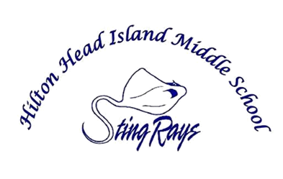

- Student Performance Data

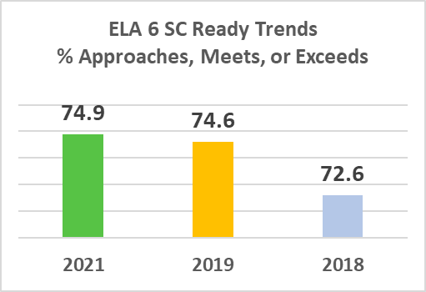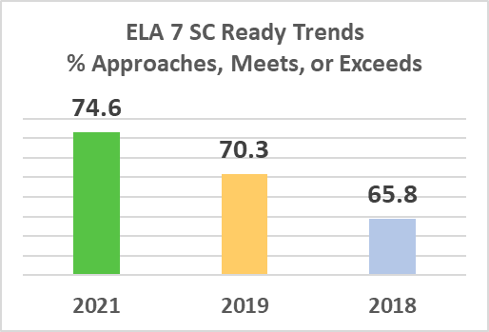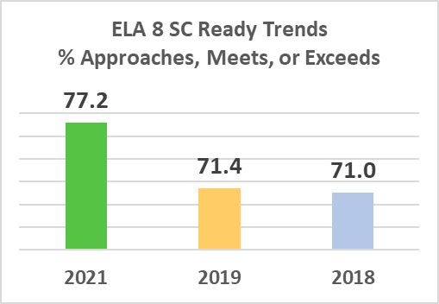

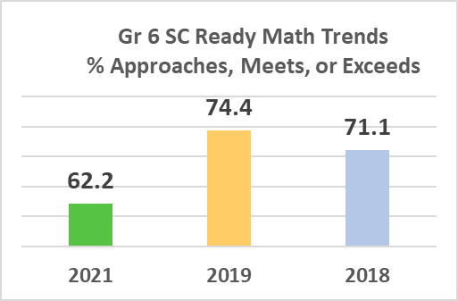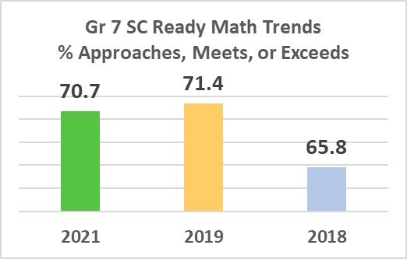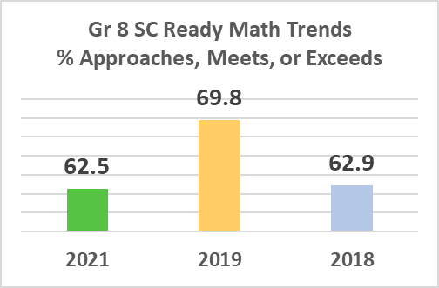

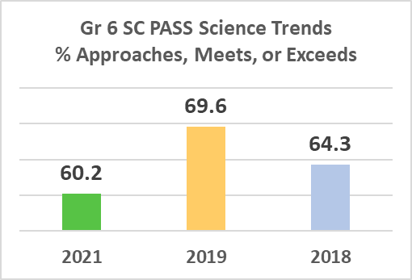

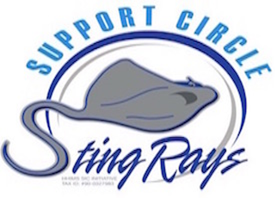

For more information, please visit our website at
https://hhims.beaufortschools.net/
or contact our main office at 843-689-4500.

SCHOOL SPONSORED STUDENT ACTIVITIES
AND OPPORTUNITIES
2021-2022

Arts & Crafts Club | - Honor Roll Celebrations sponsored by PTA | - HP Device 1 to 1 Student Initiative
6^{th,} 7th and 8th grade Awards Ceremonies | - Hour of Code | - Safety/Security Trainings
8th grade End of Year Celebrations | - Impact Mentor Group | - Second Helping  - Canned Food Drive
Advanced Studies Program | - I Ready | - Seventh Grade  - Kayak Trip
Athletic Teams | - Junior Interact Club | - SIC Christmas Shop
Advisory | - Like us on Facebook | - South Carolina  - Junior Scholar Banquet
Back Pack Buddies | - National Junior Honor Society | - SCOIS
Before School Care | - NJHS & Student Council  - Fundraiser | - Exceptional Special Olympics Track & Field
Black History Month | - Military Appreciation Week | - Special Olympics Tennis
Catch Up Club | - Military Purple Star School | - Spirit Week
College Colors Day | - Open House | - Stellar Stingray  - Monthly Recognition
District Character Education Student of the Month | - Organizational Support Groups | - Student Health Screening
ESOL Parent Nights | - PBIS Incentive Days | - Summer ESOL Enrichment Program
Follow us on Twitter | - Preventive Worksite  Screening for Staff | - Summer Reading Program
- Girls on the Run Club | - Principal’s Leadership Meetings | - Summer School
- Grade Level Dances | - PTA | - Teacher Appreciation Luncheon
- HHIMS Pursuit of Freedom | - Red Ribbon Week | - Thanksgiving Luncheon and canned food drive
- HHIMS Science Fair | - Regional Science Fair | - USCB Guidance  Field Trip
- High School Credit Courses | - Rising 6th Grade  Transition Orientation | - Yearbook

STINGRAY HIGHLIGHTS

2021-2022

- HHIMS students meeting criteria submitted applications for the Hilton Head Island School Chapter of the National Junior Honor Society. Thirty 7th and 8th grade candidates were inducted into the HHIMS Chapter of the National Junior Honor Society.
- Seventeen 8th grade students qualified for SC Junior Scholars
- Over 150 7th grade students participated in “Kids in Kayaks”.
- 70 students participated in the band and percussion concert. The featured piece was Riverdance Medley.
- Chorus sang Spanish folk songs at ESOL Parent Breakfast Drop In. And HHIMS hosted 2 other ESOL Parent Nights with dinner.
- Over 200 students participated in the HHIMS Science Fair. Of those students, 5 students went on to compete in the Sea Island Regional Science Fair and 3 of the projects placed.
- HHIMS hosted an inaugural science fair gallery walk for families to showcase student projects.
- Approximately 200 people attended the Pursuit of Freedom and Opportunity Gallery and Mural Open House.
- 6th, 7th and 8th graders traveled to University of South Carolina Bluffton Campus to learn about post secondary opportunities.
- NJHS students highlighted Famous African Americans during Black History month and Famous Women during Women’s History month.
- NJHS and Student Council took the students to Fort Sumter and the SC Aquarium.
- The Student Council organized events like spirit weeks, candy grams, and sold wristbands for school spirit.
- 260 HHIMS student athletes participated in sports this school year.
- Girls and Boys Basketball Team won the Beaufort County Championship for 2021.
- Girls and Boys Track Team won the Beaufort County Championship for 2022.
- Girls and Boys Soccer Team won the Beaufort County Championship for 2022.
- 278 – 8th grade Individual Graduation Plans created by the guidance department

SCHOOL IMPROVEMENT COUNCIL

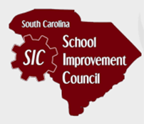
The Council meets on the 2nd Tuesday of each month at 5:00 p.m. via zoom or in the Media Center. Minutes are published and posted on the school website under the SIC link. The 2021-22 members are as follows:

- Keri Olivetti Chairperson | - Ann Buckley, Teacher
- Chad Cox, Executive Director Ex-Officio | - Kathleen Harper, Teacher  - Amy Prior, IB MYP Coordinator
- Christopher Limkimer, Parent | - Brantley Wilson, AP, Ex-Officio
- Anjanette Olander, Parent | - Maelda Chalk, AP, Ex-Officio
- Jessika Diaz-Armengol, Parent | - Angela Ballantone, AP, Ex-Officio
- Amanda Phillips, Parent | - Richard Storm, Community Rep.
- Marasol Jenkins, Parent | - Sonny Huntley, Community Rep.
- Meredith DiMuzio, Parent | Maury Purcell, Community Rep.
- William Rawl, Parent | - Kathryn Purcell, Community Rep.
- Lori Hall, Parent | - Jeanette Davis, Community Rep.  - Jane Carnahan, Community Rep.
- Elizabeth Simpson, Parent | - Barbara Barthelman, Community Rep.
- Heather Stout, Parent | - Amy Nardi, Ex- Officio, Past President,  - Jessica Howard, Ex- Officio PTA President

