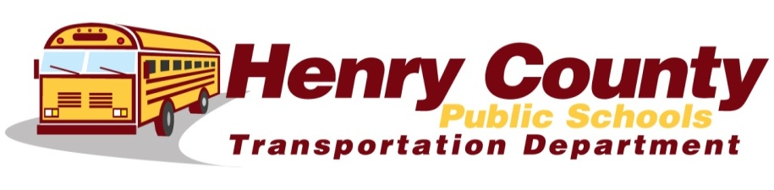
- The Driver is in charge of the students while on the bus. Follow the driver’s instructions at all times. The Driver has the authority to assign seats.

- Students are expected to be on time and wait at their assigned stop until the bus comes to a complete stop, opens the door, & the driver signals to enter. Students shall remain properly seated while the bus is in motion. (Back to Back, Seat In Seat, & Face to Front)

- Students shall not extend their arms, legs, or heads out the bus windows.

- Students shall not change from one seat to another while the bus is in motion unless given permission by the bus driver.

- Students are expected to help take care of their bus. Students shall not throw trash on floor, mar or deface the bus. Students caught damaging bus equipment will be subject to disciplinary action & restitution.

- Students are expected to keep noise to a level that doesn’t distract the bus driver or interfere with the driver’s ability to hear the signals of emergency vehicles or an approaching train.

- Students are expected to keep their hands and feet to themselves. Bullying of any kind will not be tolerated.

- Students shall not fight, use profanity, or create any other disturbances.

- Eating or drinking is not permitted unless driver gives permission for special circumstances (i.e. drinking water on hot days)

- Possession and/or use of tobacco products & other drugs is prohibited.

- Students are required to ride their assigned bus, unless they have written
approval from the principal or his/her designee.
Bus Rules & Expectations

