
Horizon Elementary
Parent/Guardian Information Guide
2022—2023
THE BASICS

School Hours
- Mornings:
  - First Bell—7:45 a.m. Students will enter class at this time.
  - Late Bell—7:50 a.m. Students are considered late once this bell rings.
  - See Student Arrival/Dismissal Procedures below.
- Dismissal:
  - 2:30 p.m. on regular release days; 1:30 p.m. on early release days.
  - See Student Arrival/Dismissal Procedures below.
- Main Office:
  - Phones are answered from 7:15 a.m. – 3:30 p.m. Main office number is 386-322-6150.
  - Doors are open from 7:30 a.m. – 3:30 p.m.

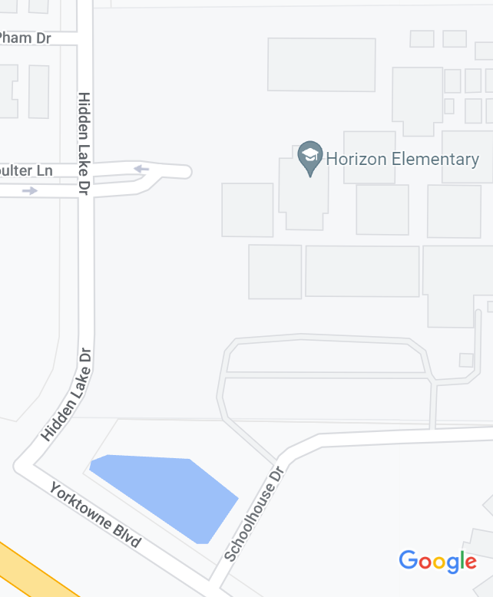
Student Arrival/Dismissal Procedures
Bus Parking Lot
Parent
Loop
North
Parking
Lot
- Parent Loop is for vehicle drop off/pick up only throughout the day. No cars are permitted to park in the loop, they must be parked in the north parking lot.
- The bus parking lot next to the bus loop is only for Multi-VE students with a school issued tag.
- Parent/Guardians are not permitted to walk onto campus to drop their child off or to pick them up at dismissal.
- Students eating breakfast will be permitted to enter campus at 7:15 a.m., entering through the gate closest to the cafeteria on the bus loop side of campus (Schoolhouse Dr.) until 7:30 a.m., then they will enter through the gate at the Main Office.
- All other students are not permitted on campus until 7:30 a.m., as there is no supervision until that time.
- Parent/Guardians are to stay in their vehicle when using the parent/guardian loop. There is assistance and supervision in this area.
- Horizon Elementary uses a colored pickup card to facilitate the pickup process. The cards will only be given to the parent/guardian of the student. Parent/Guardians may then pass the card to the person picking up their child. By giving the card to another person, you are giving your permission for that individual to pick up your child.
- At dismissal, all individuals using the Parent/Guardian Loop MUST have a pick-up card placed on the passenger side of the dash with the student(s) names clearly written. Those without the pickup card will be directed to park in the north parking lot and take their ID to the main office where they will receive a temporary daily pass.
- Students should exit and enter the car from the right side of the vehicle, so they do not step into the driving lane.
- Please do not park cars in the Parent/Guardian Loop at any time during the day. This is an emergency lane.
- Students that walk or ride a bike to school will enter through the front gate on Hidden Lake Drive beginning at 7:30 a.m.

Dress Code
Responsibility for the dress and appearance of students enrolled in the School District of Volusia County primarily rests with parents and the students. The standards of appearance for students shall ensure that the students are clean, neat, and properly dressed. They shall observe modes of dress and standards of personal grooming which are appropriate for the academic environment. It is the responsibility of the principal to see that the dress appearance of any student shall not be extreme, to the point of creating a disturbance, or be hazardous to the student and/or others, or school property. Complete guidelines can be found in Policy 217.
General Dress Code Policy Requirements (per Volusia County School Board Policy 217)
- Appropriate sizes - Garments must be of a length and fit that are suitable to the build and stature of the student.
- Upper garments – Upper garments must be long enough to clearly overlap the beltline or stay tucked in during the course of normal movement during the day.
- Lower garments – Lower garments with visible belt loops shall be worn with a belt that is properly fastened. Exceptions will be allowed for students in grades K – 5 and in individual cases based upon the discretion of the principal or designee. The waistband of pants, shorts or skirts must be worn and secured between the hips and the waist. Undergarments and the buttocks must remain entirely covered even while seated. Jumpers, skirts and shorts must be at least mid-thigh or below in length.
- Head - No hats, caps, visors, hoods, bandanas, sunglasses or other head gear may be worn inside an enclosed school building except with administrative permission (i.e. medical necessity, religious, school related events).
- Shoes/Footwear - All students shall wear shoes/footwear. Students must wear shoes that are safe and appropriate for the learning environment. Students must wear athletic shoes in all physical education classes.
- Outerwear – Coats, jackets, sweaters and other appropriate outer garments when necessary due to weather conditions. When outer garments with hood are worn, the hoods must be removed from the head while in school buildings. The outer garments must be of the appropriate size and shall not be overly baggy or violate any provisions of the dress code.
Unacceptable Attire
A student may not wear clothing (including bandanas), jewelry (including body piercing jewelry), buttons, haircuts, tattoos, or other attire or marking which are offensive, suggestive, disruptive or indecent, such as:
- Clothing associated with gangs.
- Clothing encouraging or promoting the use of tobacco, drugs, alcohol or violence.
- Clothing associated with the discrimination on the basis of age, color, handicap, national origin, marital status, race, religion or sex.
- Clothing exposing the torso or upper thighs, such as see-through garments, mini-skirts or mini-dresses, halters, backless shirts or dresses, tube tops or tank tops without over-blouses or shirts, spaghetti strap garments without over-blouses, bare midriff outfits, or shirts or blouses tied at the midriff.
- Clothing not properly fastened or with tears.
- Clothing or outer garments traditionally designed as undergarments, such as boxer shorts, underwear, tights, hosiery and sleepwear.
- Clothing or footwear that is construed by the principal, or designee, as hazardous or dangerous to the health or safety of the student or others or which might reasonably lead the principal or designee to forecast substantial disruption of, or material interference with school activities.

SAFETY AND SECURITY:
School Guardian:
- Horizon will be provided with a school guardian. This individual will provide additional security and surveillance to Single Point of Entry.
Emergency Contact Information
- Please ensure your child’s emergency card is correct when sent home at the beginning of the school year and return it quickly. Call if you have any changes to contact phone numbers. The school must have a way to contact parent/guardians in case of an emergency situation.
Emergency Guide for Parent/Guardians
- Visit VCSEDU.org and click on Parents at the top of the page.
Smoking
- Per School Board Policy, smoking is not permitted on any School Board property at any time. This includes in vehicles while on campus or in the parent/guardian pick up loop.
Pets
- Animals permitted in schools and elsewhere on District property shall be limited to those necessary to support curriculum-related projects and activities as well as those that provide assistance to students, staff members or visitors due to a disability (e.g. seizure disorder, etc.) or those that serve as service animals as required by Federal and State law. Please take into consideration that some animals exacerbate allergic reactions, spread bacterial infections, or could cause damage or injury if they escape from the owner or their containment.
Cell Phones & Driving in a School Zone
- Per Florida Law, it is illegal to hold a cell phone in your hands while driving in a school zone. Keep our students safe during morning arrival and afternoon dismissal by not texting and driving through the parent loop.

ATTENDANCE
Daily Attendance
- Bell to Bell attendance is expected so students can reach their highest potential.
- If an absence is unavoidable, you must call the Main Office each day.
Late Arrivals (Remember, instruction begins as soon as the bell rings.)
- Parent/guardians need to park their car in the north parking lot and accompany the student into the Main Office for a late pass to be issued.
- Parking in the parent/guardian loop/driveway is not permitted, this is an emergency lane and should only be used for dropping off or picking up while the driver remains in the car.
Checking Students Out Early (Remember, instruction continues.)
- The individual checking the student out MUST have photo identification with them and be listed on the emergency card with pick-up authority.
- Students will only be called to the office after the individual checking them out has arrived and been verified.
Dismissal Changes
- In order to ensure the safety and security of our students, we are no longer able to take dismissal changes by phone less than 30 minutes prior to dismissal (2:00 on regular release and 1:00 on early release) as we cannot guarantee the message will reach the student and teacher in time.
- The only exception would be an emergency situation that must be cleared through an administrator.

COMMUNICATION
Parent/Guardian/Teacher Communication
- Open communication between the parent/guardian and teacher will provide the best growth for your child.
- Parent/guardians are asked to respect the instructional day and schedule conferences to discuss matters.
- Conferences can be scheduled by contacting your child’s teacher and arranging a mutually agreed on time.
School Messenger
- Horizon generally sends out a weekly call. These messages contain important information to help families plan their week.
Horizon Webpage
- VCSEDU.org click on Schools at the top of the page, then choose Horizon Elementary.
  - This site contains breakfast & lunch menus, newsletters, activity calendar, parent/guardian information, homework help, VPortal link, media information, and much more. Visit the site often to stay informed.
Parent Portal
- Parents are able to view grades, absences, and news from this site. You will need to obtain your child(ren)’s PIN from the school prior to setting up your account. Once you have the PIN, go to VCSEDU.ORG, click on the Parents tab, then Parent Portal and follow the directions.
Social Media
- Facebook - Simply go to Facebook.com and type in Horizon Elementary Port Orange. Choose the one with our school logo.
- Twitter - HorizonElem89
District Parent/Guardian Information
- This information can be found at VCSEDU.ORG, click on the Parents tab, scroll down to for the topic you are interested in.

BREAKFAST & LUNCHES
- Breakfast & Lunch are free to all students. There will be additional charges for ala-carte items. Menus and other information can be found at VCSEDU.ORG, click on the Parents tab, then School Meals Information.

PARENT/GUARDIAN INVOLVEMENT
Volunteer/Chaperone/Mentor: Parent volunteer opportunities can be during the school day or at home. Contact Kim Schoeps or Christina Ellis in the main office to find the best way for you to support Horizon.
- Individuals must have an active and approved volunteer application with Horizon Elementary to volunteer at school events or chaperone field trips. Applications should be submitted online as VCSEDU.org by clicking the COMMUNITY tab, and then VOLUNTEER / PARTNERSHIP PROGRAMS. Volunteer applications must be updated every year.
- You must sign in as a volunteer in the Main Office each time you are campus to volunteer or chaperone. You will need to provide photo identification each time. This is a security measure.

PTA: Please join Horizon’s PTA. They sponsor many great programs and activities at our school so support them to make these possible. Here are a few of the ways PTA supports us: Technology, Tutoring, Winter Festival, Field Day, Reading Counts, Reflections, Safety Patrols, Copy Machines, Laminating Machine, Clinic Supplies, Teacher/Staff Appreciation, and many more. You can also support Horizon PTA by purchasing Horizon t-shirts, supporting their fundraisers, volunteering, and/or serving on the board.

SAC (School Advisory Council): This council, which meets 8 times throughout the year, assists in making recommendations on how our school operates. SAC membership is comprised of elected parent/guardians, staff, and business community partners. The SAC elections are held near the end of each school year for the following year. Periodically, a member will resign during the year making availability for a new member to join. Contact Meg Bagby at 386-322-6150 if you are interested in joining SAC.
VCS School Board Policy 418: The School Board recognizes that parent participation and support in the education of their children is vital. Parents must be provided access to student records regarding their children, and reasonable opportunities to discuss issues of concerns with the classroom teacher(s), other instructional personnel, and the school administration. Such discussions can only be successful if mutual respect is maintained. While school personnel are required to professionally participate in discussions regarding the educational progress of a student, they are not required to continue discussions when other individuals involved become rude, discourteous, disruptive, threatening or disrespectful. When participating in these discussions, whether in person or by telephone, parents and other individuals involved must treat teachers, school administrators and other school district employees with courtesy and respect. If inappropriate behavior as described in this policy repeatedly occurs during these discussions, the teacher, school administrator or other school district employee may, after giving appropriate notice, end the discussion. If these discussions take place at a school, other school district facility, or school activity the individual engaging in such inappropriate behavior may be directed by the principal/designee to leave the school, other school district facility, or school activity.

