KENTUCKY TECH SYSTEMS
Morgan County Area Technology Center
PARENT PORTAL ACCESS INSTRUCTIONS

*By logging into the Kentucky Tech Systems Parent Portal the user agrees to the Acceptable User Policy that can be found under the District Announcement section of the login screen*

THIS IS NOT THE SAME PORTAL AS THE HIGH SCHOOL

Step-by-Step Instruction for New Users

- First time users will need to obtain a Campus Portal Activation Key (GUID) from the ATC office staff. Activation keys will only be given in person with a valid picture ID, or you can request to have the activation key sent home with the student. Activation keys will not be given by phone.
  - Attention ATC & RCA Office Staff: Activation key (GUID) numbers can be found by printing a Person Summary Report from Census > People record. Additionally, be sure to provide the parent’s Person Summary report and not the student’s.
- Log in using the hyperlink below:
KTS IC Parent Infinite Campus Portal
- From the login screen, select Campus Parent
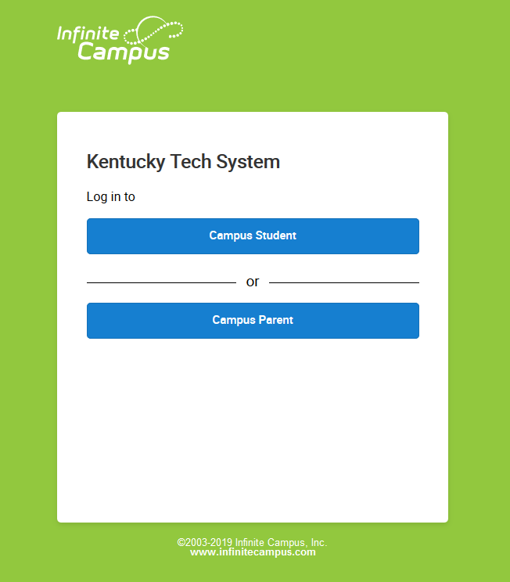

- Click on the New User? hyperlink if you are a new user to Campus Portal
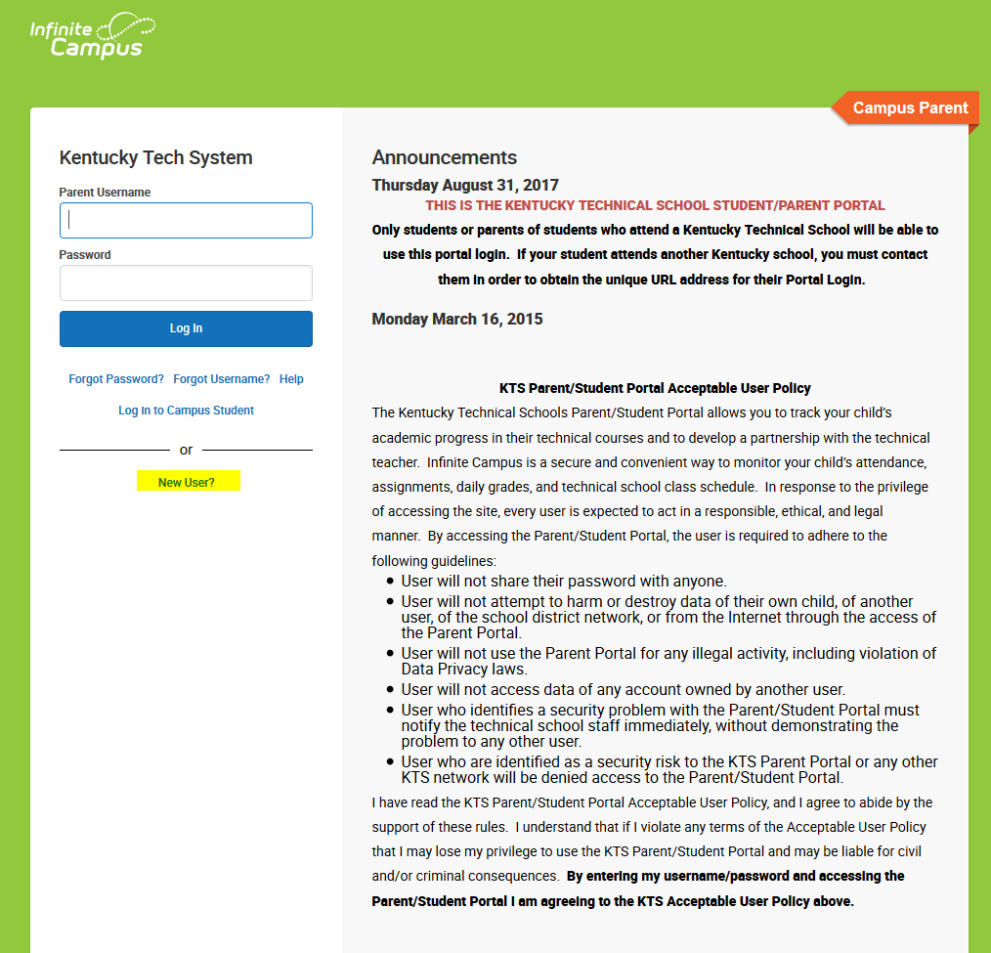

- Enter the Activation Key (GUID number) that was provided to you by your technical school office staff in the Activation Key space, and click Submit.
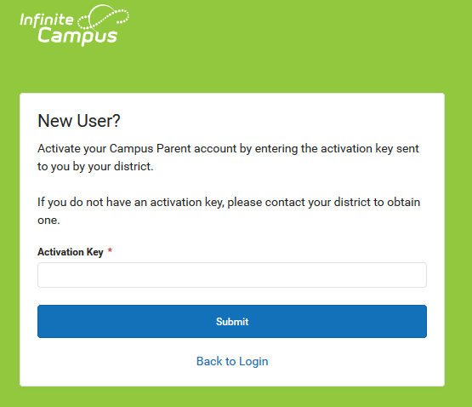

- You must now create a Username and Password.
  - Type your desired Username in the area indicated.
  - Type your desired Password in the area indicated. Passwords must be a minimum of 6 characters. Keep in mind that passwords are case sensitive.
  - Retype your Password.
  - Click on Submit when you are finished.
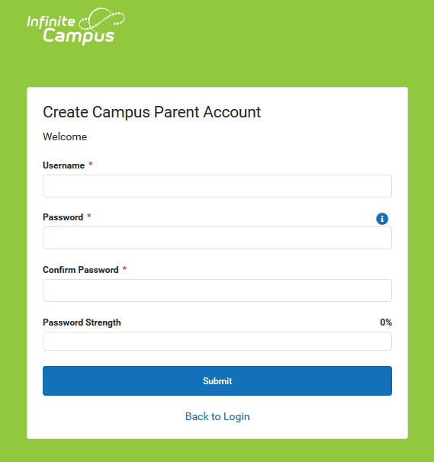
- NOTE: It is important to keep your access information private. Do not share with anyone.
- You are now ready to log into the system! User the newly created username and password to log in.
- The first screen you will see is the Set Email screen. Add an email address to receive emails if you should ever get locked out in the future. 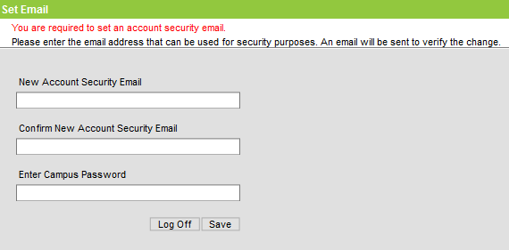
Returning Users

- Log in using the hyperlink below:
KTS IC Parent Infinite Campus Portal
- From the login screen, select Campus Parent
- In the boxes indicated type in the Username and Password you created and click the Log In button.
- If you have problems logging select the Forgot Password, Forgot Username, or Help hyperlinks
- Once logged in, enter a security email address on the Set Email screen
- To update your security email address, log into your Parent Portal account, click on the avatar, top right corner of the screen, select Settings, then select Account Settings. Click Update next to Account Security Email and follow the prompts to add a new email address. Select Save.
