The unique URL specific for Kentucky Technical Schools can be found on the KTS Data Exchange webpage, under the Infinite Campus Login heading, or it can also be found below:
https://kyede13.infinitecampus.org/campus/portal/atc.jsp
- To access the Student Portal, go to the URL address above, then select Campus Student
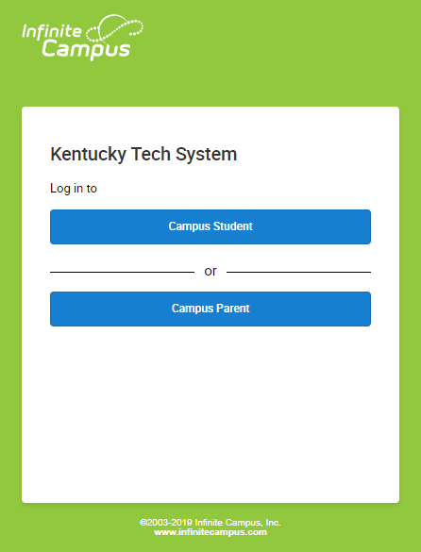
- In the boxes indicated on the login screen, type in the Username and Password
  - All ATC and RCA students accounts are generated when they become enrolled in a Kentucky technical school course
  - Student usernames are their State Student Identification Numbers (SSID).
  - Student passwords are in the following format:
    - <first name initial><last name initial><MMDDYY>

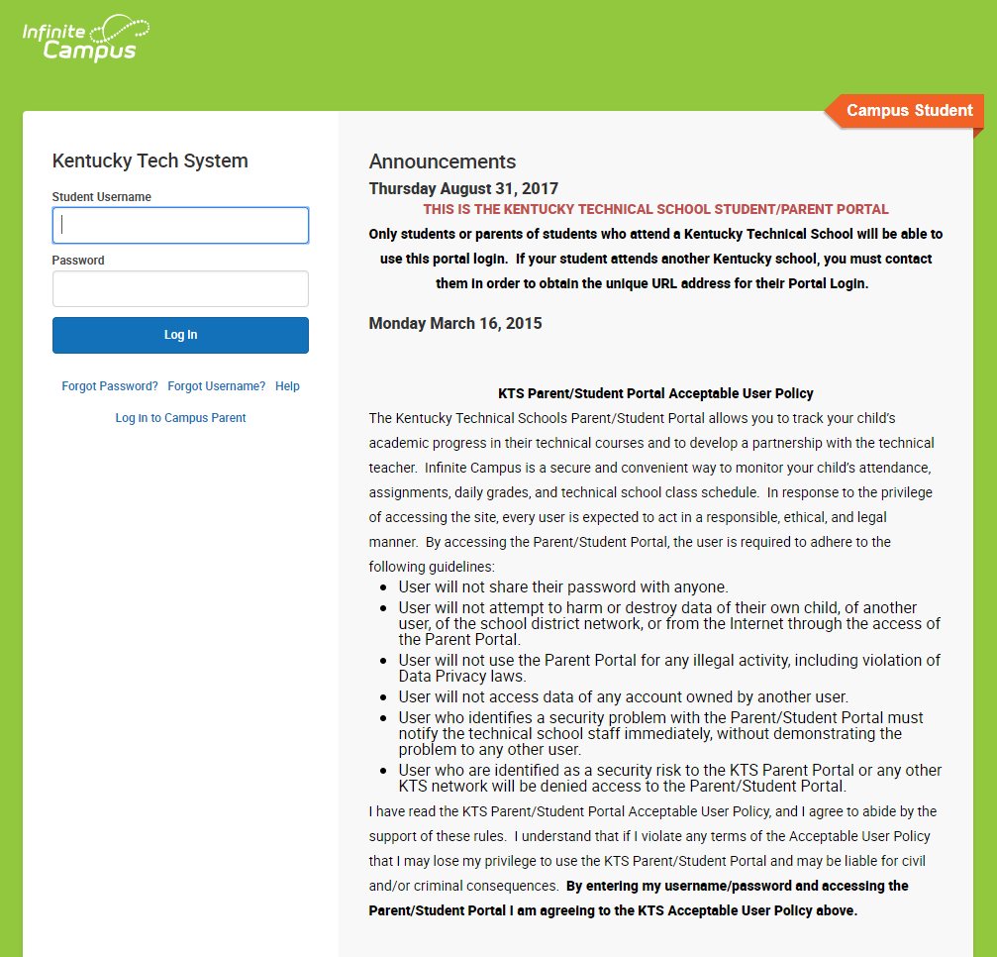
- If logging in for the first time, you will be prompted to enter a security email address on the Set Email screen. This should be an email address you can use to retrieve your information if you get locked out in the future.
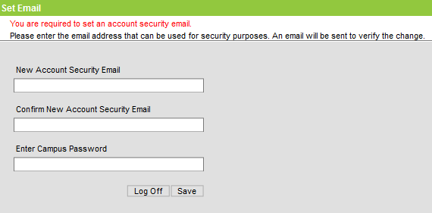
- If you are a returning user, log into your Student Portal account, click on the avatar, top right corner of the screen, select Settings, then select Account Settings. Click Update next to Account Security Email and follow the prompts to add a new email address. Select Save.
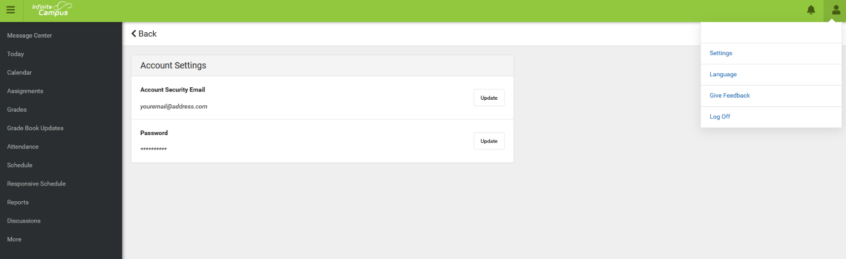
- If you have problems logging select the Forgot Password, Forgot Username, or Help hyperlinks. If AFTER following the links and the prompts, students must email KTSSupport@education.ky.gov for further assistance.
