Buckner Elementary School Council
Oldham County Schools
REGULAR CALLED MEETING
A G E N D A

August 15, 2022
3:00 p.m.

Google Meet joining info
https://meet.google.com/tjo-zbja-mwq
Or dial: +​1​ ​2​5​2​-​3​7​6​-​1​4​3​8 PIN: 3​6​1​ ​5​9​8​ ​3​7​0​#

- Call to Order

- Agenda Approval

- Approval of the Minutes from the June 6th regular called meeting and the June 14th, July 8th, July 13th and August 9th special called meetings

- Principal’s Report
- Update on Enrollment (Enclosure A)

- Council Action Items
  - Review/ Approve Review / Discuss “Your Duty Under the Law” and “Managing Public Records” (Enclosure B)

  - Sign Student Free Speech and Religious Liberty Rights

  - Sign Code of Ethics

  - Review/ Approve Calendar of Meetings for the upcoming school year
(Enclosure C)

  - Review/ Approve Title 2 Purchasing Plan (Enclosure D)

- Enter Closed Session to Discuss Certified & Classified Personnel Selection per KRS 61.801 (1)(f)

- Adjourn

Record of Council Proceedings
(Minutes)
Buckner, Kentucky
June 6, 2022
Regular Called Meeting
3:00 p.m.

DRAFT
The Buckner Elementary School Council advertised a regular called meeting at the front of school and in the Buckner Buzz. The following members were in attendance in Liz’s office: 1. Liz Dant 2. Erin Marvin (3:03 pm) 3. Lee Hamilton 4. Devan Lindemier (virtual) and 5. Roderick Pack were present. Beth Lindauer, Lisa Laws and Jennifer Dolan were absent.

- The meeting was called to order at 3:01 p.m.

- The Council reviewed and approved the agenda

- The Council reviewed and approved the minutes from the May 9 regular called meeting and the May 20th special called meeting. The May 20th minutes were revised to show that Devan Lindemier was in person in attendance.

- Mrs. Dant reviewed the proposed Title 2 plan. After discussion, the Council approved the plan for the 2022-2023 school year that supports a new teacher induction program.

- Mrs. Dant shared the updated budget for the 2022-2023 school year which would increase the number of staffing by 1. After discussion, the Council approved the updated budget.

- Mrs. Dant presented the fundraising requests for the 2022-2023 school year. It was proposed to increase the Fun Run monies to reflect that the PTO generated $45,000 for the playground renovation. After discussion, the Council approved the fundraising requests.

- Ms. Dant reviewed the revisions to policy 1008 that added a definition to what minority means for the Council membership. After discussion, the Council approved the revisions to policy 1008.

- At 3:28 pm the Council entered into closed session to discuss candidates per KRS 61.801 (l)(f)

- At 3:32 pm the Council returned to open session.

- Having no further business, the Council adjourned at 3:32 p.m.

Record of Council Proceedings
(Minutes)
Buckner, Kentucky
June 14, 2022
SPECIAL Called Meeting
2:00 p.m.

DRAFT
The Buckner Elementary School Council advertised a special called meeting at the front of school. The following members were in attendance in Liz’s office: 1. Liz Dant 2. Roderick Pack 3. Devan Lindemier (virtual) 4. Jennifer Dolan (virtual) and 5. Lisa Laws (virtual) were present. Beth Lindauer, Lee Hamilton, and Erin Marvin were absent.

- The meeting was called to order at 2:01 p.m.

- The Council reviewed and approved the agenda

- Mrs. Dant reviewed the proposed budget for the 2022-2023 school year which reflected updated school enrollment numbers from 648 to 654 students which would result in 25 first grade students in a class unless a teacher was added. After discussion, the Council agreed to add one more staff member and approved the new budget.

- At 2:10 pm the Council entered into closed session to discuss candidates per KRS 61.801 (l)(f)

- At 2:17 pm the Council returned to open session.

- Having no further business, the Council adjourned at 2:18p.m.

Record of Council Proceedings
(Minutes)
Buckner, Kentucky
July 8, 2022
SPECIAL Called Meeting
10:30 a.m.

DRAFT
The Buckner Elementary School Council advertised a special called meeting at the front of school. The following members were in attendance in Liz’s office: 1. Liz Dant 2. Julie Brown and 3. Devan Lindemier were present. Lisa Laws, Heather McDonald, Roderick Pack Lee Hamilton, and Melissa Riggs were absent.

- The meeting was called to order at 10:31 p.m.

- The Council reviewed and approved the agenda

- At 10:32 am the Council entered into closed session to discuss candidates per KRS 61.801 (l)(f)

- At 10:37 am the Council returned to open session.

- Having no further business, the Council adjourned at 10:37a.m.

Record of Council Proceedings
(Minutes)
Buckner, Kentucky
July 13, 2022
SPECIAL Called Meeting
2:30 p.m.

DRAFT
The Buckner Elementary School Council advertised a special called meeting at the front of school. The following members were in attendance in Liz’s office: 1. Liz Dant 2. Julie Brown 3. Lee Hamilton and 4. Roderick Pack were present. Devan Lindemier, Lisa Laws, Heather McDonald, and Melissa Riggs were absent.

- The meeting was called to order at 2:31 p.m.

- The Council reviewed and approved the agenda

- At 2:32 pm the Council entered into closed session to discuss candidates per KRS 61.801 (l)(f)

- At 2:34 p.m. the Council returned to open session.

- Having no further business, the Council adjourned at 2:35 p.m.

Record of Council Proceedings
(Minutes)
Buckner, Kentucky
August 9, 2022
SPECIAL Called Meeting
3:00 p.m.

DRAFT
The Buckner Elementary School Council advertised a special called meeting at the front of school. The following members were in attendance in Liz’s office: 1. Liz Dant 2. Julie Brown 3. Devan Lindemier (virtual) 4. Lisa Laws 5. Heather McDonald, and 6. Melissa Riggs. Lee Hamilton and Roderick Pack were absent.

- The meeting was called to order at 3:00 p.m.

- The Council reviewed and approved the agenda

- Mrs. Dant shared an update on the enrollment numbers with the Council. We anticipate 657 students. After discussion, the Council took the report under advisement.

- Mrs. Dant reviewed the Emergency Management Plan with the Council. After discussion, the Council approved the Emergency Management Plan for the 2022-2023 school year.

- At 3:06 pm the Council entered into closed session to discuss candidates per KRS 61.801 (l)(f)

- At 3:09 p.m. the Council returned to open session.

- Having no further business, the Council adjourned at 3:10 p.m.

Enclosure A
August 9, 2022

Buckner Elementary School Council
Oldham County Schools

CONCERN:

Review the current enrollment

DISCUSSION:

As of August 15th our current enrollment number is 647 enrolled. As you can see, the number has dropped from what we were expecting. There were lots of last minute changes, but we are financially still in a good position.

Grade | Total  Enrolled | # of teachers | # of students per teacher in the building | State  Cap-size
5th grade | 110  110 | 5 | 22:1 | 29
4th grade | 131  133 | 5 | 26:1 | 28
3rd grade | 92  91 | 4 | 23:1 | 24
2nd grade | 109  112 | 5 | 21:1 | 24
1st  grade | 120  124 | 6 | 20:1 | 24
Kinder-  garten | 85  *2 more coming  87 | 4 | 21:1 | 24

RECOMMENDATION:
Take this report under advisement.
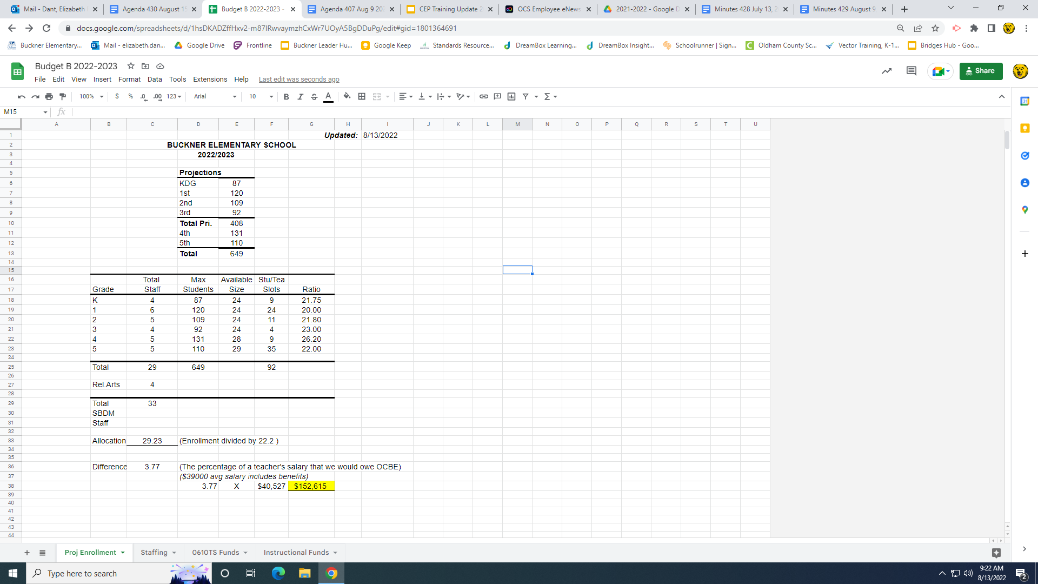
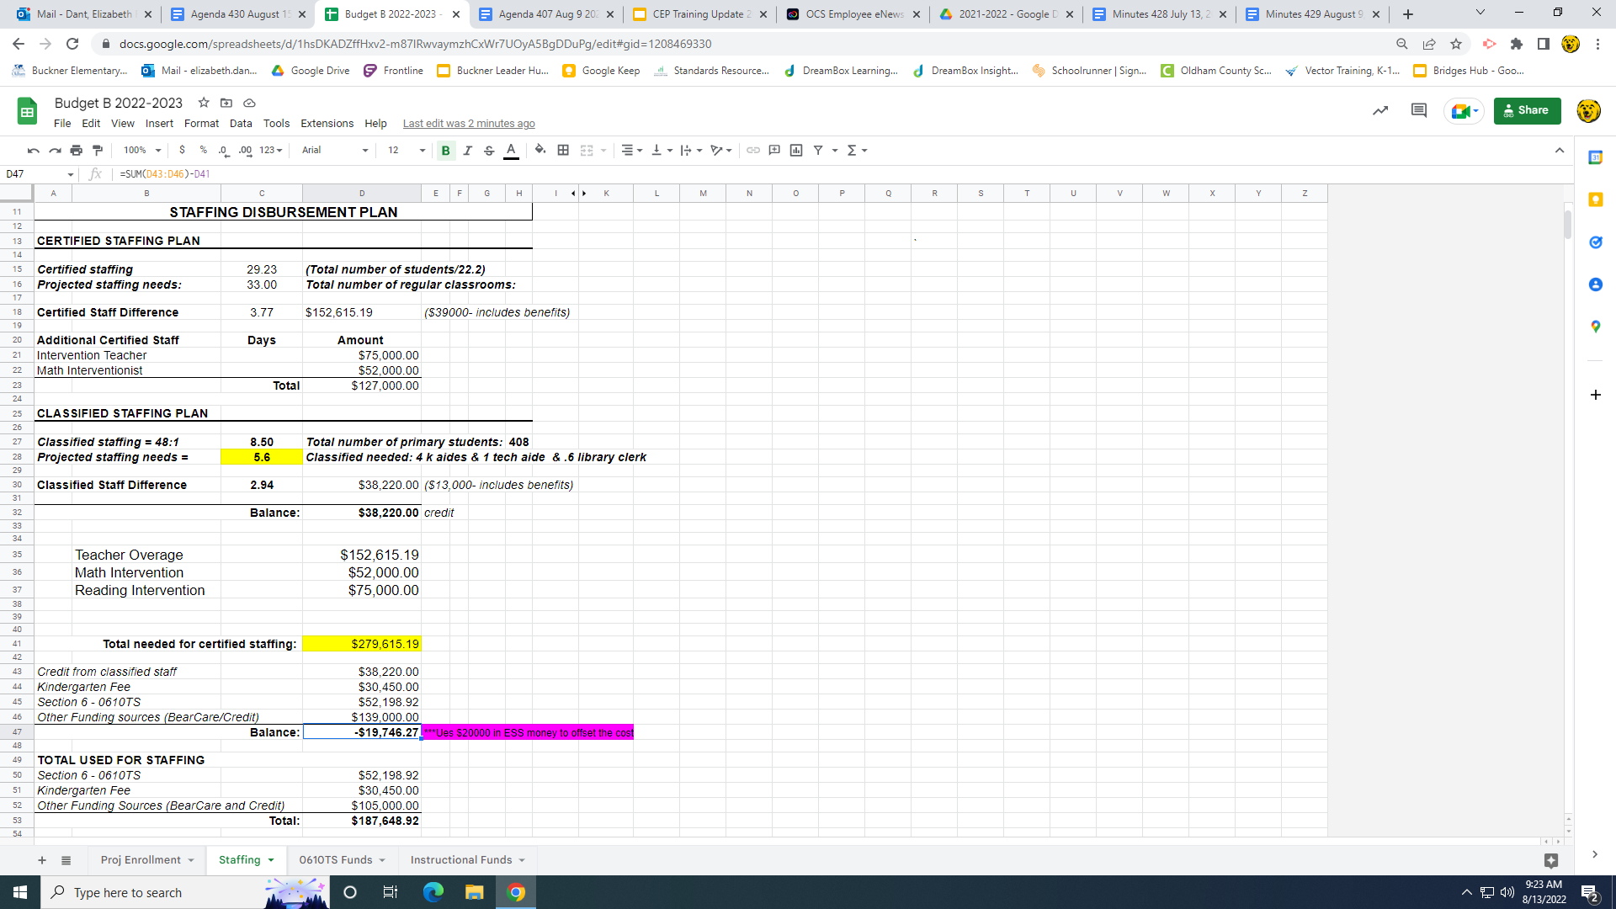

Enclosure B
August 15, 2022

Buckner Elementary School Council
Oldham County Schools
CONCERN:

Review and approve “Your Duty Under the “Law” and “Managing Public Records”

DISCUSSION:

On July 15, 2016 HB 132 took effect, which amended the Open Records Act. Pursuant to KRS 160.395(1), superintendents of public school districts must distribute Your Duty Under the Law and Managing Government Records to each elected school board member and each school-based decision making council member within their respective districts. The materials must be distributed within 60 days of receipt of the newly revised information from the Attorney General and to newly elected or appointed board and council members within 60 days of their election or appointment.

Please find a Proof of Receipt following this discussion.

RECOMMENDATION:

Review the documents “Your Duty Under the Law” and “Managing Public Records.” Sign a copy for the official records.

Enclosure C
Aug. 15, 2022

Buckner Elementary School Council
Oldham County Schools

CONCERN:

Consider a proposed calendar of Council meetings for the 2022/2023 school year.

DISCUSSION:

Our B.E.S.C. Policy 1002, "Operating Council Meetings," dictates that we "annually establish a schedule of meetings for the coming year at our regularly scheduled meeting.

I am proposing that we conduct our meetings on Mondays at 3:00 in the ARC room

The proposed schedule(s) of BESC meetings for the 2022/2023 school year is as follows:
August 15 January 23
September 19 February 27
October 17 March 20
November 21 April 17
December 12 May 15
June 19

RECOMMENDATION:

Consider/ Approve the proposed schedule of meetings for the 2022/2023 school year.

Enclosure D August 15, 2022 Buckner Elementary School Council
Oldham County Schools
CONCERN:

Review and approve the plan for Title II funds

DISCUSSION:

We were unable to spend all of the Title 2 funds in the past 2 years that were focused on co-teaching due to the sub shortage and therefore have monies left over to spend. In addition we have this years monies of about $2000 to spend. So, I have attached 2 different Title II plans. I am proposing that the past 2 years monies be spent on the Reading Recovery conference in January to help support our reading achievement initiative and this year monies to be spent on new teacher training. Title II funds are federal monies and therefore require a great deal of paperwork and specific rules that come attached with the money.

The professional development has to meet the following requirement:
(1) increase student achievement consistent with challenging State academic standards;
(2) improve the quality and effectiveness of teachers, principals, and other school leaders;
(3) increase the number of teachers, principals, and other school leaders who are effective in improving student academic achievement in schools; and
(4) provide low-income and minority students greater access to effective teachers, principals, and other school leaders.

RECOMMENDATION:

Consider/ Approve the expenditures for Title II funds

Oldham County
Title II School Project Planning and Application
Year: FY 2021 and 2022 Carryover
School Name: Buckner Elementary
Video for FY2223 T2 Funding Application Directions

Purpose of Title II, Part A
The purpose of Title II, Part A is to provide sub-grants to districts/schools to
(1) increase student achievement consistent with challenging State academic standards;
(2) improve the quality and effectiveness of teachers, principals, and other school leaders;
(3) increase the number of teachers, principals, and other school leaders who are effective in improving student academic achievement in schools; and
(4) provide low-income and minority students greater access to effective teachers, principals, and other school leaders.
Allowable Uses of Title II Funding Associated with this Project (Highlight all that apply.)
- Support Teacher and Principal Professional Growth and Effectiveness Systems
- Recruit, hire, and retain highly qualified and effective teachers and principals
- Teacher advancement initiatives that emphasize multiple career paths
- Provide professional learning activities that improve the knowledge and effectiveness of teachers, principals and superintendents (For schools – using a school-wide approach)
- Establish induction and mentoring programs
- Provide professional learning, course work and exams to assist educators to become highly qualified
Title II Program Description
Describe your program in space below. As a school allocation, your focus and funds should be used to provide professional learning with SCHOOL-WIDE impact. Ex. Unlike Flex Focus Funds, this would not be a PD where you would want to send the music teachers to conference for their own professional learning. Consider topics/areas that have school wide implications aligned to your school priority needs when utilizing these funds FIRST as a recommendation. This does not mean you can’t use it for these other unique projects, but it is recommended that you first look to maximize the dollars on school wide impact projects. (per KDE)

Briefly describe your intended project below.
This project will provide the opportunity for the principal, instructional coach and 2 teacher representatives to improve their knowledge and understanding on the teaching of reading. Participants will attend the National K-8 Literacy Conference and then come back and share their new learning with colleagues in order to make a school wide impact on our approach to reading instruction. The conference will include 3 days of keynote speakers and differentiated sessions on topics related to the Science of Reading, phonics, phonemic awareness, and recovering literacy learning loss as a result of disrupted learning in the emergent reading grade levels. Additionally there are sessions targeted for instructional leaders in the area of effective coaching and leading school wide approaches.
Each teacher participating will engage in a collaborative coaching cycle with our instructional coach to determine ways in which they can put their new learning into action.
The principal and instructional coach will use their new learning to

Title II Program Requirements (Note every question must be answered thoroughly for the proposal and budget to be approved.) Please ensure you complete each answer section.
- How does this activity/project align or support identified needs outlined in the school’s Needs Assessment and/or CSIP? (Schools must conduct an assessment of local needs for professional learning. There should be a clear connection between identified needs and Title II, Part A activities.). These activities and projects should be included on your CSIP/PD Plans in the fall of 2023.
This activity aligns with Goals 1 and 5 as teachers will complete targeted professional learning activities that are directly tied to a student learning goal in the area of reading achievement, growth, or gap reduction. Knowing that improvement in reading achievement impacts ALL content areas, this project would indirectly support other CSIP goals as well.

- How does this activity/project: align with state standards?
State standards call for students to be able to read and make sense of grade level complex texts by the end of each grade level. This project aligns with that by providing new learning for a strong understanding of current research, trends, and best practice in reading instruction for students K-5.

- How will you show evidence it was designed to have a substantial, measurable and positive impact on student achievement?
Student learning data will be analyzed in post-training reflection with our school leadership; MAP achievement and growth scores will be analyzed; and teacher evaluations/PGP reflections will be reviewed to show growth in teacher performance.
How have you ensured that teachers, paraprofessionals, principals and other relevant school personnel, and parents collaborate in the planning of this activity?
Teacher survey feedback indicated that professional development opportunities on topics related to reading instruction, coaching cycles, and collaborative data analysis are perceived as highly valuable professional learning activities in alignment with our CSIP achievement and growth goals.
- The goal/purpose of Title 2 is to ultimately improve student achievement, through professional learning/mentoring, etc. Describe the evaluation system you will use to ensure the professional learning described in the activities below has impacted student achievement.
MAP growth and achievement data along with formative assessments are analyzed at the classroom level to evaluate student progress toward proficiency in reading over the course of the school year. This data will be analyzed during collaborative reflective conversations with the school instructional coach to gauge the immediate impact and to determine next instructional steps. This data will also be used by school leadership to plan and/or refine school wide initiatives for change in approach to reading instruction

- Provide the dates for each activity in your plan.
Conference dates are January 28-31, 2023
Post Conference Dates TBD, at intervals that allow for effective implementation and are determined by evidence of student growth.
- If conference attendance is part of your plan, please include the conference information below, including venue, dates, etc. Be cautious about reserving flights or hotels that do not allow for cancellations given the Covid19 situation. Unfortunately, this situation is not over.
National K-8 Literacy Conference
January 28-31
Columbus, Ohio
Hyatt Regency Columbus / Columbus Convention Center - Hotel x 3 nights (Jan 28,29 and 30)
Traveling by car - 376 round trip miles x (.53 cents / mile), note this changes quarterly and so is an estimate.
Registration - Early Bird x 4 people @ $565/per person
Pre Conference - $165 x 4 people

Meals : (note if breakfast is served at the hotel, then you can’t be reimbursed for it even if you choose to eat somewhere else)

Jan 28 - Lunch, Dinner x 4 people MAX
Jan 29 - Breakfast, Lunch, Dinner x 4 People MAX
Jan 30 - Breakfast, Lunch, Dinner x 4 People MAX
Jan 31 - Breakfast and Lunch x 4 People MAX

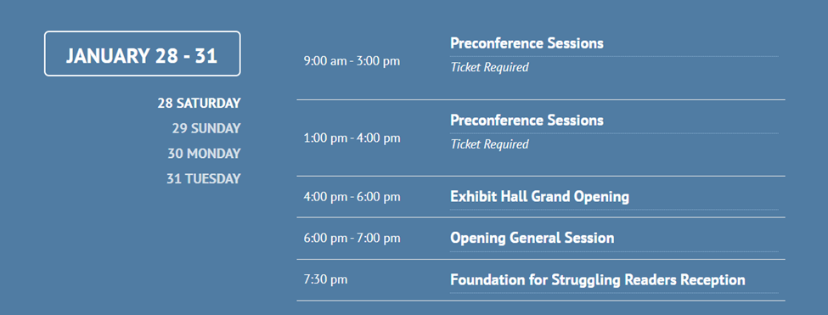
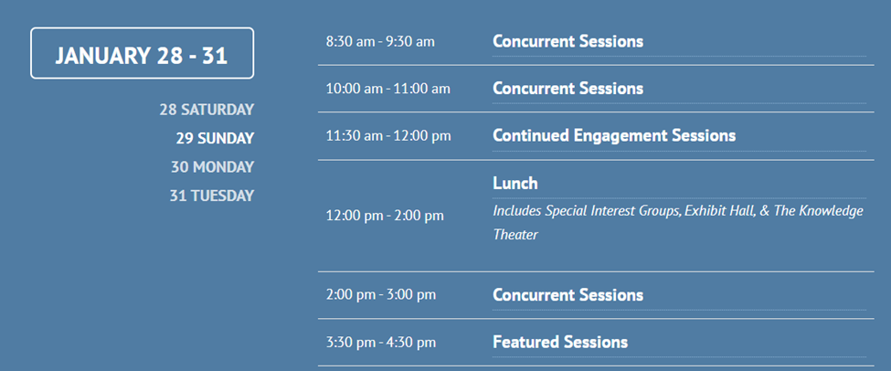
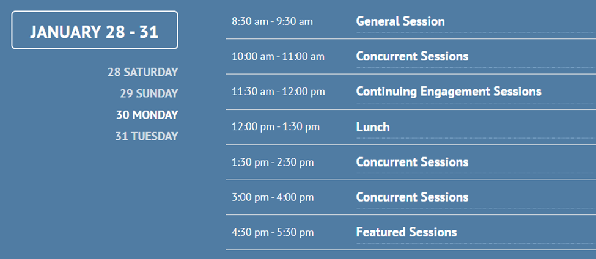
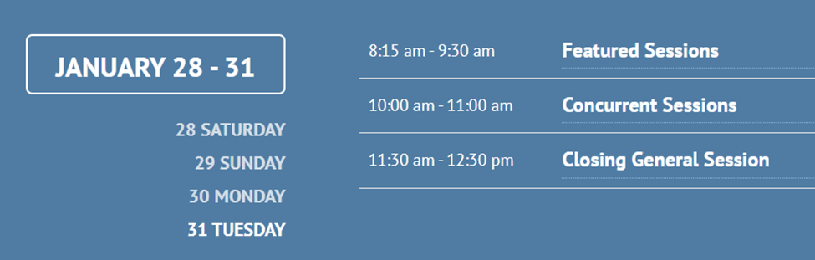
- If you are using internal facilitators, describe how they were chosen and how their expertise to provide high level professional learning was determined.
n/a

- List the names of personnel, by activity that will either receive a stipend, need a sub, facilitating or attending a conference. You may add more columns as necessary.

Initiative | Facilitator | PL Participant Requiring a Sub | PL Participant Requiring a Stipend | PL Conference Attendee
Conference  Attendance | none | none | none | Principal
Conference  Attendance | none | none | none | Inst. Coach
Conference  Attendance | none | Teacher 1 January 30 and 31 | none | Teacher 1
Conference  Attendance | none | Teacher 2  January 30 and 31 | none | Teacher 2

- If you are contracting with an outside agent, include their information below along with the proposed contract submitted by them. This must be attached to this application!
N/A

Title II Expectations for High Quality Professional Learning
- How will this project Improve and increase teachers' knowledge of the subjects they teach?
Teachers will participate in professional learning current research on topics related to the Science of Reading, phonics, phonemic awareness, and recovering literacy learning loss as a result of disrupted learning in the emergent reading grade levels. Additionally there are sessions targeted for instructional leaders in the area of effective coaching and leading school wide approaches.
The final program and schedule are not yet finalized
- Explain how this project is of high quality, sustained, intensive, and classroom-focused.
This conference is the largest K-8 Literacy Conference in North America and has been held for the past 38 years. Because it has keynote speakers who share current, relevant information around topics directly related to teaching and improving students as readers it is of the highest quality. This conference has 14 differentiated sessions to be held over 3 days. This makes it possible for us to choose the sessions that are most aligned to our goal, which is to study and grow our understanding surrounding the Science of Reading, phonics and phonemic awareness. This new learning will all be intensively focused on classroom implementation of practices to move students to proficiency.

- Explain how this project is ongoing not just a 1 or 2 day workshop or conference.
This learning will help frame our school wide approach to ensuring that we are providing a comprehensive, instructional reading curriculum for our students. The team that will be attending, will be working alongside school leadership to ensure that our guaranteed and viable curriculum in reading is current, relevant and researched. The team will be sharing new learning with colleagues by delivering job embedded professional development.

- How does this project advance teacher understanding of effective instructional strategies that improve teacher practice?
- Principal, Coach & Teachers will hear keynote presentations on current, researched approaches in teaching reading
- Principal, Coach & Teachers will participate in differentiated professional learning sessions connected to our school goal of developing proficiency readers
- Principal, Coach & Teachers will name their walk away learning and identify next steps, explaining why they believe this step will impact student growth.
- Teachers will identify an assessment measure that will correlate with their next step and be used to evaluate the impact on students.
- Principal, Coach & Teachers will have follow-up meetings to reflect on evidence of student learning.
- Teachers will lead peers in learning based upon their new learning and subsequent implementation of it.
- School leaders will use data to refine/redesign school wide instructional approaches to teaching of reading

Title II FY2223 Evaluation
You are required to assess the effectiveness of the projects and plans that you put into place and that you pay for with T2 funding. In doing so, you should consider the impact of the activities on student achievement. While it is acceptable, depending on the topic to have some qualitative data. It is expected that you will also have some quantitative data. Describe your evaluation plan below. Include frequency of monitoring, your overall goal or objective that you will be measuring, etc. At the end of the year, you will use this plan to evaluate your program.
Qualitative data:
Teacher feedback (survey)
Team reflective conversations

Quantitative data:- Frequency TBD, dependent upon new learning
Student learning outcomes- MAP achievement and growth
Pre/Post assessment data
Formative assessment data

Title II Budget Summary
Note: While the district allows a teacher to “cover” a class with no sub, and be reimbursed at the $35/hour rate for planning time that they give up to do so, this is NOT allowable for T2 activities. Subs will only be paid at the sub rate for T2 activities.
- What is your total TENTATIVE allocation? Note: The budget below must match exactly to the allocation, not under or over.
$4461

- Complete the budget table below: (This budget must be detailed and show actual calculations by number of staff members, etc. when necessary. It should be clear exactly how many people are involved, rate of pay, number of days/hours, etc. in the actual budget table.) For your convenience, the table is broken into 3 columns so that you can isolate, if necessary for each activity. Feel free to add more columns if necessary.

Description | FY2021 Unspent Fuds $2935.54 | FY2022 Unspent Fuds $2000.00
Amount of Funds | 2954.54 | 2000 | spend oldest funds first
Stipend Amount
Substitute Amount | 480
Medicare | 7
KTRS | 86
Worker’s Compensation | 4
Unemployment | 0
General Supplies (limited must be preapproved)
Reference Materials (limited must be preapproved)
Travel Expenses: Hotel | $1080 3 nights x 2 rooms
Travel Expenses: Food Reimbursement | Breakfast (4 people x 3 days) @ high rate of 10= 120  Lunch (4 people x 4 days) @ 11 = 176  Dinner (4 people x 3 days) @ 23 = 276  Total: $572
Travel Expenses: Airfare
Travel Expenses: Mileage Reimbursement | $199.28  376 miles round trip
Travel Expenses: Taxi SVC/ shuttle
Registration Costs | $2260.00 Reg  $660 Pre Conference
Consultant Costs
Subtotal
Budget Total (Must match the allocation amount exactly.) | $412.74 over …if this stays true i will reallocate enough funds to cover the difference.

Note:
Attendees: PD Rate ($125/day or $62.50/.5 day) + fringe
Sub Costs (estimate at $120/day) + fringe

In-district facilitator and planner: $35.00 per hour (expected number of hours for delivery and presentation must be stated so reasonableness can be determined). These staff members must complete and submit a Stipend Agreement and have it approved by the District Federal Programs Director prior to any work being done. Additionally, a detailed log must be submitted for payment.

Federal Rates:
Medicare = .0145
KTRS = .16105
Worker’s Compensation = .0075
Unemployment – (see Leslie McKinney)

ALL WORK MUST BE COMPLETED OUTSIDE OF THE CONTRACTED DAY FOR STIPEND PAYMENT TO PARTICIPANTS AND/OR FACILITATORS.

- What expectations have been set for leaders, facilitators, and/or participants in terms of work that will be performed to earn the stipend, if applicable? Note this will also be included in the Stipend Agreement for Facilitators if applicable. (Include how you will verify work was completed, outside of the current contracted workday.)
No stipends will be given for this project

This section to be completed at the completion of all Title 2 Activities.
EVALUATION – FY 22
Refer to your evaluation plan from your FY2122 planning document. (Question 4 of part 1). Include information here as to how well you followed/implemented your evaluation plan, any changes you made to the evaluation plan and the results of the professional learning on student achievement (include data). There should be evaluative data for each T2 activity you participated in/conducted!

Oldham County
Title II School Project Planning and Application
Year: FY 2022-2023
School Name: Buckner Elementary - New teacher training
Video for FY2223 T2 Funding Application Directions

Purpose of Title II, Part A
The purpose of Title II, Part A is to provide sub-grants to districts/schools to
(1) increase student achievement consistent with challenging State academic standards;
(2) improve the quality and effectiveness of teachers, principals, and other school leaders;
(3) increase the number of teachers, principals, and other school leaders who are effective in improving student academic achievement in schools; and
(4) provide low-income and minority students greater access to effective teachers, principals, and other school leaders.
Allowable Uses of Title II Funding Associated with this Project (Highlight all that apply.)
- Support Teacher and Principal Professional Growth and Effectiveness Systems
- Recruit, hire, and retain highly qualified and effective teachers and principals
- Teacher advancement initiatives that emphasize multiple career paths
- Provide professional learning activities that improve the knowledge and effectiveness of teachers, principals and superintendents (For schools – using a school-wide approach)
- Establish induction and mentoring programs
- Provide professional learning, course work and exams to assist educators to become highly qualified
Title II Program Description
Describe your program in space below. As a school allocation, your focus and funds should be used to provide professional learning with SCHOOL-WIDE impact. Ex. Unlike Flex Focus Funds, this would not be a PD where you would want to send the music teachers to conference for their own professional learning. Consider topics/areas that have school wide implications aligned to your school priority needs when utilizing these funds FIRST as a recommendation. This does not mean you can’t use it for these other unique projects, but it is recommended that you first look to maximize the dollars on school wide impact projects. (per KDE)

Briefly describe your intended project below.
This project will provide first and second year teachers with ongoing support to improve teacher retention and expand the knowledge base of our early career teachers. Each month we will focus on a specific area of teaching with our “Bear Squad.” The teachers will read research related to the instructional practice that they are learning about and then go and observe the instructional practice with seasoned teachers.
Each teacher participating in the Bear Squad will also engage in a coaching cycle with our instructional coach to refine their practice with a goal that they have set for themselves. Observations will be conducted in small groups organized by PGP goals and will occur during the school day, necessitating sub coverage. Post-session reflections will focus on student learning outcomes as evidenced by formative assessment data.
Teacher-specific data will be used to determine the focus for each targeted instructional sessions. Sessions will be led by the instructional coach.
Title II Program Requirements (Note every question must be answered thoroughly for the proposal and budget to be approved.) Please ensure you complete each answer section.
- How does this activity/project align or support identified needs outlined in the school’s Needs Assessment and/or CSIP? (Schools must conduct an assessment of local needs for professional learning. There should be a clear connection between identified needs and Title II, Part A activities.). These activities and projects should be included on your CSIP/PD Plans in the fall of 2023.
This activity aligns with Goals 1, 2, and 3 as teachers will complete targeted professional learning activities that are directly tied to a student learning goal in the area of achievement, growth, or gap reduction.

- How does this activity/project: align with state standards?
Classroom visits will focus on real-time lessons that are aligned with state standards. Standards will be identified in pre-observation learning sessions and will be utilized in post-observation reflections.

- How will you show evidence it was designed to have a substantial, measurable and positive impact on student achievement?
Student learning data will be analyzed in post-training reflection with our literacy coach; MAP achievement and growth scores will be analyzed; and teacher evaluations/PGP reflections will be reviewed to show growth in teacher performance.
How have you ensured that teachers, paraprofessionals, principals and other relevant school personnel, and parents collaborate in the planning of this activity?
Teacher survey feedback indicated that classroom visits, coaching cycles, and collaborative data analysis are perceived as highly valuable professional learning activities in alignment with our CSIP achievement and growth goals.
- The goal/purpose of Title 2 is to ultimately improve student achievement, through professional learning/mentoring, etc. Describe the evaluation system you will use to ensure the professional learning described in the activities below has impacted student achievement.
MAP growth and achievement data are analyzed at the classroom level to evaluate progress toward Professional Growth Goals over the course of the school year. Formative assessment data will be analyzed during a reflective post-session conversation with the school instructional coach to gauge the immediate impact and to determine next instructional steps.

- Provide the dates for each activity in your plan.
Dates TBD, at intervals that allow for effective implementation and are determined by evidence of student growth.
- If conference attendance is part of your plan, please include the conference information below, including venue, dates, etc. Be cautious about reserving flights or hotels that do not allow for cancellations given the Covid19 situation. Unfortunately, this situation is not over.
Not applicable

- If you are using internal facilitators, describe how they were chosen and how their expertise to provide high level professional learning was determined.
Our instructional coach has a vast knowledge about best practices in instruction and a deep knowledge of the standards and how to target those within instruction.

- List the names of personnel, by activity that will either receive a stipend, need a sub, facilitating or attending a conference. You may add more columns as necessary.

Initiative | Facilitator | PL Participant Requiring a Sub | PL Participant Requiring a Stipend | PL Conference Attendee
Facilitated lab observations | Instructional Coach, | 1st and 2nd year teachers | none | none
Evidenced-based reflection meeting | Instructional Coach | 1st and 2nd year teachers | none | none

- If you are contracting with an outside agent, include their information below along with the proposed contract submitted by them. This must be attached to this application!
N/A

Title II Expectations for High Quality Professional Learning
- How will this project Improve and increase teachers' knowledge of the subjects they teach?
Teachers will participate in professional learning/work sessions and will leave equipt to better make timely instructional decisions based on relevant data
Possible professional development work sessions:
- Understanding and assessing standards
- Using formative assessments to monitoring progress
- Instruction that matches standard based learning target
- Explain how this project is of high quality, sustained, intensive, and classroom-focused.
This project will take place at regular intervals throughout the year and follow the process outline in #13. The outcome of this additional support and learning will be increased collective teacher efficacy (Hattie 1.57) which has the highest impact on student achievement. By increasing this group's collective efficacy we will increase teacher retention.

- Explain how this project is ongoing not just a 1 or 2 day workshop or conference.
The Bear Squad meets monthly for a total of 5 times (Sept, Nov, Jan., Feb. and March). There are also coaching cycles to support the work. The initiative is differentiated to support teachers in their area of need.

- How does this project advance teacher understanding of effective instructional strategies that improve teacher practice?
- Teachers will observe a lesson delivered by a master teacher noting evidence based practices and be led through a reflection protocol.
- Teachers will engage in professional learning session connected to their PGP goal.
- Teachers will name their next step and explain why they believe this step will impact student growth.
- Teachers will identify an assessment measure that will correlate with their next step and be used to evaluate the impact on students.
- Teachers will follow-up with the instructional coach to schedule This poa reflective conversation focused on evidence of student learning.

Title II FY2223 Evaluation
You are required to assess the effectiveness of the projects and plans that you put into place and that you pay for with T2 funding. In doing so, you should consider the impact of the activities on student achievement. While it is acceptable, depending on the topic to have some qualitative data. It is expected that you will also have some quantitative data. Describe your evaluation plan below. Include frequency of monitoring, your overall goal or objective that you will be measuring, etc. At the end of the year, you will use this plan to evaluate your program.
Qualitative data: Teacher feedback (survey)
PGP reflection
Exit interview, understanding reasoning for leaving if doing so.

Quantitative data: Student learning outcomes, MAP achievement and growth, TPGES evaluation ratings, teacher retention rates

Title II Budget Summary
Note: While the district allows a teacher to “cover” a class with no sub, and be reimbursed at the $35/hour rate for planning time that they give up to do so, this is NOT allowable for T2 activities. Subs will only be paid at the sub rate for T2 activities.
- What is your total TENTATIVE allocation? Note: The budget below must match exactly to the allocation, not under or over.
$2000

- Complete the budget table below: (This budget must be detailed and show actual calculations by number of staff members, etc. when necessary. It should be clear exactly how many people are involved, rate of pay, number of days/hours, etc. in the actual budget table.) For your convenience, the table is broken into 3 columns so that you can isolate, if necessary for each activity. Feel free to add more columns if necessary.

Description | FY 2022 (if Carry Forward) Can use for the remainder of 2122 and in 2223 | FY 2023 (Can’t be used until July 1, 2022) | Comments
Amount of Funds | $0 | $2070
Stipend Amount
Substitute Amount |  | $125 x 14 = $1750
Medicare |  | 25
KTRS |  | 282
Worker’s Compensation |  | 13
Unemployment |  | 0
General Supplies (limited must be preapproved)
Reference Materials (limited must be preapproved)
Travel Expenses: Hotel
Travel Expenses: Food Reimbursement
Travel Expenses: Airfare
Travel Expenses: Mileage Reimbursement
Travel Expenses: Taxi SVC/ shuttle
Registration Costs
Consultant Costs
Subtotal |  | 2070
Budget Total (Must match the allocation amount exactly.)

Note:
Attendees: PD Rate ($125/day or $62.50/.5 day) + fringe
Sub Costs (estimate at $120/day) + fringe

In-district facilitator and planner: $35.00 per hour (expected number of hours for delivery and presentation must be stated so reasonableness can be determined). These staff members must complete and submit a Stipend Agreement and have it approved by the District Federal Programs Director prior to any work being done. Additionally, a detailed log must be submitted for payment.

Federal Rates:
Medicare = .0145
KTRS = .16105
Worker’s Compensation = .0075
Unemployment – (see Leslie McKinney)

ALL WORK MUST BE COMPLETED OUTSIDE OF THE CONTRACTED DAY FOR STIPEND PAYMENT TO PARTICIPANTS AND/OR FACILITATORS.

- What expectations have been set for leaders, facilitators, and/or participants in terms of work that will be performed to earn the stipend, if applicable? Note this will also be included in the Stipend Agreement for Facilitators if applicable. (Include how you will verify work was completed, outside of the current contracted workday.)
No stipends will be given for this project

This section to be completed at the completion of all Title 2 Activities.
EVALUATION – FY 22
Refer to your evaluation plan from you FY2122 planning document. (Question 4 of part 1). Include information here as to how well you followed/implemented your evaluation plan, any changes you made to the evaluation plan and the results of the professional learning on student achievement (include data). There should be evaluative data for each T2 activity you participated in/conducted!

