Maps of Europe
Additional maps can be found at https://www.yadvashem.org/
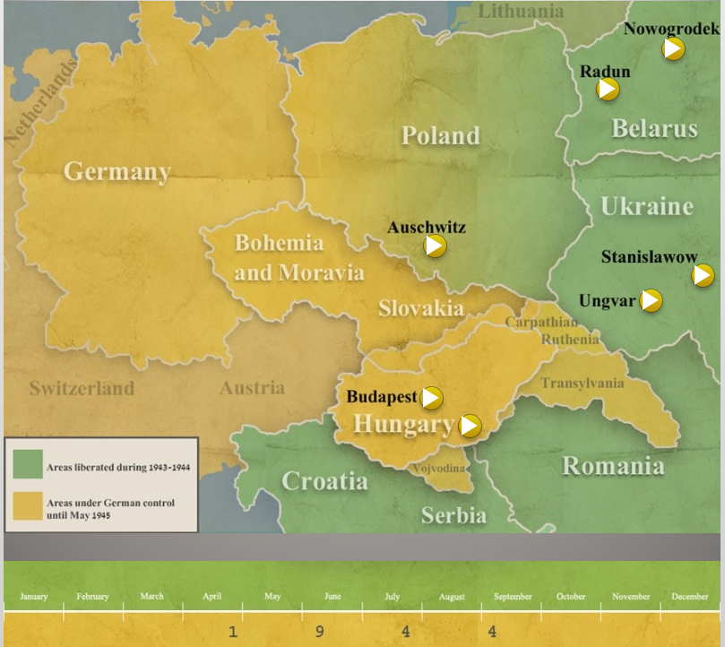
Timeline of liberated areas

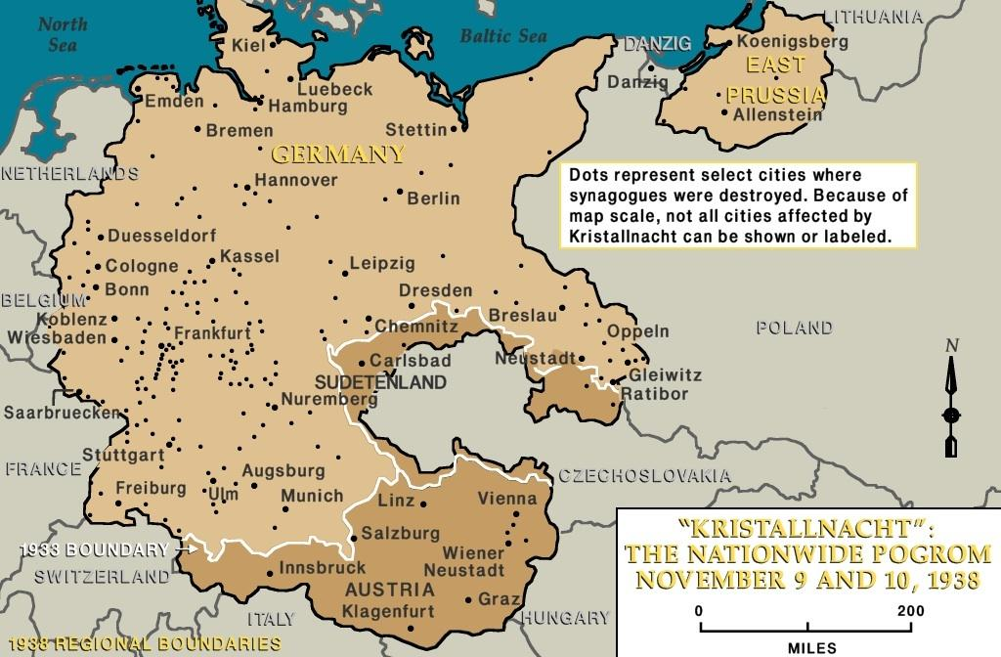

Kristallnacht (Night of Broken Glass) 1938 – Each black dot represents a city where one or more synagogues were destroyed. Not all can be represented due to map scale.
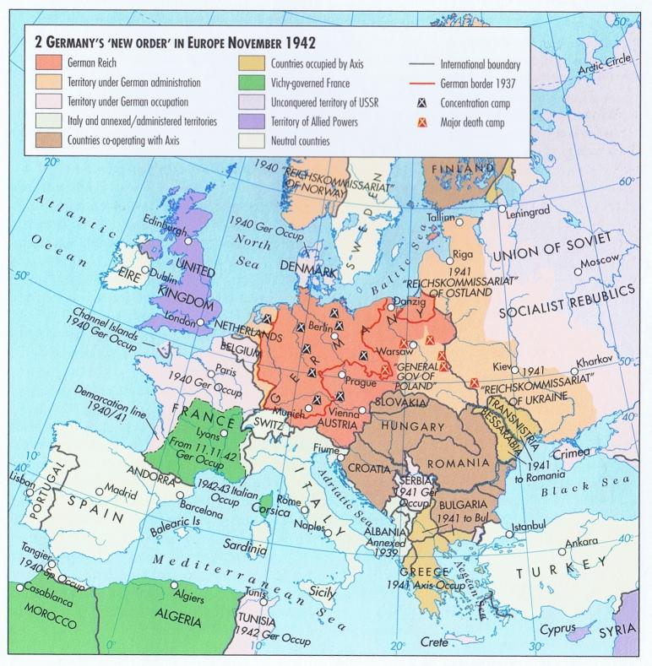
Germany’s influence in Europe as of November 1942

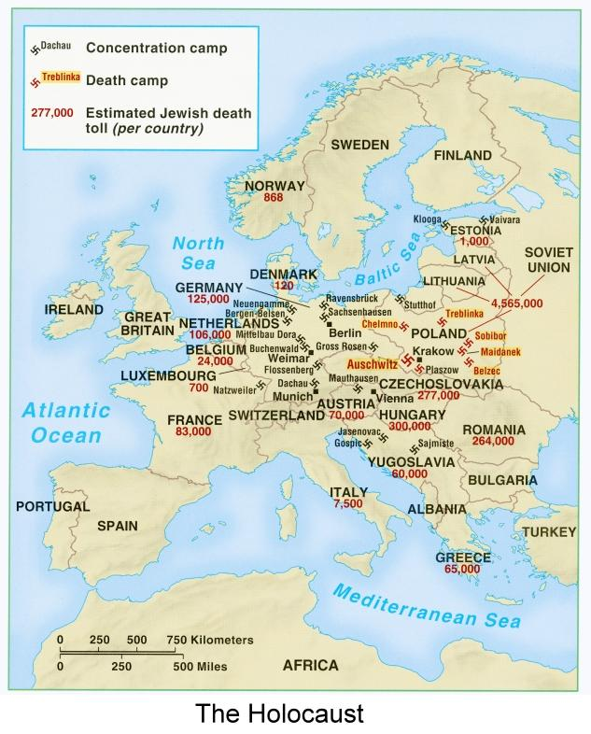
Distribution of Concentration Camps, Death Camps, and Jewish death toll throughout Europe
