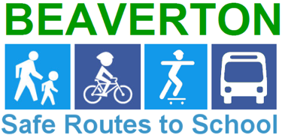
Barnes Elementary
Safe Routes to School Action Plan

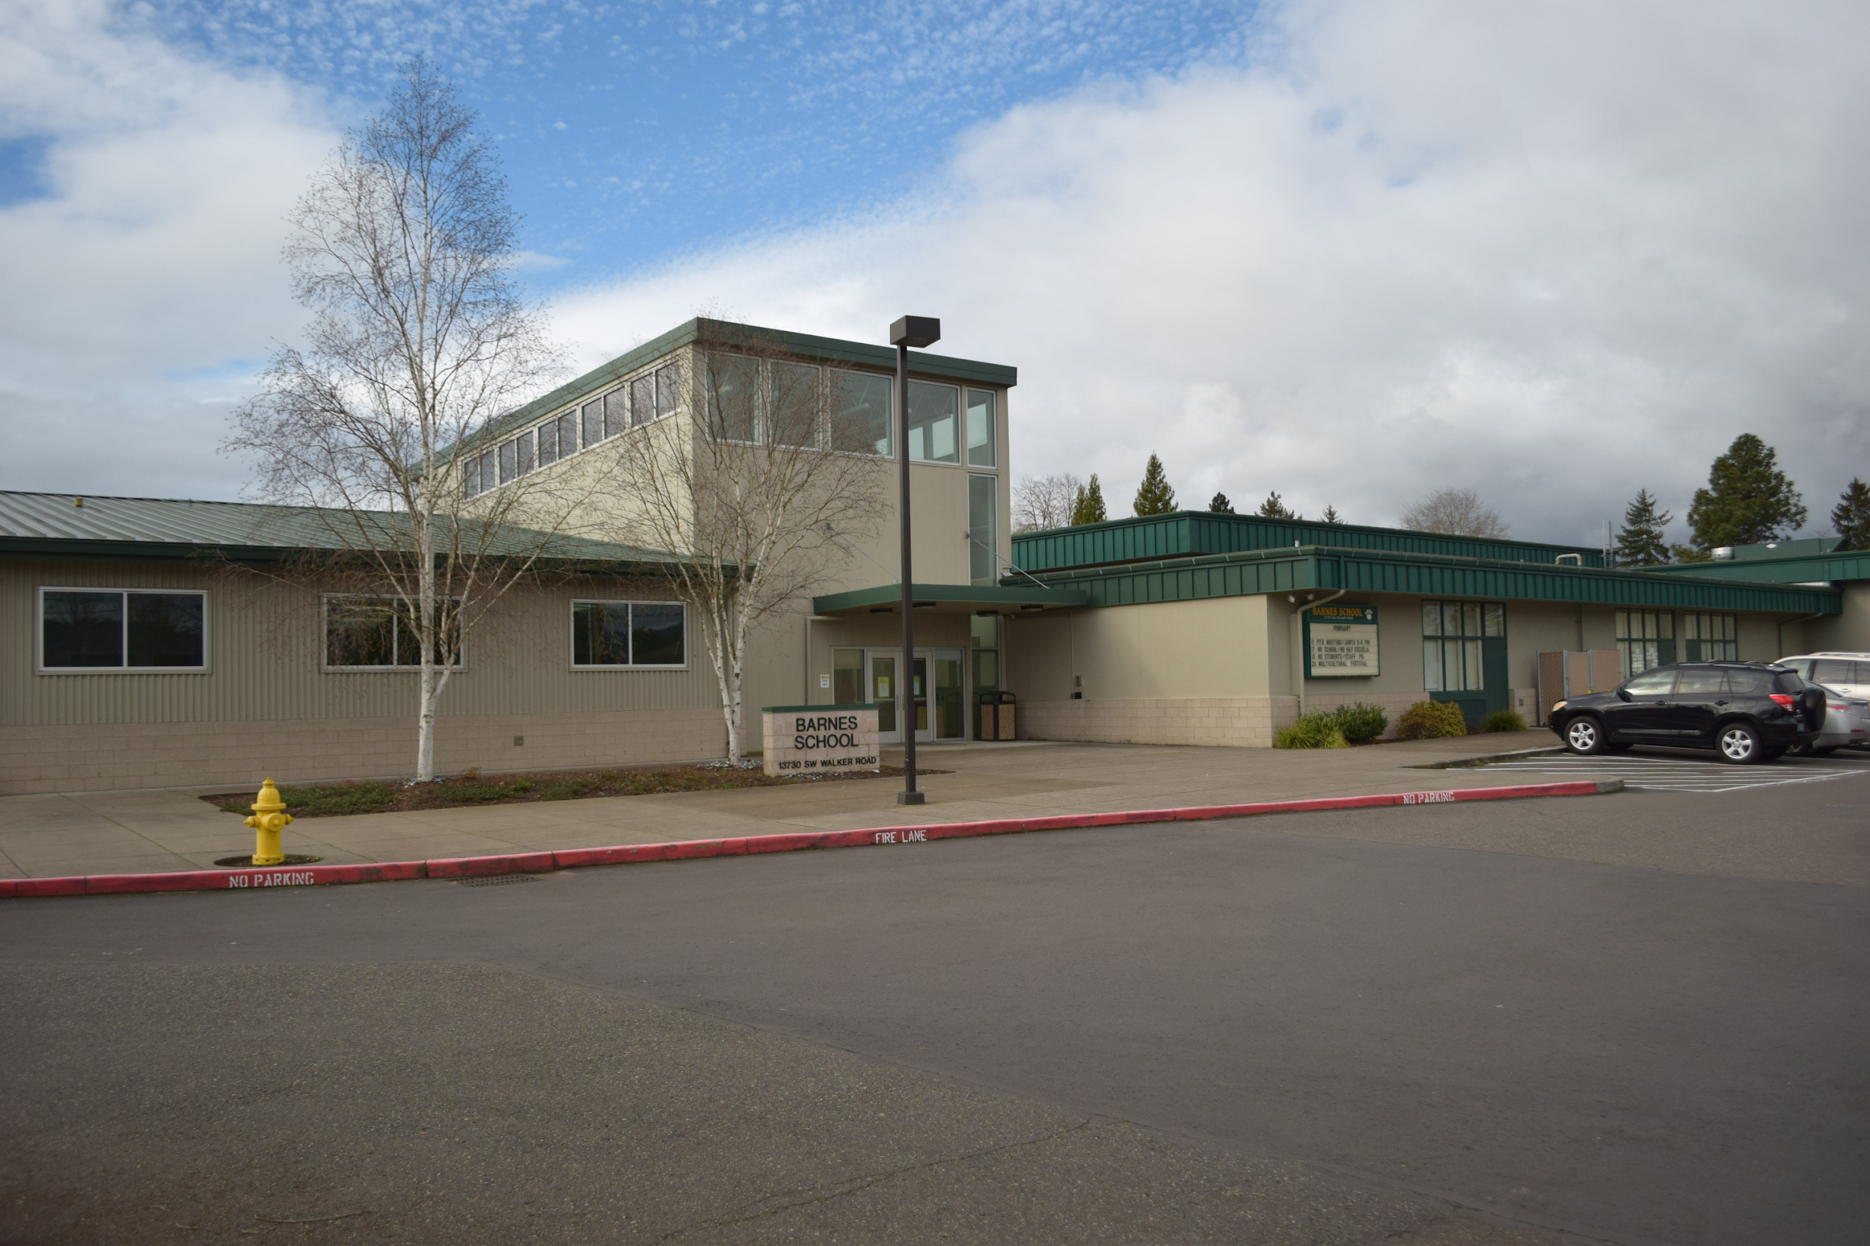
Spring 2020

Table of Contents

INTRODUCTION 3
What is Safe Routes To School? 3
Why is SRTS Needed? 3
School Information 4
The Project Team 4
EXISTING CONDITIONS 5
School Attendance Area 5
District Transportation Policy 6
School Supplemental Transportation Area 6
Walk and Bike Audit Evaluation 7
Active Transportation Support 7
Arrival/Departure Procedure 8
EVALUATION AND DATA-MAY 2019 10
Student Travel Data 10
Parent Survey Data 12
RECOMMENDATIONS AND PLAN IMPLEMENTATION 13
Infrastructure Options 13
Programmatic Options 15
Education: Introduce, inform and promote SRTS program to students, staff and community. 15
Encouragement 15
Evaluation 16
Enforcement 16
Prioritization 17
FINAL THOUGHTS 17

INTRODUCTION

What is Safe Routes To School?
The Beaverton Safe Routes to School (SRTS) program is all about creating safe, convenient, and fun opportunities for youth to walk and roll (bike, scooter, skateboard and bus) to and from schools. This is important for the health and safety of our kids and to foster livable, vibrant communities. SRTS programs increase physical activity and improve unsafe walking and bicycling conditions on routes to and from school and throughout the community.
The majority of students attending Beaverton School District (BSD) schools are either within a safe walk/ bike zone or are offered bus service. BSD’s SRTS Program encourages students to walk and bike to school where it is possible and take the bus provided by the school district when it’s not.

Why is SRTS Needed?
A generation and a half ago, nationally, over 50% of students walked or biked to school; now only 13% of students use active transportation to get to school. Since the mid 1970s the number of children who are overweight has roughly tripled from 7% to almost 20%. Health concerns related to sedentary lifestyles, including diabetes, high blood pressure and cardiovascular disease, have become the focus of statewide and national efforts to reduce health risks associated with being overweight. Additionally, on average, 30% of students are being driven to BSD schools every day. That is an extra 12,000 cars on the road and around 23,500 pounds of carbon emissions daily. Safe, active transportation is important for the health of our students, our community and our planet.
Beaverton School District would like to be part of the solution. SRTS Coordinators are working with each school to develop a comprehensive SRTS Action Plan. Integrated into each plan are the “Six E’s”:
Education – Students learn lifelong safety behaviors and skills, while parents can learn about the benefits of active transportation and safe travel for students to school.
Encouragement – Parents and students are invited to engage in biking and walking events and activities that promote healthy and active transportation options.
Enforcement – Promote safe walking and biking through consistent enforcement of traffic laws around and on the routes to schools.
Engineering – Implement engineering changes such as new sidewalks, improved crossings, and other traffic calming measures to enhance safety of the walk or bike to school.
Evaluation – Assess the neighborhood travel routes, and drop-off and pick-up processes at the school; as well as evaluate the success of the SRTS Program as a whole and throughout the district.
Equity – Reduce health and wealth disparities by providing equitable services in all school communities.

School Information
School Name: | Barnes Elementary School  https://barnes.beaverton.k12.or.us/
Address: | 13730 SW Walker Road
County: | Washington
School District: | Beaverton School District  www.beaverton.k12.or.us
Enrollment: | 623
Title 1 | Yes
Action Plan Contact: | Leah Biado-Luis leah_biado-luis@beaverton.k12.or.us 503-356-4274

The Project Team
School Principal: | Paul Marietta Paul_Marietta@beaverton.k12.or.us
Parent/ Staff Representatives: | Judith Linnick judith_linnick@hotmail.com
Local Traffic Safety Representative | Sergeant Colin Kurfess colin_kurfess@co.washington.or.us
City or County Representative: | Shelley Oylear shelley_oylear@co.washington.or.us
Community Representative: | Mark Nicklas, Beaverton Four Square Church, mnicklas@b4church.org
School District Representative: | Rick Puente rick_puente@beaverton.k12.or.us
BSD Safe Routes to School Coordinator: | Leah Biado-Luis leah_biado-luis@beaverton.k12.or.us

EXISTING CONDITIONS

School Attendance Area
Barnes School is the oldest continuously operated grade school in the district, founded on its present site in 1879. The school attendance area is bound by Highway 20 to the North, Highway 8 to the South and SW 158th to the East. The school's small walkable area is bordered by the three heavily utilized arteriel roads, Murray Blvd runs North and South and Jenkins Rd and Walker Rd run East to West. Both the Nike World Campus, West of the school, and Tektronix, South of the school, bring a significant amount of work traffic to the area. Most of the streets North of the school are county roads and to the South, belong to the City. Students that reside North of the school within the 1 mile walkable area are provided with hazard busing due to insufficient sidewalks and a safe crossing on Walker Road. Students East of Ecole Ave. are also provided with hazard busing due to the volume of traffic and high speeds (cars frequently travel at 40 mph along Ecole Ave utilizing this road as a cut-through), as well as insufficient sidewalks on the East side of Ecole Ave. Finally, this school is a dual language school (English and Spanish) and a small percentage of students reside outside of the school attendance boundary. Those students are offered a shuttle bus that departs from Elmonica Elementary School.
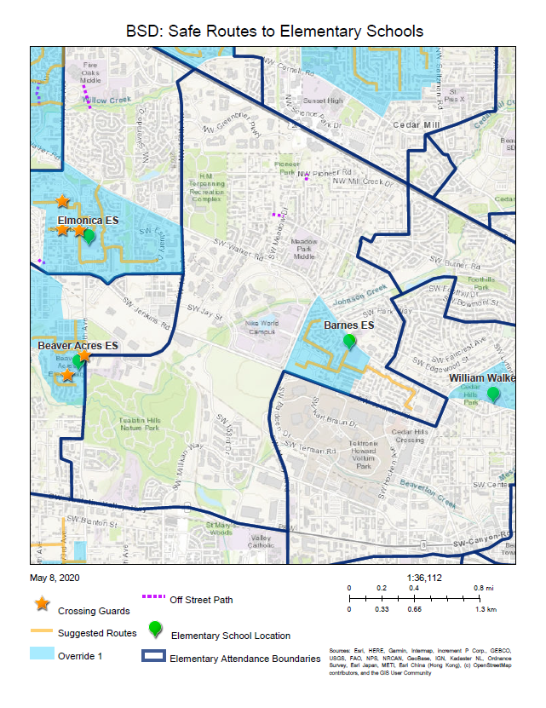

District Transportation Policy
Walking and biking are the preferred methods for students traveling to and from school if students live within one mile from the school property. For those living beyond one mile, busing is the preferred mode.
Students are eligible to ride the bus if they meet one or more of the following criteria:
- They are a primary student who resides more than one mile from school.
- They are a primary student who resides less than one mile from the school, but within a hazardous area, that has been approved by the State Board of Education and the Beaverton School District School Board for Transportation.
- They are a middle or secondary student who resides more than one and one-half miles from school.
- They are a middle or secondary student who resides less than 1 ½ mile from the school, but within a hazardous area, that has been approved by the State Board of Education and the Beaverton School District School Board for Transportation.

School Supplemental Transportation Area
Barnes has one supplemental transportation plan in place which includes three hazard areas: West of SW Murray Road, East of SW Ecole, and North of NW Walker Road. These hazard areas are due to speed and volume of traffic along all three roads, lack of sidewalks along NW Walker Road and the East side of SW Ecole and no controlled intersection on SW Ecole or enhanced crossing across NW Walker Road. These students are encouraged to ride the bus.
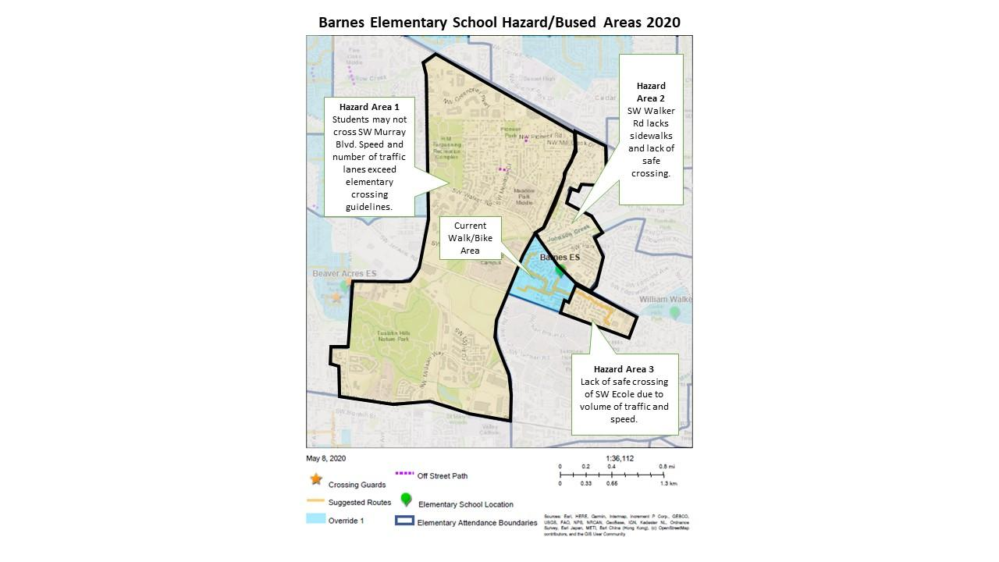

Walk and Bike Audit Evaluation
The walk and bike area for Barnes is very small. Apart from Burlwood Street, most of the area lacks sidewalks. However, all routes are located within a residential area with little traffic and families feel safe walking in the street.
There are two main entry points for pedestrians and bicyclists to enter campus:
- Walking path from 139th Ave.
- SW Briggs Rd.
The walking path from 139th Ave. is dark, littered with garbage and school sign is covered in graffiti, making it illegible. The fence on the north side of the path is also in disrepair.
Briggs Road has completed sidewalks on the east side that connect to the entrance at the back of the school. While there are no marked crossings, there are stop signs and stop lines at Briggs Ct. and Brightwood St. there is also a school crossing sign close to the intersection of Briggs Rd. and Brightwood St. Additionally the crossing at Burlwood St. and Briggs Rd. has ADA accessible ramps.
Families have expressed the desire for an increased opportunity for walking and biking to school, especially those residing east of Ecole Ave. and north of Walker Rd.

Active Transportation Support
Barnes is beginning to look at active transportation options. The crossing of SW Walker Road and SW Ecole Avenue has always been a barrier to promotion. With the potential upgrades due to the Walker Rd. Project and the possibility of coordinating with local faith partners on the installation of a RRFB, Barnes wants to be ready for an opportunity to show how the community can benefit from a proper crossing treatment of Walker Rd. With the county, Metro and state looking at the benefits of improving routes around schools, especially in Title One school areas, the school’s Action Plan Team will work to identify ways to ensure that Barnes families are ready for more active transportation opportunities. The first step included an increase in pedestrian and bicycle safety education. All Barnes elementary students participated in bicycle and pedestrian safety classes during P.E. in the 2019-20 school year.
The school community is very active and parents favor more opportunities to walk and bike to school. They know that with more people walking and biking, the neighborhood and the commute to school is safer for everyone.
Beaverton School District and the school’s Safe Routes to School Team know that students who are active while traveling to school arrive better prepared to learn and are more likely to get the CDC’s recommended 60 minutes of daily exercise. Increased walking and biking in and around the school neighborhood also helps reduce pollution and congestion for our students and staff and teaches safe, healthy and active skills that can last a lifetime.

Arrival/Departure Procedure
Between 34% and 40% of students, 249 and 211 students respectively are driven to school according to Winter 2020 Student Travel Mode Surveys. The majority of Barnes ES students are either within the designated walk/bike area or have bus service provided (including shuttle bus service for a group of students residing outside of the Barnes ES attendance boundary).
There are two parking lots and a third small lot for staff use on the west side of the school. The front parking lot is intended for visitors who need to park and enter the building. Motorists that park here do not have enough room to turn around and will need to park and back out, in order to exit through the same way they entered. This is also the route utilized by daycare vans which arrive to pick up students after the school buses have departed. Only the school buses and daycare vans are to utilize the center exit lanes.
The bus area is fully used and the first bus, that departs to take students for after school care across Walker Road, must pull in through the car route entrance and blocks the center exit lanes. Students must cross through the parking lot and in front of the line up of other buses to load this first bus. Adequate supervision and safety procedure education for these students is important. Additionally, the majority of students who ride the buses are unaware of other safety procedures, such as staying on the school side of the yellow stand back line and not walking in between buses. Bus safety education and enforcement during arrival and dismissal by staff is recommended.
The parking lot in the back of the school is utilized primarily by parents dropping off or picking up students curbside from their vehicle, or parking in the lot to walk up and meet their student. A handful of families utilize the back path and/or exit here to walk home. The flow of traffic moves fairly well, however, with the amount of cars in the lot, safety and congestion could be improved with more opportunities for walking and biking in this area. Drivers who drop or pick up their students in cars are reminded to pull all the way forward and that children must exit towards the sidewalks. Pedestrians and motorists need to use extra caution in this lot, as there are no identified crossing areas for families to travel from their parked cars to the building. After school, many cars can be found idling while they wait, this is an environmental problem that contributes to poor air quality for young children waiting to be picked up.
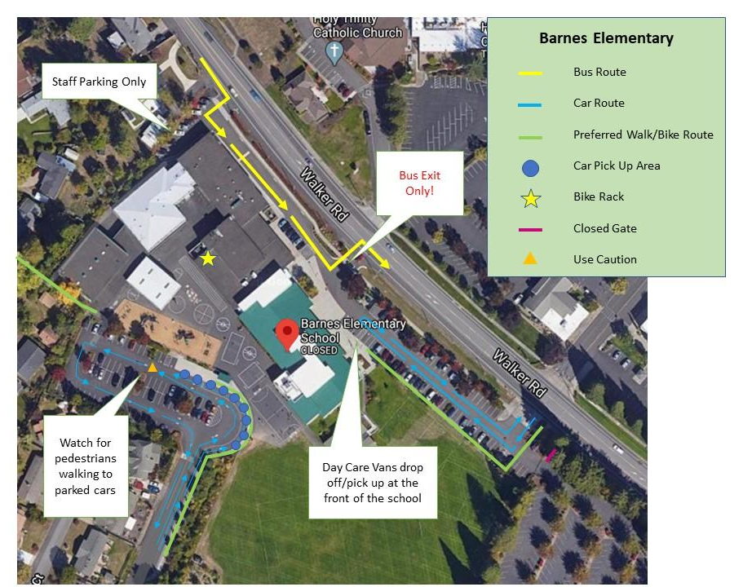

The following reminders would be helpful to include in regular messaging to parents, day car van drivers or other care givers who drive in and around school campus:
- Parents who are dropping off students curbside should remain at the wheel and turn off engines while waiting during departure time.
- Parents in the drop off/pick up lane should pull all the way forward and remain in their lane until merging with through traffic at the west end of the building.
- Children must exit towards the sidewalks.
- Use extra caution when walking to and from parked cars in the back parking lot.
- Parents should only use the front parking lot if they need to park and enter the building. The center exit lanes are for buses only.
- Parents are not to utilize the staff parking lot for parking, u-turns, or as a drop off/pick up site.
- Parents must yield to pedestrians.
- U-turns, double parking and blocking crosswalks and intersections is illegal and creates a dangerous situation for others.

EVALUATION AND DATA-February 2020

Student Travel Data
We conducted In-Class Student Tallies and this is how our students travel to and from school.
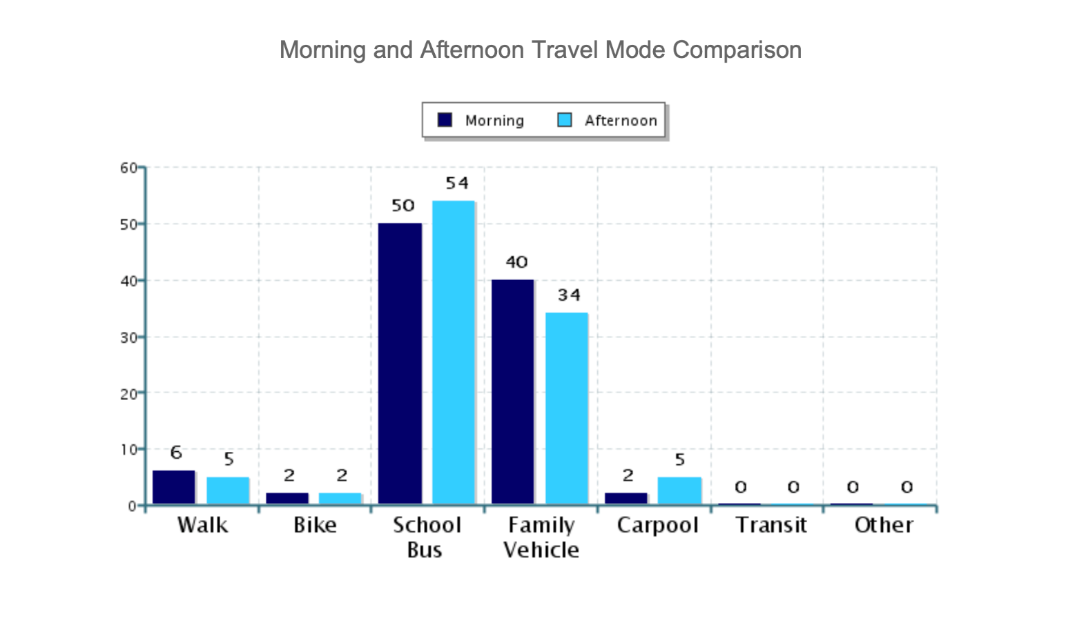

Parent Survey Data
We conducted a Parent Survey to gather information about how students get to and from school and learn about concerns and issues surrounding the walk or bike to school.

RECOMMENDATIONS AND PLAN IMPLEMENTATION

Infrastructure Options
- Sidewalk infill on Walker Rd, north and south side of the street from Murray Blvd. to Wynwood Ave.
- Enhanced crossing with crosswalk and RRFB on Walker Rd at Ecole Ave and staffed with crossing guard (ideally two). (This crossing could also be located on Walker Rd but offset from Ecole Ave and across from the east entrance to school campus.)
- Treatment or calming measure along Ecole Ave to decrease speed of motorists. While the posted speed is 25 mph, cars often travel at 40 mph and the volume of traffic is large due to use as a cut through road.
- Replace all campus signs that are faded and/or damaged.
- Install no idling signs along curb where parents pick up/drop off by car.
- Crosswalk installation in the rear parking lot from curb to first row of parking.
- Beautify and clean up the walking path adjacent to the gym (fix fencing, trim trees/brush, clean up litter, replace signs).
Please note, all infrastructure and enforcement projects are coordinated through Washington County and City of Beaverton or the Beaverton School District.
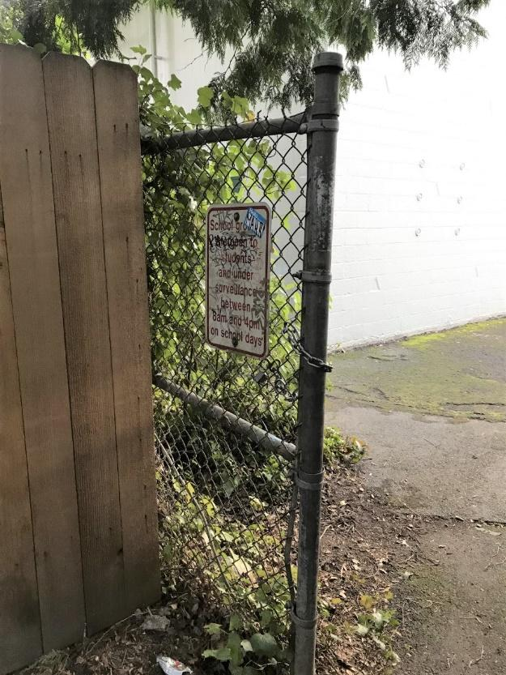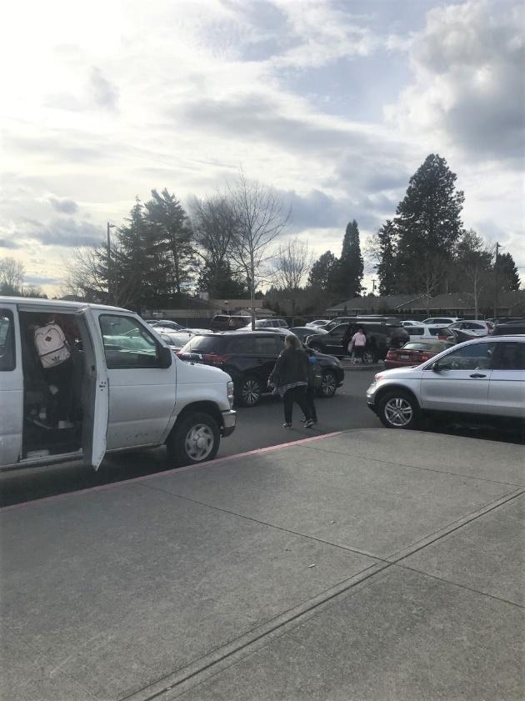

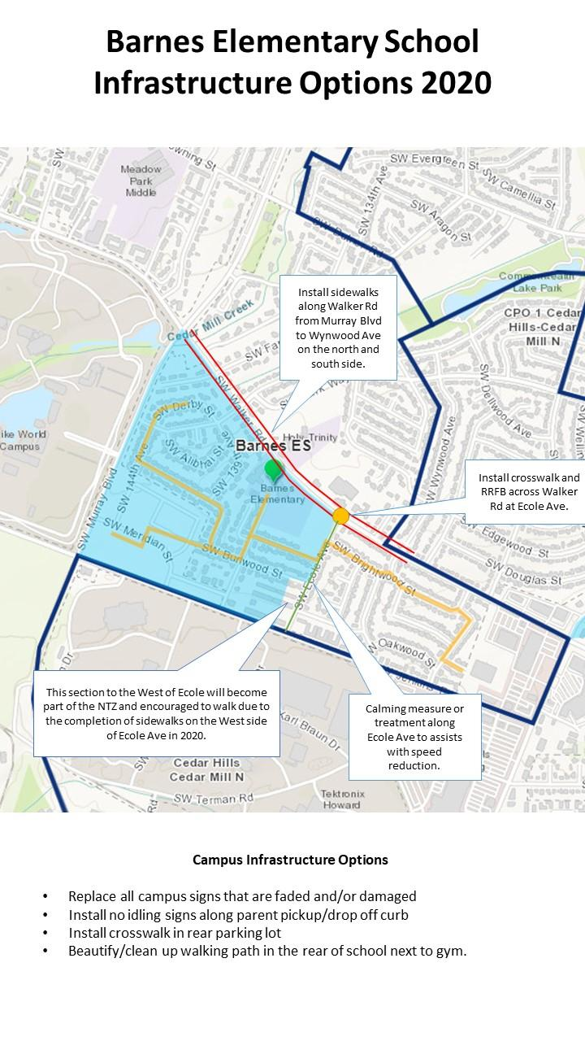

Programmatic Options

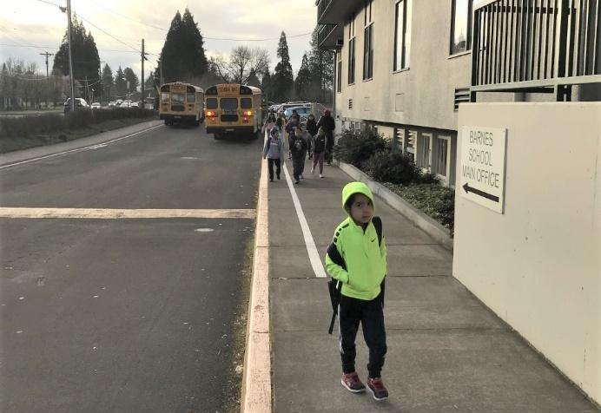

Education: Introduce, inform and promote SRTS program to students, staff and community.
- Post procedures poster and preferred routes map inside school building and on school’s webpage.
- Distribute procedures map, safe driver tips, basic Pedestrian and Biking safety information and walk map at back to school and after spring break.
- Bike/ Pedestrian Safety in PE classes every three years.
- Bus safety procedures practiced with students at back to school and after spring break. Specifically: walking outside of the stand back line, danger zones when walking near buses and how to load and unload buses safely.
- Anti-idle campaign around Earth Day, could be student-led.

Encouragement
- Encourage students, staff and community to participate in walking and rolling to school with a Walk + Roll event. International Walk and Roll to School Day is held annually in October. Could include an option to park and walk from a designated location.
- Encourage students to ride their provided school bus with a “Love the Bus” event (often this is held in February).
- Regular SRTS safety tips and updates in monthly school newsletter.
- Host a community walk or bike ride/rodeo as an after school event to practice pedestrian and bike safety skills, build community and increase knowledge of neighborhood safe routes.

Evaluation
- Parent survey in May 2020.
- Student Tally in May 2020.

Enforcement
- Traffic reduction: examine and enforce rules at school level
  - Staff or sandwich board signs encouraging parents to pull forward and designating where students should exit cars.
  - Handouts and messaging at Back to School and throughout the year on safe driving practices and campus traffic procedures.
- Ecole Ave speed reduction, ask for enforcement at Back to School time and throughout the year.
- Streamline all daycare vans to pick up and drop off at the front of the school.
- Enforce bus safety with additional staff to supervise students walking next to buses and especially for students who have to cross parking lot to load first bus after school.
- Lock the back gates after drop off until staff members are present for dismissal.
- Designate a separate area for parents to walk up and pick up students, possibly the west back gate near walking path.
- Note: Enforcement requests are best made here.

Prioritization
- Coordinate with Washington County LUT and Faith Partners to install an enhanced crossing with RRFB across Walker Rd.
- Place community requests for enforcement along Ecole Ave during first weeks of school and throughout the school year. Place community concerns with Washington County LUT about speed and volume of traffic along Ecole Ave.
- Regular SRTS safety tips and updates in monthly school newsletter
- Distribute procedures map, safe driver tips, basic Pedestrian and Biking safety information and walk map at back to school and after spring break.
- Post procedures poster and preferred routes map inside school building and on school’s webpage.
- Place work order for the replacement of any campus signs that are worn or damaged.
- Coordinate with community to clean and beautiful the walking path. Possible groups to ask, include: CPO 1, Scouts, Faith Partners.

FINAL THOUGHTS
Thank you for your interest in making the trips to school safe, healthy and fun! This Action Plan is to be updated annually to continue to make it easier for parents, guardians and students to choose to take the bus, walk or bike to school. We need to continue to work to make the active choice the easy choice for the health and safety of our students and community.
The success of this plan will require students, parents, school staff, Washington County, City of Beaverton, Beaverton School District, CPO 1 and the community to work together to ensure students are able to walk, bike or roll to school safely.
We need people to help us with this on-going project. If you would like to be more involved in Barnes Elementary School’s SRTS Program, please reach out to Mr. Marietta or the PTB.

