  What is a School-Parent Compact?
  A School-Parent Compact is jointly developed by our parent involvement team and school leadership team. This document, as required by Title 1-A of the Elementary and Secondary Education Act, outlines how parents, school staff, and students will share responsibility for improved academic achievement at our school, and the means by which the school and parents will build and develop partnerships that help children achieve Idaho’s high standards.
  Activities
  to Build Partnerships
  Communication about Student Learning
  - Parent-Teacher Conferences in Fall and Spring
  - Parent Involvement Team Meetings
  - School and Teacher Newsletters
  - Progress Letters and Calls
  - PowerSchool Parent Portal
  - Class Dojo
  - Spanish Translations of documents/Interpreters at meetings and conferences
  Parma Middle School
    - 2021-2022
  Parma School District #137
  P R I D E
  
  REVISED 01/10/2022

  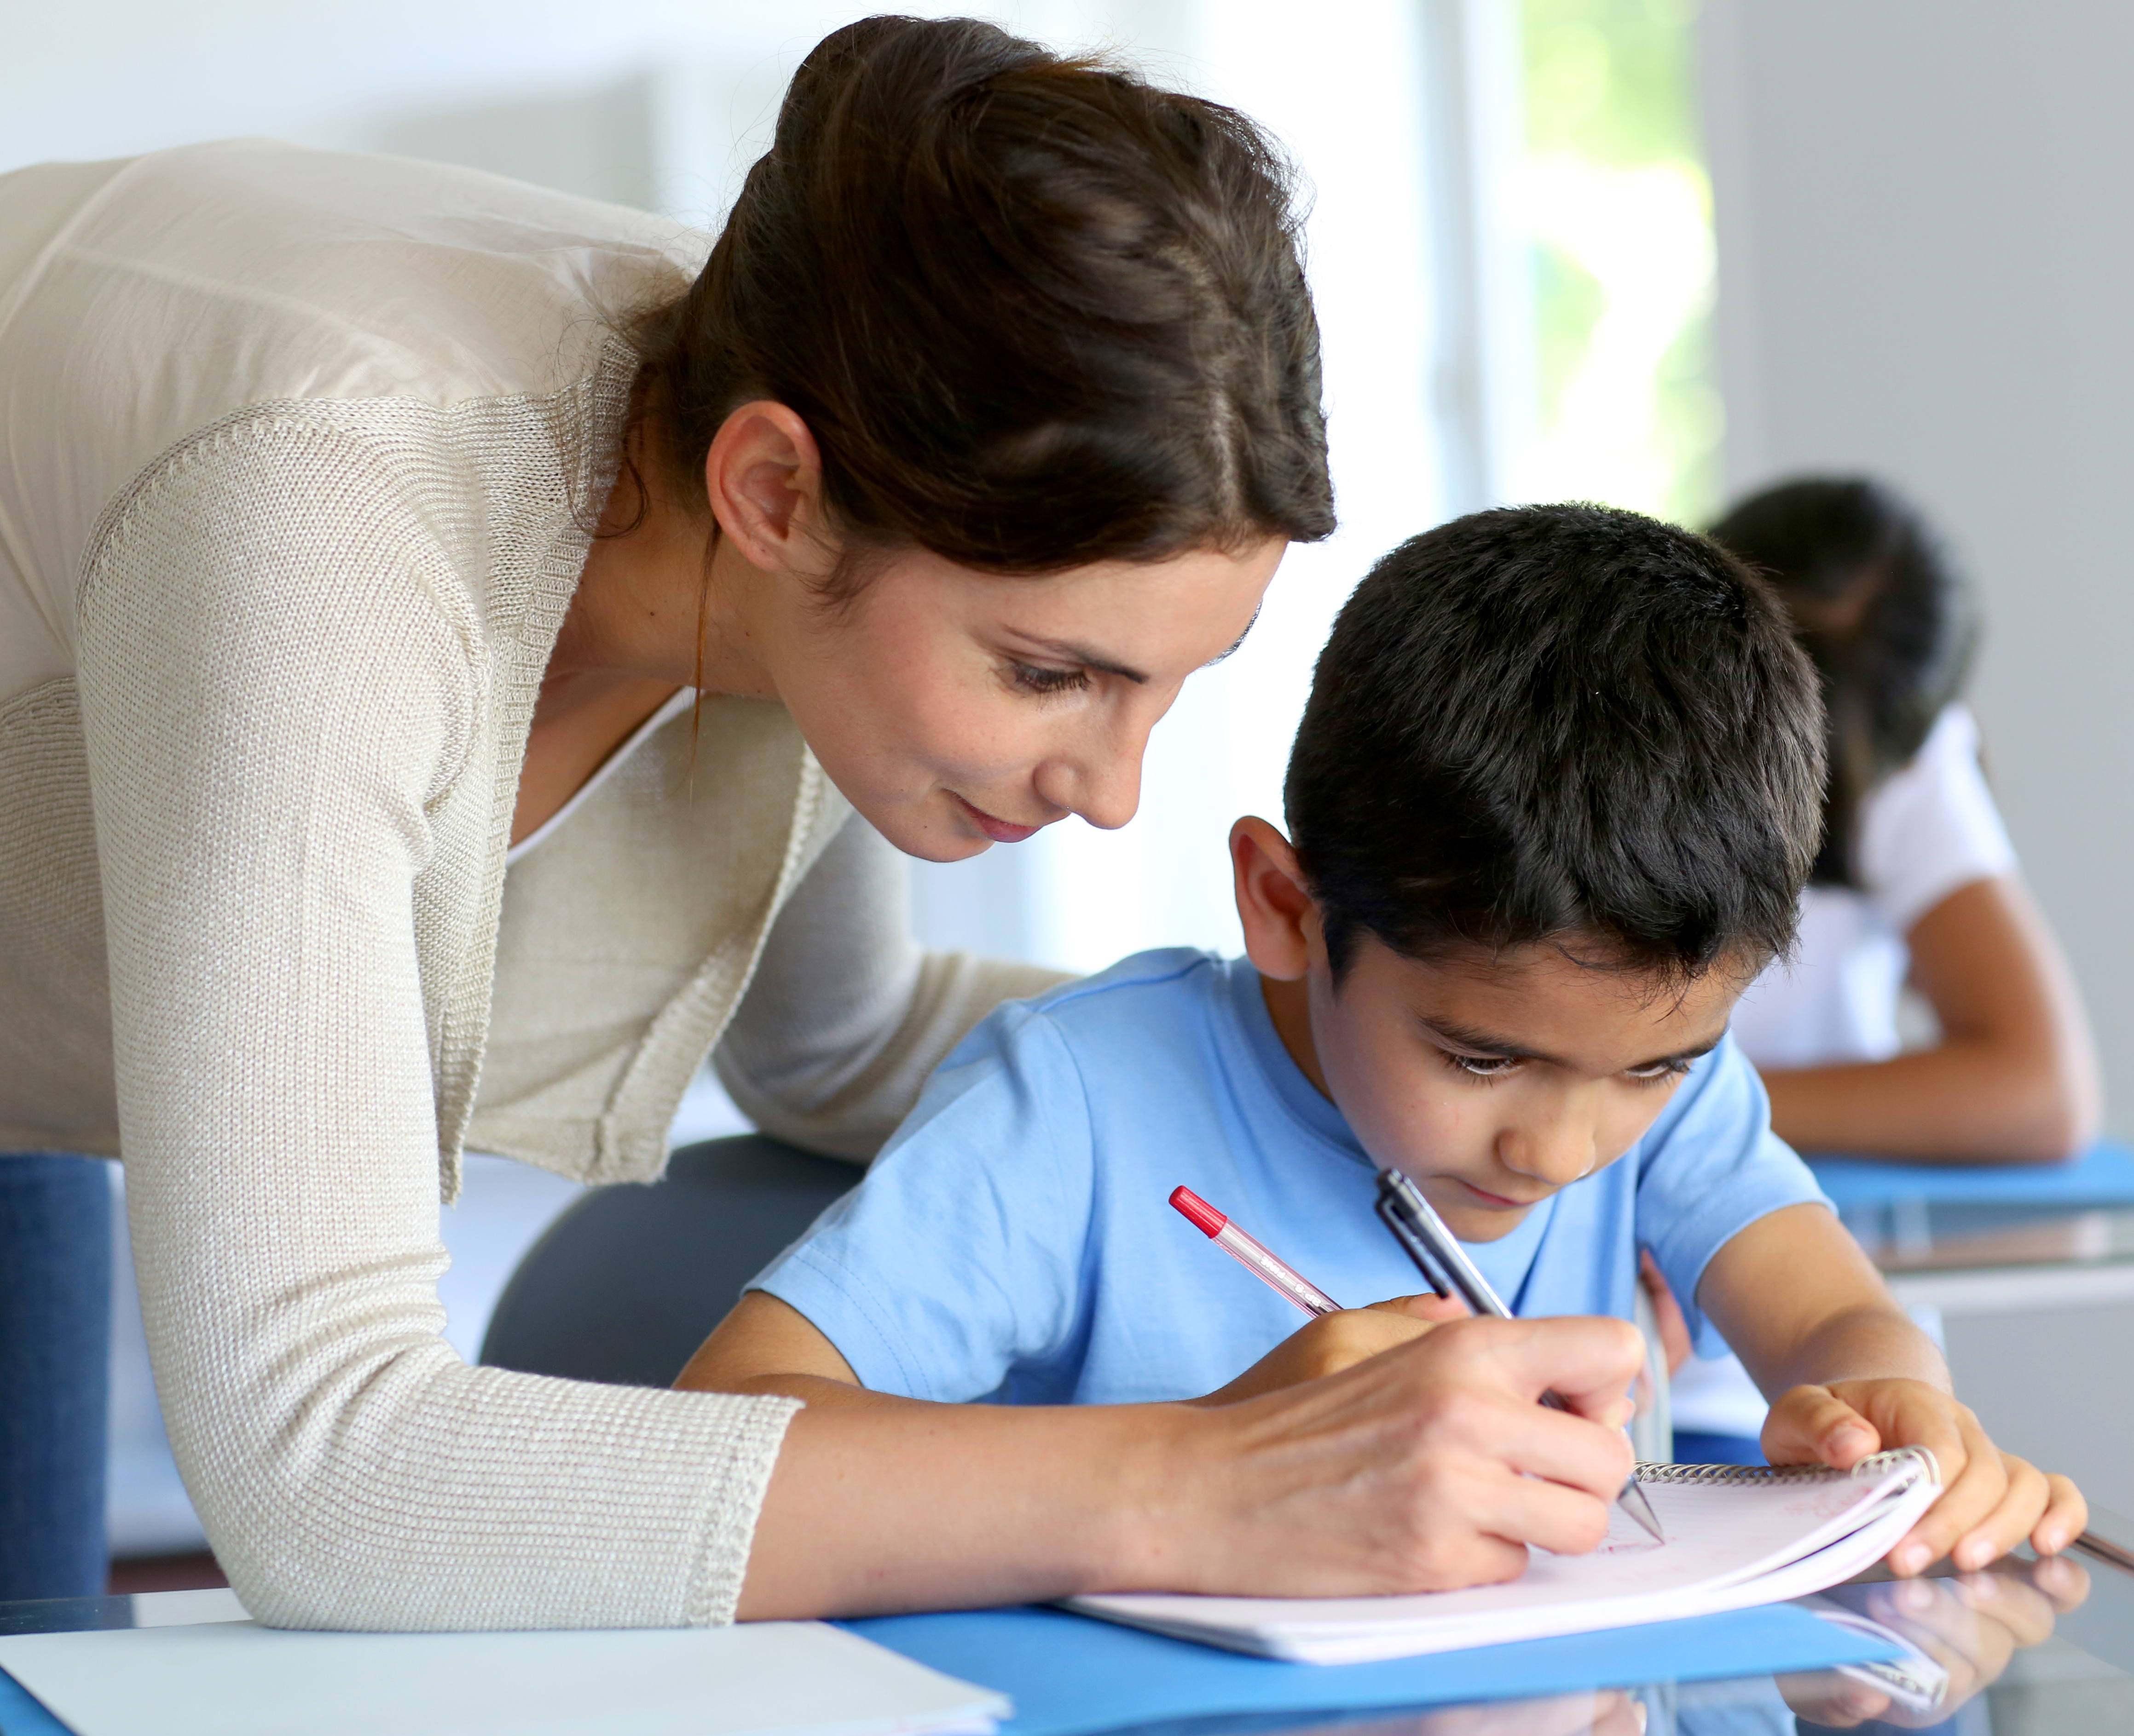
  Goals for Student Achievement
  District Goal
  The Parma School District will provide a solid foundation of knowledge and skills on which students can build a rewarding career and life of purpose. Our teachers will provide a learning environment of excellence while communicating regularly about student needs in order to improve programs, instruction, and student performance.
  School Goals and Focus areas
  We continue to focus on improving math scores and reading and writing scores in each grade level. Our students are steadily achieving increased proficiency on state standards and are ready for high school.
  We also provide career and trade-focused learning opportunities for PMS students.
  Teachers, Parents, and Students—Together for Success
  Teacher/School Responsibilities
  We provide parents reasonable access to staff and encourage communication with teachers about needs and strengths of their children.
  We provide parents opportunities to volunteer and participate in their child’s classroom and school activities.
  We provide educationally focused events geared toward parents’ abilities to help their children succeed as learners and individuals.
  Student Responsibilities
  Students will exhibit Panther P.R.I.D.E. by
  *coming to school prepared to learn, *persevering,
  *participating actively and positively in class, *producing quality work.
  Do your best every day.
  Also, Read for Leisure every day.
  Family Responsibilities
  * Encourage PRIDE in attitude and action
  * Support school discipline policies and work with us if any issues arise
  * Make sure children attend school regularly
  * Encourage ample sleep, nutrition, and non-screen time activities
  * Establish a time and place for study and homework
  * Make positive use of family time
  * Go back to basics—Talk to kids and ask about their day.
  Contact Us
  Parma Middle School
  905 E McConnell Ave
  Parma ID 83660
  208 779 4069
  Visit us on the Web:
  parmaschools.org

