Instructor Module

Using the Instructor Dashboard
Instructors can access their assigned courses and have access to tasks from their dashboard.

- Login to your Instructor Account here or find the link on your PD student account home page.

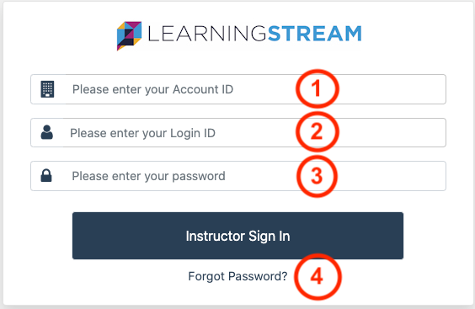

Enter:
- Account ID (You will receive an account ID.)
- Login ID or email
- Password (You will receive a temporary password upon initial login.)
- Forgot Password? link will email your account information

2. Instructor's Dashboard

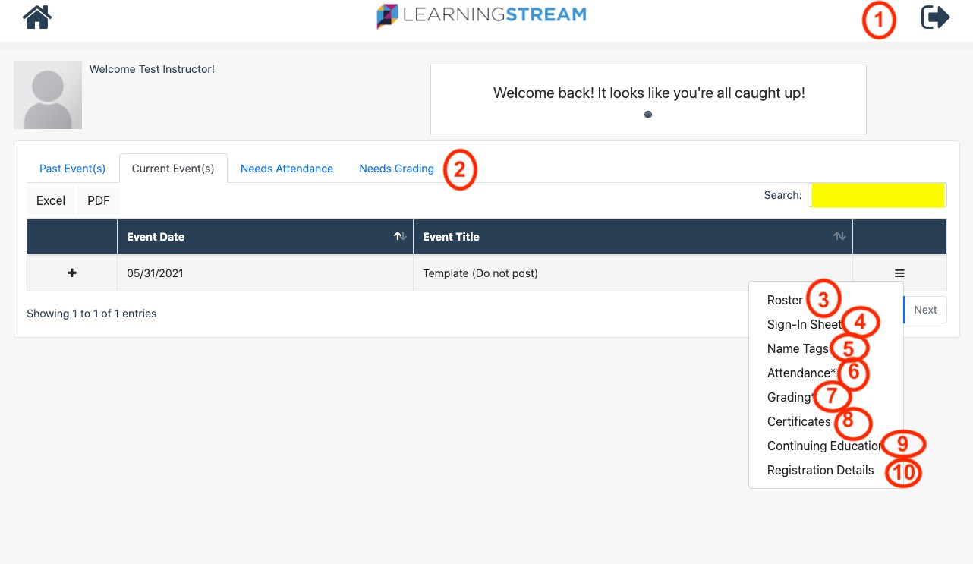

From your home page, you can:
- Logout
- Default tab shows Current Event(s). Click tabs to view Past Event(s), Event(s) that Need Attendance, and Event(s) that Need Grading. View and print as an Excel or in PDF format. Search bar allows you to enter Course Name.
Click on the menu button which consists of three parallel horizontal lines to display actions for the event.

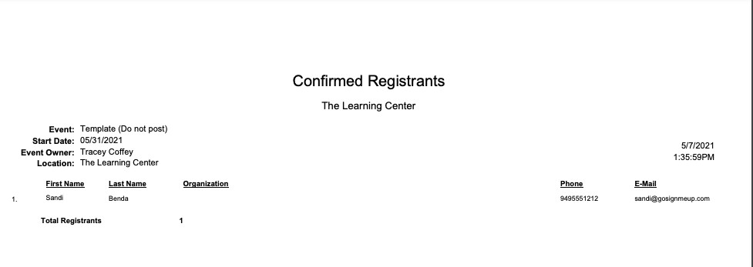
- Sample Roster
- Sample of Sign-In Sheet

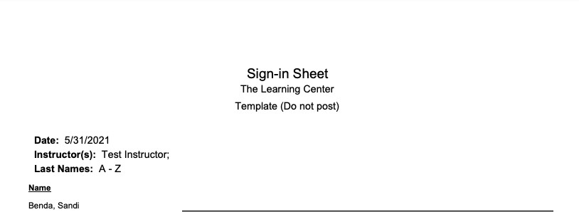

- Name Tags (Sample) - Created by Admin and assigned to the course with layout format: Avery 5384 or Avery 5395

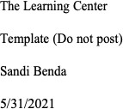

- Attendance Page PLEASE MARK ATTENDANCE FOR VIRTUAL SESSIONS

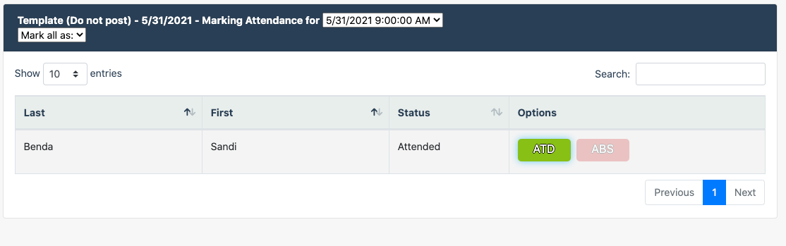

- Grading - Grades manually recorded for assignments assigned to an event in Learning Stream. We will use CANVAS for our grading purposes for asynchronous courses
- Sample of Certificates-These are automatically distributed after students complete evaluations.
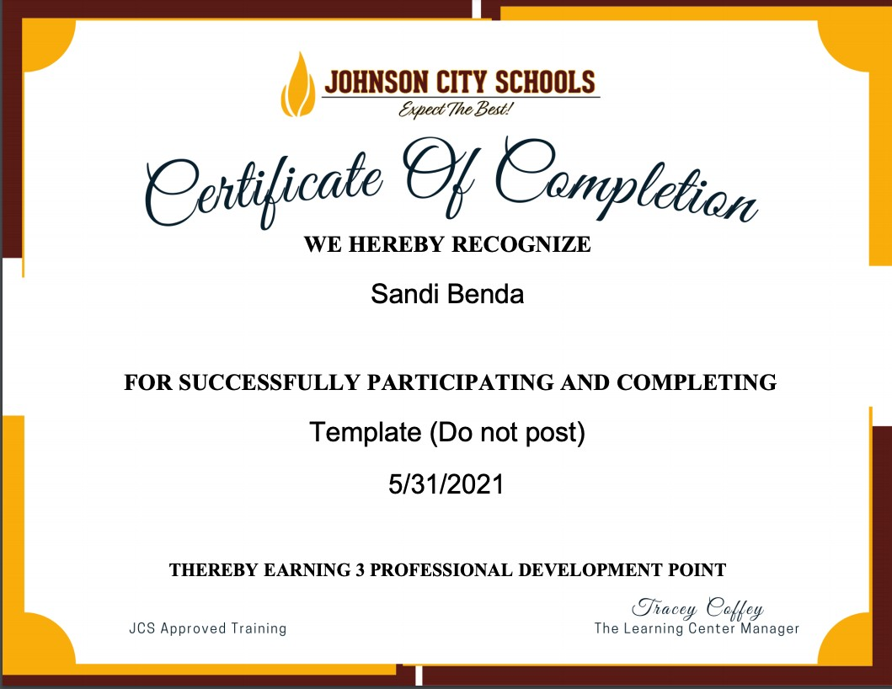
- Continuing Education - Sample
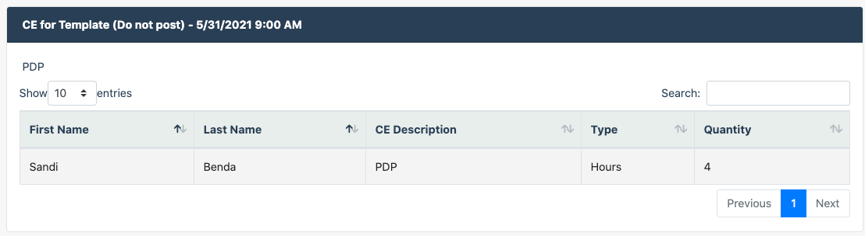

- Registration Details - Sample - Report is in excel format
