Buckner Elementary School Council
Oldham County Schools
REGULAR CALLED MEETING
A G E N D A

May 9, 2022
3:00 p.m.

Meeting code - Sbdm

- Call to Order

- Agenda Approval

- Approval of the minutes from the April 11 regular called meeting and the minutes from the April 26 special called meeting

- Council Action Items

  - Consider/Approve revisions of policies 1002 and 1008

  - Review/Approve Plan for Utilization of School Space and Schedules for the 2022/2023 School Year (Enclosure B)

  - Review/Approve the Bear Care Budget (Enclosure C)

- Enter Closed Session to Discuss Certified & Classified Personnel Selection per KRS 61.801 (1)(f)

- Adjourn

Record of Council Proceedings
(Minutes)
Buckner, Kentucky
April 11, 2022
Regular Called Meeting
3:00 p.m.

DRAFT
The Buckner Elementary School Council advertised a regular called meeting at the front of school and in the Buckner Buzz. The following members were in attendance in room 103: 1. Liz Dant 2. Erin Marvin 3. Lisa Laws 4. Beth Lindauer 5. Jennifer Dolan 6. Lee Hamilton 7. Devan Lindemier (on the phone) and 8. Roderick Pack were present.

- The meeting was called to order at 3:02 p.m.

- The Council reviewed and approved the agenda.

- The Council reviewed and approved the minutes from the March 14 & February 14 regular called meeting.

- Mrs. Dant reviewed the proposed policy changes of policy 1002 and 1008. After discussion, the Council took the policy changes under advisement.

- Mrs. Dant made the returning members of the Council aware of the updated trainings.

- Having no further business, the Council adjourned at 3:15 p.m.

Record of Council Proceedings
(Minutes)
Buckner, Kentucky
April 26, 2022
Special Called Meeting
7:15 a.m.

DRAFT
The Buckner Elementary School Council advertised a special called meeting at the front of school. The following members were in attendance in Liz’s office: 1. Liz Dant 2. Erin Marvin (virtual) 3. Lisa Laws 4. Beth Lindauer (virtual) 5. Jennifer Dolan 6. Lee Hamilton (virtual) and 7. Roderick Pack (virtual) were present. Devan Lindemier was absent.

- The meeting was called to order at 7:19 a.m.

- The Council reviewed and approved the agenda.

- Mrs. Dant reviewed the purchase plan of the virtual resource DreamBox. After discussion, the Council approved the purchase of DreamBox for the 2022-2023 school year.

- Having no further business, the Council adjourned at 7:23 p.m.

Enclosure A
May 9, 2022

Buckner Elementary School Council
Oldham County Schools

CONCERN:

Review revisions to Buckner Elementary SBDM policy 1002 and 1008

DISCUSSION:

I recently reviewed all of our SBDM policies and I am working to update a few of them in the upcoming months.

In this enclosure, you will find a proposal to amend policy 1002 and 1008. I will go into more detail at our meeting and will answer any questions that the Council may have.

RECOMMENDATION:

Review and approve the proposed policy revisions for 1002 and 1008.

BUCKNER ELEMENTARY SCHOOL COUNCIL POLICY

OPERATING COUNCIL MEETINGS 1002

TOPICS STATEMENT

a. Types Council members shall attend three (3) types of meetings:
(1) Regular - meetings held on a set day of the month and at a set time of day,
(2) Special - meetings scheduled as they are needed between regular scheduled meetings,
(3) Training - meetings designed for council members to acquire knowledge and/or develop skills.

Special meetings may be called by the principal at his/her discretion or upon the request of three council members.

b. Schedule of The Buckner Elementary School Council shall annually
Meetings establish a schedule of meetings for the coming year at a regularly scheduled meeting in August. The length of a meeting shall not exceed two (2) hours unless the Council agrees to extend the meeting to complete the agenda. If agenda items have not been addressed by the end of a meeting, a special meeting shall be called to complete the unfinished business.
c. Agenda Each regular and special council meeting shall operate by an agenda. The chairperson shall form the agenda with items provided by council members. The agenda shall be approved by the council at the beginning of the meeting. Other items may be added to the agenda with approval from the council. The agenda for regular meetings shall be written and disseminated to council members at least two days prior to the meeting. Teachers and executive officers of the PTO shall be informed of special meetings by the most convenient method.

d. Chairperson The principal shall serve as chairperson at all meetings. The responsibilities of the principal as chairperson shall be delegated to a teacher member of the council through a majority vote in the event of an emergency situation when the principal is unable to attend work for both general and special called meetings.
When the council is in the process of selecting a principal, the council shall select an alternate chairperson which shall be a teacher representative elected by a majority vote. The principal (or the interim principal) shall recuse him/herself from any meeting or portion of a meeting dealing with principal selection and the alternate chairperson will conduct the meeting.
e. Decision The method of making decisions and adopting policies
Making shall be by consensus. An effort shall be made to thoroughly discuss all possible alternatives, provide each member ample opportunity to be heard, and make a final decision that can be supported by the group. If a Council member feels a conflict of interest in a proposed action of the council, that member may remove himself or herself from the discussion and the decision making process.
In the event consensus cannot be reached,
the decision will be tabled for one month to attempt to reach consensus. If after the second month of discussion, no decision can be reached by consensus, the decision will then be made by majority rules.

f. Quorum Four (4) members of the Council, including at least one teacher and one parent member, shall constitute a quorum for the transaction of business.

g. Minutes Minutes of all regular and special council meetings shall be recorded in writing and kept on file in the principal's office. Minutes shall be stored in a minute book. A copy of all minutes shall be provided for the district superintendent. Minutes of the previous meeting shall be reviewed and approved by the Council at the beginning of each meeting.

h. Open Meetings The meetings of the Council at which any public business is discussed or at which any action is taken by the Council are declared to be public meetings, open to the public at all times, except for discussion of proposed or pending litigation against or on behalf of the Council, to allow the principal to confer with the Council on recommendations for employment, or to allow the Council to deliberate on the selection of a principal. All decisions made by the Council shall be made in open session. The Council shall abide by the state's open meetings law (KRS 61.810).

i. Recording The principal shall serve as the recording secretary for the
Secretary Council. The principal shall be responsible for:
(1) Recording in writing all minutes of
meetings,
(2) Processing minutes,
(3) Processing and disseminating meeting agendas.

Adopted – Buckner Elementary School Council – November 17, 1998
Revised - Buckner Elementary School Council – October 19, 1999
Revised – Buckner Elementary School Council – October 29, 2009
Revised - Buckner Elementary School Council ---April 15, 2019
Revised - Buckner Elementary School Council -

BUCKNER ELEMENTARY SCHOOL COUNCIL POLICY

ELECTION OF COUNCIL REPRESENTATIVES 1008

TOPICS STATEMENT
a. Membership The membership of the Buckner School Council shall consist of the Principal, two parent representatives, and three teacher representatives unless the school’s minority population is 8 percent or more. If this is the case, then, it must have at least one minority member of a parent and teacher on the school council. Combined minority population is determined by the annual reporting of attendance and ethnicity to the Kentucky Department of Education. If minority representation is required and no minority was elected in the general election cycle or the principal is not a minority, the principal must organize the special election for an additional parent and teacher member. The parent and teacher elected must be a minority. If the school has no minority teachers, the school faculty will elect, by majority, an additional teacher member to the school council. Term limitations do not apply to a minority teacher council member who is the only minority teacher on the school’s faculty.

b. Eligibility Any certified staff member employed on an annual basis in the school, except the principal or assistant principal, shall be eligible to serve as a certified member on the Council and to vote in the election of certified Council members.

Parent members on the Council shall be the legal parent/guardian of a student(s) enrolled at the school during the term of office and not be an employee of the school.
[KRS 160.345(2) (a)] A parent may vote in the election of parent members if he or she is the legal parent/guardian of a student pre-registered to attend the school during the term of office. Parent, for the purpose of this policy, is defined as a parent, stepparent, or a person who has legal custody of a student and with whom the student resides.

c. Election Process Written notice shall be provided by the principal, pursuant
for Certified to this policy, as to the nomination process and eligibility
Staff Members for election to the School Council. The notice shall state when and where School Council elections will occur. The notice shall be provided at least two weeks prior to the School Council election. The election shall be conducted no later than May 15 in the school year preceding the term for which the election is being conducted. The ballots shall be counted and reported to the principal. The principal shall report the results to the superintendent.

Nomination for candidacy for a teacher position on the School Council shall require a nomination petition signed by at least five members of the eligible staff. No staff member may sign more than three petitions. Candidates will be nominated for one of three Council positions.

Balloting for teacher seats on the School Council shall be by secret ballot. The vote shall be conducted in a faculty meeting. Candidates must receive a majority of the votes to be elected. The candidate for each Council position receiving a majority of the votes shall be elected. Tie votes require a new vote. In the event that three candidates do not receive a majority of the votes, any candidate for a position with the highest number of votes with a majority shall be declared elected and a new vote will be conducted to fill the remaining positions. Absentee ballots submitted prior to the election shall be permitted.

d. Election of Parent The principal shall provide notice to the governing
Members board of the Parent Teacher Organization of the requirement to conduct an election for parent representatives. Nomination for candidacy for a parent position on the School Council shall require a nomination petition signed by at least five parents of parents who will have children enrolled at the school during the term of office. The PTA PTO shall conduct the election of parent Council members no later than May 15.

e. Term of Service Teacher or parent members on the School Council shall serve for a two-year term. Terms will be staggered. Eligible teacher or parent Council members may be re-elected to serve no more than four consecutive years.
Minority membership of a teacher and parent will serve for a 1 year term as outlined by the Kentucky Department of Education.

f. Vacancies Teacher or parent vacancies on the School Council shall be filled using the election process in this policy. Election for a vacancy shall be held within six weeks of the effective date of the vacancy. The term of office for a teacher or parent elected to fill a vacancy shall be the unexpired term.

g. Campaigning Certified staff candidates may post campaign information in the teacher work room (lounge) of the school, distribute printed material in the faculty mailboxes at the school, and the principal shall provide time at faculty meeting(s) for candidates to orally present their qualifications and motives for Council service to faculty.

Parent candidates may post campaign information in a parent work area designated by the principal.

Any campaign literature or material shall be paid for by the candidate. No school funds may be expended for any expense related to campaign material for any candidate for the School Council.

Adopted - Buckner Elementary School Council – January 19, 1999
Revised - Buckner Elementary School Council – October 16, 2001
Revised – Buckner Elementary School Council – January 21, 2010
Revised – Buckner Elementary School Council – March 18, 2015
Revised – Buckner Elementary School Council – May 16, 2017

Enclosure B
May 9, 2022
Buckner Elementary School Council
Oldham County Schools
CONCERN:

Consider and approve the plan for the utilization of school schedules for the 2022/ 2023 school year.

DISCUSSION:

Each year, the School Climate committee has the task of making recommendations to the Council about two of the most delicate issues with which we deal: the usage of school space and the schedule of the day. These are two areas in which school councils have authority about, and which teachers can sometimes have extremely proprietary feelings. Ownership is so strong here because these decisions have a direct impact on teaching/working conditions.

You will find, immediately following this discussion, the recommended master schedule for the coming year. You will notice that the first related arts does not begin until 8:15 each day. The reason for that is to allow for a common resource time from 7:45 - 8:15 for any student with a disability. When there is a common time the LBD resource teachers can share students in a more effective manner.

In addition to the daily schedules, a footprint of classroom placements is included. We are lucky to have additional space for this upcoming year with the addition of the new wing; however, with the increase in enrollment we are forced to put STEM in a regular classroom to try and keep grade level teachers together.

I will answer any questions that the Council might have, after reading the recommendation and rationale that follows this enclosure. I will also have colored maps for you at our meeting.

RECOMMENDATION:

Review the recommendation of the committee. Approve the recommendations for the 2022/2023 school year.

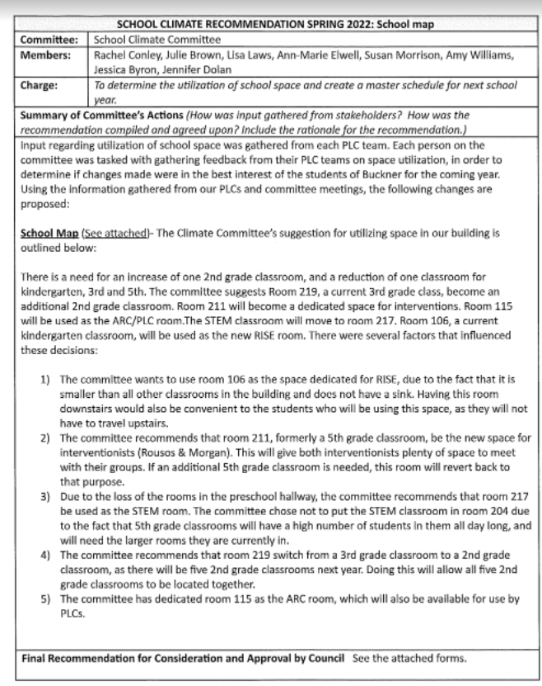

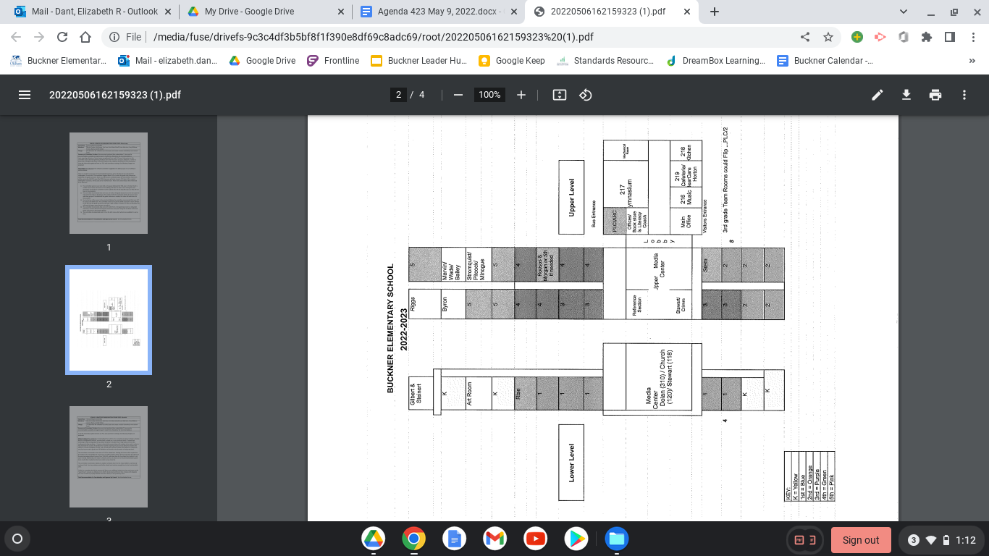

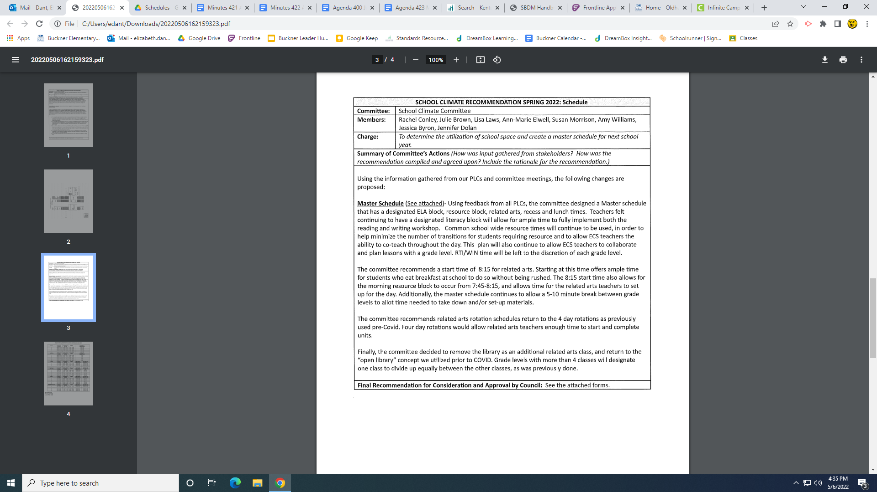

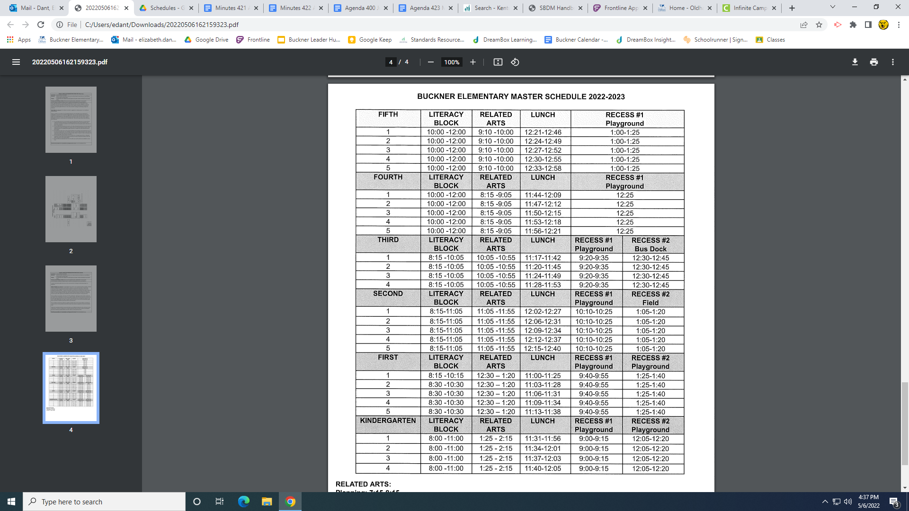

Enclosure C May 9, 2022
Buckner Elementary School Council
Oldham County Schools

CONCERN:

Review the 2022/2023 daycare budget.

DISCUSSION:

State auditors required Councils to review and approve daycare budgets. Please click this link and you will find a budget that Mrs. Horton, BearCare Director, Amber Waller, bookkeeper, and I have pulled together for Council consideration. (It’s important to note that the daycare is for profit and helps secure additional staffing and equipment for elementary schools that, in the past, they would never be able to afford. Many of the computers, iPads, laser printers, and playground upkeep have been funded by our daycare funds.)

The pandemic caused a surmountable financial strain on our current Bear Care budget, but luckily to ESSER relief funds we have received a number of grants that have offset the cost of our payroll for the entire year and we have a very healthy balance at this time. Although it does look like we have a large amount of money in our Bear Care budget we must keep 3-6 months worth of expenses in the case of an emergency (like a pandemic), we also must be able to pay out our director or any other long time employee that has accrued a lot of sick days over the years and/or pay for the upcoming staffing bill that will be due in January of 2023. If you recall our budget that we passed in March has an estimate of $100,000 needed from Bear Care to be balanced.

I will have a hard copy of the budget at our meeting and discuss the budget in more detail and answer any questions the Council might have.

RECOMMENDATION:

Review and adopt the proposed daycare budget documents for 2022-2023.

