Buckner Elementary School Council
Oldham County Schools

A G E N D A
Google Meet joining info
https://meet.google.com/tqr-tdze-qos
Or dial: +​1​ ​8​7​2​-​8​1​3​-​0​0​4​6 PIN: 5​8​3​ ​2​2​6​ ​7​9​1​#

September 13, 2021
3:00 p.m.

- Call to Order

- Agenda Approval

- Approval of the Minutes from the August 9th regular called meeting and August 13th special called meeting

- Personnel Actions

- Council Action Items

A. Review/Approve the School Profile Report (Enclosure A)

B. Review/Approve the Purchasing Plans for Bridges Intervention Materials
(Enclosure B)

C. Review/Approve the Purchasing Plans for Learning Without Tears
(Enclosure C)

D. Review Proposed Fundraising Requests for 2021/2022 (Enclosure D)

E. Consider and Approve Teacher Membership to Standing Committees for
2021-2022 (Enclosure E)

F. Review/Approve plan for ESS funds (Enclosure F)

F. Sign Student Free Speech and Religious Liberty Rights

G. Sign Code of Ethics

- Enter Closed Session to Discuss Certified Personnel Selection per KRS 61.801 (1)(f)

- Adjourn

Record of Council Proceedings
(Minutes)
Buckner, Kentucky
August 9th, 2021
In person Regular Called Meeting
3:00 p.m.

DRAFT
The Buckner Elementary School Council advertised a regular meeting at the front of school. The following members were in attendance in person in room 103: 1. Liz Dant 2. Jennifer Dolan 3. Beth Lindauer and 4. Lee Hamilton. Roderick Pack, Erin Marvin and Devan Gunderson were absent.

- The meeting was called to order at 3:04 p.m.

- The Council reviewed and approved the agenda.

- The Council reviewed and approved the minutes from the June 7th regular called meeting and the June 11th, June 22nd, June 30th, July 15th, July 30th and August 5th special called meetings.

- Ms. Dant informed the Council of the following personnel actions.

Recommendations:

Kelly Milberger, 2nd Grade Teacher (conferred with Council on 7/30/21)

Michele Kopp, ECS assistant (conferred with Council on 7/15/21)

Wendy Doyon, Kindergarten Assistant (conferred with Council 8/5/21)

Jody Antonini, Custodian (conferred with Council 8/5/21)

- Mrs. Dant updated the Council on the most recent enrollment numbers.

- Mr. Parrott presented the Emergency Management Plan to the Council members. After discussion the Council approved the plan for the 2021-2022 school year.

- Mrs. Dant presented the updated budget based on the newest enrollment numbers. After discussion the Council approved the budget.

- Mrs. Dant explained the Duty Under the Law and the Managing Public Records documents with the Council.

- Due to time constraints and three members absent, the Council did not sign the Student Free Speech and Religious Liberty Rights or Sign the Code of Ethics. Those will be completed at the September regular called meeting.

- The Council did not need to go into closed session.

Having no further business, the Council adjourned at 3:27 p.m.

Record of Council Proceedings
(Minutes)
Buckner, Kentucky
August 13th, 2021
In person Special Called Meeting
3:00 p.m.

DRAFT
The Buckner Elementary School Council advertised a special called meeting at the front of school. The following members were in attendance in Mrs. Dant’s office: 1. Liz Dant 2. Jennifer Dolan and 3. Erin Marvin. Roderick Pack, Beth Lindauer and Devan Gunderson were absent.

- The meeting was called to order at 3:03 p.m.

- The Council reviewed and approved the agenda.

- At 3:04 pm the Council entered into closed session to discuss candidates per KRS 61.801 (l)(f)

- At 3:07 pm the Council returned to open session.

- Having no further business, the Council adjourned at 3:07 p.m.

Enclosure A
September 13, 2021
Buckner Elementary School Council
Oldham County Schools
CONCERN:

The state requires every school to update its School Report Card on an annual basis.

DISCUSSION:

Attached is a hard copy of the School Report Card that I sent you electronically in August. The annual School Profile Report highlights programs offered in our school. It includes how schools address and implement the adopted Kentucky Academic Standards for the programs of Health and Physical Education (Practical Living), Career and Technical Education (Career Studies),Visual and Performing Arts, and World Languages (Foreign Language). Reporting is in accordance with KRS 158.6453 Section 3 (20) as amended in Senate Bill 1 (2017).

All member of our Council have signed the School Report Card but I wanted to give you an opportunity to ask questions if you have any. Please review the School Report Card and let me know if you have any questions.

A link to the School Profile Report is made available to the Kentucky Department of Education and is accessible on the department’s website through the School Report Card.

RECOMMENDATION:

Review/approve the information on the 2020-2021 School Report Card.

Enclosure B
September 13, 2021

Buckner Elementary School Council
Oldham County Schools

CONCERN:

Consider a proposed purchasing plan for the intervention materials that correspond with our Bridges math materials.

DISCUSSION:

On May 10th of this year, the SBDM Council approved the recommendation by the Curriculum Committee for a new math resource, Bridges. The company also sells an intervention set (resources for students who are struggling) that our special education teachers have tried out using our on-line resources. After several weeks of using them they have asked for me to purchase these materials and I agree that it would be a good resource. The cost of the kit is $938.93.

RECOMMENDATION:

Consider/Approve the intervention materials that correspond with the Bridges math resource.

Enclosure C
September 13, 2021

Buckner Elementary School Council
Oldham County Schools

CONCERN:

Consider a proposed purchasing plan for Learning Without Tears

DISCUSSION:

Part of our ELA curriculum standards given to us by the state requires explicit instruction in handwriting including cursive. The teachers in the past have used Handwriting Without Tears materials to teach the cursive and we have found success with these. The teachers are requesting again that the workbooks be purchased and the PTO has agreed to pay for these materials. Each workbook costs $11.50 and the total cost of the purchase would be $2858.90

RECOMMENDATION:

Consider/Approve the Handwriting Without Tears materials for 2nd and 3rd grade students to use.

Enclosure D
Sept. 13, 2021

Buckner Elementary School Council
Oldham County Schools

CONCERN:
Review the Fundraising Requests for 2021/22

DISCUSSION:
You will find a copy of the fundraising requests for the coming year according to OCBE 3045.01-AR. Each year, schools must submit requests for fundraising activities to the Oldham County Board of Education for review and approval by July 1. The Board of Education has strongly urged fewer product sales and has always prohibited door-to-door sales in the last 15 years. The board asks that the focus of PTA and PTO’s to be on students and services to them rather than have an emphasis on fundraising. The funds our PTA has raised over the years have made many things possible – the school playground equipment, computers, Chromebooks and cultural arts assemblies to name a few – which Buckner would not have without their financial support.

Although most events sponsored by the PTO and school are targeted to provide enriching opportunities for students and families, some do bring in small profits. The PTO is, once again, proposing one major fundraiser – The Buddy Bear Fun Run and a Silent Auction. However, in addition the PTO will also host a Playground Capital Campaign which will help us raise money for our new playground As you review the spreadsheet, you will see that we must inform the board of the type of sales, the intended uses of the proceeds, estimated net proceeds, proceeds needed for the sale, and approximate dates of the sales. Included are requests for charitable fundraising events which cover what we do for the Red Cross, Relay for Life and Jump Rope for Heart. These three charities have been identified by the Board of Education as the only charitable organizations for which we ask for monetary donations.

I’ll lead you through the requests and answer any questions or concerns the Council might have.
Here is the link for the fundraising requests.

RECOMMENDATION:

Approve fundraising requests for 2021-2022

Enclosure E
Sept. 13, 2021

Buckner Elementary School Council
Oldham County Schools
CONCERN:

Consider standing committees for the 2021-2022 school year.

DISCUSSION:

According to BESC policy 1005, six standing committees shall be formed to make committee recommendations to the Council. The standing committees are: Instructional Practices, School Climate, Curriculum, Evaluation & Professional Development, Student Services, and School Improvement Planning Committee. Council members may serve on standing and ad-hoc committees. According to policy, teachers serving on standing committees shall be appointed by the chairperson by August 30th of the year of their service and approved by the Council. (Sorry!!! I missed the deadline a little on this one.) Parents serving on standing committees shall be appointed by the chairperson by September 30th and approved by the Council. Standing committees shall report to the Council.
I’ve included the non-SBDM committees, not for Council approval, but just to inform Council members about the additional committees on which teachers serve. In particular, there are a couple of committees that will have a direct impact on student learning. Also, due to requirements and improvement goals in the Program Review for Practical Living, there needs to be a committee in place to serve as an Advisory Committee for Health and Wellness.
Finding parent representatives has been the most challenging part of standing committees in the past. So, if you know parents who have expressed a desire to get more involved at school, encourage them to complete the SBDM form that will be in Wednesday folders and in the PTA newsletter.

RECOMMENDATION:

Review and approve the recommended standing committee memberships of teacher representatives for the coming year.

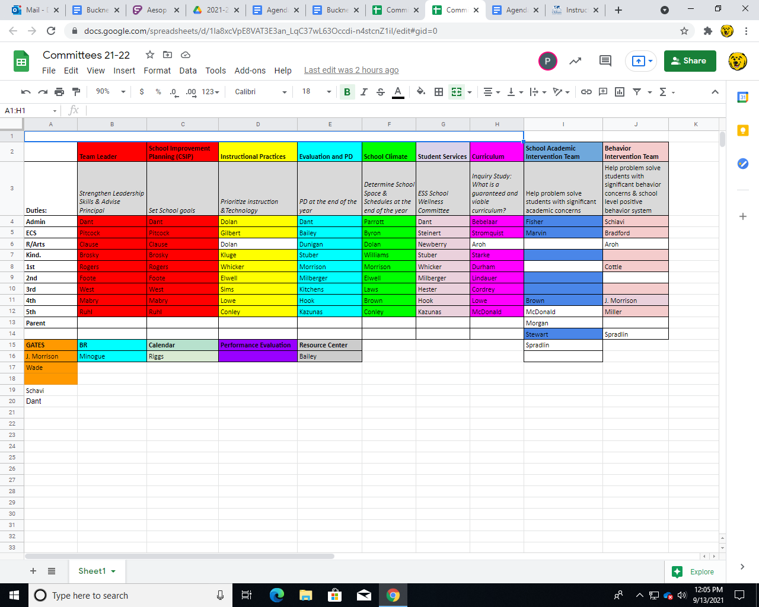

School Academic Intervention Team | Behavior Intervention Team
Help problem solve students with significant academic concerns | Help problem solve students with significant behavior concerns & school level positive behavior system
Fisher | Schiavi
Marvin | Bradford
Brown | Aroh
McDonald | Cottle
Morgan | J. Morrison
Stewart | Miller
Spradlin | Spradlin

Enclosure F
Sept. 13, 2021

Buckner Elementary School Council
Oldham County Schools
CONCERN:

Consider the disbursements of categorical funds for ESS 2021/2022

DISCUSSION:

The state gives the Oldham County school district a lump sum of money to be used for extended school services (ESS). The District then gives each school a chunk of ESS money, in our case approximately $19,000, to be utilized for helping students who struggle.

The money can be used for during the school day and after the school day to offer remediation support. Typically in the past we have hired 2-3 part time interventionists as well as paid teachers to stay after school during the winter months to support students.

My recommendation is that we use our ESS funds to hire 2 interventionists.

RECOMMENDATION:

Review and approve the recommendations for ESS for 2021-2022.

Oldham County
ESS Program and Evaluation Planning
2021-2022
School: Buckner Elementary
NOTE EVERY SECTION/BOX must be completed thoroughly for this application to be approved.
Will you be utilizing an approved Daytime Waiver Program? If yes…
Who will the DW program service? K-5 demonstrating a need for intervention in the area of math, reading or writing
In what content areas will student’s be served? Mathematics, Reading or Writing
How often will they be served? 2-3 times/week
MAKE A TABLE BELOW that includes the NAMES of all Personnel paid for with ESS funds, including their exact hours, days of work, rate of pay, start and stop anticipated dates, etc. THIS INCLUDES daytime waiver, staff paid for before and after school, summer school, etc. Staff who are FULL time must be paid from the appropriate salary schedule rate. Part time staff must be paid for at the $35/hour rate! We will be using this table to approve payments so if they aren’t on here correctly their pay will not be processed in a timely manner.
Daytime ESS Part-Time Program Teacher -

Two Part Time Certified - $35/hour -
Judy Sanders
Person #2

After-school ESS - 6 Teachers

Extended Time Schedule | Transportation Provided (yes, no, or partial) | Projected # of Students to Serve | Grades to Serve, e.g., P-6 | Projected # of Classified Staff | Projected # of Student Tutors | #s of Certified Staff
July/Aug.  Summer 2021 | no | 50 | 1-5 | 0 | 0 | 8
After School** | no | 30 | K-5 | 0 | 0 | 5
Before School**
Daytime Waiver** | NA | 45 | K-5 | 0 | 0 | 2
Evening**
Saturday**
Intersession**
June-Sept.  Summer 2022 | no | 30 | TBD based on need | 0 | 0 | 4

By law you are required to have out of school services through ESS, even if you have a DW.
Describe your out of school ESS program. Teachers will work with small groups of students in grades K-5 for tutoring sessions in Reading, Writing or Math.
Who will provide the services? Certified staff will provide intervention.
How will they be paid? Include funding sources if not ESS.
ESS funds will be used.
Summer School 2022 will be paid with day care funds

Will you be providing summer school (through June 30th) or Jumpstart (July 1-start of school)? Yes. If so...
Describe your program. 30 students selected based on need will access literacy/math instruction in Summer 2022.
Who will provide the services? 2 Certified Teachers
How will they be paid? Include funding sources if not ESS. Daycare funds will be used once ESS has been exhausted.

Will you be providing services during intercession/over breaks? No If so...
Describe your program. Who will provide the services? How will they be paid? Include funding sources if not ESS.
NA

If applicable, how does the use of these funds, in the way you have described, connect with your school’s improvement plan?
We are always looking for ways to improve the achievement of our students in the area of literacy and mathematics who are not yet proficient.

How will you evaluate the effectiveness of your ESS Program, not just individual students?
Grade level PLCs meet regularly to analyze, discuss and respond to common formative data as a grade level, and the ongoing progress of all students. PLCs utilize School Runner to house student progress data. Common formatives will be utilized to monitoring individual student progress and provide feedback to teacher on mastery learning for planning purposes.
In order to evaluate the overall effectiveness of the ESS program, though, we will look to MAP growth data from Fall 2021 to Spring 2022 for individual students identified for ESS by their grade level PLC. More than a student mastering one specific standard, we desire our ESS program to support increased overall achievement.

How often will you evaluate the students and program?
Regular common formative assessments will be utilized by teachers to inform student progress, uncover misconceptions and guide next steps for ESS lessons. Students will be assessed in Reading and Math on MAP in the Fall, Winter and Spring. These will be our checkpoints to evaluate our ESS program.

Budget Allocation __$19,098________________
Category | Description (# hours/days, fte base salary info calculations, etc.) SHOW the MATH by category! For example, separate out summer school, after school, intercession, Daytime waiver folks, etc. | Budgeted Amount
Stipend Amount (after/before/out of school) @ $35.00 per hour (NOT Daytime Waiver) | 5 teachers * 1day/ week  50 minutes/ day + 10 minutes of planning  $35/ hour  6 weeks | $1050
Base Salary @ fte (for Daytime Waiver Salaries) based on salary schedule
Stipend Amount @$35.00/ hour if person will be paid for Daytime Waiver with a standard invoice | Judy Sanders-  3 days/ week (4 hours/ day)* 26 weeks  Person #2  2 days/ week (4 hours/day) * 24 weeks | $10,920  $6720
Medicare (1.45% of stipend and base salary amounts)
KTRS (3% of stipend and base salary amounts)
Worker’s Comp (.08% of stipend and base salary amounts)
Unemployment (Start with $60)
General Supplies (requires approval from Leslie before purchasing) |  | $408
Total (BUDGET MUST EQUAL not exceed or fall below your allocation) MAKE it an exact match! |  | $19,098

