La Grange Elementary School Council
Oldham County Schools
A G E N D A

January 24, 2022

- Call to Order
- Agenda Approval
- Review Norms

Council discussions stay within the group until the action item has been approved by the Council
- Start on time and end on time
- Maintain a focus on ensuring the learning of all students
- Be willing to share ideas and open to new learning

- Council Action Items
- Family Resource Bi-Annual SBDM/Principal Agreement (Enclosure A)
- Enter Closed Session to Discuss Certified Personnel Selection per KRS 61.801 (1) (f) for discussions that might lead to the appointment of an individual employee.

- Principal’s Report
- Board Report (Enclosure B)
- Staffing

January 24, 2022
Enclosure A

La Grange Elementary School Council
Oldham County Schools

CONCERN:
La Grange Elementary, based on our percentage of free and reduced lunch numbers, is designated as a Family Resource Center School. Every two years, Mr. Drury, our Family Resource Center Coordinator, is required to converse with the Site Based Council and Principal to ensure our policies and procedures are in alignment with all FRYSC-related statutes.

DISCUSSION:
Mr. Drury will be joining our Council meeting to present the FRYSC-related statutes and facilitate our discussion.

RECOMMENDATION:
Review and certify that our school policies are consistent with FRYSC-related statutes.
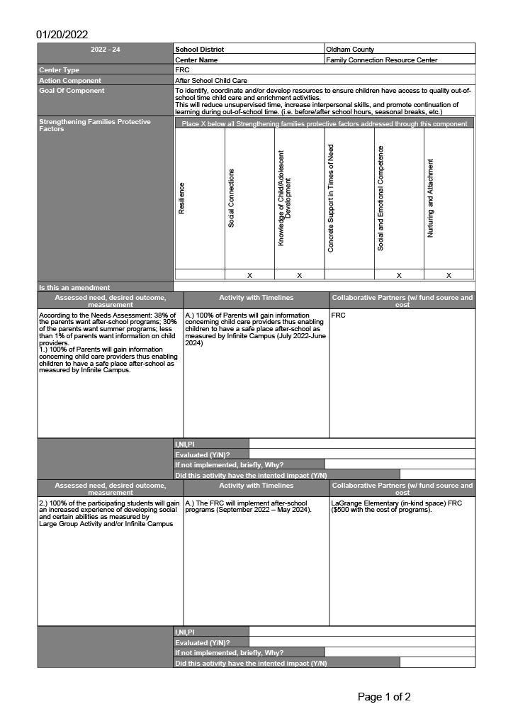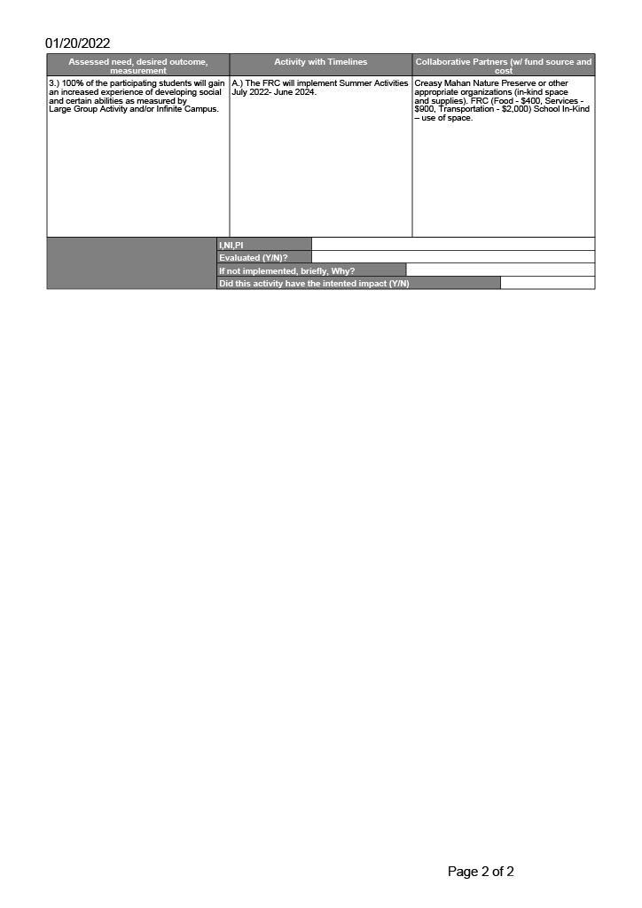
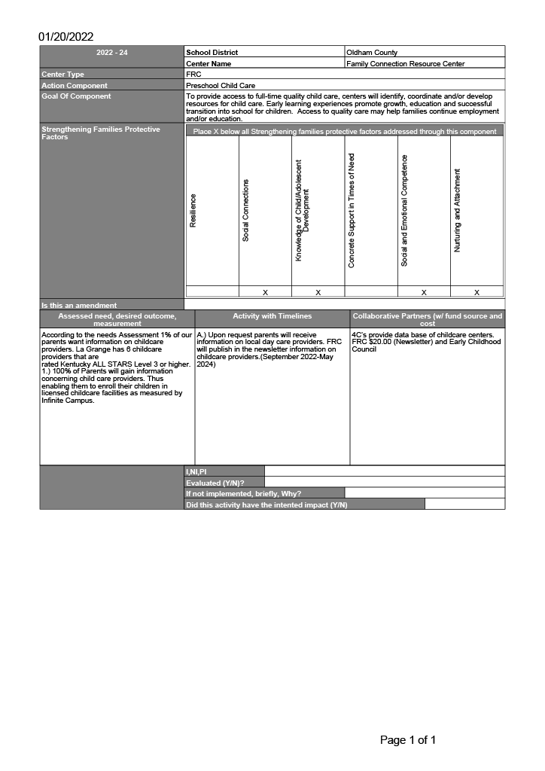
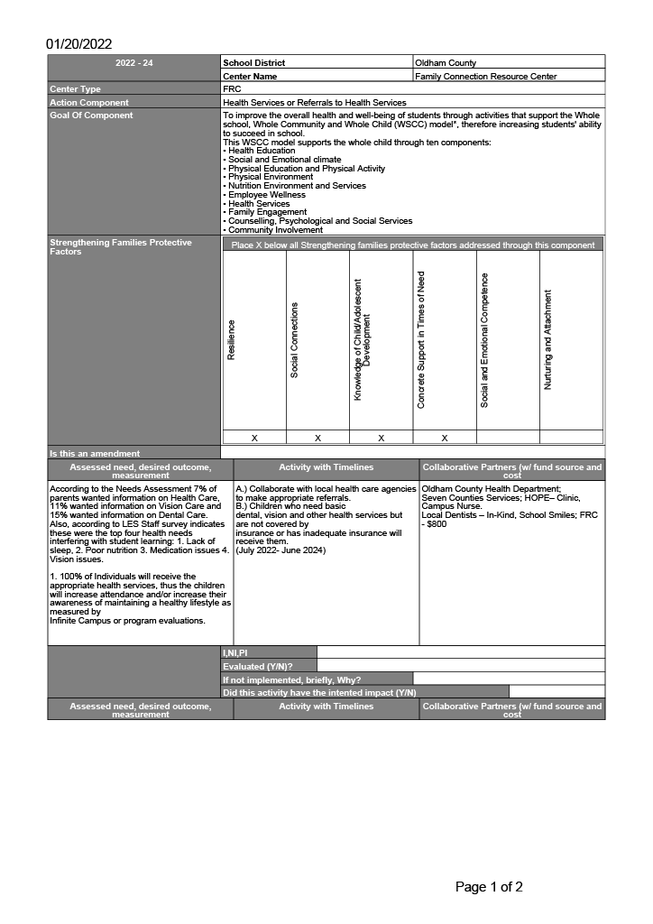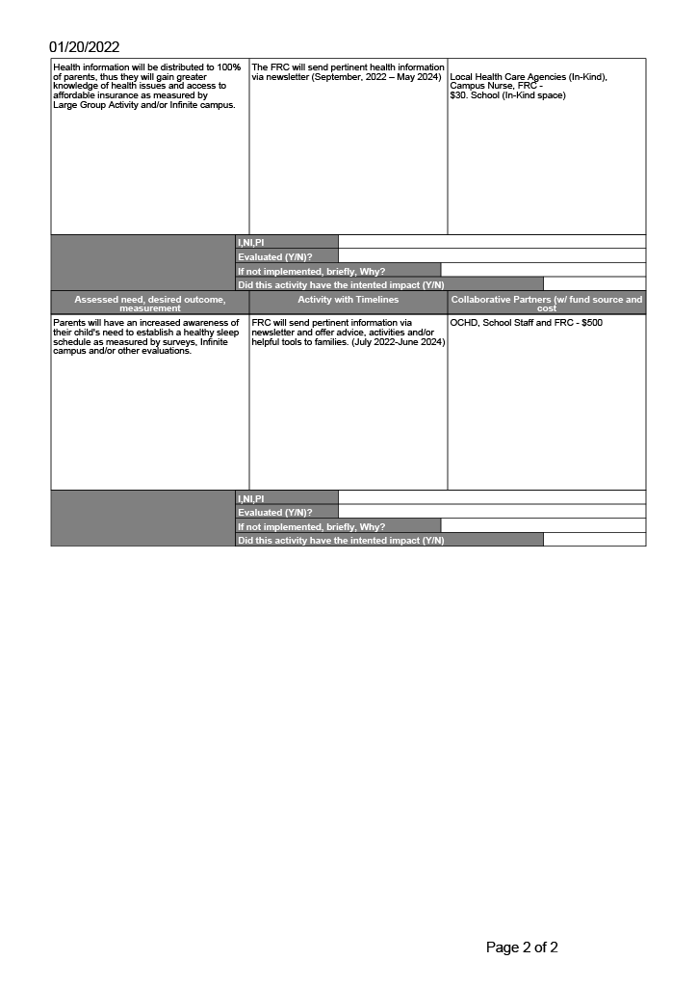
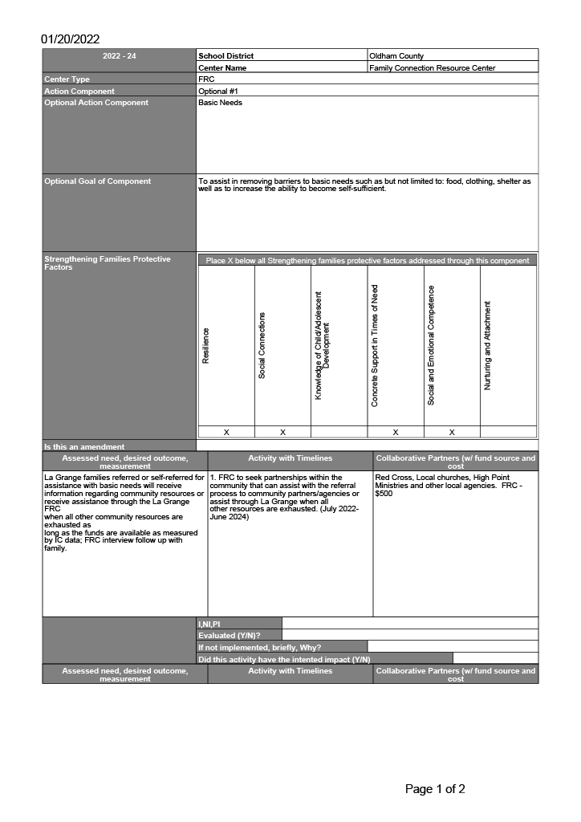
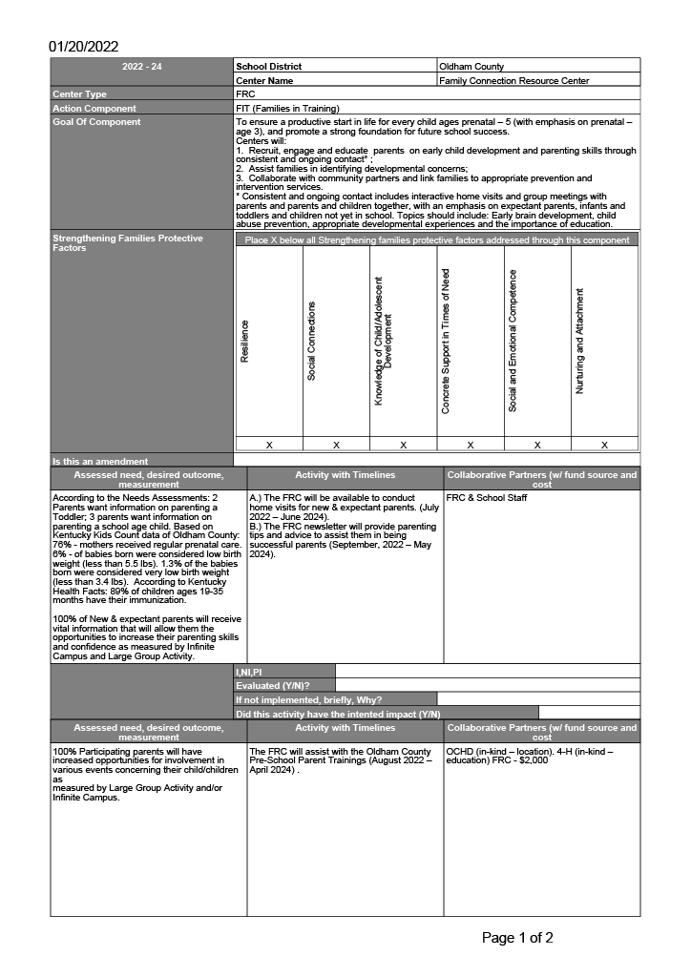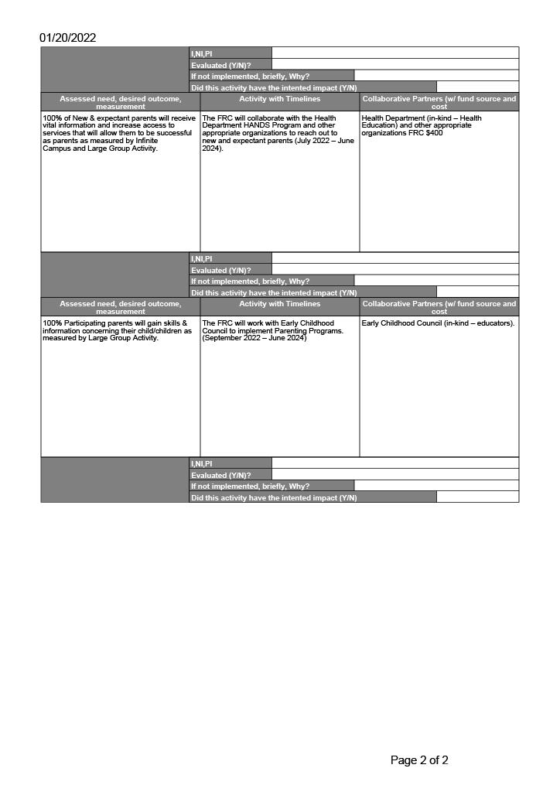
Principal’s Report
Board Report & Staffing
La Grange Elementary SBDM COUNCIL REPORT: 2021-2022
SBDM Council Members: Parents: Sara Melhourne and Kiley Walker; Teachers: Meagan Ahlers, Jessie Gray and Tracy Simpson; and, Chair: Heather Thomas
Date of Presentation to the Board: February 8, 2022
School Report (Not to Exceed Two Pages):
- What is working well in your building? What would you like to highlight about classroom instruction and its impact on student learning at your school?
What works well at La Grange is building on the strengths of our students and staff. Our students thrive under structure and routine. Remaining in school throughout the 21-22 school year has been the greatest gift the Board could give our students. Our mid-year MAP growth in both reading and math is the highest we’ve ever had for either content area. According to NWEA, strong growth on MAP starts at 64%. All K-5 grades scored above 64% growth in reading with 3 grades levels hitting 99%, which is as high as you can go with a growth percentage. In math, all grades also exceeded 64% growth in math with 3 of the 6 again scoring 99%. The strengths and skills of our staff and coaches play a critical role in the growth of our students. Teachers' strengths are highlighted through our LA Way Walkthroughs, teacher videotaped lessons shared during staff meetings, Peer Walkthroughs, and in-district and out-of-district observations. Our staff has been observed by a Bullitt County school, OC Preschool, 4 JCPS schools, and the JCPS AIS Team with Dr. Hogue.
Our Writing Coach is an example of building off the strengths of our staff. Prior to this year our Writing Coach was a 5th grade classroom teacher that focused on writing instruction as our 5th grade is departmentalized. For the 2018-2019 school year, our 5th graders scored 67.6% Proficient/Distinguished in writing which was 6.9% above the district norm and 20.9% above the state norm. For the 2020/2021 school year, our 5th graders scored 79.1% Proficient/Distinguished in writing which was 11.5% above the district norm and 39.3% above the state norm. In order to utilize this teacher’s strengths and build capacity in other teachers, we moved this teacher to a Writing Coach position for this school year. She is now working with grades 2-5 in order to help support the success of more students in the area of writing. She is performing “Live Lessons” in which she works in one classroom but streams across the other classrooms live for a writing lesson. This allows the entire grade level to access her expertise at one time. In addition to providing explicit instruction which is a model in writing instruction for teachers, she guides teachers in weekly data analysis of the writing process to pinpoint next steps in instruction.
Data analysis within our PLC’s have resulted in adjusting instruction to best support students in mastering the standards. Within the PLC’s we have focused on identifying our priority standards in ELA and determining learning targets that build upon each other to reach these standards. This gives teachers ownership of the standards and allows them an opportunity to calibrate what student mastery of the standards really looks like which in turn raises their level of instruction.
- Based on the needs of your school, what priority areas have you identified? How will you work on these priority areas this year and how will you measure progress over time?
Math remains one of our priority areas at La Grange. Eureka Math: Grades 2-5 use digital pre-assessments from Eureka Equip/Affirm for each math module aligned with our Eureka Math curriculum. Teachers then analyze the pre-assessment data and determine next steps for instruction. For example, to help meet the needs of our tier 2 math students, this computer program matches students’ pre-assessment data with essential foundational skills they are lacking. Teachers are then able to print ready to teach lessons from Eureka Equip designed to help students fill the gaps so they can successfully complete mathematical questions pertaining to the essential foundation skills for the module. Students’ progress is monitored throughout the module when they take the mid-module assessment and end of module assessment. Both of these assessments are also administered through Eureka Equip/Affirm so that students have immediate assessment data to help determine next steps.
In addition to the Eureka Equip/Affirm platform, we would like the new Eureka Math curriculum, called Eureka Math squared. The new curriculum is still aligned with the Eureka Equip/Affirm online platform, but has been revised so that it is more teachable with lessons that follow a consistent routine. The new curriculum is more accessible and engaging to all students. We know money was spent to buy resources for the schools using Bridges for math and we feel our school, and other Eureka schools, would benefit from having resources such as the new teacher manuals and student workbooks purchased to help enhance our student learning in the area of mathematics.
- What are two topics that you and your council would like to discuss with the Board?

Technology: We were working diligently towards a goal of becoming 1:1 with technology and were ahead of schedule due to the generosity of our school Board, district, and PTA. At the beginning of this year, we were 1:1 in 2nd-5th & 1:2 in 1st grade. However, some of our Chromebooks have reached their “end of life” as designated by the manufacturer meaning they no longer receive updates and pose a security risk. At the beginning of this year, we lost 150 Chromebooks due to “end of life” and by the end of this school year another 130 will reach their end of life, for a total of 280 Chromebooks lost this year! So, instead of continuing towards meeting our 1:1 goal, we are losing ground. We did receive a large donation from the City of La Grange to help supplement this loss, but with more devices slated for “end of life” surplus, there is no way for us to maintain or reach our goal financially. Due to roughly 60% of our population being free/reduced lunch, it is essential that we provide the necessary tools to help them succeed in life.

Wrap-Around Supports: Our ability to grow students is a strength at La Grange. We have a high percentage of poverty, EL and special education students, and that is why our free breakfast & lunch program, the Camp Literacy summer program, and a large staff of ECE, EL, & Intervention teachers are so essential for our students’ academic growth. Our Family Resource Center and Hispanic liaison are vital in helping meet and support the needs of our families. Our two counselors, full-time school psychologist, wrap-around facilitator, and Mental Health Consultant address the vast mental health needs of our population. As of 1/10/22, the mental health team has conducted 24 threat assessments for the 21-22 school year, including both threat and suicide screenings. Individual assessments require a multi-faceted team approach and may take more than 5 hours when referrals to mobile assessments are required to ensure safety of all students. This is just one example of why these programs and staff are crucial to the safety and success of our students.

