La Grange Elementary School Council

Oldham County Schools

AGENDA

October 26, 2020

- Call to Order

- Agenda Approval

- Review Norms
- Council discussions stay within the group until the action item has been approved by the Council
- Start on time and end on time
- Maintain a focus on ensuring the learning of all students
- Be willing to share ideas and open to new learning

- Council Action Items
- Policy Review: 4004
- Technology Fees

- Principal Items
- Impact Survey and Principal Reflection

- La Grange Elementary
School-Based Decision Making Council
Minutes
September 28, 2020

The La Grange Elementary School Council met in regular session in the Library/Media Center at LaGrange Elementary with the following members in attendance: Jessie Gray - Teacher Rep, Jessica Galati - Teacher Rep, Matthew Butterfield – Teacher Rep, Ashley Phenix – Parent Rep, Kiley Walker – Parent Rep and Heather Thomas - Chair. Mrs. Thomas called the meeting to order at 2:41 pm.
- A motion was made by Matthew Butterfield to accept the minutes as read. Jessica Galati seconded and the motion carried with no opposition.
Mrs. Thomas reviewed two SBDM policies. The first being Policy 5002 – Consultation. She explained what the policy means and what revisions she would recommend. After discussion and revisions, a motion was made by Kiley Walker to accept the revised policy as written. Jessie Gray seconded the motion and the motion carried with no opposition. The second policy reviewed was Policy 3001 – School Budget. Mrs. Thomas explained what the policy means and what revisions she would recommend. After discussion and revisions, a motion was made by Jessica Galati to accept the revised policy as written. Ashley Phenix seconded the motion and the motion carried with no opposition.
With no further business to discuss, Jessie Gray made a motion to adjourn. Kiley Walker seconded.
Meeting was adjourned at 2:55 pm

La Grange Elementary
School-Based Decision Making Council
Minutes
October 13, 2020
The La Grange Elementary School Council met in a special-called session in the library of La Grange Elementary School with the following members in attendance: Jessie Gray (teacher), Ashley Phenix (parent), Jessica Galati (teacher) and Heather Thomas, chair, called the meeting to order.

- The meeting was called to order at 7:10 am.
- The Council reviewed and approved the agenda.
- The Council entered closed session to discuss certified personnel selection as provided by KRS 61.810 (1)(f) at 7:12 am.
- The Council resumed open session at 7:13 am, and, having no further business, adjourned.

- Enclosure A October 26, 2020

La Grange Elementary School Council
Oldham County Schools

CONCERN:

The phrase council policies refer to what the school council develops and adopts concerning how the school operates. This includes such items as curriculum development, determining school schedules and technology use in schools. Policies are the rules, guidelines and procedures for school operations.

DISCUSSION:

School council policies need to contribute to raising student performance and keep a focus on achieving our mission and goals. As our goals and procedures evolve, the council needs to review our policies to determine if and how they need to be revised.

RECOMMENDATION:

Discuss council policy 4004 presented, make revisions, ask questions and seek additional information if needed.

LAGRANGE ELEMENTARY SCHOOL COUNCIL POLICY

PROMOTION, RETENTION, AND EXTENSION OF PRIMARY SCHOOL 4004

TOPICS STATEMENT

a. Philosophy Successful completion of the Primary School, (kindergarten through third grade) fourth grade, or fifth grade for students not in a special education program is based upon satisfactory academic achievement as indicated by demonstration of the district Exit Standards, grades, progress reports, and other pertinent data including ability, chronological age, attendance, and the probable effect of promotion or retention upon the student.

b. Guidelines Decisions regarding an extension of time in any grade will be consistent with state regulations and Oldham County Board of Education Policy 4065.

- Any student not achieving up to his or her grade level expectations may be considered for additional time. Teachers and administrators must follow state regulations when considering an extra year for Primary students.
- A student should generally not spend more than one extra year in the elementary school; however, teachers, the counselor, and the principal are responsible for rendering a judgment that will best meet the individual needs of the student in consideration. Parents are to be included in this discussion. It is possible that a second additional year may meet those needs and as such may be considered.
- Students spending an additional year at the elementary school are to have a significantly different plan of instruction than experienced in the previous year.
- In situations where the principal feels retention is warranted, he or she must notify the level director, who will assemble a committee to review the request and provide district level approval for retention. The Superintendent will establish the committee structure and process for review by administrative regulation.

c. Procedures Extending the time of education for a child should be a cooperative decision between teacher, parent(s), administrator, and other professional personnel who can provide pertinent information about the child. (DELETE)

By the end of the second trimester, teachers will identify those students who are likely to be considered for an extra year and will contact (the principal) parents to discuss the issues. The school will follow district guidelines as mentioned above.

During the final month of school, in cases where there is a lack of consensus between the parent(s) and teacher(s) concerning the advisability of retention/extension, a school screening committee including the teacher(s), principal, counselor, and parent(s) will study the data and recommend appropriate placement. If a consensus decision cannot be reached between the aforementioned parties, the principal will determine the final decision. For students being considered for an extension of the primary school, the teacher will complete the “Successful Completion of the Primary School” form. (DELETE)

Written confirmation of the committee’s final decision will be sent to the parents.

Adopted – La Grange School Council – August 2013; Revised- October 26, 2020

Enclosure B
October 26, 2020
CONCERN:

Students, not approved for fee reduction, are required to pay a yearly technology fee of $15. The Council, with input from our Technology Coordinator and Technology Committee, need to determine the technology needs at La Grange and how to best spend these funds.

DISCUSSION:

After reviewing the technology needs in the building, Mrs. Sangalli recommends we continue building the 2nd grade Chromebook supply.

RECOMMENDATION:

Review the recommendation to approve or make additional changes.

Student Technology Fee
Recommendation to
La Grange Elementary School Council
2020 - 2021

The Oldham County Board of Education approved a $15.00 student technology fee for the 2020-2021 school year.

As of October 1, 2020, La Grange Elementary School has collected $2,310.00 in student technology fees. Additionally, the PTA donated $2000 for technology.

- Following La Grange Elementary’s 5-year technology plan, it is our recommendation that we continue building our second grade supply of Lenovo (touchscreen) Chromebooks toward the goal of 1:1 student-to-device ratio.

Respectfully submitted,
Schoen Sangalli, STC

Enclosure C
October 26, 2020
CONCERN:

Every two years the state invites certified staff to participate in a working condition survey known as the Impact Survey, or formerly known as the Tell Survey. Participants are asked a series of questions under eight broad categories. The results of the data allows for a deeper dive into the culture and community within a school as well as comparing the school with the district and state.

DISCUSSION:

After reviewing the data, the council needs to discuss strengths, growth areas and if the professional development for the building aligns with the areas of needed growth.

RECOMMENDATION:

Review the recommendation to approve or make additional changes.

Below are examples of how the data is presented when reviewing the Impact Survey.
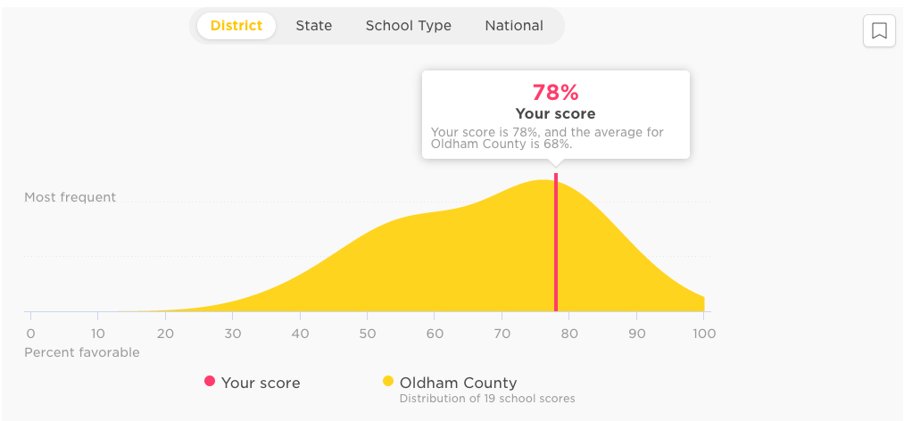
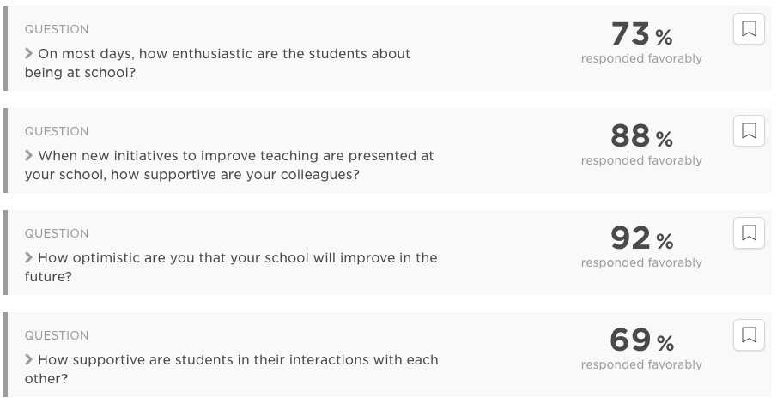
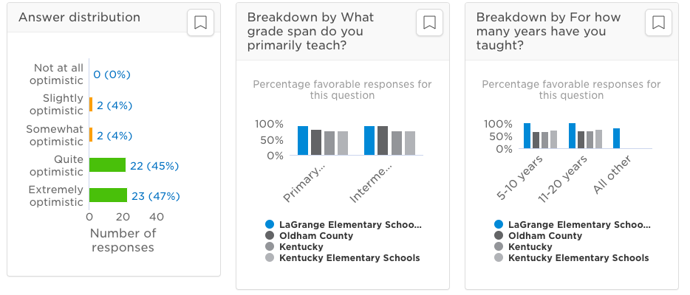
Here is more information based on each of the eight broader categories.

Topic | Overall  School Score | District  Comparison | Highlights within each topic
1. School Climate | 78% | 68% | + 92% How optimistic are you that your school will improve in the future?  - 69% How supportive are students in their interactions with each other?
2. Staff-Leadership Relationships | 78% | 77% | + 92% How confident are you that your school leaders have the best interest of the school in mind?  - 67% How motivating do you find working with the leadership team?
3. Educating all Students | 76% | 75% | + 96% How often do teachers use assessment data to inform their instruction?  - 59% How knowledgeable are you regarding where to find resources for working with students who have unique learning needs?
4. School Leadership | 76% | 61% | + 86% How clearly do your school leaders identify their goals for teachers?  - 67% How important is teacher satisfaction?
5. Professional Learning | 75% | 61% | + 88% How helpful are your colleagues’ ideas for improving your teaching?  - 61% How much input do you have into individualizing your own professional development?
6. Managing Student Behavior | 71% | 65% | + 96% Overall, how safe is the school environment?  - 18% How often does student misconduct disrupt the learning environment at your school?
7. Feedback and Coaching | 70% | 52% | + 80% How useful do you find the feedback you receive on your teaching?  - 57% How much do you learn from the teacher evaluation processes at your school?
8. Resources | 43% | 46% | + 82% How urgently does your school’s technology need to be updated?  -8% How often do your school’s facilities need to be repaired?
As the Principal, I would like to share my growth goal for the 20-21 school year and also our professional development plan for the year.

Professional Development Plan

Goal Topic | Your Goal (SMART* format)
Impact Survey | In reviewing our Impact survey data from the spring of the 19-20 school, the question about teachers locating knowledge/resources for students with unique learning needs was only 59% in agreement. During the 2020-21 school year, staff will build understanding of the BRIDGES process and with support, will implement early stage interventions. By spring of 2021, the goal will be to have 85% of staff to indicate that they have knowledge/resources to support students with unique needs.
Local Growth | Co-Teaching and “All Block”  Kentucky Tell Survey, 50% of staff believe that students waiting for help impacts student learning as well as 59% of staff believe that the school needs extra help for students. SMART goal  By April of 2021, administer a survey to all co-teaching partnerships. 80% of respondents will show a positive response to Co-Teaching and the impact on student learning.
PLC goal | According to KY Tell Survey, although 96% of staff agreed that La Grange has a safe learning environment, 82% of staff feel that student behavior disrupts the learning process. The goal is, through the use of the Foundations team & PLCs, increase staff knowledge and use of early stage interventions so that by Spring 2021, 62% of staff assert that student behavior disrupts the learning process.
PBIS growth | For the 2018-19 school year there were 100 instances (ISS & OSS) where students were removed from instruction due to behavioral concerns. The goal is by Spring 2021, to reduce by 10% the number in instances when students are removed from the instructional setting related to behavior

