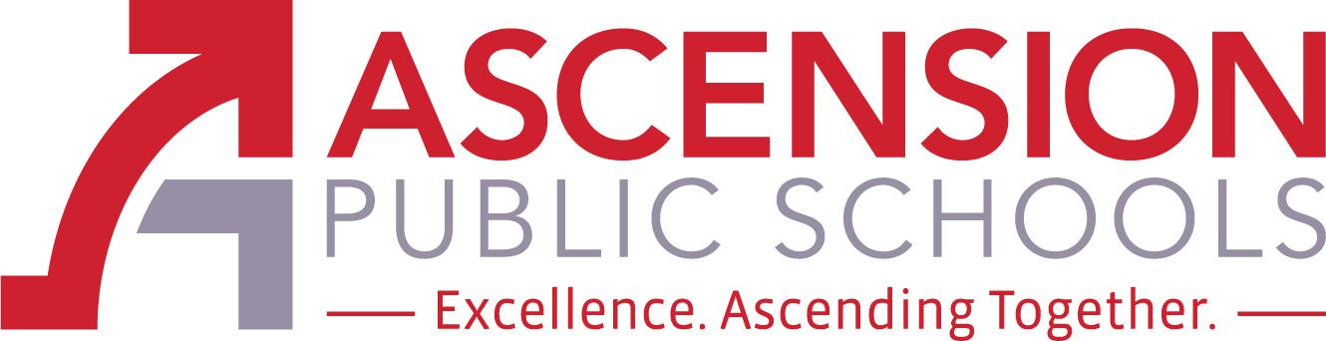

Ascension Special Education Advisory Council

June 29, 2022 AGENDA
12:00 p.m. NOON

Join Zoom Meeting
https://apsb.zoom.us/j/86204593804?pwd=OC9WbVljVEN5RTBuK0dNWkpScDUyQT09
Meeting ID: 862 0459 3804
Passcode: 974254
One tap mobile
+16465588656,,86204593804#,,,,*974254# US (New York)
+13017158592,,86204593804#,,,,*974254# US (Washington DC)
Dial by your location
+1 312 626 6799 US (Chicago)
+1 346 248 7799 US (Houston)
Meeting ID: 862 0459 3804
Passcode: 974254
Find your local number: https://apsb.zoom.us/u/kkOVE57tz

The Ascension Special Education Advisory Council (Ascension SEAC) is an opportunity for parents, district staff, and community stakeholders to provide advice and feedback regarding special education policies, procedures, and resources. The members of Ascension SEAC shall engage in outreach activities in the community to increase the level of knowledge, support, and

collaboration in regard to special education. The council will consist of 4 members, 2 shall be

parents of a child who receives special education services, one shall be an Ascension Parish Principal, Teacher or Paraprofessional, and one shall be a special education stakeholder. Each member will be appointed for a one school year term and will act as an advisory council to the superintendent and/or the school board. The Ascension SEAC will meet three times per school year.

SEAC Members: Honesty Howard (parent member), Jodi Rollins (parent member), Katie Millet (teacher member), and Sara Recile (other special education stakeholder). Chair: Lynn Hathaway, Director of Special Education
- Call to Order
- Roll Call
- Public comment procedures
- SEAC Purpose & Process

OLD Business -
- 1. a. Approval of minutes from April 27, 2022 SEAC meeting
- 1. b. Parent Survey - August; Parent Welcome Binder - August

NEW Business -
- - District Agenda Items -
2.a. New SEAC members for 2022-2023 - 8 parents (non-employee, 1 community stakeholder, 1 special education teacher)
2.b. APS SEAC Annual Report for 2021-2022
2. b. Special Education Teacher & Paraprofessional Survey Results

- - Parent Agenda Items -
3.a. Cameras in Special Education classrooms - updates & new legislation
3.b. Advertising for SEAC meetings
3.c. Parent meeting/forum

Closing of Meeting -

Next APS SEAC Meetings: August 31 , 2022 at 6:00 p.m.

