AURORA CITY SCHOOLS
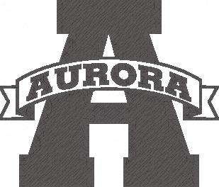
DISTRICT ACCOMPLISHMENTS
Only school district in Ohio to receive 9 straight A’s on the Ohio Department of Education 2013-14 Report Card
Rated Excellent with Distinction (with Distinction 12 Consecutive Years) ~ Ohio Department of Education
Earned “A” Rating ~ Ohio Department of Education
The District Performance Index Score ranks the district #11 in the State of Ohio out of 613 public schools with a score of 110.1
Ranked in Top 15 Districts Eleven Years in a Row ~ Cleveland Magazine
Rated One of the Most Efficient Districts in Ohio ~ KnowledgeWorks
Earned Auditor of State Award 2011-14 ~ 4th Consecutive Year
Ranked Top Work Place 2 Consecutive Years ~ Cleveland Plain Dealer

Aurora High School
Performance Index Score #13 in the State of Ohio ~ Ohio Department of Education
National Blue Ribbon School Award ~ U.S. Department of Education
Among Nations Top Public High Schools ~ Newsweek Magazine
Ranked #15 in Ohio and #497 Nationally ~ Washington Post
Ranked #13 in Ohio and #287 Nationally ~ U.S News & World Report
National AP Honor Roll 4th Consecutive Year (One of only 3 high schools in Ohio and one of only 477 public schools named nationally) ~ CollegeBoard
Harmon Middle School
Performance Index (PI) Score #8 in the State of Ohio ~ Ohio Department of Education
Ranked #9 nationally in the 2014 The Best Schools website
#1 Science Score in State on Ohio Achievement Test (2011, 2013) ~ Ohio Department of Education
National Blue Ribbon School Award ~ Earned in 2013 ~ U. S. Department of Education
Leighton Elementary School
Hall of Fame School
Buckeye Best Gold Award
Craddock/Miller Elementary School
Buckeye Best Gold Award
