

The Texas Comptroller of Public Accounts awards the Carroll Independent School District
the Traditional Finances Star

for exemplary efforts in creating financial transparency around public services and spending decisions. The Transparency Stars program recognizes local governments across Texas that are striving to meet a high standard for financial transparency online. These efforts provide citizens with clear, consistent information about public spending in user-friendly formats.


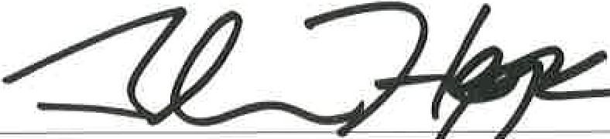February 17, 2017

